Shabina Hoque
1715293

Programme: BSC Health and Social Care

Module: Introduction to Physiology

Module code: BMHP5003

Lecturer: Mumtaz Goolam

Assignment title: Task 1- Individual Academic poster
Task 2- Individual Poster Presentation

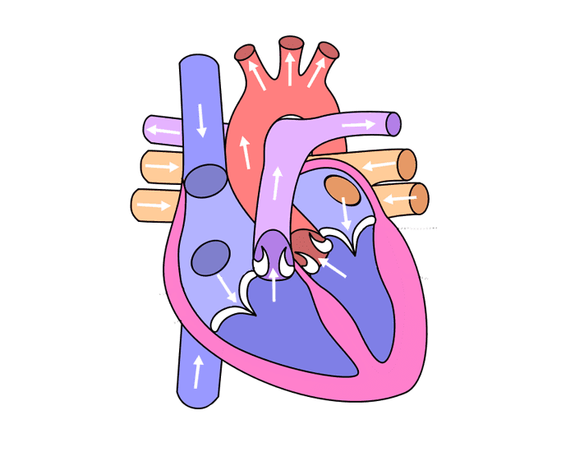
CARDOVASCULAR SYSTEM
Left ventricle
Left atrium
Right ventricle
Inferior vena cava transmits the blood to the lower body.
Right Atrium
Pulmonary artery for the left lung
Pulmonary veins for the left lung

Aorta- It supplies blood for the thorax.
Pulmonary veins that is from the right
Pulmonary artery goes to the right lung.
Superior vena cava-It transmits blood to the thorax.

The cardiovascular system is like a blood carrier through your body, it consists of three parts they are the heart the blood vessel and the blood itself. The heart does the pumping of the blood and the blood vessels work with it, the blood itself carries the oxygen and also provides nutrients which they body needs and also its needs to carry the waste that they body has stored.
The blood vessel carries the blood, the veins also carry blood to the body and to the heart, the arteries also carry blood to the heart.
The largest artery is called the aorta. The blood both has oxygen and nutrient which the body persist to survive. The essential nutrients are taken from the blood and at the same time carbon dioxide is being removed from the body which is very toxic. The function of the cardiovascular system in your body is to make sure the blood is flowing to all parts of your body for you to survive. The cardiovascular supplies oxygen to the body and helps to fight against disease and all types of injuries hydration level of the body in control it also helps to keep the
The blood then empties and pumps into the left ventricle. The oxygen is then distributed through the rest of the body and other arteries.
The heart consists of three layers of tissues which 1- Pericardium – this is a thin layer protecting the heart 2- Myocardium- this is a thick layer which pushes the blood to the heart 3 – Endocardium- this is a thin layer which has four chambers that leads to the heart there are two on the left and two on the right.

The problems the heart will face if your circulatory system doesn’t function properly or if you get clogged arteries the type of problems or disease you will develop are stroke, heart attack, angina this happens when you get excessive fat building up in your blood vessels. If the arteries become blocked it will stop supplying blood to your brain and that could lead to brain damage and vascular dementia (British
Heart Foundation). For the cardio vascular to maintain its homeostasis it must be able to supply oxygen and glucose to the brain and to the nervous system and to the spinal cord, if the brain doesn’t get enough oxygen after a certain time it will go dead which makes the brain the important part of the body for the homeostatic process, so the cardio vascular cant fail in supplying the brain with oxygen otherwise the homeostasis cant be maintained through out the body to function properly.
If by any chance the cardiovascular malfunctions at any time and the blood fails to supply through the body, then your muscles in your body will not function properly causing complications. The blood also carries oxygen and glucose which then is converted into energy which is needed for the body to carry on living if they don’t receive enough blood then it will eventually lead to death or the organism getting killed through the process. All these happen if the cardio vascular at anytime malfunctions which will result in the body not being able to make enough energy to make the body to be used to help the blood flowing and giving the benefits it needs and to keep surviving.
If to help you maintain a healthy cardiovascular system from working you should avoid diseases such as hypertension, stroke, heart attack and dementia. These diseases occur when your heart or your arteries become clogged or become narrow which results in you getting these illnesses. Angina is called a heart syndrome where the supply of your oxygen is being stopped flowing to your heart(NHS, 2019) for this to get treated the doctors will give a medicine called glyceryl trinitrate this will improve your situation after taking it after five minutes if it doesn’t then you should call for and ambulance and go to A and E as soon as possible because it can cause to become a heart attack.

Reference

Health Engine Blog. (2020) Anatomy of The Human Heart and Cardiovascular System | Myvmc. [online] Available at: https://healthengine.com.au/info/cardiovascular-system-heart
([Accessed 5 November 2020)

NHS.uk. (2020.) Congenital Heart Disease. [online] Available at: https://www.nhs.uk/conditions/congenital-heart-disease
(Accessed 5 November 2020)

England, N., (2020.) NHS England » Cardiovascular Disease (CVD). [online] England.nhs.uk. Available at: https://www.england.nhs.uk/ourwork/clinical-policy/cvd
(Accessed 5 November 2020)

GOV.UK. (2020.) Health Matters: Preventing Cardiovascular Disease. [online] Available at:
https://www.gov.uk/government/publications/health-matters-preventing-cardiovascular-disease/health-matters-preventing-cardiovascular-disease
(Accessed 5 November 2020)

Heartuk.org.uk. (2020). Healthy Living - HEART UK. [online] Available at: https://www.heartuk.org.uk/healthy-living/introduction
(Accessed 6 November 2020)

Bhf.org.uk. (2020) How Your Heart Works. [online] Available at: https://www.bhf.org.uk/informationsupport/how-a-healthy-heart-works
(Accessed 5 November 2020)

NHS.uk. (2020) Symptoms of A Heart Attack. [online] Available at: https://www.nhs.uk/conditions/heart-attack/symptoms
(Accessed 5 November 2020)

Waugh, A. and Grant, A., n.d. (2018) Ross & Wilson Anatomy and Physiology in Health and Illness.13th edition

Reference

Health Engine Blog. (2020) Anatomy of The Human Heart and Cardiovascular System | Myvmc. [online] Available at: https://healthengine.com.au/info/cardiovascular-system-heart
([Accessed 5 November 2020)

NHS.uk. (2020.) Congenital Heart Disease. [online] Available at: https://www.nhs.uk/conditions/congenital-heart-disease
(Accessed 5 November 2020)

England, N., (2020.) NHS England » Cardiovascular Disease (CVD). [online] England.nhs.uk. Available at: https://www.england.nhs.uk/ourwork/clinical-policy/cvd
(Accessed 5 November 2020)

GOV.UK. (2020.) Health Matters: Preventing Cardiovascular Disease. [online] Available at:
https://www.gov.uk/government/publications/health-matters-preventing-cardiovascular-disease/health-matters-preventing-cardiovascular-disease
(Accessed 5 November 2020)

Bhf.org.uk. (2020) How Your Heart Works. [online] Available at: https://www.bhf.org.uk/informationsupport/how-a-healthy-heart-works
(Accessed 5 November 2020)

NHS.uk. (2020) Symptoms of A Heart Attack. [online] Available at: https://www.nhs.uk/conditions/heart-attack/symptoms
(Accessed 5 November 2020)

Waugh, A. and Grant, A., n.d. (2018) Ross & Wilson Anatomy and Physiology in Health and Illness.13th edition

