

BA Leadership and Management skills for the Workplace

BMSK5005: WORKPLACE CULTURE AND ITS IMPACT ON ORGANIZATIONAL ASPECTS

Student Name: Shopik Ali
Student ID: 1604735

Table of Contents
Introduction 3
2.0 Critically assess the workplace culture of the organization 3
2.1 Concept of organizational culture 3
2.2 Types of organizational culture 4
2.3 Organizational culture practices by McDonald’s 6
2.4 Ethos and values practiced by McDonald’s 7
3.0 Evaluate an organization within its broader environment using appropriate environmental and organizational analysis techniques 8
External environment analysis 8
Competitive situation analysis of McDonald’s 11
Internal environment analysis 12
Stakeholder Analysis 15
4.0 Critically appraise the cultural and ethical behaviour present in McDonald’s 16
4.1 Business ethics 16
4.2 McDonald's Business Ethics 16
4.3 McDonald’s CSR practices 17
Conclusion 22
Reference 23

Introduction
Organization culture is the term used for several functions in an organization like employee managements, customers’ satisfaction analysis, and conformations of the facilities for the workers. This paper discuss the main and most extraordinary factors of the workplace culture of the famous business company McDonald’s plc. McDonald’s is the most famous restaurant and hospitability business authority in the UK. They hold their business both local and international sector. They made profit from various foreign countries like USA, UK, EU, Canada, Australia and many other developed countries. They serve for several items of foods like burgers, fried rice, light meals, weight meals, breakfast items, vegetables products, chicken items, any types of fish and meats popular in the country. They develop their business too high that more than 33,000 branches are set up in the worldwide marketplace. They always try to serve with 1.5 million dedicated skilled employees to satisfy the customers by services.
Firstly, this paper assesses about the workplace culture of any organization and describes how McDonald’s is practicing the very important factors of workplace culture. Secondly, it uses some models and ethos to analyse business environment of McDonald’s. And finally, this paper appraises about the cultural and behavioural existence in McDonald’s organization.

2.0 Critically assess the workplace culture of the organization

2.1 Concept of organizational culture
Culture combines the traditions, beliefs, trends, attitudes, religious organs, rules and regulations, legislations by the state and many other elements which is very essential in every spheres of human life, organization and institute. In this sense, workplace culture has emerged for the assurance of the basic structures and several factors related to the functional development of the organization. Workplace culture can be defined from several views. The conditions and policies by the company should be accepted so that the company can satisfy the customers and any other clients. This helps to make more profit by creating promotions of their products. Workplace culture also defines opportunity and restrictions of the company to the customers so that the customers can rely on the company. Any organization can develop the workplace culture at several levels like: a) National culture, b) Culture and nation, c) Corporate culture, d) Cultural management; and e) Professional culture.

2.2 Types of organizational culture
According to Browaeys and Price (2015), the basic kinds of organizational culture are:

Bureaucratic culture
This term includes universal frames for combining the most necessary rules, terms and conditions, policies and fundamental legislations to run the organization perfectly. This type of culture ensure the proper management and productions of the materials and services by the company and any business organization (Browaeys and Price, 2015).

Clan culture
There are different castes employee in an organization to serve the clients of different types of culture. Clan culture ascertains the development and promotion of the products as the employees understand the actual needs of the different cultural people (Browaeys and Price, 2015).

Market culture
Market culture aims to attain the financial support and sales development, making best profit and market share properly. This helps the marketer to understand the market demands and they can able to assure the customer about his proper services regard to the customer (Browaeys and Price, 2015).

Entrepreneurial culture
Every entrepreneurial activities demands high level risk taking and unwanted situation facing mentality of a marketer. It is the nature and culture of any kinds of entrepreneurial culture (Browaeys and Price, 2015).
In accordance with Huczynski and Buchanan (2011) there requires four types of cultures those can be used in organizations are as follows:

Power Culture
Power is the earning force of an organization which confirms the proper utilization of their labourer and their performances. In a small business sector, power is only applied as belief and trust to the employees of that firm (Mullins, 2015).

Role Culture
Role culture of an organization depends on the main earning forces of the organization like financial support, manpower support, management support those are exercised in an organization to run the business properly (Mullins, 2015).


Diagram: Role culture Source: Mullins (2015)

Task Culture

Culture in an organization is mainly duty oriented by the employees and managers. Matrix structural organization can be an example such kind of task culture. Task culture is based on the expert power rather than position of the chair (Mullins, 2015).

Diagram: Task culture Source: Mullins (2015)

Person Culture
Person culture is the main role playing culture in an organization because this enable company to unity the whole manpower to attain the goals. This culture has to maintain standard form of production of any kinds of products. The employees try to perform their duties individually to connect the clients by convincing the clients with his own culture (Popin Now, 2018).

Organizational culture practices by McDonald’s

The main power position plays the administrative role in the performance of the business McDonald’s. The main purpose of the company is the confirmation of healthier food services to the customers as their business is a restaurant type business. They uses organization culture to attract the customers mainly. And for this they offer some opportunity to engage the high valued customers and well skilled employees in their industry (Panemore, 201).

Features of McDonald’s Organizational Culture
There are several characteristics of cultural conditions well as organizational culture existed in McDonald’s company. Some characteristics are described below shortly:

Diversity and inclusion
Optimizing the group performances in an organization is very essential for ensuring the proper development of the company. McDonald’s restaurant company always try to attain their goals by diversifying the labour between the labourers of the company so that the duties are performed well respectively (Andrew Thompson, 2017).

People-centricity
As the customer is the main crucial factor role playing in the development of the company rather than the existence of the company McDonald’s get priority to the choices and demands of the company. So, the organizational culture existed in McDonald’s is to specifies the support encourages so that the people and employees can engage them in the development of the company (Andrew Thompson, 2017).

Individual learning
In organizational culture of McDonald’s self-improvement by acquiring training is very important factors that helps the employees to serve the company more delightedly. For facilitating the training program the company offer the employees several learning program through Hamburger University, they also offer internship of the university students (Andrew Thompson, 2017).

Organizational learning
McDonald’s business company also applies organizational learning events to the employees as the employees of an organization can uphold the company to the pinnacle success. The company establish these learning events through official meetings, seminars, policy making and the discussion with administrative body of the organization (Andrew Thompson, 2017).

2.4 Ethos and values practiced by McDonald’s
The standards and core views is are to give importance to support people so that they can be converted into their customers. There are distributed the duties from the zenith to the bottom of an office in this firm. This process of power appliance is a bureaucratic techniques to handle the employees. Values are the factors are interconnected to the clients and the managers of the offices. In defines any single objects which reflects the core views of the company like artefacts, dress codes, slogans, office designs, ceremonies and any entertaining cultural programs.

Ethos of McDonald’s
Ethos refers to any single objects, acts or substances that the company to sell their products by attracting the customers. McDonald’s authority use their logos and brand images for attracting the consumers to buy their products especially the food items. Ethos of McDonald’s is the theoretical rules and legislations by which the company manages the administrative works daily. McDonald’s company is world’s largest restaurant business company. They contained the biggest opportunity to justify the people’s demands and mind-set to their products. By observing such kinds analysis they determine their sale strategies and offers the customers with simple discounts sometimes. Communication building with clients of McDonald’s is very appreciative.

Values of McDonald’s
McDonald’s believes in their responsibilities to the customer’s welfare and the customers choices. They are committed to do good for the people and for this they try their best to serve the best foods to the customers. They do well not only for the people but also even a single element of the planet and for this they don’t pollute the environment dumping the wastes anywhere. As McDonald’s is the world’s largest brand they welcome all of the people from any walks of the world’s different cultures. Their progressiveness relies on the innovative activities by the millions of employees working in the company. They try to satisfy the customer as the can build up their future betterment of the business.
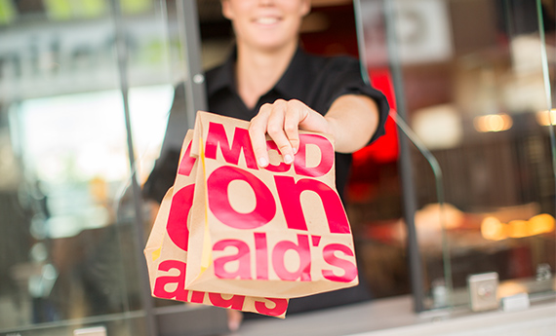
Image: Inclusiveness of McDonald’s Source: McDonald’s (2018)
Retaining the customers they had, refreshing and expanding their areas of asset with attentions on morning meals and any kinds of family functions. They obstinate to convert the people into their consumers.

3.0 Evaluate an organization within its broader environment using appropriate environmental and organizational analysis techniques

External environment analysis
External analysis for a business environment is very important to evaluate the environment of an organization broadly. There are some analytical tools to describe and evaluate the environment of the organization externally. PESTLE analysis is a tool that discuss the very essential factors those are interrelated with each other. This tool is implemented for several businesses company to analyse the strategy of the organization. McDonald's authority uses this tools to evaluate their business strategy and policy making so that they can promote the products. PESTLE analysis is considered as the best analytical tools which collectively discuss about political, economic, social, technological, environmental and legal factors impacting on any sort of business firms (PESTLE, 2018).

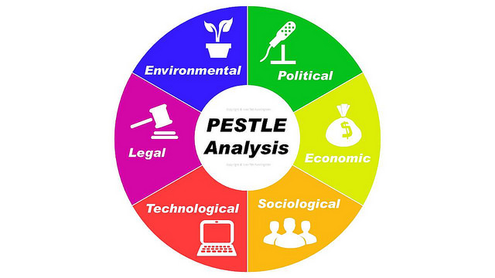
Diagram: PESTLE Analysis on map. Source: Ivan (2016)

PESTLE Analysis of McDonald
Political
McDonald's has to pay taxes on their revenues to the government. Besides this, McDonald's faces some political crisis like Brexit treaty conflicts by the UK government. This causes heavy loss of their profits from the EU countries. This political factor includes some legislative rules running any sort of business in the government. But intact, McDonald's is accused of pretending taxes in due proportion. In accordance with Guardian (2012) McDonald's paid only £85 million as their fiscal tax over 14 years in the UK revenue authorities, despite having revenues about more than £3 billion revenues in those years. Though it offered £20 million extra charges claiming some taxes cut latter (BBC, 2012).
Economic
Economic influence on a business is one of the major factor that evaluate the interest rates, inflation rates, revenues, growth measures, currency exchanging rates and unemployment rates in those countries wherein it has a wide existence. Some economic factors determine the abilities of the customers of buying the products. As per as example, McDonald's coffee is optional for the customers as it costs high rate. Some other economic factors are labourer salary management which directly impact on the development of the company.
Social
In PESTLE analysis social impact plays very important role to know the mind-set of the customers. In accordance with Dudivskiy (2016), social factors like people health concerns, lifestyle trends, communication broadly can be both opportunity and curse for McDonald’s.
Technological
They launched their website to connect worldwide customers and promote their business in the world largest restaurant market in the UK. They publish their new food items in their website and preach them to the socially connected people with several media like Facebook, twitter, snapchat, imo, whatsap etc. they advertise their products by several search engines too (McDonald's Website, 2016).
Legal
Several legal issues are related to McDonald’s business strategy like health security and safety for workplace and provident funds, festivals bonus, minimum privileges of the employees. Besides, data protection act for the customer, consumer’s right, employment acts etc. (Pratap, 2016).
Environmental
Environmental factors are considered as the very significant for measuring the broader environment of an organization. McDonald’s faces various environmental situations like climate, area selection, weather, corporate meetings, greenhouse effect etc. (Greenspan, 2017).

Competitive situation analysis of McDonald’s
Any business company justifies the market to evaluate their competitiveness with respective sector business firm. This helps them to identify the weakness and the probability of strengths so that they adopt several attempts. To analyse the competitiveness of McDonald’s Michael Porter gave five porter forces model concept. In this model, he describes five exclusive factors those are really causes the development or falls of a business firm. This model describes about the buyers, suppliers, consumers, potential new entrant, substitute those have same power to bargain with each other so that the real facts of competitiveness comes out. The objectives of this model really good (Lumen, 2017).

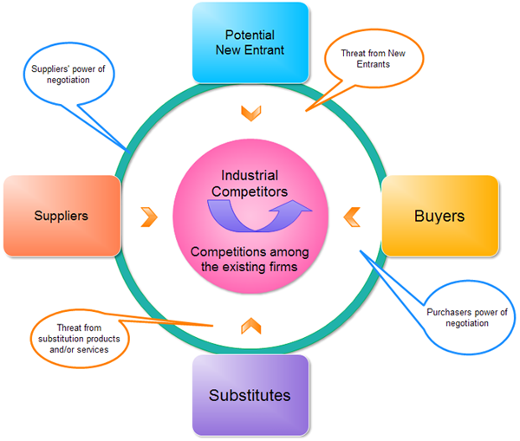

Diagram: Porter's Five Forces Model Source: Edraw (2016)

Competitive situation analysis of McDonald
Competitive situation existed in McDonald’s are the factors that directly impact on the progress of the company. The main factors that form the competitive surroundings are the talk’s power of suppliers, the talk’s power of patrons, the prevailing competition on the market, the threat of substitutes and also the threat of recent entrants (Porter, 1991). Arguably, the threat of recent entrants on the coffeehouse market is high, as a result of the barriers to entry on the market ar usually low. From a money, technological and intellectual capital purpose of read it's comparatively low-cost and simple to open a coffeehouse. However, owing to its size, complete and different competitive benefits, McDonald's has the tools to impose premium costs and accomplish lower prices than its competition. Secondly, the threat of substitutes is low within the short term, however high within the long run. The coffee-drinking social-cultural trend is presently highly regarded and is unlikely to alter within the short term. However, in years, folks might develop style for different beverages like shakes or tea and different strategies of socialization. Thirdly, the prevailing competition on the market is typically high within the markets within which McDonald's activates. for instance, in London, there are an outsized variety of tiny freelance that charge worth costs and supply sensible quality occasional and variety of enormous occasional shop chains that charge premium costs and supply tight quality occasional like McDonald's, Costa occasional, Café Lucius Domatiums and EAT. McDonald's` main competitors are the massive coffeehouse chains and any promoting call that it makes has to take into consideration the competitive position and moves of its rivals. For instance, McDonald’s purchase their coffee from responsible and reliable sources. Their coffee is famous worldwide for their ethical willing to provide best coffee of the world. 93% coffee purchase is Fair trade and the company has promoted their coffee quality and at the same time they are improving their social, ethical, environmental standards. The competitiveness of their products with the other companies in the UK are very much low but the coffee competence is very much high. For this they are always honest to serve the best products with best value and quality foods.

Internal environment analysis
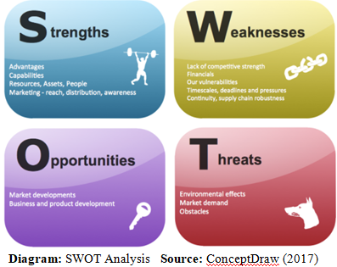
SOWT analysis techniques can be very effective for analysing any kinds of business which help to make strategic plan for any organization, business institution etc. It analyse several factors related to the business combing the companies’ strength, weakness, threats and opportunities collectively. This analytical technique is very helpful application system which main advantage is less expensive, promotes visual effects, insight facilities of the internal and external environment of an organization. This analysis technique is very helpful for McDonald’s marketing approaches by creating the strength, finding weakness existed, evaluating opportunities, measuring threats. In accordance with Nordmeyer (2016), the SOWT analysis can direct business decisions based on the imperfect sides of the functions.

SWOT Analysis of McDonald
McDonald’s SWOT Analysis in terms of CSR functions
Strengths | Weaknesses
- Dedicated appeal to CSR with 'Ronal McDonald House': In corporate Social Responsibilities McDonald’s developed dedicated appeal and strengthen their social communication.  - Strong leadership and international presences in food industry: McDonald’s hold strong leadership and international existence in the world’s food market promoting their foods grade at high level performances and quality maintenance.  - Brand value and brand awareness: McDonald’s achieved a famous brand value and for this they aware of their brand value and try to maintain the proper quality of their products.  - Model of Sustainable business: It is an extraordinary strength of McDonald’s by which they inspire the other small business existed in the UK market. They have made a remarkable sacrifices to reach in this level of business.  - High level of revenue and profitability: McDonald’s acquired the position by which they managed high level profitability and revenue.  (Dudovskiy, 2016) | - Sometimes have unhealthy food items on the menu  - They losing appeal for brand image  - Increasing much income of worker can be weakness.  - McDonald’s I recent days unable to advertise products positively.  - Competitiveness is lowering with respective sectors.  - There is Weaknesses in evolution in the CSR strategy in McDonald’s  (Dalavagas, 2015)
Opportunities | Threats
- Updating CSR idea development of the business progressing focus on nutritious menu  - Have prospect of home delivery and online sales  - Can promote business processes in both local and global markets  (Jurevicius, 2017) | - Along with around pollutions McDonald’s are very concerns with their food safety  - Fast food are losing appeal in advanced countries due to proper nutrients management  - As restaurant marketing is increasing rapidly severe competitiveness is getting high  - Various factors like legal, political economic, environment, and social, and technological causing hampers of development.  (Bhasin, 2016)

Stakeholder Analysis
As McDonald’s is the world’s biggest restaurant business company they consider their stakeholders giving much more priority performing with them best development. They maintain CSR (Corporate Social Responsibility) to manage the stakeholders. Their main stakeholders are of two category such as employees and customers. These can be described separately in below:
Employees: According to their priority list they consider their employees as the first class stakeholders. Because, employees are the most reliable earning force for the organization and the development of their business mostly depends on the proper utilization of the employees’ labour. McDonald’s offers their workers proper privileges and handsome basic needs of life.
Customers: The customer always wish to have healthier and delicious foods by the company. As the customers are the buyer of their foods and keep contribute to their economy they are considered as the second positioned stakeholders. Though sometimes the food value are severely criticized by the customers.
Investors: Every investor in an organization targets to have profits and revenues made by the business company wherein they invest. But recently McDonald’s seems unable to fulfil benefits to the investors. To meet up this unexpected situation, they launched their new products luxury McCafe.
Communities: To hold the rank at high level McDonald’s sometimes offer several social welfare activities to the needy people around their business. This help them to draw attention of the human welfare organization and they are rewarded for their social performance. This activity helps them to draw attention of the customers like community of existed around their business firm.
Suppliers: McDonald’s collect their raw materials from various suppliers. The suppliers of their main products items are also considered as the shareholders of their business. The company mostly depends on the proper performance of the suppliers of goods, several foods items. According to McDonald’s (2017), suppliers wish to have orders from their company so that they can make more earnings.
The Government: The government activities for the general people of the state can be blessed by the recruitment for several posts of McDonald’s plc. McDonald’s arrange recruitment examination to provide jobs to the candidate and thus the government performance is sanctified. The government can also be benefited by getting revenues from their fiscal incomes.
Trade unions: Trade union concept emerged for the betterment of the workers in their workplace by safety, security, privileges, optimum salaries, and other basic facilities in their working industry. The union plays role significantly whether there occurs any conflict between the workers and the managers.

4.0 Critically appraise the cultural and ethical behaviour present in McDonald’s

4.1 Business ethics
Ethics or legal attributes implemented in an organization helps the authority to perform their duty very honestly. The managers and the workers of an organization have to be very ethical to their duties so that they serve their best to the customers and make sure the disciplines in the organization. According to Shaw (2017), Ethics is confirms the proper management of the business by its working forces. Sometimes there occurs unusual incidents in an office, then conflicts occurs in the organization. Only ethics and its branches can diminish such kind of conflict between two groups. Some unexpected sins like misuse of workers, bribes taking, dumping waste to the rivers and cannels and polluting environment and water can be very much affecting activities due to lacking of ethics in an organization. In this situation, the authority have to redefine some legislative rules to run the business properly and execute the administration with ethics.

4.2 McDonald's Business Ethics
McDonald’s managing body have always tried to maintain their whole business activities ethically. For this they adopted several policies, legislative rules, comprehensive governance structure and acts on the welfare of the workers by a Board of directors. The board of directors has formed of six standing committee to perform the ethical activities correctly. As the biggest organization of the world’s market McDonald’s has to be a social responsible business company. They need to justify their popularity in the communal area in where their business firms exist. The standing for ensuring the ethical performance by the employees of McDonald’s try to make best policies, safety and security management for data protection of the clients, social responsibilities in perspective sectors they lead. The ethical activities of McDonald’s also covers the stakeholder’s aspirations, ensure maximum training programs for the workers, restricts pretends with the clients, provide committed online orders etc. (McDonald’s Corporation, 2017).
Corporate Social responsibility department
Global environment council
Quality System board
Sustainable Supply Steering Committee
WORLDWIDE CORPORATE RELATIONS COUNCIL
CR COMMITTEE OF THE BOARD OF DIRECTORS
Diagram: McDonald's corporate responsibility including oversight and coordination

4.3 McDonald’s CSR practices

Carroll’s Four-Part Model of CSR practiced in McDonalds
International business company McDonald’s has to practise CSR to justify the popularity in local or international market to exist their business and promote their products. They emerged their extraordinary rules and regulations to obtain the highest rank in the marketplace by conforming CSR activities properly. For this, McDonald’s authority is trying to collect social impacting factors those help their business better than the before. Most famous CSR model practiced in modern business organization is Carroll’s four-part model. In this model he describes the social corporate responsibilities like legal, economic, ethical, philanthropic etc. for the betterment of an organization with stakeholders belongs to them. But this model has some limitation of having weakness of the model. Firstly this model cannot identify some significant factors related to the business like historical, environmental, rational effects those varies from nation to nation. Secondly it cannot address conflicting situation exists in an organization and thirdly this model is USA experience based.
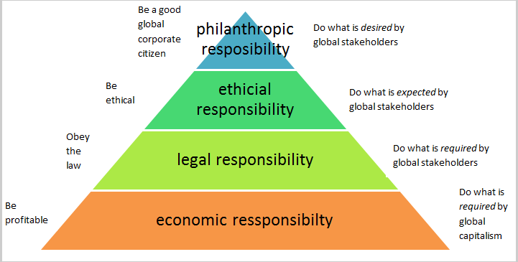
Diagram: Pyramid of corporate social responsibility Source: Aaronson (2013)
Economic responsibilities of CSR
Economic responsibilities refers to the obligations that compel the business authority to make profit for the company and for the stakeholders. It involves: a) business sustainability by making profit for shareholders and investors, b) have to be a profit making firm, c) should require sustainable competitive advantages, d) having support operations of better performance.
Legal responsibilities of CSR
Legal responsibilities otherwise ethical responsibilities by the company for betterment of their products to do well for the people especially for child’s care by providing healthier foods without any harm to the environment. To practise this type of CSR approach McDonald’s has formed their basic rules and legislative acts for the welfare of the customers. They obstinate to serve the customers by high level services. They launched a program ‘Global Happy Meal promotion’ to promote their foods value and thus they want to make a healthier nation worldwide.
Ethical responsibilities of CSR
In every action there should be combination of ethics or religious mentality so that they can be very honest at their performance in an offices. Ethical responsibilities of CSR has emerged for doing well in an organization for: a) to ascertain moral activities wherein their business is running, b) hold consistent business performance by doing social norms, rules and religious legislation.
Philanthropic responsibilities of CSR
This sort of corporate responsibilities is very essential to ensure the benevolent facilities to the local community that includes: a) support and performance of fine and artiste of business, b) contribution to society by charitable and humane activities. McDonald’s authority are very willing to serve the people especially disabled people with helpful minds.

Stakeholder approach of CSR practiced in McDonald
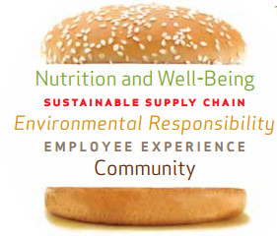
Stakeholders approach of corporate social responsibility (CSR) practiced in McDonald's has been a tradition and own characteristics of their business (Carroll, 2011). They offers various facilities to their stakeholders connected with their business so that along with the stakeholders they can be able to reach their goals and objectives. McDonald's meet their stakeholders approach through several procedures. They apply five specific process to reach their CSR practices corrected such as a) providing nutrition and well-being information to the customers; b) maintaining sustainable supply chain for its suppliers; c) contributing to the local community; d) being responsible towards global environment; and e) gaining workforce experiences.

Nutrition and Well-being
As the customers are one of major stakeholders of McDonald’s they try to fulfil the appeal from the customers with different choices and demands. Children choices are for newer beverages and fast foods is considered by the authority. All of the offerings by the authority ensures proper nutrition management. Another opportunity by the authority is to well-being for the children and their parents advertising of several foods with funny videos that like the children.
High-quality choice
Consumers friendly nutrition information
Communicate responsibly
Diagram: McDonald's holistic approach for well-being
High-quality choice
Consumers friendly nutrition information
Communicate responsibly
Diagram: McDonald's holistic approach for well-being

Responsibility to sustainable supply chain
Suppliers are also considered as significant stakeholders of McDonald’s as they provide continuous materials and readymade products to contribute in the business economy. Stakeholders’ approaches in CSR practice in McDonald’s mostly performed by the suppliers of the company. To ensure proper food value and high grade nutrition the suppliers have to be examined by ethical, environmental, safety and security issues of carrying of foods to the shops. To confirm the sustainable supply chain the suppliers are well trained up at several times by the McDonald’s authority. They are promised to continue proper food ingredients management before supply. In this regard they need to manage proper packaging systems before supply.

Environmental responsibility
McDonald’s has adopted global energy leadership board (GELB) to minimize the costs against their energy consumption. They maximizes energy efficiency so that environment of working place get safe from risk and pollutions. GELB has established several initiatives energy losing solutions by which they can be able to cope with inflation rates of money in the global world. This mentality to diminishing the losses of energy and thus they would be able to save extra money in future success. This tendency of saving the energy used in their factory will be very helpful to the environment by reducing the pollution. And by this responsibility performance by the company helps them to sustain environment safe and fresh.
Energy Efficiency
Sustainable packaging and waste management
Green restaurant design
Diagram: McDonald's environmental responsibility
Energy Efficiency
Sustainable packaging and waste management
Green restaurant design
Diagram: McDonald's environmental responsibility

Employee Experience
McDonald has emerged seven Hamburger Universities (HU) as progressive coaching and development centre for the eating place and company staffs across the globe. It’s continuing to focus its efforts on magnified variety of eating place managers United Nations agency area unit HU certified. Additionally, it's continuing to market its employees worth proposition to drive employee’s engagement progress. The employee’s engagement proposition of flexibility, future, and family and friend has been its international strategic folk’s platform. It’s conjointly mirrored in market-level business still as folk’s plans. Moreover, McDonald has continuing to integrate its worth into variety of individuals programs-from hiring to coaching and development progress. It conjointly taken initiatives of values activation introducing a Values Activation Council, that support share experiences, best observe concerning group action values and challenges in each short and long-run designing.
Respects
Commitment Enhancement
Talent Management
Diagram: McDonald's Approach -People Priority

In a word, the initiatives taken on workers progress has develop and retain a gifted, numerous and engaged force for McDonald. Folks program and policies have conjointly created an efficient cultural setting and dealing setting by worker worth proposition, talent management, and respect and inclusion.

Responsibility toward community
Every business firm has their own strategies to meet up their customers as well as with community for better customer relationship. They do this task from their own interest to make the best profit by the community by selling their products to them. McDonald’s has developed a group of volunteer with a view to help the disabled customers in their shops. They guide the customers with helpful minds. They arrange several programs to help the community building relations with them. They offer three major programs such as the Ronald McDonald Family Room, the Ronald McDonald Care Mobile, and Ronald McDonald House to make the life of lag behind children over the world. This the hearty welfare activities by the company.
Support to the community by McDonald is very important social welfare work to help the remote corner people with their volunteer services. These social works are served by four avenues: local, involvement in local communities, charities and children's programs, global partnership and sponsorships, and disaster relief that helps poor and unable customers.
Diagram: McDonald's framework for community support
RMHC and Children programs
Partnership and Sponsorship
Operator involvement
Disaster Relief

Conclusion
McDonald's is the UK most reliable restaurants business company and for they bear a legacy to confirm healthier and fresh foods to consumers. Interest rate has direct influence on the operations of McDonald's progressive activities. . It is also a barrier to progress the business in a greater extent. McDonald’s apply most recent technological approaches to promote their business in greater extent in the marketplace. Economy determine the present existence and build future progress of the company. They apply the affiliate marketing system also in their business strategy. Political factor impacting on the progress of McDonald's business company is tax giving to the government. Lower interest rates by the bank loan enable the company to lessen the products price more before fixed. Technology plays a vital important in present marketing strategy to promote the products to the remote corner of the world of a famous business company. Culture in an organization cover s many things related to the company’s daily affairs. McDonald’s plc. Is the world’s most famous food and Restaurant Company whose main target is profit making and at the same time they launched several humane welfare social activities. Their whole activities are chained to serve the customers by their sweet will.

Reference
- Popin Now, (2018). Types of Organizational culture. Also available at: https://popinnow.com/four-types-organizational-culture/. [Accessed on: April 17 2018]
- Panemore, (2018). McDonald’s Organization Culture Analysis. Also available at: http://panmore.com/mcdonalds-organizational-culture-analysis. [Accessed on: April 17, 2018]
- PESTLE, (2018). What is environmental analysis? Also available at: http://pestleanalysis.com/what-is-environmental-analysis/. [Accessed on: 17 April 2018]
- Aaronson, A (2013) Corporate responsibility in the global village. Business and Society Review, 109 (4), 309-38.

- Carroll, B. (2011) Ethical challenges for business: corporate social responsibility and models of management. Business Ethics, 198-203.
- McDonalds (2015) The Annual Report-2014. Available at: www.mcdonalds.co.com. [Accessed on: 12 November 2015]
- Michael, P. (2012) The competitive advantages in business. 3th Ed. Harlow: Pearson Educations.
- Shaw, W. (2011) Business Ethics. 4th Ed. London: Pearson Educations Ltd.

