
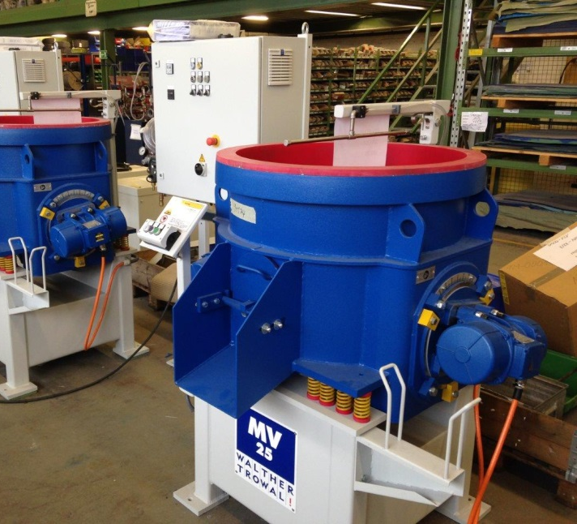

Multi-Surface Directional Polisher Working Practices and fixtures

(Note: I have previously used this project and a big proportion of that has been uploaded to a different institution)

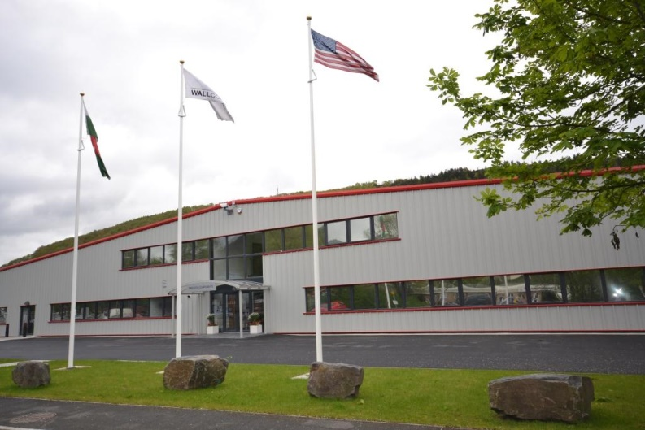
Introduction

Wall Colmonoy are an industry leader in its field of advanced metals and manufacturing. As part of the growth strategy the business executes improvement projects on existing processes and researches new technologies and processes that can aid the manufacturing process. With changes in demands to customer expectations for surface finish on components produced by the Precision Component division, an improvement project was identified to source Multi Surface Directional Polisher (MSDP). A MSDP can be used for deburring and polishing components using a vibrating circular motion and with the help of different media (finishing stones/ceramics/cutting compounds) it can achieve a consistent surface finish over all surfaces, unlike polishing by hand which is currently carried out. The current process can be very time consuming creating a bottleneck and incurring high consumable costs as material changes from batch to batch. The benefits of this project are not only to improve product quality; this also strives to lean out the manufacturing route to remain cost competitive in a crowded market whilst supporting profitability of the organisation. This machine was installed and commissioned however the working practices and training has not been identified and standardised.

Objective
The primary objective of this project is to identify suitable working practices to achieve customer requirements whilst incurring minimal cost to the business. Wall Colmonoy purchased this machine back in March 2018 and currently use this for a minimal amount of products, thus not using the equipment to its full potential. This is largely due to insufficient fixtures to hold components not supporting the full product range.
By creating new fixtures for products it is possible to save the operator time by moving hand polished components into the MSDP, this then allows the operator to work on urgent components (jaw marks on Steel plant roll end bushes/ improvements to surface finish with wet and dry) or could potentially run a different machine to keep work flowing.
Currently the MSDP is guess work, such as;
- How long should we run this for?
- How many components can we put in there at one time?
- Can we put a mixture of components in the machine?

Part of the scope within this project is to identify suitable means of creating standardised work that aligns to the business needs. In creating working practices for all current and future components this will provide control and repeatability within the manufacturing process. Success of standardised processes can be verified by testing the surface finishes at recommended run times (2, 4, 8, 12, 16 and 20 hours). Over time, it will be possible to gain a knowledge of what is achievable in the given cycle times, all of which will feed into the cost model and lead times to ensure accuracy for both business and customer.
This Project can be achieved by testing different run times, media and range of parts. All this will be added into the project plan. Continual improvement is a philosophy at WCL and focused on getting the basics right, we can create a solid foundation to build from.

Contents
Introduction 1
Objective 2
Contents 3
Teamwork-Tuckmans theory……………………4
Motivation - Maslow Hierarchy of needs………6
Belbin’s theory……………………………………7
What needs to be done………………………….8
Project planning………………………………….9
Project Justifcation study……………………….10
Bibliography………………………………………12

Team work- Tuckman’s theory

You can't expect a new team to perform well when it first comes together. Forming a team takes time, and members often go through recognizable stages as they change from being a collection of strangers to a united group with common goals. Bruce Tuckman's theory.
Tuckman broke down this into stages known as Forming, Storming, Norming, and Performing. Psychologist Bruce Tuckman first came up with the memorable phrase "forming, storming, norming, and performing" in his 1965 article, "Developmental Sequence in Small Groups." He used it to describe the path that most teams follow on their way to high performance. Later, he added a fifth stage, "adjourning".
Forming
This is the stage in where the team starts to come together. Everyone has been chosen and is introducing themselves to each other. As it is the start of the project everybody is excited about starting something new and getting to know each other. At this stage things are discussed like member’s skills, Individual roles, and project roles.
Storming
This is the stage where the reality of the project starts to kick in. The feeling that everyone was excited starts to die down and people and personalities start to clash. Certain member’s might disagree about how a task is being completed or ideas people may have or even if some people aren’t working as hard as others. As the project manager I will remind the team that this is normal.

Norming
With this stage people start to appreciate other team member’s strengths and some groups settle in with each other. Everybody is contributing and working together as a unit. This stage sometimes overlaps with storming as new tasks happen there may be some conflict again between team members. But if you have dealt with a disagreement before it will be easier to deal with next time.

Performing
The performing stage is a stage where you know you are on your way to a successful project. Team member’s are confident with each other and are motivated to get the project completed successfully, everybody wats to achieve that end goal together as a team.
Adjourning
This stage was added by Tuckman in 1977. Once the project has come to completion the team seems to disband. It’s like mourning because team member’s have become close and now that it’s all over they may never be able to do it again. (5 Stages of Team Development, 2020)

Motivation – Maslow’s Hierarchy of needs

According to Maslow, we have five categories of needs. Physiological, safety, love, esteem, and self-actualisation. In this theory higher needs in the hierarchy begin to emerge when people feel they have sufficiently satisfied the previous need.

Physiological - These refer to basic physical needs like drinking when thirsty or eating when hungry. Maslow considered physiological needs to be the most essential of our needs. If someone is lacking in more than one need, they’re likely to try to meet these physiological needs first. If someone is extremely hungry, it’s hard to focus on anything else but food or if they are too tired due to lack of sleep.

Safety - Once people’s physiological requirements are met, the next need that arises is a safe environment.

Love and Belonging - According to Maslow, the next need in the hierarchy involves feeling loved and accepted. It also includes our need to feel that we belong to a social group. Researchers have continued to explore how love and belonging needs impact well-being and having social connections is related to better physical health but feeling isolated has negative impact for health and well-being

Esteem - Our esteem needs involve the desire to feel good about ourselves. According to Maslow, esteem needs include two components. The first involves feeling self-confidence and feeling good about oneself. The second component involves feeling valued by others. Feeling that our achievements and contributions have been recognised by other people.

Self-Actualisation - Self-actualization refers to feeling fulfilled, or feeling that we are living up to our potential. One unique feature of self-actualization is that it looks different for everyone. For one person, self-actualization might involve helping others; for another person, it might involve achievements in an artistic or creative field. (Maslow's Hierarchy of Needs Explained, 2020)

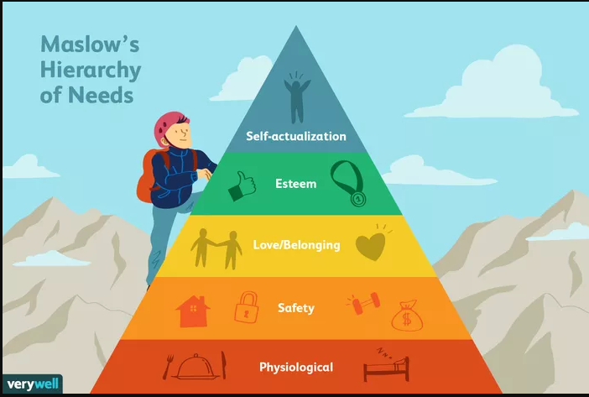

Belbin’s theory

This method was developed by Belbin in 1981. He spent 9 years on studying this method and it is used still to this day to support team building. He came up with team roles to define potential success of the management of a team and also that teams have a different diversity of personality types. The 9 team roles Belbin had used, describe the pattern of behavior and characteristics in an individual. This then gives you roles that are best suited to the individual and can give a team the understanding of their strengths and weaknesses. This is a great way to assemble a team because everyone will have different strengths and weaknesses and will get the best performance out of the team and the best result for the project.
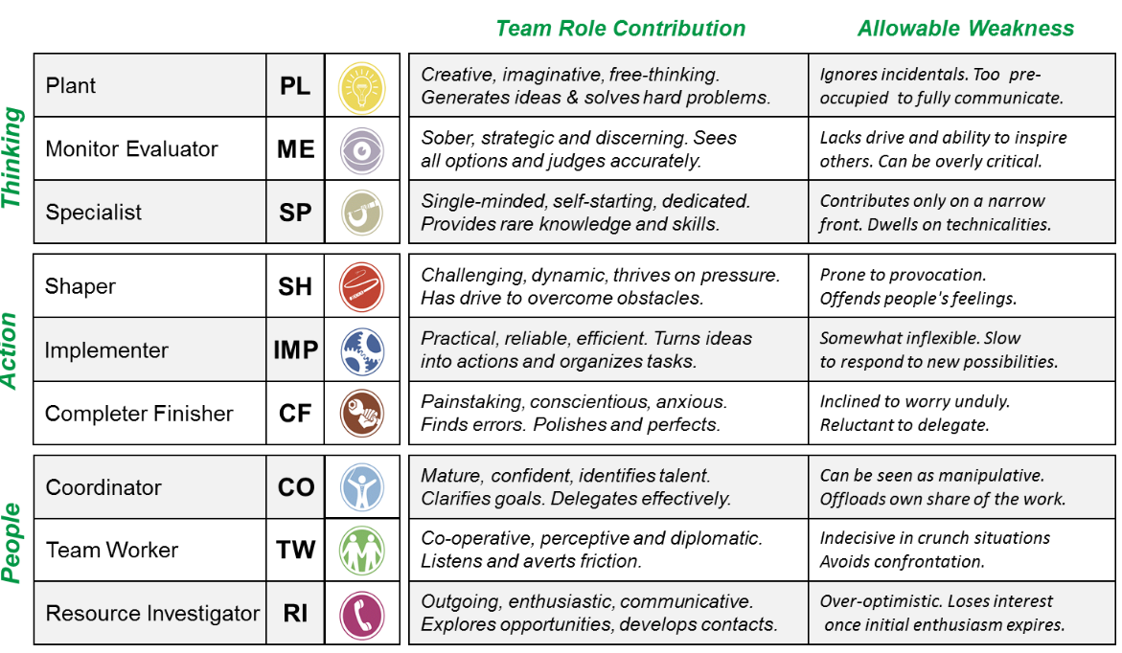
The 9 Roles are as listed as follows:-
(Belbin's team roles, 2020)

What needs to be done
In order to complete this project a number of tasks will need to be carried out. Such as:
- Evaluate where we are currently
- Drawings to be made for jigs and fixtures
- All Machining instructions to be updated
- Costs for Jigs and Fixtures and the feasibility of getting them made
- Costs from hand polishing to MSDP and potential savings to be made
- Lead time improvements

In order for this project to be carried out a team that works in the Precision Components division has been put together. They will discuss problems when they arise and will take on new ideas to create a lean manufacturing process route for the MSDP.
The colleagues who will be working on this required project:
- Myself – Project Manager
- Colleague A – Machine Shop Supervisor
- Colleague B – Unit Manager
- Colleague C – Improvement engineer
- Colleague D – Bench Operator

Other employees may be required to join at a later date but for now these are the main employees required to complete this project.

Project Planning
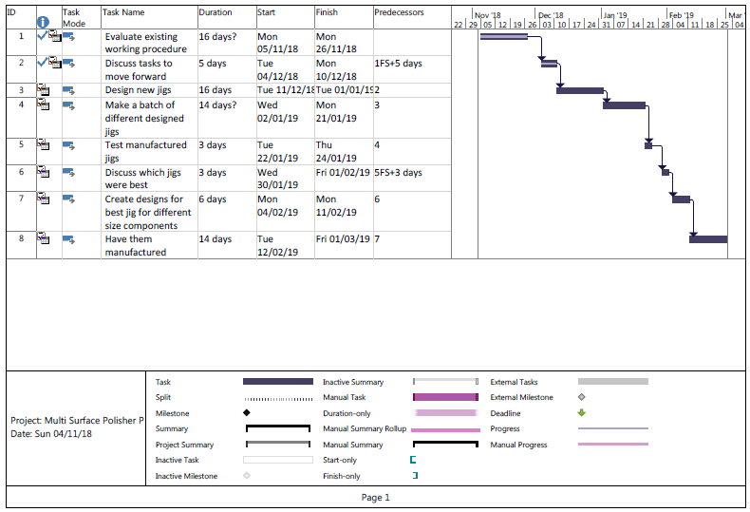
This project will be planned using Microsoft Project. This software allows you to create and manage a Gantt chart. You can make an estimate of how long you think a task is going to complete and can build in flexibility (if a task goes late it will not impact other tasks) and can assign people, resources and costings to individual tasks. This software can be shared amongst the team and updated to show progress. Each task does not have to be completed to 100% in one step, but can increase a few percentages at a time. This allows it to be tracked more accurately and to maintain the course of the project.
Above is the proposed project plan to initiate the project; however this plan may change as tasks that were not considered may play a key responsibility and take more/less time than allocated. As shown above the first two tasks have been completed and have finished before scheduled. Therefore this has created a bit of space before the next task needs to be started. Tasks may be delayed by bank holidays, a main team member taking annual leave or if another project/role takes priority. The first projected planned stages could potentially be finished by Friday 1st March 2019. This will then allow the company to progress further into the project by looking into the working practices and when Wall Colmonoy receives an order for new homogenizing valves a process can be put into place to establish new fixtures and working practices.

Project justification study
  - Project Name
Multi-Surface Directional Polisher: Working Practices and fixtures
  - Purpose
To create consistent working practices and suitable fixtures for individual components for the Multi –Surface Directional Polishing Machine to aid with the finishing of all Homogenizing valves for the food & pharmaceutical industry ensuring a lean fast processes which will cut consumable and labor costs and ensure a far superior consistent surface finish for the process.
  - Describe the current situation
Currently an operator hand polishes all Homogenizing valves using rotary die grinders these are used with various types of abrasive stones or gritted cap heads. This operation is very labour intensive with high consumable costs, overtime booked and the inconsistencies with the manual surface finish process.
2016 costs for labour & consumables for two of Wall Colmonoys largest homogenizing customers was £45,287
Also to lean out the manufacturing times to understand what can be achieved in desired cycle times. This will help to keep all component surface finishes uniformed and consistent.
  - Describe what the project will achieve
The Multi –Surface Directional Polishing Machine will minimize the amount of overtime & consumable costs. It will also speed up the process and ensure surface finish consistency on all Homogenizers which have been through the Multi –Vibratory process. The figures are currently only based on the Bench work carried out for the two main customers. However with the current customer market expanding and more ‘copycat’ companies arise into the homogenizing business, it will help Wall Colmonoy be leading manufacturers with the homogenizing and pharmaceutical business.
At the Current loadings of the two largest customers of Wall Colmonoys it could potentially save the company £29,000 per year. This saving could potentially be redirected into expanding the business, investing into new processes or even justify giving employees pay rises/bonuses. Expanding the business up to 4x is Wall Colmonoy’s goal and can be achieved by creating lean process changes.

  - Describe any alternatives to the project
There is no alternative to do the project; working and sustainable practices need to be put in place just like any other new machine.

  - Describe what would happen if the project didn’t happen
Wall Colmonoy would stay on the current process which is not only labour and consumable intensive; it will also incur overtime cost, bottle necks and production inconsistencies. This will eventually impact on Wall Colmonoys on time in full (OTIF) with their customers. It would also have been a waste of money to invest into the Multi –Surface Directional Polishing machine if working practices and fixtures are not going to be investigated and improved to aid in lean manufacturing.
  - Old Process Vs New Process
Actual Costs current process £45,287
Potential Costs New Process £16,331
Potential savings Old V New £28,956
These costs are only based on the two main homogenizing customers in Wall Colmonoy and an estimate of run times and consumables (media/cutting compound). As this project progresses the costings will become more accurate. Other customers will be taken into account when redoing costings. If Wall Colmonoy has a potential to save £29,000 in one year on two customers, imagine the savings that could be created if all homogenizing customers were taken into account. As 2018 is not yet over, all the homogenizing valve sales from 2017 will be costed using the old process and when knowledge of the machine and its capabilities has been acquired it will then be costed again using the leaner manufacturing processes.
  - Calculation of payback
This will be calculated more accurately as the project progresses, however by looking at the potential savings, it is clear that there will not be an issue investing into this project to create lean sustainable practices for the machine.

Bibliography
NPTC College
Toggl.com. 2020. 5 Stages Of Team Development. [online] Available at: https://toggl.com/stages-of-team-development/
ThoughtCo. 2020. Maslow's Hierarchy Of Needs Explained. [online] Available at: https://www.thoughtco.com/maslows-hierarchy-of-needs-4582571
Baumeister, Roy F., and Mark R. Leary. “The Need to Belong: Desire for Interpersonal Attachments as a Fundamental Human Motivation.” Psychological Bulletin 117.3 (1995): 97-529. https://www.ncbi.nlm.nih.gov/pubmed/7777651
﻿Kremer, William, and Claudia Hammond. “Abraham Maslow and the Pyramid That Beguiled Business.” BBC (2013, Sep. 1). https://www.bbc.com/news/magazine-23902918
Maslow, Abraham Harold. “A Theory of Human Motivation.” Psychological Review 50.4 (1943): 370-396. http://psycnet.apa.org/record/1943-03751-001
Ryff, Carol D., and Burton H. Singer. “Know Thyself and Become What You Are: A Eudaimonic Approach to Psychological Well-Being.” Journal of Happiness Studies 9.1 (2008): 13-39. https://link.springer.com/article/10.1007/s10902-006-9019-0
Tay, Louis, and Ed Diener. “Needs and Subjective Well-Being Around the World.” Journal of Personality and Social Psychology 101.2 (2011): 354-365. http://psycnet.apa.org/record/2011-12249-001
Villarica, Hans. “Maslow 2.0: A New and Improved Recipe for Happiness.” The Atlantic (2011, Aug. 17). https://www.theatlantic.com/health/archive/2011/08/maslow-20-a-new-and-improved-recipe-for-happiness/243486/
Ifm.eng.cam.ac.uk. 2020. Belbin's Team Roles. [online] Available at: https://www.ifm.eng.cam.ac.uk/research/dmg/tools-and-techniques/belbins-team-roles/
https://www.smarttstrategies.com/about-belbin

