Table of Contents
Introduction 2
Main body 2
Model 2
Landscape 2
Problems 3
Business Model Canvas (BMC) 4
Strategic Formulation Framework (SFF) 5
Tools/systems. 7
Conclusion 8
Bibliography 9

Introduction

Over the last ten years, Airbnb has drastically changed how the hospitality and tourism industry operates, bringing the sharing economy to the heart of this sector. In this report, I will be looking at the main factors to Airbnb’s success, its current position in the market, its business model, financials, strategy, target market, and challenges, and how it can continue to be successful.

Main body

Model

Airbnb is one of the most successful peer-to-peer accommodation networks, one of the key contributing factors to this success is its business model. Dave Chaffey (2019) defines a business model as “how a company will generate revenue, identifying its product offering, value-added services, revenue sources and target customers”. Reinhold and Dolnicar (2017) suggest business models link strategy and operations with one another and provide managers with a good overall view of the organisation, ensuring they are operating in line with the organisation's mission and vision statements.

A business model consists of six different elements these are, value proposition, value creation, value communication and transfer, value capture, value dissemination, and value development, each of these elements allows people to see how a business operates. Airbnb operate using the multi-sided platform business model, this model refers to a facilitator that connects two or more parties, the interaction occurs between the host and customer, with Airbnb simply facilitating the transaction (Reinhold and Dolnicar, 2017). One of the keys to Airbnb’s success was their attention to customer service and satisfaction which enabled them to create a reputation based on personalisation, reliability, and trust, this led to a highly expandable business model (Wu et al., 2012).

Landscape

When Airbnb first entered the market ten years ago, traditional hotels were not worried by their presence however, according to von Briel and Dolnicar (2021), as peer-to-peer accommodation networks became more widely accepted and embraced, traditional hotels began to feel the effects of these networks as their profits lessened. What made Airbnb truly unique was its ability to attract an astonishing number of consumers in a very short period, which created a huge amount of traffic This popularity also tempted other businesses to enter the peer-to-peer accommodation market (von Briel and Dolnicar, 2021).

When Airbnb first penetrated the tourism and hospitality market, its target market was relatively niche, targeting guests who were happy sleeping on someone's floor for example, however, this strategy would not last in the long term. For Airbnb to be truly successful they needed to use three key strategies, market penetration, market development and product development which they were able to achieve. After gaining a larger share of the market they posed a greater threat to traditional hotels, especially low to mid-tier hotels (von Briel and Dolnicar, 2021). To combat this the accommodation sector publicly raised concerns as Airbnb did not have to abide by the same rules as traditional hotels, this gave Airbnb an unfair competitive advantage according to rivals (Davidson and Infranca, 2018).

Von Briel and Dolnicar state (2021) very few facilitators were able to replicate the success of Airbnb (7 million listings), their main competitors are Booking.com (5 million listings), Couchsurfing (15.9 million listings), HomeAway (2.3 million listings) and VBRO (2 million listings). In a study conducted by von Briel and Dolnicar (2021), they asked hosts that had listed previously on Airbnb what their favourite network was, 85% chose Airbnb, 7% choose Booking.com and 4% chose Facebook despite not being a peer-to-peer accommodation platform, Facebook does allow for short term rentals on their site, and with the sheer volume of users of Facebook, the chances of their success and recognition increases exponentially, as volume is a key factor to success in the peer-to-peer market.

Wu et al. (2012) state in the early stages, Airbnb used the Google Display Network to strategically place adverts to reach potential customers, this was hugely successful increasing searches by 120% and increasing the number of nights from 800,000 to 2 million. This focus on advertising allowed Airbnb to grow rapidly, with its revenue increasing from $850,000 in 2009 to $45 million in 2012 (Wu et al, 2012). Fast forward to 2022 and these figures have increased even further, with its revenue in the 3rd quarter of 2022 reaching $2.9 billion which was a 29% year-on-year increase (Airbnb, 2022). Airbnb’s financials took a considerable hit during the pandemic with their estimated loss reported to be $1 billion (Crane, 2020).

Problems
Airbnb faces many different problems, primarily in building trust and providing confidence to potential guests, Airbnb must ensure and prove to potential guests that hosts have been properly vetted to ensure they are safe and competent. Von Briel and Dolnicar (2021) found hosts' biggest concern with potential guests was regarding property safety, this relates to both the property and the owner of the property, with 60% of respondents stating it would put them off using peer-to-peer networks, the second and third biggest concerns were being scammed and property cleanliness, with 56 and 54% respectively refusing to book because of these concerns (von Briel and Dolnicar, 2021). As Airbnb operates globally, different countries have different laws and these must be abided by (iGMS, 2021). In New York, anyone seeking to rent out a property for less than 30 consecutive days must register with the Mayor’s Office of Special Enforcement and receive a registration number to be legal, this law gets put into place on the 9th of January 2023 (Morris, 2022). This is just one example of the legalities that Airbnb must consider.

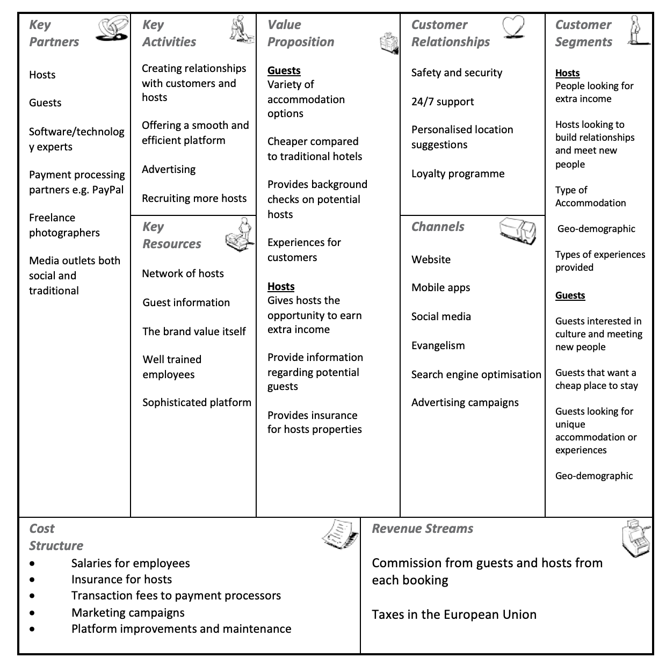
Business Model Canvas (BMC)
(Adapted from Singla, 2017)

“A business model describes the rationale of how an organisation creates, delivers and captures value” (Osterwalder and Pigneur, 2010, p.14). The BMC is “a shared language for describing, visualising, assessing and changing business models” (Osterwalder and Pigneur, 2010, p.12). The canvas is split into two sections the left side highlights efficiency and the right-side value. Osterwalder and Pigneur (2010) collected responses from businesses regarding how they utilised the BMC and discovered people used it to ‘establish a common language with colleagues’, ‘easily illustrate how it makes financial sense’, and clarify their current business models.

The business model canvas is a simple and effective tool that allows an organisation to assess its business strategy, and identify strengths, weaknesses, and potential risks (SCORE, 2021). Osterwalder and Pigneur (2010) state that when searching for a new business model the BMC can be a useful tool, as one or a few of the nine building blocks can each be a starting point of a new model, there are four epicentres in the BMC each having a major effect on the other eight building blocks, these are known as customer-driven, offer-driven, resource-driven or finance-driven. Conducting a SWOT analysis of each building block will also be hugely beneficial as this can lead to potential innovations and assesses the model's integrity. Prior to the adoption of a model, four different operational characteristics must be considered these are volume, variety, variation, and visibility (Osterwalder and Pigneur, 2010). One of the key building blocks is the value proposition as this is what differentiates a business from its competitors, as can be seen in the BMC I have identified the value that Airbnb offers both guests and hosts.

Strategic Formulation Framework (SFF)
The Strategic Formulation Framework (SFF) was created by Fred David and was done so because he believed that “objectives should be measurable, quantitative, challenging, realistic, consistent, and prioritised” David (2011, p.133). In recent times the strategic process has shifted from a qualitative-oriented planning process to a quantitative one, which may hinder communication, which is why strategists should use strategic tools to not only analyse data but also facilitate communication (David, 2011). According to David (2011), the SFF consists of nine different techniques divided into three different stages, stage one or the input stage is where basic data gets inputted and then decisions are made using the rating system, at this stage a SWOT and PESTLE analysis is conducted to determine both internal and external strengths, weaknesses, opportunities, and threats. This is also the stage whereby an organisation identifies its main competitors, using a scoring method in the Competitive Profile Matrix (David, 2011).
In stage two or the input stage, an organisation turns the threats and weaknesses into opportunities and threats, essentially combining the SWOT and PESTLE analysis, this is known as a TOWS analysis (Weihrich, 1982). This allows an organisation to link its internal resources & skills to the opportunities and risks created by its external factors, this is done using quantitative scales. From this four strategies can emerge, these are Strengths-Opportunities (SO), which uses a firm’s internal strengths to take advantage of external opportunities, Weaknesses-Opportunities (WO), this strategy works to improve upon internal weaknesses by taking advantage of external opportunities, Strengths-Threats (ST), this strategy uses an organisation's strengths to help prevent or reduce the impact of external threats, finally, Weaknesses-Threats (WT), this is a tactic which aims to diminish internal weaknesses and prevent external threats (David, 2011).

Stage 3 or the decision stage is the final stage of the SFF, where an organisation or managers decide upon a strategy, to do this they use The Quantitative Strategic Planning Matrix (QSPM). This is a technique that analyses the key features of each matrix and determines which strategy is most effective for that organisation using the information from the input and matching stages (David, 2011). Some potential limitations of the SFF include the fact that the success of the QSPM is completely dependent on the analyses and information which it is based upon (Torlak et al., 2007). Another limitation of the framework is the fact that the person using the framework may disregard lower-level staff, with the aim of appeasing the hierarchy which may cause problems down the line, finally, the framework could be subject to bias which would affect the effectiveness of the QSPM (Torlak et al., 2007)
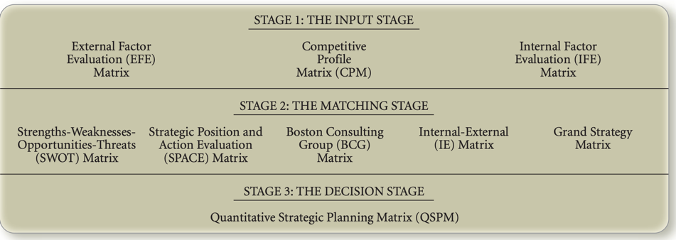
Strategic Formulation Framework (David, 2011)

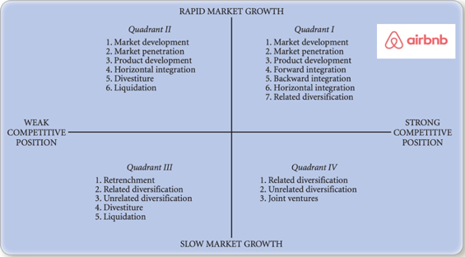
The matrix I will be applying to Airbnb is the Grand Strategy Matrix (GSM). David (2011) states that the GSM is based on two dimensions, these are competitive position and market growth, this is a tool used to formulate alternative strategies. Airbnb falls into quadrant 1 of the GSM, which means that Airbnb is in a great strategic position, organisations in the quadrant are generally excelling in their market and thus have the option to take more risks to be even more successful (David, 2011). The Peer-to-Peer market is currently thriving with a value of $115.61 billion in 2021 with the market predicted to reach $802.34 billion by 2028 and a Compound annual growth rate of 27.4 % which is another reason why Airbnb are in quadrant 1 (Koshti, 2022).
Grand Strategy Matrix (Adapted from David, 2011)

Airbnb is currently utilising many of the strategies that are listed in quadrant 1, for example, Airbnb is now operating in over 220 countries which highlight its market development (Airbnb Newsroom, 2023). An example of horizontal integration includes Airbnb’s acquisition of other peer-to-peer facilitators such as Accoleo (2011), Crashpadder (2012) Luxury Retreats (2017), Accomable (2017) Gaest (2019), Hotel Tonight (2019) and Urbandoor in 2019 (Sonnemaker, 2020). Alongside this Airbnb also acquired other organisations to aid their success, for example, they acquired Trooly in 2017, Trooly used machine learning to perform efficient and effective background checks on people, this type of acquisition is known as backward integration (Jurevicius, 2022; Skowronski, 2022). This is just one of the few acquisitions Airbnb has made to gain a larger market share and further develop the business and diversify its markets, an example of this is its acquisition of Accomable which was a facilitator that made it easier for travellers with disabilities to find accommodation (Sonnemaker, 2020), this is known as product development (David, 2011).

An example of Airbnb using related diversification was in 2016 when Airbnb started offering experiences, these experiences are defined by Airbnb (n.d.) as “in-person or online activities hosted by inspiring local experts”. According to Skillicorn (2019), these experiences offered further value for current customers and attracted new ones in the form of hosts for the experiences themselves. This is what’s also known as a product system innovation, these types of innovations help to create an ecosystem that benefits the customer and the organisation as it helps to retain customers which in turn helps fend off competitors. An example of Airbnb using market penetration is, during the first three quarters of 2022 Airbnb spent $771.9 million on brand and performance marketing an increase of $76.9 million from 2021 (O’Neill, 2022). David (2011) suggests organisations in quadrant 1 should continue using these strategies. A key reason why Airbnb is in quadrant 1 and is the current market leader is the value they offer both hosts and guests, as highlighted in the business model canvas under the value proposition.

Tools/systems.

Enterprise resource planning (ERP) systems are a form of software that connects all departments within an organisation so that they are all in one database. ERP is a structured approach to enhancing an organisation's internal value chain (Nah, 2002). ERP systems support all departments within an organisation including manufacturing, accounting, finance, project management, procurement, and the supply chain (Oracle, n.d.). The system Airbnb uses is Amazon’s web services (AWS) which store its ERP modules (AWS, 2022).

A key role of ERP is to act as a platform for other tools and systems, such as customer relationship management (CRM), Airbnb primarily uses e-CRM which is essentially CRM done digitally and is defined as “using digital technologies to maximise sales to existing customers and encourage continued usage of online services” (Chaffey, 2011, p.455). In the sharing economy trust and building relationships with your customers are crucial, as Chaffey (2011) states, by just retaining 5% of customers an organisation can increase profits by 25% to 95%. Customer retention is also much more cost-effective compared to attracting new customers, especially for e-businesses as the cost of attracting new customers online is 20-30% more expensive in comparison to conventional businesses. A key component of customer loyalty is trust, to create trust Airbnb implemented a review system for guests and hosts and performed background checks on hosts and provide 24/7 help to their customers. They also involve hosts in decision-making by hosting a three-day event called ‘One Airbnb’ where hosts and employees come together to discuss the strengths and weaknesses of the platform and how they can make improvements going forward (Krajewski, 2021). Highlighting your value is also crucial and is a key element in the acquisition, retention, and extension of CRM (Chaffey, 2011).

“Supply Chain Management is the coordination of all supply activities of an organisation from its suppliers and partners to its customer” (Chaffey, 2011, p.312). Airbnb’s primary suppliers are the hosts as they provide the facilities for their guests to stay, therefore, Airbnb must manage their hosts closely. The members of the Airbnb supply chain include the suppliers (hosts), Organisation (Airbnb) and the customer (guests). The three key activities of SCM are the internal supply chain, the upstream supply chain, and the downstream supply chain. Airbnb utilises the pull supply chain model which focuses on the customer’s needs, this supply chain is designed to create value for the customer by reducing costs and improving their service (Chaffey, 2011), Airbnb works closely with hosts who are suppliers as well as customers and guests who are also customers, improving their services based on their feedback. The main way of adding value to the supply chain is through efficient consumer response, this is a concept “aimed at creating and satisfying customer demand by optimizing product assortment strategies, promotions, and new product introductions” (Chaffey, 2011, p.313).

Conclusion

Airbnb is still very much at the forefront of the sharing economy, their success is down to its business models and strategies. Airbnb expanded globally by entering different geographical markets and developing its product through the acquisition of different businesses. One of the key factors to their success was the fact that they put their customers first and focused heavily on marketing, enabling them to attract a huge consumer base, which they were then able to build upon using technological resources and systems to aid their growth. Amongst peer-to-peer networks Airbnb look set to continue being the market leader.

Bibliography

About Us. Airbnb Newsroom. (2023). Retrieved January 8, 2023, from https://news.airbnb.com/about-us/
Airbnb on AWS. AWS. (2022). Retrieved January 10, 2023, from https://aws.amazon.com/solutions/case-studies/airbnb/
Airbnb. (2022, November 1). Airbnb third quarter 2022 financial results. Airbnb Newsroom. Retrieved January 3, 2023, from https://news.airbnb.com/airbnb-third-quarter-2022-financial-results/
An introduction to airbnb experiences - airbnb help centre. Airbnb. (n.d.). Retrieved January 2, 2023, from https://www.airbnb.co.uk/help/article/1581
Benefits of using the Business Model Canvas. SCORE. (2021, July 29). Retrieved January 5, 2023, from https://www.score.org/philadelphia/resource/blog-post/benefits-using-business-model-canvas
Chaffey, D. (2019, January 23). Business Model Review definition - what is? - digital marketing glossary. Dr Dave Chaffey : Digital Insights. Retrieved December 11, 2022, from https://www.davechaffey.com/digital-marketing-glossary/business-model-review/
Chaffey. (2011). E-business & e-commerce management : strategy, implementation and practice (5th ed.). Pearson/Financial Times Prentice Hall.
Crane, E. (2020) Airbnb’s founder estimates they’ve lost $1 billion during the COVID-19 pandemic as it’s revealed the company plans to confidentially file for IPO this month, retrieved on October 10, 2020 from https://www.dailymail.co.uk/news/article-8617085/Airbnbs-founder-estimates-theyve-lost-1billion-covid.html
David, F. R. (2011). Strategic management: Concepts and cases: A competitive advantage approach (thirteenth). Pearson Education Limited.
Davidson, N. and Infranca, J. (2018) The place of the sharing economy, in N. Davidson, M. Finck, and J. Infranca (Eds.), The Cambridge Handbook of the Law of the Sharing Economy, Cambridge: Cambridge University Press, 205-219.
Jurevicius, O. (2022, August 16). Horizontal Integration (the complete guide) - SM insight. Strategic Management Insight. Retrieved January 3, 2023, from https://strategicmanagementinsight.com/tools/horizontal-integration/
Koshti, S. (2022, August 24). Peer to peer (P2P) lending market growth, trends, Size & Analysis: Industry Report 2028. LinkedIn. Retrieved January 8, 2023, from https://www.linkedin.com/pulse/peer-p2p-lending-market-growth-trends-size-analysis-industry-koshti/?trk=pulse-article_more-articles_related-content-card
Krajewski, L. (2021). 4 reasons why airbnb’s on my list of companies with the best customer ... 4 Reasons Why Airbnb’s on My List of Companies with the Best Customer Experience. Retrieved January 10, 2023, from https://www.business2community.com/customer-experience/4-reasons-why-airbnbs-on-my-list-of-companies-with-the-best-customer-experience-02432777
Mansfield, T. (2019, July 26). Alex Osterwalder's business model canvas template: Why use it and how. Alex Osterwalder’s Business Model Canvas template: why use it and how. Retrieved January 5, 2023, from https://interaction.net.au/articles/business-model-canvas-template/
Morris, B. (2022, November 17). New law to require registration of all short-term housing rentals. Habitat Magazine, New York's Co-op and Condo Community. Retrieved January 4, 2023, from https://www.habitatmag.com/Publication-Content/Legal-Financial/2022/2022-November/New-Law-to-Require-Registration-of-All-Short-Term-Housing-Rentals
Nah, F. F. (Ed.). (2002). Enterprise Resource Planning: Solutions and Management. IGI Global. https://doi-org.ezproxy.uwtsd.ac.uk/10.4018/978-1-930708-36-5

Osterwalder, A., and Pigneur, Y. (2010). Business Model Generation: A Handbook for Visionaries, Game Changers, and Challengers (The Strategyzer series) (1st ed.). John Wiley and Sons.
Reinhold, S. and Dolnicar, S. (2017) Chapter 3 – Airbnb’s Business Model, in S. Dolnicar, Peer-to-Peer Accommodation Networks: Pushing the boundaries, Oxford: Goodfellow Publishers, pp. 27–38, https://dx.doi.org/10.23912/9781911396512–3601,
Scott, T. (2002), “Aligning your data collection and ERP implementation decisions”, IT Papers, available at: www.unova.com/whitepaper_align.asp
Singla, S. (2017, June 29). How airbnb works: Insights Into Business & Revenue Model. JungleWorks. Retrieved January 5, 2023, from https://jungleworks.com/airbnb-business-model-revenue-insights/
Skillicorn, N. (2019, July 22). Ten types of innovation: 30 new case studies for 2019. Idea to Value. Retrieved January 2, 2023, from https://www.ideatovalue.com/inno/nickskillicorn/2019/07/ten-types-of-innovation-30-new-case-studies-for-2019/
Skowronski, J. (2022, October 5). What is an acquisition? definition, types, and examples. Forage. Retrieved January 3, 2023, from https://www.theforage.com/blog/skills/acquisition#h-types-of-acquisitions
Sonnemaker, T. (2020, January 12). Here are all the companies Airbnb has acquired to help it grow into a $31 billion business. Business Insider. Retrieved January 3, 2023, from https://www.businessinsider.in/slideshows/miscellaneous/here-are-all-the-companies-airbnb-has-acquired-to-help-it-grow-into-a-31-billion-business/slidelist/73216414.cms#slideid=73216430
The top 12 airbnb problems and how to solve them. iGMS. (2021, April 30). Retrieved January 4, 2023, from https://www.igms.com/airbnb-problems/#
Torlak, Nuri Gökhan & Şanal, Mehmet. (2007). David's Strategy Formulation Framework in Action: The Example of Turkish Airlines on Domestic Air Transportation. Journal of Science Istanbul Commerce University. 6. 81-114.
von Briel, D. and Dolnicar, S. (2021) The evolution of Airbnb’s competitive landscape, in S. Dolnicar (Ed.) Airbnb before, during and after COVID-19, University of Queensland DOI: https://doi.org/10.6084/m9.figshare.14195960
Weihrich, H. (1982). 'The TOWS matrix – A tool for situational analysis,' Long Range Planning 15(2):54-66
What is Erp? Oracle United Kingdom. (n.d.). Retrieved January 10, 2023, from https://www.oracle.com/uk/erp/what-is-erp/
Wu, S., Lee, F., & Reynard, J. (2012). (rep.). Airbnb. Retrieved January 2, 2023, from http://www.econ.ucla.edu/sboard/teaching/tech/Airbnb.pdf.

