Network Operating Systems and Services (ACCA5023_LON): Assessment 2 – Individual Screenshots
By Michael Ziumbe (2428301)

Table of Contents

Task 1: Routing
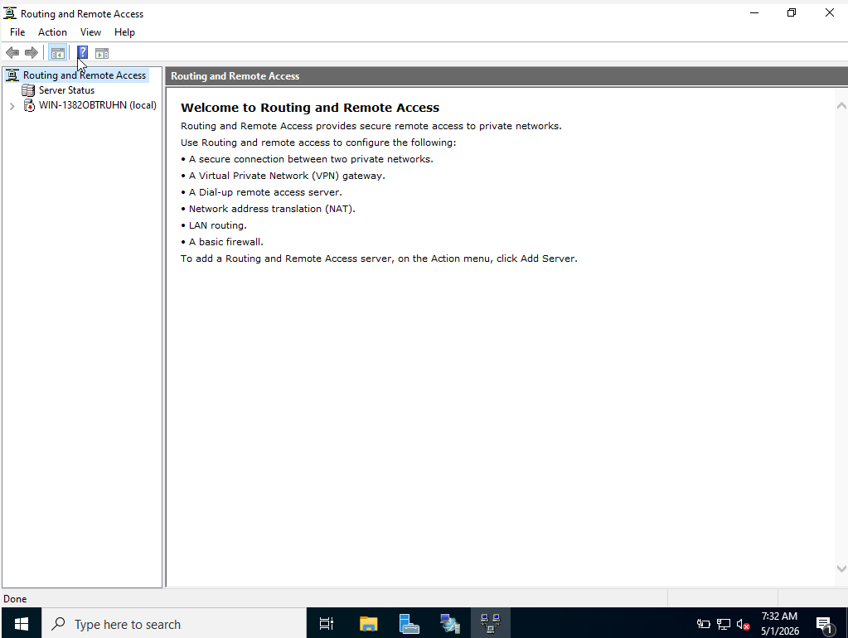

Task 2: Domain Server (Birmingham)
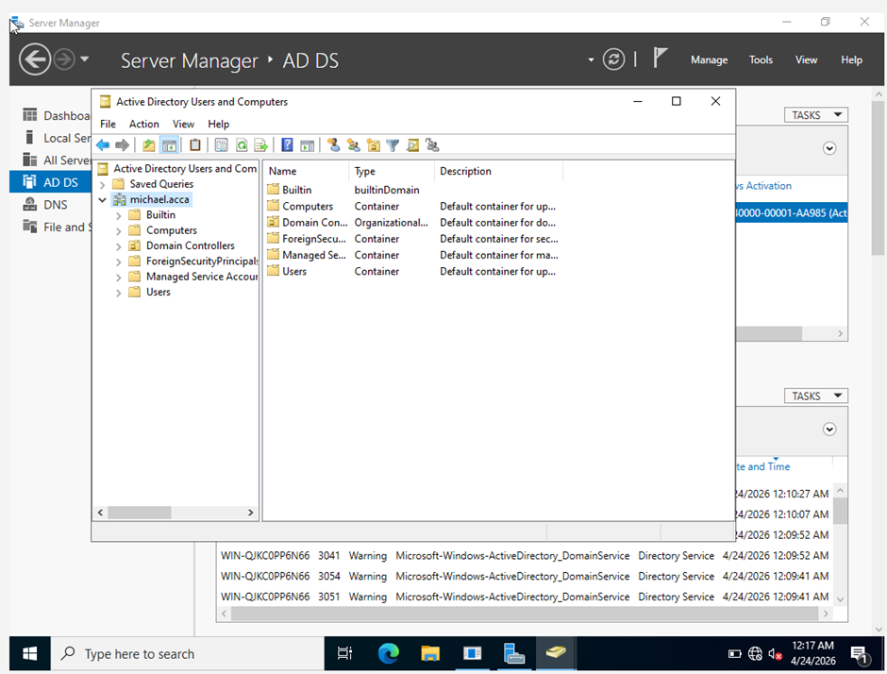

Task 3: Encrypted Connection between Birmingham and London
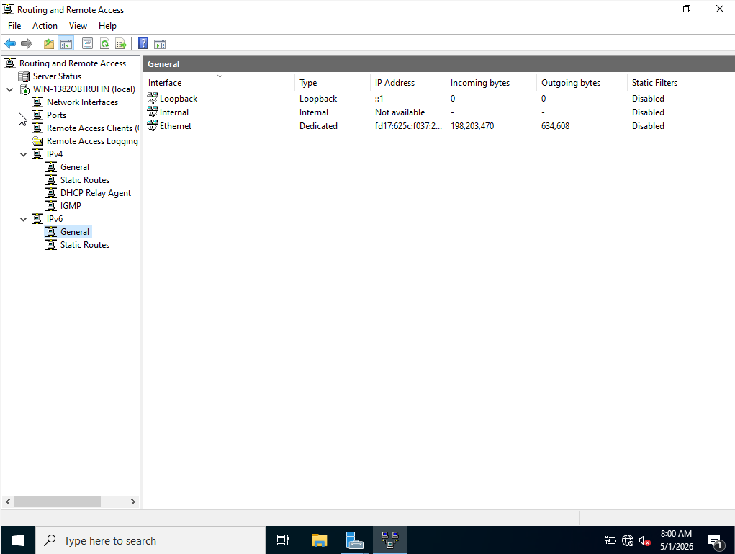

Task 4: Users
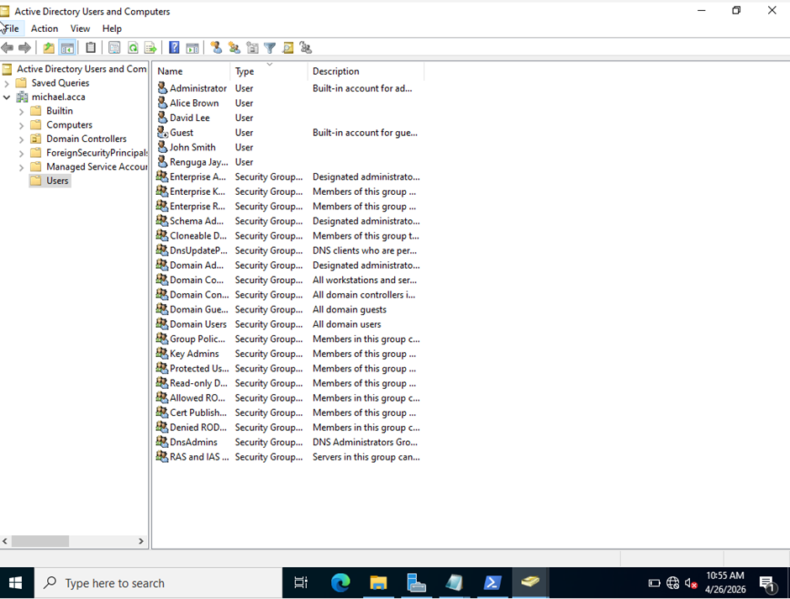

Task 5: Domain Membership
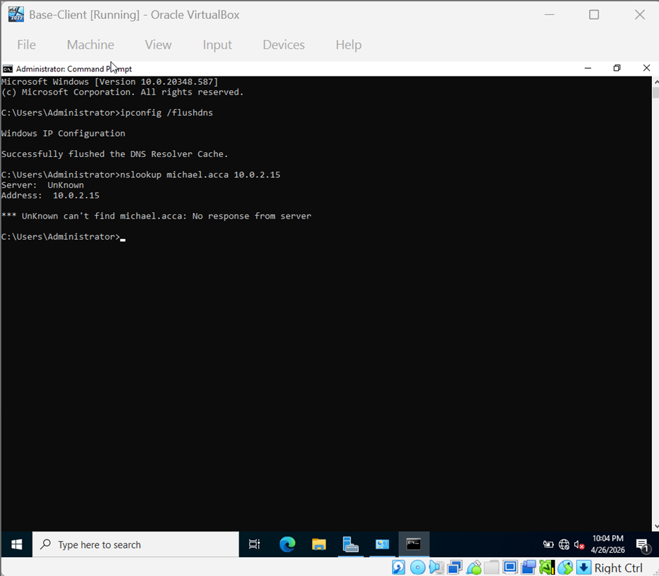

Task 6: DHCP Server
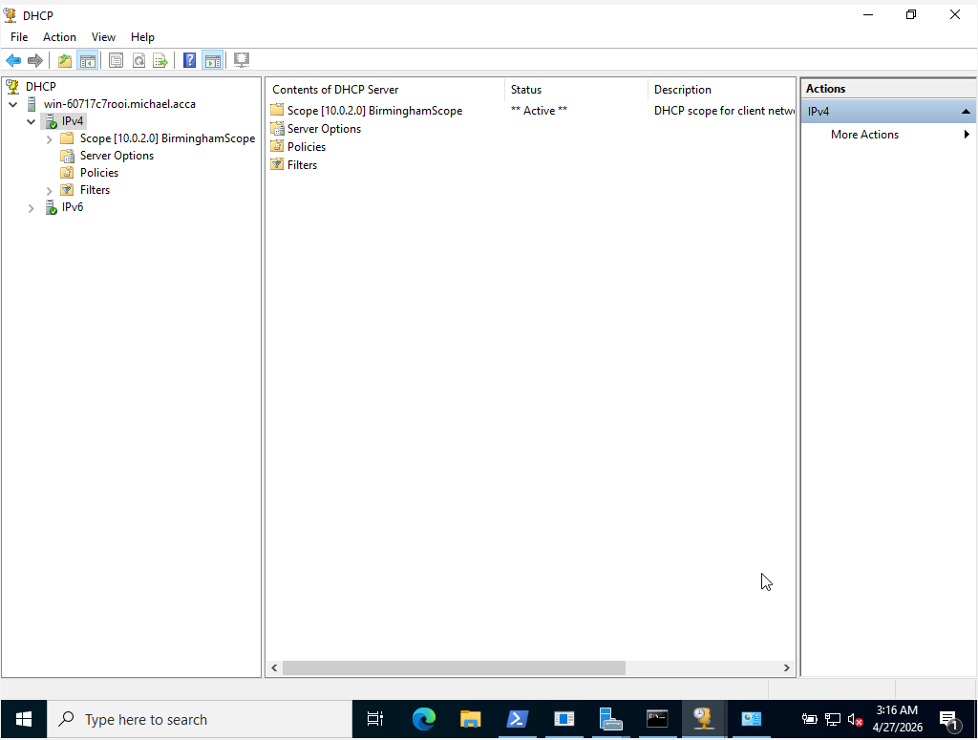

Task 7: Test and Troubleshoot
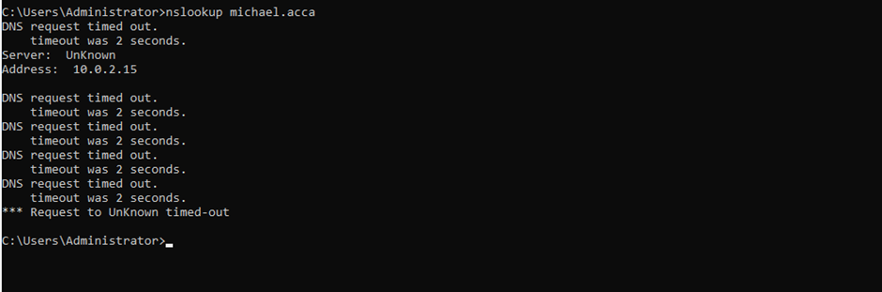

Task 8: Disk Drive
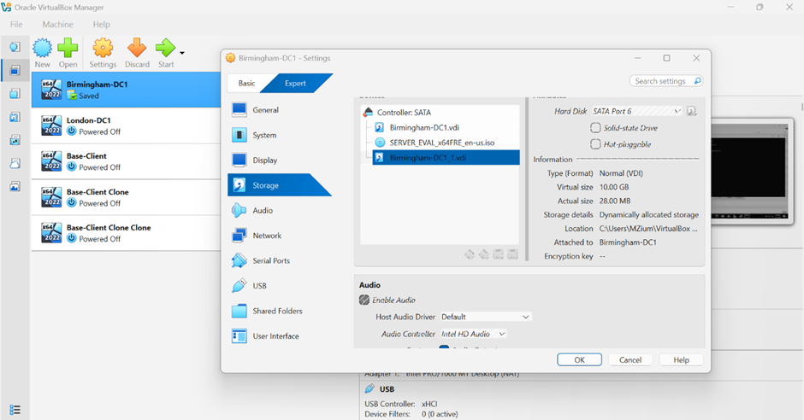

Task 9: IIS Server
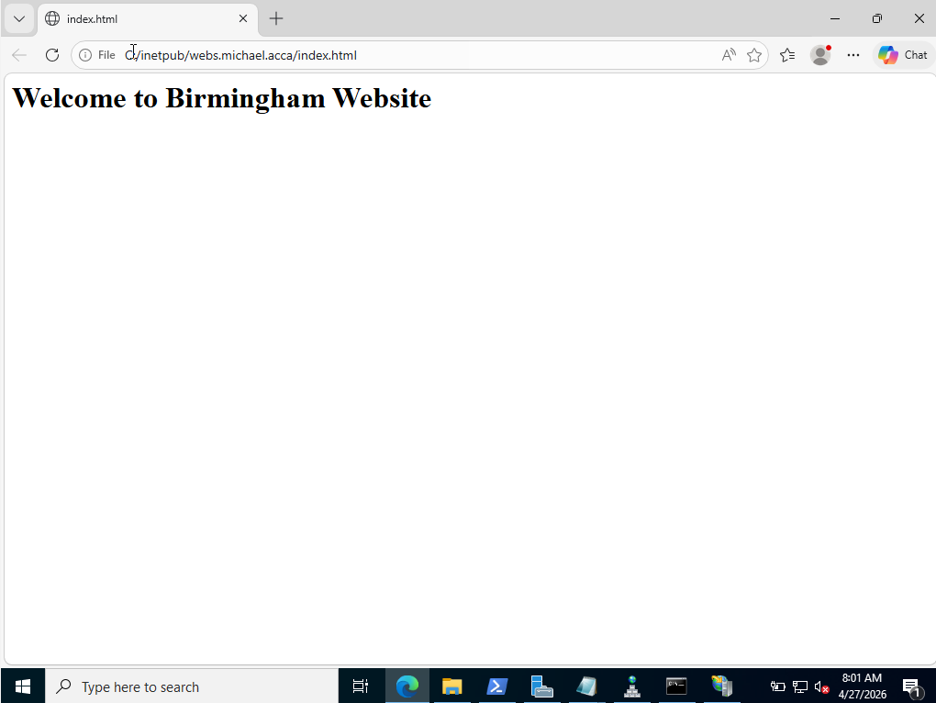

Task 10: Remote Desktop Services


