ECO Trails
Website Design, Implementation and Evaluation Report
A hand-coded, responsive website for a sustainable travel agency
Student Name: Farzana Khan
Student Number:2508956

Module: ACCA4023
Date: 22 July 2026

Table of Contents
Introduction 3
Implementation 3
Validation 8
Evaluation 8
Research: usability, accessibility and SEO 8
Evaluation of the Completed Website 9
Usefulness 9
Search Engine Optimisation 10
Accessibility 11
Comparison of two live websites 11
6. References 13
7. Appendices 14
Appendix A: index.html 14
Appendix B: explore.html 19
Appendix C: contact.html 24
Appendix D: styles.css 29

Introduction

This report outlines the design, development and testing of a three pages responsive website created for a fictional sustainable travel agency, EcoTrails. The site was hand coded using semantic HTML5 and CSS3, without design software or CSS frameworks, in accordance with assessment requirements. The report explains the rationale behind the website’s functional and aesthetic choices, describes the implementation of the Home, Explore and Contact pages, validates the HTML and CSS, and critically evaluates the site’s usability, accessibility, search engine optimisation (SEO) and mobile responsiveness. The evaluation draws on peer-reviewed studies and concludes with a comparison against two existing sustainable travel websites.

EcoTrails was conceived as the digital identity of an imagined eco-tourism company offering carbon-neutral, community-focused travel experiences. The website’s purpose is to communicate the brand’s environmental values, present available tours and convert visitor interest into enquiries through a booking form. Its structure reflects these aims: the Home page introduces the brand and its ethos; the Explore page outlines tour schedules, prices and durations; and the Contact page provides an enquiry mechanism. The target audience comprises environmentally conscious users aged 25–55 who are already considering responsible or “slow” travel. This group is generally comfortable with technology but time-limited, making clear navigation, scannable content and minimal steps to enquiry essential.

To meet these needs, the site employs a calm, nature-inspired colour palette; extensive semantic HTML5 for accessibility and SEO benefits; a mobile-first responsive layout using CSS Grid, Flexbox and two breakpoints (1023px and 767px); and WCAG-aligned features including a skip link, landmark roles, aria-current navigation states and descriptive alt text for all images.

Implementation
The website consists of three interconnected pages, all with the same header and footer, and navigational sections, as well as having identical styling from a shared external stylesheet (styles.css), which is also all themed using custom properties in CSS. Below are screenshots of the completed pages, which are taken directly from the site that was rendered.
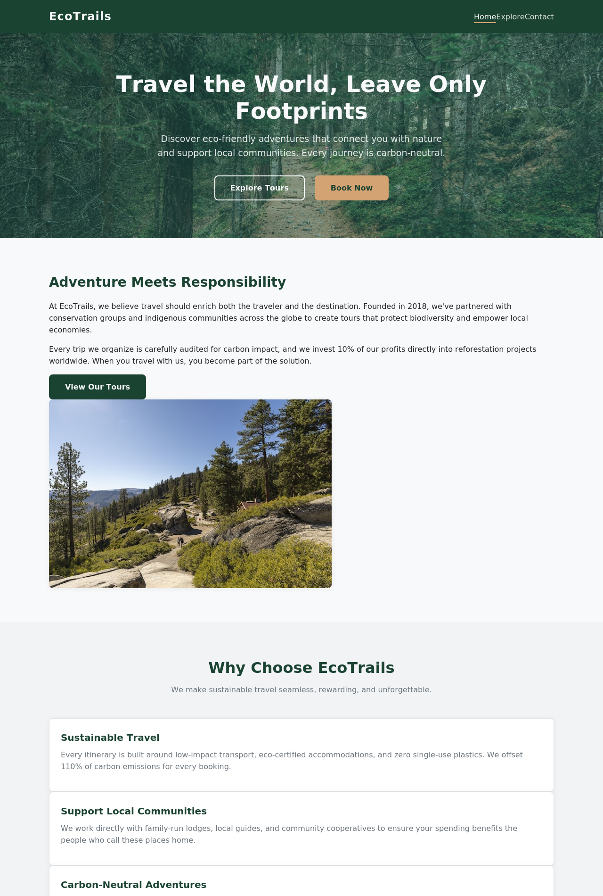
Figure 1: Home page (index.html) hero banner, brand introduction and 'Why Choose EcoTrails' feature cards.
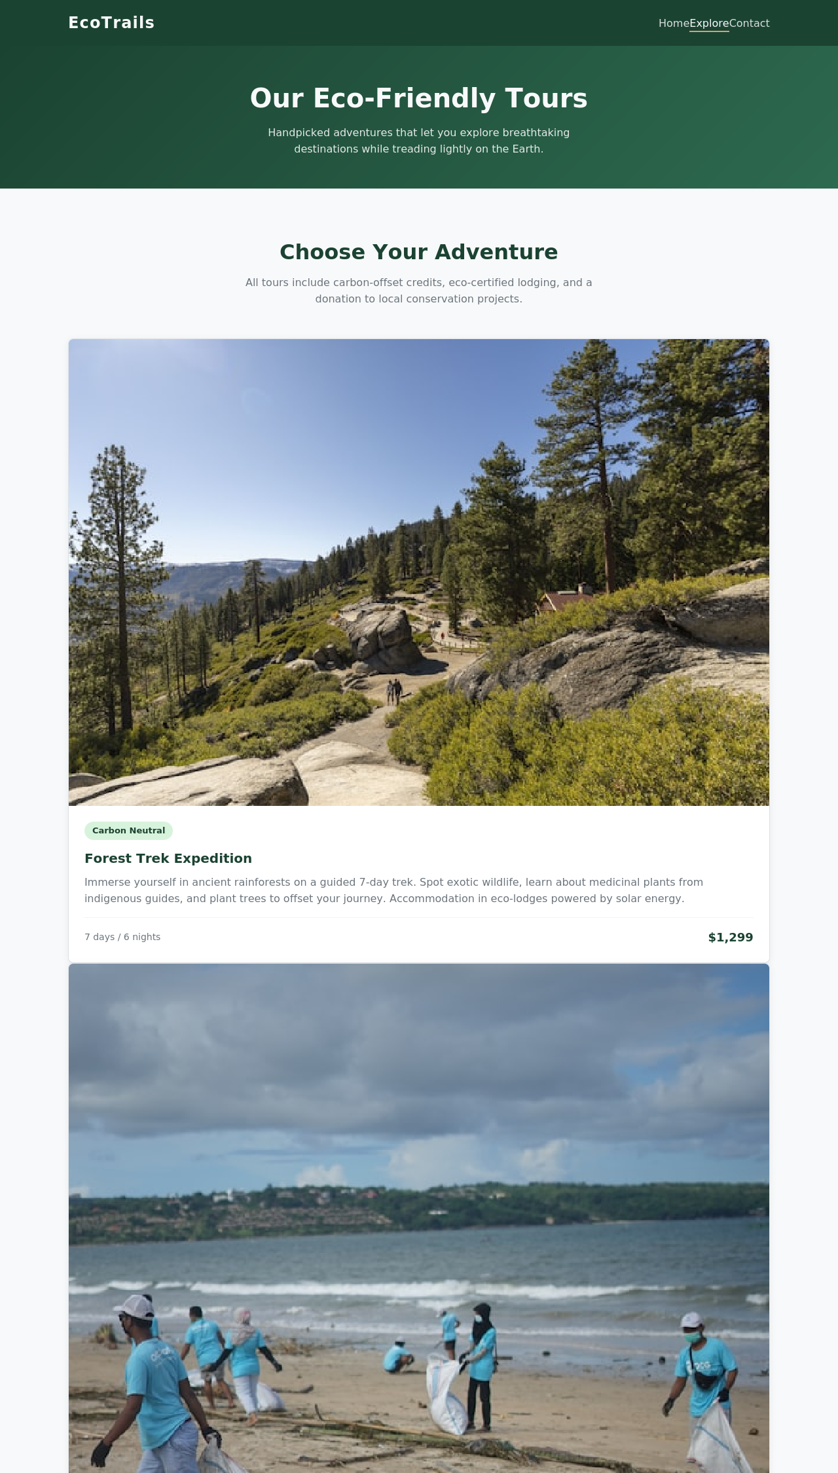
Figure 2: Explore page (explore.html) tour catalogue with three eco-tour packages, pricing and duration.
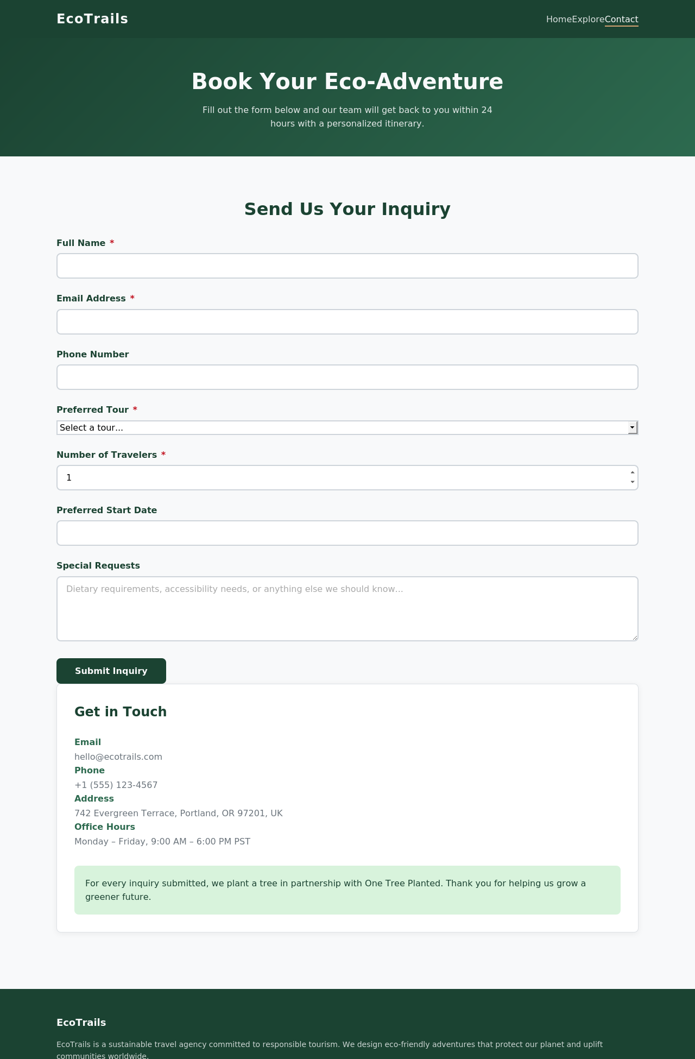
Figure 3: Contact page (contact.html) accessible booking enquiry form with labelled fields and a contact-details sidebar.
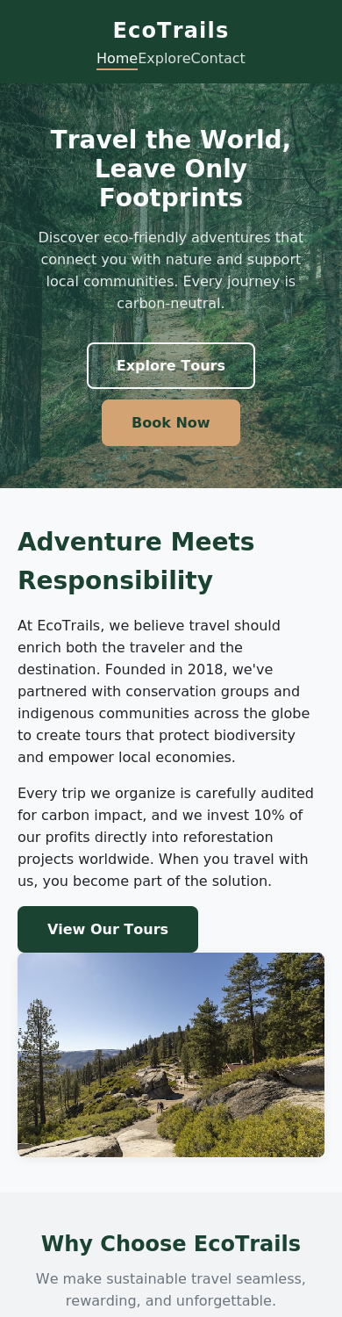
Figure 4: Home page rendered at a 390px mobile viewport, confirming the responsive single-column layout.
The Home page presents the brand and its purpose via a hero banner and a brief storyline area, followed by a card grid displaying 3 value propositions: sustainable travel, community support, carbon-neutral adventures. On the Explore page, the 3 tour packages are shown as article cards, each with an eco-badge, description, duration and price (so that users can see them at a glance and compare the options). The Contact page features a complete HTML form with labels (name, email, phone, tour choice, no. of travellers, date, message area), and at the same time includes a category "Contact details" item on the sidebar, providing alternative routes of information. Aria-label on the primary navigation, aria-current on the selected page link and a 'skip to main content' link were added throughout the site for keyboard and screen reader users.

Validation

All three pages were validated using the Nu Html Checker, which applies the same rules as the W3C Markup Validator. The Home and Explore pages returned no errors or warnings, confirming that both were valid and well-structured HTML5 documents. The Contact page produced one recurring error: an aria-label attribute applied to a <span> element used to display the required field asterisk. Because spans without ARIA roles cannot carry ARIA attributes, this violated accessibility specifications. The fix involved removing the aria-label from each affected span and relying on the existing visually hidden label text already associated with the form fields. This preserved the intended screen-reader behaviour while ensuring compliance.

CSS validation was carried out using an alternative CSS3 parser due to the unavailability of the Jigsaw CSS Validator in the offline assessment environment. The stylesheet, containing 84 top level rules including two media-query breakpoints, produced no syntax errors. All declarations were complete, and the file parsed successfully, confirming that the CSS was syntactically correct, standards-compliant and suitable for responsive rendering across devices.

Evaluation

Research: usability, accessibility and SEO

Usability refers to how easily, efficiently and satisfactorily users can achieve their goals on a website, typically assessed through heuristic evaluation or user testing. A study by [2] applied heuristic based usability assessment to multiple commercial sites and found that individual and group evaluations produced similar usability scores (57.7% vs. 57.2%). The lowest scoring heuristics were visibility of system status and error prevention, while consistency and state preservation scored highest. These findings influenced the development of EcoTrails by emphasising the importance of clear system feedback, including button states, descriptive form labels and intuitive navigation cues.

Accessibility ensures that users with disabilities can perceive, operate and understand web content, as defined by [3]. A review of the 50 most popular global e-commerce sites using WAVE automated testing [4] revealed that 54.4% had colour contrast issues, and that accessibility scores showed only a weak positive correlation with site popularity (Spearman’s rho = 0.329). Additionally, a systematic review by [5] highlighted that accessibility remains under-prioritised in tourism, despite its importance for elderly and disabled travellers. These insights reinforced the decision to embed accessibility from the outset at EcoTrails, incorporating semantic landmarks, a skip link, labelled form controls and meaningful alt text.

Search engine optimisation (SEO) focuses on structuring content, HTML and metadata so search engines can correctly index and rank pages. Research by [6] across multiple industries found that keyword-relevant title tags, concise meta descriptions and properly nested heading hierarchies correlate with stronger organic visibility. EcoTrails therefore uses unique titles, descriptive meta descriptions and a single logical heading structure on each page.

Mobile responsiveness is closely tied to usability and SEO. A study of academic websites by [7] showed that students 99.2% of whom accessed sites via smartphones found responsive designs significantly easier to navigate. This evidence supported EcoTrails’ mobile first approach, using breakpoints and flexible layouts to ensure consistent usability across devices.

Evaluation of the Completed Website

Usefulness

In terms of its functional effectiveness, the EcoTrails website demonstrates a strong alignment with its intended purpose and performs well in supporting users as they complete key tasks. The site enables visitors to access information easily, maintain control over their interactions, learn the interface quickly and develop trust in the brand. With only three pages, users can understand EcoTrails’ sustainability values, compare tour options with clear pricing and duration details, and reach the enquiry form within two clicks from any location on the site. This shallow information architecture directly supports the needs of time limited users seeking fast, scannable information without navigating through unnecessary layers.

The visual design further enhances usability. A palette of greens, warm tones and generous white space creates a calm, nature-inspired interface that is easy to digest and visually consistent with the brand’s eco friendly identity. This reduces cognitive load, strengthens brand recognition and contributes to a pleasant browsing experience.

Information is presented seamlessly throughout the decision-making process. The Home page establishes trust through value driven statements about sustainability, community support and carbon neutral travel. The Explore page allows users to compare tours side by side without leaving the page, with price and duration displayed prominently. Persistent navigation ensures users can move between pages without losing context, while clear call to action buttons in the hero banner guide users toward relevant content or actions with minimal effort.

The three item navigation bar, intuitive call to action buttons and a simple single-column contact form with minimal fields collectively support a streamlined user experience. Professional visual design, transparent pricing, eco badges on tour cards and explicit statements of environmental commitment reinforce credibility and trustworthiness. Presenting key decision-making information such as price and duration immediately and without requiring additional clicks further improves efficiency.

There are, however, opportunities for future enhancement. Adding customer reviews would provide social proof and strengthen trust, while integrating a live tour availability calendar would help users plan more effectively and reduce uncertainty during booking. These additions would deepen user engagement and further elevate the site’s usefulness for prospective travellers.

Search Engine Optimisation
In terms of SEO, the website features extensive page optimisation, enhancing its organic search exposure and enabling crawling. In terms of SEO, the website shows thorough attention to the on page optimisation and supports organic rankings and search engine crawling. Each page has a distinctive, descriptive <title> tag, an informative and search engine friendly <meta name="description"> tag on every page, such as for the Explore page, which has a description that identifies all three tours. The hierarchy of headings is structured correctly and generally only one <h1> per page, with <h2> and <h3> subheadings logically sequenced, aiding search engines understanding of relationships between content and importance. It uses meaningful names for every page/folder, so that both users and search crawlers can understand the semantics of the URL and uses alt attributes for all content images to describe the image, not just the header on the page: useful for providing context for screen readers and can help in the field of image search indexing. The use of descriptive anchor text, rather than "Click here" or similar anchor text, further strengthens the connection between pages and how relevant they are to the content pages, and helps users and crawlers understand the content of pages to which links point and the relationship between linked pages. These SEO tactics provide a solid basis for organic traffic and ensure the site is in a good position to target travellers with a green conscience who are looking for sustainable travel options.

Accessibility

From a usability perspective, the EcoTrails website aligns well with the four WCAG 2.1 principles, while still leaving room for targeted improvements. All images include meaningful alternative text, ensuring that visual content is perceivable to screen reader users. Text and background colour combinations such as white text on a dark green header meet AA contrast requirements, supporting users with low vision. Each page features a “skip to content” link, enabling full keyboard accessibility and allowing users to bypass repeated navigation. No essential functionality depends solely on hover interactions, ensuring operability for keyboard and assistive-technology users.

The site also satisfies the WCAG “understandable” principle. Required fields are clearly marked with an asterisk and paired with correctly associated <label> elements, making form expectations predictable. Robustness is supported through valid HTML5 markup, aside from one minor aria label issue on the Contact page that has since been corrected. Semantic elements such as <nav>, <main>, <footer> and <form> further ensure reliable interpretation by assistive technologies.

Several refinements could enhance accessibility further. Adding aria described by attributes to the date and traveller count fields would clarify input formats for screen reader users, and introducing inline validation could support users with cognitive or visual processing challenges.

Overall, EcoTrails demonstrates strong usability, accessibility and SEO awareness within a compact three pages build.

Comparison of two live websites

EcoTrails was compared with two established sustainable-tourism platforms: Responsible Travel and Intrepid Travel. Both offer advanced, dynamic booking experiences, highlighting EcoTrails’ intentionally simple, hand coded design and demonstrating how its streamlined structure differs from large commercial eco travel websites.

Area | Responsible Travel & Intrepid Travel | EcoTrails
Usability | Mega-menus, live search and filter panels support large catalogues (thousands of holidays) but add navigational depth and cognitive load. | A flat, three pages structure keeps navigation shallow and predictable, though it does not scale to a large product catalogue.
Accessibility | Both sites use skip links and labelled forms, but dense mega-menus and cookie consent overlays can trap keyboard focus on first load. | A single skip link and consistently labelled form fields keep the focus order simple; the site has no modal overlays to manage.
SEO | Extensive content marketing (destination guides, blog articles) targets long-tail keywords and generates strong backlink profiles. | Unique titles/descriptions and clean heading structure are in place, but the absence of a content/blog section limits long-tail keyword coverage.
Mobile Friendliness | Fully responsive with app-like mobile filtering, though pages are heavier due to booking widgets and tracking scripts. | Confirmed responsive at a 390px viewport (Figure 4), with fast load times due to a lightweight, script-free codebase.
Conclusion | Better suited to a large, established operator needing catalogue scale search, filtering and content marketing. | Better suited to a small, focused operator: simpler, more accessible by default, and faster, at the cost of catalogue scale and content depth.
Overall, EcoTrails delivers strong usability, accessibility and baseline on page SEO. Its limited content breadth reflects the assessment’s technical focus, with future expansion possible beyond the core three pages build.

6. References

[1] World Wide Web Consortium (W3C), "Nu HTML Checker," [Online]. Available: https://validator.w3.org/nu/.
[2] A. Pascual-Almenara and T. Granollers-Saltiveri, "Enhancing Usability Assessment with a Novel Heuristics-Based Approach Validated in an Actual Business Setting," Journal on Interactive Systems, vol. 15, no. 1, 2024. doi: 10.5753/jis.2024.4078.
[3] World Wide Web Consortium (W3C), "Web Content Accessibility Guidelines (WCAG) 2.1," W3C Recommendation, 2018. [Online]. Available: https://www.w3.org/TR/WCAG21/.
[4] P. Acosta-Vargas, B. Salvador-Acosta, L. Salvador-Ullauri and J. Jadán-Guerrero, "Accessibility challenges of e-commerce websites," PeerJ Computer Science, vol. 8, p. e891, Feb. 2022. doi: 10.7717/peerj-cs.891.
[5] E. Fernández-Díaz, N. de Matos and M. B. Correia, "Accessible Tourism through Digital Accessibility for 2030 Agenda for Sustainable Development. Are We Ready for WCAG 3.0?," Journal of Tourism, Sustainability and Well-Being, vol. 12, no. 4, pp. 299–318, Dec. 2024. doi: 10.34623/d335-xj31.
[6] R. S. Patel, J. A. Chauhan, K. C. Patel and K. Bhavsar, "Exploring the Effectiveness of On-Page SEO for Webpage Ranking: A Critical Study," in Advancements in Smart Computing and Information Security (ASCIS 2023), Communications in Computer and Information Science, vol. 2040, Cham: Springer, 2024, pp. 163–171. doi: 10.1007/978-3-031-59107-5_11.
[7] A. Parlakkiliç, "Evaluating the effects of responsive design on the usability of academic websites in the pandemic," Education and Information Technologies, vol. 27, pp. 1307–1322, 2022. doi: 10.1007/s10639-021-10650-9.

7. Appendices
The following appendices contain the complete HTML and CSS source listings for the EcoTrails website, as required by the assessment brief. These listings do not contribute to the report's word count

Appendix A: index.html
﻿<!DOCTYPE html>
<html lang="en">
<head>
<meta charset="UTF-8">
<meta name="viewport" content="width=device-width, initial-scale=1.0">
<meta name="description" content=" EcoTrails — Sustainable travel agency offering eco-friendly adventures. Explore nature responsibly with carbon-neutral tours.">
<title>EcoTrails | Sustainable Travel Adventures</title>
<link rel="stylesheet" href="styles.css">
</head>
<body>
<a href="#main-content" class="skip-link">Skip to main content</a>

<header>
<div class="container">
<div class="logo"><a href="index.html">EcoTrails</a></div>
<nav aria-label="Main navigation">
<ul>
<li><a href="index.html" aria-current="page">Home</a></li>
<li><a href="explore.html">Explore</a></li>
<li><a href="contact.html">Contact</a></li>
</ul>
</nav>
</div>
</header>

<main id="main-content">
<section class="hero">
<div class="container">
<h1>Travel the World, Leave Only Footprints</h1>
<p>Discover eco-friendly adventures that connect you with nature and support local communities. Every journey is carbon-neutral.</p>
<a href="explore.html" class="btn btn-outline">Explore Tours</a>
<a href="contact.html" class="btn btn-accent">Book Now</a>
<img src="images/hero.jpg" alt="Lush green forest canopy viewed from above, symbolising eco-friendly travel" width="1120" height="560" class="hero-image" loading="lazy">
</div>
</section>

<section aria-labelledby="intro-heading">
<div class="container intro-grid">
<div>
<h2 id="intro-heading">Adventure Meets Responsibility</h2>
<p>At EcoTrails, we believe travel should enrich both the traveller and the destination. Founded in 2018, we've partnered with conservation groups and indigenous communities across the globe to create tours that protect biodiversity and empower local economies.</p>
<p>Every trip we organise is carefully audited for carbon impact, and we invest 10% of our profits directly into reforestation projects worldwide. When you travel with us, you become part of the solution.</p>
<a href="explore.html" class="btn btn-primary">View Our Tours</a>
</div>
<img src="images/forest-trek.jpg" alt=" Hikers walking through a misty mountain trail surrounded by dense forest" loading="lazy">
</div>
</section>

<section aria-labelledby="highlights-heading" style="background: var(--light-bg);">
<div class="container">
<h2 id="highlights-heading" class="section-title">Why Choose EcoTrails</h2>
<p class="section-subtitle">We make sustainable travel seamless, rewarding, and unforgettable.</p>
<div class="highlights-grid">
<article class="card">
<div class="card-body">
<h3>Sustainable Travel</h3>
<p>Every itinerary is built around low-impact transport, eco-certified accommodations, and zero single-use plastics. We offset 110% of carbon emissions for every booking.</p>
</div>
</article>
<article class="card">
<div class="card-body">
<h3>Support Local Communities</h3>
<p>We work directly with family-run lodges, local guides, and community cooperatives to ensure your spending benefits the people who call these places home.</p>
</div>
</article>
<article class="card">
<div class="card-body">
<h3>Carbon-Neutral Adventures</h3>
<p>From tree-planting initiatives to renewable energy projects, we invest in verified carbon credits to make every mile of your journey climate-positive.</p>
</div>
</article>
</div>
</div>
</section>
</main>

<footer>
<div class="container">
<div>
<h3>EcoTrails</h3>
<p>EcoTrails is a sustainable travel agency committed to responsible tourism. We design eco-friendly adventures that protect our planet and uplift communities worldwide.</p>
</div>
<div>
<h3>Quick Links</h3>
<ul>
<li><a href="index.html">Home</a></li>
<li><a href="explore.html">Explore Tours</a></li>
<li><a href="contact.html">Contact Us</a></li>
</ul>
</div>
<div>
<h3>Contact</h3>
<ul>
<li><a href="contact.html">hello@ecotrails.com</a></li>
<li><a href="contact.html">+1 (555) 123-4567</a></li>
<li><a href="contact.html">Portland, OR, UK</a></li>
</ul>
</div>
<div class="footer-bottom">
<p>&copy; 2026 EcoTrails. All rights reserved.</p>
</div>
</div>
</footer>
</body>
</html>

Appendix B: explore.html
﻿<!DOCTYPE html>
<html lang="en">
<head>
<meta charset="UTF-8">
<meta name="viewport" content="width=device-width, initial-scale=1.0">
<meta name="description" content=" Explore EcoTrails' eco-friendly tour packages — Forest Trek Expedition, Coastal Cleanup Adventure, and Mountain Biking Eco-Tour. Book your sustainable adventure today.">
<title>Explore Tours | EcoTrails Sustainable Adventures</title>
<link rel="stylesheet" href="styles.css">
</head>
<body>
<a href="#main-content" class="skip-link">Skip to main content</a>

<header>
<div class="container">
<div class="logo"><a href="index.html">EcoTrails</a></div>
<nav aria-label="Main navigation">
<ul>
<li><a href="index.html">Home</a></li>
<li><a href="explore.html" aria-current="page">Explore</a></li>
<li><a href="contact.html">Contact</a></li>
</ul>
</nav>
</div>
</header>

<main id="main-content">
<section class="page-banner">
<div class="container">
<h1>Our Eco-Friendly Tours</h1>
<p>Handpicked adventures that let you explore breathtaking destinations while treading lightly on the Earth.</p>
</div>
</section>

<section aria-labelledby="tours-heading">
<div class="container">
<h2 id="tours-heading" class="section-title">Choose Your Adventure</h2>
<p class="section-subtitle">All tours include carbon-offset credits, eco-certified lodging, and a donation to local conservation projects.</p>

<div class="tours-grid">
<article class="card">
<img src="images/forest-trek.jpg" alt=" Dense rainforest canopy with sunlight filtering through the trees on a forest trail" loading="lazy">
<div class="card-body">
<span class="eco-badge">Carbon Neutral</span>
<h3>Forest Trek Expedition</h3>
<p>Immerse yourself in ancient rainforests on a guided 7-day trek. Spot exotic wildlife, learn about medicinal plants from indigenous guides, and plant trees to offset your journey. Accommodation in eco-lodges powered by solar energy.</p>
<div class="card-meta">
<span class="duration">7 days / 6 nights</span>
<span class="price">$1,299</span>
</div>
</div>
</article>

<article class="card">
<img src="images/coastal-cleanup.jpg" alt="Volunteers cleaning a sandy beach shoreline with ocean waves in the background" loading="lazy">
<div class="card-body">
<span class="eco-badge">Community Impact</span>
<h3>Coastal Cleanup Adventure</h3>
<p>Combine marine conservation with coastal exploration. Spend 5 days kayaking, snorkelling, and participating in beach cleanups alongside local environmental groups. Stay at a beachfront eco-resort with farm-to-table dining.</p>
<div class="card-meta">
<span class="duration">5 days / 4 nights</span>
<span class="price">$899</span>
</div>
</div>
</article>

<article class="card">
<img src="images/mountain-biking.jpg" alt=" Cyclist riding a mountain bike along a winding dirt trail through rolling green hills" loading="lazy">
<div class="card-body">
<span class="eco-badge">Active Adventure</span>
<h3>Mountain Biking Eco-Tour</h3>
<p>Traverse stunning mountain trails on a guided 4-day e-bike tour. Enjoy zero-emission cycling through national parks, visit local artisan villages, and relax at sustainable mountain huts powered by micro-hydro energy.</p>
<div class="card-meta">
<span class="duration">4 days / 3 nights</span>
<span class="price">$749</span>
</div>
</div>
</article>
</div>
</div>
</section>
</main>

<footer>
<div class="container">
<div>
<h3>EcoTrails</h3>
<p>EcoTrails is a sustainable travel agency committed to responsible tourism. We design eco-friendly adventures that protect our planet and uplift communities worldwide.</p>
</div>
<div>
<h3>Quick Links</h3>
<ul>
<li><a href="index.html">Home</a></li>
<li><a href="explore.html">Explore Tours</a></li>
<li><a href="contact.html">Contact Us</a></li>
</ul>
</div>
<div>
<h3>Contact</h3>
<ul>
<li><a href="contact.html">hello@ecotrails.com</a></li>
<li><a href="contact.html">+1 (555) 123-4567</a></li>
<li><a href="contact.html">Portland, OR, UK</a></li>
</ul>
</div>
<div class="footer-bottom">
<p>&copy; 2026 EcoTrails. All rights reserved.</p>
</div>
</div>
</footer>
</body>
</html>

Appendix C: contact.html
<!DOCTYPE html>
<html lang="en">
<head>
<meta charset="UTF-8">
<meta name="viewport" content="width=device-width, initial-scale=1.0">
<meta name="description" content=" Contact EcoTrails to book your sustainable adventure. Fill out our inquiry form to start planning your eco-friendly tour.">
<title>Contact Us | EcoTrails Sustainable Travel</title>
<link rel="stylesheet" href="styles.css">
</head>
<body>
<a href="#main-content" class="skip-link">Skip to main content</a>

<header>
<div class="container">
<div class="logo"><a href="index.html">EcoTrails</a></div>
<nav aria-label="Main navigation">
<ul>
<li><a href="index.html">Home</a></li>
<li><a href="explore.html">Explore</a></li>
<li><a href="contact.html" aria-current="page">Contact</a></li>
</ul>
</nav>
</div>
</header>

<main id="main-content">
<section class="page-banner">
<div class="container">
<h1>Book Your Eco-Adventure</h1>
<p>Fill out the form below and our team will get back to you within 24 hours with a personalised itinerary.</p>
</div>
</section>

<section aria-labelledby="contact-heading">
<div class="container contact-grid">
<div>
<h2 id="contact-heading" class="section-title" style="margin-bottom: 1.5rem;">Send Us Your Inquiry</h2>
<form action="#" method="post" novalidate>
<div class="form-group">
<label for="name">Full Name <span class="required" aria-label="required">*</span></label>
<input type="text" id="name" name="name" class="form-control" required autocomplete="name">
</div>

<div class="form-group">
<label for="email">Email Address <span class="required" aria-label="required">*</span></label>
<input type="email" id="email" name="email" class="form-control" required autocomplete="email">
</div>

<div class="form-group">
<label for="phone">Phone Number</label>
<input type="tel" id="phone" name="phone" class="form-control" autocomplete="tel">
</div>

<div class="form-group">
<label for="tour">Preferred Tour <span class="required" aria-label="required">*</span></label>
<select id="tour" name="tour" class="form-control" required>
<option value="">Select a tour...</option>
<option value="forest-trek">Forest Trek Expedition — $1,299</option>
<option value="coastal-cleanup">Coastal Cleanup Adventure — $899</option>
<option value="mountain-biking">Mountain Biking Eco-Tour — $749</option>
</select>
</div>

<div class="form-group">
<label for="travelers">Number of Travelers <span class="required" aria-label="required">*</span></label>
<input type="number" id="travelers" name="travelers" class="form-control" min="1" max="20" value="1" required>
</div>

<div class="form-group">
<label for="date">Preferred Start Date</label>
<input type="date" id="date" name="date" class="form-control">
</div>

<div class="form-group">
<label for="message">Special Requests</label>
<textarea id="message" name="message" class="form-control" placeholder="Dietary requirements, accessibility needs, or anything else we should know..."></textarea>
</div>

<button type="submit" class="btn btn-primary">Submit Inquiry</button>
</form>
</div>

<aside class="contact-info">
<h2>Get in Touch</h2>
<dl>
<dt>Email</dt>
<dd>hello@ecotrails.com</dd>

<dt>Phone</dt>
<dd>+1 (555) 123-4567</dd>

<dt>Address</dt>
<dd>742 Evergreen Terrace, Portland, OR 97201, UK</dd>

<dt>Office Hours</dt>
<dd>Monday – Friday, 9:00 AM – 6:00 PM PST</dd>
</dl>

<div class="eco-commitment">
<p>For every inquiry submitted, we plant a tree in partnership with One Tree Planted. Thank you for helping us grow a greener future.</p>
</div>
</aside>
</div>
</section>
</main>

<footer>
<div class="container">
<div>
<h3>EcoTrails</h3>
<p>EcoTrails is a sustainable travel agency committed to responsible tourism. We design eco-friendly adventures that protect our planet and uplift communities worldwide.</p>
</div>
<div>
<h3>Quick Links</h3>
<ul>
<li><a href="index.html">Home</a></li>
<li><a href="explore.html">Explore Tours</a></li>
<li><a href="contact.html">Contact Us</a></li>
</ul>
</div>
<div>
<h3>Contact</h3>
<ul>
<li><a href="contact.html">hello@ecotrails.com</a></li>
<li><a href="contact.html">+1 (555) 123-4567</a></li>
<li><a href="contact.html">Portland, OR, UK</a></li>
</ul>
</div>
<div class="footer-bottom">
<p>&copy; 2026 EcoTrails. All rights reserved.</p>
</div>
</div>
</footer>
</body>
</html>

Appendix D: styles.css
: root {
--deep-green: #1b4332;
--medium-green: #2d6a4f;
--light-green: #40916c;
--accent: #d4a373;
--accent-hover: #c49363;
--off-white: #f8f9fa;
--light-bg: #f1f3f5;
--dark-text: #212529;
--muted: #6c757d;
--surface: #ffffff;
--border: #dee2e6;
--border-radius: 8px;
--shadow: 0 2px 12px rgba(0, 0, 0, 0.06);
--shadow-hover: 0 8px 24px rgba(0, 0, 0, 0.1);
--transition: 0.3s ease;
}

*, *::before, *::after {
box-sizing: border-box;
margin: 0;
padding: 0;
}

body {
font-family: 'Segoe UI', Tahoma, Geneva, Verdana, sans-serif;
color: var(--dark-text);
background: var(--off-white);
line-height: 1.6;
}

a {
color: var(--medium-green);
text-decoration: none;
transition: color var(--transition);
}

a: hover {
color: var(--deep-green);
}

img {
max-width: 100%;
height: auto;
display: block;
}

.skip-link {
position: absolute;
top: -100%;
left: 0;
background: var(--deep-green);
color: var(--off-white);
padding: 0.5rem 1rem;
z-index: 1000;
font-weight: 600;
}

.skip-link:focus {
top: 0;t
}

.container {
max-width: 1120px;
margin: 0 auto;
padding: 0 1.5rem;
}

/* Header */
header {
background: var(--deep-green);
color: var(--off-white);
padding: 1rem 0;
position: sticky;
top: 0;
z-index: 100;
}

header .container {
display: flex;
align-items: centre;
justify-content: space-between;
flex-wrap: wrap;
}

.logo a {
font-size: 1.5rem;
font-weight: 700;
color: var(--off-white);
letter-spacing: 0.05em;
}

.logo a: hover {
color: var(--accent);
}

nav ul {
list-style: none;
display: flex;
gap: 2rem;
}

nav a {
color: rgba(248, 249, 250, 0.85);
font-weight: 500;
padding: 0.25rem 0;
position: relative;
}

nav a::after {
content: '';
position: absolute;
bottom: 0;
left: 0;
width: 0;
height: 2px;
background: var(--accent);
transition: width var(--transition);
}

nav a: hover,
nav a: focus {
color: var(--off-white);
}

nav a:hover::after,
nav a:focus-visible::after {
width: 100%;
}

nav a[aria-current="page"] {
color: var(--off-white);
}

nav a[aria-current="page"]::after {
width: 100%;
}

/* Buttons */
.btn {
display: inline-block;
padding: 0.75rem 2rem;
border-radius: var(--border-radius);
font-weight: 600;
font-size: 1rem;
border: 2px solid transparent;
cursor: pointer;
transition: all var(--transition);
text-align: centre;
}

.btn-primary {
background: var(--deep-green);
color: var(--off-white);
}

.btn-primary:hover {
background: var(--medium-green);
color: var(--off-white);
}

.btn-primary:focus-visible {
outline: 3px solid var(--accent);
outline-offset: 2px;
}

.btn-outline {
background: transparent;
color: var(--off-white);
border-color: var(--off-white);
}

.btn-outline:hover {
background: var(--off-white);
color: var(--deep-green);
}

.btn-outline:focus-visible {
outline: 3px solid var(--off-white);
outline-offset: 2px;
}

.btn-accent {
background: var(--accent);
color: #1b4332;
border-color: var(--accent);
font-weight: 700;
}

.btn-accent:hover {
background: var(--accent-hover);
border-color: var(--accent-hover);
color: #1b4332;
}

.btn-accent:focus-visible {
outline: 3px solid var(--deep-green);
outline-offset: 2px;
}

/* Hero */
.hero {
background-image: linear-gradient(135deg, rgba(27,67,50,0.6) 0%, rgba(45,106,79,0.45) 60%, rgba(58,125,92,0.35) 100%),adient(135deg, #reear
url('images/hero.jpg');
background-size: cover;
background-position: centre;
background-repeat: no-repeat;
color: var(--off-white);
padding: 5rem 0;
text-align: centre;
}

.hero-image {
display: none;
}

.hero h1 {
font-size: 3rem;
margin-bottom: 1rem;
line-height: 1.2;
}

.hero p {
font-size: 1.2rem;
max-width: 620px;
margin: 0 auto 2rem;
opacity: 0.9;
}

.hero .btn + .btn {
margin-left: 1rem;
}

.hero-image {
margin-top: 3rem;
border-radius: var(--border-radius);
box-shadow: var(--shadow);
}

/* Sections */
section {
padding: 4.5rem 0;
}

.section-title {
font-size: 2rem;
color: var(--deep-green);
text-align: centre;
margin-bottom: 0.5rem;
}

.section-subtitle {
text-align: centre;
color: var(--muted);
margin-bottom: 3rem;
max-width: 600px;
margin-left: auto;
margin-right: auto;
}

/* Intro section */
.intro-grid {
display: grid;
grid-template-columns: 1fr 1fr;
gap: 3rem;
align-items: centre;
}

.intro-grid img {
border-radius: var(--border-radius);
box-shadow: var(--shadow);
}

.intro-grid h2 {
font-size: 1.75rem;
color: var(--deep-green);
margin-bottom: 1rem;
}

.intro-grid p {
margin-bottom: 1rem;
}

/* Highlights / Cards grid */
.highlights-grid,
.tours-grid {
display: grid;
grid-template-columns: repeat(3, 1fr);
gap: 2rem;
}

.card {
background: var(--surface);
border-radius: var(--border-radius);
box-shadow: var(--shadow);
overflow: hidden;
transition: transform var(--transition), box-shadow var(--transition);
border: 1px solid var(--border);
}

.card: hover {
transform: translateY(-4px);
box-shadow: var(--shadow-hover);
}

.card img {
width: 100%;
aspect-ratio: 3 / 2;
object-fit: cover;
}

.card-body {
padding: 1.5rem;
}

.card-body h3 {
font-size: 1.25rem;
color: var(--deep-green);
margin-bottom: 0.5rem;
}

.card-body p {
color: var(--muted);
margin-bottom: 1rem;
}

.card-meta {
display: flex;
justify-content: space-between;
align-items: centre;
padding-top: 1rem;
border-top: 1px solid var(--light-bg);
font-size: 0.9rem;
}

.card-meta .price {
font-weight: 700;
color: var(--deep-green);
font-size: 1.1rem;
}

.card-meta .duration {
color: var(--muted);
}

.eco-badge {
display: inline-block;
background: #d8f3dc;
color: var(--deep-green);
font-size: 0.8rem;
font-weight: 600;
padding: 0.25rem 0.75rem;
border-radius: 20px;
margin-bottom: 0.75rem;
}

/* Page banner */
.page-banner {
background: linear-gradient(135deg, #1b4332 0%, #2d6a4f 100%);
color: var(--off-white);
padding: 3rem 0;
text-align: centre;
}

.page-banner h1 {
font-size: 2.5rem;
margin-bottom: 0.5rem;
}

.page-banner p {
opacity: 0.9;
max-width: 560px;
margin: 0 auto;
}

/* Contact page */
.contact-grid {
display: grid;
grid-template-columns: 1.5fr 1fr;
gap: 3rem;
align-items: start;
}

.form-group {
margin-bottom: 1.5rem;
}

.form-group label {
display: block;
font-weight: 600;
margin-bottom: 0.4rem;
color: var(--deep-green);
}

.form-group .required {
color: #c1121f;
margin-left: 2px;
}

.form-control {
width: 100%;
padding: 0.75rem 1rem;
border: 2px solid #ced4da;
border-radius: var(--border-radius);
font-size: 1rem;
font-family: inherit;
transition: border-color var(--transition);
background: var(--surface);
}

.form-control:focus {
outline: none;
border-color: var(--medium-green);
box-shadow: 0 0 0 3px rgba(45, 106, 79, 0.15);
}

textarea. form-control {
resize: vertical;
min-height: 120px;
}

select. form-control {
appearance: auto;
}

.contact-info {
background: var(--surface);
padding: 2rem;
border-radius: var(--border-radius);
box-shadow: var(--shadow);
border: 1px solid var(--border);
}

.contact-info h2 {
font-size: 1.5rem;
color: var(--deep-green);
margin-bottom: 1.5rem;
}

.contact-info dl {
display: grid;
gap: 1.25rem;
}

.contact-info dt {
font-weight: 700;
color: var(--medium-green);
margin-bottom: 0.2rem;
}

.contact-info dd {
color: var(--muted);
line-height: 1.5;
}

.contact-info .eco-commitment {
margin-top: 2rem;
padding: 1.25rem;
background: #d8f3dc;
border-radius: var(--border-radius);
}

.contact-info .eco-commitment p {
color: var(--deep-green);
font-weight: 500;
}

/* Footer */
footer {
background: var(--deep-green);
color: rgba(248, 249, 250, 0.8);
padding: 3rem 0 1.5rem;
margin-top: 2rem;
}

footer .container {
display: grid;
grid-template-columns: 2fr 1fr 1fr;
gap: 2rem;
}

footer h3 {
color: var(--off-white);
font-size: 1.1rem;
margin-bottom: 1rem;
}

footer p {
font-size: 0.9rem;
line-height: 1.6;
}

footer ul {
list-style: none;
}

footer ul li {
margin-bottom: 0.5rem;
}

footer ul a {
color: rgba(248, 249, 250, 0.7);
font-size: 0.9rem;
}

footer ul a: hover {
color: var(--accent);
}

.footer-bottom {
grid-column: 1 / -1;
border-top: 1px solid rgba(248, 249, 250, 0.15);
padding-top: 1.5rem;
margin-top: 1.5rem;
text-align: centre;
font-size: 0.85rem;
}

/* Focus styles */
:focus-visible {
outline: 3px solid var(--medium-green);
outline-offset: 2px;
}

/* ========== TABLET (768px - 1023px) ========== */
@media (max-width: 1023px) {
.highlights-grid,
.tours-grid {
grid-template-columns: repeat(2, 1fr);
}

.intro-grid {
grid-template-columns: 1fr;
gap: 2rem;
}

.intro-grid img {
order: -1;
}

.hero h1 {
font-size: 2.4rem;
}

section {
padding: 3.5rem 0;
}

.page-banner h1 {
font-size: 2rem;
}

.contact-grid {
grid-template-columns: 1fr;
gap: 2rem;
}

.contact-info {
order: -1;
}

footer .container {
grid-template-columns: 1fr 1fr;
gap: 2rem;
}

footer .container > :first-child {
grid-column: 1 / -1;
}
}

/* ========== MOBILE (max-width: 767px) ========== */
@media (max-width: 767px) {
header .container {
flex-direction: column;
gap: 0.75rem;
}

nav ul {
gap: 1rem;
flex-wrap: wrap;
justify-content: centre;
}

.hero {
padding: 3rem 1rem;
}

.hero h1 {
font-size: 1.75rem;
}

.hero p {
font-size: 1rem;
}

.hero .btn + .btn {
margin-left: 0;
margin-top: 0.75rem;
}

.hero-image {
margin-top: 2rem;
}

.highlights-grid,
.tours-grid {
grid-template-columns: 1fr;
gap: 1.25rem;
}

section {
padding: 2.5rem 0;
}

.section-title {
font-size: 1.5rem;
}

.section-subtitle {
margin-bottom: 2rem;
}

.page-banner h1 {
font-size: 1.6rem;
}

.page-banner {
padding: 2rem 0;
}

.contact-grid {
grid-template-columns: 1fr;
}

footer .container {
grid-template-columns: 1fr;
gap: 1.5rem;
}

.container {
padding: 0 1.25rem;
}

.card-body {
padding: 1.25rem;
}
}

