Study skills for Psychology and Counselling

ECPS4018

E-Portfolio

AI acknowledgement:

I can confirm that for this assignment there has not been any use of AI tools or materials to research or create any work provided within this E-Portfolio. I have kept copies of notes, drafts and research for the purpose of providing evidence if asked.
K. Harris.

Contents

Summary…………………………………………….6

Essay outline……………………………………….8

Infographic………………………………………….10

References………………………………………….11

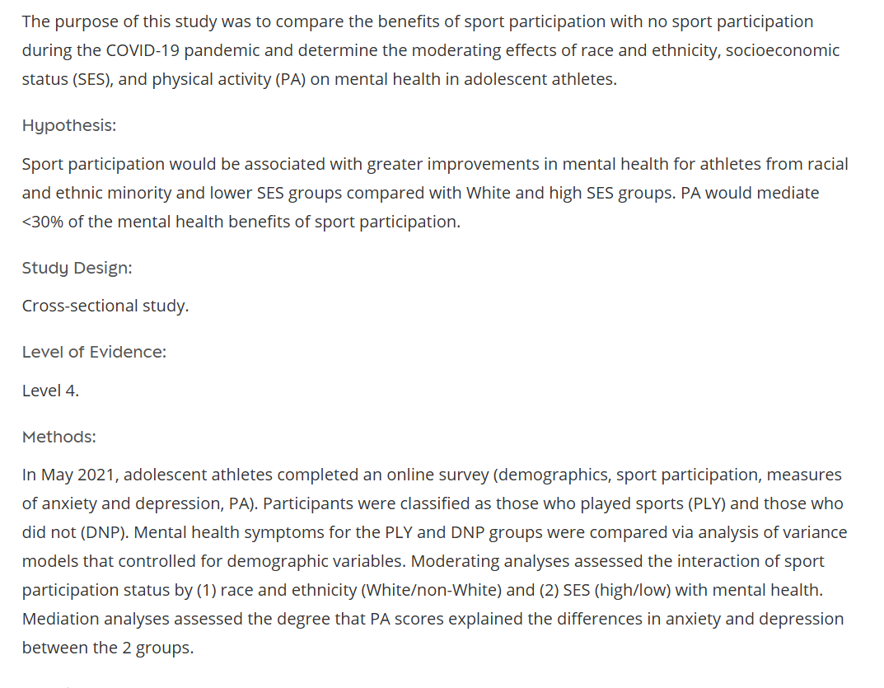
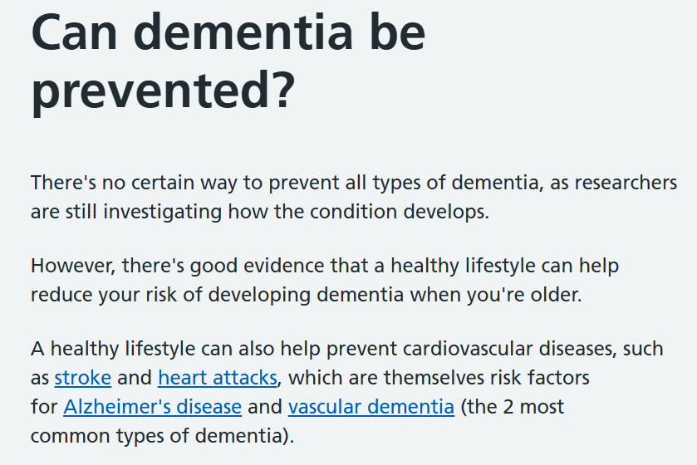
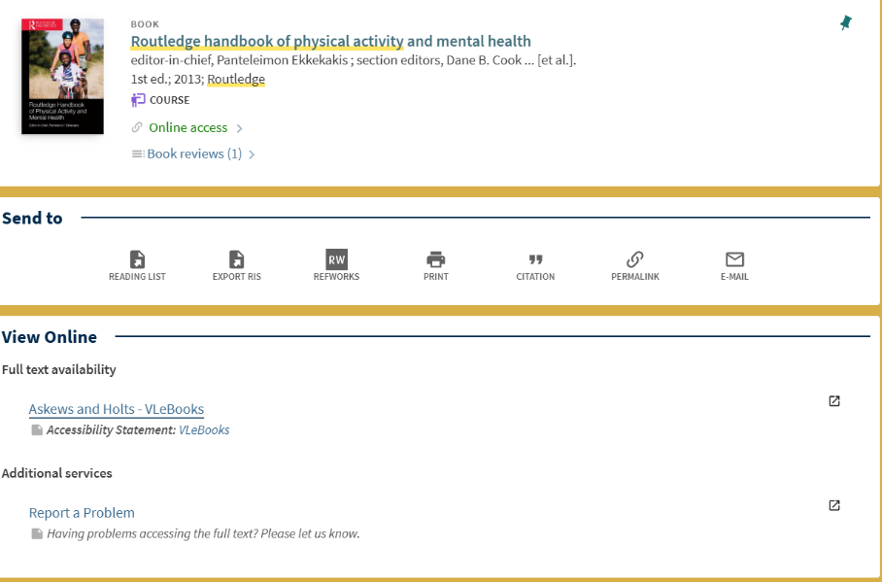

The reason for the selection of Sage journals is, to gather an understanding of the different
racial and ethnicity groups that participate in sporting activities and, how those
activities may impact mental health. Observational studies were conducted leading to
reliable results that indicate this source includes relevant and credible information.
Using the NHS website to search for information is reliable, as that information is gathered
from scientific research. However, such information is limited and research should be carried
out in more depth for a clearer understanding. The NHS website provides a small
amount of information relating to the risks of inactivity and, provides guidelines that
recommend adults participating in physical activity for at least 150 hours per week. This
information has much relevance to the topic under discussion.
E-books are a good way of conducting research as they are reliable and accessible. The
Routledge handbook of physical activity and mental health provides a significant
amount of information on how physical activity improves symptoms of mental health,
however, information has also been provided relating to how mental health contributes
to physical inactivity which gives an understanding of both these aspects. All information is
relevant to the topic of discussion and that is why this resource has been selected. Due to
there being far more accessible, and relevant, information online and, in this assignment there have been fewer
library sources used.

`

Summary

‘The bear necessities of stress.’

‘The bear necessities of stress’. An article by Professor Mark Wetherell, taken from his
inaugural lecture, Northumbria University: 2022. It examines the response of the human
body to stress, acute-or rapid, and longer term. He considers the steroid hormone
cortisol in detail. Cortisol affects several aspects of the body, and helps regulate the
body’s response to stress. The author explains two forms of response, the quick release
of adrenaline when the brain recognises a source of stress, he calls it a ‘stressor’; and
the slower release of cortisol after 20-30 minutes of stress.
The article continues discussing what happens shortly after the immediate stress
response, and, longer term. The author uses the well-known term ‘fight, flight or freeze’
for the initial reaction, then describes a number of techniques used to research
people’s stress in a laboratory situation. From undertaking mentally complex tasks- to
noise, or other stimuli such as ‘pain induction’!

A significant number of potential experiences are linked to the mechanism of stress,
and he outlines several of those he has been involved in during his long term research.
Of these, a number are mentioned in greater detail and one, ‘multi-tasking’ using a
computer is at the heart of his research- he suggests that people dislike multitasking,
and that there are significant bodily changes, ie cortisol, to deal with it. He gives
examples.

Other areas of research include the effects of multitasking; levels of cortisol on
cannabis users, and on those ‘jumping out of aeroplanes.’ He suggests cortisol can
adjust itself if the body knows that during the day, stress will take place. The article
closes with a discussion on the matter of ‘chronic stress’ among adults who care for
autistic children, and forms of support which may help to reduce stress.
His work on the mechanisms of stress is clearly wide-ranging and he recognises the
existence of stress across daily life, suggesting that what humans need to do is achieve
a ‘necessary balance’ in life.

Essay outline.

Discuss and describe the psychological, social and physical benefits of participating in sport.

Introduction
The introduction provides a short explanation of what is to follow, and the
reason why the questions of psychological, social and physical advantages
of sport are to be examined. The essay will concentrate on the value of
sport as a range of activities for younger people for the most part under 25.
Some studies suggest that such activities are less frequently undertaken by
those who have married, have families or undertake complex work
activities, for reasons of time and money (Ekkekakis & Cook, 2013). There is
much recent research on the effects of the Covid-19 Pandemic on sporting
activity, on the individual, and on society as a whole, which supports the
positive review. The benefits of the three areas examined in terms of
gender, race, ethnicity, as well as disability and social disadvantage are
also now regarded as important in terms of inclusion and completeness (Biese et al., 2024).

Psychological
At a time when mental health issues among young people and the not so
young people are recorded by the National institution of health as on the
rise, several studies have shown a positive link between playing a sport and
improved mental health, reduced stress and anxiety symptoms. It is
suggested that this improves self-image, and lowers depression (NIH, 2022)

Social
And emotional benefits of course. Participating in almost any sport can
develop social and personal skills, communication, teamwork, encourage
engaging with those from different cultures, faiths or backgrounds, and
build emotional strength. The psychological improvement of mental health
is to be found here as well, it may even enable the participant to manage
time and make decisions more efficiently and speedily (Eime et al., 2013).

Physical
“Physical wellbeing” would appear to be the bedrock reason for anyone
participating in sport, and this has been accepted for decades- the
recognition of sport to aid development from childhood to adolescence
and into adult life. There are many offshoots, energy, weight and calorie
consumption control, circulation and respiratory efficiency. Exercise is also
recognised in terms of ‘brain power’ and may even, in later life, have
benefits in preventing dementia (NHS, 2023).

Conclusion
While the physical benefits of sport have long been agreed, recognising the
social benefits came later, as part of wider integration of society. The
psychological value of sport and what it can bring to any individual is still
the subject of a huge field of active research.
The importance of the three sub headings to participants can be seen by
the recent development of professions, Sports Psychologist and Sports
Sociologist alongside the physical trainer. There is a vast amount of published research
and of developmental texts and assessments across this huge field of human activity.
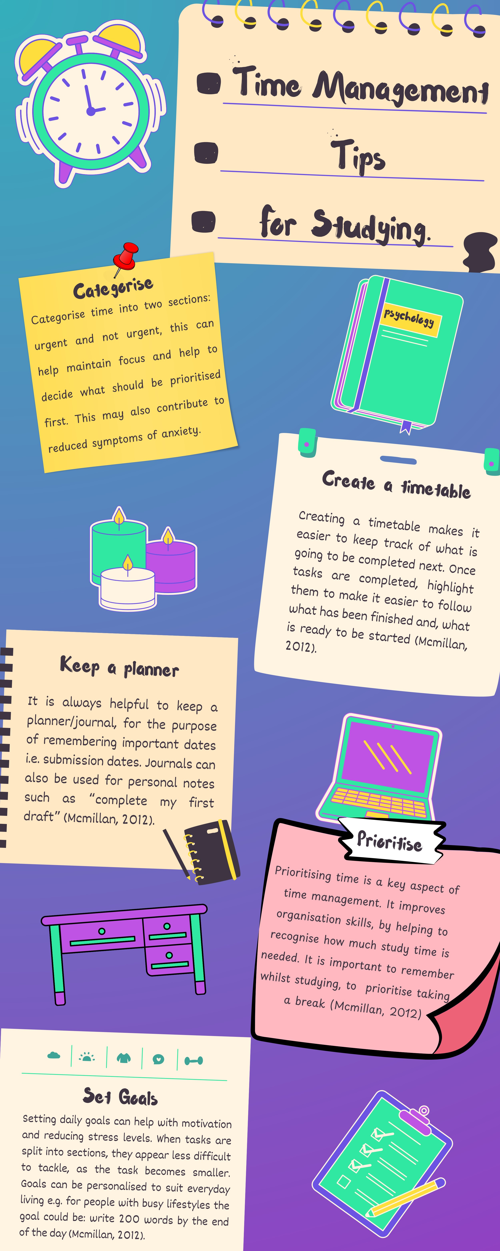
Reference list:
Ashdown-Franks, G., Firth, J., Carney, R., Carvalho, AF., Hallgren, M., Koyanagi, A., Rosenbaum, S., Schuch, FB., Smith, L., Solmi, M., Vancampfort, D., Stubbs, B. (2022). Exercise as Medicine for Mental and Substance Use Disorders: A Meta-review of the Benefits for Neuropsychiatric and Cognitive Outcomes. Sports Med, 50(1),151-170. doi: 10.1007/s40279-019-01187-6.
Biese, K.M., McGuine, T. A., Haraldsdottir, K., Reardon, C., Watson, A. M. The Influence of Race, Socioeconomic Status, and Physical Activity on the Mental Health Benefits of Sport Participation During COVID-19. Sports Health, 16(2), 195-203. doi:10.1177/19417381231223494
Eime, R., Young, J., Harvey, J., Payne, W. (2013). Psychological and social benefits of sport participation: The development of health through sport conceptual model. Journal of Science and Medicine in Sport, 16, e79–e80. https://doi.org/10.1016/j.jsams.2013.10.190
Ekkekakis, P., Cook, D. B. (2013). Routledge handbook of physical activity and mental health (1st ed.). Routledge. https://doi.org/10.4324/9780203132678
Mcmillan, K. (2012). The study skills book (3rd ed.). Pearson Education
NHS. (2023, July 31). Can dementia be prevented?. Can dementia be prevented - NHS.
Wetherell, M. (2022). The bear necessities of stress. Psychologist, 35(10), 42-45. https://www.bps.org.uk/psychologist/bear-necessities-stress

