

Student Name: Evaristo Freite De Melo.
Student ID: 2129710.
Programme: Certificate in Higher Education Skills for The Workplace.
Module: Professional and Career development.
Module code: BMSW4005
Lecturer Name: Olubukola Adegbite.
Assignment Title: Reflective Portfolio.

Table contents
- My career
- Identify the skills and knowledge.
- Use analytical tools (PDP).
- Skills Evaluation.
- Gibbs reflective cycle.
- Reflection on various concepts and topics.
- References

My Career

Forklift driver and Chef.
I would like to work as a chef or forklift driver. Even though I have already worked in a variety of different professions, these two are the ones that I enjoy the most both as a career and as a profession.

Forklift driver
Skills
- Good spatial awareness.
- Attention to detail.
- Ability to work well with others.
- Ability to operate and control equipment.
- Understanding of health and safety.
Good spatial awareness.
A person with high spatial awareness can readily and accurately perceive their physical position in relation to other people, their surroundings, and the items or persons in it. They can also understand other people's places in relation to one another.
Attention to detail.
Focusing on every aspect of a job or work, no matter how tiny, shows attention to detail. Individuals with exceptional attention to detail carefully examine their work. The job is hence more accurate and error-free overall.
Ability to work well with others.
Is the capacity to work well with others to accomplish tasks and reach common objectives. It involves effective communication, cooperation, and conflict management. It entails being aware of and operating within the culture, standards, and values of a group or organisation.
Ability to operate and control the equipment.
The duties of a forklift operator include seeing potential dangers like loose loads, distributing the weight of a forklift load as evenly as possible, and being aware of the forklift's maximum load weight, and have the ability and training to efficiently handle the equipment.
Understanding of health and safety.
Recognize that it is our responsibility to safeguard the operator's and others' health, safety, and well-being to the best of our ability and to keep everyone else, including employees, safe.

Chef

- Kitchen skills. ( A chef needs to run a smooth-operating kitchen).
- Food preparation skills.
- Business skills.
- Knowledge of nutrition.
- Attention to detail.
- Creativity.
- A high level of discipline.
- Strong leadership and management skills.

PDP

Objectives | Time | Activities | Success Criteria | Resources
Short -Term | On two years’ time  On Three years times | Be a good Forklift operator, understand well how work works within the warehouses, have knowledge in the use of scanners, know well the system used to do the work.  Going to university to study business management, in order to have academic and technological knowledge and training.  Obtain full qualification and graduate in Business Management | Become a certified forklift operator trainer, become an instructor on how to use the scanner, the system used to work in the warehouse.  Open my own training company for Machine and Equipment Operator, used system in warehouses.  Also bet on the culinary area, because it is an area that I manage well, because I have some years of experience as a chef. | Internet  Computer  Internet  Computer
Long-Term | On three- or four-years times | Be able to unite the two businesses and expand it in numerous cities across several countries. Being able to open 5 or 6 restaurants and 2 training centres for operators of machines, equipment.  and systems | Manage my own business | Internet  Computer  Restaurant

I am a qualified forklift operator with over a decade of experience, I have worked in several warehouses, and performed this function working with different materials, some more fragile, and other more dangerous, some hard to handle and others easier to handle. As a forklift operator, I also have experience in picking, loading, put away, using scanners and using the system to place and remove products from stock in the warehouse, and all this knowledge will potentially help me in this career.
As a chef, I have also worked in both the land restaurant and the restaurant on a fishing boat. It was on the boat that I have gained more experience in terms of managing food. Because poor food management can be crucial to the voyage, as food supplies were determined for exactly the number of days we would be at sea before returning to land.
I like challenges, I like learning new things, I like going beyond the limits when it comes to learning. I also like to pass on testimonies of what I learn, that's why learning is something that gives me strength and I also enjoy teaching, as it is also satisfying to share my knowledge with others.
However, like most people I do have some fears, especially when it requires working with a lot of people as I am afraid of making mistakes, and when working in a big group I always end up making mistakes and I perceived this as my weakness, maybe I get distracted by others and lose my concentration. Something I need to work on.
What motivates me to pursue this career is my passion to cook, the idea of mixing different ingredients together and come up with a brilliant dish, I love this, and I am very confident doing so. And this being something I know how to do and feel comfortable, my motivation reaches higher levels as I do it out of passion and desire, and my goal is to create my own business and continue this career path.

Gibbs’ Reflective Cycle is one of the most well-known cycles of reflection guides you through six phases of experience exploration: description, feelings, assessment, analysis, conclusion, and action plan.
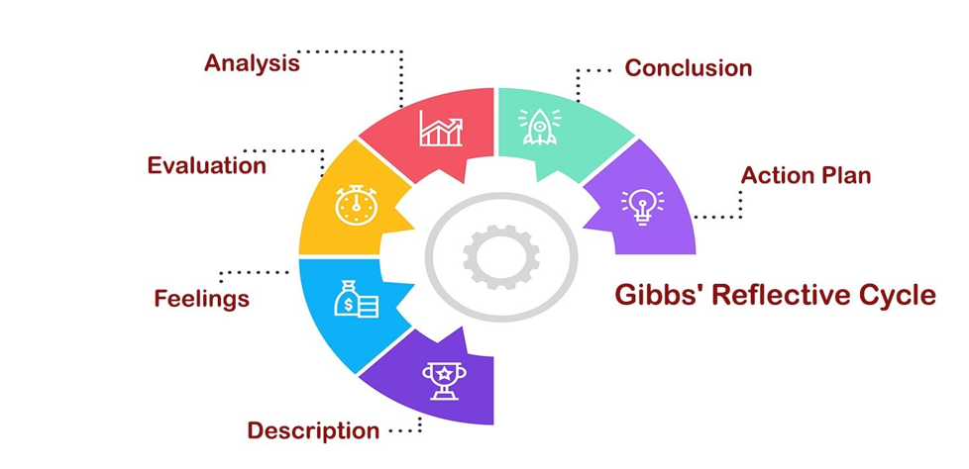

The first part of the description is where I briefly outline the events that took place in the classroom, what we did, and what was spoken about the Module.
In the second stage of Gibbs' reflective model, I assessed my own capabilities and tried to determine what I might learn from this module, what I would gain from it, and how it would affect me.
In the third step, the module's positive and negative aspects are evaluated, along with how the themes and questions affected me personally as I learned them and how well the material would benefit a student's overall wellbeing.
In the fourth stage, students will comprehend how the themes that were discussed in class are reflected in themselves, determine whether a more thorough investigation of the themes is required, and learn how to handle these themes as students.
In the fifth step, I analyse all topics that were taught during the module, reaching the conclusion of how these topics contributed to my development as a student over time and how it is catalysed so that I can acquire more knowledge as a student.

In the 6st step, using what I learned in this module will help me advance and achieve my goals by allowing me to use all the topics I learned to handle the information as much as possible in my professional job and daily life.

Career Development:
I discovered that career development refers to the assistance a company provides for a worker's professional advancement, particularly when the worker moves to a new role or project within the company. This assistance typically consists of networking, career planning, skill development, training, and mentoring.
This topic taught me what self-awareness is, how to achieve my goals, and what I need to do so. With the Swot personal analysis, I also learnt how to assess my own performance (Strengths, Weaknesses, Opportunities and Threats)
Employment Legislation:
Employment law: In this area, I delved deeper into the duties and responsibilities of each party, the interaction between employers and employees, as well as the rights of workers and some laws that protect them. that are:
- Recruitment, working hours, contracts, employment status (full or part time/flexible)
- Pay and entitlement for: holidays, sickness, maternity/paternity/adoption.
- Redundancy and retirement. Recruitment, working hours, contracts, employment status (full or part time/flexible)
- Pay and entitlement for: holidays, sickness, maternity/paternity/adoption.
- Redundancy and retirement.
I recognize that all laws in the Legislation are important, but I want to mention one that for me is the most fundamental, which is The Equality act 2010, because I think it is the basis for protecting ethnic diversity, sexual orientation, people with disabilities, and more cases of discrimination in the workplace, because this is one of the biggest causes for a worker to feel dissatisfied.

Recruitment: People are legally protected from discrimination in the workplace and in larger society by the Equality Act of 2010.
It strengthened protection in particular circumstances and made the legislation more easily understandable by consolidating earlier anti-discrimination statutes into a single Act. It outlines the various ways that treating someone is prohibited.

Mock interview experience:
I participated in many job interviews during my professional career. After that classroom test, I realized why I failed so many of them, and after the feedback I got from my teacher, I'm sure what I missed in the past to succeed in an interview. I feel more confident in points that were crucial for me at another time. I was also able to create a much more concise and stronger resume.
Note: I became unemployed a week after taking the mock interview experience test, so I sent the CV I made in this module topic, and sent it to some companies, in less than three days I received several calls and several interviews were scheduled, some I couldn't even go, but I'm already employed again.
Conclusion: I learned a lot from this topic.
Open-book assessment:
How can a company attract and retain employees over the next decade and what a management is serious about keeping skilled and committed employees, it needs to concentrate on guaranteeing employee satisfaction. Find out why employees leave their jobs so you can put an end to it. This study aims to highlight the significance of employee retention in contemporary workplaces as well as the potential repercussions for the company and the industry if executives fail to recognise the problem and act quickly. Keep in mind that collecting data and creating reports won't suffice to address the issue of employee retention. It simply depends on how knowledgeable the employers are about the many concerns held by their staff members, and how well they support them in identifying solutions when necessary. To prepare new hires for the corporate world, every company spends time and money on their training. After getting all required training, these employees could leave the company, which would be a complete loss for the business.

So, the business must consider certain factors, such as:
- Treating someone with respect is giving them special consideration, appreciation, or respect. As the pyramid shows, respect is the cornerstone of maintaining your employees. Awards and recognition won't mean anything if you don't value your employees.
- The act of clearly perceiving" and "special concern or attention" are two definitions for recognition. Retention and morale problems frequently occur as a result of management ignoring the needs and reactions of employees.

- Rewards are the additional advantages you provide people in addition to the essentials of respect and recognition in order to encourage them to work hard, care, and go above and beyond the call of duty. Although rewards only make up a small portion of the retention equation, they are nevertheless quite important.

The following fundamental guidelines should be considered while developing staff retention strategies:
- Make sure you first hire the correct personnel.
- Give workers more autonomy. Give the staff the power to complete tasks.
- Help workers understand that they are the company's most important asset.
- Have confidence, respect, and trust in them.
- Share knowledge and information with them.
- Continue to comment on their performance.
- Acknowledge and value their accomplishments.
- Maintain a positive attitude.
- Foster an atmosphere where workers want to work and have fun.

Conclusion:
Make work enjoyable for people because they want to like what they do. Provide employees with flexible start times and core hours because you understand that they need to balance their personal and professional lives. To encourage open communication, provide surveys and 360-degree feedback tools. Occasionally allowing employees to participate anonymously to surveys may inspire them to be franker and more honest in their responses. Provide for internal career advancement and cross-training opportunities. Provide forceful, enticing benefits.
References

Betz, M. (2022) What is self-awareness, and why is it important? What Is Self-Awareness, and Why Is It Important? Available at: https://www.betterup.com/blog/what-is-self-awareness (Accessed: March 16, 2023).
Davis, P.J. (2015) Implementing an employee career-development strategy: How to build commitment and retain employees, Human Resource Management International Digest. Emerald Group Publishing Limited. Available at: https://www.emerald.com/insight/content/doi/10.1108/HRMID-05-2015-0066/full/html (Accessed: March 16, 2023).
Gibbs, G. (2023) Reflective practice, Wikipedia. Wikimedia Foundation. Available at: https://en.wikipedia.org/wiki/Reflective_practice (Accessed: March 15, 2023).
University of Cumbria, U. Of C. (2020) Gibbs’ reflective cycle - University of Cumbria, https://my.cumbria.ac.uk/media/MyCumbria/Documents/ReflectiveCycleGibbs.pdf. Available at: https://my.cumbria.ac.uk/media/MyCumbria/Documents/ReflectiveCycleGibbs.pdf (Accessed: March 16, 2023).

