Niral Popatbhai Ranavaya
Enrollment Number: 2530032
To: DR. TOLA ODUGBSESAN

University Name: University of Wales Trinity Saint David
Module: Marketing Management
Module code: LCMB7024

Assessment component 1: - Marketing Environmental Analysis

Table of Contents
Introduction 3
Task 1 3
1.1 Pioneer & Follower Context 3
1.2 External Macro-Marketing Factor 1: Technological Environment 3
1.3 External Macro-Marketing Factor 2: Socio-Cultural Environment Changes 7
Task 2 10
2.1 Strategic Response Overview for Both Companies 10
2.2 Porter’s Generic Strategic Analysis 11
2.4 Comparative Advantage Based Strategic Evaluation 14
Conclusion 15
References 16

Introduction
The marketing management assignment has been developed for analysing the marketing environment for a pioneer organisation and its follower. In this regard, Netflix is the pioneer brand and Disney+ has been the follower here. The entire task 1 represents the socio-cultural and technological progression regarding transformation for competitive landscape in streaming industry. Netflix has benefited due to global content diversity and use of Advanced AI systems. However, the Disney+ has established market and brand heritage, with challenges of audience diversification, personalisation depth demands and speed of innovation. The task 2 represents the extensive use of strategic path where the Netflix maintain the Global perspective with differentiation by analytics and innovation regarding the diversified growth and global expansion. In this context, Disney+ implements a follower approach regarding franchise best content with cost efficiency and bundling offers for create a competitive value.

Task 1

1.1 Pioneer & Follower Context
The current Global streaming industry which focuses on adaption and early adoption and first innovation that shaped the current state of companies "Netflix and Disney+". In this, Netflix is the industry pioneer transforming through technology and digital entertainment by early integration of a "Subscription-based model" with high investment-based data-leading personalization. This involves use of algorithms to drive the audience engagement and viewing activity around 70%. Contradictory, Disney+ presents the active "follower strategy" by entering in 2019 and have benefits of already existed brand equity and intellectual property ecosystem. This involves the brand positioning, content differentiation and strategic adaptation as a follower in an established market.

1.2 External Macro-Marketing Factor 1: Technological Environment
Critical Analysis focused on Factor on Industry
The current technological environment and tools are dominant for activities shaping the Global streaming industry by inclusion of the Data Analytics, cloud infrastructure and integration of AI based personalization (Suntsova, 2025). The difference streaming platforms are constantly growing dependency on the algorithmic system where around 80% of the consumption of content or impacted by the recommendation system and actively streaming traffic accounting by the share of the different internet band switch use. Industry constantly witnessing the Rapid changes and investment in CDNs (content delivery networks) and cloud computing for ensure low latency and Global access. The use of viewer analytics and AI based content optimisation of different digital platforms are helps to reduce the Churn and predict demands (Netflix, 2025). Technology-focused market where organisations compete for both high quality content and user experiences.
Impacts on Netflix & Disney+ (Opportunity & threat)
The analysis of Technological Impacts is like these:
Factor | Netflix | Opportunity/Threat | Disney+ | Opportunity/Threat
AI Recommendation Systems | Highly influencing majority of viewing; | Opportunity: High retention | Basic to moderate recommendation systems | Threat: weaker personalisation
Data Analytics Capability | Extensive user data utilisation for predictive targeting and recommendation system (Netflix, 2026) | Threat: privacy/regulation risks | Growing data use; relies more on content strength than analytics depth | Threat: limited insights
Cloud & CDN Infrastructure | AWS-based systems enabling scalability (Chia, 2025) | Opportunity: global reach | AWS systems scalable but less optimized | Threat: dependency risk
R&D Investment | High technology and platform investment costs annually | Threat: financial pressure & R&D Costs | Less R&D burden due to late entry advantage (BBC, 2024) | Opportunity: cost efficiency;
Innovation Speed | First mover in adopting streaming innovations and formats | Opportunity: market leadership | Reactive adoption of existing technologies | Threat: delayed response
Table 1: The analysis of Technological Impacts
The above table represents the advancement of the technological integration which presents asymmetric result where Netflix achieved scale ability of infrastructure, high data utilisation and AI sophistication (Netflix, 2026). Contradictory, Disney+ have benefits of cost efficiency and multilingual impact but faces limitation of the innovation speed and gaps in personalization which reinforce the uncertain competitive positioning in the streaming industry.
Comparative Evaluation
In high level of Technology enforcement of Netflix differentiation advantage and lead by the super infrastructure capabilities, at once AI systems and extensive data analysis to improve the Global capability and user engagement around 320 million subscribers with around over 80% of view impact for recommendation systems (Curry, 2025).
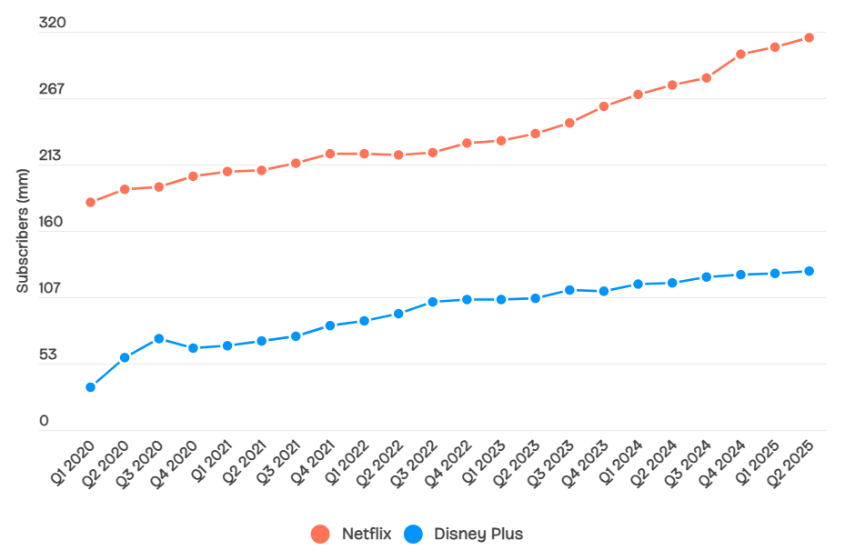
Figure 1: Comparing Subscribers Rate Fluctuations of Netflix & Disney+
(Source: Curry, 2025)
Netflix have the market position as the technology-based market leader with limitations of Technology expenditure and annual content cost exceed beyond $15 billion which replace the strong pressure of Sustainable innovation.
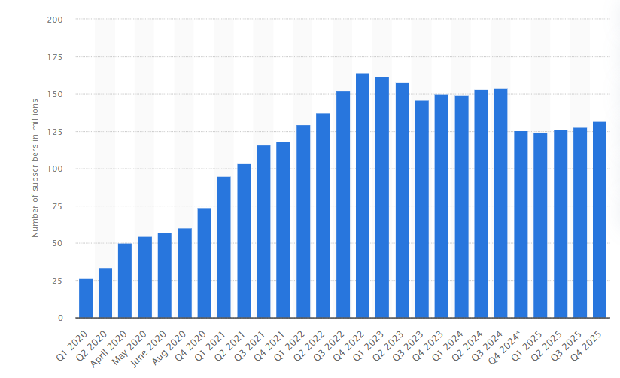
Figure 2: Disney+ Subscribers rate by 2025
(Source: Statista, 2025)
Contradictory, Disney+ have around 130 million subscribers worldwide which includes follower approach and Laboratories the established Technologies and cloud infrastructure minimum cost (Statista, 2025). Moreover, these also have significant challenges of personalization efficiency with pricing issues due to which in 2025 subscription rate constantly declined.
Connection with Competitive Position
The technology environment improves the market leadership of Netflix by use of Data Analytics, scalability and AI for constant sustainable differentiation. On the other hand, Disney+ still on follower position and depends on the first efficient but active technological adoption that create barriers for ability to gain the comparable competitive dominance and personalization depth in the streaming market for the audiences.

1.3 External Macro-Marketing Factor 2: Socio-Cultural Environment Changes
Critical Analysis focused on Factor on Industry
Socio-Cultural environment is constantly ratio the streaming industry buy used of changes adoption as digital lifestyles, consumers behaviours and content preferences. In worldwide market the adoption is in rapid fire where the around 1.8 billion subscriptions for the video on demand users changes towards the "Binge watching, mobile first and on demand" watching patterns. The audience are constantly demanding the locally relevant, diverse, and personalized content which can replies the globalisation Trends with involvement of cultural heterogeneity (De, Isabel and Selma Maria Silva, 2024). The constant growth of cutting behaviours is focused on demographics which reveals the structural issues related to traditional televisions, and constant growing dependency on the digital platform. In addition, the social media-based trends such as family-based consumption models growing and multi device using are impact the pricing Strategies and platform design. The active social cultural dynamics are the most critical driver for difficult streaming organisations which constantly adopt the different content strategies to improve the Market Positioning and use of engagement models for sustainable relevance with growing fragmented Global audience models.
Impacts on Netflix & Disney+ (Opportunity & threat)
The socio-cultural changes are constantly reshaping the users’ preferences, competitive positioning and engagement behaviours in digital platforms as Netflix and Disney+ worldwide (Wang et al., 2022). The changes and its impacts are both as follows:
Factor | Netflix | Opportunity/Threat | Disney+ | Opportunity/Threat
Binge-watching Culture | Strong catalogue supporting continuous viewing | Opportunity: high engagement | Franchise-based content | Threat: lower retention
Global Content Demand | Diverse international originals such as multi-language content (PwC, 2025) | Opportunity: global reach | Relies on established franchises | Threat: limited diversity
Changing Viewing Habits | Mobile-first and flexible consumption model | Opportunity: accessibility | Adapting to digital shift | Opportunity: growing adoption
Brand Loyalty Trends | Moderate brand loyalty | Threat: high switching behaviour | Strong legacy brands as Marvel, Disney owned (PwC, 2025) | Opportunity: loyal audience
Subscription Fatigue | Multiple pricing tiers introduced | Threat: churn risk | Bundle strategy of Disney (BBC, 2024) | Opportunity: value perception
Table 2: Impacts on Netflix & Disney+
The table illustrates the impacts of socio-cultural elements changes which creates both opportunities and significant threats for each company separately regarding the competitive positioning reshaping in streaming industry. In this context, Netflix have advantage of global appeal and content to Diversity on own with dominating market. Meanwhile Disney+ have the leverages of already established market and brand loyalty, along with niche dominance, however also have competition and difficulties of diverse audience segments.
Comparative Evaluation
The current social cultural environment constantly changing which replies the creation of the different strategic advantages for the Disney Plus and Netflix. Currently Netflix have capitalised Global audience demand and content diversity which enables the sustainable engagement and market among the regions. The dependency on the Limited content segments limits the broader appeal for Disney where the socio culture factors are helps Netflix to each Global mass market Disney Steel focused on the Limited market with competitive space.
Connection with Competitive Position
The socio culture changes impact the comparative positioning of Disney Plus and Netflix which shape the engagement patterns and customers preferences. The Netflix improve the position by flexible consumption models and global content adoption to attract to different age and diverse audiences with management of the brand market presence. Strategically, these various environmental changes precisely create a ‘pioneer-follower’ dynamic rapidly. Through comprehensive Netflix data-driven personalisation and advanced technological expertise. Disney+, on the other hand, is attracting certain high-value family segments from all over the world. It can be said that its vast IP library and family-centric heritage are particularly quickly exploited in this. It can also be seen as a more sophisticated challenge to Netflix's dominance.

Task 2

2.1 Strategic Response Overview for Both Companies
Netflix
The strategic activity of Netflix shows an innovative activity that focuses on technological growth. These organisations have maintained technological growth and cultural transition. Netflix applies an innovation-based approach that is dependent on technological growth which ensures its differentiation activity. This allows Netflix to provide suggestion gives individualised contents and ensures viewers retention in this platform (Neglur and PS, 2024). Moreover, Netflix supported also regional contents based on the viewers choices. Netflix also performs cost-based innovation and flexibility that helps it is acting against high competition. For example, Netflix creates Money Heist and Sacred Games that are motivated from regional contents which supports it is align with growth in global market and cultural market.
Disney+
This organisation maintains strategic response by using IP rights for attractive contents compared to technology growth. For example, popular shows like Marvel as well as Pixar are able to gain attention of viewers and increases subscription. The content-based activity supports Disney+ in creating difference through various engaging franchise motivated contents compared to innovation. Moreover, Disney+ has applied partnership activity which included its service Hulu and ESPN+ (Shields and Bratches, 2024).
Strategic Area | Netflix (Pioneer) | Disney+ (Follower)
Innovation | AI-based personalisation | Low, reactive application
Content Strategy | Original and international content | Franchise contents (Marvel, Disney)
Pricing | Tiered, ad-based models | Bundling strategies
Market Expansion | Aggressive global growth | slow international growth
Technology Use | Updated analytics & algorithms | Standard infrastructure
Customer Engagement | Data-based retention | Brand loyalty-driven
Cost Structure | High R&D and content price | Cost based approach
Table 3: Strategic analysis on Netflix and Disney+

2.2 Porter’s Generic Strategic Analysis
The activity of both Netflix and Disney+ have presented their difference in this streaming sector. Netflix mainly applies differentiation activity that highlights giving individualised experience to the viewers. It focuses on innovative data analytics techniques that can suggest viewers relevant contents. Moreover, Netflix has made significant amount of investment on AI, and data analytics as well that can increase viewers individualisation and engagement as well. The report shown that Netflix made high amount of investment that supports technology growth and AI based suggestion system (Butts, 2025).
Disney+ uses differentiation approach as this model suggests depending on its activity. It does not focus on technological innovation or growth, but it is consists of contents like Disney, Marvel, and Pixar. This develops brand position in this highly competitive market sector. Moreover, family and franchise enthusiastic viewers are also possible to target. Moreover, Disney+ also maintains cost leadership model especially by maintaining competitive costing model as well.
2.3 Evaluation by Application of Ansoff Growth Matrix
Netflix
1. Market Penetration
Netflix secures its market position through its innovation and customer communication or engagement activity. Their ad-based subscription model supports in gaining viewers who are sensitive to cost (Jati, Serenade and Umar, 2024). This also secures organisation competitive advantage.
2. Product Development
Netflix makes investment in regional entertainment contents to ensure their alignment with customer demands. Their strategy is evident from contents like Money Heist and Sacred Games that focuses on localised contents. This activity increases viewers retention along with maintaining difference from the competitor organisation.
3. Market Development
Netflix has been successful in performing in both developed and emerging market (Goncharenko et al., 2023). Therefore, they are also improving their activity based on the regional demands such as providing localised cost model and creating mobile based approach.
4. Diversification
Netflix also maintains its business in gaming platform that has expanded its profit and brand reputation (Zhang, 2024). However, this model is not fully developed but it shows organisation growth potential.
Ansoff Strategy | Application (Netflix) | Example | Evaluation
Market Penetration | Pricing tiers, ads | Ad-supported plan | Reduces churn
Product Development | Original/local content | Money Heist | Drives engagement
Market Development | Global expansion | India entry | Increases subscribers
Diversification | Gaming expansion | Netflix Games | High risk, future growth
Table 4: Application of Ansoff Growth Matrix Netflix
Disney+
1. Market Penetration
Disney+ enhanced its market growth by using competitive costing model that provides discounts on subscription and other activity as well (Baieva, 2024). This is able to increase a large number of viewers.
2. Product Development
The main strategy of Disney+ is based on IP rights as they have The Mandalorian and Loki like contents. It decreases the investment risk and follows a low-cost model.
3. Market Development
Disney+ has increased its business in global platform. However, compared with Netflix the market expansion is slower.
4. Limited Diversification
Disney+ does not have enough different products in their business model and mostly depends on past contents.
Ansoff Strategy | Application (Disney+) | Example | Evaluation
Market Penetration | Bundling, costing strategy | Disney+ bundle (Hulu, ESPN+) | rise in value perception
Product Development | Franchise motivated content expansion | The Mandalorian | Ensures loyal viewership
Market Development | International rollout | Growth in Europe and Asia | Moderate growth
Diversification | Limited diversification | Core streaming focus | Low risk, and innovation
Table 5: Application of Ansoff Growth Matrix Disney+
Disney+ activity on using old contents decreases its threat and makes it cost saving as well. Though its dependence on franchise decreases its innovation potential and viewers growth.

2.4 Comparative Advantage Based Strategic Evaluation
From an advanced strategic assessment, it is observed that Netflix, through technological advancement, particularly maintains a comparative advantage rapidly. It precisely prioritises fast-paced data analytics and various AI-powered personalisation. Additionally, in retaining the entire Netflix customer base accurately, it swiftly achieves such an indomitable capability that it becomes difficult for all its competitors to replicate precisely (SS, 2025). While rapidly expanding globally, it maintains the right balance among various ultra-local content such as ‘Money Heist.’ Additionally, different capabilities have been observed to create a quick advantage, particularly in ‘product development.’ Moreover, it quickly reduces various risks of losing all customers in a highly complete overall market. On the other hand, Disney+ has particularly maintained certain comparative advantages swiftly based on its intellectual property dominance (Curry, 2025). It has also been observed to provide numerous opportunities specifically for Disney+ to effectively adopt advanced strategies for low-risk 'follower' growth.

Conclusion
In conclusion of task 1, the various external environment forces are beneficial to reinforce the technology-based Netflix leadership in comparison of the Disney plus in competitive reactive market. The both organisations experience significant challenges and opportunities. However, Netflix has strong capabilities with sustainable competitive advantage more than Disney+ for growth in dynamic global streaming conditions. Finally in conclusion of task 2, the different strategic choices are deepen the relationship of pioneer-follower. In this context to Netflix current innovative differentiation offers the long term growth while the Disney Plus has opportunities for franchise strength with limitation of technology sophistication.

References
BBC (2024) Disney and Warner bundle streaming services to rival Netflix, www.bbc.com. Available at: https://www.bbc.com/news/articles/c51nz9d2w3ro (Accessed: 21 March 2026).
Chia, O. (2025) ‘Netflix uses AI effects for first time to cut costs’, BBC, 18 July. Available at: https://www.bbc.com/news/articles/c9vr4rymlw9o (Accessed: 21 March 2026).
Curry, D. (2025) Netflix Revenue and Usage Statistics (2025), Business of Apps. Business of Apps. Available at: https://www.businessofapps.com/data/netflix-statistics/ (Accessed: 21 March 2026).
De, A., Isabel, A. and Selma Maria Silva (2024) ‘Streaming services consumer behaviour: a Netflix user case study in Brazil and Portugal’, Marketing i menedžment innovacij, 13 (3), pp. 20–31. Available at: https://doi.org/10.48099/1982-2537/2023v17n3p2031.
Netflix (2025) UNITED STATES SECURITIES AND EXCHANGE COMMISSION . Available at: https://s22.q4cdn.com/959853165/files/doc_financials/2025/ar/99482238-46b2-4d0d-b292-40e6781bdf03.pdf (Accessed: 21 March 2026).
Netflix (2026) How Netflix’s Recommendations System Works, Netflix Help Center. Available at: https://help.netflix.com/en/node/100639 (Accessed: 21 March 2026).
PwC (2025) India’s E&M growth rides its youth wave Global Entertainment & Media Outlook 2025-29: India perspective. Available at: https://www.pwc.in/assets/pdfs/industries/entertainment-and-media/global-entertainment-and-media-outlook-2025-29-india-perspective.pdf (Accessed: 21 March 2026).
Statista (2025) Number of Disney Plus subscribers worldwide from 1st quarter 2020 to 4th quarter 2025, Statista. Available at: https://www.statista.com/statistics/1095372/disney-plus-number-of-subscribers-us/?srsltid=AfmBOoo2Of9kA33iWxqYGDZ7ZCRuv3aj7CTClaX-S2ypRr2qh663GFhE (Accessed: 21 March 2026).
Suntsova, O. (2025) ‘THE IMPACT OF “FIRST-MOVER ADVANTAGE” ON GLOBAL MARKET STRUCTURE AND DYNAMICS’, SSRN Electronic Journal [Preprint]. Available at: https://doi.org/10.2139/ssrn.5125609.
Wang, Y., Lu, Z., Cao, P., Chu, J., Wang, H. and Wattenhofer, R. (2022) ‘How Live Streaming Changes Shopping Decisions in E-commerce: A Study of Live Streaming Commerce’, Computer Supported Cooperative Work (CSCW), 31(4), pp. 701–729. Available at: https://doi.org/10.1007/s10606-022-09439-2.
Baieva, A. (2024). Strategic management of marketing activities at the enterprise. [online] Sumdu.edu.ua. Available at: https://essuir.sumdu.edu.ua/items/9088ce08-3fa4-4332-85bf-8dffde91f6a6.
Butts, D. (2025). Netflix ‘all in’ on leveraging AI as the tech creeps into entertainment industry. [online] CNBC. Available at: https://www.cnbc.com/2025/10/22/netflix-all-in-on-leveraging-ai-in-its-streaming-platform.html?msockid=2f6a834e786c6b6020ae96b079de6ad3 [Accessed 21 Mar. 2026].
Goncharenko, M., Zhen, W.Z., Yang, X.Y., Ismail, N.A. and Xu, D.R. (2023). Netflix, the Success of a Global Storytelling. Journal of Business and Social Sciences, [online] 2023. Available at: https://iuojs.intimal.edu.my/index.php/jobss/article/view/432.
Jati, I.M., Serenade, V. and Umar, N. (2024). Netflix’s Global Market Entry and Adaptation Strategies Critical Review. Jurnal Informatika Ekonomi Bisnis, [online] 6(4), pp.932–936. Available at: https://infeb.org/index.php/infeb/article/view/1049.
Neglur, I.S. and PS, R. (2024). Keeping Viewers hooked: Netflix’s Innovative Strategies for Reducing Churn. Journal of Information Technology Teaching Cases. doi:https://doi.org/10.1177/20438869241296895.
Shields, B. and Bratches, S. (2024). ESPN Navigates a New World Order. [online] pp.24–225. Available at: https://mitsloan.mit.edu/sites/default/files/2024-07/ESPN%20Navigates%20a%20New%20World%20Order_0.pdf.
Zhang, J. (2024). Netflix Evolution and Strategy for Future Development. Lecture notes in education psychology and public media, 51(1), pp.36–40. doi:https://doi.org/10.54254/2753-7048/51/20240649.
SS, H., (2025). Deconstructing the Netflix Machine: A Case Study of Netflix's Production-to-Delivery Ecosystem. Available at SSRN 5537379. https://papers.ssrn.com/sol3/papers.cfm?abstract_id=5537379

