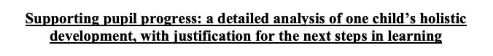
Word count: 4,700

The aim of this essay is to critically analyse data collected from a child during PTE2 to gain an overall holistic view of the child’s learning by using the ASK model, which acknowledges the Child’s attitude, skill and knowledge of learning. The chosen child was selected at the beginning of placement with consent from both parents, child and class teacher (See appendix one and two). The essay will follow a Mosaic Approach, a methodology that listens to young children and brings together verbal and visual tools to reveal the child’s perspective on the learning taking place (Clark and Moss, 2011; Clark and Statham (2005). Thus, meaning data collected will include: observations, a learning walk, map making, drawings, interviews with the child and the class teacher as well as annotated samples of work that have informed the planning and the learning experiences. The main focus will be on the analysis of the child’s Language, Mathematics, Wellbeing, Knowledge and Understanding of the World and Welsh Development and assess the benefits, limitations and any areas of improvement for future development of the child.

The child in question is a five-year old girl and attends the school within a small village in the North West of Swansea. There are currently over 400 pupils on roll from the ages of 3 to 11. The Reception class consists of a two-form entry and Year one through to Year 6 consists of a three-form mixed entry (Reference removed for anonymity). Child A has a reading age of a six years old and is reading stage 5 Oxford reading tree books. She is also working at a high Outcome 4 in Language, Literacy and Communication but is hitting aspects of Outcome 5 (See appendix three). Child A is hitting Outcome 4 for Mathematics, Knowledge and Understanding of the world and Welsh (See appendix four – six, and is reaching Outcome 3 but hitting aspects of Outcome 4 for Personal and Social development (See appendix seven). Miller and Bell (2002) state gaining consent from children can be difficult as it may not be clear what they are consenting to. However, the child was spoken to prior starting the research and it was explained what it would entail. Child A was asked if she would like to take part and was given the opportunity to decline, also ensuring she knew she had the right to withdraw at any time. As previously stated consent was given from child, parents and class teacher. This is something David et al. (2013, p.352) state is of critical importance, by adding consent must be ‘formalised through written consent’. To maintain the confidentiality of the child, her name will not be mentioned and she will be referred to as Child A, which is in accordance with BERA’s guidelines (2018) as well as the Schools Safeguarding Policy. Due to the School’s Policy no photographs or audio-recordings will be included.

Data collected
Greenfield (2011) states that the Mosaic approach is about combining different types of data to gain a better understanding of the child’s perspective and learning. Furthermore, adding that children’s perspectives are understood better if the researcher involved takes part alongside the child. Clark (2007) states that the Mosaic approach follows a constructivist approach to learning where the child is seen as an independent learner and constructs their own learning (Bourne, 2006). Furthermore, stating this approach was developed to empower the voice of children. Wexler (2004) states that it was inspired by the work of Reggio Emilia, which relies heavily on observations, taking notes, photographs and tape recordings of the children. Thus, meaning both the Mosaic approach and the Reggio Emilia approach to education take into consideration pupil voice and the child constructing their own learning. Nottingham (2013) and Halim et al. (2011) state that the ASK model is used to develop the learner and to encourage independent thinking.

The Mosaic approach has a variety of approaches that will be used to collect data, but will combine together the findings to gain a clearer understanding of Child A (Cowie et al. 2014). Following this approach means that observations and interviews will be used which allow for a triangulation of qualitative data to be collected and analysed, as well as a learning walk, map making and drawings being part of the data collected. Bell (2005) states that in order to ensure reliability and validity of data that it needs to be examined critically beforehand. Silverman (2016: 56) adds that ‘qualitative research offers reliability and validity to data analysed’. Dewey (1938: 68) states that observations alone are not enough and that other forms of data must be collected in order to be reliable. Mack et al. (2005) state that it is extremely difficult to observe and record what is going on at the same time. Whereas Wragg (1994) disagrees, adding that written observations allow for detailed analysis and a record of the event. Herr (2015) agrees by stating that observations are the most important methodology to use to be able to gain an understanding of the situation. This methodology of observations was chosen as it is a key element in the Mosaic approach as well as it enabling individuals to gain deeper understandings of situations that take place within the classroom.

Bell (2005) states that a structured interview can be intimidating and has many limitations such as being bias, as the researcher decides the focus and the questions being asked. However, King and Horrocks (2010) argue that an interview gives opportunities to share different opinions and gain the persons perspective and attitude towards the issue. The interview that took place was unformal to ensure that the Child A did not feel intimidated which is something Bell strongly agrees with, instead the interview took place in the reading garden where Child A stated she loves and feels safe. Tienken et al. (2010) believe that there are many factors that influence the types of responses received by the interviewee, one being the environment they are in. This is something that was taken into consideration. Black and William (1998) agree adding that it is essential for a child to feel safe and secure in the learning environment. As well as these approaches underpinning Maslow’s Hierarchy of needs, where in order for children to learn and develop is dependent on the level of low and high order needs that have been met (Doherty and Hughes, 2009). Bates (2016) highlights that in order for children to meet the basic low level of needs they must have a feeling of security in the environment they are in, hence the reason for using a safe and familiar place in the classroom to conduct the interview.

Clark (2007) states that the mosaic approach uses audio-recordings as a method of collecting data, King and Horrocks (2010) state audio-recordings are the preferred method of collecting data when observing due to the reliability and validity. However, audio-recordings and pictures were not possible to use without the consent from the school, but would have been the preferred method of use to collect a variety of data that follows a Mosaic approach. Denise et al. (2014, p.113) states that a learning walk is a ‘mode of inquiry-based learning’ that allows individuals to gain better knowledge and understandings of a certain area. The National Union of Teachers (2011) state a learning walk should allow for the collecting of evidence about the learning that takes place within a school. Furthermore, adding they should be used to develop and construct appose to being judged. The Primary National strategy (2007) state that a learning walk is only beneficial if the learner has time to reflect on the observations taking place during the walk. This was taken into consideration whilst on the learning walk as Child A drew her favourite areas to learn (Appendix eight and appendix twenty-three). She was able to discuss why she liked these areas which enabled her to reflect on her own learning through having the opportunity to think why she liked the areas. Something Bates (2016) states is crucial, to be able to reflect on your own learning. Clark (2007) and Greenfield (2011) highlight the use of drawings as part of the Mosaic approach, both stating that drawings are encouraged to help with the map making. Something Child A followed during the learning walk as she drew the areas that she likes outdoors and indoors (See appendix eight).

Analysis of learner
Bullard (2010) highlights the importance of children being in a suitable and safe environment in order to help their overall development and well-being. Furthermore, adding that adults play a key role in developing children linguistically through social interactions. According to the Welsh Assembly Government’s Foundation Phase Profile Handbook (2017) the age children are expected to reach outcome 4 for Language, Literacy and Communication is between 60 – 72 months and Outcome 5 between 72-84 months (See appendix nine). Thus, suggesting Child A is reaching the expected outcome for her age of 62 months in Language and this is evident in Child A’s work. As well as exceeding in her writing through hitting aspects of Outcome 5 (see appendix 3). Nottingham (2013) highlights that children having a positive attitude towards learning can be influenced by those around them. Doherty and Hughes (2009) add that Vygotsky’s theory on cultural learning where children learn from those around them and children pick up mental and physical habits and adopt the attitudes and values of those around them. Furthermore, suggesting children’s knowledge as well as skills can be influenced by those around them (Doherty and Hughes, 2009; Bates, 2016).

Child A can communicate clearly with both adults and children this can be seen through observations carried out within the role play area as well as in appendix ten where Child A was required to orally retell the story of Jack and the Beanstalk. This evidence suggests Child A is reaching a high Outcome 4 and is hitting aspects of Outcome 5 for her Oracy (see appendix three). Child A’s attitudes towards learning may also be seen to have a positive impact on her learning, a learning walk helped to find out Child A’s likes and dislikes indoors and outdoors. Child A was in charge and led the learning walk, during it she made drawings of her favourite areas. Child A drew several pictures of areas relating to literacy, she drew the the reading garden, the writing table and the literacy shed outdoors (see appendix eight). Appendix eleven also highlights that Child A’s map making and circling her favourite areas once again relate to Literacy. During the interview Child A was asked why she had chosen to draw areas relating to literacy and she replied with that she loves learning and reading (Appendix twelve). Child A is able to form upper and lower-case letters, start sentences with Capital letters and ends sentences with full stops as well as being able to spell high frequency words and write independently by using strategies such as spelling phonetically as shown in appendix three, appendix thirteen and appendix twenty-four.
Clark and Rumbold (2006) state the importance of home and school influences in shaping the attitudes of reading for pleasure. Furthermore, adding that in order for reading to become a lifetime habit that it is essential that the home environment fosters this approach and encourages children to read and be read to. Child A regularly reads at home with mum and dad, as well as reading once a week in school with the teacher. From observations carried out, Child A enjoys reading and enjoys reading to the other children in the reading garden (see appendix fourteen). Child A has a positive attitude towards reading, however may lack some social skills in the context of listening and taking turns. Child A was very dominant and wanted the children to do what she wanted and listen to her read. Piaget’s theory of egocentrism suggests that children have an inability to see situations from other people’s point of views and that could be seen whilst observing this situation with Child A only
taking into consideration herself and her own feelings (Doherty and Hughes, 2009; Bates 2016).
Mathematics
Child A did not necessarily highlight that she enjoyed maths, however did draw pictures of the role play and mud kitchen areas that incorporates aspects of mathematics these can be seen in appendix eight during the learning walk. Norman and Smith (2016) state the importance of incorporating mathematics into role play and everyday situations, which is also something Donaldson (2015) highlights where the aim is for children to be ambitious capable learners who are ready to learn throughout their lives. Furthermore, adding that it is the role of the teachers to reinforce numeracy skills in different contexts. This could be seen during observations where Child A regularly chose to play in the role play area and Outdoors Child A regularly chose the Mud kitchen area to play in. Appendix fifteen shows a lesson on capacity, after the activity the children were given time to reflect on the lesson. Feedback from Child A revealed that she ‘loved’ the lesson and wanted to ‘learn more’, suggesting mathematics is an area of enjoyment for her even though she did not necessarily state she enjoyed maths like she did with language. Williams-Siegfredson (2012) highlights that the outdoors provides many benefits and opportunities for children’s learning and development. Cremin and Burnett (2018) add that it is important for children to have regular access to the outdoors, as the outdoors can help to develop children cognitively, physically, socially, emotionally and creatively. As well as the Foundation Phase (2010) placing emphases on learning outdoors. Appendix sixteen shows a mathematics activity conducted in the forest school, the children were required to estimate if the object were bigger or smaller and had to use a mixture of nonstandard and standard units to measure if their estimations were correct. This is also in accordance with Outcome 4 for mathematics and can be seen in Appendix four. However, appendix seventeen shows that Child A needed support for a basic subtraction activity, feedback highlighted that Child A was rushing the activity and was distracted. Thus, suggesting Child A is more than capable however perhaps learns better in the outdoors with more practical and hands on activities, which is something Williams-Siegfredson (2012) states the outdoors provides new rich and exciting opportunities where children want to learn and explore. Donaldson (2015) would agree by suggesting the new curriculum needs to prepare children to be competent adults who have life-skills. This is also something the ASK model recognises as curiosity and having the correct attitudes as well as having the correct skills with these dimensions of learning being key. During the learning walk Child A drew that one of her favourite areas to learn was in the forest school, when prompted about this during the interview she said that the forest school was “fun and helped her to learn more” (see appendix twelve)
Child A is able to write and read numbers up to 100 including being able to start at different points, recognise 2D shapes and use money up to £1, can partition two-digit and three-digit numbers which can be seen in appendix eighteen and appendix four. This suggests that Child A is reaching Outcome 4 and hitting aspects of Outcome 5 which is exceeding expectations for her age, this also demonstrates Child A’s high attainment and this must be recognised to ensure she is pushed to her full capabilities.

Wellbeing
Donaldson (2015) highlights the importance of the well-being of all children, furthermore, suggesting that all children should feel engaged and ready to thrive throughout their education by taking a holistic approach to support health and well-being. The Well-being of Future Generations Wales Act (2015) also recognises the importance of improving Social, Cultural and Environmental Well-being of all individuals in Wales. During the interview Child A expressed that she enjoys playing with a few children in her class, however when drawing her favourite areas Child A did not state that she played with anyone else or mentioned anybody else. During observations carried out, Child A was very upset and stated that she ‘had nobody to play with’. Child A comes across very confident and can be disruptive on the carpet by shouting out, however from observations carried out lacks some basic social interaction skills with others and can be overpowering for the other children (see appendix nineteen). However, during the interview Child A stated she enjoyed playing with 4 children (See appendix twelve) Personal and Social development, Well-being and cultural diversity Outcome 4 suggests that children should take part in cooperative play independently, however Child A was unable to do this from the observations. carried out. This suggests that Child A is hitting Outcome 3 and some aspects of Outcome 4 (See appendix seven). This is lower to the other Outcomes that Child A is reaching, suggesting that Child A may struggle socially within her classroom. Other observations of Child A revealed that she had two toileting accidents within the same week, during an interview with the class teacher she mentioned that this was extremely unusual and ‘out of character’ for Child A (Appendix twenty-two). This may be as a result of having a new adult within the classroom as well as her behaviour being influenced by the new unfamiliar face. Donaldson (2015) highlights the importance of having a safe home and a community to support the child’s Emotional and Physical Well-being. Crozier (2003) states that a child’s reaction to unfamiliar face within the classroom or any encounters with unfamiliar adults or children can have an enormous impact on the behaviour of the child. This may suggest the reason for the ‘out of character’ behaviour presented by Child A.
Furthermore, during the interview with Child A, she stated that she liked to go into the reading garden to meditate (see appendix twelve), also stating that it helps her to calm down and relax when she is excited. The school practice mindfulness regularly, with the children watching Cosmic Kids Zen Den videos. Cosmic Kids (no date) state that the videos have a positive effect on children’s wellbeing with changes in behaviour as well as children enjoying the videos. Observations carried out demonstrate that Child A enjoys watching the videos and when asked during the interview (Appendix twelve) she stated that she enjoys meditating. This suggests that the videos have a positive impact on her well-being, as well as her using the techniques independently to calm herself down.

Welsh
The Welsh Assembly Government (2017) have a target of a million Welsh speakers by 2050. With English-medium schools being committed to implement Welsh throughout everyday learning. This could be seen from the observations carried out within the school, where Welsh is implemented in every way possible and all the children are familiar and are able to communicate in Welsh. This is something Donaldson (2015) states is crucial and that the first steps in acquiring a new language are hearing and understanding it through everyday situations.
Child A in particular enjoys learning Welsh and is the ‘Captain Cymraeg’ for her class. This means it is her duty to encourage everybody in her class to use as much Welsh as possible. Appendix six and appendix twenty demonstrates the high attainment of Welsh that Child A acquires. Child A was orally able to give the sentences in Welsh but needed support to be able to spell the majority of the Welsh words. According to the ASK model this positive attitude towards Welsh has enabled Child A to gain skills and knowledge of another Language. Something Donaldson (2015, p.30) would argue is key for children to be “knowledgeable about their culture, community and the world and are ready to be citizens of Wales”
During the interview Child A was asked if she enjoyed learning Welsh, she responded with “yes, it is fun” and that she is the Captain Cymraeg for her class (Appendix twelve).
According to the Welsh Language Development Outcomes Child A is reaching Outcome 4, as she is able to copy correctly and write words and simple phrases from memory and is able to express simple information. Child A is also able to count to 100 in Welsh with some support, these can be seen in appendix twenty.

Knowledge and Understanding of the World

The Welsh Assembly Government (2014) state the importance of children gaining first hand experiences of how plants grow, how animals live and the changing weather. This also interlinks with the Education for Sustainable Development and Global Citizenship (ESDGC) where their aim is to educate learners about the decisions they make having impacts on other people and the environment (WAG, 2017). During the learning walk and interview Child A stated that she enjoyed being in the forest school as well as ensuring the animals within the classroom were well looked after. Child A would regularly choose to play in the area where the Chicks were. The evidence collected in appendix twenty-one highlight the start of the science investigation carried out on how plants grow, Child A was able to name all five things needed to help plants grow. Therefore, this suggests Child A is working at an Outcome 4, she is able to predict and identify what will work for the plants to grow within the investigation (appendix twenty-one). This is something Froebel and Issacs state is a key area of learning, where they develop and understanding of the importance of nature and living things. As well as the new curriculum emphasising the importance of children being “ethical informed citizens who are committed to the sustainability of the planet” (Donaldson, 2015; Doherty and Hughes, 2009). A limitation of analysing data on the Knowledge and Understanding of the World was limited due to not having enough time in the placement to gather data to fully analyse the child’s knowledge and understanding of this area of learning. To fully gain a true and fair reflection on the child’s development within this area, more data and time would need to be gathered. This would allow to have a full perspective and gain a deeper understanding of her holistic development.

Next steps

The work of Piaget saw children as “lone scientists” or independent learners, he believed children needed to develop their own schemas without the support of others to build their own knowledge of the world (Doherty and Hughes, 2009). However, Siegal and Brainerd (1978) state Piaget’s theory does not take into consideration the impacts Social and Cultural factors have on the learning. This corresponds with Vygtosky and Bruner’s theory on social interactions playing a key role in children’s development (Doherty and Hughes, 2009). Thus, suggesting that if Child A has the appropriate support to build her social skills, it will help improve all areas and the overall holistic development of her learning.

It is evident to see from the data collected that Child A has a strong interest in Language with a great emphasis on learning indoors and outdoors. It is crucial that Child A continues to develop these interests further, the ask model highlights that a child’s curiosity in an area will spark all three dimensions of learning within the model. Child A’s curiosity of language will help build the skills and knowledge needed to progress her learning. However, a limitation that was recognised during the data collection was Child A’s social skills and the ability to independently play cooperatively. To help Child A develop and improve her Social Skills and develop her overall helictical development, strategies such as working with peers or peer assessing work could be beneficial to extend her learning. A gallery wall could be created in the class where all the children including Child A will have the opportunity to display their work and discuss what they have been doing with one another. Grez et al. (2012) states that peer assessments help students with their own learning processes. Baker (2008) agrees by adding that peer assessment allows for children or adults to improve their social skills, through orally providing feedback with one another. Jacobson (2017) stresses the importance of metacognition where children are given the opportunity to reflect on their own thoughts on how they learn and adapt to new experiences. Allowing Child A to be reflective also gives her the opportunity to have a voice on how she would like to learn and be involved with the planning and decision making. Something the UNCRC state is critical to give pupil’s a voice (UNICEF, 1990). This is something Donaldson also recognises (2015) and highlights that the new curriculum will be an inclusive one, including the rights of each child and respecting the rights of others. Moraes et al. (2016) adds that the younger children are taught metacognitive strategies the more resilient and successful they will be within school and out of school in everyday life. Child A would benefit significantly from these strategies to help build resilience, as the evidence collected suggests that she does not cope well with changes in the class, the evidence suggests that she demonstrated an ‘out of character behaviour’ through having two toileting incidences within one week. Other strategies to help build Child A’s resilience would be to play competitive games within the school such as puzzles which also links to her interest of Language. Therefore, incorporating something that sparks her interest and curiosity would benefit her in all areas of learning something the ASK model also recognises as important (Nottingham, 2013). Other games such as bingo and ensuring Child A can work in a team and playing games that emphasises the importance of listening to others and taking turns. Continuing to watch the Zen Den videos to help with the mindfulness would also benefit Child A, mindfulness has been proven to help build children’s resilience (Doherty and Hughes, 2009). Flook et al. (2014) states that Social, Emotional and Cognitive skills are essential to school success. Furthermore, adding that mindfulness allows children to learn skills such qualities of kindness and the ability to pay attention. These would have a positive impact on Child A to understand how to pay attention and play cooperatively.

Another area identified that sparked Child A’s interest was the forest school, evidence suggests that her learning Mathematics in the outdoors improved, this may be as result of being in an environment she loved and is engaged. Williams-Siegfredson (2012) states that risk taking and challenge is a key aspect in a child’s development and learning, adding that children gain life skills through the support of others who can guide and support them. As a result mening activities in the forest school would be beneficial where Child A would have the opportunity to build up resilience and build relationship with her peers. Thus, meaning taking into consideration pupil voice as she has stated that she learns better and enjoys being in the forest school.

To help Child A continue to improving her Mathematical and Language skills it is vital that provisions are still implemented to support a possible more able and talented (MAT) pupil. Wallace and Donnelly (2004) state the importance of giving MAT children the opportunities to be extended to develop their talents further, in Child A’s case her talent lays within her Literacy and Language. To continue to improving and push Child A’s to her full ability strategies such as ensuring differentiation of tasks between herself and her peers to ensure she is not being held back. As well as ensuring Child A has the correct support strategies in place within school and at home. Strategies at home to build Child A’s social skills could be to play games with her brother at home, which is using the home environment to help her progression.

To conclude, the many methods of data collected following the Mosaic approach has allowed for a clearer picture of the overall holistic development of Child A. It is also clear to see that the voice of the child is a key factor and giving children the opportunity to be a part of their own learning is key. The data and evidence collected highlights that Child A is reaching the expected outcome and exceeding in aspects of her Language, Maths and welsh, but is hitting a lower outcome for Personal, Social Development, Well-being and Diversity due to her Social skills. Discussed within the essay is a range of strategies that would help improve Child A’s social skill development which will in hindsight will help to improve the overall holistic development of Child A. The new curriculum focusing on seamless progression through the new progression steps, where the progress is designed on the individual and not where they should be for their age. The new progression steps and curriculum would have a positive impact on the way Child A will learn, as the progression will not be limited to her age and she would be able to progress with her ability appose to her age.

Reference list
Baker, D. F. (2012) ‘Peer Assessment in Small groups: A comparison of methods’. Journal of Management Education. 32, pp.183-209.

Bates, B. (2016) Learning theories simplified. London: Sage Publications.

Bell, J. (2005) Doing your Research Project A guide for first-time researchers in education, health and social science. England: McGraw-Hill.

Black, P. and William, D. (1998) Inside the black box: raising standards through classroom assessment, London: King’s College School of Education.

Bourne, J. (2006) Thinking through primary Practice. London: Routledge.

British Educational Research Association. (2018) Ethical Guidelines for Educational Research. Available at: https://www.bera.ac.uk/researchers-resources/publications/ethical-guidelines-for-educational-research-2018 [Accessed: 24th May 2019].

Bullard, J. (2010) ‘Why is the Environment Important for Children's Learning?’ http://www.education.com/reference/article/environment-important-children-learning/ [Accessed: 25th May 2019].
Carr, M. (2000). Seeking children's perspectives about their learning. Auckland: Pearson Education.
Clark, A. (2007) ‘A Hundred Way of Listening: Gathering Children’s perspectives of their early childhood environment’. Young Children, 62, pp. 76–81.

Clark, A. and Moss, P. (2011) Listening To Young Children: The Mosaic Approach (2nd ed.). London: National Children's Bureau.

Clark, A. and Statham, J. (2005) ‘Listening to Young Children: Experts in Their Own Lives’. Adoption & Fostering. 29, pp.45–56.

Clark, C. and Rumbold, K. (2006) Reading for Pleasure. London: National Literacy Trust.

Cosmic Kids. (no date) ‘Zen Den’ https://www.cosmickids.com/tag/zen-den/ [Accessed: 15th May 2019].

Cowie, H. Huser, C. and Myers, C.A. (2014) ‘The use of participatory methods in research un the experience of children and young people’ Croatian Journal of Education.16,pp.51-66.

Crozier, W. R. (2003) ‘Shyness in the classroom’. The British Education Research Association. 11. Pp.11-13.

David, M., Edwards, R. and Alldred, P. (2013) ‘Children and School‐based Research: ‘informed consent’ or ‘educated consent’?’. British Educational Research Journal. 27, pp. 347-365.

Denise, Z. Gelduld, D. Delpot, A. and Jordaan, C. (2014) ‘‘Learning walks’: Dialogic spaces for integrating theory and practice in a renewed BEd foundation phase curriculum’. South African Journal of Childhood Education. 4(3),pp.103-12.

Dewey, J. and Bento, J. (2009) ‘Activating children's thinking skills (ACTS): The effects of an infusion approach to teaching thinking in primary schools’, Journal of Educational Psychology. 79, pp.329-351

Doherty, J. and Hughes, M. (2009) Child Development: Theory and Practice 0-11. London: Longman.

Donaldson, G. (2015) Successful Futures: Independent review of curriculum and assessment arrangements in Wales. Cardiff: Welsh Assembly Government.

Donaldson, G. (2015) Successful Futures: Independent review of curriculum and assessment arrangements in Wales. Cardiff: Welsh Assembly Government

Flook, L., Goldberg, S., Pinger, L. and Davidson, R. J. (2014) ‘Promoting Prosocial Behaviour and Self-Regulatory Skills in Preschool Children Through a Mindfulness-Based Kindness Curriculum’. The American Psychological Association. 51, pp.44-51.
Greenfield, C. (2011) ‘Personal reflection on research process and tools: Effectiveness, highlights and challenges in using the Mosaic Approach’. Australian Journal of Early Childhood. 36, pp.109-116.

Grez, D. L., Valcke, M. and Roozen, I. (2012) ‘How effective are self- and peer assessment of oral presentation skills compared with teachers’ assessments?’. Sage Journals. 13, pp.129-142.
Halim, M. A. S., Muda, S. M. and Amin, W. A. (2011) ‘A conceptual study’. International Business and Management. 2, pp.91-97.

Herr. J. (2015) Working with Young Children, 8th Edition. United States: Goodheart-Willcox.
Jacobson, R. (2017) ‘Metacognition: How Thinking About Thinking Can Help Kids’ https://childmind.org/article/how-metacognition-can-help-kids/ [Accessed: 24th May 2019]

Johnson, S., Siegel, H., Winch, C. (2010) Teaching Thinking Skills. New York: Continuum International Publishing Group.

King, N. and Horrocks, C. (2010) Interviews in Qualitative Research. London: Sage Publications.

Mack, N., Woodsong, C., Macqueen, K., Guest, G. and Namey, E. (2005) Qualitative Research Methods: A DATA COLLECTOR’S FIELD GUIDE. USA: Family Health International.

Maconochie, H. (2008) ‘The (im-)possibility of using participatory methods to access and represent young children's views’. The British Educational Research Association. 3, pp.3-38.

Miller, T. and Bell, L. (2002) Consenting to what? Issues of access, gate-keeping and informed consent. London: Sage Publications Ltd.

Moraes, C., Michaelidou, N. and Canning, L. (2016) ‘Students' Attitudes toward a Group Coursework Protocol and Peer Assessment System’. Industry and Higher Education, 30, p.117–128.

National Union of Teachers. (2011) ‘Learning Walks Model Policy’ https://www.teachers.org.uk/learning-walks-model-policy [Accessed: 25th May 2019].
Norman, A. and Smith, J. (2016) Mud kitchens and Beyond. London: Lawrence Educational Publications.

Nottingham, J. (2013) Encouraging Learning: How you can help children learn. London: Routledge.

Pritchard, A. (2014) Ways of learning. London: Routledge.

Siegal, L. S and Brainerd, C. J. (1978) Alternatives to Piaget: Critical Essays on the Theory. United States: Academic press.

Silverman, D. (2016) Qualitative Research. London: SAGE.

The Primary National strategy. (2007) ‘Learning Walks: Tools and templates for getting started’ http://www.aettraininghubs.org.uk/wp-content/uploads/2012/08/8_National-Strategies_Learning-walks.pdf [Accessed: 24th May 2019].

The Primary National strategy. (2007) ‘Learning walks’ http://www.aettraininghubs.org.uk/wp-content/uploads/2012/08/8_National-Strategies_Learning-walks.pdf [Accessed: 14th May 2019].

The United Nations Convention on the Rights of the Child. (1990) ‘United Nations Convention on the Rights of the Child’ https://www.unicef.org.uk/wp-content/uploads/2010/05/UNCRC_summary-1.pdf [Accessed: 24th May 2019].

Tienken, C., Goldberg, S. and Dirocco, D. (2012) ‘Questioning the Questions’. Taylor and Francis online. 46, pp. 39-43.

UNICEF. (1992) A Summary of UN Convention on the Rights of the Child. Available at: https://downloads.unicef.org.uk/wp-content/uploads/2010/05/UNCRC_summary-1.pdf?_ga=2.262971916.1222807064.1539701116-211252551.1539701116 [Accessed: 12th October 2018].
Welsh Assembly Government. (2014) Foundation Phase Outdoor Learning Handbook. Available at http://learning.gov.wales/docs/learningwales/publications/140828-foundation-phase-outdoor-learning-handbook-en.pdf [Accessed: 5th October 2018].

Welsh Assembly Government. (2015) ‘Well-being of future Generations Act’ http://futuregenerations.wales/about-us/future-generations-act/ [Accessed: 24th May 2019].

Welsh Assembly Government. (2017) ‘Foundation Phase Profile Handbook’. https://gov.wales/sites/default/files/publications/2018-03/foundation-phase-profile-handbook-revised-september-2017.pdf [Accessed: 23rd May 2019].

Welsh Assembly Government. (2017) Education for Sustainable Development and Global Citizenship a common understanding for schools. Available at: http://learning.gov.wales/docs/learningwales/publications/081204commonunderstschoolsen.pdf [Accessed: 6th October 2018].

Wexler, A. (2004) ‘A theory for living: Walking with Reggio Emilia’. Art Education. 57, pp.13.

Williams-Siegfredson, J. (2012) Understanding the Danish Forest School Approach. London: Routledge.

Wragg, E. C. (1994) An Introduction to Classroom Observation London: Routledge.

Appendices

Appendix one: Consent form from class teacher
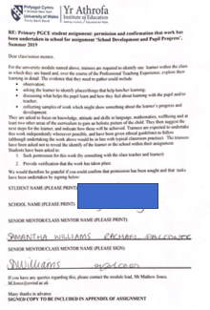

Appendix two: Consent form from pupil and Parent
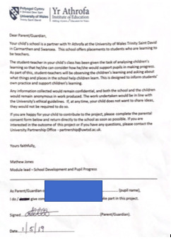

Appendix three: Language Outcomes
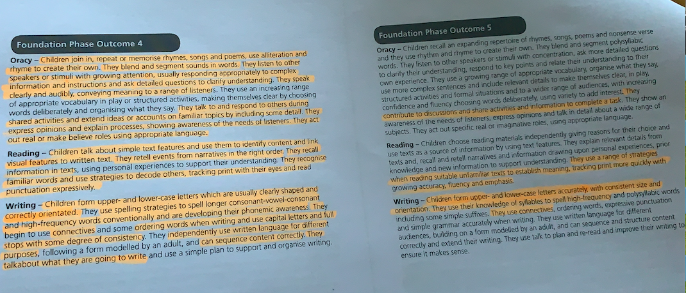
Appendix four: Mathematics Outcomes
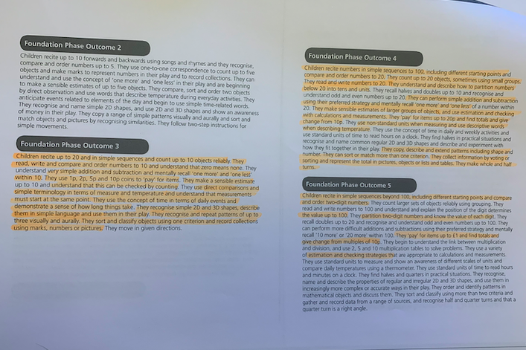

Appendix five: Knowledge and understanding of the World
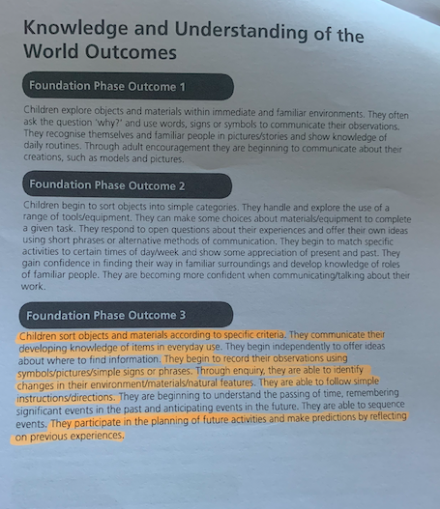

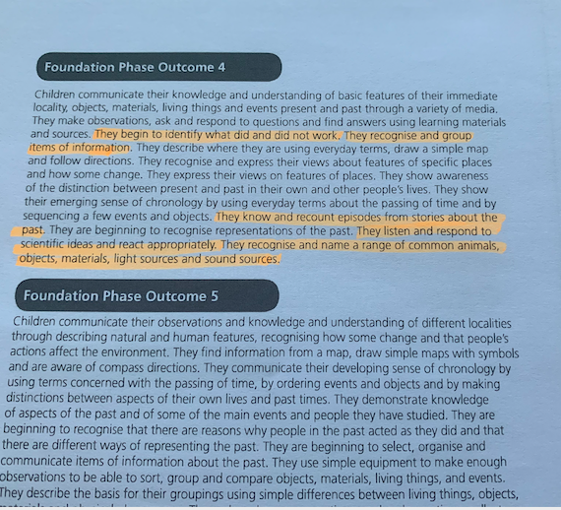

Appendix six: Welsh Outcomes
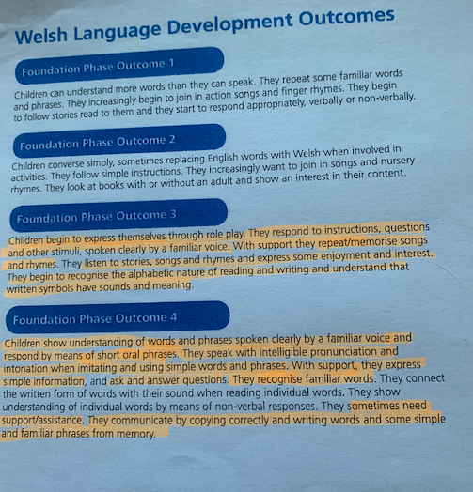

Appendix seven: Personal, Social Development, Well-being and Cultural diversity Outcome
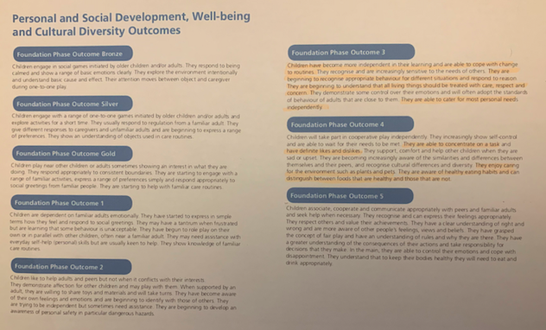

Appendix eight: Drawings from the Learning Walk
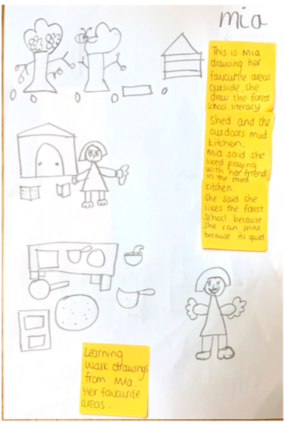

Appendix nine: Expected outcomes (WAG, 2017)
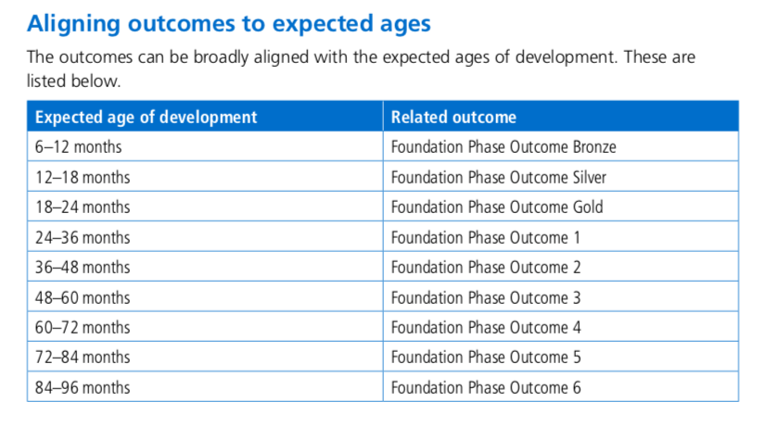

Appendix ten: Oracy – story retell of Jack and the Beanstalk.
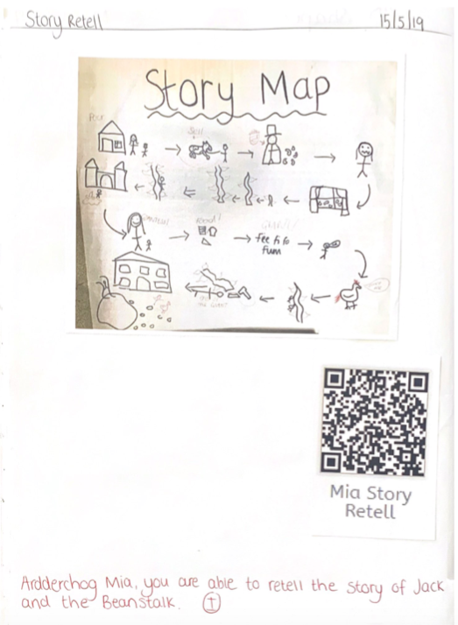

Appendix eleven: Map making
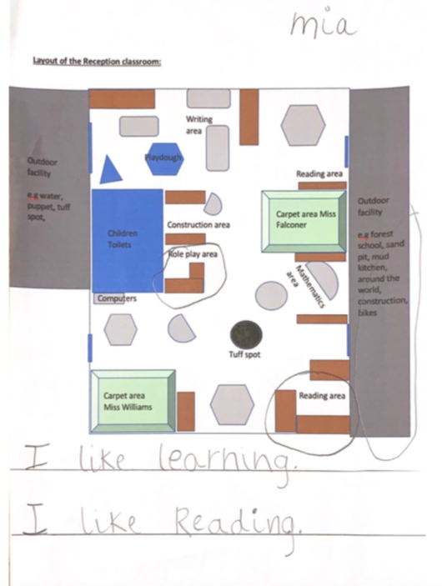

Appendix twelve: Child Interview

Appendix Thirteen: Holiday recount

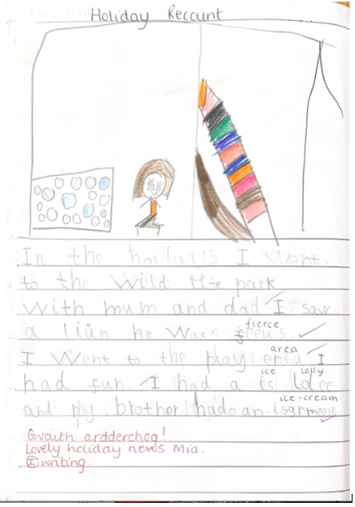

Appendix Fourteen: Observations of the reading garden.

Appendix fifteen: Capacity.
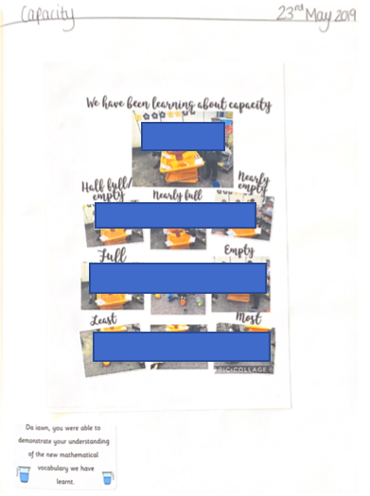

Appendix sixteen: Bigger/Smaller than the Giant’s foot, measuring using non-standards and estimation.
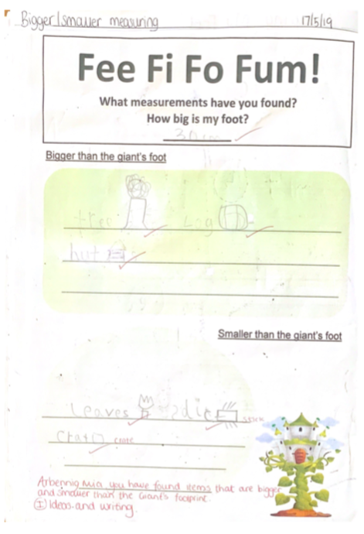

Appendix seventeen: Subtraction
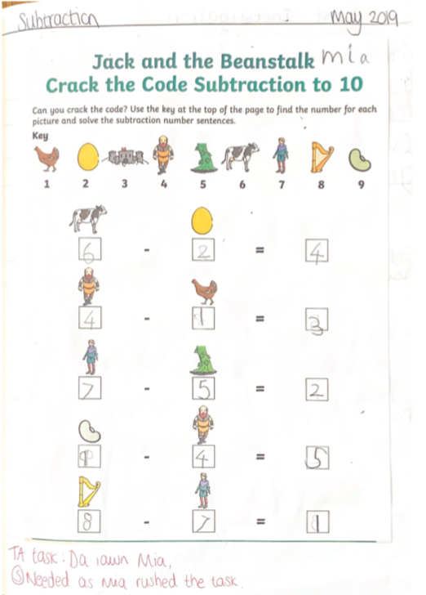

Appendix eighteen: Partitioning numbers
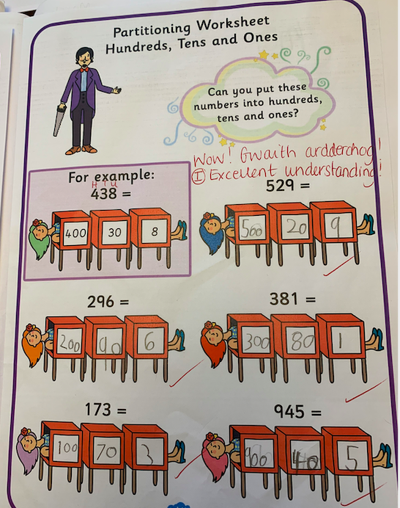

Appendix nineteen: Observations – ‘nobody to play with’

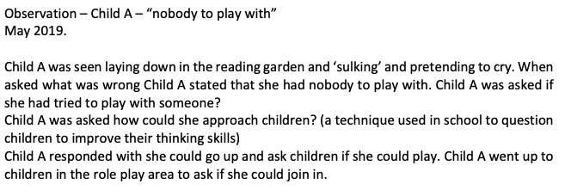

Appendix twenty: Welsh work

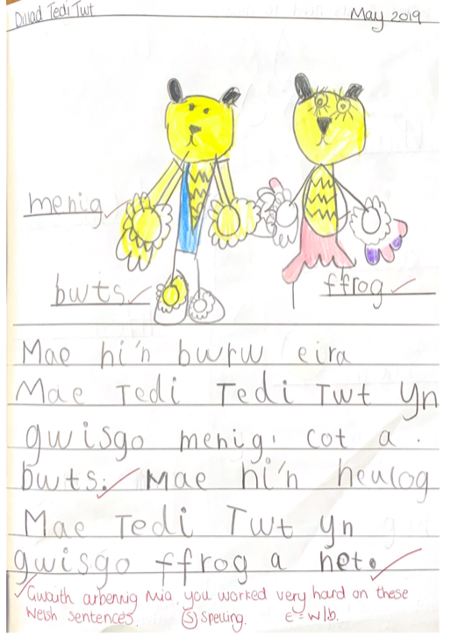

Appendix twenty-one: Science investigation
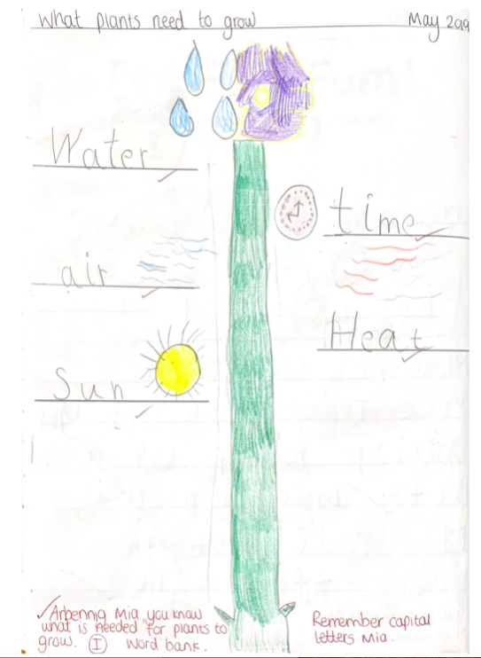

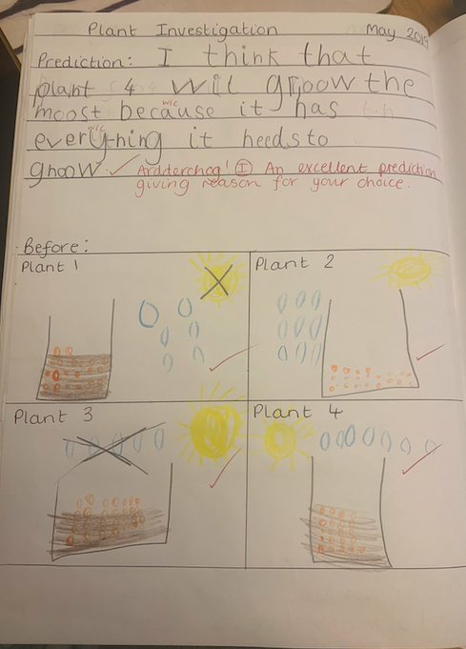

Appendix twenty-two: interview with teacher

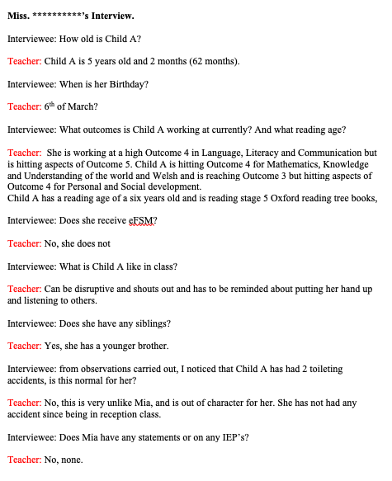

Appendix Twenty-three: Learning walk

Appendix Twenty-four: Simile work


