Name: Finlay Broadhead

Student number: 1902747

Programme of Study: Outdoor Adventure Education

Module: Business Inquiry and Research

Tutor: Dr Roisin Mullins

Date: 30-04-2021, by 3pm

My Survey
In this report I will present my study about people’s opinions of single use plastic. This has always been an area of interest to me, and I wanted to conduct an investigation in order to determine if peoples view on the matter change due to factors such as education, and age. I will begin by describing my process of designing the survey itself, and why I chose the subject under research. I will then talk about how I compiled the data and analysed it. I will then show my finding using the data to compile my conclusion.

Procedure
Plastic Pollution survey- I wanted to find out people’s opinions of single use plastic and littering in their area. In order to do this, I made an online survey that followed a quantitative research approach, to establish what people already know about plastic and how they feel about it. Quantitative research specifies numerical assignment to the phenomena under study (VanderStope, Jonstone, 2008). I had to ensure that all my data was already quantified or that it was quantifiable could then be transformed into quantitative data, that is data which can be recorded as numbers and analysed quantitatively (Saunders, 2019). As all the data I collected was given a numerical value the research is considered quantitative. To do this I began with designing a multiple-choice questionnaire, giving each answer a specific numerical assignment all in the hope to increase my own knowledge or epistemology. “Epistemology is the study of the nature of knowledge and justification: in particular, the study of the defining components, the substantive conditions or sources” (Moser, Paul, 2002). I then put the questions into Google Forms, which allowed me to create a professional looking survey that I then shared on my social media. This allowed me to reach a greater demographic thus getting more accurate and fair results (VanderStope, Jonstone, 2008). The survey included 10 questions that I designed to find out if there is a correlation between age and education in regard to what people know and are doing about single use plastic. I will then compile all of the data through SPSS, a program that will help me to analyse my data better by making graphs and charts to gather a greater understanding.

My Hypothesis is that the more educated people are the more likely they will make a conscious effort to use less single use plastic. I also predict that people under the age of 40 are also less likely to use single use plastic and know more about the devastation it has caused. I believe this because their world views will be different in a lot of cases. How people perceive the world and how things appear to them can often be very different, this is known as Phenomenology (Sloan and Bowe, 2014, 1293). “It is the study of how people experience the world” (OUP, 2009, P. 9).

To combat any GDPR (General Data Protection Regulation) issues I refrained from asking any personal questions like names, addresses and email addresses. This was to ensure that all my participants were completely anonymous. This allowed me to ask questions like their age and what qualifications they have, without having to worry about data protection. I also filled out an ethics form to ensure that I followed all the correct procedures and that I kept mine and the participants data safe.

Data presentation and findings
Below I will present some of my findings, describe any issues I came across, what I did to overcome them and analyse the results.

Frequencies

Statistics
 |  | Q1. What is your Age? | Q2. What would you consider to be your highest form of educational qualification? | Q3. Would you like to reduce the amount of single-use plastic you use? | Q4. Are you concerned about the amount of single-use plastic pollution in your area? | Q5. Do you feel businesses in your area have embraced the 'Plastic Free' initiative? | Q6. Do you think that the recycling of plastic waste is an adequate and effective solution to plastic pollution? | Q7. Before your participation in this survey, were you aware of 'bioplastic' technologies? | Q8. Do you believe that change in the plastic pollution crisis needs to be driven by: | Q9. Would you pay a higher prices for environmentally friendly bioplastic objects (for example bioplastic bottled water) ? | Q10. Have you ever, knowingly (purposefully or accidentally), contributed to plastic pollution? For example: littering and 'fly-tipping'. A reminder that your response is anonymous, and honesty would be greatly appreciated to provide valid results
N | Valid | 40 | 40 | 39 | 40 | 40 | 39 | 39 | 39 | 40 | 40
N | Missing | 0 | 0 | 1 | 0 | 0 | 1 | 1 | 1 | 0 | 0
This table shows all my questions in order and how many people answered them. I thought this was important as there where some questions missed by people which made the averages in the data different. This may affect my results, but I will be taking this factor into account. As I used SPSS to analyse the data the rest of the frequency tables are still added up to 40 (100%) because the software adds a column for missing data allowing me to know what exactly is missing and where. As shown below:
Q1. What is your Age?
 |  | Frequency | Percent | Valid Percent | Cumulative Percent
Valid | 0-18 | 1 | 2.5 | 2.5 | 2.5
Valid | 18-25 | 29 | 72.5 | 72.5 | 75.0
Valid | 25-30 | 1 | 2.5 | 2.5 | 77.5
Valid | 30-45 | 2 | 5.0 | 5.0 | 82.5
Valid | 50-65 | 2 | 5.0 | 5.0 | 87.5
Valid | 65-70 | 2 | 5.0 | 5.0 | 92.5
Valid | 70+ | 2 | 5.0 | 5.0 | 97.5
Valid | prefer not to say? | 1 | 2.5 | 2.5 | 100.0
Valid | Total | 40 | 100.0 | 100.0

Q6. Do you think that the recycling of plastic waste is an adequate and effective solution to plastic pollution?
 |  | Frequency | Percent | Valid Percent | Cumulative Percent
Valid | Extremely effective | 1 | 2.5 | 2.6 | 2.6
Valid | Very effective | 4 | 10.0 | 10.3 | 12.8
Valid | Somewhat effective | 25 | 62.5 | 64.1 | 76.9
Valid | Not so effective | 9 | 22.5 | 23.1 | 100.0
Valid | Total | 39 | 97.5 | 100.0
Missing | System | 1 | 2.5
Total |  | 40 | 100.0

As you can see from question 1 the majority of my participants where of the ages 18 to 25 this wasn’t quite the response, I expected but it will make for interesting data to analyse. What made it harder was to analyse was the missing data. It is shown as its own frequency and value of 1 or 2.5%. This makes it clear that there was only 1 participant that did not answer the question. Because of this missing data the pie charts are no longer as reliable as the percentages are skewed. This means some will have the total as 40 as their 100% and others like in question 6 will have a total of 39 as their 100% this can be seen in the pie charts below:
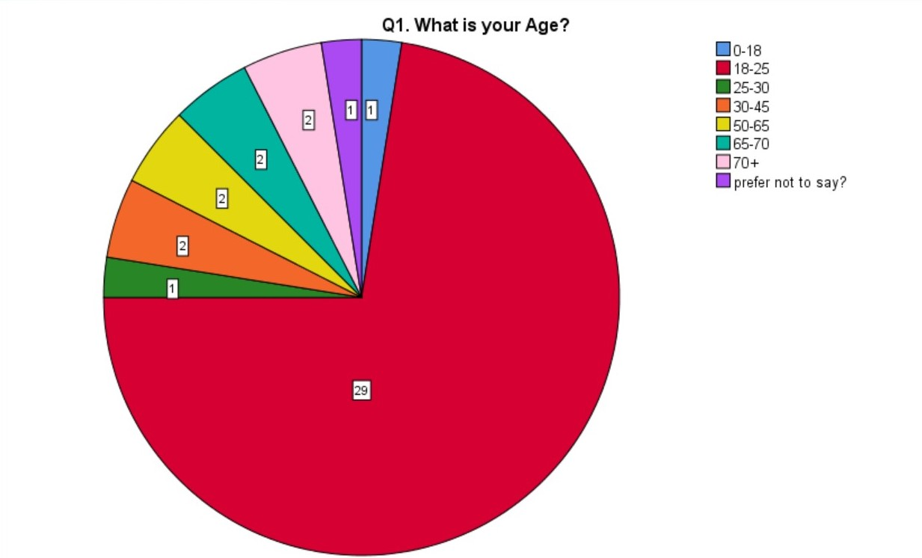
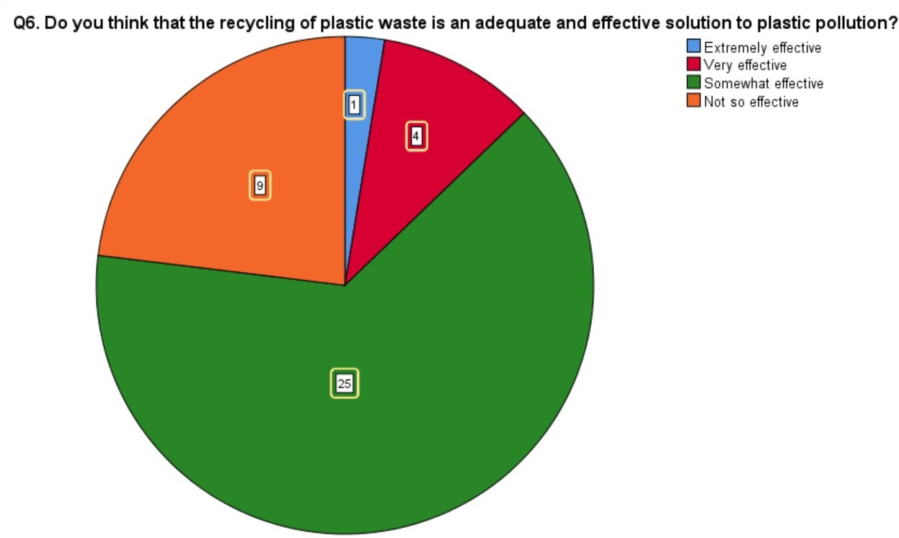
Question 1 pie chart adds up to 40 and question 6 adds up 39. The only problem that this creates is that each participant is worth a different numerical value. So rather than being 2.5%, like it is in Q.1, it is worth 2.6%. This will not affect my overall results, but it did make it harder to input the data and will make it harder to examine the pie charts. To prevent this from happening next time I will make it clear that all questions must be answered, along with creating a ‘prefer not to say’ options on more questions.

Crosstabs
Crosstabulation or contingency tables usually feature a test for independence between row and column counts (Jamil, Morey, et al.2017). I used them to compare age and education to the other questions. Which gave me some fascinating results.

Case Processing Summary
 | Cases
 | Valid |  | Missing |  | Total
 | N | Percent | N | Percent | N | Percent
Q1. What is your Age? * Q3. Would you like to reduce the amount of single-use plastic you use? | 39 | 97.5% | 1 | 2.5% | 40 | 100.0%
Q1. What is your Age? * Q7. Before your participation in this survey, were you aware of 'bioplastic' technologies? | 39 | 97.5% | 1 | 2.5% | 40 | 100.0%
Q1. What is your Age? * Q10. Have you ever, knowingly (purposefully or accidentally), contributed to plastic pollution? For example: littering and 'fly-tipping'. A reminder that your response is anonymous and honesty would be greatly appreciated to provide valid results | 40 | 100.0% | 0 | 0.0% | 40 | 100.0%
Q2. What would you consider to be your highest form of educational qualification? * Q3. Would you like to reduce the amount of single-use plastic you use? | 39 | 97.5% | 1 | 2.5% | 40 | 100.0%
Q2. What would you consider to be your highest form of educational qualification? * Q7. Before your participation in this survey, were you aware of 'bioplastic' technologies? | 39 | 97.5% | 1 | 2.5% | 40 | 100.0%
Q2. What would you consider to be your highest form of educational qualification? * Q10. Have you ever, knowingly (purposefully or accidentally), contributed to plastic pollution? For example: littering and 'fly-tipping'. A reminder that your response is anonymous and honesty would be greatly appreciated to provide valid results | 40 | 100.0% | 0 | 0.0% | 40 | 100.0%

Crosstabulation Summary- This allows me to get a brief glimpse of what percentage of participants answered what, before I analyse the individual crosstabulation.

Q1. What is your Age? * Q3. Would you like to reduce the amount of single-use plastic you use? Crosstabulation
Count
 |  | Q3. Would you like to reduce the amount of single-use plastic you use? |  |  | Total
 |  | Definitely would | Might do | Definitely would not | Total
Q1. What is your Age? | 18-25 | 29 | 0 | 0 | 29
Q1. What is your Age? | 25-30 | 1 | 0 | 0 | 1
Q1. What is your Age? | 30-45 | 2 | 0 | 0 | 2
Q1. What is your Age? | 50-65 | 2 | 0 | 0 | 2
Q1. What is your Age? | 65-70 | 2 | 0 | 0 | 2
Q1. What is your Age? | 70+ | 0 | 2 | 0 | 2
Q1. What is your Age? | prefer not to say? | 0 | 0 | 1 | 1
Total |  | 36 | 2 | 1 | 39

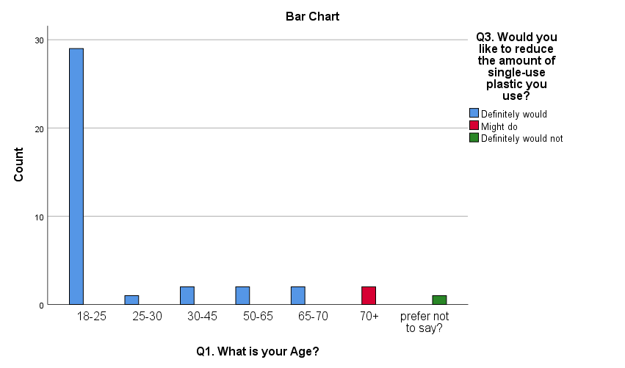Crosstabulation A.
Q2. What would you consider to be your highest form of educational qualification? * Q7. Before your participation in this survey, were you aware of 'bioplastic' technologies? Crosstabulation
Count
 |  | Q7. Before your participation in this survey, were you aware of 'bioplastic' technologies? |  |  |  | Total
 |  | I have a good understanding, and use them as much as I can | I have a moderate understanding | I have heard of bioplastics but have not yet used it | I have never heard of it | Total
Q2. What would you consider to be your highest form of educational qualification? | level 3 (BTEC, A-level's, AS level's, advanced apprenticeship etc.) | 0 | 3 | 0 | 17 | 20
 | level 4 | 0 | 6 | 0 | 0 | 6
 | level 5 | 0 | 3 | 0 | 0 | 3
 | level 6 | 0 | 1 | 3 | 0 | 4
 | level 7 | 2 | 0 | 2 | 0 | 4
 | level 8 | 2 | 0 | 0 | 0 | 2
Total |  | 4 | 13 | 5 | 17 | 39

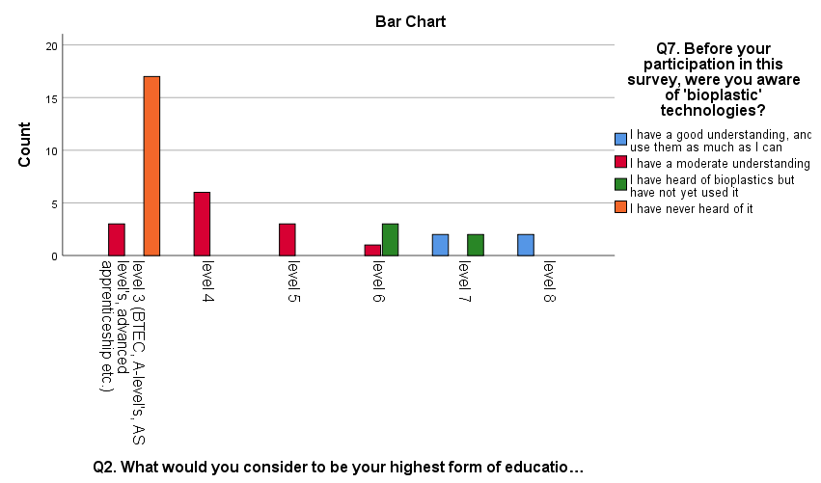

Crosstabulation B.
Q1. What is your Age? * Q10. Have you ever, knowingly (purposefully or accidentally), contributed to plastic pollution? For example: littering and 'fly-tipping'. A reminder that your response is anonymous and honesty would be greatly appreciated to provide valid results Crosstabulation
Count
 |  | Q10. Have you ever, knowingly (purposefully or accidentally), contributed to plastic pollution? |  |  | Total
 |  | Yes | No | Maybe | Total
Q1. What is your Age? | 0-18 | 0 | 0 | 1 | 1
Q1. What is your Age? | 18-25 | 7 | 22 | 0 | 29
Q1. What is your Age? | 25-30 | 1 | 0 | 0 | 1
Q1. What is your Age? | 30-45 | 1 | 0 | 1 | 2
Q1. What is your Age? | 50-65 | 0 | 0 | 2 | 2
Q1. What is your Age? | 65-70 | 0 | 0 | 2 | 2
Q1. What is your Age? | 70+ | 0 | 0 | 2 | 2
Q1. What is your Age? | prefer not to say? | 0 | 0 | 1 | 1
Total |  | 9 | 22 | 9 | 40

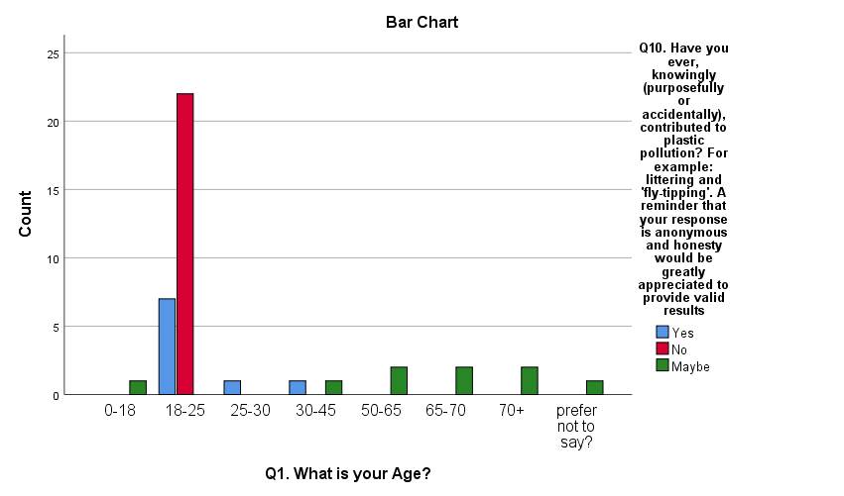

Crosstabulation C.
In crosstabulation A, I compared question 1, What is your Age? and question 3, Would you like to reduce the amount of single-use plastic you use? As you can see the from both the chart and the table the people over the age of 70 said they might reduce the amount of single use plastic. 92.5% of the people I asked said they would like to reduce the amount of single plastic, leaving one person saying that they would not reduce it. This leads me believe that perhaps this was a hokes participant, as they also put their age as prefer not to say. Despite this, the data does still back up my original hypothesis that more of the older generations are less likely want to reduce their plastic usage.

In crosstabulation B, I compared question 2 what was their highest form of educational qualification? And question 7 before your participation in this survey, were you aware of 'bioplastic' technologies? This was interesting as there were a lot of mixed answers across the board. 43.6% of the participants said that they had never heard of bio plastics and all 43.6% came from level 3 participants. The 10.3% of the participants that had a good understanding of bio plastics were all level 7 and 8, backing up my hypothesis that the higher educational qualification you hold the more likely you are to know about the impacts of plastic. But as you can see from the results the data does not completely back up my theory, as there is a moderate understanding of bio plastics from levels 3 to 6. This is interesting as it is obvious that many people do know what bio plastics are, which does partially contradict my hypothesis.

Finally, there is crosstabulation C. This was interesting as I was expecting more people to say that they had littered. With only 22.5% saying that they had littered, all of them being between the ages of 18 and 45. The other 22.5% said maybe to littering, and this answer was across the board, but the majority came from over 50’s. The remaining 55% of people said No to ever littering. All of them coming from between the ages of 18 to 25, this was actually a surprise to me as I thought it would be less than this. Again, it backs up my hypothesis that the younger generations may be more aware of damage every piece of litter can have on the environment.

In conclusions the data that I have collected from my survey shows how many people are aware of the destruction of single use plastics but more importantly is shows the split in divide in knowledge and understanding of the problem’s plastic can cause. This has never been made clearer than when I analysed the data from the crosstabulations. They show that there is a clear gap between the generations and those who are more educated. Of course, this was not all way the case as there where exceptions just like in every survey. But overall, the averages show that older generations may not want to reduce their plastic consumption and more educated people may have a greater desire to switch to bio plastics because they understand the consequences better. Where my survey failed is gaining the audience I wanted. I do not feel that it reached the right demographics to get a true representation of the rest of the country.

Reference list:
Jamil, T., Ly, A., Morey, R.D. et al. (2017), Default “Gunel and Dickey” Bayes factors for contingency tables. Behav Res 49, 638–652, found: https://doi-org.ezproxy.uwtsd.ac.uk/10.3758/s13428-016-0739-8 .

Moser & Moser, Paul K, (2002). The Oxford Handbook of Epistemology, Oxford: Oxford University Press.

Oxford University Press, (2009), Glossary of Key Term.

Robert K. Yin, (2008), Case Study Research: Design and Methods, Fourth Edition, Applied Social Research Methods, Volume 5, Sage Publications Incorporated, 240 pages.

Saunders, Mark, et al. Research Methods for Business Students, Ebook, Pearson Education, Limited, 2019. ProQuest Ebook Central: http://ebookcentral.proquest.com/lib/trinity/detail.action?docID=5774742, accessed on: 15/04/21.

SLOAN, A. and BOWE, B., 2014. Phenomenology and hermeneutic phenomenology: the philosophy, the methodologies, and using hermeneutic phenomenology to investigate lecturers' experiences of curriculum design. Quality and Quantity, 48(3), pp. 1291-1303.

Vander Stoep, S.W. & Johnston, D.D., (2009), Research methods for everyday life: blending qualitative and quantitative approaches First

