Homeless Shelter Eco-Design

Firstly we got together and discussed the brief and putting together what each other anticipated from the brief on a sheet. From this we then discussed the sheet as a whole and decided where was going and what we as a team was going to create and how efficient it would be with the brief,
After reading the brief we went to the design board and came up with a basic structure of a wave, we did this because within the brief it stated we need to use an eco brick to design the structure for a homeless shelter. For us the wave was an idea as the arc would be open underneath where people are able to stand underneath and be able to stand out of the harsh weather conditions we have to endure within the UK. To form the wave we had the idea of holding the bricks within a thick cardboard cutout. We’d make a hole in the cardboard using a laser cutter to make sure that the bottle lid would be flush with the thickness of the cardboard. By doing this we would then be able to add several singular waves together to make a bigger wave. We then come up with model for the wave and how it would look. Then came a brief discussion as a team, we came up with the idea of closing the wave off and turning into a homeless home. By doing this we can add strength to the wave and more support. By doing this we can add sides to the wave meaning the wind wouldn’t be as much of a problem. The final change we agreed to as a team is to bring in a pallet and raise the structure off the floor. This would mean the inside of the home wouldn’t become wet unless there is flooding.
As you can see in the photo [1] the initial idea was to have a wave and go for more of a bus shelter approach where it was only covered from behind and above your head. We felt like this was appropriate however any wind and it would be absolute hell for the homeless people to shelter from. So that’s when design [2] came together where we could shelter it off and make it a home for people and somewhere they can call their home and make it personal. We felt like this was more appropriate as the occupants of the shelter would be a lot more warmer and dryer, this way they have somewhere to keep their belongings too. I personally feel like the second design fitted the brief more regarding a shelter.
The inspiration behind our design was keeping someone as dry as possible in the most sustainable way, the wave was a huge park of our inspiration, this is because arcing the building means the building will be less noisy with the wind as these shelters are going to have to endure all weather conditions. We then developed the wave but keeping the arc in the building. It looks now rather similar to the Krusty Krab off spongebob. The message behind the project was also a big inspiration for myself as homelessness is something that needs to be stamped out in my opinion. Another key inspiration for us was the effect our shelter would have on the environment, the structure would consist of sustainable materials and would have a positive effect on the environment as our choices of materials are all recycled.
The construction of our Eco-Design would become with a lip of 2 inches on the pallet and would be made with cardboard, eco prick plastic and some recycled aluminium sheet which is possible to be made from empty cans. The cardboard would be used as a structure for the support.within the cardboard structures the 4 sides of the structure would consist of circular cardboard tubes filled with eco bricks. The wave would construct of eco bricks fixed flushed into cardboard waves. Then we would make the structure a lot more weather proof by adding in some insulation and using the metal inside of the structure too, it also makes the eco-bricks more of a cavity. We feel like these are the best materials to use and it fits in well with the brief. We also believe that if we did it this way the cost of our materials would be very minimal however fit with the brief extremely well. As [3] shows the structure of the wall in the shelter the bottles will be laid on top of one another and in sections to make the shelter wider if the customer requires it to be. We feel like with the size of our shelter, 2.2m in height at the highest point, being 2.2m in width too we feel like it has enough space to accommodate one person and a pet.
What I enjoyed most about doing the project was i felt like after we finished this design could be done easily and would be cheap as everything is made from a recyclable product which within the world we need to control more as they’re having a negative effect, the plastic especially. The part of the design I like the most was the part where we agreed to put it on a pallet, this means we can add several pallets together to make a village or even add more than one together, this can also help within the loneliness of the homeless people within the country or community where they can be placed. What I learnt from doing this project was the effect that plastic is having to our climate and the damage it is causing to our planet. That opened my eyes and made me realise the impact im causing and I need to reduce my own single plastic use, or even non-recyclable plastics and make people aware of the damage that their causing to their own planet.
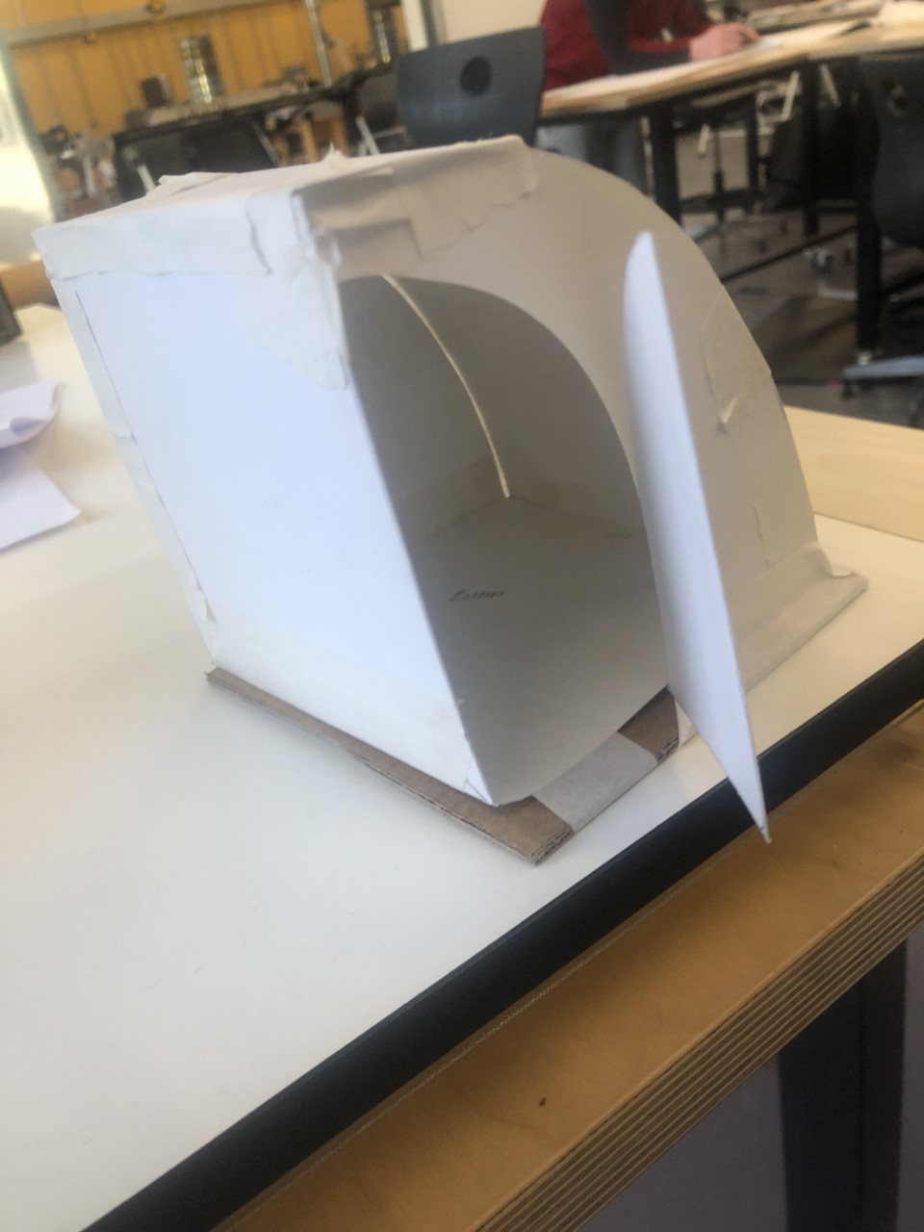
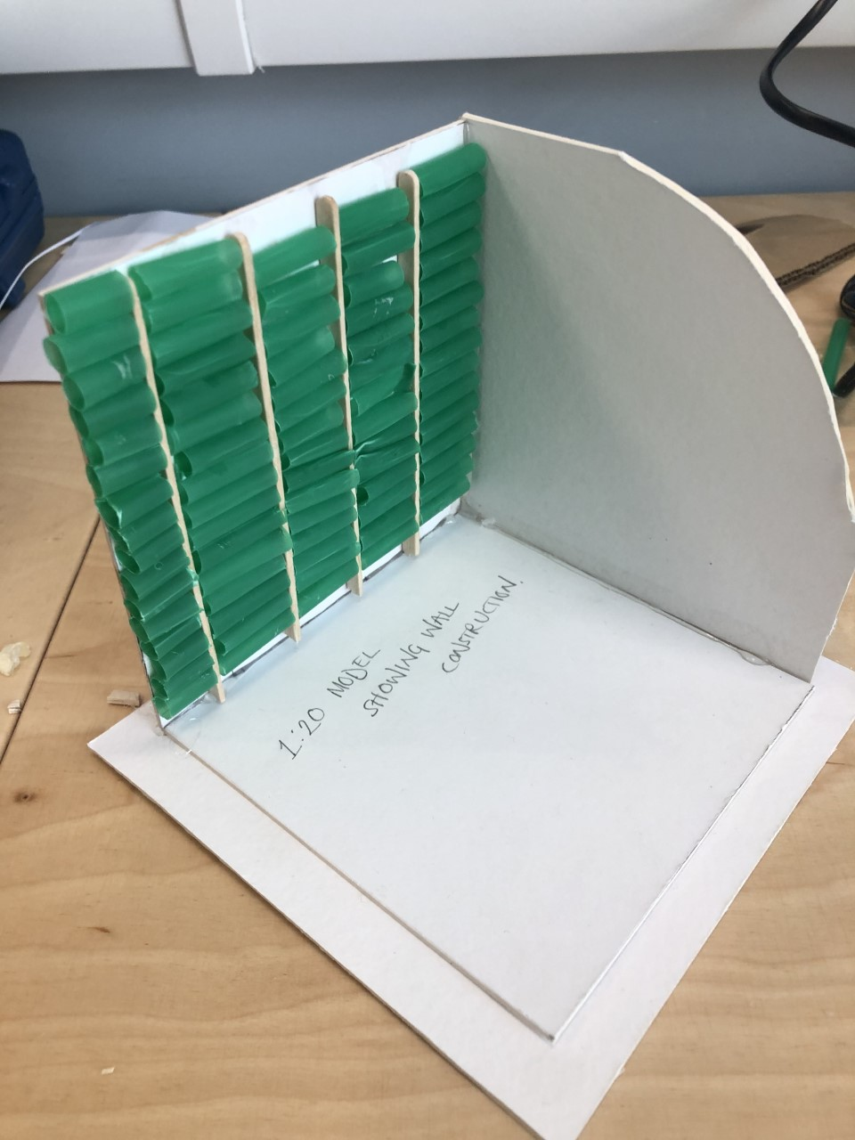
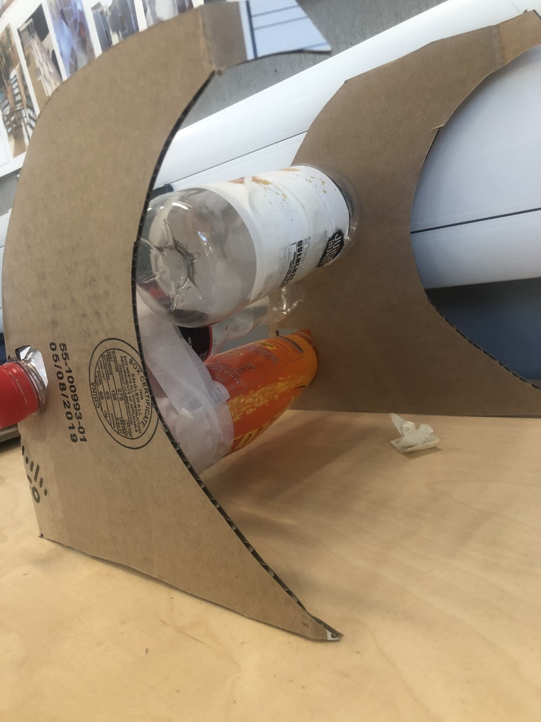

[1] Design 1- initial wave [2] Design 2 - Taken off [3] Wall Structure.

Refrences
[1][2][3]- Blaine Smith 2019, Photos from Blaines IPhone.

