
OME – Instrumentation and Control (ACDA5011)

31/12/2021

Nathan Rowe - 1910544

Declaration
I declare that this report is the product of my own work and is not being submitted for any other degree etc.

Contents

1 Introduction 4
2 Background 4
2.1 CIWS 4
2.2 Control System Types 4
2.2.1 Open-Loop 4
2.2.2 Closed-Loop 5
2.3 Applications 5
2.3.1 Mechanical Applications 5
2.3.2 Electronic Applications 5
2.4 Transfer Function 6
2.4.1 Open-loop Transfer Function 7
2.4.2 Closed-loop Transfer Function 7
3 Simulation 7
4 Results 8
4.1 Matlab Results 8
4.2 Calculated Results 11
4.2.1 PID Controller TF 11
4.2.2 Forward Path TF 11
4.2.3 Whole System TF 11
4.2.4 Pole 12
4.3 Results Comparison 14
5 Discussion 15
6 Conclusion 15
7 Appendix 16

References

[1] | “TechTarget,” [Online]. Available: https://whatis.techtarget.com/definition/control-system. [Accessed 31 12 2021].
[2] | “NavWeaps,” [Online]. Available: http://www.navweaps.com/Weapons/WNUS_Phalanx.php. [Accessed 31 12 2021].
[3] | ElectronicsCoach, “Open Loop,” [Online]. Available: https://electronicscoach.com/open-loop-control-system.html. [Accessed 31 12 2021].
[4] | ElectronicsCoach, “Closed Loop,” [Online]. Available: https://electronicscoach.com/closed-loop-control-system.html. [Accessed 31 12 2021].
[5] | S.Mosey, Control Mechanisms, 2021.

Introduction
The purpose of this study and document, is to give a background of Control Systems, what they do and where they are used. The study will Simulate a type of Electrical Control System used on a Close-in Weapon Systems (CIWS) which are used to engage anti-ship cruise missiles.
Using Matlab and Simulink software, a Closed-loop control system will be designed and simulated. This will form part of the CIWS’s positioning software.
A control system is a set of mechanical or electronic devices which regulate other devices/systems by way of control loops [1].

Background

Control System Types
There are 2 main types of control system:

Open-Loop
Open-loop control is a type of control whereby the output of the system is relative to the input. The systems do not contain any feedback loop – therefore can also be referred to as a ‘non-feedback system’. The Block Diagram [Figure 1] shows this pictorially.
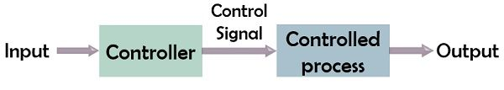
Figure 1 - Open-loop Control Block Diagram [2]

Closed-Loop
Closed-loop control is a type of control whereby the output of the system control the input applied. Variation in input relative to the output leads to produce a more accurate system. Controllability of a closed-loop system is achieved through the output generated by the feedback path.
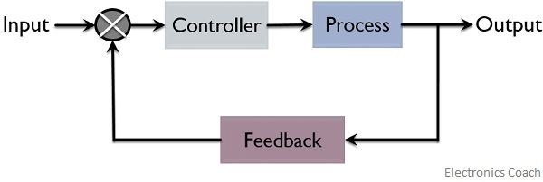
Figure 2 - Closed-loop Control Block Diagram [3]
Closed-loop systems can be considered as a fully automatic system because it is designed such that he output is always comparing itself with the reference input to achieve the required output. They can be referred to as a ‘feed-back system’. The Block Diagram [Figure 2] shows this pictorially.

Applications

Mechanical Applications
Centrifugal Governors are used throughout the modern world. A common application for their use, is within the governor assembly of diesel injection engines. The governor uses flyweights, acting upon a spring, dictate the amount of fuel injected into the engine depending on throttle position, load, and engine speed [Figure 3]. This is an example of a Closed-loop Mechanical Control System
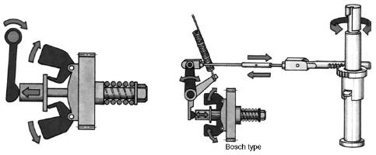
Figure 3 - Bosch Style diesel governor

Electronic Applications
Every Most households have an iron. These are a basic closed-loop system – it is represented with the following block diagram [Figure 5]. A temperature is set by the operator and becomes the reference input for the system. When input is provided, the resistive heating element generates heat. The new output temperature is compared against the reference input. This results in an increase of the iron, until the temperature of the iron exceeds the reference. Once the reference has been met, the heating element turns off.

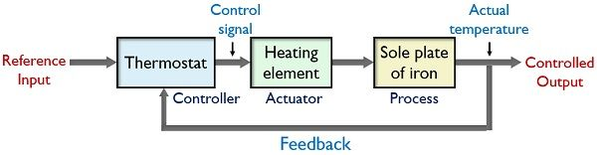
Figure 4 - Iron Block Diagram

Response Curve
In the example of the iron, there is a period where the temperature exceeds the reference. Once the iron has begun to cool, there is lag whereby the temperature drops below the reference. This is known as system Hysteresis [4], and is plotted on the following Response Curve [Figure 5]:
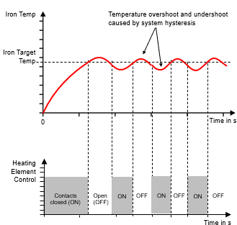
Figure 5 - Response Curve

Transfer Function
System behaviour can be mathematically described by a ‘Transfer Function’. This is the ratio of the output compared to the input. Alternatively, this can be referred to as a ‘Gain Function’. As an equation, it can be shown as the following:
$$Transfer Function= \frac{Output Value}{Input Value}$$
As an example, the transfer function of a simple amplifier would be the output voltage divided over the input.

Open-loop Transfer Function
Open-loop TF can be represented with the following Equation:
$$G=\frac{θ_{o}}{θ_{i}}$$

Closed-loop Transfer Function
Closed-loop TF can be represented with the following Equation:
$$\frac{G}{1+GH}=\frac{θ_{o}}{θ_{i}}$$

CIWS
Close-in Weapon Systems are designed to engage anti-ship cruise missiles and fixed-wing aircraft at short ranges [5]. The System is a Fast-reaction, detect-through-engage, radar guided 20mm weapon system, fitted to many US Navy warships.
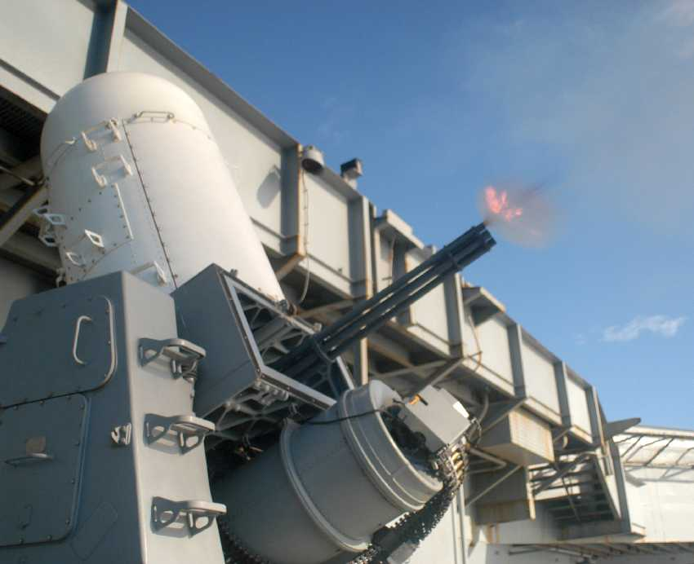
Figure 6 - CIWS Weapon System
The CIWS automatically detects, evaluates, tracks, engages, and performs kill assessment against ASM and high speed aircraft threats [6], through the use of a electro optic stabilised sensor.

Simulation
A Closed-loop control system as part of the positioning system attached to a CIWS Weapon System as described in [Section 2.1] will be designed and simulated.
Through the use of Matlab and Simulink, a closed-loop control system will be simulated following a unit step input. The control system will bring the process under control within 2 seconds and have an overshoot of less than 5%.
Transfer function a, b, and c values are given as:
a | b | c
3 | 3 | 1
Table 1 - Transfer Function Values
Transfer Function Block Parameters as [Table 1]
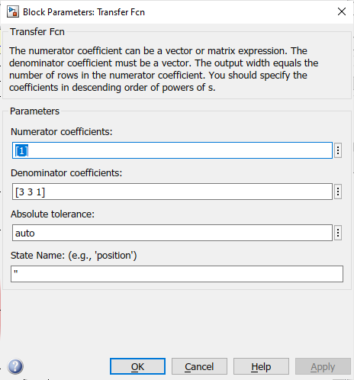
Figure 7 - Block Parameters

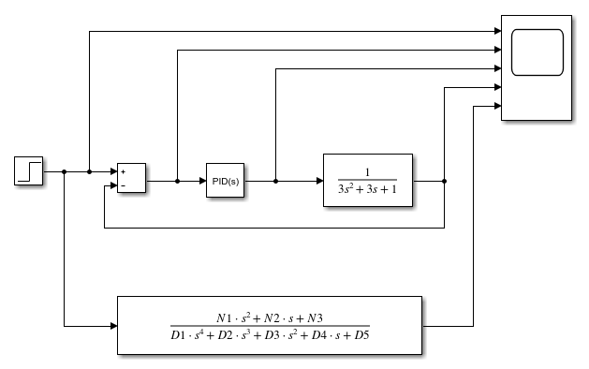
Figure 8 - System Diagram

Results

Matlab Results
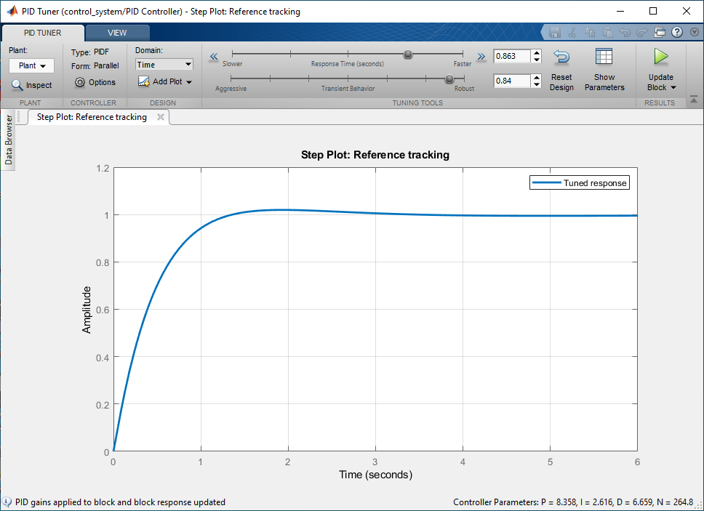
Figure 9 - Tuned PID Step Plot

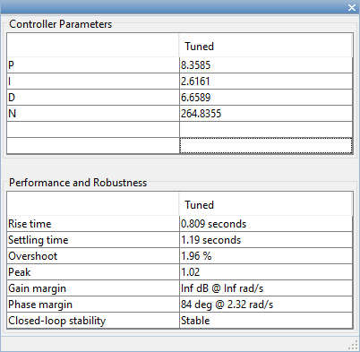 | 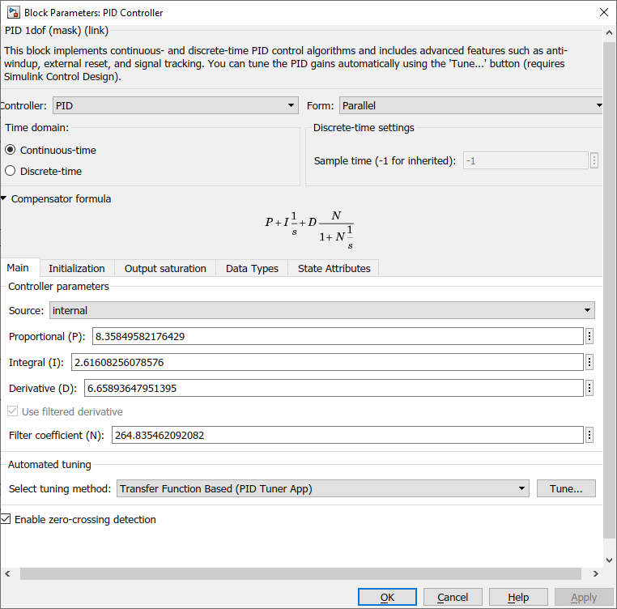
Figure 10 - Tuned Controller Parameters

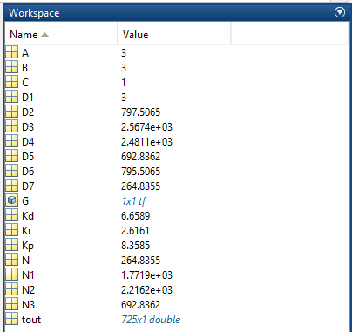
Figure 11 - Simulation Input/Output Values

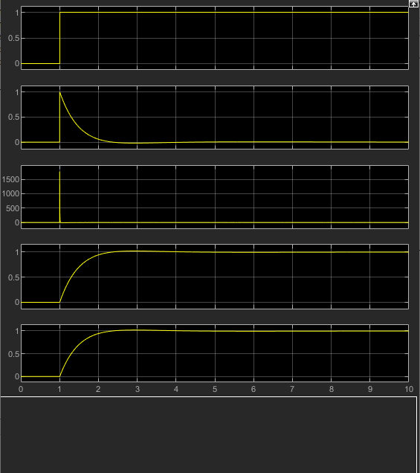
Figure 12 - Scope Output from Tuned System

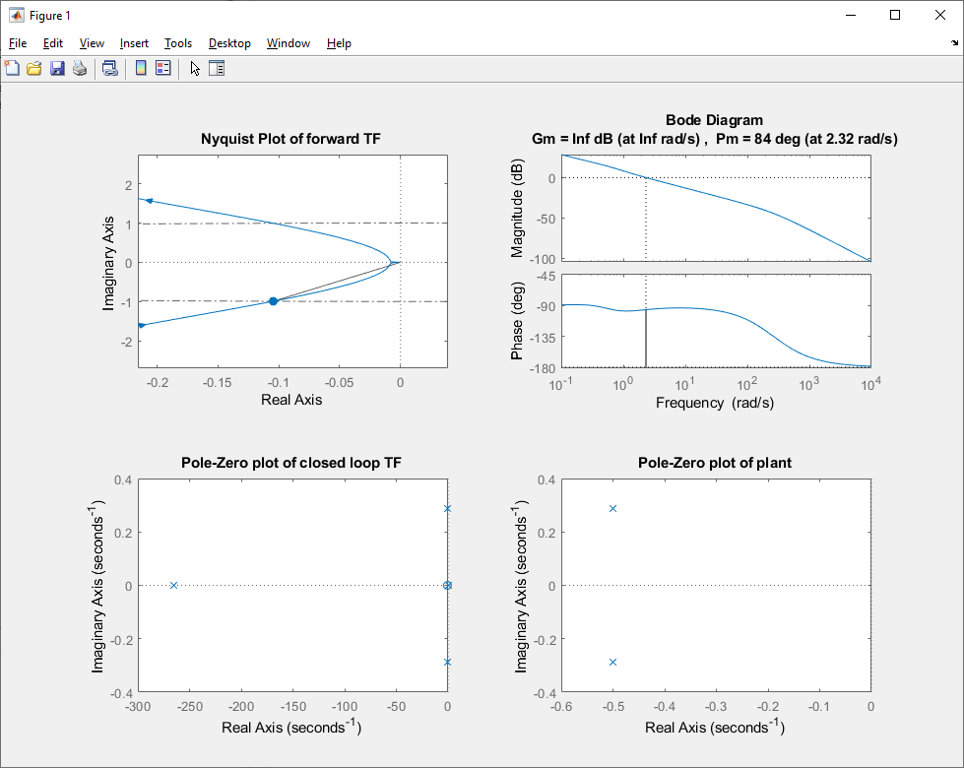  Figure 13 - Nyquist Plot forward TF | Figure 14 - Bode Diagram
Figure 15 - Pole-Zero of closed-loop TF | Figure 16 - Pole-Zero of plant

Calculated Results
PID tuner values as [Figure 9]:
Kp: 8.3585
Ki: 2.6161
Kd: 6.6589

PID Controller TF
$$\frac{K_{d}s^{2}+K_{p}s+K_{i}}{s}$$

$$\frac{6.6589s^{2}+8.3585s+2.6161}{s}$$

Forward Path TF
$$\frac{6.6589s^{2}+8.3585s+2.6161}{s}×\frac{1}{3s^{2}+3s+1}$$

$$\frac{6.6589s^{2}+8.3585s+2.6161}{3s^{3}+3s^{2}+1s}$$

Whole System TF
$$\frac{\frac{6.6589s^{2}+8.3585s+2.6161}{3s^{3}+3s^{2}+1s}}{1+\left(\frac{6.6589s^{2}+8.3585s+2.6161}{3s^{3}+3s^{2}+1s}\right)×1}$$

$$TF=\frac{\frac{6.6589s^{2}+8.3585s+2.6161}{3s^{3}+3s^{2}+1s}}{\frac{3s^{3}+3s^{2}+1s}{3s^{3}+3s^{2}+1s}+\frac{6.6589s^{2}+8.3585s+2.6161}{3s^{3}+3s^{2}+1s}}$$

$$TF=\frac{\frac{6.6589s^{2}+8.3589s+2.6161}{3s^{3}+3s^{2}+1s}}{\frac{3s^{3}+3s^{2}+1s+6.6589s^{2}+8.3585s+2.6161}{3s^{3}+3s^{2}+1s}}$$

$$TF=\frac{\frac{6.6589s^{2}+8.3589s+2.6161}{3s^{3}+3s^{2}+1s}}{\frac{3s^{3}+9.6589s^{2}+9.3585s+2.6161}{3s^{3}+3s^{2}+1s}}$$

$$TF=\frac{6.6589s^{2}+8.3589s+2.6161}{3s^{3}+3s^{2}+1s}×\frac{3s^{3}+3s^{2}+1s}{3s^{3}+9.6589s^{2}+9.3585s+2.6161}$$

$$TF=\frac{\left(6.6589s^{2}+8.3589s+2.6161\right)\left(3s^{3}+3s^{2}+1s\right)}{\left(3s^{3}+3s^{2}+1s\right)\left(3s^{3}+9.6589s^{2}+9.3585s+2.6161\right)}$$

$$TF=\frac{19.9767s^{5}+19.9767s^{4}+6.6589s^{3}+25.0767s^{4}+25.0767s^{3}+8.3589s^{2}+7.8483s^{3}+7.8483s^{2}+2.6161s}{9s^{6}+28.9767s^{5}+28.0755s^{4}+7.8483s^{3}+9s^{5}+28.9767s^{4}+28.0755s^{3}+7.8483s^{2}+3s^{4}+9.6589s^{3}+9.3585s^{2}+2.6161s}$$

Whole System TF
Whole System Transfer Function now in a format which can be added into a single block for comparison purposes.
$$TF=\frac{19.9767s^{5}+45.0534s^{4}+39.5839s^{3}+16.2072s^{2}+2.6161s}{9s^{6}+37.9767s^{5}+60.0522s^{4}+45.5827s^{3}+17.2068s^{2}+2.6161s}$$

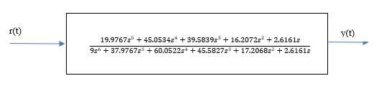

Pole
Polynomial TF
$$G\left(s\right)=\frac{1}{as^{2}+bs+c}$$
Substitute a,b,c [Table 1]
$$G\left(s\right)=\frac{1}{3s^{2}+3s+1}$$
Numerator = 1
Therefore, only the denominator is required to calculate the Gain
$$G(s)={3s}^{2}+3s+1$$
Solve Quadratic
$$G\left(s\right)=\frac{-b±\sqrt{b^{2}-4ac}}{2a}$$
$$G\left(s\right)=\frac{-3+\sqrt{3^{2}-4*3*1}}{2*3}$$ | $$G\left(s\right)=\frac{-3-\sqrt{3^{2}-4*3*1}}{2*3}$$
$$G\left(s\right)=\frac{-3+\sqrt{9-12}}{6}$$ | $$G\left(s\right)=\frac{-3-\sqrt{9-12}}{6}$$
$$G\left(s\right)=\frac{-3+\sqrt{-3}}{6}$$ | $$G\left(s\right)=\frac{-b±\sqrt{-3}}{6}$$
$$G\left(s\right)=\frac{-3}{6}+\frac{\sqrt{-3}}{6}$$ | $$G\left(s\right)=\frac{-3}{6}-\frac{\sqrt{-3}}{6}$$
$$G\left(s\right)=-0.5+\frac{\sqrt{-3}}{6}$$ | $$G\left(s\right)=-0.5-\frac{\sqrt{-3}}{6}$$
$$G\left(s\right)=-0.5+\frac{\sqrt{3}*\sqrt{-1}}{6}$$ | $$G\left(s\right)=-0.5-\frac{\sqrt{3}*\sqrt{-1}}{6}$$
$$G\left(s\right)=-0.5+\frac{1.732j}{6}$$ | $$G\left(s\right)=-0.5-\frac{1.732j}{6}$$
$$G\left(s\right)=-0.5+0.289j$$ | $$G\left(s\right)=-0.5-0.289j$$

Results Comparison
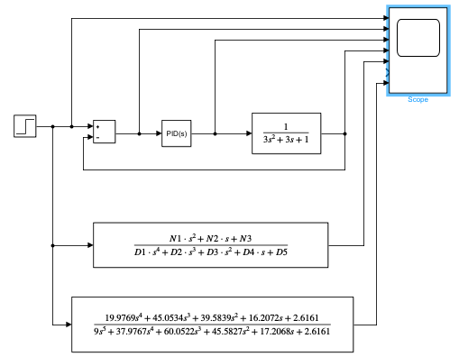
Figure 17 – System Diagram of Tuned System with Calculated Results Transfer Function
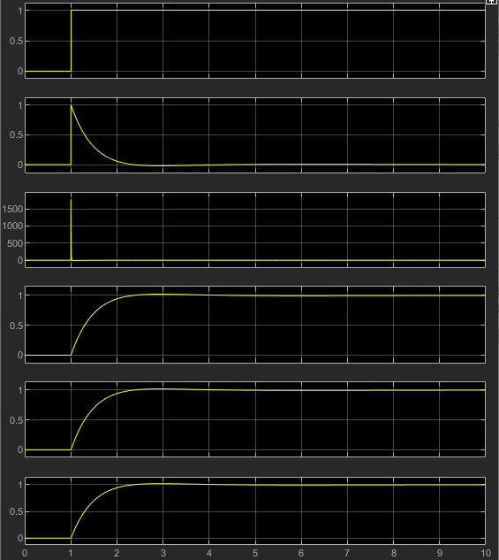
Calculated TF
Simulated TF
Figure 18 - Scope Output from Tuned System with Calculated Results Trace

Discussion
[Figure 12,13, 14, and 15] Show the Nyquist Plot, Bode Diagram, Pole-zero plot of closed-loop TF, and the Pole-zero plot of plant respectively.
The Nyquist Plot [Figure 12] shows the distance from the origin. Phase shift is shown as the angular component from the horizontal axis. Gain and Phase margin can be determined from the Plot, and gives an indication as to the stability of the system. Hand Calculations in [Section 4.2.4] back up the data done by the simulation.
The Bode Diagram [Figure 13] plots the Gain of the system (dB) against the Frequency (rad/s). The bottom plot within the Body Diagram shows the phase shift of the system (°) against the Frequency (rad/s). The Bode Diagrams show the system response through changes in Frequency.
The Pole-zero plot Closed-loop TF [Figure 14] shows that the poles are in the left hand segment of the XY axis graph. This demonstrates that the system is stable.
The Pole-zero plot of Plant [Figure 15] shows the pole and zero locations within the complex plane. Both poles are in the left hand segment of the XY axis graph. This demonstrates that the system is stable.

Conclusion
The Closed-loop control system provides a stable system, with a rise and settle time below the maximum required as stated in [Section 3].
The Rise and Settling time (0.809s and 1.19s respectively) gave a total response time of 1.999s with an overshoot of 1.96%.
Simulation construction and PID tuning was quick and easy to do within the Matlab software. Even with the input values given, hand calculations were long winding and prone to error. It is recommended to utilise Matlab software for this application of PID tuning.

Appendix
Matlab Command inputs
% Plant transfer function values from assignment spec
A=3;
B=3;
C=1;

% Controller parameters from PID tuning block in Simulink
Kp=8.3585;
Ki=2.6161;
Kd=6.6589;
N=264.8355;

% Numerator coefficients of transfer functions
N1=Kp+(N*Kd);
N2=(Ki+(N*Kp));
N3=N*Ki;

% Denominator coefficients of closed loop transfer function
D1=A;
D2=(A*N)+B;
D3=Kp+(N*Kd)+(B*N)+C;
D4=(N*Kp)+Ki+(C*N);
D5=N*Ki;

% Denominator coefficients of forward transfer function
d1=A;
d2=(A*N)+B;
d3=(B*N)+C;
d4=C*N;
d5=0;

% create forward transfer function
fwd_tf=tf([N1 N2 N3],[d1 d2 d3 d4 d5]);

% Create Nyquist plot of forward transfer function
% This HAS to exclude the feedback as it will be a measure of
% System stability - how much gain / phase shift needed to make instable
figure;
subplot(2,2,1);
nyquist(fwd_tf);
title('Nyquist Plot of forward TF');

% Create Bode plot of foward transfer function
% - provides similar info to Nyquist plot
subplot(2,2,2);
margin(fwd_tf);
%title('Bode plot of forward TF')

% Create closed loop transfer function of whole system (inc. feedback)
system_tf=tf([N1 N2 N3],[D1 D2 D3 D4 D5]);

% Plot Pole-Zero diagram of closed loop system
subplot(2,2,3);
pzplot(system_tf);
title('Pole-Zero plot of closed loop TF');

% Create transfer function to represent only the plant
plant_tf = tf(1,[a b c]);

% Plot pole-zero diagram of plant transfer function
subplot(2,2,4);
pzplot(plant_tf);
title('Pole-Zero plot of plant');

Nathan Rowe 1910544

