
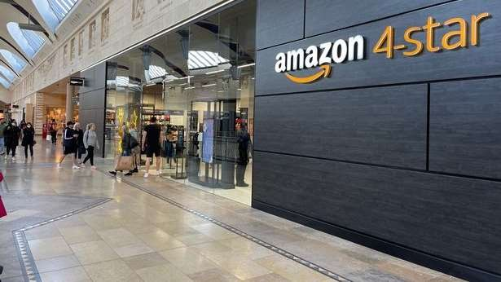

Amazon 4-stars at Bluewater

Management Team

Mihai Jicu
(2029965)
Samuela Prianka Sousa (2030400)
Noemi Bregolin (2030799)
Lilija Tconeva
(2029799)
Cosmin Rotar
(2030537)


Amazon getting physical stores analisys
Differences between Amazon’s physical and online structure and performance
Management tasks and skills at Bluewater
Motivate non- management staff members and improve the performance
Internal and external factors influencing behaviour


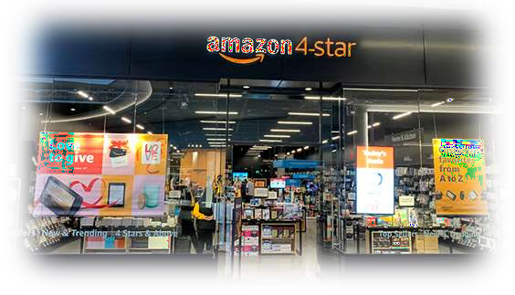

Background of Amazon and why has decided to move into physical stores?

Student ID:2029965
Amazon Getting Physical Store Analysis Tutor: Gregory Cowan
Student’s Name: MIHAI JICU
Institution: University of Wales Trinity Saint David-London
Date:10/12/2021

Amazon Organizational Structure & Culture
- Amazon is an online retail company(Amazon.com)

- It uses boldness, customer-centric, and peculiarity as its organizational culture (Bedarkar et al., 2016)

- It uses the global function-based team, global hierarchy, and geographical divisions as its organizational structure (Bedarkar et al., 2016)
- The two have been combined to motivate employees and success of the company (Bedarkar et al., 2016)

- Amazon is an online retail company that deals with both food and non-food commodities. The company has employed a motivating work environment through an organizational culture that allows employees to innovate new ideas through boldness, customer-centric, and peculiarity that could help the company excel in the online retail
space (Bedarkar et al., 2016).

Measures to Influence Consumers
- Amazon has adopted different factors to influence consumer

decisions (Amazon.com)

  - The company provides exciting offers (Bedarkar et al., 2016).

  - It ensures customer loyalty is achieved (Bedarkar et al., 2016).

  - It delivers high quality customer services (Bedarkar et al., 2016).

  - It has adopted time and money saving approaches (Alvesson & Sveningsson, 2015)
Currently, the company has put in place measures to influence consumers to purchase from its platforms. The company has come up with different approaches like providing exciting deals like free delivery, discounts, customer- centred services, and time and money-saving approaches that have been captivating in the eyes of consumers. Such factors have been the approach that Amazon uses in influencing consumers to stick with purchasing from its platform.

Amazon’s Bid to Ensure Sustainability

    - The company has employed a comprehensive approach to ensure sustainability (Mullins, 2016)
    - It uses innovation to attract consumers and increase loyalty (Alvesson, & Sveningsson,
2015)
    - It allows employees to implement new ideas (Alvesson, & Sveningsson, 2015)
    - It also distinguishes itself from competitors (Alvesson, & Sveningsson, 2015)
. As a way to continue its profitability, Amazon has continually been innovative in its approach to attract more customers and increase loyalty. Employees are allowed to implement their ideas without interference from the top management. Additionally, they are allowed to come up with new ideas that are likely to improve service delivery to customers. Also, the company has tried to distinguish itself from competitors by allowing employees to come up
with suggestions that are likely to make it better than its competitors

Reason for having a physical Store
- To improve customers services (Bedarkar et al., 2016).

- To add other products lines (Bedarkar et al., 2016)

- To enable other vendors, list their product with the company (Bedarkar et al., 2016)
- To increase its channels of revenue (Bedarkar et al., 2016)
- Movement into a physical store is one of the approaches that are likely to improve the customer's services as they could come and test the products before they get to purchase them. It will also reach extended categories that the company currently cannot deal with in the online space. Also, the company will bring in different products apart from those labelled by Amazon, which will increase its competitiveness. Also, the company will likely add a channel of revenues that could contribute to its profitability.

References

  - Alvesson, M., & Sveningsson, S. 2015. Changing organizational culture: Cultural change work in progress. Routledge.
  - Bedarkar, M., Pandita, D., Agarwal, R., & Saini, R., 2016. Examining the Impact of Organizational Culture on Customer Centricity in Organizations: An Analysis. Prabandhan: Indian Journal of Management, 9(2), 19-28.




Vs
Differences between Amazon’s physical and online structure and performance
Student ID :2030400 Tutor: Gregory Cowan
Student’s Name: Samuela Prianka Sousa Institution: University of Wales Trinity Saint David- London
Date: 8/12/2021



  - Opening the physical store is one of the great initiatives taken by Amazon as this develops the direct communication between the customers and company.
  - Although they started as an online bookstore, Amazon has earned Billions in
profits from its online stores globally in the present times. (Weise,K 2021)




Reasons for
opening offline store
Amazon observes the prospect of shopping being modified and blended.

Physical stores help Amazon overcome increasing delivery expenses. (Vijayakumar et al. 2021).

Difference between online and offline organizational structure and performance

EFFECTIVE ORGANIZATIONAL FRAMEWORK THAT CAN ATTENTIVELY CONTROLS ALL THE ACTIVITIES IN BOTH OFFLINE AND ONLINE PLATFORM.
THE SUPPLY CHAIN MANAGEMENT IS VERY
EFFICIENT.
THE MAJOR DIFFERENCE IN BOTH CATEGORY IS IN THE GOVERNMENTAL REGULATIONS IN SELLING AND BUYING PROCESSES.




(Vollero et al.2021).

Effectiveness of management team
of amazon at Bluewater Amazon
store
The items for sale are amongst those given four stars or higher on Amazon's online shop, with several from the Wishlist category shown online, varying from kitchen equipment to pet accessories. (Simpson,E 2021)

Shoppers may get the latest trendy arrivals, “surefire page-turners”, top-rated electronics and devices, much more at this outlet. . (Wu and Gereffi, 2018).

Also the products' costs, average star review, and quantity of user reviews shown under every product. (Wu and Gereffi, 2018).


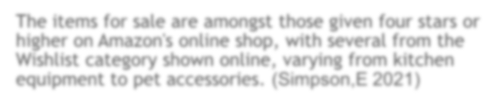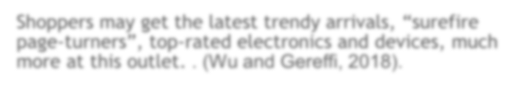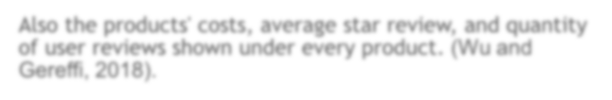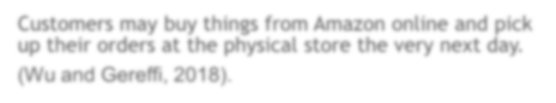

Customers may buy things from Amazon online and pick
up their orders at the physical store the very next day.
(Wu and Gereffi, 2018).

Influence of internal and external factors on employees’ performance



Internal factors like company’s financial condition, market research, organizational condition, employees’ mentality during the pandemic etc. have a great impact on business.

External factors are lockdown period, governmental rules and regulations, changes in customers’ priorities and purchasing pattern etc.

Although the physical store has faced a lot of challenges during the lockdown period, the online store effectively deals with this situation.

The outcome of this is very much positive as it provides numerous opportunities along with top-rated products and services under a roof for both online and offline buyers.

Reference list
Journals & Articles
- Weise,K 2021,’ Amazon’s profit soars 220 percent as pandemic drives shopping online', The New York Times,2021,viewed 14 December 2021, https://www.nytimes.com/2021/04/29/technology/amazons-profits-triple.html.
- Simpson ,E 2021,’ Amazon opens first UK non-food store ’BBC News, Viewed 14 December 2021, <https://www.bbc.co.uk/news/business-58806762>.

- Dillaway, M.E., 2021. The New" Web-Stream" of Commerce: Amazon and the Necessity of Strict Products Liability for Online Marketplaces. Vand. L. Rev., 74, p.187.

- Jindal, R.P., Gauri, D.K., Li, W. and Ma, Y., 2021. Omnichannel battle between Amazon and Walmart: Is the focus on delivery the best strategy?. Journal of business research, 122, pp.270-280.
- Smith, B. and Linden, G., 2017. Two decades of recommender systems at Amazon. com. Ieee internet computing, 21(3), pp.12-18.

- Vijayakumar, S., Vidyashankar, G., Venkatesakumar, R., Madhavan, S. and Riasudeen, S., 2021. Online Review Characteristics and Information Asymmetry Is it easy to switch between Online Shopping sites? A Case Study of Reviews from Amazon and Flipkart. SDMIMD Journal of Management, 12(1), pp.27-39.
- Vollero, A., Sardanelli, D. and Siano, A., 2021. Exploring the role of the Amazon effect on customer expectations: An analysis of user‐generated content in consumer electronics retailing. Journal of Consumer Behaviour.
- Wankhede, K., Wukkadada, B. and Nadar, V., 2018, July. Just walk-out technology and its challenges: A case of Amazon Go. In 2018 International Conference on Inventive Research in Computing Applications (ICIRCA) (pp. 254-257). IEEE.
- Wu, X. and Gereffi, G., 2018. Amazon and Alibaba: Internet governance, business models, and internationalization strategies. In International business in the information and
digital age. Emerald Publishing Limited.




Management tasks and skills to bring operational effectiveness
Student ID :2030799
Management tasks and skills of Amazon at Bluewater
Tutor: Gregory Cowan
Student’s Name: Noemi Bregolin
Institution: University of Wales Trinity Saint David-
London
Date:12/12/2021

OPERATIONAL EFFICIENCY

Or better the ‘metric that measures the efficiency of profit earned as a function of operating costs’ (Hayes, 2021)


  - Our management team focuses on providing stability for Amazon 4 -stars by establishing skills and tasks
Our main objective



PLANNING

Planning for a company, in this case for Amazon 4-star, means deciding on different purposes for the future and how to achieve these goals (Mullins, 2016, p. 417).

- Maximize the profit of the company (Target jobs, 2021), by
lowering the output.

- Provide local products (Itv News, 2021) that may reflect the taste of residents and give the chance to small suppliers to get engaged in the business.

- Renovation, that means ‘the assortment of products in
the store will change regularly” (Itv News, 2021)

- Provide “compliance with health and safety legislation’ (Target jobs ,2021.) and ensure to employees their rights and prosperity.
- Possible extension of stores in the UK.




ORGANIZE

  - To make our plans factual, organization is a focal task of our management to establish the way, the timing, the materials and the human resources to achieve a goal (Mullins, 2016, p. 417).

  - The management of the inventory.
  - Leading (encouragement, motivation, and developing
communication)
  - Provide online training to the staff
  - Recruting the staff [“employability assessment’ (Buchanan, 2016, p 37) ]
  - Renovate the look of the store (select new products, preparing promotional materials for sales, installing eye- catching displays and reorganizing the departments)



CONTROL

The last phase is the control, which establishes whether the performance needs to be improved and consequently decide whether further actions must be taken (Mullins, 2016, p. 417).

  - Handling customers’ complaints and queries.
  - Feedback is effective to guarantee the stability of and supervise
different aspects like customer service and staff professionality.
  - Reward the employees based on the performance or by transmitting more power by delegating responsibility and authority.
  - Check daily data to improve areas like materials, machinery,
money, employees’ performance and conduct.
  - Keep track of the financial records and the budgets and to cooperate with the head office (Target jobs, 2021).



SKILLS

Human relationship area
(solve conflicts in the workplace
and guarantee equality)

Conceptual area (understand and solve complex
situation)

Technical areas
(to carry on statistics and
financial activities)

enthusiasm, teamwork, effective communication (verbal and written)
Multi-tasking, decision- making (Phibbis B, 2021), adaptability, organizational skills, confidence, critical thinking

IT and numerical skills, market knowledge, sales experience.

References
BOOKS
  - Buchanan, D. A., (2016) Organizational behaviour. 9th edn, Harlow; New York: Pearson
  - Mullins, L.J. (2016), Organizational behaviour in the workplace. 12th edn, Harlow: Pearson

ARTICLES
  - Hayes, A. (2021) ‘Operational efficiency’, Investopedia, Available at:
<https://www.investopedia.com/terms/o/operationalefficiency.asp>
  - Itv News (2021) ‘Amazon opens first UK non-food store at Bluewater Shopping Centre’, available at:<https://www.itv.com/news/2021-10-05/amazon-furthers-physical-retail- expansion-with-first-uk-general-store>
  - Phibbis, B. (2021), ‘7 Essential Retail Manager Skills Your Store Needs To Succeed’ Bobphibbis the retail doctor, Available at: https://www.retaildoc.com/blog/7-skills-every- retail-manager-needs-to-succeed
  - Target jobs (2021) ‘Retail manager: job description’, Available at:
<https://targetjobs.co.uk/careers-advice/job-descriptions/retail-manager-job-description>



Motivation practices to increase the performance
of non-management staff at the Amazon Bluewater
store

Student ID : 2030537 Tutor: Gregory Cowan Student’s Name: Lilija Tconeva
Institution: University of Wales Trinity Saint David-London
Date:12/12/2021


Amazon Organizational Structure & Culture

MOTIVATION

- Organisation as an iceberg. (Mullins and McLean 2019, p.9)
- Link between organizational behavior ( Mullins,2019.p.6) and motivation (Armstrong, 2012,p.181)
- Lawler's High Involvement Management ( engagement through commitment and involvement
)(Armstrong, 2012, p.25)

Strengthening workforce relationships
- Tendency towards replacement of macho
management ( Buchanan and Huczynski, 2017.p.45)

Policies towards organisational democracy/
more authentic human relationships;
- Communication; ( Armstrong, 2012, p. 175)



Amazon Organizational Structure & Culture

MOTIVATION

  - Motivation theories;Herzberg’s Two Factor and Maslow's Hierarchy of Needs/ Goal setting, Equity and Expectancy theories ( Armstrong,2012, p. 188)
  - Safe work environment/ health and safety, pay and benefits, absence;
  - Ethical workplace;employee wellbeing, managing diversity, handling disciplinary matters, job security and redundancy; (Armstrong, 2012, p. 103)
  - Flexible working/ work-life balance; ( Mullins and McLean, 2019, p. 77)
  - Training for all non- management employees/ 2000 products in
the store (Partridge, 2021)
  - Flexible reward system and promotion opportunities;
(Boddy,2017,p.362)
  - Job design as an intrinsic motivation; Challenging goals increase performance, however tying pay to preset sale targets can lead to fraudulent behavior. (Boddy, 2017, p. 494)

REFERENCES

    - Mullins L. and McLean, J. (2019) Organisational Behaviour in the Workplace. 12th Ed.
Harlow: Pearson Education
- Armstrong, M. (2012) Armstrong’s Handbook of Human Resource Management Practise.
12th Ed. London: Kogan Page
- Partridge, J. (2021) Amazon opens first UK bricks-and-mortar non-food store. [ The Guardian Online] Accessible on: https://www.theguardian.com/technology/2021/oct/06/amazon-opens-first-uk-bricks-and- mortar-non-food-store-bluewater-kent (Accessed: 08 December 2021)
- Buchanan, D. and Huczynski, A. (2017) Organisational Behaviour. 9th Ed. Harlow: Pearson
Education
  - Boddy, D. (2017) Management: an introduction. 7th Ed. Harlow: Pearson Education



An analysis of internal and external factors influencing individual and group behavior
and performance of the management team of Amazon at Bluewater Amazon store

Student ID :2029799
Tutor: Gregory Cowan Student’s Name: Cosmin Rotarr
Institution: University of Wales Trinity Saint David-London
Date:12/12/2021

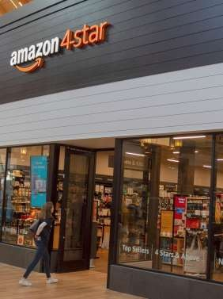

Internal factors

    - Products assortments- This is major internal
factor which can change entire Bluewater firm’s curators respond regular basis in terms of customer feedbacks (Gerrard,, 2021)
    - Leadership principles- This is the major internal factors of Bluewater as this helps management to lead to their group and keeping customers at decisions centre. This helps Bluewater store to become customer-centric organisation and also the safest place to the work (US About Amazon, 2021).

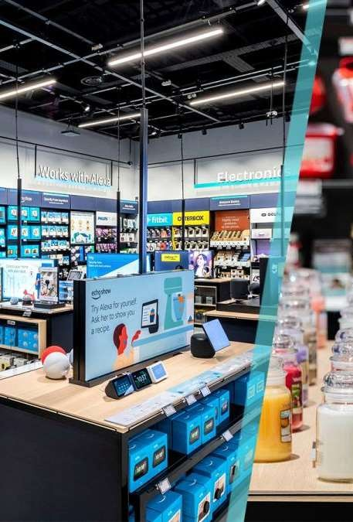

External factors

- External factors are-
  - COVID-19- This is the major external factor that highly influenced management performance and group behaviour. The stores atmosphere of working has been entirely changed along with behaviour of groups. They faced difficulty with the changing habits in initial months (GREENSPAN, 2021)
  - Increase cybercrime rate- This is the major issue management group of Blue water stores have faced. The management does not have any choice but to invest in IT to boost the competitive advantage by eliminate cybercrime attack.

Reference
- Gerrard, B., 2021. Amazon opens first UK 4-star store in physical premises push. [online] inews.co.uk. Available at:
<https://inews.co.uk/inews-lifestyle/money/amazon-opens-first-uk-4- star-store-in-physical-premises-push-1234883> [Accessed 9 December 2021].
- US About Amazon. 2021. Leadership Principles. [online] Available at:
<https://www.aboutamazon.com/about-us/leadership-principles>
[Accessed 9 December 2021].
- GREENSPAN, R., 2021. Amazon.com Inc. PESTEL/PESTLE Analysis, Recommendations - Panmore Institute. [online] Panmore Institute. Available at: <http://panmore.com/amazon-com-inc-pestel-pestle- analysis-recommendations> [Accessed 9 December 2021].

END

