
Skills for the Workplace
Module Assignment Submission
Student Name: | Carmen carter
Student Number: | 1917766
Module No: | BMSK4005
Module Title: | Professional Career Development

Statement of Confirmation of Authenticity
By the act of making this submission, the student declares that this is the work of the student named above. The work has not, in whole or in part, been knowingly presented elsewhere for assessment, or where assessment has been built on a previous assessment, this has been identified. Where materials have been used from other sources it has been properly acknowledged. If this statement is untrue, the student acknowledges that an assessment offence has been committed.
Attention is drawn to the plagiarism and unfair practice policies of both the University and of ILM.

Table of Contents
Section 1: Knowing how to identify development needs 3
1.1 Identify learning styles for myself and another team member 3
1.2 I have used swot charts for myself and team member. 5
1.3 Identify problems to learning for myself and another team member. 8
1.4 how can problems to learning be overcome. 9
Section 2: Know how to develop self & others to achieve organisational objectives 9
2.1 learning/development options to meet needs of self & team member. 9
2.2 support mechanisms for the development of self & team member. 11
2.3 Development plans for yourself and another team member. 14
2.4 Method used to monitor the development of self & team member. 16
Section 3: preparing for the recruitment process 16
Reflection on the recruitment process 16
3.1 Description 17
3.2 Feelings 18
3.3 Evaluation 18
3.4 Analysis 18
3.5 Conclusion 19
3.6 Action Plan 19
References 19
Appendix A 19
Appendix B 21
Appendix C 22
22
Appendix D 22

Section 1: Knowing how to identify development needs

Identify learning styles for myself and another team member

To be able to identify my own or another person’s way of learning. I have three questionnaires that will be able to help me find personal styles of learning, this can help me or someone else understand our own ways of learning. And help make it easier.
The three questionnaires are “VARK”, Honey and Mumford and DANTEC.
The VARK questionnaire was written by Fleming,N.D and Mills, C.(1992) and helps you find your best way of learning by suggesting strategies you should be using to help you further your studies. The four strategies are, Visual, Aural, Read/write and kinaesthetic.
After taking part in “VARK” questionnaire my results from this told me that I am the type that uses a few different ways of learning. Which are Visual, Aural and Kinaesthetic. I do like to see things visually as this helps me understand more when learning new roles. I do like to listen to demonstrations and instructions as this can sometimes help to see things more clearly and helps the mind understand more by seeing things physically while listening can make more sense to me. (See Appendix A)
I completed the same questionnaire for another member of my team. Her results came out the same as me. Visual, Aural and Kinaesthetic. Even though we work in different ways in our job and sometimes had different views on how things should be done or change we scored similar scores which was quite surprising for us both.
Honey and Mumford (1986) designed this questionnaire to help you find your preferred learning style, they identified four distinct learning styles, Activist, Theorist, Pragmatist and Reflector.
I filled out the Honey and Mumford questionnaire. My results came back to me being a reflector. This made sense to me as I’m the kind that likes to sit back and observe situations and take my time not to rush into things so that I get things right and learn what I can first to give me a better understanding. I also like to watch and listen to other people’s views. Whether they be positive or negative I like to listen to what they have to say before making my own decisions or speaking out. Sometimes I have things in my mind to say in group discussions but do not always speak out first and wait for others to speak out. this is to do with lack of confidence. Which is something I need to work on.
Honey and Mumford (1986) said. “Reflectors are much better at listening and observing. They are effective at reflecting on their own and others’ experience and good at analysing what happened and why. In terms of the learning cycle, reflectors are seen as those who perform well in the ‘MONITOR’ role above all else.”

I also filled out the same questionnaire for another team member. Her results came back that she was an Activist. Which after discussing this with her we agreed this was true as she is the kind to try any kind of challenge without hesitation or thinking into something and diving in headfirst to give anything a try. And always the first to perform roleplay in any team group meetings. This makes a lot of sense to me because she is always full of confidence.
Honey and Mumford (1986) said this about “Activists learn best from ‘having a go’ and trying something out without necessarily preparing. They will be enthusiastic about role-play exercises and keen to take risks in the real environment. Activists are considered as those most keen to ‘DO’ in terms of the learning cycle.”
Dantec learning styles (2006)
The last questionnaire I took was Dantec. This told me that I am the type that likes to use my own method of learning style. This helps avoid mistakes being made from using your own preferred way of learning. Jumping in headfirst is not my preferred style of learning.
I also took the Dantec questionnaire for another team member and on this one we both came up the same. She has her own way of learning and doing what she thinks is right at the time. After discussing this with her we both agreed this was true. ( see appendix a.1 )

I have used swot charts for myself and team member.

SWOT on myself

STRENGTHS  Works well with a team.  Good time management.  Works well alone.  Good communication skills.  Helping management jobs. | WEAKNESSES  Lack of confidence.  Lack of knowledge in a Managerial role.  Not Academic
OPPORTUNITIES  Working towards my first degree in cert AE skills in the workplace level 4.  Manager opportunity in my workplace. | THREATS  Not having the qualifications to move forward.

After filling in the swot graph and discussing this with my team member we agreed the one thing that does let me down is my confidence. This is the one area that I do need to work on to better myself in certain areas of my current work and study. We believe improvement of my weakness in confidence will help me move forward to get the knowledge of being a manager and be able to complete my studies. I already help with my manager do jobs in my current job, to help me go forward I’m going to ask my manager for more responsibility to help me get more confidence in my work life, and this will also help me with my studies.

SWOT another team member

STRENGTHS  Works well within the team  Hugely confident  Works well given tasks to complete  Works well alone.  Willing to try anything new.  Good time management. | WEAKNESSES  Jumps in without thought.
OPPORTUNITIES  Management opportunity.  Other job opportunities. | THREATS  Can be impatient at times. Which can let her down to make mistakes.

The swot graph above I filled in about another team member. Giving all her good and bad points, she had many more good points than bad after we both discussed this together, we realised that she had a lot of good strengths as she works well with or without a team by her side. She also works well under pressure and is very confident around people. Her only weakness was sometimes she would jump right into a situation without any thought or consideration. We talked about improving that weakness and decided that she has to stop and think before speaking and getting involved with things that she shouldn’t.

Identify problems to learning for myself and another team member.

Being a single parent to three children can be very hard for me with not much help on offer at the best of times I tend to struggle, my confidence is another huge barrier that stops me going forward. This is a huge barrier for me. It can be stressful with just getting them all off to school and sometimes having to arrange childcare on half terms can be hard. Making sure they get to school on time with clean uniforms and packed lunches and being there for any after school activities they do is my main job. And then holding onto my part time job trying to progress higher in my job role by finishing my university course has been extremely hard. And since the pandemic started it has been tougher again having to home school the children and keep them entertained with no break has not been easy.
After talking to my other team member, it looked like there was two barriers in her way, jumping into something before thinking and she also looks after her nephew twice a week for her single parent sister to go to work. So, this holds ger back from doing more hours in her job which we talked about how this is preventing her from earning more money.

how can problems to learning be overcome.

These barriers I can overcome in this pandemic with using planning and time keeping and improving my confidence. I can plan my day, the day before and keeping a log of my day written down so that I know how my day is going, to start and finish by seeing it visually in front of me, will help me prioritise what is more important first. This will also help prevent stress and help my time keeping and have a better organised life. I am currently on furlough so I cannot improve on my confidence in work. I can use this time to reflect on myself and improve my mind set so when I do get back to work, I can start going forward.
After talking with my team member about her barriers and how she will overcome them, she also can overcome her barrier by simply being honest with her sister and talking about applying for professional childcare so that they can both work with no problems. And to always think before jumping into something.

Section 2: Know how to develop self & others to achieve organisational objectives

2.1 learning/development options to meet needs of self & team member.

To allow myself to carry on learning and to further my education and succeeding with my university course. I will need to make sure that I attend all my online classes, as attending classes is important for me and my learning, so that I can ask any questions if I do not understand something and listen in on other students’ questions and views which helps me even more. The meetings are also recorded on Microsoft teams, for you to go back to later, which is helpful for us. I find it better to be able to interact with the group and be involved with the discussions. We also have a what’s app group, which we use to communicate and ask questions about our assignments, we also as a group have open discussions with our tutor, and know if we needed any support, she would be there for us for whatever help we needed, or any further information.
To continue to develop in my job role, we have regular training, and other training is available to learn to do more skilled jobs leading to management roles. It is important to attend all staff meetings to have the ability to share and listen to any new ideas that the team have and get up to date on how the business is doing. Having regular monthly one to one meeting with management is very important in my job role, feedback, good or bad gives me the chance to work on improving my role. We communicate with the team via our what’s app group and Facebook group, these are updated regularly with rotas and information needed for our shifts, we also discuss any new changes or ideas together.
After discussing with my team member, we found that we are similar, as we work together and have similar job roles. To continue moving forward in her job role, she would also need to attend all meetings and staff training and any other training offered, have regular contact with management and as she is already training to be part of the management team, she will need to attend management meetings and training. We also discussed the idea of her applying to do the same CertHe course or something similar that I am doing to give her more knowledge and qualifications that she would need to move forward.

2.2 support mechanisms for the development of self & team member.
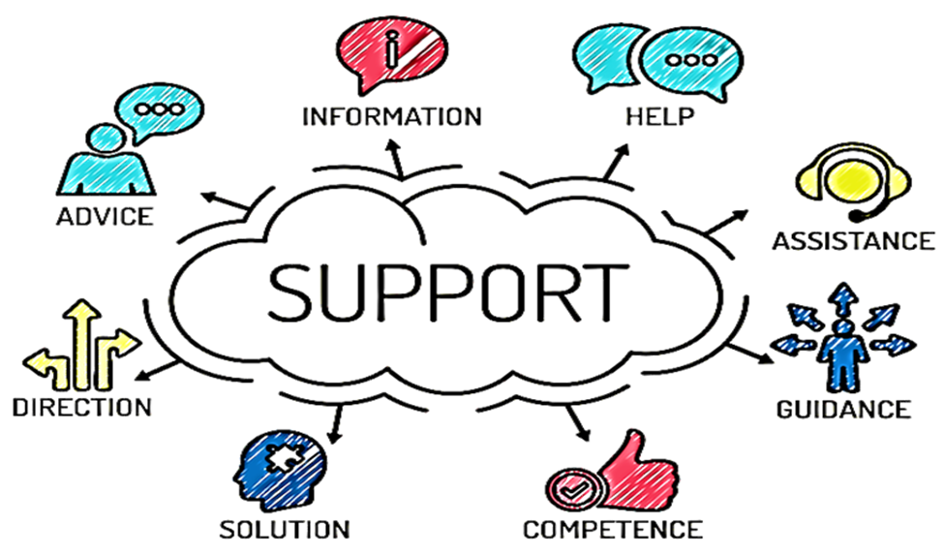

Researching support mechanism models to help us continue with our learning and development, I found this model on Starstek.com. It’s a simple picture, but you can see it is simple to understand, if you need to get help or support with anything you have options.
Advice: Speak with a manager or tutor.
Information: Research what information is needed
Help: Ask if you need HELP.
Assistance: Ask for assistance from manager or Tutor.
Guidance: Speak with management or Tutor for guidance.
Competence: When you have all the knowledge and tools in place you will be able to move forward.
Solution: Speak with manager or Tutor with help in finding a solution to the problem.
Direction: Combine this all together and it will help guide you in the direction you need to move forward.
It is a good way to visually see and help identify a way to support and help develop the learning of myself and the other team member. We both found that this picture was very clear of showing us both how to develop and learn going forward.

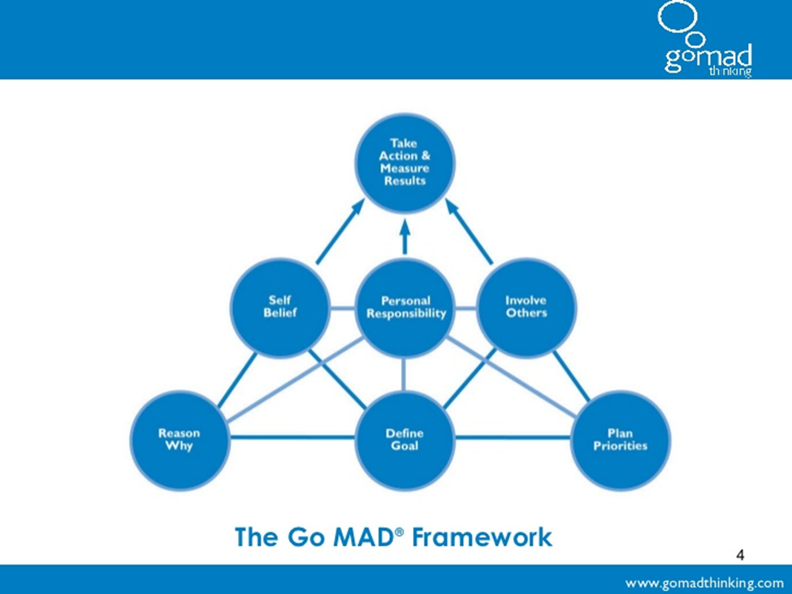
Gilbert, A (2001)
The Go M.A.D (Go Make A Difference) thinking system by Gilbert, A (2001) has been around for over 20 years and has helped people bring out their full potential of thinking power. The thinking system has been proven by people in over 40 countries and has helped them achieve their dream goals. Thousands of hours of research were undertaken by Andy gilbert (2001). To find a simple way to explain the key success principles. This led the 7 key principles of the Go M.A.D system.
This model helps you set out a plan for your development, when complete it shows you what ideas can be achievable, your strengths and that you are 100 % responsible for your own development.

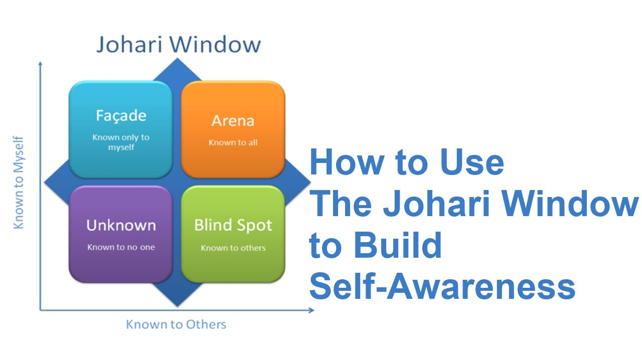
Johari Window Luft and ingram (1955)
The Johari window was developed in 1955 by American phycologists Joseph Luft and Harry Ingham, the model is to help people improve on their self-awareness and enhance their perception of themselves and others. The window is made up of 4 panes.
Arena is known to all. This is about the persons communication with others, their attitude personality and feelings. This can not only be seen by yourself but by others.
Blind spot is an area known by others, but a person would be unaware of. This can be improved by listening to other people’s views and feedback about yourself.
Façade is an area only known by yourself. This can be a personal area which people do not like to share with others like past experiences, secrets, or personal problems. This can also be because a person has trust issues with other people so prefer not to share any personal information.
Unknown this is an area that is unknown to yourself and others. This can be something that you or another person is totally unaware of about yourselves and go unnoticed for years until a hidden talent is discovered. Open communication is an effective way to minimise the area.
The Johari window (1955) is a very useful tool for me and the other team member, this lets us see where our strengths and weaknesses are, and how we can work on them. I know I do not have a lot of confidence, and this tool shows me ways of dealing with it. The other team member has issues with jumping headfirst into a situation, this tool will help her learn a different way.

2.3 Development plans for yourself and another team member.

Part 1: Personal Analysis
See SWOT Analysis in 1.2

Part 2: Setting Goals for myself.

What do I want to learn? | What do I have to do? | What support and resources will I need? | How will I measure success? | Target Date for Review
How to be more confident. | Be more open.  Speak out.  Take on more tasks | I need management and my team for encouragement. | Asking my management, team, and family & friends to tell me what they think. | 6 Monthlies
Improve my knowledge of management roles | Ask my manager to give me more responsibilities in my role, and time scales for completion. | Management support.  Regular one to ones with manager. | From feedback from my manager. | Monthly
Complete my level 4 CertHe skills in the workplace | Complete my assignments and Submit my work on time. | I need the support from my tutor friends and family | Completing my assignments on time. | November 2020

Part 2.1 Setting Goals for team member
What do I want to learn? | What do I have to do? | What support and resources will I need? | How will I measure success? | Target Date for Review
How to be less impulsive. | Stop and think before acting on impulses. | Support from management and my team. | Asking for feedback from management and team. | First 6 months monthly.
How to improve on impatience. | Take my time to complete tasks set by my manager. | Management support and team.  Regular one to one meeting. | Regular feedback from my manager and team. | Monthly.
Complete management training. | Complete all management training and tasks set by on shift manager. | I need the support of my manager and team. | Completing my management training.  And being able to apply for management role. | January 2022

Part 3: My Personal Objectives

Short Term Goals (next 12 months)
Complete and pass my level 4 CertHE skills in the workplace.
Medium Term Goals (2-3 years)
Continue with lever 5 and 6. And move up in my job to bigger a better role.

Long Term Goals (3-5 years)
Finishing level 5 and 6. And running or possibly owning my own business.

Part 3.1: Team Member Personal Objectives
Short Term Goals (next 12 months)
Complete all management training.
Medium Term Goals (2-3 years)
Be in a management role.
Long Term Goals (3-5 years)
Running my own restaurant or general manager of a restaurant chain.

2.4 Method used to monitor the development of self & team member.

To monitor my learning and development I will be attending regular one to one meeting with all my management team individually, to listen to all their feedback about my progress and development. I will also be referring to my personal development plan to help me achieve and succeed in my set goals that I have set for myself. I will be monitoring this regularly and use my feedback to help me identify areas for improvement. And I will complete all tasks given to me by management team in the time and date given.
After discussing with other team member, we will be using the same methods to monitor her. She will be attending regular one to one meeting with myself and management. She will continue her management training with regular tasks set by management to help her develop and give regular feedback to make sure she is learning at her own pace.

Section 3: preparing for the recruitment process

Reflection on the recruitment process

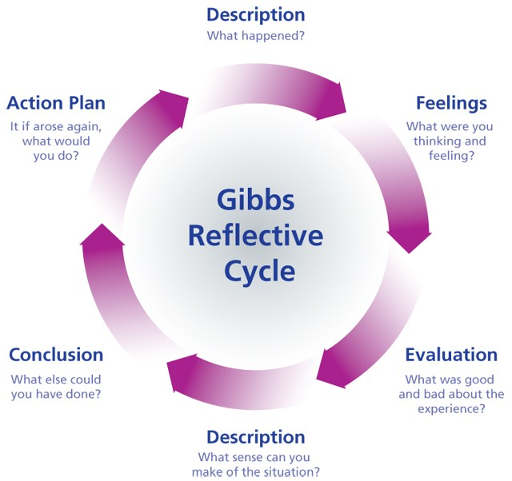
Gibbs (1988)
This model is used to help you reflect on things you have learnt and how to move in the right direction.

3.1 Description

When I have applied for jobs in the past, I have used the job centre or our local paper. Times have changed and the internet is used instead of having to go into a job centre or look through local papers. Applying for jobs is different for most companies. Some use the application process where you have to fill in all your details, others request a cv before you get to the interview stage. A cv is your personal detailed background of work history, qualifications and gives an idea of the type of person you are with any interests and hobbies you may have.
I came across this job on a site called CV library. The job involves more responsibility and a step up from where I currently am now. It was pretty easy to apply, no time wasted on filling out an application all they required was my CV which I also sent with a cover letter.

CV (see appendix C)
Job application ( see appendix D)

3.2 Feelings

Job hunting have become so much simpler with the internet. I found it overwhelming at first with the number of jobs available. I found a job I was interested in the information provided about the job was clear and easy for me to understand. I also found it quite simple to apply by uploading my CV and my cover letter. This gave me some confidence and if I ever need to apply for any jobs again in the future, I will feel confident to be able to do it.

3.3 Evaluation

Searching for jobs is not great when you lack in confidence and knowledge, before applying it took me a few hours to be able to follow through due to my lack of confidence. but once I saw how easy and quick it can be done it made me feel empowered and confident to do it again if ever needed. this part in Gibbs (1988) reflective cycle helped me understand myself a little bit more.

3.4 Analysis

After applying for this position, I was contacted on the telephone by the company wanting to know a little bit more about me. I was available to talk at the time and answer all questions needed. they then told me they would be in contact either by telephone or email. I was contacted by telephone for an interview, I was available to talk so we completed the interview there and then. As I was available on both calls it worked better for me due to my lack of confidence as I had no time to think and talk myself out of it. So, on this occasion it worked out well for me.

3.5 Conclusion

This whole experience can be very worrying, from beginning to end it turned out to be a simple and quick to complete and made me feel confident to do this again when I would need to. I was lucky to have gotten the telephone calls when I did as I did not have time to over think and panic. This will be something I will need to work on as not all calls would be a surprise, they would be booked in advance.

3.6 Action Plan

Using Gibbs (1988) model I will be able to monitor my development, I will update my PDP every three months to make sure I am improving on my weaknesses I found by creating a swot, and by continuing my one to ones with my management team, using their feedback to help update my PDP.

References

VARK Learn Limited. “VARK Questionnaire.” VARK - A Guide to Learning Preferences, 2020, vark-learn.com/the-vark-questionnaire/?p=results. Accessed 26 Nov. 2020. Honey, P. and Mumford, A. (1986b) Learning Styles Questionnaire, Peter Honey Publications Ltd.
Dantec, C. and Mozzon - McPherson, M. (2006). Supporting Independent Learning through Explicit Strategy – Based Training. In: Supporting Independent Language Learning: Issues and Interventions. Berlin: Peter Lang.

https://www.ebusinessweekly.co.zw/building-customer-relationships/
Gilbert, Andy. Go Mad : The Art of Making a Difference. Leicester, Go Mad Books, 2005.
Luft, J., Ingham, H., (1955) The Johari Window: a graphic model for interpersonal relations, Los Angeles, University of California Western Training Lab.
Gibbs, G. (1988). Learning by doing: A guide to teaching and learning methods. London: Further Education Unit.

Appendix A
Myself

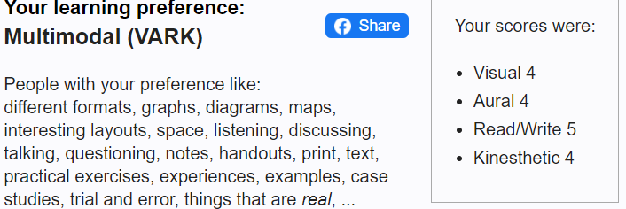

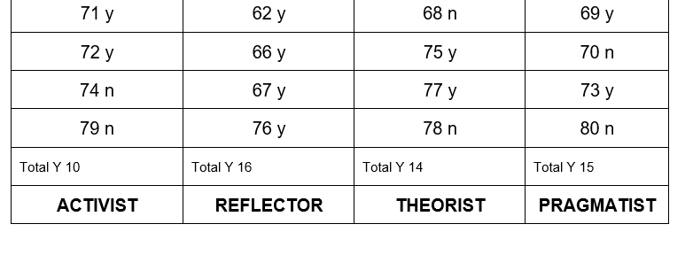
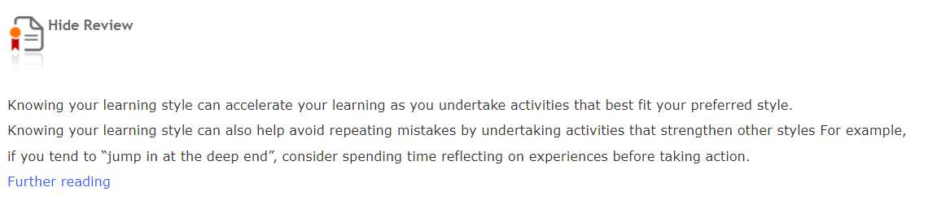

Team member

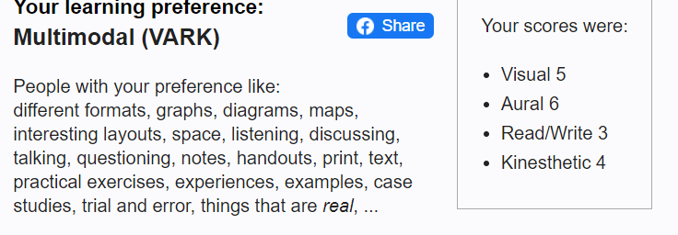

Appendix B

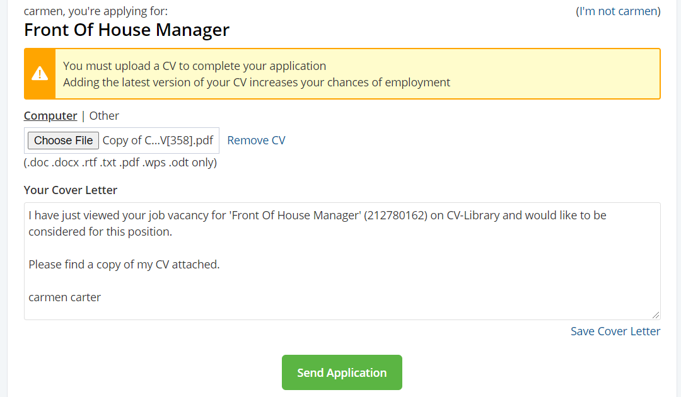

Appendix C

Appendix D
Cover letter
Carmen Carter
07368260249

I have just viewed your job vacancy for 'Front of House Manager' (212780162) on CV-Library and would like to be considered for this position.
I have 13 years’ experience in the hospitality industry. The role you have advertised for is very appealing to me as I am ready to develop my career. I have excellent customer service skills, experience with working alone or part of a team. I work well under pressure.
I feel I can offer your company some fresh eyes and to learn more about the company and help it move forward and develop in the future.

Please find a copy of my CV attached.

I look forward to hearing from you.

Kind Regards

Carmen carter

