University of Wales Trinity Saint David


Wales Institute of Science & Art
BEng Manufacturing Systems Engineering
Module: Control & Automation (ACMA5001)
Assignment Title: Application of automation in wastewater treatment
Name: Mathew Soroka
Student ID: 2406846
Date: April 2026
Total Word count = 2746 words
Table of Contents
Table of Figures 2
1. Introduction 3
2. Process Overview 4
3. Control System Topology 6
4. Control Systems and Strategies 8
5. Sensors in Wastewater Treatment Systems 11
6. Actuators 14
7. History 16
8. Advanced Technology 18
9. Standards and Regulations 19
10. Conclusion 20
11. References 21
12. Bibliography 24

Table of Figures
Figure 1: Wastewater Treatment Process (Source: Tyagi, 2025) 4
Figure 2: Wastewater control system topology (Source: Author, AI generated using Microsoft Copilot, 2026) 6
Figure 3: PID Controller (Source: Chen, 2024) 8
Figure 4: PLC ladder logic for pump control (Source: Instrumentation Tools, 2023) 10
Figure 5: Example of SCADA System (Source: Boughton, 2013) 11
Figure 6: Common level sensing technologies used in wastewater treatment (Source: Welander, 2007) 12
Figure 7: IoT system for remote sensor monitoring through cloud connectivity (Source: Renke, 2026) 13
Figure 8: Key actuator types in wastewater treatment (Source: Author, AI generated using Microsoft Copilot, 2026) 15
Figure 9: Watt flyball governor illustrating mechanical closed-loop feedback control (Source: Christen, 2022) 17

Introduction
Wastewater treatment removes physical, chemical and biological contaminants from used water so that it can be safely returned to the environment or reused. Although water appears abundant, only around 0.03 percent is available for human use, making it a limited and valuable resource (Osman, 2014). Population growth, industrial activity and climate pressures continue to increase demand, placing greater pressure on available supplies. This requires wastewater to be treated to a consistently high standard, since natural ecosystems have limited capacity to absorb pollutants without long term degradation.
Automation has become essential in meeting these challenges. Modern facilities rely on integrated instrumentation, control and automation systems to maintain stable operation under variable influent conditions. Sensors monitor key parameters such as pH, dissolved oxygen and nutrient concentrations, while controllers regulate pumps, valves and aeration systems through supervisory platforms. These systems operate within a strict regulatory framework, with the Environment Agency enforcing discharge standards to ensure environmental protection (Yates et al., 2019).

Process Overview
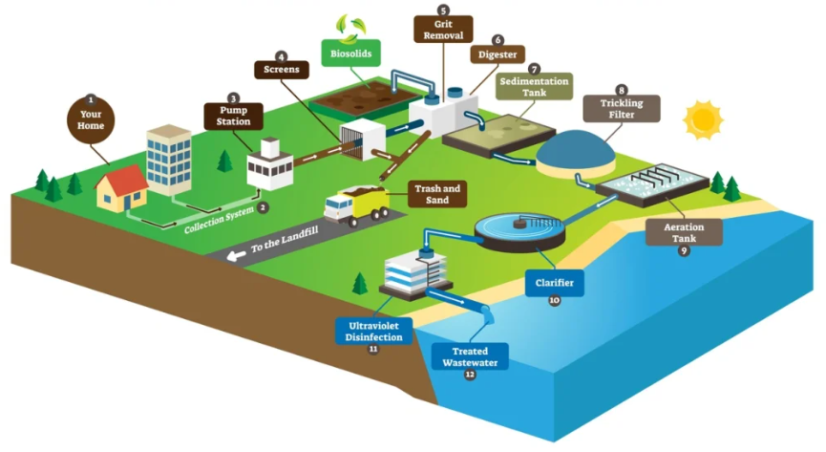
The wastewater treatment process can be interpreted as a control problem in which varying conditions must be regulated to achieve a consistent effluent. Crini and Lichtfouse (2019) identify that wastewater treatment plants are designed to achieve cost effective pollutant removal through sequential stages, commonly classified as preliminary, primary, secondary and tertiary treatment. However, rather than functioning as a simple sequence of tanks, the process operates as an integrated system in which multiple variables must be controlled simultaneously. Wastewater composition and flow vary due to changes in population activity, weather conditions and industrial discharge, while effluent standards remain fixed. This variability necessitates continuous monitoring and feedback control to maintain stable operation. The overall process is illustrated in Figure 1.
Figure 1: Wastewater Treatment Process (Source: Tyagi, 2025)
The process begins at the source, where wastewater is generated from domestic and industrial properties and enters the collection system. This network transports wastewater to pump stations, where flow and level must be controlled to prevent surcharging and ensure consistent delivery to the treatment plant.

Initial treatment removes large debris and grit using screening and grit removal processes. Control focuses on flow rate and channel level to maintain stable hydraulic conditions and protect downstream equipment. The process then progresses through the main treatment stages, where increasingly advanced methods are applied to achieve the required effluent quality.
During primary treatment, suspended solids are removed through sedimentation, requiring control of flow distribution and solids residence time to maximise settling efficiency and minimise carryover. Samer (2015) explains that secondary treatment relies on microbial processes to degrade organic matter and nutrients. Dissolved oxygen is regulated through aeration systems, while parameters such as pH, sludge age and recirculation rates are adjusted to maintain stable biological performance. Clarification removes remaining suspended solids.
Kato and Kansha (2024) highlight that tertiary treatment requires precise control of nutrient concentration and disinfection to meet discharge standards. Filtration, nutrient removal and ultraviolet disinfection must therefore be carefully regulated.
In practice, these control functions are implemented through integrated automation systems, where sensors provide real-time data to PLCs and SCADA platforms, enabling continuous monitoring and adjustment of process conditions.

Control System Topology
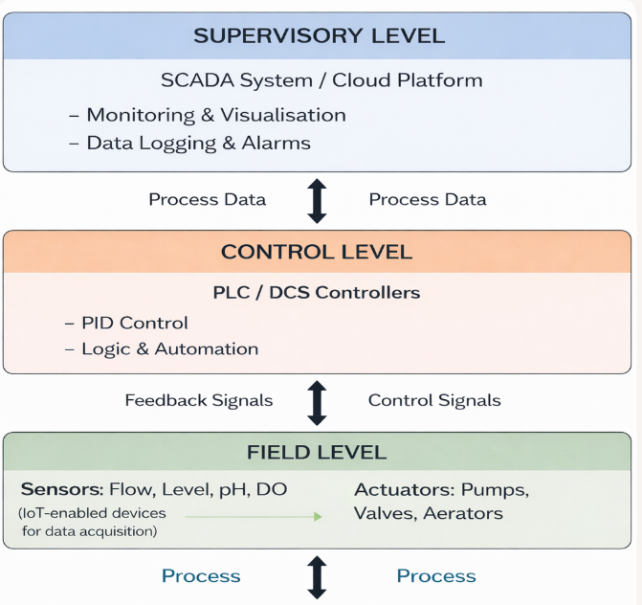
The performance of a wastewater treatment plant depends not only on individual components but on the overall control topology, which defines how measurement, control and actuation are structured across the system. Industrial control systems, including SCADA, distributed control systems and programmable logic controllers, underpin modern wastewater treatment operations, where hierarchical control structures manage complex and interconnected processes (Rao et al., 2017). This hierarchy is typically divided into supervisory, control and field levels (Figure 2).
Figure 2: Wastewater control system topology (Source: Author, AI generated using Microsoft Copilot, 2026)

At the supervisory level, SCADA systems provide centralised monitoring, data logging and alarm management. Operators can visualise plant performance, identify trends and intervene when necessary to maintain stable operation. SCADA coordinates plant wide processes and supports informed decision making by presenting real time data from across the facility.
At the control level, programmable logic controllers receive inputs from field devices and execute control strategies. PLCs are widely recognised as the primary automation devices in industrial systems, replacing relay-based control and enabling flexible, programmable operation through central processing, memory and input and output modules (Hudedmani et al., 2017). These controllers apply algorithms, typically proportional integral derivative control, to maintain stable process conditions under varying loads.
At the field level, sensors and actuators interact directly with the physical process. Sensors measure variables such as flow, level, dissolved oxygen and pH, while actuators including pumps, valves and aeration systems respond to control signals. These elements form local feedback loops that maintain stable operation. Increasing integration of Internet of Things technologies enhances data acquisition and connectivity. This hierarchical topology provides the structural foundation for regulating process performance.

Control Systems and Strategies
Control systems in wastewater treatment can be classified as open loop or closed loop. Open loop systems operate without feedback, while closed loop systems adjust outputs based on measured conditions. Because influent characteristics vary significantly, wastewater treatment relies on closed loop control, where sensors, controllers and actuators work together to maintain stable operation.
PID control is one of the most widely used strategies in engineering practice due to its simplicity and dependable performance. Chen (2024) notes that PID control remains dominant because it performs well even when system parameters are not fully known. A PID controller generates an output based on the error between the setpoint and the measured variable, expressed in equation [1]:
$u(t) = Kp·e(t) + Ki∫e(t)dt + Kd·de(t)/dt$ [1]
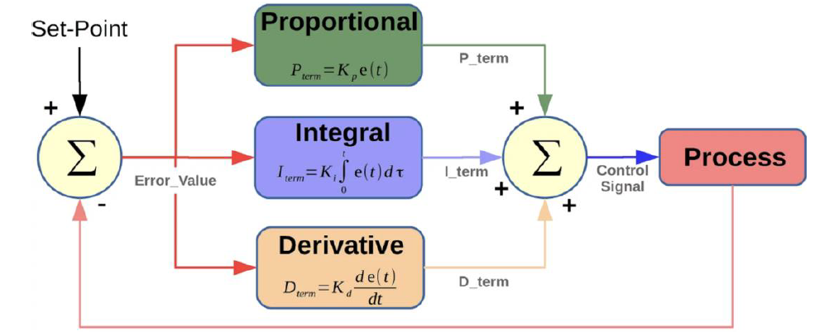
Where u(t) is the control output, e(t) is the error, and Kp, Ki and Kd are the controller gains. The proportional term responds to current error, the integral term removes steady state offset, and the derivative term predicts future behaviour. Figure 3 illustrates how these actions combine to form the overall control signal. In wastewater treatment, PID control is widely applied to dissolved oxygen regulation in aeration tanks.
Figure 3: PID Controller (Source: Chen, 2024)

.

Adaptive control can improve performance under highly variable conditions by adjusting controller parameters in real time. This is particularly relevant when influent load or biological activity changes, reducing the effectiveness of fixed parameter PID control.
Programmable logic controllers form the core of real time control. PLCs receive signals from field devices, execute programmed logic and generate outputs to control pumps, valves and aeration systems. Ladder logic is commonly used to implement strategies such as pump control, where level signals prevent rapid cycling and ensure safe operation. In a typical arrangement, a high-level input becomes true, which latches an internal coil and drives the pump output. The pump continues to run until the low-level input becomes true, which breaks the latch and turns the pump off. This simple arrangement ensures reliable start and stop behaviour while avoiding unnecessary switching (Figure 4).
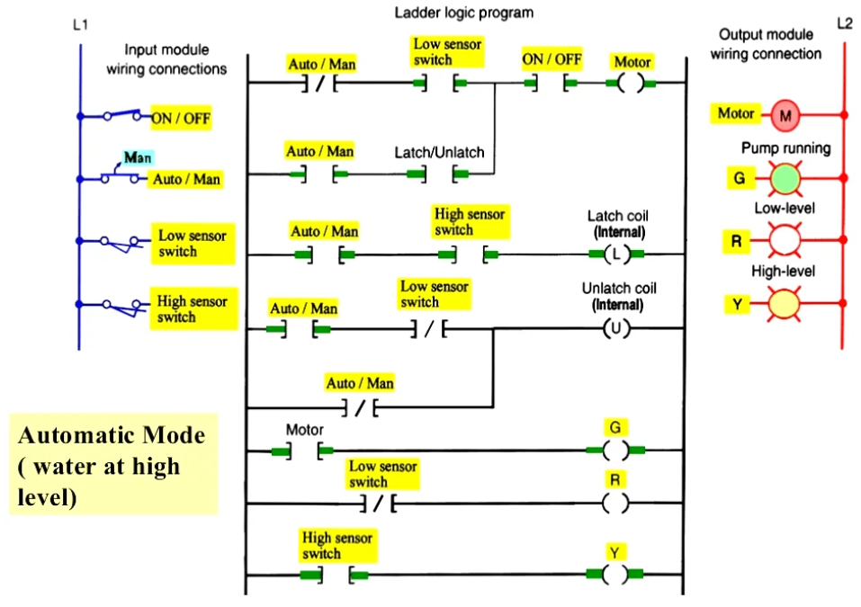
Figure 4: PLC ladder logic for pump control (Source: Instrumentation Tools, 2023)
PLCs are widely used due to their robustness and flexibility. Alphonsus and Abdullah (2016) note that PLCs offer strong noise immunity and modular expansion. At a higher level, supervisory control and data acquisition systems provide centralised monitoring, data logging and alarm management. SCADA platforms collect real time data from PLCs and present it through graphical displays, supporting informed decision making. Communication across larger facilities is achieved
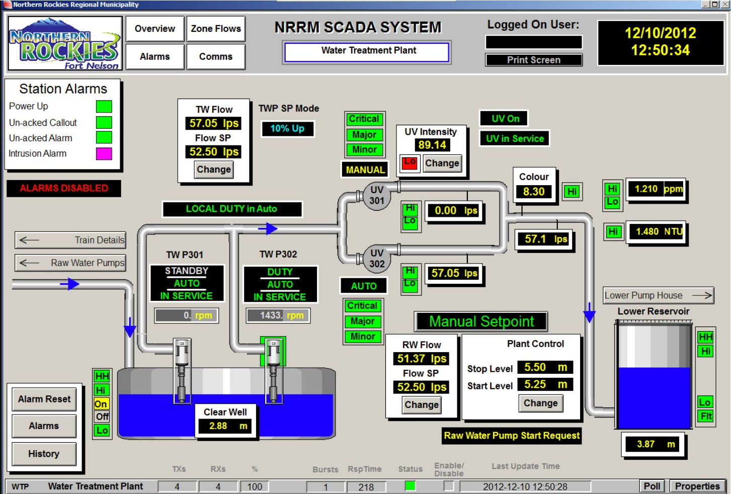
through industrial protocols such as fieldbus and industrial Ethernet, although increased connectivity introduces cybersecurity risks that require secure system design. An example of a typical SCADA set up is shown in Figure 5.
Figure 5: Example of SCADA System (Source: Boughton, 2013)

Sensors in Wastewater Treatment Systems
Instrumentation is essential to effective automation in wastewater treatment because control performance depends on the quality and stability of sensor measurements. As Olsson et al. (2005) emphasise, even well-designed control strategies cannot compensate for inaccurate or drifting data. Wastewater presents a harsh environment, with turbulence, solids, biofilm and chemical exposure all challenging sensor reliability and increasing the need for robust measurement technologies.

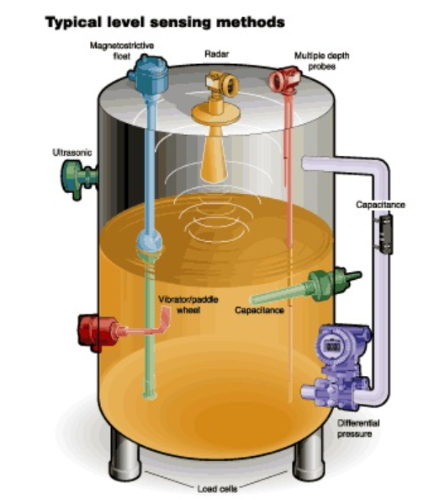
Flow, level and pressure measurements form the foundation of hydraulic control across the treatment process. Flow sensors are installed at influent channels, recirculation lines and final discharge points to monitor hydraulic loading and ensure compliance with permit conditions. However, debris, ragging and variable flow profiles can introduce measurement noise and instability. Level sensors are widely used in wet wells, tanks and clarifiers to prevent overflow, maintain pump protection and regulate flow distribution.
Figure 6: Common level sensing technologies used in wastewater treatment (Source: Welander, 2007)

As illustrated in Figure 6, wastewater facilities use a range of level sensing technologies including ultrasonic, radar, differential pressure and float-based devices to suit different process conditions (Welander, 2007). Turbulence, foam and grease layers can distort readings, while differential pressure sensors are sensitive to density variations caused by solids concentration. Pressure sensors are used in pumping systems to detect blockages, leaks and abnormal operating conditions, but are prone to drift and require regular calibration to maintain accuracy in corrosive environments (Morris, 2001).
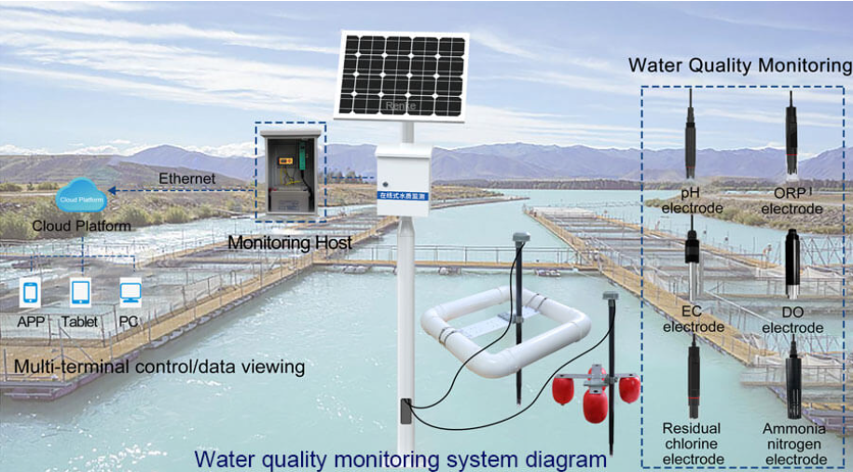
Chemical and biological process control relies heavily on pH, dissolved oxygen (DO) and turbidity measurements. pH sensors are essential where chemical dosing or discharge compliance is required, yet they are vulnerable to fouling, scaling and chemical attack. DO sensors are critical in aeration tanks because oxygen concentration directly influences microbial activity and energy consumption. Turbidity sensors measure water clarity and detect solids carryover, providing an indication of treatment performance.
Figure 7: IoT system for remote sensor monitoring through cloud connectivity (Source: Renke, 2026)
As represented in Figure 7, modern monitoring systems increasingly use networked architectures, where sensors transmit data to local processing units for digitisation and onward communication to supervisory systems. This enables real-time monitoring, automated analysis and remote access via control room systems or mobile devices.
Most wastewater sensors interface with PLCs using 4–20 mA analogue signals, which are robust against electrical noise. The live zero at 4 mA allows fault detection such as signal loss when the 4 mA drops to 0mA. Some sensors also support digital communication via Fieldbus protocols for diagnostics and configuration.
Sensor faults including drift, fouling and signal noise propagate directly into control loops. Chen et al. (2025) demonstrate that unstable measurements can lead to oscillation, overdosing or inefficient operation. This highlights a key limitation of automation: overall control performance is constrained by sensor reliability rather than controller sophistication.

Actuators
Actuators form the final element in the automation chain, converting PLC control signals into mechanical actions that move water, adjust flows or deliver air and chemicals. Their performance determines how effectively the control system can implement decisions based on sensor data, making them essential for stable and efficient operation.
Pumps are the most widely used actuators in wastewater treatment, responsible for transferring wastewater, sludge and return flows between process stages. Variable-speed pumps allow the PLC to match flow rates to real-time conditions, improving energy efficiency and reducing hydraulic shock. Valves provide another critical actuator function by regulating flow paths, isolating equipment and controlling chemical dosing. Motor-driven or pneumatic valves can modulate position continuously, enabling precise adjustment of aeration air supply, sludge wasting or reagent addition.
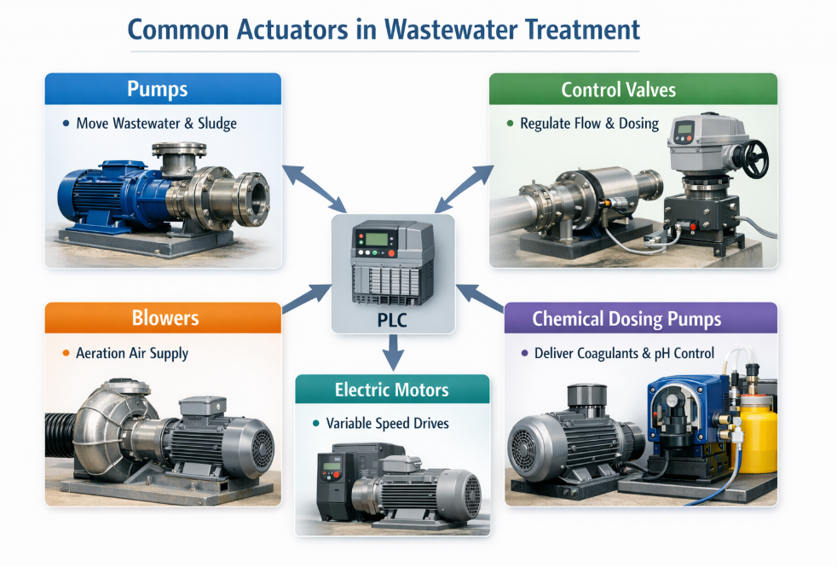
The main actuator types used in wastewater treatment include pumps, valves, blowers, electric motors and chemical dosing pumps, as illustrated in Figure 8. The diagram clarifies how each actuator is driven by PLC commands, reinforcing their role as the physical execution layer of the control system.
Figure 8: Key actuator types in wastewater treatment (Source: Author, AI generated using Microsoft Copilot, 2026)

Blowers are major energy-consuming actuators and play a central role in biological treatment. Their output determines the rate of oxygen transfer in aeration tanks, directly influencing microbial activity and nutrient removal. Amand and Carlsson (2012) show that blower responsiveness strongly affects dissolved oxygen stability, with slow or oscillatory behaviour increasing energy use and reducing treatment efficiency. Electric motors, often paired with variable-speed drives, provide finer control than fixed-speed operation and are used on pumps, mixers and blowers to improve process flexibility and energy performance. Chemical dosing pumps deliver coagulants, pH correction chemicals and disinfectants, with accuracy dependent on calibration and suction conditions.
Actuator performance is closely linked to the quality of the control signals they receive. Rosén et al. (2008) highlight that poor actuator response can limit the achievable performance of even well-designed control strategies, particularly in nutrient removal processes where rapid adjustments are required.

History
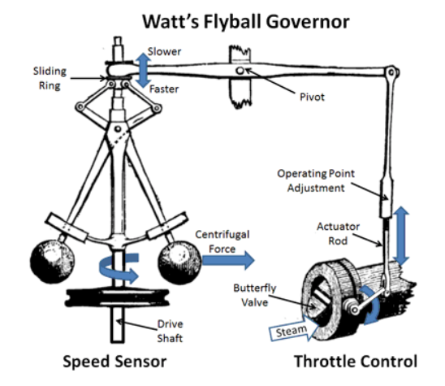
The development of modern control systems can be traced to early mechanical devices that demonstrated the principle of feedback. A key example is the flyball governor, developed by James Watt in the late eighteenth century, which regulated steam engine speed by adjusting steam input in response to rotational changes. Figure 9 shows how the system uses a speed sensor, mechanical linkage and throttle valve to form a closed loop feedback mechanism. Annaswamy (2025) argues that the governor did not arise from a single invention but from wider industrial demands, showing that control systems evolved in response to increasing process requirements.
Figure 9: Watt flyball governor illustrating mechanical closed-loop feedback control (Source: Christen, 2022)

Early mechanical systems were limited by non-analytical design approaches and lacked a formal understanding of stability. Bennett (1993) notes that these limitations often caused oscillations and inefficient performance. The introduction of mathematical modelling and differential equations marked the emergence of classical control theory, enabling more reliable and predictable system design.
As industrial processes became more complex, particularly in water and wastewater treatment, mechanical systems were replaced by electrical relay-based control, improving reliability and flexibility. This progression continued with the introduction of programmable logic controllers in the 1970s, enabling real time digital control of multiple process variables. Modern systems now integrate PLCs with supervisory control and data acquisition, supporting fully automated and networked operation.

Advanced Technology
Advanced digital technologies are increasingly used to improve the efficiency, reliability and sustainability of wastewater treatment. Smart sensors and Internet of Things enabled monitoring platforms provide high-resolution, plant-wide data that support early disturbance detection and more proactive operational decisions. Combined with cloud-based analytics, these systems also enable predictive maintenance by identifying emerging equipment issues such as pump vibration anomalies or sensor drift, reducing downtime and avoidable energy use.
Digital twins represent a major recent development. A digital twin creates a real-time virtual model of the treatment plant that mirrors biological, hydraulic and energy behaviour, allowing operators to test aeration strategies, chemical dosing or pump schedules without affecting the physical system. This approach has been demonstrated as an effective framework for real-time optimisation in water and wastewater systems (Ramos et al., 2023). Soft sensors further support advanced automation by estimating difficult-to-measure variables such as ammonia, nitrate or chemical oxygen demand, improving control accuracy and reducing reliance on laboratory analysis.
Energy optimisation remains a key driver for advanced control, particularly because aeration accounts for a large proportion of electricity use. This aligns with wider sustainability objectives, as highlighted in recent environmental technology research (Khan et al., 2022). Artificial intelligence assisted optimisation has also shown promising results, with systems integrating PLCs and long short-term memory models to optimise dosing, aeration intensity and sediment separation using real-time data, reducing energy consumption while improving effluent quality.

Standards and Regulations
Wastewater treatment processes are governed by strict environmental regulations designed to protect public health and receiving water bodies. In the UK, discharge permits issued under the Environmental Permitting Regulations set limits on key parameters such as biochemical oxygen demand, ammonia, suspended solids and nutrient concentrations (Gov.uk, 2016). These limits act not only as compliance thresholds but also as performance drivers, requiring treatment plants to maintain precise and continuous process control to avoid environmental harm and regulatory penalties.
The Urban Wastewater Treatment Regulations reinforce this by requiring the identification and ongoing review of sensitive areas where more stringent treatment is necessary (Gov.uk, 2013). This demonstrates that wastewater regulation is dynamic, with treatment requirements adapting to environmental conditions. Plants must therefore consistently meet higher performance standards, particularly in regions where nutrient removal and process stability are critical.
As a result, regulatory frameworks drive the adoption of advanced instrumentation, control and automation systems. Continuous monitoring through sensors and supervisory control via PLC and SCADA platforms is essential to ensure real-time compliance. Regulation therefore not only enforces environmental protection but also shapes system design, operational reliability and process optimisation in modern wastewater treatment.

Conclusion
The analysis shows that effective wastewater treatment depends on the integration of reliable instrumentation, robust control strategies and well-designed automation architectures. While conventional systems such as PLC based control and PID regulation provide dependable performance, their effectiveness can be limited under highly variable influent conditions. Issues such as sensor drift, biological instability and changing load profiles highlight the need for continuous monitoring and adaptive control capability. These challenges demonstrate that treatment plants must balance operational stability with energy efficiency, particularly in processes such as aeration where electricity demand is significant. Advanced technologies including soft sensors, digital twins and data driven optimisation offer clear benefits, yet their performance depends on accurate modelling, high quality data and appropriate operator oversight.
Overall, the findings indicate that modern wastewater treatment requires a coordinated approach that combines established control methods with emerging digital tools. Automation enhances reliability, supports regulatory compliance and enables more efficient use of energy and chemicals. As environmental standards become more stringent and influent variability increases, the role of advanced monitoring and intelligent control will continue to grow. The integration of these technologies strengthens process resilience and supports the long-term sustainability of wastewater treatment operations.

References
Alphonsus, E.R. and Abdullah, M.O. (2016). A Review on the Applications of Programmable Logic Controllers (PLCs). Renewable and Sustainable Energy Reviews, [online] 60, pp.1185–1205. doi:https://doi.org/10.1016/j.rser.2016.01.025. [Accessed 1 Apr. 2026].
Åmand, L. and Carlsson, B. (2012). Optimal Aeration Control in a Nitrifying Activated Sludge Process. Water Research, [online] 46(7), pp.2101–2110. doi:https://doi.org/10.1016/j.watres.2012.01.023. [Accessed 20 Mar. 2026].
Annaswamy, A. (2025). Feedback: Origins to Practice–An Examination of James Watt and His Flyball Governor [From the Editor]. IEEE Control Systems, [online] 45(6), pp.3–4. doi:https://doi.org/10.1109/mcs.2025.3614475. [Accessed 15 Mar. 2026].
Bennett, S. (1993). A History of Control Engineering 1930-1955. [online] London: Peter Peregrinus, Cop. Available at: https://books.google.co.uk/books?hl=en&lr=&id=VD_b81J3yFoC&oi=fnd&pg=PR7&dq=Bennett,+S.+(1993)+A+history+of+control+engineering+1930%E2%80%931955&ots=SLwX17NhIf&sig=WUMtwYdhyKbmadeB9-Vqvb-Tp3E#v=onepage&q=Bennett%2C%20S.%20(1993)%20A%20history%20of%20control%20engineering%201930%E2%80%931955&f=false [Accessed 5 Apr. 2026].
Boughton, P. (2013). Fully Automated SCADA System for Water and Wastewater Treatment | Engineer Live. [online] Engineerlive.com. Available at: https://www.engineerlive.com/content/fully-automated-scada-system-water-and-wastewater-treatment [Accessed 2 Apr. 2026].
Boyer, S.A. (2004). SCADA. [online] ISA. Available at: http://www.iqytechnicalcollege.com/Scada_%20Supervisory%20Control%20And%20Data%20Acquisition.pdf [Accessed 1 Apr. 2026].
Chen, R. (2024). A Comprehensive Analysis of PID Control Applications in Automation Systems: Current Trends and Future Directions. Highlights in science, engineering and technology, [online] 97, pp.126–132. doi:https://doi.org/10.54097/6q4xxg69. [Accessed 19 Mar. 2026].
Chen, S., Wang, X., Bi, X. and Maletskyi, Z. (2025). Sensor Fault Characteristics and Fault Detection in Wastewater Treatment plants: Current Status and Trend Analysis. Journal of Process Control, [online] 155, p.103574. doi:https://doi.org/10.1016/j.jprocont.2025.103574. [Accessed 17 Mar. 2026].
Christen, R. (2022). The Centrifugal Govenor: James C. Maxwell’s Inspiration for Modern Control Theory. [online] Medium. Available at: https://medium.com/@robinchristen/the-centrifugal-govenor-james-c-maxwells-inspiration-for-modern-control-theory-f60f2ace833e [Accessed 4 Apr. 2026].
Crini, G. and Lichtfouse, E. (2018). Advantages and Disadvantages of Techniques Used for Wastewater Treatment. Environmental Chemistry Letters, [online] 17. doi:https://doi.org/10.1007/s10311-018-0785-9. [Accessed 14 Mar. 2026].
Gov.uk (2013). The Urban Waste Water Treatment (England and Wales) (Amendment) Regulations 2003. [online] Legislation.gov.uk. Available at: https://www.legislation.gov.uk/uksi/2003/1788 [Accessed 2 Apr. 2026].
Gov.uk (2016). The Environmental Permitting (England and Wales) Regulations 2016. [online] Legislation.gov.uk. Available at: https://www.legislation.gov.uk/uksi/2016/1154/contents [Accessed 2 Apr. 2026].
Hudedmani, M.G., Umayal, R.M., Kabberalli, S.K. and Hittalamani, R. (2017). Programmable Logic Controller (PLC) in Automation. Advanced Journal of Graduate Research, [online] 2(1), pp.37–45. doi:https://doi.org/10.21467/ajgr.2.1.37-45. [Accessed 10 Mar. 2026].
Instrumentation Tools (2023). PLC Program for Water Level Control | PLC Level Control Ladder Logic. [online] Instrumentation Tools. Available at: https://instrumentationtools.com/plc-program-water-level-control/ [Accessed 31 Mar. 2026].
Kato, S. and Kansha, Y. (2024). Comprehensive Review of Industrial Wastewater Treatment Techniques. Environmental Science and Pollution Research, [online] 31(39), pp.51064–51097. doi:https://doi.org/10.1007/s11356-024-34584-0. [Accessed 26 Mar. 2026].
Khan, S.A.R., Ponce, P., Yu, Z., Golpîra, H. and Mathew, M. (2022). Environmental Technology and Wastewater treatment: Strategies to Achieve Environmental Sustainability. Chemosphere, [online] 286, p.131532. doi:https://doi.org/10.1016/j.chemosphere.2021.131532. [Accessed 26 Mar. 2026].
Microsoft Co-Pilot (2026). Figure 8: Key Actuator Types in Wastewater Treatment (Source: Author, AI-generated Using Microsoft Copilot, 2026). Available at: https://copilot.microsoft.com/ [Accessed 8 Apr. 2026].
Microsoft Co-Pilot (2026). Figure 2: Wastewater Control System Topology (Source: Author, AI Generated Using Microsoft Copilot, 2026). Available at: https://copilot.microsoft.com/ [Accessed 1 Apr. 2026].
Moldovan, A. and Nuca, I. (2019). Automation of Wastewater Treatment Plant. 2019 International Conference on Electromechanical and Energy Systems (SIELMEN). [online] doi:https://doi.org/10.1109/sielmen.2019.8905867. [Accessed 19 Mar. 2026].
Morris, A.S. (2001). Measurement and Instrumentation Principles. [online] Oxford: Butterworth-Heinemann. Available at: https://www.sciencedirect.com/book/monograph/9780750650816/measurement-and-instrumentation-principles [Accessed 6 Apr. 2026].
Olsson, G., Nielsen, M., Yuan, Z. and Steyer, J.-P. (2005). Instrumentation, Control and Automation in Wastewater Systems. [online] IWA Publishing. Available at: https://books.google.co.uk/books?hl=en&lr=&id=RW6aprXf7l0C&oi=fnd&pg=PR4&dq=Olsson,+G.+(2012).+Instrumentation,+Control+and+Automation+in+Wastewater+Systems.+IWA+Publishing.&ots=gC467IMYhN&sig=QWU1YkCXCmS_BtJ8l3sm5x7Owfk#v=onepage&q&f=false [Accessed 6 Apr. 2026].
Osman, M. (2014). Waste Water Treatment in Chemical Industries: the Concept and Current Technologies. Journal of Waste Water Treatment & Analysis, [online] 05(01). doi:https://doi.org/10.4172/2157-7587.1000164. [Accessed 23 Mar. 2026].
Ramos, H.M., Kuriqi, A., Coronado-Hernández, O.E., López-Jiménez, P.A. and Pérez-Sánchez, M. (2023). Are Digital Twins Improving urban-water Systems Efficiency and Sustainable Development goals? Urban Water Journal, [online] pp.1–13. doi:https://doi.org/10.1080/1573062x.2023.2180396. [Accessed 20 Mar. 2026].
Rao, B.S., Chakravarthi, Ch.Vishnu., Jawaha, A. and International Journal for Modern Trends in Science and Technology eds., (2017). Industrial Control Systems Security and Supervisory Control and Data Acquisition (SCADA. [online] Academia.edu. Available at: https://www.academia.edu/35009639/Industrial_Control_Systems_Security_and_Supervisory_Control_and_Data_Acquisition_SCADA?auto=download [Accessed 30 Mar. 2026].
Renke (2026). Top 11 Water Quality Sensors for Water Treatments Easily - Renke. [online] Renke. Available at: https://www.renkeer.com/top-7-water-quality-sensors/ [Accessed 6 Apr. 2026].
Rosen, C., Rieger, L., Jeppsson, U. and Vanrolleghem, P.A. (2008). Adding Realism to Simulated Sensors and Actuators. Water Science and Technology, [online] 57(3), pp.337–344. doi:https://doi.org/10.2166/wst.2008.130. [Accessed 14 Apr. 2026].
Samer, M. (2015). Biological and Chemical Wastewater Treatment Processes. Wastewater Treatment Engineering. [online] doi:https://doi.org/10.5772/61250. [Accessed 9 Apr. 2026].
Tyagi, S. (2025). How to Run a Wastewater Treatment Plant: a Step-by-Step Guide for New Operators. [online] Sewage Treatment Plant | Packaged STP | SUSBIO ECOTREAT. Available at: https://susbio.in/how-to-run-a-wastewater-treatment-plant/ [Accessed 29 Mar. 2026].
Welander, P. (2007). Choosing Level Sensors - Control Engineering. [online] Control Engineering. Available at: https://www.controleng.com/choosing-level-sensors/ [Accessed 5 Apr. 2026].
Yates, C.A., Johnes, P.J. and Spencer, R.G.M. (2019). Characterisation of Treated Effluent from Four Commonly Employed Wastewater Treatment facilities: a UK Case Study. Journal of Environmental Management, [online] 232, pp.919–927. doi:https://doi.org/10.1016/j.jenvman.2018.12.006. [Accessed 5 Apr. 2026].

Bibliography
Spanish Fork City (2022). WasteWater Treatment Plant • from Beginning to End. [online] www.youtube.com. Available at: https://www.youtube.com/watch?v=aSTFFhk3tzM [Accessed 02 Mar. 2026].

