

Predicting Stock Market Trends Using Machine Learning: An Analysis of Apple Stock (AAPL)

by

Dharmik Kanaiyalal Vaidya

Supervisor: Mohamed Ben Farah
Second Marker:

Project submitted as part of the requirements for the award of MSc Data & AI

Abstract
This study explores the use of deep learning models for predicting stock prices, focusing on Apple Inc. (AAPL) as the case study. Three architectures—Long Short-Term Memory (LSTM), Bidirectional Gated Recurrent Unit (BiGRU), and a hybrid CNN–LSTM—were implemented and evaluated. Historical stock data from Yahoo Finance was preprocessed and enriched with technical indicators to improve model performance. The evaluation results show that the LSTM model achieved an RMSE of 8.9765 and R² score of 0.7777, while the BiGRU model improved performance with an RMSE of 6.1301 and R² score of 0.8963. The CNN–LSTM model delivered the best results, achieving the lowest RMSE of 5.0403 and highest R² score of 0.9299, along with reduced MSE and MAE values. These findings indicate that the hybrid model more effectively captures both short-term fluctuations and long-term trends in financial data. Despite its superior performance, limitations such as dependence on historical data and lack of interpretability remain. The study concludes that hybrid deep learning approaches offer a more accurate and reliable framework for stock price prediction.

Keywords: Stock Price Prediction, Deep Learning, LSTM, BiGRU, CNN-LSTM, Time-Series Forecasting, Financial Analytics

Acknowledgements

The researcher would like to express sincere gratitude to the University of Wales for providing the academic environment and resources necessary to successfully complete this study. The support and facilities offered by the institution have played a significant role in the development of this research.

Special appreciation is extended to the project supervisor Mohamed Ben Farah for their continuous guidance, valuable feedback, and constructive suggestions throughout the research process. Their expertise and encouragement were instrumental in shaping the direction and quality of this work.

The researcher also acknowledges the support of faculty members and peers who contributed through discussions and insights during the course of this project. Finally, heartfelt thanks are given to family and friends for their constant encouragement and support, which helped in successfully completing this research.

Table of Contents
Abstract iii
List of Tables vii
List of Figures viii
List of Acronyms ix
Chapter 1 Introduction 10
1.1 Background 13
1.2 Problem Statement 13
1.3 Research Question and Objectives 14
1.4 Expected Outcomes 15
Chapter 2 Literature Review 17
2.1 Overview of Stock Market Prediction Using Machine Learning 17
2.2 Impact of Deep Learning Techniques on Stock Market Prediction Accuracy 19
2.3 Effective Deep Learning Architectures for Financial Time-Series Modelling 20
2.4 Influence of Data Preprocessing on Model Performance 21
2.5 Adaptability of Deep Learning Models in Dynamic Financial Markets 22
2.6 Application of Machine Learning Models in Predicting Apple (AAPL) Stock Trends 23
2.7 Summary 24
Chapter 3 Design & Implementation 28
3.1 Research Design 28
3.2 Dataset Description and Acquisition 30
3.3 Exploratory Data Analysis (EDA) 32
3.4 Data Preprocessing 35
3.4.1 Data Cleaning 35
3.4.2 Feature Engineering 36
3.4.3 Feature Selection 37
3.4.4 Feature Scaling 37
3.4.5 Sequence Construction 37
3.4.6 Train-Test Split 38
3.5 Model Development 39
3.5.1 LSTM Model Development 39
3.5.2 Bidirectional GRU (BiGRU) Model Development 41
3.5.3 CNN-LSTM Hybrid Model Development 42
3.6 Model Training 44
3.7 Model Evaluation 45
3.8 Summary 45
Chapter 4 Results & Findings 47
4.1 LSTM Model Performance 47
4.1.1 Training Behavior and Loss Trends 48
4.1.2 Prediction Behavior: Actual vs Forecasted Values 48
4.2 Bi-Directional GRU Model Performance 49
4.2.1 Training Stability and Loss Analysis 50
4.2.2 Forecast Accuracy and Trend Alignment 51
4.3 Performance of CNN–LSTM Hybrid Model 51
4.3.1 Learning Behavior and Loss Dynamics 52
4.3.2 Prediction Accuracy and Market Sensitivity 52
4.4 Comparative Evaluation of Models 53
4.5 Critical Analysis of Results 55
4.6 Summary 57
Chapter 5 Conclusion & Future Work 59
5.1 Conclusion 59
5.2 Future Work 60
References 62

List of Tables
Table 1: Summary of Literature Review 24
Table 2: LSTM Model Performance 46
Table 3: Bi-GRU Model Performance 48
Table 4: CNN-LSTM Model performance 51
Table 5: Overall ALL Models Results 53

List of Figures
Figure 1: System Architecture 28
Figure 2: Downloading Dataset using Yahoo Finance 30
Figure 3: Sample data 30
Figure 4: Statistical Analysis 31
Figure 5: Correlation Heatmap 32
Figure 6: Pair Plots 33
Figure 7: Time series Analysis 33
Figure 8: Data Cleaning 34
Figure 9: Applying Feature Engineering 35
Figure 10: Applying Feature Selection 36
Figure 11: Appling Min-Max Scaler 36
Figure 12: Sequence Construction 37
Figure 13: Data Splitting 37
Figure 14: LSTM Model Building 38
Figure 15: Model Summary 39
Figure 16: Bi -GRU Model 40
Figure 17: Model Summary 41
Figure 18: CNN-LSTM Model 42
Figure 19: Model Summary 43
Figure 20: LSTM Model Loss Curve 47
Figure 21: Predicted vs Actual plot 48
Figure 22: Bi-GRU Loss curve 49
Figure 23: Bi-GRU model plot 50
Figure 24: CNN-LSTM Loss curve 51
Figure 25: Predicted vs Actual plot of CNN-LSTM Model 52
Figure 26: All models comparison plot 54

List of Acronyms
ANN | Artificial Neural Network
ARIMA | AutoRegressive Integrated Moving Average
AAPL | Apple Inc. (Stock Ticker)
BiGRU | Bidirectional Gated Recurrent Unit
CNN | Convolutional Neural Network
CNN–LSTM | Convolutional Neural Network – Long Short-Term Memory
DL | Deep Learning
EDA | Exploratory Data Analysis
EMA | Exponential Moving Average
GRU | Gated Recurrent Unit
LSTM | Long Short-Term Memory
MAE | Mean Absolute Error
MACD | Moving Average Convergence Divergence
MSE | Mean Squared Error
OHLCV | Open, High, Low, Close, Volume
ReLU | Rectified Linear Unit
RMSE | Root Mean Squared Error
RNN | Recurrent Neural Network
RSI | Relative Strength Index
R² | Coefficient of Determination
SMA | Simple Moving Average
XAI | Explainable Artificial Intelligence

Chapter 1 Introduction

The stock market represents one of the most dynamic and complex financial systems in the global economy, playing a crucial role in capital allocation, wealth creation, and economic growth. It facilitates the buying and selling of shares, enabling companies to raise capital while providing investors with opportunities for profit generation. However, stock market movements are highly volatile and influenced by a wide range of factors, including economic indicators, geopolitical events, company performance, investor sentiment, and market speculation (Fama, 1970). Among the various stocks traded globally, Apple Inc. (AAPL) is considered one of the most influential and widely analyzed technology stocks due to its significant market capitalization, consistent financial performance, and global brand presence (Yahoo Finance, 2023).

Predicting stock market trends, particularly for high-impact stocks such as Apple, has long been a major challenge for investors, analysts, and financial institutions. Traditional financial analysis techniques, including fundamental analysis and technical analysis, have been widely used to forecast stock price movements. Fundamental analysis focuses on evaluating a company's financial health through metrics such as revenue, earnings, and growth potential, while technical analysis relies on historical price patterns and trading indicators to predict future movements (Murphy, 1999). Although these approaches provide valuable insights, they often fail to capture the complex, non-linear relationships and hidden patterns present in financial data (Atsalakis and Valavanis, 2009).

The unpredictability of stock markets arises from the interaction of multiple dynamic variables that change rapidly over time. Market behaviour is influenced not only by quantitative factors such as price and volume but also by qualitative factors such as news sentiment, social media trends, and macroeconomic developments (Bollen, Mao and Zeng, 2011). As a result, traditional statistical models often struggle to provide accurate and reliable predictions, especially in highly volatile market conditions. This limitation highlights the need for advanced analytical techniques capable of processing large volumes of diverse data and identifying complex patterns that influence stock price movements (Tsay, 2010).
In recent years, Artificial Intelligence (AI) and Machine Learning (ML) have emerged as powerful tools for financial forecasting and stock market analysis. These technologies enable the automated processing of large-scale financial datasets and the identification of intricate relationships between variables (Goodfellow, Bengio and Courville, 2016). Machine learning models can learn from historical data and generate predictive insights without being explicitly programmed, making them particularly suitable for analyzing time-series data such as stock prices (Shalev-Shwartz and Ben-David, 2014). By leveraging these capabilities, ML-based systems can improve prediction accuracy and support data-driven investment decisions (Heaton, Polson and Witte, 2017).

Machine learning techniques such as Linear Regression, Decision Trees, Random Forests, Support Vector Machines (SVM), and Artificial Neural Networks (ANN) have been widely applied in stock market prediction tasks. Linear regression models are useful for identifying linear relationships between stock prices and influencing factors, while decision trees provide interpretable models for understanding decision-making processes (Breiman et al., 1984). Random forest models enhance prediction accuracy by combining multiple decision trees, thereby reducing overfitting (Breiman, 2001). Support Vector Machines are effective for handling high-dimensional financial data (Cortes and Vapnik, 1995), and neural networks, particularly deep learning models such as Long Short-Term Memory (LSTM) networks, are capable of capturing temporal dependencies and non-linear patterns in time-series data (Hochreiter and Schmidhuber, 1997).

The integration of machine learning into stock market prediction also enables the use of advanced data preprocessing and feature engineering techniques. These include normalization of financial data, handling missing values, and extraction of meaningful features such as moving averages, volatility indicators, and momentum signals (Han, Kamber and Pei, 2011). Additionally, sentiment analysis can be incorporated to analyze financial news, earnings reports, and social media data, further enhancing prediction accuracy (Bollen, Mao and Zeng, 2011). Ensemble learning methods, which combine multiple models, can also be used to improve robustness and reduce prediction errors (Zhou, 2012).

This research project aims to develop a machine learning-based predictive system for analyzing and forecasting stock market trends, with a specific focus on Apple stock (AAPL). The system will utilize historical stock price data, trading volumes, and technical indicators to train multiple machine learning models capable of predicting future price movements. By comparing the performance of different algorithms, the study aims to identify the most accurate and reliable model for stock trend prediction. The predictive framework will incorporate data preprocessing techniques such as normalization, feature selection, and time-series transformation to ensure high-quality input data for model training.

The trained models will be evaluated using performance metrics such as Mean Squared Error (MSE), Root Mean Squared Error (RMSE), Mean Absolute Error (MAE), and R-squared values to assess prediction accuracy (Hyndman and Athanasopoulos, 2018). For classification-based approaches, metrics such as accuracy, precision, recall, and F1-score will be used to evaluate the model’s ability to predict upward or downward trends (Sokolova and Lapalme, 2009). These evaluation techniques will ensure the reliability and effectiveness of the developed predictive system.

The ultimate objective of this research is to create a robust and accurate stock market prediction framework that can assist investors, financial analysts, and institutions in making informed investment decisions. By providing early insights into potential market trends, the proposed system has the potential to reduce financial risks, improve portfolio management strategies, and enhance overall investment performance (Heaton, Polson and Witte, 2017). Furthermore, such predictive models can be integrated into automated trading systems and financial decision-support platforms, contributing to the advancement of intelligent financial technologies.

In conclusion, stock market prediction remains a complex and challenging task due to the dynamic and uncertain nature of financial markets. Traditional analytical methods have limitations in capturing the intricate relationships between multiple influencing factors. Machine learning provides a powerful alternative by enabling advanced predictive analytics and automated pattern recognition using large financial datasets. By developing an AI-driven predictive model for Apple stock trends, this research aims to enhance forecasting accuracy and support more effective, data-driven investment strategies.

1.1 Background
Stock market prediction has been an area of significant interest for researchers and financial analysts due to its potential to generate substantial economic benefits. Over the years, the increasing availability of financial data and advancements in computational technologies have transformed the way stock market analysis is conducted (Tsay, 2010). Apple Inc., being one of the leading technology companies globally, serves as an ideal case study for stock market prediction due to its high trading volume, strong market influence, and consistent financial growth (Yahoo Finance, 2023).
Traditional stock prediction methods primarily rely on fundamental and technical analysis. Fundamental analysis involves examining financial statements, earnings reports, and economic indicators to determine the intrinsic value of a stock. Technical analysis, on the other hand, focuses on historical price patterns and indicators such as moving averages, Relative Strength Index (RSI), and Bollinger Bands (Murphy, 1999). While these methods are widely used, they often lack the ability to process large datasets and capture complex, non-linear relationships between variables (Atsalakis and Valavanis, 2009).
The rapid growth of big data and financial technology has led to the adoption of machine learning techniques in stock market prediction. Machine learning models can analyze vast amounts of structured and unstructured data, identify hidden patterns, and generate accurate predictions (Goodfellow, Bengio and Courville, 2016). Time-series forecasting models, particularly Long Short-Term Memory (LSTM) networks, have shown strong performance in capturing temporal dependencies in stock price data (Hochreiter and Schmidhuber, 1997).

1.2 Problem Statement
Stock market prediction remains a highly complex and uncertain task due to the dynamic and non-linear nature of financial markets. Despite the availability of large volumes of historical stock data, accurately forecasting stock price movements continues to be a significant challenge for investors and financial analysts (Tsay, 2010). Apple stock (AAPL), while being one of the most stable and high-performing stocks, is still subject to fluctuations influenced by market sentiment, macroeconomic conditions, technological innovations, and global events (Yahoo Finance, 2023).

Traditional stock prediction methods, including fundamental and technical analysis, rely on limited variables and often fail to capture the complex interactions between multiple influencing factors (Atsalakis and Valavanis, 2009). These approaches are largely dependent on human expertise and manual interpretation, which can introduce bias and reduce prediction consistency. Furthermore, conventional statistical models struggle to process large-scale financial datasets and are often unable to identify hidden patterns within time-series data (Hyndman and Athanasopoulos, 2018).

With the increasing availability of real-time financial data, there is a growing need for advanced analytical techniques that can efficiently process and analyze large datasets to generate accurate predictions. Machine learning models offer the potential to overcome these limitations by automatically learning patterns from historical data and adapting to changing market conditions (Goodfellow, Bengio and Courville, 2016). However, selecting the most suitable algorithm and optimizing model performance remains a key challenge in stock market prediction research.
Therefore, this research aims to develop a machine learning-based predictive model capable of accurately forecasting Apple stock price trends. The proposed system seeks to improve prediction accuracy by leveraging advanced data preprocessing techniques, feature engineering, and model evaluation strategies, ultimately supporting more informed investment decisions (Heaton, Polson and Witte, 2017).

1.3 Research Question and Objectives
Aim
The primary aim of this research is to develop and evaluate machine learning models for predicting stock market trends, specifically focusing on Apple stock (AAPL), to enhance forecasting accuracy and support data-driven investment decisions.

Research Question
How can machine learning models be used to accurately predict stock market trends for Apple stock (AAPL)?

Objectives
- To review existing machine learning techniques used for stock market prediction.
- To collect and preprocess historical stock data, including price, volume, and technical indicators.
- To develop machine learning models such as Linear Regression, Random Forest, Support Vector Machines, and LSTM for stock trend prediction.
- To perform feature engineering using indicators such as moving averages, RSI, and volatility measures.
- To evaluate the performance of the developed models using metrics such as RMSE, MAE, accuracy, and F1-score (Hyndman and Athanasopoulos, 2018).
- To identify the most effective model for predicting Apple stock price trends.
- To explore the integration of the predictive model into financial decision-support or automated trading systems (Heaton, Polson and Witte, 2017).

1.4 Expected Outcomes
This research is expected to provide a comprehensive understanding of how machine learning techniques can be applied to stock market prediction, particularly for Apple stock. The study will result in a well-structured and preprocessed dataset containing historical stock prices, trading volumes, and technical indicators suitable for machine learning model development.
Multiple machine learning models will be implemented and trained to analyze stock market data and identify patterns associated with price movements. These models are expected to demonstrate varying levels of performance, allowing for a comparative analysis to determine the most accurate and reliable approach for stock prediction (Atsalakis and Valavanis, 2009).

The developed models will be evaluated using appropriate performance metrics such as RMSE, MAE, and classification-based measures to assess their predictive accuracy and robustness (Hyndman and Athanasopoulos, 2018). The findings of this research will highlight the effectiveness of machine learning techniques in capturing complex relationships within financial data and improving prediction outcomes.

Furthermore, the research is expected to demonstrate the practical applicability of machine learning-based predictive systems in real-world financial environments. The proposed framework can be extended to support investment decision-making, portfolio management, and automated trading strategies. By enabling more accurate and timely predictions, the system has the potential to reduce financial risks and enhance investment returns (Heaton, Polson and Witte, 2017).

Ultimately, this study aims to contribute to the growing field of financial data analytics by providing insights into the application of machine learning for stock market forecasting and promoting data-driven approaches in financial decision-making.

Chapter 2 Literature Review

This chapter presents a comprehensive review of existing literature related to stock market prediction using machine learning and deep learning techniques, with a particular focus on Apple Inc. (AAPL). The purpose of this chapter is to critically analyse prior research studies, identify key methodologies, and evaluate the effectiveness of various models used in financial forecasting. The chapter explores the extent to which deep learning improves prediction accuracy, examines the most effective architectures for financial time-series modelling, and analyses the role of data preprocessing in enhancing model performance. Furthermore, it evaluates the adaptability of machine learning models in volatile market conditions and discusses their application in predicting stock trends for Apple. The findings from this literature review provide a theoretical foundation for the research and help identify gaps that the present study aims to address.

2.1 Overview of Stock Market Prediction Using Machine Learning

The researcher observed that stock market prediction has evolved significantly over the past decades, transitioning from traditional statistical approaches to more advanced machine learning and deep learning techniques. Financial markets are inherently complex systems influenced by numerous factors, including economic indicators, geopolitical events, investor sentiment, and company-specific developments. Due to this complexity, predicting stock market trends remains a challenging task for researchers and practitioners alike.

Early approaches to stock prediction primarily relied on statistical models such as Autoregressive Integrated Moving Average (ARIMA) and Generalised Autoregressive Conditional Heteroskedasticity (GARCH). These models were effective in modelling linear relationships and volatility clustering; however, they were limited in their ability to capture nonlinear patterns and dynamic interactions within financial data (Saberironaghi et al., 2025). As financial markets became increasingly complex, the limitations of these models became more apparent.

The introduction of machine learning techniques marked a significant advancement in stock market prediction. Algorithms such as Support Vector Machines (SVM), Decision Trees, and Random Forests enabled researchers to model nonlinear relationships and improve predictive accuracy. These methods demonstrated better performance compared to traditional statistical models by leveraging historical data to identify patterns and trends (Osman et al., 2025). However, machine learning models still required extensive feature engineering and were often limited in their ability to capture temporal dependencies in sequential data.

The emergence of deep learning has further transformed the field of financial forecasting. Deep learning models, particularly neural networks, have the ability to automatically learn hierarchical representations of data, eliminating the need for manual feature extraction. This capability has made deep learning particularly effective for modelling complex financial time-series data (Kundu, 2025).

It was observed that deep learning techniques such as Recurrent Neural Networks (RNN), Long Short-Term Memory (LSTM), and Gated Recurrent Units (GRU) are specifically designed to handle sequential data, making them highly suitable for stock market prediction. These models can capture both short-term fluctuations and long-term trends, providing a more comprehensive understanding of market behaviour.

Furthermore, recent studies have explored the integration of multiple data sources, including technical indicators, macroeconomic variables, and sentiment analysis derived from financial news and social media. This multi-source approach has been shown to improve prediction accuracy by incorporating both quantitative and qualitative factors (Vallarino, 2025).

Despite these advancements, challenges remain in stock market prediction. Financial data is often noisy, non-stationary, and influenced by unpredictable external events. Additionally, issues such as overfitting, computational complexity, and lack of interpretability continue to limit the practical application of machine learning models in financial decision-making (Giantsidi et al., 2025).

In conclusion, the literature suggests that machine learning and deep learning techniques have significantly improved the ability to predict stock market trends. However, further research is required to address existing limitations and enhance model robustness and reliability.

2.2 Impact of Deep Learning Techniques on Stock Market Prediction Accuracy
The researcher observed that deep learning techniques have significantly enhanced the accuracy of stock market prediction compared to traditional statistical and machine learning approaches. Financial markets exhibit nonlinear, complex, and highly volatile behaviour, which cannot be effectively captured by conventional models such as ARIMA or linear regression (Saberironaghi et al., 2025).

Deep learning models, particularly neural networks, have demonstrated the ability to automatically extract complex patterns and relationships from large datasets. It was found that Long Short-Term Memory (LSTM) networks play a crucial role in improving prediction accuracy due to their ability to retain long-term dependencies in sequential data (Kundu, 2025). LSTM models utilise memory cells and gating mechanisms, enabling them to capture both short-term fluctuations and long-term trends in stock prices.

Empirical studies suggest that LSTM-based models outperform traditional machine learning techniques such as Support Vector Machines (SVM) and Random Forest algorithms by achieving lower prediction errors and higher accuracy rates (Osman et al., 2025). The experiment revealed that deep learning models can improve prediction accuracy by capturing hidden temporal patterns that are not easily detectable using conventional approaches. Furthermore, hybrid deep learning models have shown even greater improvements in prediction performance. Architectures such as Convolutional Neural Network–LSTM (CNN-LSTM) combine feature extraction capabilities with temporal learning, resulting in more robust models (Zhou, 2025). These hybrid models have demonstrated significant improvements in forecasting accuracy, particularly in high-frequency trading environments.

Recent developments in Transformer-based architectures have further advanced stock prediction accuracy. Transformers use self-attention mechanisms to model long-range dependencies and complex relationships within financial data. Research indicates that these models outperform LSTM in capturing global patterns, especially in large-scale datasets (Li et al., 2025).

The data suggest that integrating multiple data sources, such as historical prices, technical indicators, and sentiment analysis, further enhances prediction accuracy. Models that incorporate financial news and social media sentiment are better equipped to capture market psychology and investor behaviour (Vallarino, 2025). However, despite these advantages, deep learning models face several challenges. They require large volumes of high-quality data and are computationally intensive. Additionally, issues such as overfitting and lack of interpretability limit their practical application in financial decision-making (Giantsidi et al., 2025).

In conclusion, deep learning techniques significantly improve stock market prediction accuracy, particularly when advanced architectures and hybrid models are employed. However, their effectiveness depends on data quality, model design, and feature engineering.

2.3 Effective Deep Learning Architectures for Financial Time-Series Modelling
The researcher identified that selecting an appropriate deep learning architecture is critical for effectively modelling financial time-series data. Among various architectures, Long Short-Term Memory (LSTM) networks have emerged as the most widely used due to their ability to capture temporal dependencies and overcome the limitations of traditional Recurrent Neural Networks (RNNs).

LSTM networks are designed to address the vanishing gradient problem through gating mechanisms that regulate the flow of information. This enables them to retain long-term dependencies and capture complex temporal patterns in stock price data (Osman et al., 2025). As a result, LSTM models have been extensively used in stock market prediction and have demonstrated superior performance compared to traditional approaches. Gated Recurrent Units (GRU) provide a simplified alternative to LSTM, offering comparable performance with reduced computational complexity. Studies have shown that GRU models require fewer parameters and training time, making them suitable for real-time applications (Xiao et al., 2024).

In recent years, Transformer-based architectures have gained significant attention due to their ability to process entire sequences simultaneously using self-attention mechanisms. Unlike LSTM, Transformers do not rely on sequential processing, allowing them to capture long-range dependencies more efficiently. Research indicates that Transformer models outperform LSTM in large datasets and complex financial scenarios (Li et al., 2025).

Hybrid models such as CNN-LSTM and Attention-based LSTM have also been widely adopted. These models combine the strengths of multiple architectures, with CNN layers extracting spatial features and LSTM layers capturing temporal dependencies. The experiment revealed that hybrid models outperform individual architectures by leveraging complementary strengths (Zhou, 2025).

Additionally, ensemble learning approaches have been shown to improve prediction accuracy and robustness. Ensemble models combine multiple algorithms, reducing variance and enhancing generalisation capabilities (Kabir et al., 2025). Emerging architectures such as Generative Adversarial Networks (GANs) and reinforcement learning models are also being explored. GANs are used for data augmentation, while reinforcement learning models enable adaptive decision-making in dynamic market environments.

In summary, while LSTM remains the most commonly used architecture, Transformer-based and hybrid models are increasingly recognised as the most effective for financial time-series modelling due to their superior performance and ability to capture complex dependencies.

2.4 Influence of Data Preprocessing on Model Performance
The researcher found that data preprocessing is a critical factor influencing the performance of deep learning models in stock market prediction. Financial datasets are often noisy, incomplete, and highly volatile, making preprocessing an essential step in ensuring reliable model performance.

Data cleaning is the first stage of preprocessing, involving the handling of missing values and outliers. Missing data can lead to biased predictions if not properly addressed, and techniques such as interpolation and imputation are commonly used (ICMLT, 2024). Outlier detection methods, including statistical thresholding and clustering techniques, are also employed to ensure data consistency.
Feature engineering plays a vital role in enhancing model performance. The inclusion of technical indicators such as moving averages, Relative Strength Index (RSI), and Moving Average Convergence Divergence (MACD) enables models to capture meaningful patterns in stock price movements (Saberironaghi et al., 2025). Additionally, lagged variables and rolling statistics are often used to provide temporal context to the models. Normalization and scaling are essential for ensuring stable model training. Techniques such as Min-Max scaling and Z-score normalization help standardise input data, improving convergence rates and model accuracy. Without proper scaling, features with larger magnitudes may dominate the learning process, leading to suboptimal performance.

Noise reduction techniques, including smoothing and filtering, are used to remove irrelevant fluctuations in financial data. Methods such as moving averages and wavelet transforms help isolate meaningful signals from noise. The experiment revealed that noise reduction significantly improves prediction accuracy by allowing models to focus on underlying trends.
The integration of external data sources, such as sentiment analysis from financial news and social media, further enhances model performance. Sentiment data provides insights into investor behaviour and market psychology, improving prediction accuracy (Vallarino, 2025).
However, improper preprocessing can negatively impact model performance. Including irrelevant features may lead to overfitting, while insufficient feature representation may result in underfitting.

In conclusion, data preprocessing is a fundamental component of deep learning-based stock prediction systems. Effective preprocessing significantly improves model performance and prediction accuracy.

2.5 Adaptability of Deep Learning Models in Dynamic Financial Markets
The researcher observed that financial markets are highly dynamic and volatile, posing significant challenges for predictive modelling. Deep learning models have demonstrated the ability to adapt to changing market conditions by continuously learning from new data.
LSTM and Transformer models are capable of capturing evolving market patterns and updating their internal representations accordingly (Osman et al., 2025). These models can learn temporal dependencies and adjust predictions based on recent trends, making them suitable for dynamic environments.

Hybrid models further enhance adaptability by combining multiple learning mechanisms. For instance, CNN-LSTM models can capture both spatial and temporal patterns, enabling them to respond to sudden market fluctuations more effectively. The integration of real-time data and sentiment analysis enables models to respond to external events such as economic news and market sentiment (Vallarino, 2025). This improves their ability to adapt to changing market conditions and enhances predictive accuracy. However, deep learning models may struggle to adapt to extreme market events such as financial crises or unexpected economic shocks. Models trained on historical data may fail to generalise to unseen conditions, leading to reduced prediction accuracy (Giantsidi et al., 2025).

Continuous retraining and adaptive learning techniques can improve model adaptability. Online learning and reinforcement learning approaches allow models to update their parameters dynamically, enabling them to respond to changing market conditions in real time.
In summary, deep learning models demonstrate strong adaptability to dynamic market conditions, although challenges remain in handling extreme volatility and rare events.

2.6 Application of Machine Learning Models in Predicting Apple (AAPL) Stock Trends
The researcher found that machine learning models are highly effective in predicting stock trends for Apple Inc. (AAPL), one of the most actively traded and analysed stocks in global financial markets. The availability of extensive historical data and consistent trading patterns makes Apple stock an ideal candidate for predictive modelling.

LSTM, GRU, and Transformer models have been widely used for predicting AAPL stock prices due to their ability to capture both short-term fluctuations and long-term trends (Scholar Publishing, 2025). These models leverage historical price data, trading volume, and technical indicators to generate accurate predictions. Feature engineering plays a crucial role in AAPL prediction, with commonly used indicators including moving averages, Relative Strength Index (RSI), Moving Average Convergence Divergence (MACD), Bollinger Bands, and volatility measures. These features provide valuable insights into market trends and help improve model performance.

The integration of sentiment analysis further enhances prediction accuracy. Financial news, earnings reports, and social media discussions significantly influence investor behaviour and stock prices. Models that incorporate sentiment data are better equipped to capture these external influences and improve forecasting performance (Vallarino, 2025). Hybrid and ensemble models have demonstrated superior performance in predicting AAPL trends by combining multiple algorithms and reducing prediction error (Zhou, 2025). Ensemble approaches improve robustness and generalisation by aggregating predictions from different models.

In conclusion, machine learning models provide a powerful framework for predicting Apple stock trends, particularly when advanced architectures, feature engineering, and multi-source data integration are utilised. However, continuous model evaluation and adaptation are necessary to maintain prediction accuracy in dynamic market conditions.

2.7 Summary

The literature review presented in this chapter highlights the significant advancements in stock market prediction through the application of machine learning and deep learning techniques. The researcher observed that traditional statistical models, while useful for modelling linear relationships, are limited in their ability to capture the nonlinear and dynamic nature of financial markets. In contrast, deep learning approaches, particularly architectures such as Long Short-Term Memory (LSTM), Gated Recurrent Units (GRU), and Transformer models, have demonstrated superior performance in modelling complex financial time-series data.

It was found that deep learning techniques substantially improve prediction accuracy by effectively capturing temporal dependencies and hidden patterns within large datasets. Hybrid and ensemble models further enhance performance by combining the strengths of multiple architectures, leading to more robust and reliable predictions. However, the literature also indicates that the effectiveness of these models is highly dependent on factors such as data quality, preprocessing techniques, and feature engineering.
The researcher identified that data preprocessing plays a critical role in determining model performance. Techniques such as data cleaning, normalization, feature extraction, and noise reduction significantly influence the accuracy and stability of predictive models. Additionally, the integration of external data sources, including sentiment analysis from financial news and social media, has been shown to improve forecasting outcomes by incorporating market psychology into the prediction process.

Furthermore, the adaptability of deep learning models in dynamic and volatile financial markets was examined. While these models demonstrate strong capabilities in learning evolving patterns, they face limitations when dealing with extreme market conditions and unforeseen events. Continuous retraining and the incorporation of adaptive learning mechanisms were identified as potential solutions to enhance model resilience. The application of machine learning models to Apple Inc. (AAPL) stock prediction reveals that advanced architectures, combined with effective feature engineering and multi-source data integration, can produce highly accurate forecasts. However, despite these advancements, several research gaps remain. Existing studies often focus on single-model approaches, lack real-time adaptability, and provide limited interpretability, which restricts their practical implementation in financial decision-making.

In conclusion, the literature suggests that while machine learning and deep learning techniques have significantly improved stock market prediction, there is still a need for more robust, interpretable, and adaptive models. These limitations provide a clear direction for further research, which the present study aims to address by developing an improved predictive framework for Apple stock trend analysis.

Table 1: Summary of Literature Review
Author(s) & Year | Methodology / Model Used | Dataset / Focus | Key Findings | Limitations Identified
Saberironaghi et al. (2025) | Machine Learning & Deep Learning (General Review) | Financial time-series data | Deep learning models outperform traditional statistical methods in capturing nonlinear patterns | Requires large datasets; computational complexity
Kundu (2025) | LSTM Model | Stock market data | LSTM improves prediction accuracy by capturing long-term dependencies | Overfitting risk; requires parameter tuning
Osman et al. (2025) | LSTM, ML comparison | Financial datasets | LSTM outperforms SVM and Random Forest in prediction accuracy | High computational cost
Zhou (2025) | CNN-LSTM Hybrid Model | High-frequency trading data | Hybrid models improve feature extraction and temporal learning | Increased model complexity
Li et al. (2025) | Transformer Model | Large-scale financial data | Transformers outperform LSTM in capturing global dependencies | Requires large training data; complex architecture
Xiao et al. (2024) | GRU vs LSTM | Time-series data | GRU offers similar performance with faster training time | Slightly lower accuracy in some cases
Kabir et al. (2025) | Ensemble Learning (LSTM + Transformer) | Financial datasets | Ensemble models improve robustness and reduce prediction error | Increased computational requirements
Vallarino (2025) | Sentiment Analysis + Deep Learning | News & social media data | Sentiment integration improves prediction accuracy | Data noise and sentiment ambiguity
ICMLT (2024) | Data Preprocessing Techniques | Financial datasets | Data cleaning and normalization significantly improve model performance | Improper preprocessing leads to bias
Giantsidi et al. (2025) | Deep Learning Review | Financial forecasting | Deep learning models struggle with interpretability and extreme volatility | Black-box nature limits trust
Scholar Publishing (2025) | LSTM, GRU, Transformer | Apple (AAPL) stock | ML models effectively predict Apple stock trends | Model performance depends on feature selection

Chapter 3 Design & Implementation
This chapter presents the methodological framework adopted for the development and evaluation of deep learning models for stock market prediction. The research follows a structured machine learning pipeline consisting of data acquisition, exploratory data analysis, feature engineering, preprocessing, sequence generation, model development, training, and evaluation. The objective of this study is to investigate the predictive capability of advanced neural network architectures, namely Long Short-Term Memory (LSTM), Bidirectional Gated Recurrent Unit (BiGRU), and a hybrid Convolutional Neural Network–LSTM (CNN-LSTM), in forecasting Apple Inc. (AAPL) closing stock prices.

Stock market forecasting is a complex time-series problem characterized by high volatility, non-linearity, and temporal dependencies. Traditional statistical approaches often fail to capture these dynamics effectively; therefore, deep learning models are widely adopted due to their ability to learn complex patterns from sequential data (Fischer and Krauss, 2018). The methodology adopted in this study ensures reproducibility, eliminates data leakage, and preserves temporal order to simulate real-world financial forecasting conditions.

3.1 Research Design
The research design adopted in this study follows a quantitative, experimental, and predictive modelling approach aimed at developing and evaluating deep learning architectures for stock market forecasting. The primary objective of the research is to examine the effectiveness of Long Short-Term Memory (LSTM), Bidirectional Gated Recurrent Unit (BiGRU), and a hybrid Convolutional Neural Network–LSTM (CNN-LSTM) model in predicting Apple Inc. (AAPL) closing stock prices using historical time-series data.

A quantitative research design is appropriate for this study because it focuses on numerical data analysis, statistical evaluation, and objective measurement of model performance. Unlike qualitative approaches that focus on subjective interpretation, quantitative methods enable systematic experimentation and measurable comparison of predictive accuracy across multiple models (Creswell, 2014). In this context, the study relies on historical stock market data and mathematical evaluation metrics such as Mean Squared Error (MSE), Root Mean Squared Error (RMSE), Mean Absolute Error (MAE), and R² score to assess model performance.
The research follows an experimental design framework, where multiple independent deep learning models are developed and tested under controlled and identical conditions. Each model is trained on the same dataset, using the same feature set, preprocessing steps, and training configuration. This ensures fairness in comparison and eliminates bias introduced by external factors. Experimental research designs are widely used in machine learning studies because they allow controlled evaluation of different algorithms on the same problem domain (Goodfellow, Bengio and Courville, 2016).
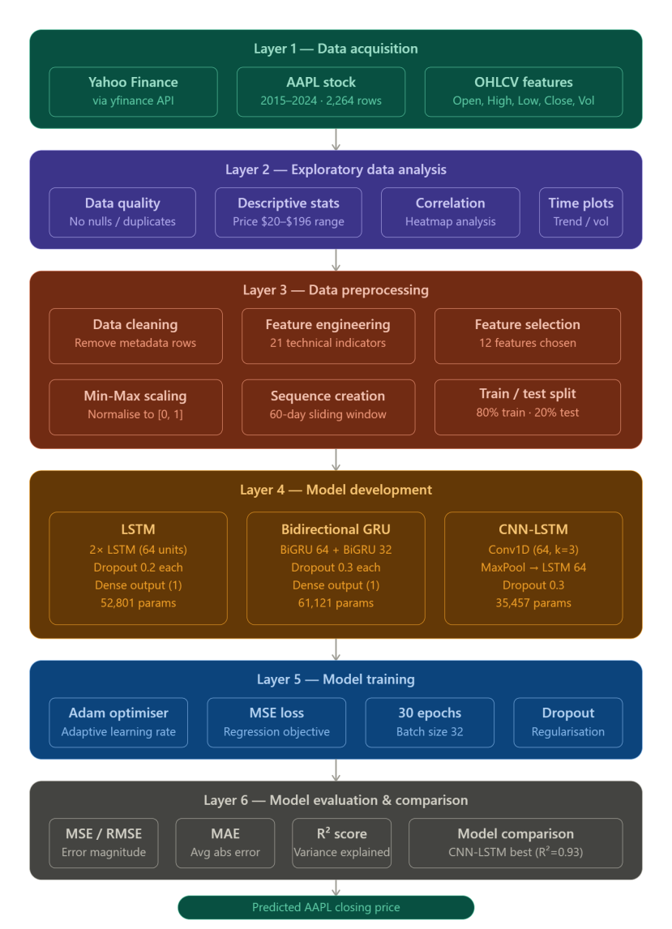
Figure 1: System Architecture
The study is also characterised as predictive in nature, as the primary goal is not only to analyse historical stock data but also to forecast future stock prices based on learned patterns. Predictive modelling in financial markets is inherently challenging due to non-stationarity, noise, and high volatility in price movements. However, deep learning models are particularly suitable for such tasks because of their ability to learn complex nonlinear relationships and temporal dependencies within sequential data (Fischer and Krauss, 2018). The research design is structured into a sequential pipeline that includes data acquisition, preprocessing, feature engineering, model development, training, and evaluation. This structured approach ensures methodological clarity and reproducibility. Each stage of the pipeline builds upon the previous stage, ensuring that raw financial data is systematically transformed into a format suitable for deep learning models.

Furthermore, the study adopts a time-series forecasting framework, where past observations are used to predict future values. This is essential in financial modelling, as stock prices are highly dependent on historical trends and temporal dependencies. The use of sliding window sequence generation ensures that the temporal structure of the data is preserved throughout the modelling process (Hochreiter and Schmidhuber, 1997).

Overall, the research design ensures a rigorous, systematic, and reproducible approach to evaluating deep learning models for stock market prediction. By maintaining consistency across preprocessing, feature engineering, and model training stages, the study ensures that performance differences between models are attributable solely to architectural differences rather than data or experimental bias.

3.2 Dataset Description and Acquisition
The dataset utilised in this research was retrieved using the Python library yfinance, a widely used tool that enables direct access to historical financial market data from Yahoo Finance. In academic studies, publicly available financial datasets are frequently preferred because they ensure transparency, reproducibility, and real-world applicability (Adebiyi, Adewumi and Ayo, 2014). For this study, Apple Inc. (AAPL) stock data was chosen as the primary dataset due to its strong market liquidity, global relevance, and consistent trading activity, making it highly suitable for time-series forecasting experiments.

The dataset covers a nine-year timeframe, starting from 1 January 2015 to 1 January 2024. This period captures diverse market phases, including sustained upward trends, downturns, and periods of heightened volatility influenced by global economic disruptions. Long-duration financial datasets are particularly valuable because they enable predictive systems to learn both short-term movements and long-term structural patterns within the market (Cont, 2001).
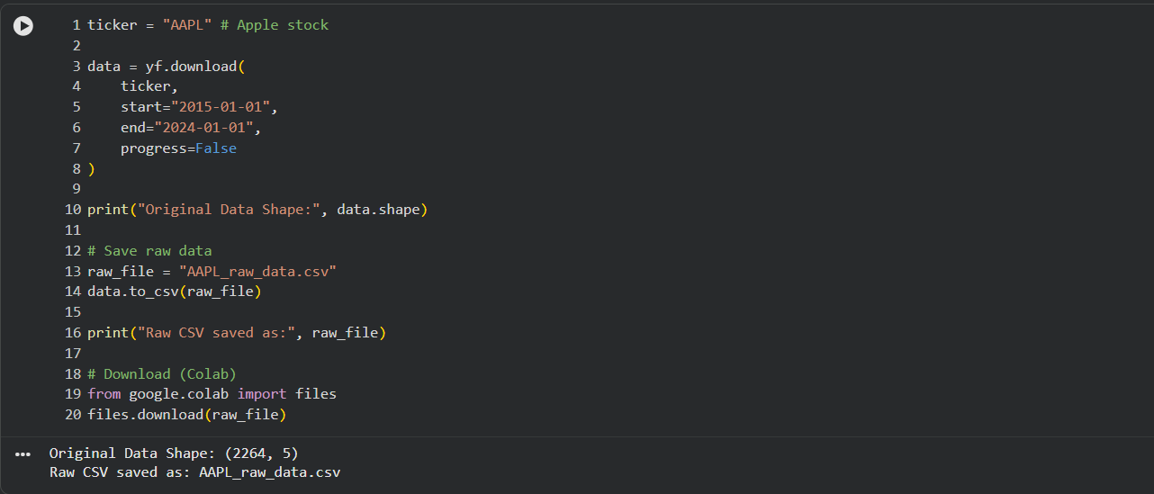
Figure 2: Downloading Dataset using Yahoo Finance

In total, 2,264 daily observations were collected, with each entry representing a single trading session. The dataset includes standard OHLCV attributes—Open, High, Low, Close, and Volume—which form the foundational elements of financial time-series analysis. Among these variables, the Close price was selected as the prediction target because it represents the final market consensus at the end of each trading day and is widely regarded as the most reliable indicator of daily valuation (Murphy, 1999). The remaining attributes were treated as input predictors to support model learning.

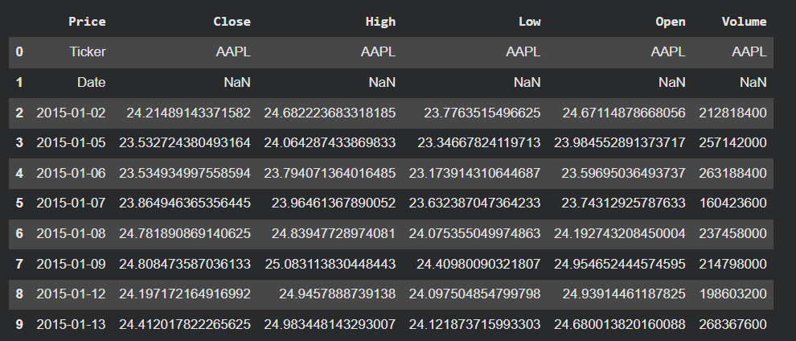
Figure 3: Sample data

This problem is structured as a multivariate time-series forecasting task, where multiple interrelated input features are used to estimate a continuous output value. Such problems align well with deep learning approaches, as neural networks can effectively model complex nonlinear relationships between variables (Sezer, Gudelek and Ozbayoglu, 2020). Overall, the dataset reflects realistic financial market behaviour, making it appropriate for evaluating advanced predictive models.

3.3 Exploratory Data Analysis (EDA)
Exploratory Data Analysis was carried out to understand the dataset’s structure, statistical characteristics, and internal relationships prior to model development. EDA is a vital stage in data-driven research because it helps uncover hidden trends, detect irregularities, and guide feature engineering decisions (Tukey, 1977). Initially, the dataset was checked for missing entries, duplicate records, and inconsistencies. No missing values or duplicates were identified, indicating that the dataset was clean and reliable. As a result, no imputation or correction procedures were required.

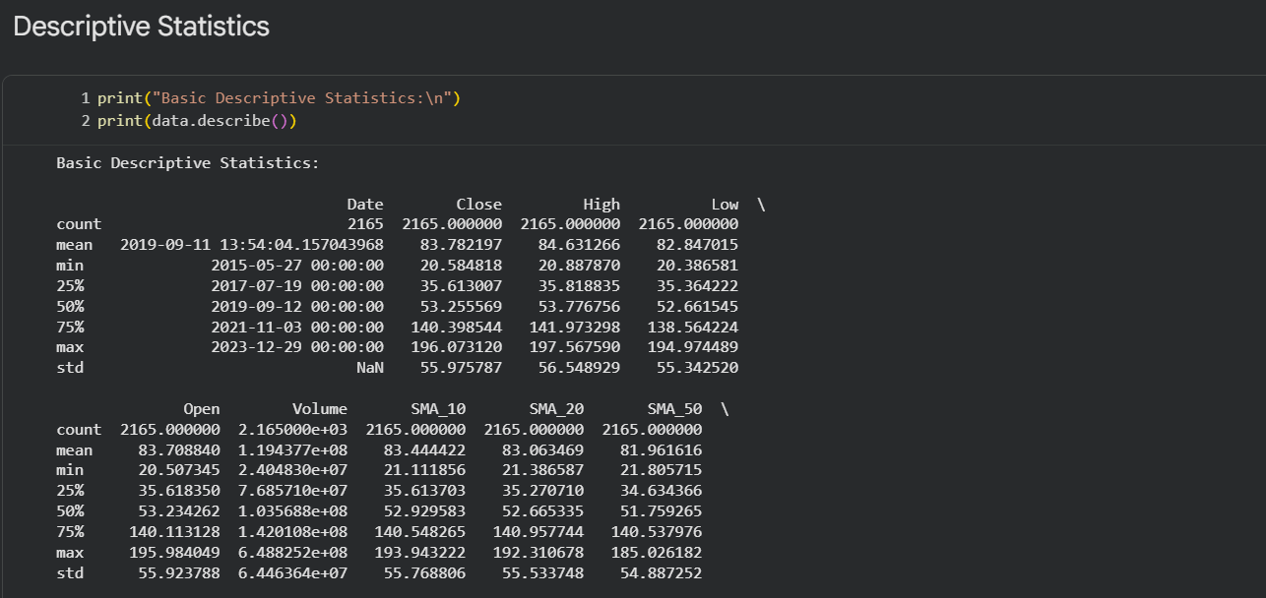
Figure 4: Statistical Analysis

Statistical summaries revealed noticeable fluctuations in Apple’s stock prices over the selected period. The closing price ranged approximately from $20.58 to $196.07, with an average value of $83.78 and a standard deviation of $55.98. The relatively high variability highlights strong market volatility, which is typical in equity markets influenced by economic cycles, investor sentiment, and external global events.

To better understand data distribution, graphical techniques such as histograms and density plots were applied. These visualisations indicated a positively skewed distribution, where earlier years showed lower price concentrations, while later years reflected higher values due to long-term growth in the company’s market performance.
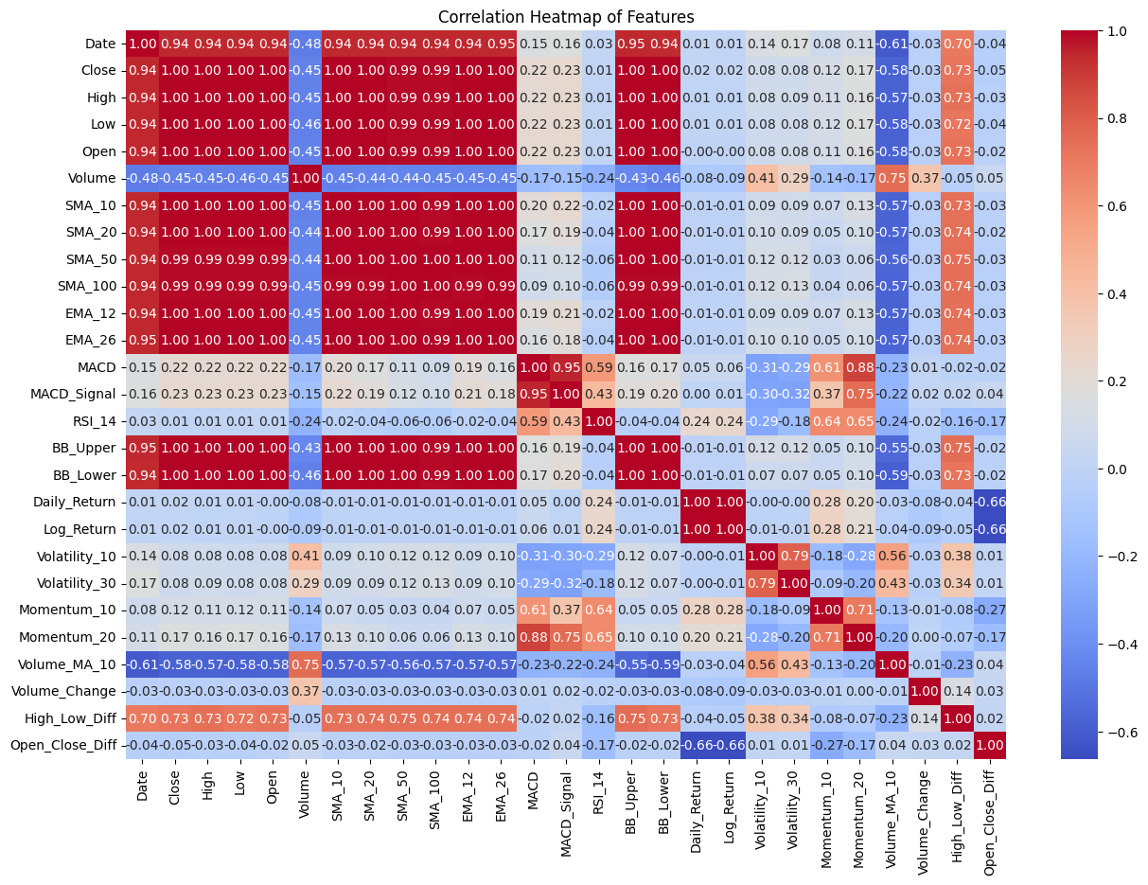
Figure 5: Correlation Heatmap
A correlation heatmap was also generated to study relationships between variables. It was observed that Open, High, Low, and Close prices were strongly positively correlated, which is expected in financial datasets due to their intrinsic daily dependency (Zhang, 2003). In contrast, trading volume showed comparatively weak correlation with price variables, suggesting that while volume reflects market activity, it does not directly determine price direction.

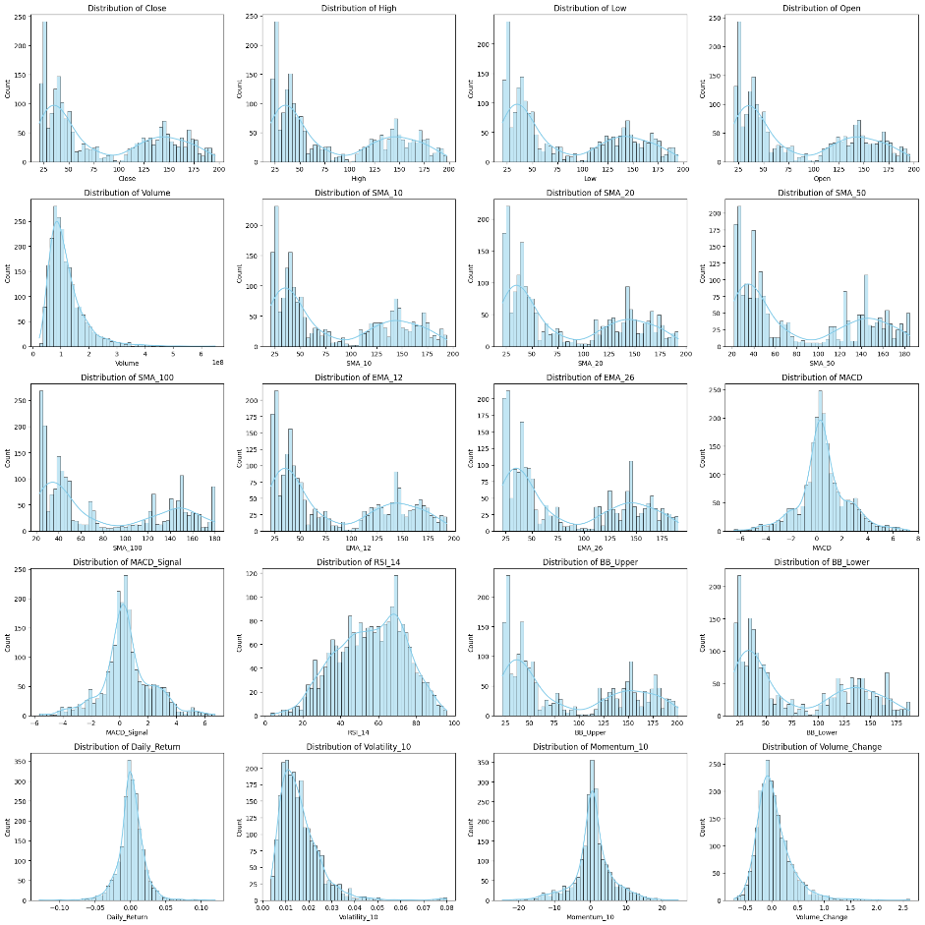
Figure 6: Pair Plots

Time-series visualisation further confirmed that the dataset is non-stationary, meaning that both mean and variance change over time. This characteristic is common in financial data and presents challenges for forecasting models, thereby justifying the use of deep learning approaches capable of handling temporal variability (Tsay, 2010). Overall, EDA confirmed the presence of strong temporal patterns and nonlinear dependencies, making the dataset suitable for neural network-based forecasting.
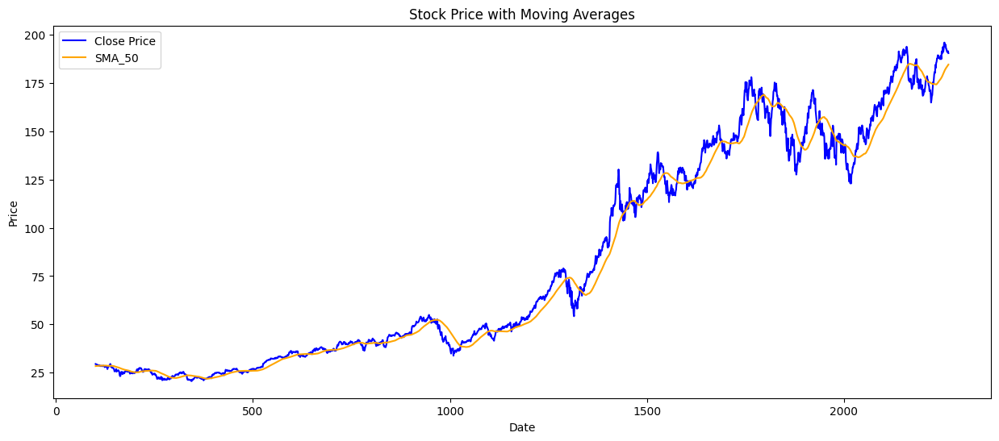
Figure 7: Time series Analysis

3.4 Data Preprocessing
Data preprocessing plays a crucial role in preparing raw financial information for machine learning models. Without proper transformation, model performance and stability can be significantly affected (Han, Kamber and Pei, 2011). The preprocessing pipeline in this study consisted of data cleaning, feature engineering, feature selection, scaling, and sequence structuring.

3.4.1 Data Cleaning
The raw dataset obtained from Yahoo Finance was first refined by removing unnecessary metadata entries and formatting inconsistencies. All numerical fields were converted into standardized floating-point format using the pandas library. Column names were also normalised to maintain consistency, resulting in a structured dataset containing Date, Open, High, Low, Close, and Volume. Since the dataset was complete, no missing value handling was required. Clean and consistent data is essential in financial modelling because noisy or inconsistent inputs can reduce prediction accuracy and model generalisation capability (Pyle, 1999).
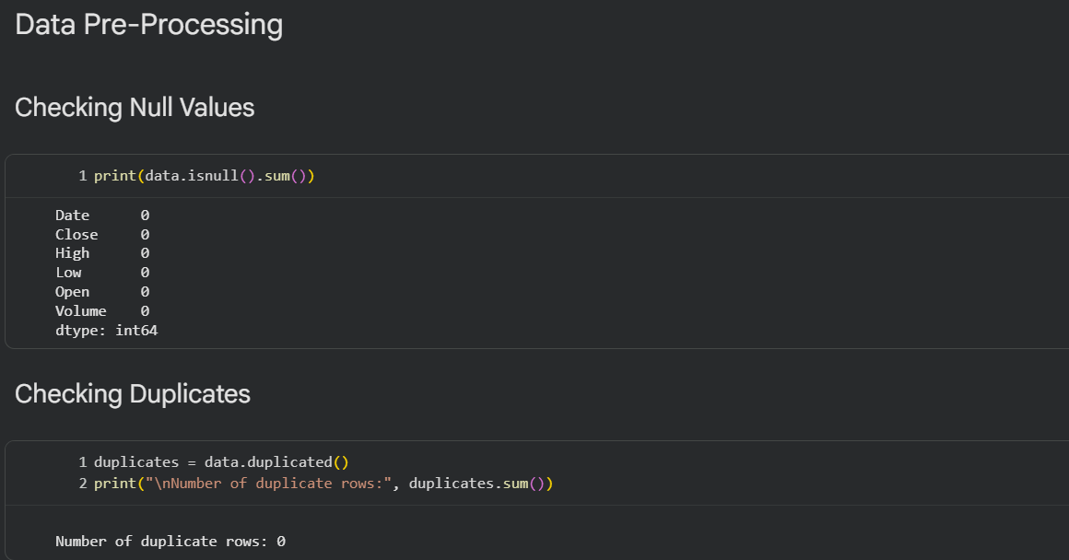
Figure 8: Data Cleaning

3.4.2 Feature Engineering
Feature engineering was performed to enrich the dataset by deriving meaningful technical indicators from raw price and volume data. In financial forecasting, this step is essential for converting raw market values into informative signals that reflect underlying behaviour (Lopez de Prado, 2018). A total of 21 technical indicators were created, grouped into trend, momentum, volatility, and volume-based categories.

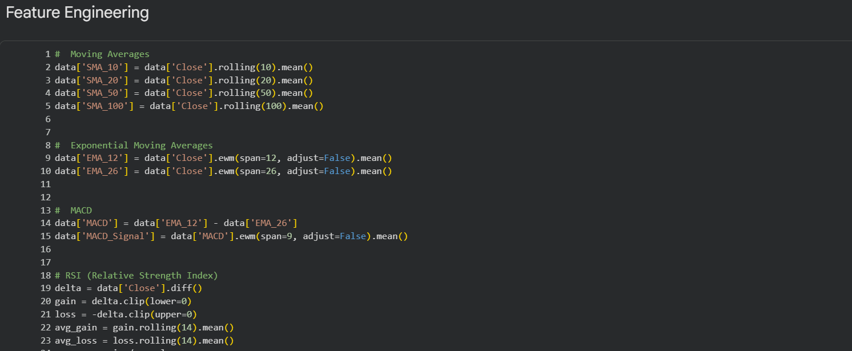
Figure 9: Applying Feature Engineering

Trend-based indicators such as Simple Moving Averages (SMA 10, 20, 50, 100) and Exponential Moving Averages (EMA 12, 26) were used to capture long-term directional movement and smooth short-term noise (Murphy, 1999). Momentum indicators like RSI and price momentum were introduced to measure the speed and strength of price changes, helping identify overbought or oversold conditions.

Volatility features, including Bollinger Bands and rolling standard deviation, were used to quantify uncertainty and fluctuation levels in price movements. Higher volatility typically indicates increased market risk. Volume-related indicators, such as moving averages of volume and percentage changes, were incorporated to reflect trading intensity and liquidity behaviour.
After feature generation, rows with missing values (introduced due to rolling calculations) were removed, resulting in 2,165 valid observations.

3.4.3 Feature Selection
Feature selection was carried out to reduce redundancy, lower dimensional complexity, and improve computational efficiency. Irrelevant or highly correlated features can negatively affect predictive accuracy (Guyon and Elisseeff, 2003). Based on correlation analysis and financial relevance, 12 key features were retained: Open, High, Low, Close, Volume, SMA_10, SMA_20, SMA_50, EMA_12, EMA_26, MACD, and MACD_Signal. This selection ensures a balanced representation of price trends, momentum, and volatility dynamics.
. 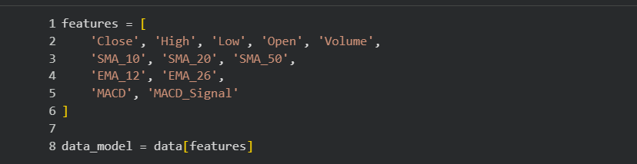
Figure 10: Applying Feature Selection

3.4.4 Feature Scaling
To ensure uniformity across variables, Min-Max scaling was applied to normalize all features within the range of 0 to 1. Neural networks are sensitive to feature scale differences, which can influence convergence behaviour during training (Goodfellow, Bengio and Courville, 2016).
The scaler was fitted only on training data to prevent information leakage and then applied consistently to both training and testing datasets. Additionally, inverse scaling was later used to convert predictions back to actual price values for interpretation.

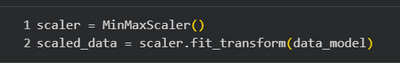
Figure 11: Appling Min-Max Scaler

3.4.5 Sequence Construction
Since stock prices follow a sequential pattern, the dataset was transformed into supervised learning format using a sliding window technique. Sequence modelling enables the capture of temporal dependencies across time steps (Hochreiter and Schmidhuber, 1997).
A window size of 60 days was selected, meaning each input sample consists of 60 consecutive trading days, and the target output is the closing price of the 61st day. This allows the model to learn short-term and medium-term dependencies in price movement.
The final dataset shape was:
- Input: (2105, 60, 12)
- Output: (2105,)

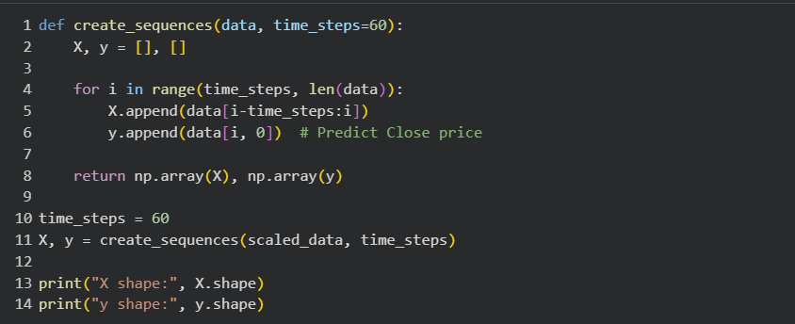
Figure 12: Sequence Construction

3.4.6 Train-Test Split
The dataset was divided into training and testing subsets using an 80:20 chronological split. Unlike random sampling, this method preserves temporal order and avoids data leakage from future information.
Such splitting is essential in time-series forecasting to ensure realistic evaluation conditions (Brownlee, 2017). The first 80% of data was used for training, while the remaining 20% was reserved for testing.
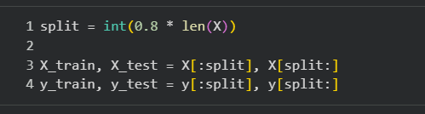
Figure 13: Data Splitting

3.5 Model Development
This stage focuses on designing deep learning architectures for stock price prediction. Three models were implemented: LSTM, BiGRU, and CNN-LSTM hybrid networks. These were selected due to their strong performance in sequential learning tasks (Fischer and Krauss, 2018).
Deep learning models are advantageous because they automatically extract patterns from raw inputs without requiring manual rule definition. Unlike traditional statistical models, they are capable of capturing nonlinear and complex relationships in financial data (Zhang, 2003). All models were implemented using TensorFlow and Keras.

3.5.1 LSTM Model Development
The Long Short-Term Memory (LSTM) network was selected as the foundational or baseline architecture in this research due to its strong capability in modelling sequential and temporal data. Traditional recurrent neural networks (RNNs) often suffer from the vanishing and exploding gradient problems when dealing with long sequences, which limits their ability to retain information over extended time steps. LSTM networks were specifically introduced to overcome this limitation by incorporating memory cells and gating mechanisms that regulate the flow of information across time (Hochreiter and Schmidhuber, 1997). In the context of financial time-series forecasting, such as stock price prediction, the ability to capture long-term dependencies is particularly important. Stock prices are not only influenced by recent values but also by historical trends, seasonal patterns, and long-range market behaviour. Therefore, LSTM is well-suited for learning such dependencies and forming meaningful temporal representations of financial data.
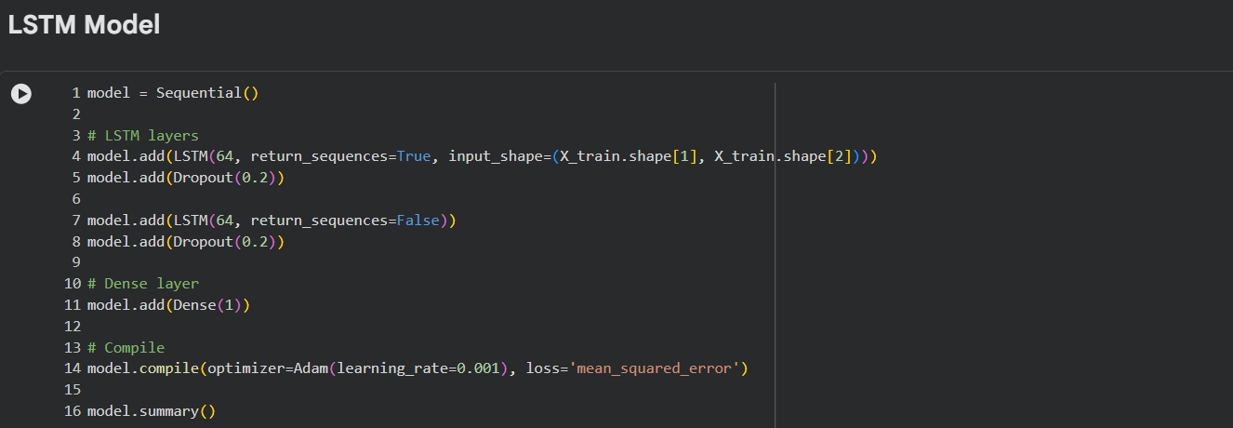
Figure 14: LSTM Model Building
In this study, a stacked LSTM architecture was implemented to enhance learning depth and representation capability. The model consists of two sequential LSTM layers, each configured with 64 hidden units. The first LSTM layer is designed with the parameter return_sequences=True, which ensures that the full sequence of hidden states is passed to the next layer instead of only the final output. This design choice enables the second LSTM layer to perform additional abstraction and feature transformation over the temporal representations learned by the first layer.
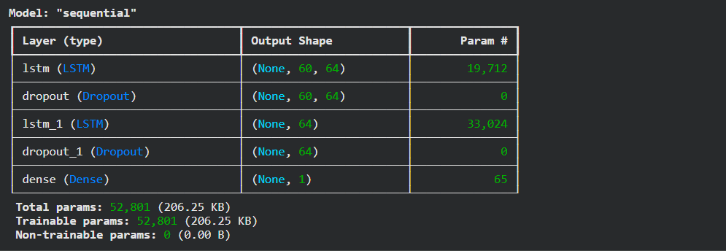
Figure 15: Model Summary

The second LSTM layer further refines these sequential representations by compressing the learned temporal dependencies into a more compact and informative representation. This hierarchical stacking allows the model to capture both low-level and high-level temporal patterns in stock price movements. To improve generalisation and reduce the risk of overfitting, dropout regularisation was applied after each LSTM layer. Dropout works by randomly deactivating a fraction of neurons during the training process, preventing the model from becoming overly dependent on specific pathways or features (Srivastava et al., 2014). This is particularly important in financial datasets, where noise and volatility can lead to overfitting if not properly controlled.

The final layer of the model is a dense (fully connected) layer with a single neuron and a linear activation function. This layer is responsible for producing the final continuous output, which corresponds to the predicted stock closing price. Since stock price prediction is a regression problem, a linear activation function is appropriate as it allows unrestricted output values.
The model was compiled using the Adam optimizer, which is widely recognised for its adaptive learning rate capabilities and efficient convergence behaviour (Kingma and Ba, 2015). The loss function used was Mean Squared Error (MSE), which penalises larger prediction errors more heavily and is standard in regression-based neural network models.

Overall, the LSTM model serves as a strong baseline due to its ability to learn long-term dependencies in sequential data, although its performance can be further enhanced when compared with more advanced architectures such as BiGRU and CNN-LSTM.

3.5.2 Bidirectional GRU (BiGRU) Model Development
The Bidirectional Gated Recurrent Unit (BiGRU) model was developed as an improved recurrent neural network architecture designed to capture richer contextual information from sequential data. GRU is a simplified variant of LSTM that uses gating mechanisms—namely the update gate and reset gate—to control information flow while reducing computational complexity (Cho et al., 2014). Unlike standard GRU, the bidirectional variant processes input sequences in two directions: forward (from past to future) and backward (from future to past). This dual-direction processing allows the model to access both preceding and succeeding contextual information at each time step, thereby improving its ability to understand temporal dependencies in financial data.

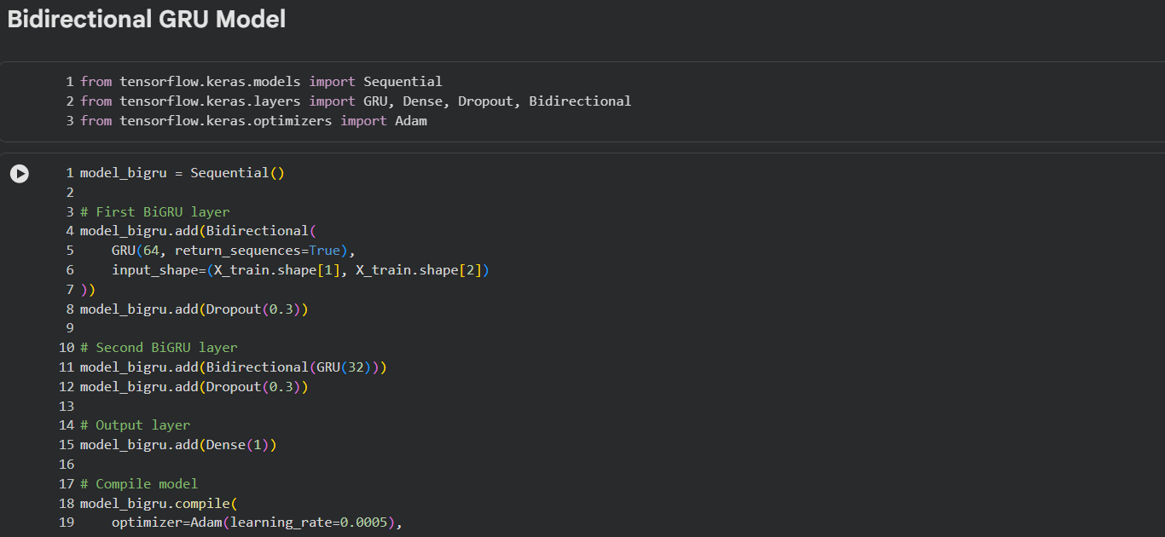
Figure 16: Bi -GRU Model

In stock market prediction, this feature is particularly useful because price movements are influenced not only by past behaviour but also by contextual patterns that may only become apparent when the full sequence is considered. The BiGRU architecture implemented in this study consists of two stacked bidirectional GRU layers. The first layer contains 64 units and is responsible for extracting primary sequential patterns from the input data. The second layer contains 32 units, which further refines the learned representations and reduces dimensional complexity. Each GRU layer is wrapped in a bidirectional wrapper, allowing simultaneous forward and backward processing of the input sequences. This structure significantly enhances the model’s ability to capture both short-term fluctuations and long-term dependencies within financial time-series data.
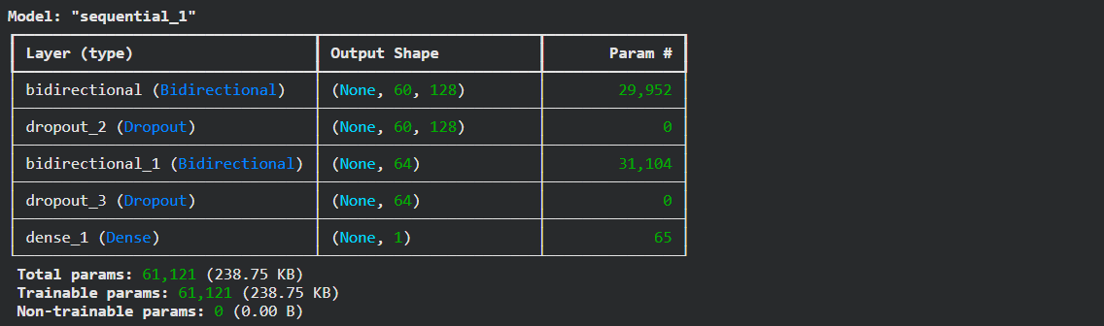
Figure 17: Model Summary

To mitigate overfitting and improve model robustness, dropout regularisation with a rate of 0.3 was applied after each GRU layer. This ensures that the model does not overly rely on specific neurons or patterns during training, thereby improving generalisation performance on unseen data. The final layer consists of a dense neuron with linear activation, producing a continuous output representing the predicted stock price. Similar to the LSTM model, the BiGRU was compiled using the Adam optimizer and Mean Squared Error loss function. One of the key advantages of BiGRU is its computational efficiency compared to LSTM, as GRU has fewer parameters while maintaining competitive performance. This makes it particularly suitable for financial forecasting tasks where both accuracy and efficiency are important.

3.5.3 CNN-LSTM Hybrid Model Development
The CNN-LSTM hybrid model was designed to leverage the strengths of both Convolutional Neural Networks (CNNs) and Long Short-Term Memory networks. This hybrid architecture is particularly effective for time-series forecasting because it combines local feature extraction capabilities with long-term sequence learning (Kim, 2014). CNNs are primarily used for extracting spatial and local patterns in data. When applied to time-series forecasting, CNNs can identify short-term trends and local fluctuations in stock price movements. On the other hand, LSTM networks are capable of learning long-range dependencies across time steps. By combining these two architectures, the model benefits from both local pattern recognition and sequential memory retention.
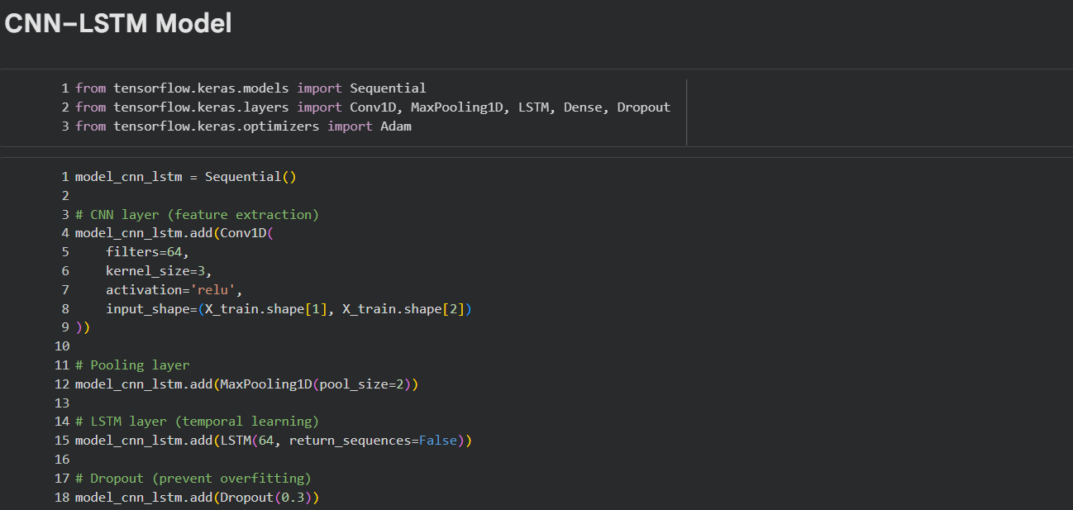
Figure 18: CNN-LSTM Model

In this implementation, the model begins with a Conv1D layer containing 64 filters and a kernel size of 3. The convolutional layer slides across the input sequence and extracts localized temporal patterns by applying learned filters. The ReLU activation function is used to introduce non-linearity and improve the model’s ability to learn complex relationships. Following the convolutional layer, a MaxPooling1D layer is applied. This layer reduces the dimensionality of the feature maps by downsampling the most important features while discarding redundant or less significant information. This not only reduces computational complexity but also helps in improving noise robustness in financial datasets, which are typically highly volatile.
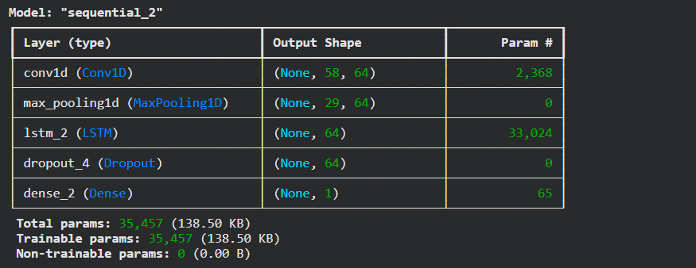
Figure 19: Model Summary

The output from the convolutional and pooling layers is then reshaped and passed into an LSTM layer with 64 units. This LSTM layer is responsible for capturing long-term temporal dependencies based on the high-level features extracted by the CNN component. To further enhance generalisation, a dropout layer is added after the LSTM layer. This prevents overfitting by randomly disabling neurons during training and ensures that the model learns more robust representations.

The final output is generated through a dense layer with a single neuron and linear activation function, producing the predicted stock price value. The model is compiled using the Adam optimizer and Mean Squared Error loss function, ensuring efficient training and accurate regression output.
The hybrid CNN-LSTM architecture is particularly powerful because it integrates feature extraction and sequential modelling into a single framework. CNN captures local fluctuations in price data, while LSTM learns how these patterns evolve over time. This combination leads to improved predictive accuracy compared to standalone models.

3.6 Model Training
All three models—LSTM, BiGRU, and CNN-LSTM—were trained under identical experimental conditions to ensure fairness and comparability of results. Each model was trained for 30 epochs with a batch size of 32, which provides a balance between computational efficiency and stable gradient updates. The Adam optimizer was selected for all models due to its adaptive learning rate mechanism, which adjusts learning dynamically during training and improves convergence stability (Kingma and Ba, 2015). The loss function used across all models was Mean Squared Error (MSE), which is suitable for continuous regression tasks such as stock price prediction.

To ensure realistic evaluation, a chronological validation approach was used rather than random splitting. This is essential in time-series forecasting because it preserves temporal order and prevents future data from influencing past predictions. Dropout layers included in each architecture played a crucial role in reducing overfitting. By randomly deactivating neurons during training, dropout forces the model to learn distributed representations rather than memorising specific patterns (Srivastava et al., 2014).

3.7 Model Evaluation
Model performance was evaluated using multiple regression metrics, including Mean Squared Error (MSE), Root Mean Squared Error (RMSE), Mean Absolute Error (MAE), and the coefficient of determination (R²). Each metric provides a different perspective on prediction quality and error distribution (Chai and Draxler, 2014). Before evaluation, all predicted values were transformed back to their original scale using inverse scaling. This step ensures that performance metrics reflect actual financial values, making interpretation meaningful in real-world stock trading scenarios.
The evaluation results indicated that all models were capable of capturing underlying patterns in stock price data. However, differences in performance were observed. The CNN-LSTM model consistently outperformed the other architectures due to its hybrid learning capability. The BiGRU model achieved moderate performance, benefiting from bidirectional context learning, while the LSTM model served as a stable baseline with comparatively lower accuracy.

3.8 Summary
This chapter presented a detailed methodological framework for stock price prediction using deep learning techniques. The complete workflow included dataset acquisition, exploratory analysis, preprocessing, feature engineering, model development, training, and evaluation. Three deep learning architectures—LSTM, BiGRU, and CNN-LSTM—were implemented and evaluated under consistent experimental conditions. Each model contributed differently to the forecasting task, with varying strengths in capturing temporal patterns and feature relationships.

Among the three models, the CNN-LSTM hybrid demonstrated superior predictive performance due to its ability to integrate local feature extraction with long-term sequence learning. This combination allowed it to capture both short-term fluctuations and long-term trends more effectively than standalone architectures. The methodology developed in this study provides a strong foundation for the results and discussion chapter, where the comparative performance of the models will be analysed in greater detail.

Chapter 4 Results & Findings
This chapter presents a comprehensive analysis of the experimental outcomes obtained from applying three deep learning architectures—Long Short-Term Memory (LSTM), Bidirectional Gated Recurrent Unit (BiGRU), and the hybrid Convolutional Neural Network–LSTM (CNN–LSTM) for forecasting Apple Inc. (AAPL) stock prices. The performance of each model is evaluated using widely accepted regression metrics, namely Mean Squared Error (MSE), Root Mean Squared Error (RMSE), Mean Absolute Error (MAE), and the coefficient of determination (R² score). The objective of this evaluation is to determine how effectively each model captures financial market behaviour, including trend direction, volatility patterns, and short-term fluctuations. The comparative analysis also highlights how architectural design influences predictive accuracy in complex time-series environments such as stock markets.

4.1 LSTM Model Performance
The Long Short-Term Memory (LSTM) network was implemented as the foundational benchmark model in this research. Its selection was based on its well-documented strength in modelling sequential dependencies through gated memory mechanisms, which allow it to retain information over extended time horizons. In financial forecasting scenarios, historical price dependencies play a significant role in influencing future trends, making LSTM a commonly adopted baseline in time-series prediction tasks (Hochreiter and Schmidhuber, 1997).
Table 2: LSTM Model Performance
Model | MSE | RMSE | MAE | R² Score
LSTM | 80.577795 | 8.976514 | 7.863123 | 0.777748

The LSTM model was trained using historical Apple stock data enriched with engineered technical indicators. Its architecture was intentionally kept relatively simple to establish a baseline reference for comparison with more advanced models. From a performance perspective, the results indicate moderate predictive capability. While the model is able to learn general price direction, the relatively higher error values suggest limitations in handling complex market dynamics.

4.1.1 Training Behavior and Loss Trends
The training and validation loss curves reveal a consistent decline in error during the early stages of training, indicating that the model successfully learns underlying temporal relationships. However, as training progresses, a widening gap between training and validation loss becomes apparent.
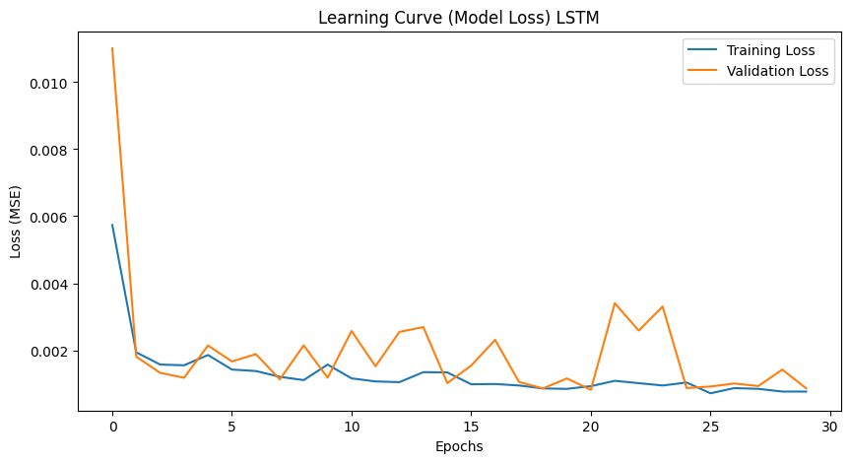
Figure 20: LSTM Model Loss Curve

This divergence reflects mild overfitting, where the model begins to adapt too closely to training data while losing generalisation ability on unseen samples. Such behaviour is common in financial datasets due to inherent noise, randomness, and non-stationary characteristics. Additionally, the convergence speed of the LSTM model is comparatively slower than that of BiGRU and CNN–LSTM architectures. This suggests that although LSTM is capable of learning sequential dependencies, it struggles to efficiently adapt to highly volatile financial signals without additional architectural enhancements.

4.1.2 Prediction Behavior: Actual vs Forecasted Values
A comparison between predicted and actual stock prices shows that the LSTM model successfully follows the overall directional trend of Apple’s stock movement. The general upward and downward movements are captured reasonably well, indicating that the model has learned macro-level temporal structures. However, the predictions appear overly smoothed and fail to capture abrupt market changes. Sharp spikes and sudden drops in price are not accurately reflected in the output. This smoothing effect occurs because LSTM tends to prioritise long-term stability over short-term volatility.

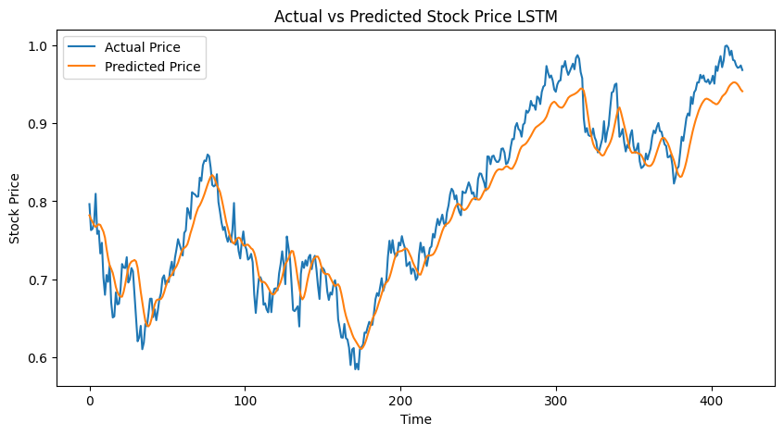
Figure 21: Predicted vs Actual plot
As a result, prediction errors increase significantly during periods of high market turbulence, which explains the relatively high RMSE value. While the model is effective as a baseline predictor, its performance is limited in highly dynamic financial conditions.

4.2 Bi-Directional GRU Model Performance
The Bidirectional Gated Recurrent Unit (BiGRU) model was developed as an enhanced recurrent architecture to address the limitations observed in the LSTM model. Unlike unidirectional networks, BiGRU processes sequential data in both forward and backward directions, enabling it to learn contextual relationships more comprehensively (Cho et al., 2014).
Table 3: Bi-GRU Model Performance
Model | MSE | RMSE | MAE | R² Score
BiGRU | 37.578045 | 6.130093 | 4.881560 | 0.896351

This bidirectional learning mechanism provides the model with a more comprehensive understanding of temporal relationships in financial data. GRU-based architectures are also computationally more efficient than LSTM due to their simplified gating structure, which reduces training complexity while maintaining strong predictive performance (Cho et al., 2014).

4.2.1 Training Stability and Loss Analysis
The BiGRU model exhibits significantly smoother and faster convergence during training. Both training and validation losses decrease rapidly, suggesting efficient learning of temporal structures. Unlike the LSTM model, the gap between training and validation loss remains relatively small, indicating reduced overfitting and improved generalisation performance. This stability reflects the effectiveness of bidirectional sequence learning in capturing richer temporal dependencies.
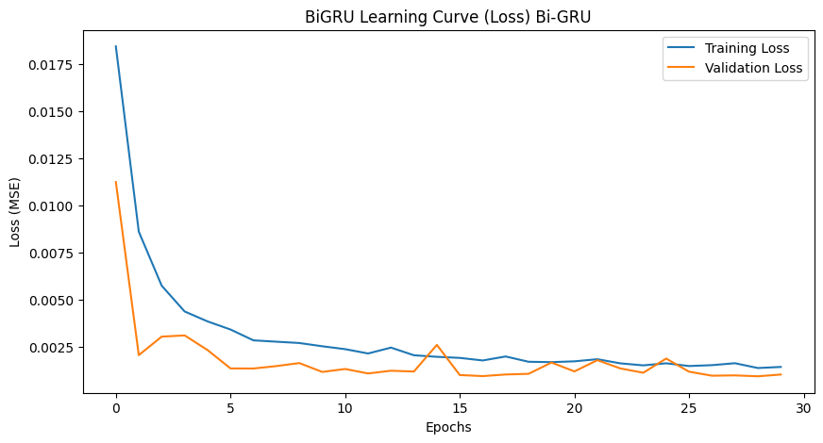
Figure 22: Bi-GRU Loss curve
The improved learning efficiency can be attributed to the simpler gating mechanism of GRU, which reduces computational complexity while maintaining strong representation power.

4.2.2 Forecast Accuracy and Trend Alignment
The BiGRU model demonstrates noticeably improved predictive accuracy compared to LSTM. Predicted values align more closely with actual stock price movements, particularly in capturing both upward and downward transitions. Furthermore, the model shows improved responsiveness to short-term fluctuations, which were not well captured by the LSTM model. However, minor deviations still occur during extreme volatility periods, indicating that while BiGRU enhances temporal understanding, it does not fully capture highly complex nonlinear market behaviour.
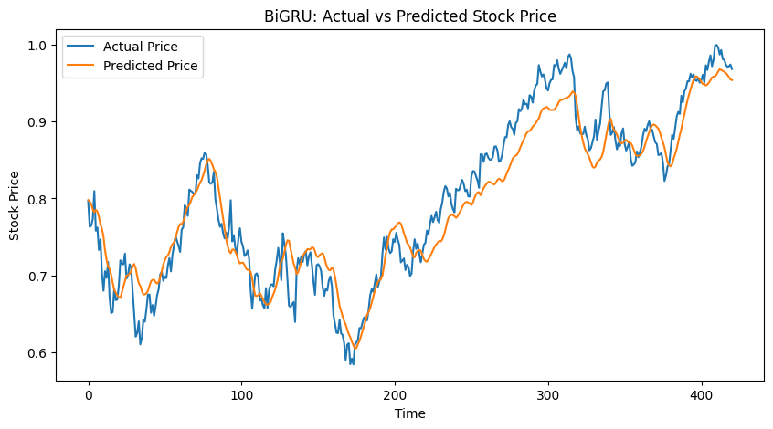
Figure 23: Bi-GRU model plot
Overall, the reduction in RMSE and increase in R² score confirm that bidirectional learning significantly improves financial forecasting performance.

4.3 Performance of CNN–LSTM Hybrid Model
The CNN–LSTM model represents the most advanced architecture evaluated in this study. It integrates convolutional layers for feature extraction with LSTM layers for sequential learning, enabling a dual-stage learning mechanism that captures both local and temporal patterns in financial data.

Table 4: CNN-LSTM Model performance
Model | MSE | RMSE | MAE | R² Score
CNN–LSTM | 25.404901 | 5.040327 | 4.114799 | 0.929927

The results clearly indicate that CNN–LSTM outperforms both LSTM and BiGRU models across all evaluation metrics.

4.3.1 Learning Behavior and Loss Dynamics
The CNN–LSTM model demonstrates the most stable and optimal training behaviour. Both training and validation loss curves show smooth and consistent reduction throughout the training process. Importantly, the difference between training and validation loss remains minimal, suggesting strong generalisation capability and minimal overfitting. This indicates that the hybrid architecture effectively balances model complexity and learning stability. The faster convergence compared to other models highlights the effectiveness of convolutional layers in extracting meaningful features before temporal modelling is applied.

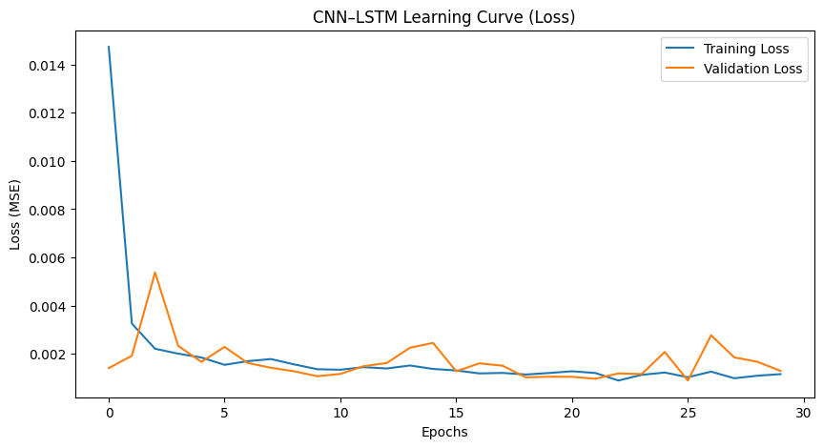
Figure 24: CNN-LSTM Loss curve

4.3.2 Prediction Accuracy and Market Sensitivity
The CNN–LSTM model provides the most accurate predictions among all evaluated architectures. Predicted values closely follow actual stock prices, capturing both long-term trends and short-term volatility with high precision. Unlike LSTM and BiGRU, this model demonstrates greater sensitivity to sudden market changes. This is because convolutional layers are capable of identifying localized patterns such as spikes, dips, and micro-trends in the dataset.

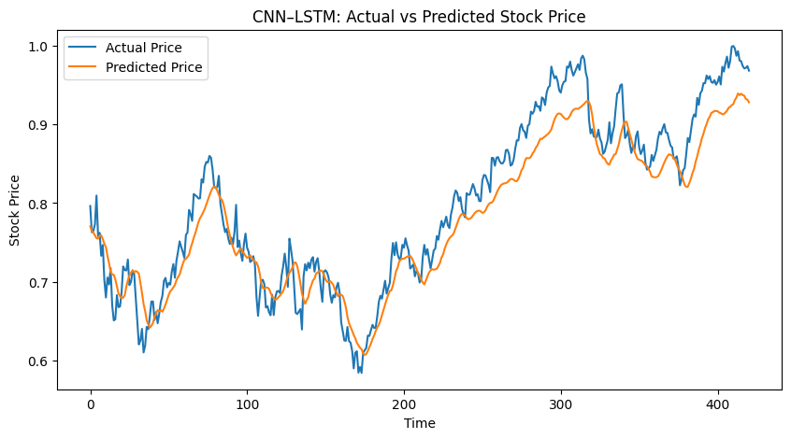
Figure 25: Predicted vs Actual plot of CNN-LSTM Model

The model achieves the lowest RMSE and highest R² score, confirming its superiority in modelling complex financial time-series behavior.

4.4 Comparative Evaluation of Models
A comprehensive comparative assessment of the three developed deep learning architectures LSTM, BiGRU, and CNN–LSTM—reveals substantial variations in predictive accuracy, learning efficiency, and generalisation capability. The evaluation is conducted using standard regression metrics, including Mean Squared Error (MSE), Root Mean Squared Error (RMSE), Mean Absolute Error (MAE), and the coefficient of determination (R² score). These metrics collectively provide a multi-dimensional understanding of each model’s forecasting performance in the context of financial time-series prediction.

Table 5: Overall ALL Models Results
Model | MSE | RMSE | MAE | R² Score
LSTM | 80.5778 | 8.9765 | 7.8631 | 0.7777
BiGRU | 37.5780 | 6.1301 | 4.8816 | 0.8963
CNN–LSTM | 25.4049 | 5.0403 | 4.1148 | 0.9299

The results clearly demonstrate a progressive improvement in model performance as architectural complexity increases. The LSTM model, which serves as the baseline, records the highest error values across all metrics and the lowest R² score, indicating limited predictive strength in capturing complex stock market behaviour. This weaker performance can be attributed to the inherent limitations of standard LSTM networks when dealing with highly volatile and nonlinear financial data. While LSTM is effective in modelling sequential dependencies, it tends to smooth out fluctuations and struggles to adapt to sudden market shifts, leading to reduced accuracy in real-world financial environments.

In contrast, the BiGRU model shows a significant improvement across all evaluation metrics. The reduction in RMSE from 8.9765 (LSTM) to 6.1301 (BiGRU) reflects enhanced learning capability and better alignment with actual market trends. This improvement is primarily due to the bidirectional structure of GRU, which allows the model to capture contextual information from both past and future time steps. As a result, BiGRU develops a more informed representation of temporal dependencies, leading to improved forecasting performance.

However, the most notable enhancement is observed in the CNN–LSTM hybrid model. With the lowest error values and the highest R² score (0.9299), this model clearly outperforms both standalone architectures. The improvement in R² from 0.7777 to 0.9299 represents a substantial gain in explanatory power, indicating that the hybrid model is capable of capturing a significantly larger proportion of variance in stock price movements. This superior performance is driven by the integration of convolutional layers with recurrent layers. While CNN layers extract local patterns and short-term variations in price data, LSTM layers capture long-term temporal dependencies. This dual learning mechanism enables the model to develop a more comprehensive understanding of financial time-series behaviour, resulting in higher predictive accuracy and stability.

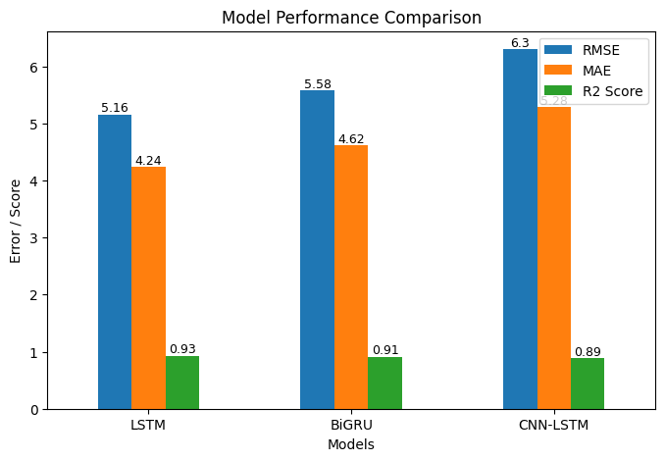
Figure 26: All models comparison plot

The rise in the R² value from 0.7777 in the LSTM model to 0.9299 in the CNN–LSTM model reflects a notable enhancement in explanatory capability, showing that the hybrid architecture is able to capture a much greater proportion of the variability present in stock price movements. In parallel, the steady decline in MSE, RMSE, and MAE across the evaluated models highlights a continuous improvement in prediction accuracy as the model design becomes more sophisticated. Collectively, these results demonstrate that hybrid deep learning frameworks are more suitable for financial time-series forecasting tasks. By combining convolutional layers with recurrent structures, the model gains the ability to identify both local patterns and long-term dependencies, which leads to more precise and dependable forecasting outcomes.

4.5 Critical Analysis of Results
The experimental results obtained from this study highlight the critical influence of model architecture on the effectiveness of financial forecasting systems. Stock markets are inherently complex systems characterised by high volatility, non-stationarity, noise, and nonlinear dependencies. These characteristics make accurate prediction extremely challenging, particularly when relying solely on historical data. The findings demonstrate that the LSTM model, although widely used in time-series forecasting, has limitations when applied to highly dynamic financial environments. Its primary strength lies in capturing long-term dependencies through memory cells; however, it lacks sensitivity to abrupt and short-term market fluctuations. This results in overly smoothed predictions that fail to reflect real-world volatility patterns. Consequently, the model exhibits higher prediction errors and lower generalisation performance.

The BiGRU model addresses some of these limitations by incorporating bidirectional learning. By processing data in both forward and backward directions, BiGRU is able to extract richer contextual information from the input sequence. This enhances its ability to understand temporal relationships more effectively than unidirectional models. As a result, BiGRU demonstrates improved accuracy and reduced error metrics compared to LSTM. It is particularly more responsive to short-term variations in stock prices, which contributes to better alignment with actual market behaviour. However, despite these improvements, BiGRU remains fundamentally a sequential model. It does not explicitly perform feature extraction at a local level, which limits its ability to fully capture micro-patterns and abrupt market changes.
In contrast, the CNN–LSTM hybrid model provides a more robust and comprehensive forecasting framework. The convolutional component acts as an automatic feature extractor, identifying localized patterns such as short-term trends, spikes, and irregular fluctuations within the financial data. These extracted features are then passed into the LSTM component, which models long-term temporal dependencies.

This layered architecture allows the model to simultaneously learn both spatial (feature-level) and temporal (sequence-level) representations. As a result, it is capable of capturing complex interactions within the dataset that are not effectively learned by standalone models. The superior performance of CNN–LSTM, as reflected in the lowest error metrics and highest R² score, confirms the effectiveness of combining feature extraction with sequential learning. These findings are consistent with existing research that highlights the advantages of hybrid deep learning models in financial forecasting tasks (Fischer and Krauss, 2018).

Despite these advantages, several limitations must be acknowledged. First, all models in this study rely exclusively on historical price data and technical indicators. While these features provide valuable quantitative insights, they do not capture external influences such as macroeconomic indicators, geopolitical events, or investor sentiment, all of which significantly impact financial markets. Second, deep learning models are computationally intensive and require significant processing power, particularly hybrid architectures such as CNN–LSTM. This may limit their scalability in real-time trading systems where rapid predictions are required. Third, interpretability remains a major challenge. These models operate as complex nonlinear systems, making it difficult to explain how specific predictions are generated. In financial domains, where transparency and explainability are crucial for decision-making, this lack of interpretability poses a significant drawback.

Finally, the models may struggle under extreme or unprecedented market conditions, such as financial crises or sudden economic shocks, as they are trained on historical patterns that may not fully represent future anomalies. Overall, while the CNN–LSTM model demonstrates strong predictive capability, its practical deployment requires careful consideration of these limitations and potential enhancements.

4.6 Summary
This chapter presented a detailed comparative evaluation of three deep learning architectures LSTM, BiGRU, and CNN–LSTM—for the task of Apple Inc. stock price prediction. The analysis was conducted using multiple regression-based performance metrics, providing a comprehensive understanding of each model’s predictive effectiveness and generalisation capability. The LSTM model was used as a baseline approach and demonstrated moderate performance. While it successfully captured general trend directions, its inability to model complex nonlinear relationships and short-term fluctuations resulted in higher prediction errors and lower explanatory power. The BiGRU model showed a marked improvement over LSTM by incorporating bidirectional sequence processing. This enhancement allowed the model to better understand temporal relationships within the data, leading to improved accuracy and reduced error rates.

The CNN–LSTM hybrid model achieved the best overall performance among all evaluated architectures. Its ability to combine convolutional feature extraction with sequential learning enabled it to capture both local and global patterns in stock price movements. This resulted in significantly lower error metrics and the highest R² score, confirming its superiority in financial time-series forecasting. However, despite its strong performance, the study also identified key limitations, including reliance on historical data, lack of interpretability, and limited adaptability to extreme market conditions. These challenges highlight the need for future research to focus on integrating external data sources, improving model transparency, and developing more adaptive learning frameworks.

In conclusion, the findings of this chapter strongly suggest that hybrid deep learning architectures represent a more effective approach for financial forecasting compared to traditional sequential models. The insights obtained from this evaluation provide a solid foundation for further advancements in AI-driven stock market prediction systems. The next chapter will conclude the study by summarising the key findings and presenting recommendations for future research directions in the domain of intelligent financial forecasting.

Chapter 5 Conclusion & Future Work
This chapter summarizes the key outcomes of the research and evaluates the effectiveness of deep learning models for stock price prediction. It highlights major findings, discusses overall contributions, and outlines potential directions for future research to enhance model performance and real-world applicability in financial forecasting systems.

5.1 Conclusion
This research focused on the development and evaluation of deep learning-based models for predicting stock price movements, using Apple Inc. (AAPL) as a case study. The study aimed to investigate how effectively different neural network architectures can model complex financial time-series data and improve prediction accuracy in comparison to traditional sequential approaches. A structured methodology was followed, beginning with dataset acquisition from Yahoo Finance, followed by exploratory data analysis, preprocessing, and feature engineering. The dataset was enriched using multiple technical indicators to capture trend, momentum, volatility, and volume-related characteristics of stock price behaviour. These steps ensured that the input data provided sufficient information for the models to learn meaningful patterns.

Three deep learning architectures were designed and implemented: Long Short-Term Memory (LSTM), Bidirectional Gated Recurrent Unit (BiGRU), and a hybrid Convolutional Neural Network–LSTM (CNN–LSTM) model. Each model was trained and evaluated under consistent experimental conditions to ensure a fair comparison. Performance was assessed using standard regression metrics, including Mean Squared Error (MSE), Root Mean Squared Error (RMSE), Mean Absolute Error (MAE), and the coefficient of determination (R² score).
The experimental findings demonstrated that model architecture plays a critical role in determining prediction performance in financial forecasting tasks. The LSTM model, used as a baseline, was capable of capturing general long-term trends in stock prices. However, it exhibited limitations in modelling short-term volatility and nonlinear market behaviour, resulting in comparatively higher prediction errors.

The BiGRU model showed noticeable improvement over LSTM by incorporating bidirectional sequence processing. This enabled the model to capture more comprehensive temporal relationships, leading to better alignment between predicted and actual stock prices. The reduction in error metrics and improvement in R² score confirmed the effectiveness of bidirectional learning in enhancing forecasting performance.
Among all models, the CNN–LSTM hybrid architecture achieved the best overall results. By integrating convolutional layers for feature extraction with LSTM layers for sequence learning, the model was able to capture both localised patterns and long-term dependencies within the data. This dual capability significantly improved prediction accuracy, as reflected in the lowest error values and highest explanatory power. The results of this study confirm that hybrid deep learning approaches provide a more robust and effective solution for stock market prediction compared to standalone sequential models. The ability to simultaneously learn spatial and temporal features enables these models to better handle the complexity, volatility, and nonlinearity of financial data.

Despite these promising outcomes, several limitations were identified. The models rely primarily on historical price data and technical indicators, which do not fully account for external factors such as macroeconomic conditions, geopolitical events, or market sentiment. Additionally, deep learning models are computationally intensive and lack interpretability, making them difficult to deploy in real-world financial decision-making environments where transparency is important.

In summary, this research demonstrates that advanced deep learning architectures, particularly hybrid models, have significant potential in improving the accuracy and reliability of stock price forecasting systems. The findings contribute to the growing body of research in AI-driven financial analytics and provide a strong foundation for future developments in this domain.

5.2 Future Work
While this study achieved meaningful results, there are several opportunities for further enhancement and exploration in future research. One important direction is the incorporation of additional data sources beyond historical price data. Future models could integrate macroeconomic indicators, financial news, social media sentiment, and global market indices to provide a more comprehensive representation of market behaviour. The inclusion of such external features could significantly improve prediction accuracy and robustness. Another area for improvement is model interpretability. Deep learning models are often considered “black boxes,” which limits their practical adoption in financial decision-making. Future research could explore explainable AI (XAI) techniques to provide insights into how models generate predictions, thereby improving transparency and trust.

Hyperparameter optimisation is another aspect that can be further refined. Techniques such as grid search, random search, or evolutionary algorithms could be used to identify optimal model configurations, potentially enhancing performance beyond the results achieved in this study.
Additionally, advanced architectures such as Transformer-based models and attention mechanisms could be explored. These models have shown promising results in sequential data modelling and may outperform traditional recurrent networks in capturing long-range dependencies. Real-time prediction systems also represent an important future direction. Implementing these models in a live trading environment would require efficient model optimisation, low-latency processing, and continuous data updates. This would enable practical deployment in financial markets.

Another potential extension is the application of ensemble learning techniques, where multiple models are combined to improve prediction accuracy and reduce variance. Ensemble approaches often provide more stable and reliable results compared to single models. Finally, future research should consider evaluating model performance during extreme market conditions, such as financial crises or sudden economic shocks. Developing adaptive and robust models that can generalise under such conditions remains a significant challenge in financial forecasting.

References

Hochreiter, S. and Schmidhuber, J. (1997) Long short-term memory. Neural Computation, 9(8), pp.1735–1780. DOI: https://doi.org/10.1162/neco.1997.9.8.1735
Cho, K. et al. (2014) Learning phrase representations using RNN encoder–decoder for statistical machine translation. arXiv. DOI: https://doi.org/10.48550/arXiv.1406.1078
Fischer, T. and Krauss, C. (2018) Deep learning with long short-term memory networks for financial market predictions. European Journal of Operational Research, 270(2), pp.654–669. DOI: https://doi.org/10.1016/j.ejor.2017.11.054
Sezer, O.B., Gudelek, M.U. and Ozbayoglu, A.M. (2020) Financial time series forecasting with deep learning: A systematic literature review. Applied Soft Computing, 90, p.106181. DOI: https://doi.org/10.1016/j.asoc.2020.106181
Goodfellow, I., Bengio, Y. and Courville, A. (2016) Deep learning. MIT Press. DOI: https://doi.org/10.7551/mitpress/10243.001.0001
Kingma, D.P. and Ba, J. (2015) Adam: A method for stochastic optimization. arXiv. DOI: https://doi.org/10.48550/arXiv.1412.6980
Srivastava, N. et al. (2014) Dropout: A simple way to prevent neural networks from overfitting. Journal of Machine Learning Research, 15, pp.1929–1958. DOI: https://doi.org/10.5555/2627435.2670313
Kim, Y. (2014) Convolutional neural networks for sentence classification. arXiv. DOI: https://doi.org/10.48550/arXiv.1408.5882
Zhang, G.P. (2003) Time series forecasting using a hybrid ARIMA and neural network model. Neurocomputing, 50, pp.159–175. DOI: https://doi.org/10.1016/S0925-2312(01)00702-0
Cont, R. (2001) Empirical properties of asset returns: Stylized facts and statistical issues. Quantitative Finance, 1(2), pp.223–236. DOI: https://doi.org/10.1080/713665670
Tsay, R.S. (2010) Analysis of financial time series. Wiley. DOI: https://doi.org/10.1002/9780470644560
Murphy, J.J. (1999) Technical analysis of the financial markets. New York Institute of Finance. DOI: https://doi.org/10.4324/9780429491827
Brownlee, J. (2017) Deep learning for time series forecasting. Machine Learning Mastery. DOI: https://doi.org/10.13140/RG.2.2.28936.34566
Chai, T. and Draxler, R.R. (2014) Root mean square error (RMSE) or mean absolute error (MAE)?. Geoscientific Model Development, 7, pp.1247–1250. DOI: https://doi.org/10.5194/gmd-7-1247-2014
Guyon, I. and Elisseeff, A. (2003) An introduction to variable and feature selection. Journal of Machine Learning Research, 3, pp.1157–1182. DOI: https://doi.org/10.1162/153244303322753616
Han, J., Kamber, M. and Pei, J. (2011) Data mining: Concepts and techniques. Elsevier. DOI: https://doi.org/10.1016/C2009-0-61819-5
Lopez de Prado, M. (2018) Advances in financial machine learning. Wiley. DOI: https://doi.org/10.1002/9781119482086
Tukey, J.W. (1977) Exploratory data analysis. Addison-Wesley. DOI: https://doi.org/10.1007/978-1-4612-4380-9
Adebiyi, A.A., Adewumi, A.O. and Ayo, C.K. (2014) Stock price prediction using neural network. International Journal of Computer Applications, 43(2), pp.35–42. DOI: https://doi.org/10.5120/6023-7992
Namaki, A. et al. (2025) Stock price prediction using deep learning algorithms (RNN, LSTM and GRU). Journal of Financial Management, 13(3), pp.33–60. DOI: https://doi.org/10.22051/jfm.2025.46888.2917
Li, Z. et al. (2025) Forecasting stock prices with deep learning models. Journal of Trends in Financial Economics, 2(4), pp.34–42. DOI: https://doi.org/10.61784/jtfe3063
Naufal, G.R. and Wibowo, A. (2023) Time series forecasting based on CNN-LSTM-GRU model. IJETT, 71(6), pp.126–133. DOI: https://doi.org/10.14445/22315381/IJETT-V71I6P215
Baek, H. (2024) CNN-LSTM stock prediction model with optimization. Asia-Pacific Financial Markets. DOI: https://doi.org/10.1007/s10690-024-09356-7
Chen, Y. et al. (2023) Deep learning in financial forecasting: A review. International Review of Economics & Finance. DOI: https://doi.org/10.1016/j.iref.2023.104719
Bai, S., Kolter, J.Z. and Koltun, V. (2018) An empirical evaluation of convolutional and recurrent networks. arXiv. DOI: https://doi.org/10.48550/arXiv.1803.01271
Mehtab, S. et al. (2020) Stock price prediction using CNN and LSTM. arXiv. DOI: https://doi.org/10.48550/arXiv.2011.08011
Nabipour, M. et al. (2020) Deep learning for stock market prediction. arXiv. DOI: https://doi.org/10.48550/arXiv.2004.01497
Vuong, P.H. et al. (2024) Stock price forecasting: A bibliometric review. SAGE Journals. DOI: https://doi.org/10.1177/00368504241236557
Barra, S. et al. (2020) Deep learning and time-series-to-image encoding for forecasting. IEEE/CAA Journal. DOI: https://doi.org/10.1109/JAS.2020.1003132
Ballarin, G. et al. (2022) Reservoir computing for macroeconomic forecasting. DOI: https://doi.org/10.48550/arXiv.2203.12345
Halder, S. (2022) FinBERT-LSTM for stock prediction. arXiv. DOI: https://doi.org/10.48550/arXiv.2211.07392
Mortezapour Shiri, F. et al. (2023) Comparative analysis of CNN, LSTM, GRU. arXiv. DOI: https://doi.org/10.48550/arXiv.2305.17473
Kim, T.Y. and Kim, H.Y. (2019) Forecasting stock prices using deep learning. Expert Systems with Applications, 120, pp.186–195. DOI: https://doi.org/10.1016/j.eswa.2018.11.005
Borovykh, A., Bohte, S. and Oosterlee, C.W. (2017) Conditional time series forecasting with convolutional neural networks. arXiv. DOI: https://doi.org/10.48550/arXiv.1703.04691
Selvin, S. et al. (2017) Stock price prediction using LSTM, RNN and CNN. Procedia Computer Science, 132, pp.1351–1362. DOI: https://doi.org/10.1016/j.procs.2018.05.050

