Name: Mahmut uraz
- Student ID: 2619180
- Module ID: LCLM4002
- Lecturer name: Anees Baqir
- Assessment title: DS1 MY Digital life
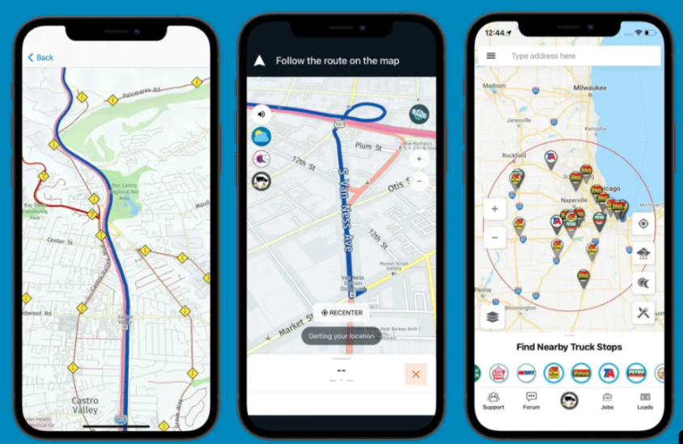This is a navigation app I use it all most every day and its very useful it helps me a lot when I am traveling with my car…

Screenshot/Photo 2
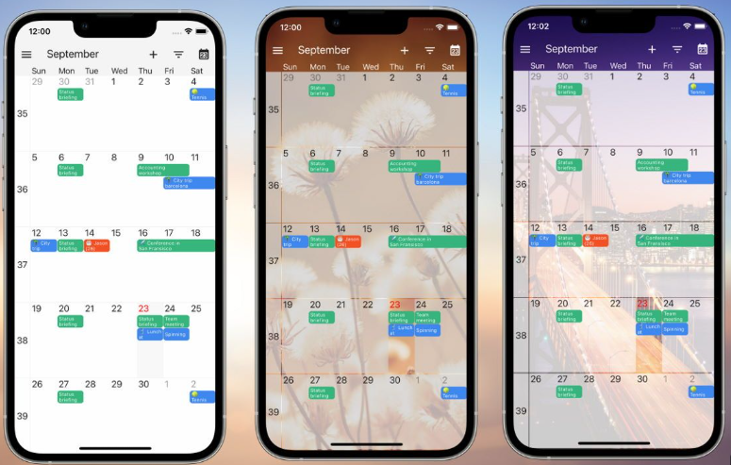This is a app call celender I organise and schedule my daily and months due…

Screenshot/Photo 3

I use those app for baying and selling items through these apps..

Screenshot/Photo 4
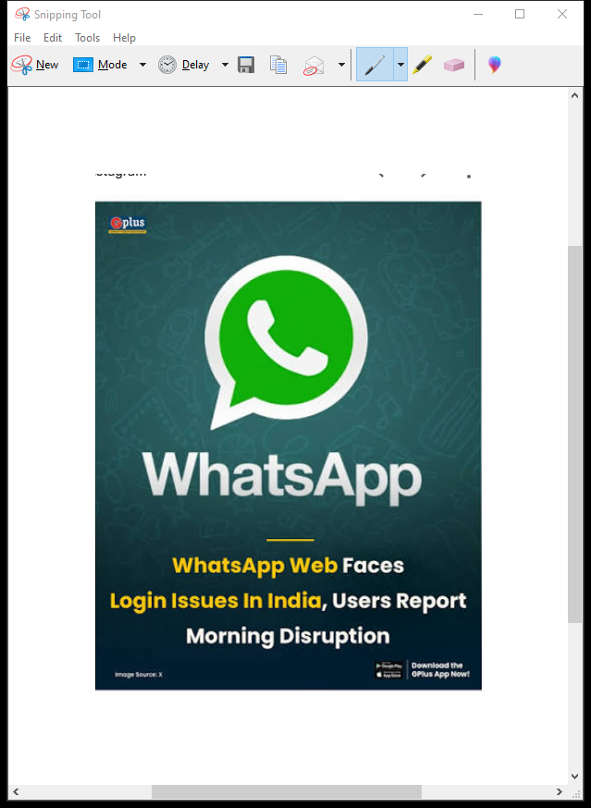 (WhatsApp) I use this app for communication with my family and friends


Screenshot/Photo 5
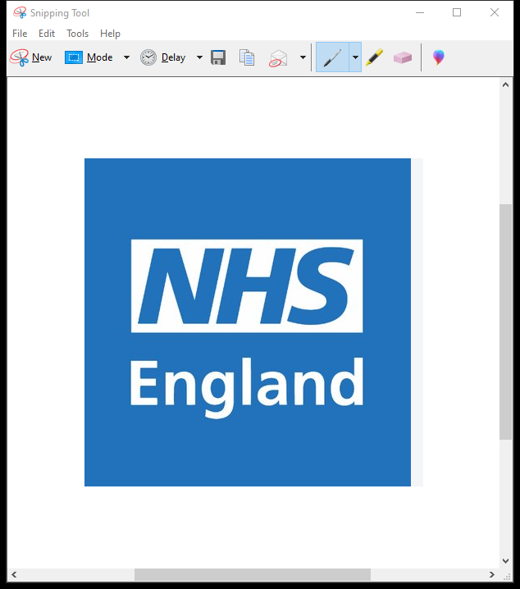
This is app call nhs app which is help me to keep my health condition under control..

Screenshot/Photo 6
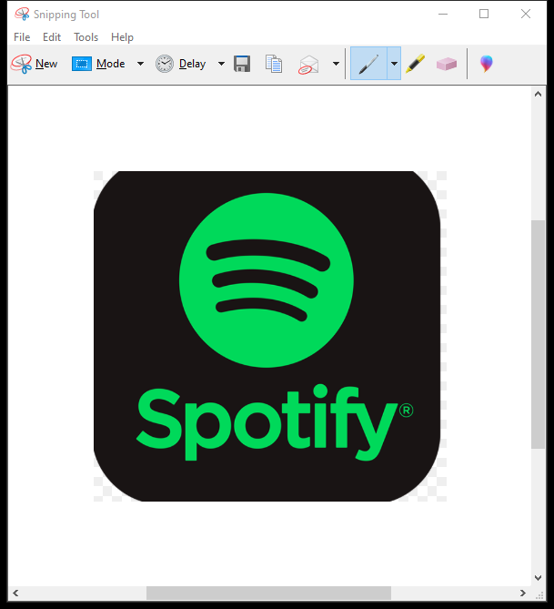Spotify app whenever I want to listen to music I use this app helps me to bring my mood to up…and keep me motivate me when I am gym…

My Short Reflection

I use digital tools to manage my daily task and communicate efficiently they help me access information instantly and stay organized..
I hope this module will help me gain practical technical skills it will enable me use modern tools more effectively…

Submission Checklist
Before you submit, please check:
​​​ ☒ I added 4–6 screenshots
☒ I wrote short sentences for each screenshot
☒ I wrote my short reflection
☒ My work is my own
☒ My file opens correctly
​​☒ My file opens correctly

