Within this case study I shall be investigating the implication of risk factors upon our current society and how protective factors come into play, in regard to building resilience. For the purposes of this case study and the anonymisation of the individual, the key subject focussed upon will be named ‘Tim’.
At this current time the world is experiencing a global pandemic, this is due to the spread of Coronavirus, also known as Covid-19. Covid-19 is a ‘new’ virus that affects the respiratory system and can present as influenza-like symptoms, in some cases this will result in severe pneumonia and can lead to mortality (NICE National Institute for Health and Care Excellence, 2020). ‘The COVID-19 virus spreads primarily through droplets of saliva or discharge from the nose when an infected person cough’s or sneeze’s’. There is currently no fully curative treatment or vaccine at present (World Health Organization, 2020).

The virus was first detected in Wuhan province, China at the end of December 2019, this has now spread across the world. In January 2020 the first two cases of the Covid-19 virus were recorded in the United Kingdom. This number has since increased to 103,093 cases in the UK as of April 16th, 2020. There have been 13,729 deaths caused by the virus as of April 16th 2020 (Stewart, 2020) - with numbers growing rapidly week-on-week. Some research that is ongoing among China has taken place in which how the virus is affecting people psychologically. There is a growing concern that the pandemic is having a massive impact on many people’s mental health and wellbeing, studies show that the psychological impact is ranging from moderate to severe, with the point of view that there is a great need to support people’s mental as well as physical health (Cuiyan Wang, 2020).
The pandemic is having a tremendous negative effect upon youth work organisations, with many of them not being able to give the support and guidance to young people as they normally would do so. UK Youth (2020) comment that 31 percent of youth work agencies are likely to be made redundant due to this crisis, with 17 percent of these closures of services likely to be permanent. This will not only impact the services for young people at the present time, but also have a negative impactive further into the future. Organisations are having to adapt to how they would normally interact with young people, in a way to still offer a service and work towards being able to support young people and the challenges they might be facing at this current time. One of many negative factors that have been highlighted is that some young people do not have a supportive network with their family. Some young people’s support networks are their close friends and not being able to see them is affecting their wellbeing. For some individuals the only means of communication is via online services and social media platforms. Another negative factor is that some young people may be feeling they are being restricted, and thus their voices, opportunities and choices have been taken away from them; they are not able to express themselves as they would in normal circumstances (UK Youth , 2020). The WHO has stated that the impact on peoples’ mental health, due to the Covid-19 pandemic, is a crisis that they are taking very seriously, they are monitoring the situation which is ever growing. With this, they are advising governments and national authorities to give guidance on the situation. A press briefing was held on the 26th of March addressing the question: ‘What could the impact of the COVID-19 crisis be on children’s mental health’. Commenting how children may be experiencing anxiety and fear and explaining also how children and young people are not being able to socialise with friends, it was noted that this will have an effect on their wellbeing. Furthermore, children and young people being forced to stay at home can increase the potential risk incidents, such has witnessing violence within their home and/or being victims themselves. Mental health psychosocial support services should be put in place, alongside child protection services, in order to be able to adapt and to still care for children and their families (World Health Organization , 2020).
Children’s and young people’s well-being are being significantly affected by the Covid-19 pandemic. There have been multiple reports linked with raised levels of anxiety and the impact upon wellbeing (World Health Organization , 2020). This can be due to many connected factors; one such being spending more time at home as aforementioned. Young people are not being able to engage with their friends in a physical manner in which they are used to and are having to adapt to maintaining these friendships remotely. This can also have an increased effect on cyberbullying, due to the extra online activity as a result of the pandemic situation (Galoustian, 2020).
The Covid-19 virus is also having an impact on young people’s physical health, as those with long-term physical health conditions may be struggling to maintain a healthier lifestyle and managing this effectively. The Children’s Society (2020) highlight that worries and concerns about the virus are more likely to have a greater impact on young people who already suffer with anxiety and depression. Young people who have a learning disability will be having to come to terms with the implications of having their routine affected and may not being able to understand what is going on around them. This having a huge negative impact upon young people with learning disabilities in many ways. Young people with learning disabilities are having to practice social (notably physical) distancing and/or becoming self-isolated due to being in a ‘high-risk’ category; this will potentially reduce the autonomy that young people have over their own lives. Finding themselves unable to partake in recreational activities, that would normally have the effect of improving their well-being, may also be a concern at this time (The Children Society , 2020).
GreatSchools Staff, (2009) state that scientific studies focusing on children with a learning disability conclude that they are at a higher risk of academic failure, social difficulties, behavioural disorders and psychological difficulties, with a wider dependence on guardians or parents and potential problems in seeking and maintaining employment. A young person with a learning disability may also be considered as a risk factor themselves. Risk factors are a variation of circumstances, but in general a risk factor is any condition/situation and event that rises the negative outcome of an individual’s life. When a young person with or without a learning disability overcomes these barriers of risk factors, this is where resilience arises. 36 percent of children and young people with a learning disability/intellectual disability experience a mental health problem(s). Routine and structure have an impact on reducing anxiety levels with these learning difficulties. The Covid-19 pandemic can be seen as exacerbating the disruption to (The Conversation , 2020).

Syder, (2011) mentions how scientific studies on children and resilience began in the mid 1960’s. It was put forward that improved understanding could potentially transform practice and policies to help promote and prevent children’s lives being at risk or hardship. One angle of resilience focuses on the criteria of wellbeing versus emotional distress, but also the importance of external factors. This presents the outlook that human beings are living in organisations and units, such as families and communities. Curran, (2013) presents the need to prevent risk and the importance of learning to manage risk, this being an essential part of growing up. There is an idea of a rehearsed framework of a ‘risk society’, where people are both the risk and the consequence of their actions and uncontrollable circumstances. There are themes in policies over the years to frame risk-based social policy models, this being to promote ‘self-reliance’.
Research by Public Health England, (2015) states what works for young people and identify six core principles, these concepts being designed to help resilience (fig.1).
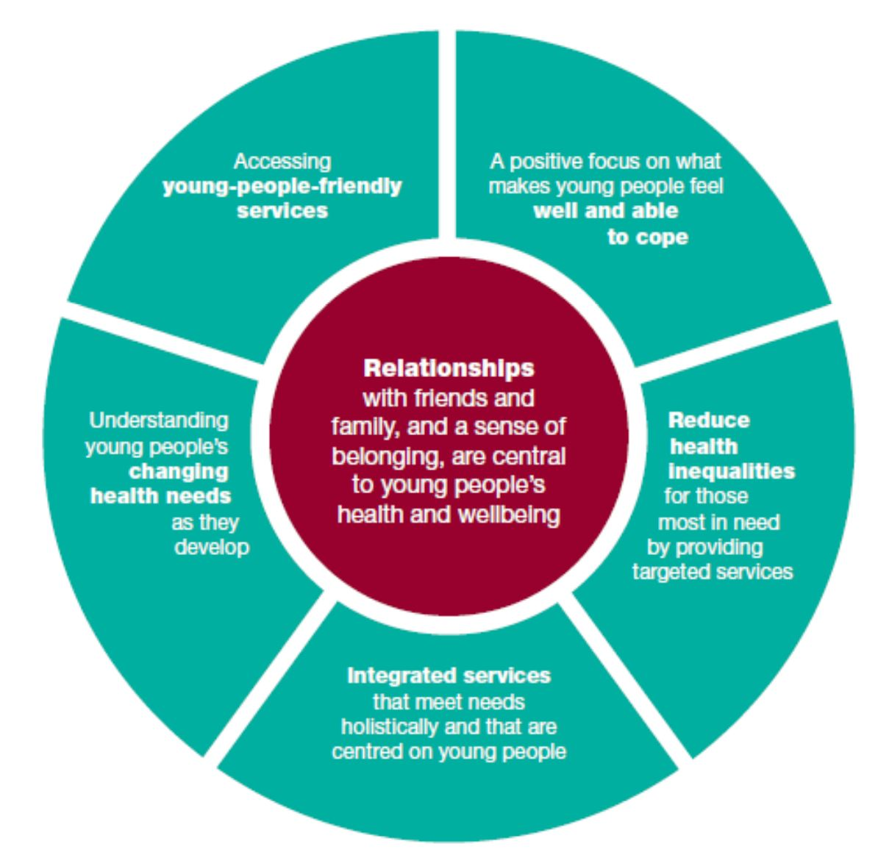
Figure 1. Six principles to shape our thinking about young people’s health, Public Health England, 2015.

The reasoning behind this strengthening of young people’s resilience, with the ability to cope, is important in delivering services that help deal with arising problems, which young people might encounter. Building upon young people’s ability to cope is will hopefully help them into and throughout their adult lives. NHS Greater Glasgow and Clyde , (no date ) furthermore, explain how it is helpful for young people to develop caring and positive relationships within social, school, family, and community settings. These positive relationships offer opportunities in life and the greater the protective factors a young person has, the more likelihood that they will have more resilience going forward.

Case study
Tim is a young person who was born with learning disabilities. Tim has never known his father and his mother died in a car crash when he was young. Tim then went to live with his grandmother until his grandmother died, to which he then went into shared/cared living accommodation. Tim went to a school that was specifically for young people with learning difficulties. Tim is a very intelligent individual who has expressed his negative experiences at this school and has even pointed out where he felt the school was going wrong regarding young people. The Covid-19 pandemic has naturally affected Tim, as he has had to go into isolation within his house. Tim normally goes out into the community every day and catches a bus. Tim also works twice a week at National Botanical Garden of Wales and Burns in the Community; both of which have been shut down due to the pandemic. Tim attends these placements through the Mencap ‘Me Time’ project, which helps run these placements. Tim struggles with his living arrangements as he would like to live independently. Tim has a challenging relationship with his carer whom he lives with. Tim has expressed on many occasions where his career has taken it upon themselves to inform Tim that he has learning disabilities and therefore cannot do things such as cook for himself, do his own washing and he will never be able to live independently. This has an extremely negative impact on Tim, where he has on occasions lashed out on specific objects, such as a dishwasher. This behaviour has then been ‘thrown back in his face’ and used against him by his career, as a form of ridicule. Tim has found being in isolation extremely difficult as he has had his independence taken away from him, but also is having to adjust to his living conditions and having to face his carer’s attitude towards him on regular occasions. Having a change in his routine has also had a negative influence on his mental health, as he now has no structure to his days.
When young people with learning difficulties have their routine disturbed, this can trigger mental health concerns. This has been the case for Tim. Among having his voice and independence constricted, he is living with negative implications from his career on a more regular basis. As my role as a youth worker to help Tim through this difficult and challenging time, I have made it a priority to have regular telephone conversations with Tim, whereby he can express himself and I can help set weekly targets he can work towards. This gives Tim some structure back and something he can work towards, thus helping to build his confidence and in-turn his resilience to the arising situation. (Balamurugan, 2014) suggests that adolescents with a learning disability need extra time and help throughout this period. If adolescents with a learning disability can receive this, then the challenges they face can be reduced and the individuals will have less of a restriction on their development. There is still a lot of research around the brain development in young people with learning disabilities. It is evident that young people with learning disabilities have different elements of the brain growing at different rates and in different ways. This being part of their learning disability. With a range of learning disabilities this is different for every individual (Sternberg, 2018). As through this pandemic I have been restricted to how I can support Tim with having regular contact, letting Tim voice his views opinions and setting out weekly targets, I have helped Tim in being able to gain some form of proactive factors to help balance out the risk factors he is facing.
As a trainee youth worker, I am helping young people with building the skills and knowledge to help build and develop resilience. Using techniques such as growing confidence, empowerment, and decision making this can have positive influence in young people being able to gain better reliance. Youth workers have an important role to play to help support young people in understanding themselves and their perception of the world around them. Although during this challenging time of a pandemic it is a youth workers ability to adapt to the situation around them to be able to still offer this support to young people through this period of time (Powell, 2015).
In conclusion, as discussed within this case study essay, notably statements by Syder (2011), and Curran (2013), there has been much research as discussion surrounding young people and risk. In one instance young people need to be protected, but in another, young people need to have an element of risk in their lives in order to be able to build reliance. With young people being provided with protective factors, they can encounter elements of risk and be able to build resilience(Public Health England , 2015)￼. Throughout this on-going global pandemic associated with the rise and spread of Covid-19, all services are being stretched, in some cases to breaking point, and our lifestyles as we know it have changed drastically. As a trainee youth worker, it is cur this my role to adapt how I can help young people, such as ‘Tim’, who are exposed at this difficult time to even more risk and their protective factors which have been withdrawn. Young people still have the right to a positive wellbeing (Social Services and Well-being (Wales) Act 2014).
To address Tim’s needs, within this current situation, I have telephoned Tim once a week to check in with him to offer support and see how he is doing within himself. I also have set Tim goals that he can achieve. For example, I have suggested he reduces time playing computer games, and instead puts effort into cleaning his room. These are little things that can help Tim in being active and having a level of productivity within his days in isolation. I am also someone who is letting Tim voice his opinions and concerns, in order to give him the ability to voice himself; this correlates with youth work core principles (CWVYS, 2018). The situation is still on- going, thus putting systems in place to help young people like Tim is going to be most challenging and organisations, support staff and young people are still adapting to this ever-changing situation. Due to the unique nature of the pandemic and the subsequent lack of current research surrounding this area, it is difficult to ascertain active theoretical reasoning and implement strategies. As a trainee youth worker I am actively engaging with the young people I support by using online resources and mobile technology, as physical distancing is in place in the majority of places. As humans we adapt, and I hope that my actions and those of others are making some difference in the lives of young people who are at risk.

References
Anon., n.d. [Online].
Balamurugan, D. J., 2014. A Study on Learning Disability in Adolescents and Young Adults. [Online]
Available at: https://www.researchgate.net/publication/269275917_A_Study_on_Learning_Disability_in_Adolescents_and_Young_Adults
[Accessed 22 April 2020].
C. R. Syder, S. J. L., 2011. Oxford Handbook of Positive Psychology. First ed. New York : Oxford University Press, Inc..
Conor, n.d. [Online].
Cuiyan Wang, R. P. ,. X. W. ,. T. L. X. C. S. H. R. C. H., 2020. Immediate Psychological Responses and Associated Factors during the Initial Stage of the 2019 Coronavirus Disease (COVID-19) Epidemic among the General Population in China. [Online]
Available at: https://www.mdpi.com/1660-4601/17/5/1729/htm#cite
[Accessed 18 April 2020].
CWVYS, 2018. Youth Work in Wales: Principles and Purposes. [Online]
Available at: http://www.cwvys.org.uk/wp-content/uploads/2018/11/YOUTH-WORK-IN-WALES-PRINCIPLES-AND-PURPOSES.pdf
[Accessed 3 5 2019].
Galoustian, G., 2020. ININTEDED CONSEQUENCE OF COVID-19 CYBERBULLYING COULD INCREASE. [Online]
Available at: https://www.fau.edu/newsdesk/articles/covid-19-cyberbullying.php
[Accessed 20 April 2020].
GreatSchools Staff, 2009. Research trends: risk and reilience in people with learning disabilities. [Online]
Available at: https://www.greatschools.org/gk/articles/risk-and-resilience-learning-disabilities/
[Accessed 9 April 2020].
NHS Greater Glasgow and Clyde , no date . Resilience Toolkit. [Online]
Available at: https://www.seemescotland.org/media/8155/resiliance-toolkit.pdf
[Accessed 22 April 2020].
NICE National Institute for Health and Care Excellence, 2020. COVID-19 rapid guideline: managing suspected or confirmed pneumonia in adults in the community. [Online]
Available at: https://www.nice.org.uk/guidance/ng165/chapter/4-Managing-suspected-or-confirmed-pneumonia
[Accessed 24 April 2020].
Powell, D., 2015. Mental health: We need to build resilience. [Online]
Available at: https://nya.org.uk/2015/05/we-need-build-resilience/
[Accessed 23 April 2020].
Public Health England , 2015. Improving young people's health and wellbeing A framework for public health. [Online]
Available at: https://assets.publishing.service.gov.uk/government/uploads/system/uploads/attachment_data/file/773365/20150128_YP_HW_Framework_FINAL_WP__3_.pdf
[Accessed 20 April 2020].
Sheila Curran, R. H. a. D. M., 2013. Young people, risk and resilience . In: T. O. University, ed. Working with Young People . Milton Keynes: SAGE, pp. 7,8.
Social Services and Well-being (Wales) Act 2014, 2014. Social Services and Well-being (Wales). [Online]
Available at: http://www.legislation.gov.uk/anaw/2014/4/pdfs/anaw_20140004_en.pdf
[Accessed 24 April 2020].
Social Services and Well-being (Wales), 2014 . Social Services and Well-being (Wales). [Online]
Available at: http://www.legislation.gov.uk/anaw/2014/4/pdfs/anaw_20140004_en.pdf
[Accessed 24 April 2020].
Sternberg, R., 2018. Perspectives On Learning Disabilities: bilogical, Cognitive, Contextual. [Online]
Available at: https://books.google.co.uk/books?hl=en&lr=&id=dJpLDwAAQBAJ&oi=fnd&pg=PT72&dq=learning+disabilities+and+brain+development&ots=9u2eNX9gtd&sig=lDHJRqVqtfGnGjeLRNkSQq5hVzo#v=onepage&q=learning%20disabilities%20and%20brain%20development&f=false
[Accessed 23 April 2020].
Stewart, C., 2020. Coronavirus (COVID-19) in the United Kingdom (UK) - Statistics & Facts. [Online]
Available at: https://www.statista.com/topics/6112/coronavirus-covid-19-in-the-uk/
[Accessed 2 April 2020].
The Children Society , 2020. The impact of COVID-19 on Children and young people. [Online]
Available at: https://www.childrenssociety.org.uk/sites/default/files/cv-19-impact-on-children-report-from-the-childrens-society.pdf
[Accessed 6 April 2020].
The Conversation , 2020. How coronavirus could affect the wellbeing of people with intellectual disabilities. [Online]
Available at: https://theconversation.com/how-coronavirus-could-affect-the-wellbeing-of-people-with-intellectual-disabilities-133540
[Accessed 19 April 2020].
UK Youth , 2020. The impact of COVID-19 on young people & the youth sector. [Online]
Available at: https://www.ukyouth.org/wp-content/uploads/2020/04/UK-Youth-Covid-19-Impact-Report-External-Final-08.04.20.pdf
[Accessed 18 April 2020].
World Health Organization , 2020. Mental health and psychological resilience during the COVID-19 pandemic. [Online]
Available at: http://www.euro.who.int/en/health-topics/health-emergencies/coronavirus-covid-19/news/news/2020/3/mental-health-and-psychological-resilience-during-the-covid-19-pandemic
[Accessed 20 April 2020].

