
Skills for the Workplace
Module Assignment Submission
Student Name: | Amanda Napier
Student Number: | 2007696
Module No: | BMSK4006
Module Title: | Part 1 Business Plan

Statement of Confirmation of Authenticity
By the act of making this submission, the student declares that this is the work of the student named above. The work has not, in whole or in part, been knowingly presented elsewhere for assessment, or where assessment has been built on a previous assessment, this has been identified. Where materials have been used from other sources it has been properly acknowledged. If this statement is untrue, the student acknowledges that an assessment offence has been committed.
Attention is drawn to the plagiarism and unfair practice policies of both the University and of ILM.

Table of Contents
Title Page 3
Executive Summary 4
Business/Industry Overview 4
Market Analysis and Competition 5
Sales and Marketing Plan 5
Product or Service Offerings 5
Pricing Strategy 5
Sales and Distribution 6
Advertising and Promotion 6
Ownership and Management Plan 7
Operating Plan 7
Financial Plan 8
Appendix 10

Title Page

Business plan for Mandy’s Childcare
(1st July 2021)
3, Clos Las,
Penlan,
Swansea,
SA5 7BJ.
07814 700959

amandkatie@yahoo.co.uk
Mandy’s Childcare


Executive Summary
The owner of a children’s childminding service called Mandy’s Childcare is looking to open the business at her premises, located in a quiet part of the Swansea area. With only two childminders in the area within a two-mile radius the owner feels confident that there would be a great need for this service as there are six primary schools in the location, therefore a need for childcare.
The owner’s mission is to start trading from the conservatory at her home to maximum capacity for a sole trader. She plans to run and manage the business independently for 2 years, with the aim to understand what the competition is doing so that she can do it better. She then plans to expand by employing staff and locating to a bigger premises after 3 years.
The target audience will be parents and carers of young children. The business will provide quality childcare in a fun, safe, caring environment.
The owner is a highly skilled and qualified, mature childcare worker. With the skills and experience she has she feels that this is an advantage towards competitors and hopes the business will thrive very quickly. The owner is hoping to work with the competitors as there are only 2 in the area in the hope of recommendations for her business if they become full themselves.
In order for the owner to start up her business she will look at how to fund the business, how to market the business, how to price services and how to budget. She will also look into the legal requirements, for example, liability insurance, car insurance etc.

Business/Industry Overview

The owner is looking to open a highly skilled childcare facility in the local area for children aged 0-12 years. The facility is able to offer quality childcare Monday – Friday 8am-6pm although times may be flexible upon need. School pick ups will also be offered at a small extra cost.
This sort of business fits very well into the industry as there is a need for this service with only two other childcare facilities serving the local area and six primary schools.
The owner feels that with a larger area than the other two competitors she will be able to offer more of a service at a very competitive price. With an area of 18.58m2 the owner would be able to offer childcare to 7 children per day. This is based on the National minimum standards for regulated childcare at a rate of 2.5m2 per child.
This will be in the form of leaflets, business cards, advertising on car and social media. This will all be completed by the owner to minimize costs.

Market Analysis and Competition
With only two other childcare facilities in the local area and six primary schools, the owner feels there will be high demand for this service and is confident that expansion will arise pretty quickly as soon as the business is established.
By undercutting prices from the competition (see appendix for prices) and taking into consideration the space available at her premises the owner feels that this is a key strength to her business in comparison to the other two competitors.

Sales and Marketing Plan
The owner plans to make a small profit over a 3-year starting up period. In order to make a profit she needs to promote her company with as little cost to the business as possible.

Product or Service Offerings
The service offered is a quality childcare service with a highly skilled worker. The customer will benefit from fantastic childcare in the form of a mature, caring environment catering for children aged 0-12 years old, five days of the week.

Pricing Strategy
The owner will price her service based on the competition in the local area and also on average market costs.
The first childminder based in the Morriston area of Swansea charges £4.50 per hour of childcare. Breakfast, lunch, desert and tea is included for full days.
The second childminder based in Llansamlet Swansea charges £4-£5 per hour. This includes meals, snacks, wipes and nappies.
A google search revealed that the average price per hour for childcare in Wales is £4.23 per hour.
The owner will charge £4.30 per hour and £40 for a full day 8am-6pm Monday-Friday. This price will include meals, snacks and drinks. Wipes and nappies will need to be provided by the parents/carers.

Sales and Distribution
The child-minding business will offer a fun and quality environment for all children attending. It will be a home from home and all children will be welcomed with open arms.
Payments will need to be made at the beginning of the week for the week ahead through bank transfer.

Advertising and Promotion
The target audience will be parents and carers of young children.
Marketing will consist of small flyers containing all the relevant business information. These will be distributed through letterboxes within a three-mile radius of the business. The owner will also place flyers on notice boards in big companies within the surrounding area, in local shop windows, libraries and community centres. The owner is looking at having one free hour of childcare printed on the flyers as an incentive to try before you buy but to mostly see if the child enjoys the service provided and feels settled and happy.
Having worked in childcare for 15 years for the Welsh Government, the business owner is familiar with many agencies and plans to provide marketing information to them in the hopes of recommendations.
The social media presence of the business will be promoted on the flyers to encourage people to look at the business and check reviews from others.
Family and friends will also be asked to share this information by word of mouth and on their social media accounts in order for the business to be seen.
The owner plans to have magnetic signs made for her business which will be attached to her car for members of the public to see.
As the business is a new business the owner is looking to spend only a small amount on advertising. An approximate budget for around £30 for 500 A7 flyers would be sufficient at the start.

Ownership and Management Plan
As the owner is the only person starting up the business, she has decided to open the business as a sole proprietor. This is a type of business entity which legally has no separate existence from its owner.
The advantages of this being that there are easier processes and fewer requirements for business taxes. Other business structures need to apply for an employment identification number (EIN) in order to collect and pay employees separate from their social security number. Sole proprietors are not required to file for an EIN, however they do have the option to apply for and use an EIN.
There is less paperwork to get started. Other business structures such as limited liability corporations, require you to register with your state government before you can do business. Sole proprietors do not generally need to do this. Instead, they become a business just by starting a business.
There are fewer registration fees.
More straightforward banking. As a sole proprietorship the owner will be able to accept business payments straight from her own personal bank accounts.
There is simplified business ownership.
The owner will be required to run and manage the company independently at the start of the business. She will then look at the staffing plan after 3 years in the hope of expanding, employing staff and employing a manager.

Operating Plan
The business will operate from a conservatory in the Swansea area which has an area of 18.58m2. The owner will look at expanding the business to a much larger area within 3 years of business. The business is at the rear of the property which is on a mortgage. Maintenance of the property will be carried out by the owner and/or tradesmen. Any work needed to be carried out will take place at weekends when the business will not be open.
The owner has all relevant training up to date and any other training will be carried out prior to opening or during weekends.
Furniture will be sourced from a local supplier and food and materials delivered on a weekly basis from a well known supermarket.
Travel will be in the form of a people carrier which will be purchased out of the business loan and repaid every month over a three-year time scale.

Financial Plan
With the childcare business the owner plans to make a small profit in the first three years of business.
The predicted income into the business each month are: -
Business loan of £25,000.00. Split over 36 months would be £694.41 per
Month.
Childcare income of 3x children (2years old) full day, 5 days a week @ £40.00 a
day = £2400.00 Per month.
1 child (6 years old) 3pm-6pm, 5 days a week @ £4.30 per hour = £258.00 per month.
2 children (9 years old) 3pm-6pm, 5 days a week @ £4.30 per hour = £516.00 per month.
1 child (8 years old) 3pm-6pm, 5 days a week @ £4.30 per hour = £258.00 per month.
The predicted outgoings each month are: -
Re pay business loan = £789.88
Utilities = £130.00
Insurance = £7.40
Training = £20.00
Car insurance = £25.00
Snacks = £300.00
Resources = £100.00
Petrol = £120.00
Mortgage = £480.00
Wages = £1000.00
Total profit each month would be £1137.33. Each year would be £13647.96.
See cash flow forecast in appendix.

Appendix

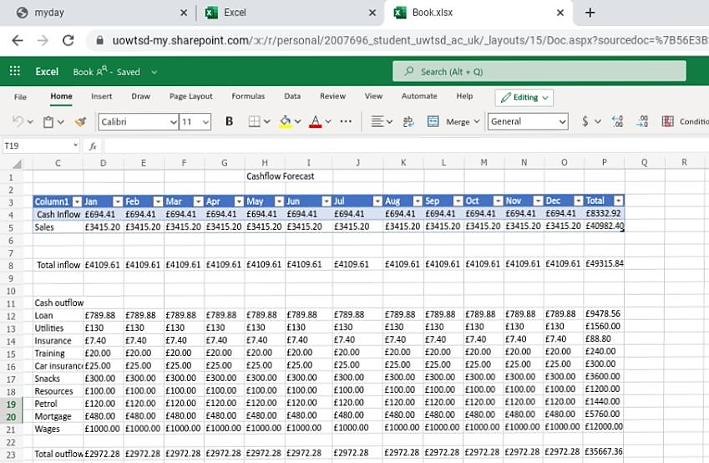
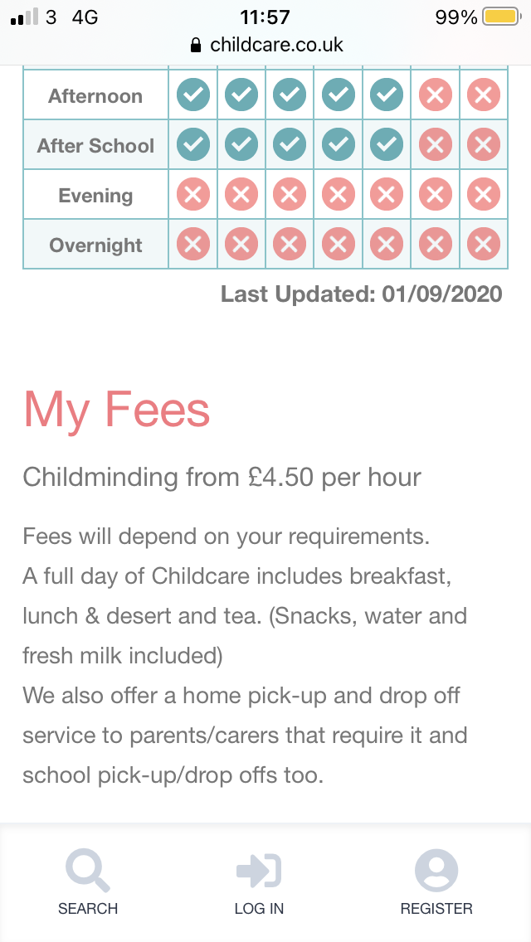
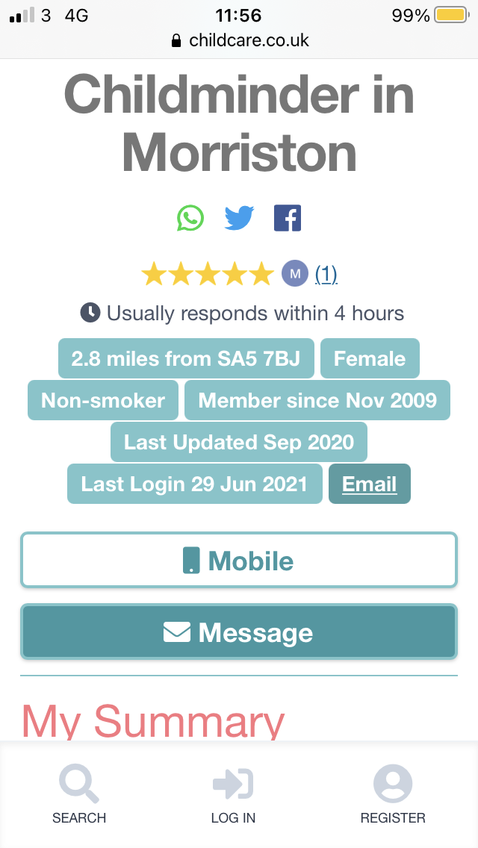
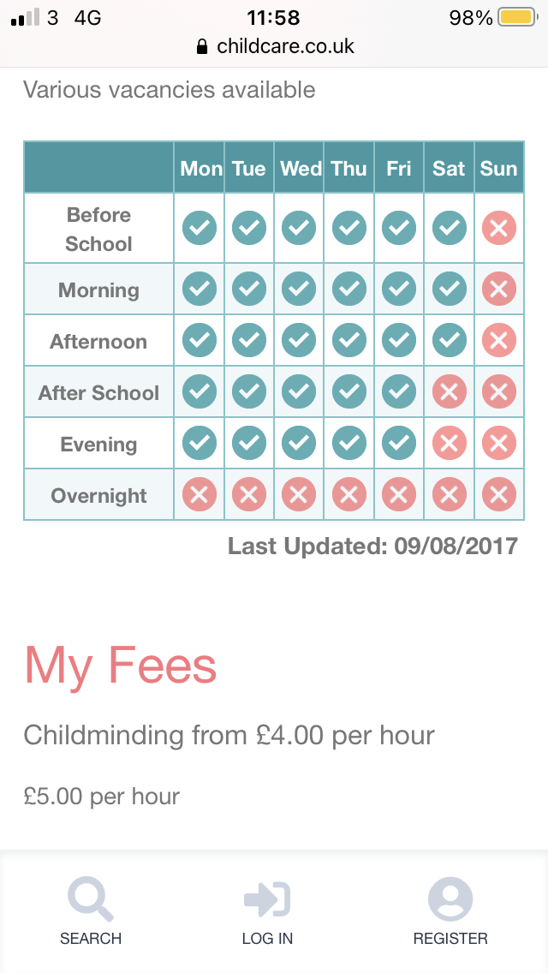
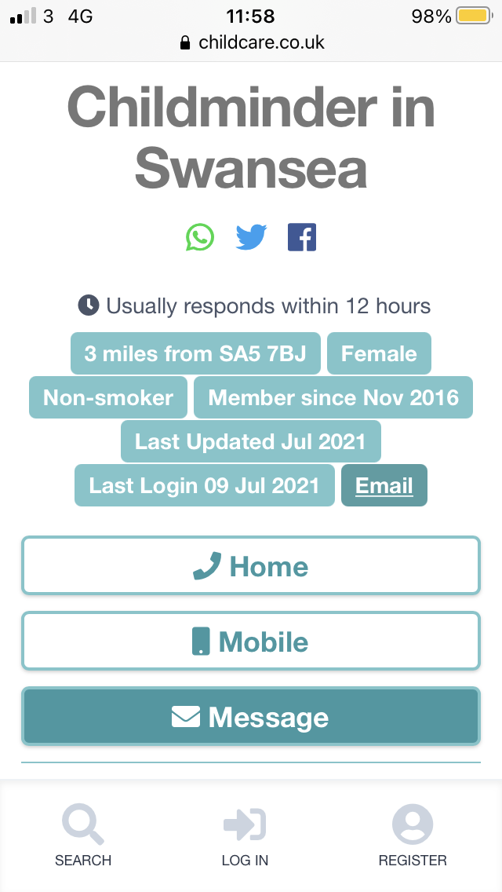
STRENGTHS  High level of experience in caring for children.  Leadership.  Support from others. | WEAKNESSES  Lacks confidence.  Scared of change.
OPPORTUNITIES  To build a career in my chosen employment.  To make a business name for myself. | THREATS  The business will fail.

P - Many courses are made available to make is easier for individuals to start up their own business. Online courses are easily accessible and are competitively priced. Government grants are also made available for those wishing to start up a new business.
E – Economic factors such as low interest rates for start up businesses make it easier and less of a worry to start up your own business.
S – With more people working rather than staying at home there is more demand for childcare.
T – With easier access to the internet it is quicker and more beneficial to advertise and sell online.
E – The business will be a place where all items will be recycled.
L – The business will keep up to date with any changes in the law or legislation.



