Llywelyn James
2217776
Module Code – ACBA 6009
For: Rhodri Thomas
The dylan thomas centre report
Advanced Construction Technology

Contents
1.0 Introduction 2
2.0 Building Overview 2
3.0 Current Issues 2
4.0 Digital Technologies 3
4.1 BIM 3
4.2 Scanning 3
4.3 Digital Twin 4
4.4 SMART System 4
4.5 Artificial Intelligence 5
5.0 Critical Evaluation of Modern Technology 5
6.0 Professional recommendations 6

1.0 Introduction
This report will be focused on the Dylan Thomas Centre (DTC) in Swansea, near the Maritime Quarter, which was built between 1825-29 (Dylan Thomas Centre, n.d.). The aim of this report is to explain how the building can be improved with the use of current technologies such as BIM, SMART technology, digital tools etc.

2.0 Building Overview
To give a brief overview of the building it’s a historic commercial building that has been repurposed and currently being used as an exhibition/ museum for the famous poet Dylan Thomas, as well as having a café, students union and lecture rooms for the University of Wales Trinity Saint Davids (UWTSD). The DTC is structure primarily consists of masonry stone walls, timber floor structures and a pitched roof (Heritage Fund, 2013). It’s also grade 2 listed (Heritage Fund, 2013) as it’s within Swansea’s heritage area, meaning that everything must meet the requirements in the Planning (Listed Buildings and Conservation Areas) Act 1990 for works to be approved. An image of the centre can be seen below.
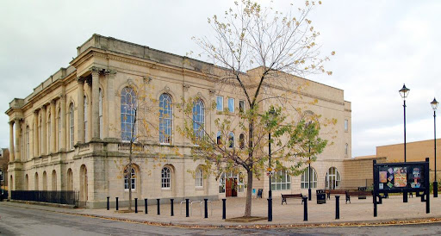
Figure 1.0, Exterior photo of the Dylan Thoms Centre.

3.0 Current Issues
Thermal inefficiency is a problem that the DTC has, with issues such as the masonry (lifecycle of up to a 100 years (L. Martin, 2023)) and timber (lifecycle of 100 years or more (Structural Timber Frame, 2025)) elements, due to the age of the building degradation may occur. BIM (specifically Heritage BIM) can determine how safe it is and when/ if these elements need to be seen too.
The windows throughout the building are all timber framed and singled glazed windows, with the doors being made of timber and have metal fittings, depending on which door. Additionally, the windows are single glazed, there’s weak thermal insulation, large rooms and masonry walls, the energy performance is poor, resulting in high energy costs.
Currently, the facility and asset management is being done manually with all maintenance being done by the tradesmen/ engineers who are called upon when a service is due, or inspections are required on the services. The certificates/ documents which are given out after these checks, are sent across either by email or the maintenance team are handed a paper copy version.

4.0 Digital Technologies

4.1 BIM
The first example of how this building can be improved is by using Building Information Modelling (BIM). Due to the age of the DTC, there is a possibility that the original drawings are outdated or inaccurate, in this context, BIM will be able to create a digital model (Zach Mortis, 2025) of the building as it is currently by working alongside with a 3D laser scanner which will give an accurate model for architects, engineers etc, allowing them to plan retrofit works without causing damage to the structure of the building mitigating the risk. BIM can also integrate grade 2 listed requirements into the system, by allowing the people who’ve got access to the model to insert regulatory information to specific elements throughout the building, like the masonry walls for example. Whenever the masonry walls are included in any works being done, it’ll get flagged up on the model to highlight and would need approval from Swansea council.
Adding to this, BIM also keeps track of the maintenance and collects detailed information from systems within the building such as lighting, HVAC and so on. It does this by adding key information about each element into the BIM model, like the installation dates, expected lifespan, the manufacturer etc which can be tracked through the system (Jennifer Williams, 2025). Every time maintenance is done the facility managers must update the model with key details of the works to make sure its accurate. The model can also support facilities management (FM) software enabling it to monitor the building, schedule maintenance and improve energy efficiency. This is particularly beneficial for the DTC, as there is an exhibition museum it’s important to maintain good environmental conditions throughout the building to protect any damage to the collection. An example of how the model will look can be seen in figure 2.0.
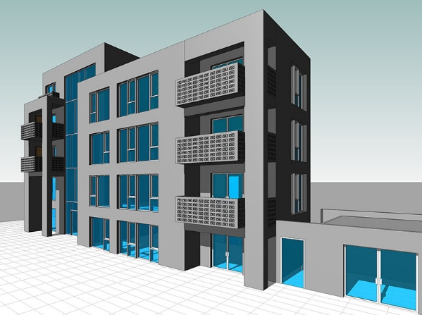
Figure 2.0, BIM model (BIM Services).

4.2 Scanning
Moving onwards to more modern technologies now specifically scanning, which as mentioned can be used in collaboration with BIM, like all the following technologies that’s included in this report. Scanning is used to create a 3D model of a building out of the information that it’s received off BIM as well as a site survey. Here it’ll capture millions of measurements as a point cloud (data captured by the scanners) (Jennifer Williamss, 2025).
In the DTC scanning with the help of thermal imaging would be able to locate areas/ rooms with air leakage or high amount of heat lost (Above All Insulation, 2025), but also poor insulation which can then be improved making it easier to manage the energy use. It also allows inspections for MEP systems, building envelope, health and safety etc to be done online reducing the number of site visits concluding in less operational costs. At the same time, if scanning was to be done to the building every 6 months or once a year, then the scans can be compared allowing you to see if any physical deterioration has occurred.
The Notre-Dame Cathedral in Paris is a prime example of where laser scanning was used and was beneficial towards the reconstruction following the devastating fire in 2019, which can be seen in figure 3.0. This enabled those involved in the reconstruction process to assess both the damage and plan the project with the least amount of risk through the point cloud model (Christopher Dollard, 2019). This can be comparable to the DTC as they are both listed, and their historical features are required to be protected plus have the same goal of detecting structural deterioration and improve maintenance planning. However, budget will play a huge role in this to determine what the best approach is, as the DTC will have a budget significantly less than the Notre-Dame. The approach is mentioned in more detail further into this report.
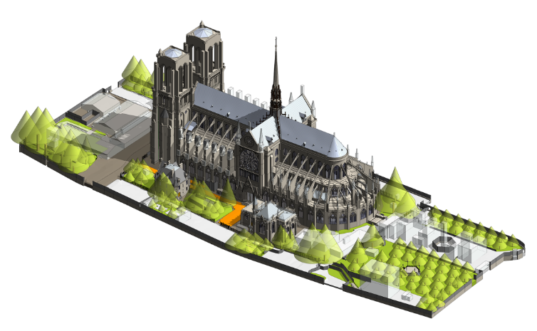
Figure 3.0, Scan of the Notre-Dame (CNN Business).

4.3 Digital Twin
In comparison to scanning, digital twin is a living system (TWI Global, n.d.) which computes real time data gathered from IoT (Internet of Things) sensors plotted around the building therefore creating an identical replica of the DTC. Whereas with scanning it only captures the condition of the building the precise moment the scan was taken, with no ‘real time’ information.
This system can analyse the live data throughout the building and predict where and when certain energy will be needed based off this (Jon Mixtelena, 2025). Additionally, the facility managers can adjust the digital model to test out new energy saving ideas to see if it would be more cost effective and suitable for the DTC in the long run. These ideas can be anything from replacing light bulbs to installing a new boiler.
This stage is where scanning, BIM and digital twin combine to work as one having a big impact on facility management, as they all merge into one system it can automatically generate alerts, maintenance schedules and work orders based on real time conditions of the asset. Furthermore, with these improving the facility management process, becoming more efficient, and increasing the buildings energy performance and costs, it’s becoming more popular each year with an average annual growth of 30% every year from 2022 until now, and is forecasted to continue at this rate over the next 12 months again (Mark Ntel, 2022). A example of a digital twin model can be found in figure 4.0.
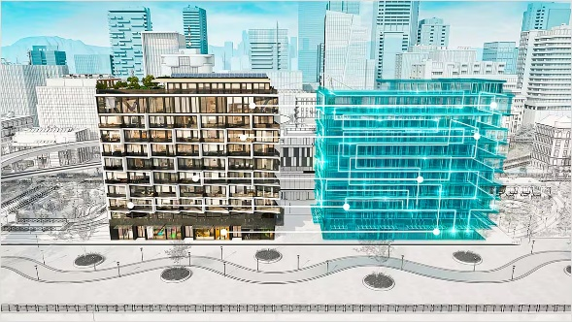
Figure 4.0, Digital twin model (Autodesk).

4.4 SMART System
As touched upon, the DTC needs to be brought up to speed with the help of modern technology. A system which can improve the building’s energy efficiency, whole life performance and facility management is the SMART system. All the information will be stored automatically on a control platform called the Central Building Management System (BMS), allowing the facility managers to track energy consumption, monitor heating, control the lights etc.
A key part of the SMART system is the IoT sensors which monitor the temperature, lighting levels, energy usage, humidity and occupancy level. For the DTC these monitors would be very beneficial. For example, the monitors can detect if there are people in the room, and if it’s empty, the lights will be turned off automatically through the system, which would cut down energy costs.
Roughly 64% of non-domestic properties across the UK have had SMART meters installed as of early 2026 (Energy Assets, 2026), and an estimated 70% of commercial buildings will be data driven by the end of 2026 (Acutro, 2024) which demonstrates a great appetite within the sector to improve efficiency and support to the governments net-zero goals.

4.5 Artificial Intelligence
Recently, Artificial Intelligence (AI) has been becoming more reliant with it being a key feature in the industry, with it now being integrated with the SMART system. AI will create the SMART system much more advanced, as it can learn sequences from the building’s data and be predictive, whereas without AI the system is more reactive. An example of how this would be used in this setting would be where an AI system may learn that a lecture room in the DCT is too hot (picked up from the fact that the room user would turn the thermostat down) and adjust the amount of heat released to suit the user’s liking.
AI can learn electricity tariffs in the Swansea area, and what time of the day is the cheapest to use electricity. In the case of the DTC, it’ll reduce the amount of energy being used and pre-heat the building before it reaches peak price periods in the day. It can also analyse the weather and the building’s occupancy to help determine where and how much energy is needed in certain areas of the building. Research shows that organisations save anywhere from 10% to 30% on energy costs through SMART systems (IET Africa, 2025). However, that isn’t including AI integration, where that percentage will just increase and taking into consideration the size of the building it will save the centre a lot of money overtime.

5.0 Critical Evaluation of Modern Technology
Each modern technology this report will improve the DTC by contributing towards it in different areas, but how well suited they are is down to any restrictions which occur in the centre. BIM will be aimed at the planning and lifecycle management element, with scanning being used alongside to make a replica of the building. Whereas digital twin adds to this by providing live monitoring and predictive maintenance, whilst the SMART system and AI look at optimising building performance through services that are controlled digitally.
However, there are some limitations that apply to each of these technology systems in the context of the DTC, with BIM staff would need to undertake training on how to use it and constantly need updating with information from the services to maintain its accuracy. This may be a challenge for the centre as it’s currently dependent on manual systems. If digital twins were to be installed then cost may be a problem, due to it having a high upfront cost (Emily Curreyr, 2022), and may not be within the DCT is budget as it’s a public heritage centre not a private or commercial building, which tends to have a bigger budget. With the DTC being grade 2 listed, the sensors fitted must not damage or affect the structure of the building, which in this case will be challenging due to the amount of sensors that would need to be fitted.
Likewise, the SMART system must be integrated into the building services. However, if the services are outdated in the DTC, then this can add complexity to the installation, which may result in the services like HVAC and electrical systems will require upgrading before it’s fitted, or increased installation cost due to the time it takes to set it up. If it isn’t set up correctly, it won’t allow AI to make the best decisions, in relation to energy efficiency and saving, due to the inaccurate/ lack of data taken. This is the case for the DTC, as the occupancy can in the building varies significantly between the Dylan Thomas museum hours and the university is lecture use.

6.0 Professional recommendations
The aim is to improve the DTC by incorporating it with modern technology that will improve its facility management. As it is grade 2 listed and has many people who visit on a regular basis then a phased approach in bringing these technologies is advised. This way the building can still be used but additionally wont damage any heritage features.
Currently, there is an existing air conditioning system in the centre, but only for one of the lecture rooms on the first floor, where it would benefit the DTC if it was removed and replaced with a new HVAC system which will be used throughout the centre benefiting by maintaining a steady temperature at all times (around 18-22˚C), creating a nice environment for visitors, students and staff. In addition to this being able to maintain 40-60% relative humidity (tt Webshape, 2024), which will prevent any potential damages to the exhibit but also preventing mould from occurring.
An area which should be prioritised by the centre is making that transition from manual maintenance to the fully digital FM system, for multiple reasons as touched upon throughout this report but also preventing the need to cancel lectures or close the exhibit for a few days due to maintenance repair work which could’ve been picked up by the FM system and avoiding this problem.
By having had a site visit to the centre recently it’s clear that the amount of wasted energy is very high, with this photo below clearly demonstrating that. The photo in figure 4.0 was taken from the bar room on the first floor of the DTC, which we were told by the current maintenance manager that it’s not being used at all, due to it not being used enough, making the following point even more valid. From this photo you can see that the window has been left open, but what you can’t see is that the radiator is on full blast. This was the case in several rooms throughout the building making the current system inefficient and incredibly wasteful due to the apparent inability to control the heating in the building.
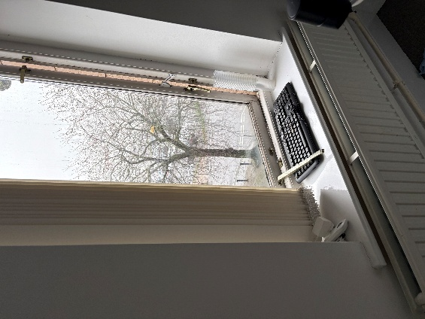
Figure 4.0, window left open with heating still on.
To improve this a SMART system of sort will be extremely beneficial. The main reason being that the exhibition is only open to the public from Wednesday to Sunday, which the amount of energy used can be reduced by having this in place as stated in this report. The same applies for the student union and the lecture rooms in the DTC as they are only used for a handful of classes per day from Monday to Friday, and only during term times.
As touched upon in the report, the windows throughout the DTC are predominantly timber single glazed specification, which aren’t very energy efficient these days. These are recommended to be replaced with timber double glazed to not change the aesthetic look of the building, increasing the likelihood of it being approved by Swansea City Council. The main purpose for this is to reduce the heating demand in the DTC and make the SMART system more efficient.
A cost benefit analysis is recommended to see which investment will provide the best ROI (Return On Investment). Following this, a phased works plan will be the most feasible option, which allows the centre to budget for the retrofit overtime by spreading the cost out and causing minimal disruption. The first phase should prioritise BIM and laser scanning to create a BIM model and set an accurate digital benchmark. Second phase should include retrofitting a SMART system (AI version budget dependent) in place to impact the energy performance. Finally, digital twin can be integrated into the centre once the building has the correct data collection systems.
Finally, due to the existing technology and the way maintenance is controlled in the DTC currently, which is outdated. If the FM isn’t updated soon, with the likes of digital twin for example, then it’ll be in risk of being left behind to similar buildings, but also increasing the risk of maintenance problems occurring due to the age of the services and technology that’s currently in place there. Resulting in the energy and maintenance costs increasing year by year.

7.0 Reference list
Above All Insulation (2025). Using Thermal Imaging to Detect Home Energy Leaks - Above All Winnipeg Insulation. [online] Above All Winnipeg Insulation. Available at: https://aboveallinsulation.net/using-thermal-imaging-to-detect-home-energy-leaks/ [Accessed 19 Mar. 2026].
Acutro (2024). Smart Buildings: In 2024 - Acutro. [online] Acutro.net. Available at: https://acutro.net/smart-buildings-in-2024/ [Accessed 19 Mar. 2026].
Africa, I. (2025). Building Management System vs Energy Management System (BMS vs. BEMS). [online] IET Africa. Available at: https://www.ietafrica.com/building-management-system-vs-energy-management-system-bms-vs-bems/?utm_source.com [Accessed 19 Mar. 2026].
Curryer, E. (2022). Meet the UK start-up that wants to make affordable digital twins for SMEs - TechInformed. [online] TechInformed. Available at: https://techinformed.com/meet-the-uk-start-up-that-wants-to-make-affordable-digital-twins-for-smes/ [Accessed 19 Mar. 2026].
Dollard, C. (2019). Precision Laser Scans of Notre Dame Cathedral Can Help to Preserve, Restore, and Rebuild. [online] Leica Geosystems. Available at: https://shop.leica-geosystems.com/leica-blk/blk360/blog/precision-laser-scans-notre-dame-cathedral-can-help-preserve-restore-and#:~:text=With%20a%20tragic%20cultural%20loss,down%20to%20one%2Dmillimeter%20accuracy. [Accessed 19 Mar. 2026].
DylanThomas.com. (2013). DylanThomas.com. [online] Available at: http://www.dylanthomas.com/.
Energy Assets (2026). Simulation vs Digital Twin (What is the Difference Between Them?). [online] www.twi-global.com. Available at: https://www.twi-global.com/technical-knowledge/faqs/simulation-vs-digital-twin.
marknteladvisors (2022). UK Digital Twin Market Size, Share and Analysis | Forecast - 2022-2027. [online] www.marknteladvisors.com. Available at: https://www.marknteladvisors.com/research-library/uk-digital-twin-market.html.
Martin, L. (2023). Life Span of Concrete Masonry Units (CMUs). [online] Nitterhouse Masonry Products, LLC. Available at: https://www.nitterhousemasonry.com/blog/lifespan-of-concrete-masonry-units/.
Mitxelena, J. (2025). Predicting Energy Consumption and Optimizing Maintenance with Digital Twins | Digital Twin. [online] Digital Twin. Available at: https://digitaltwinproject.eu/digital-twins-energy-consumption/ [Accessed 19 Mar. 2026].
Structural Timber Frame (2025). Installation | Our Solutions. [online] Structural Timber Frame. Available at: https://www.structuraltimberframe.co.uk/the-lifespan-of-timber-frame-homes-what-you-need-to-know/.
The National Lottery Heritage Fund. (2013). Dylan Thomas Centre set to become a world-class exhibition for learning. [online] Available at: https://www.heritagefund.org.uk/news/dylan-thomas-centre-set-become-world-class-exhibition-learning [Accessed 19 Mar. 2026].
tt Webshape (2024). Air Conditioning and Humidity Control: Finding the Right Balance | AAC Air Conditioning. [online] AAC Air Conditioning. Available at: https://aacairconditioning.co.uk/blog/air-conditioning-and-humidity-control-finding-the-right-balance/ [Accessed 19 Mar. 2026].
TWI Global (n.d.). Simulation vs Digital Twin (What is the Difference Between Them?). [online] www.twi-global.com. Available at: https://www.twi-global.com/technical-knowledge/faqs/simulation-vs-digital-twin.
Williams, J. (2025). What Is BIM (Building Information Modeling) And How Does It Work? Sfg20.co.uk. [online] doi:https://doi.org/101570115064/1741699221869.
Zach Mortice (2025). Installation | Our Solutions. [online] Structural Timber Frame. Available at: https://www.structuraltimberframe.co.uk/the-lifespan-of-timber-frame-homes-what-you-need-to-know/.

