Business Plan Assessment
Managing Enterprise in the 21st Century
Name: Aleksandar Mihaylov
Student Number: 2029754
Submission Date: 10/01/2022
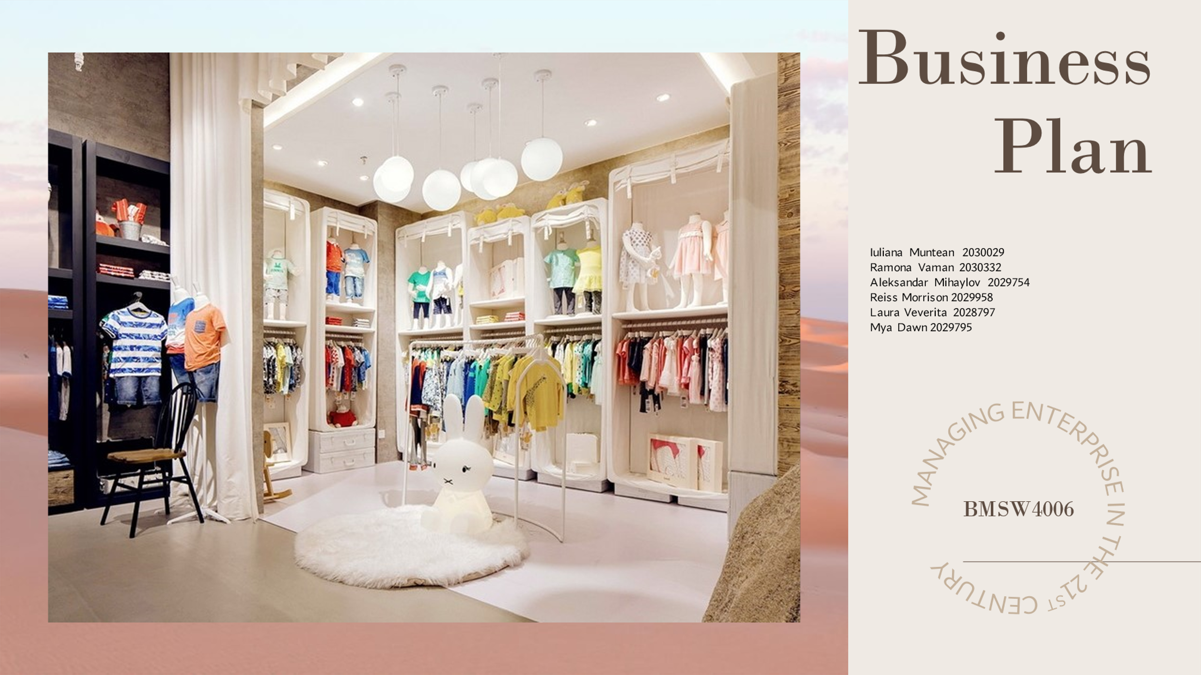

Table of Contents
Introduction and Company overview 3
Business Plan of Baby Fasho 5
Application of Marketing Mix 5
Business Plan Overview and Aims 7
Mission and vision of the Business 9
Business Structure of Baby Fasho 9
Operations Management of the Business 11
Development Milestones and Exit Plan of Baby Fasho 12
Financial Budget analysis of the Business 13
Conclusion 14
References 15

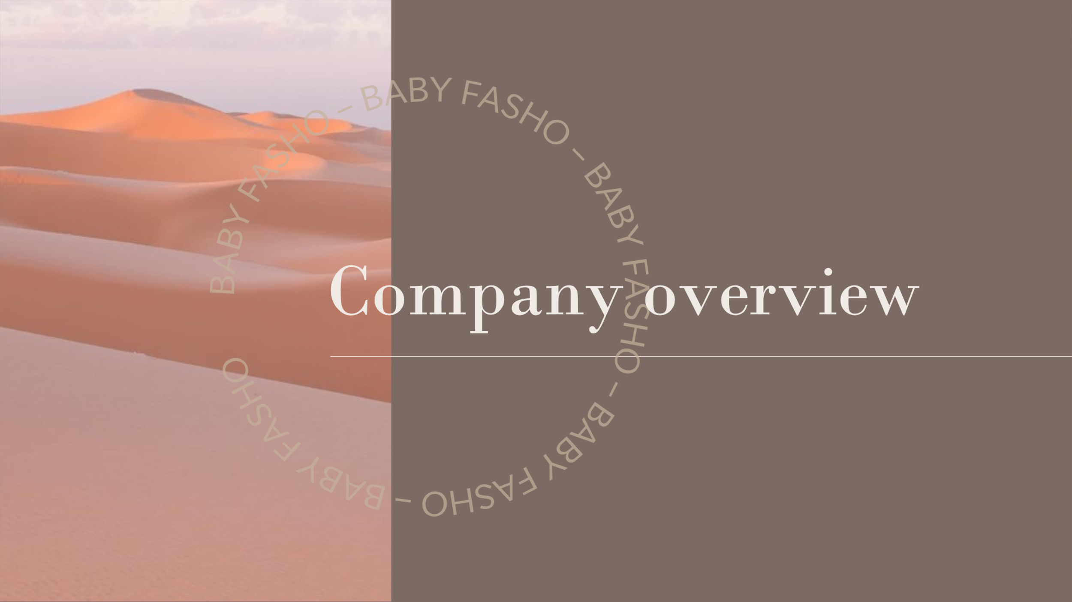
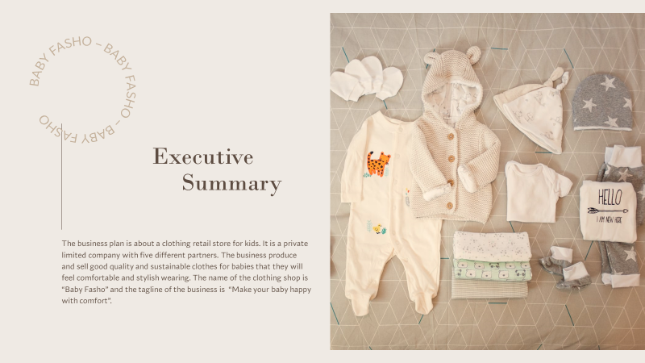
Introduction and Company overview
The report in this context, tries to highlight the business plan of a clothing retail store for kids, which is a private limited company including five different partners. The business idea and plan, which is going to be reflected through this report, produce and sell eminent and elite quality and sustainable clothes for babies. The unique selling point for these kids and baby products is their comfort and stylish designs. Baby Fasho, is the name of the retail store, which possesses a classy and attractive tagline, named “Make your baby happy with comfort”.
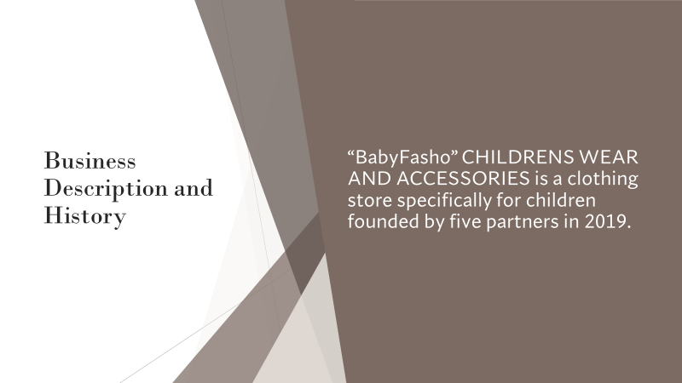

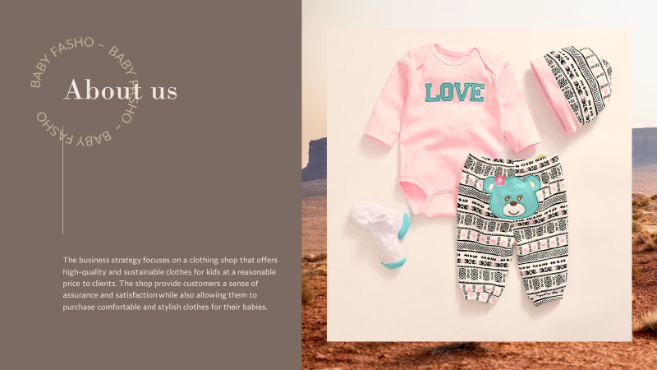
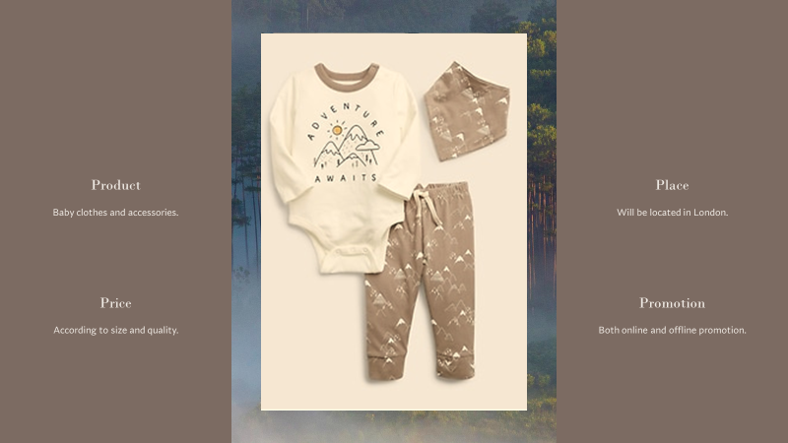
The business strategy and the company at large focus on the selling and promotion of the baby wears, offering high-quality and sustainable clothes for babies and kids, which are usually made of materials, elegant and best, suited for the natural comfort of the babies and kids. The company Baby Fasho, has therefore, planned to open a business for baby clothes, manufacturing kids' wears with sustainable materials with an eco-friendly contribution towards the society as well. The company in this context and on the verge of establishing an entrepreneurial venture in London has focused on providing the customers an elite sense of assurance and satisfaction, in order to procure and retain a royal base of consumers at large in the market. Since London can be considered to be a lucrative option for successful entrepreneurial ventures, Baby Fasho, determining its business to be established and operated in this region has itself been a profound, thoughtful and successful set up on its own. Therefore, attaining a good amount of market analysis on the region, pricing strategy and competitors in the area and industry of establishment, Baby Fasho has decided to enable the customers to purchase comfortable and stylish baby clothes in a comparatively reasonable and affordable price range.

Business Plan of Baby Fasho
Application of Marketing Mix
Product: Baby Fasho has decided upon utilising and applying marketing mix for the successful promotion of its business and products. Therefore, the company has been seen to offer baby clothes and accessories for kids as their products. The products of this company will be manufactured with high quality materials as well as sustainable substances, which will be completely comfortable, natural and skin friendly for the babies (Barrow et al., 2018). The products (clothes and accessories) of the company will further be made considering eco-friendly techniques, for the skilful acknowledgement of baby comfort and wellbeing. Moreover, the products will generally be tried and tested before the ultimate confirmation for selling and processing.
Price: The Company Baby Fasho, being an entrepreneurial venture in London, has focused on providing a reasonable and affordable pricing range of the baby products for attaining a handful of loyal consumers. The company has further determined to set the price range considering the products type, size and quality (Molnar, 2018). The company operates within and produces a range of baby wears and accessories based on the different ages of kids and therefore, will decide upon the exact prices after the market analysis and successful establishment of the company. Although for the initial processing of the business, the baby retail shop or store has generalised £10 to be the starting range of the baby products based on the size and type of the clothes (McKeever, 2018).
Place: The Company Baby Fasho has decided to open and start its business in London for the time being, until it gets a successful profit and revenue out of the business. The company has therefore not decided to expand its business in other regions of the UK and therefore, focused on gaining profit in London (Elvén and Wiman, 2017).
Promotion: The Company Baby Fasho has successfully procured its online presence, as it has strategically expanded its business through online targeting the preferable audience in London. The company therefore, has decided to focus both on online and offline media of promotion, as they desire to reach to the maximum audience and consumers for the successful establishment. Henceforth, in the online context, Baby Fasho will opt for digital marketing through social media platforms like Facebook, Instagram, Twitter, Pinterest etc. Also, the company will aim to utilise email marketing to have a more successful and innate communication with the potential audience and customers. Moreover, the company has also undertaken offline promotional techniques, like TV commercials, newspapers, billboards, hoardings etc.
Company Strategy: With the tagline of “Make your baby happy with comfort” the company has strategized its business with high quality products, sustainable baby wear, comfortable materials and stylish designs, which collectively will attract the customers towards their shop and product lines. Since, London procures families, with classy background and sophisticated status in general, the company has focused on making natural yet stylish kids' wear and accessories, which can further be acknowledged for the babies of all ages.
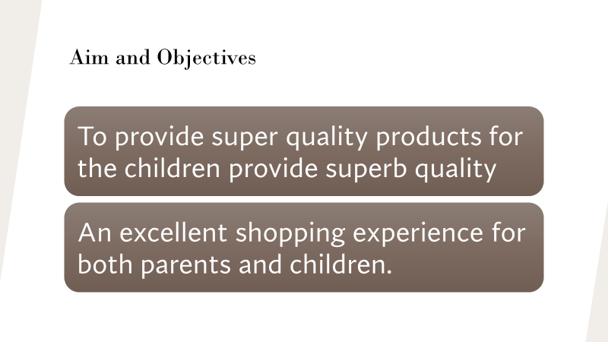
Business Plan Overview and Aims
The primary aim of the intended entrepreneurial venture that is named as Baby Fasho is the provision of high-quality durable and sustainable products for children so that they are imparted with fashion trendy outfits. The start-up venture also aims to provide an excellent shopping experience for both parents and children. On a similar note, this can also be stated that the business partners of this start-up venture aims to manufacture clothes using eco-friendly techniques and dyes so that these are easily acknowledged for child usage. Baby Fasho also aims to provide excellent quality clothing lines exclusively for children so that an excellent shopping experience can be imparted.
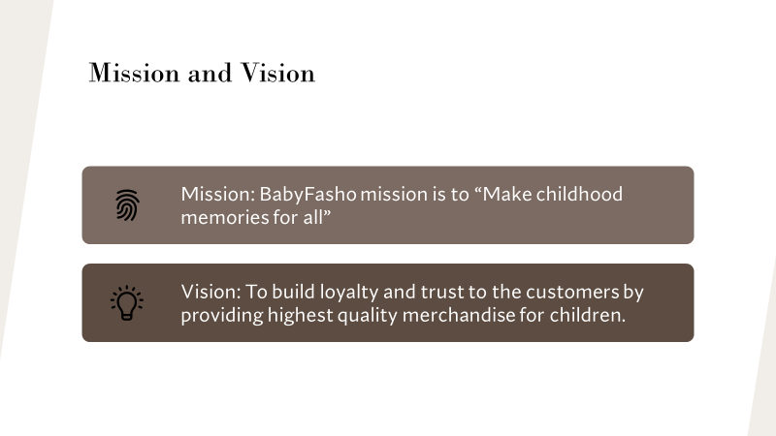
A business plan has been defined and characterised as a written document that emphasises on detailed insight of how a business usually a start-up can define its business goals and how these goals can be achieved (Young, (n.d.). A business plan illustrates a detailed roadmap for the entrepreneurial venture ranging from marketing, financial and operational standpoints (Hayes et al., 2021). Business plans are known to possess important credentials for the external audiences as well as the internal stakeholders associated with the company. For example, a business plan is known to attract investments even before a company has been able to prove its track record to secure lending. Business plan is also identified as a lucrative option for the executive teams of companies so that similar viewpoints can be established in relation to strategic actions to keep the targeted goals on line. Business plans are developed considering the market gaps existent within the market regarding the proposed product or service, while considering the business strategies, options, sales and marketing procedures and the exit strategies, for ensuring successful business operations (Blackwell, 2011). Baby Fasho’s business plan has eventually comprised of various components such as operations in the clothing sector, financial budget plan and development milestones.
Mission and vision of the Business
The primary mission of Baby Fasho is to provide children and their parents with one of the best shopping experiences through the creation of such an environment where children and their parents will be easily attracted nit because of the high quality and sustainable alternatives of clothing lines available bit also because of the highly trained and competent staffs and their serviceability. Baby Fasho’s vion in the clothing industry is to build customer loyalty and trustworthiness through the provision of highest quality merchandise for children. Baby Fasho always intend to work through customer experiences and the feedback that will be provided by them so that products can be made far more consumer friendly. Through this, the company intends to establish a good rapport with promising transparency with their consumers by providing excellent services (Stutely, 2012). Finally, the venture is also eager to make its operation customer and environmental friendly. The plan of the company is to expand its market beyond London to different various positions throughout the UK.
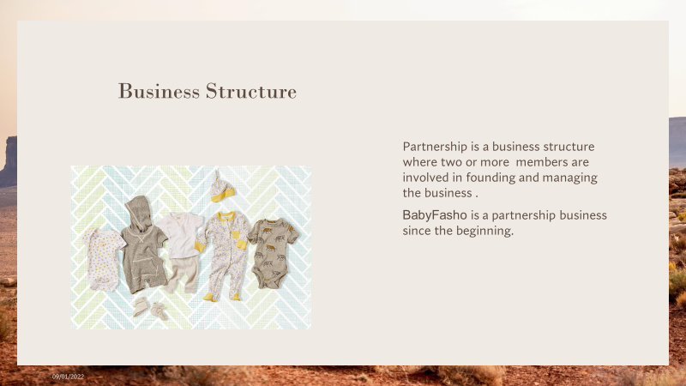
Business Structure of Baby Fasho
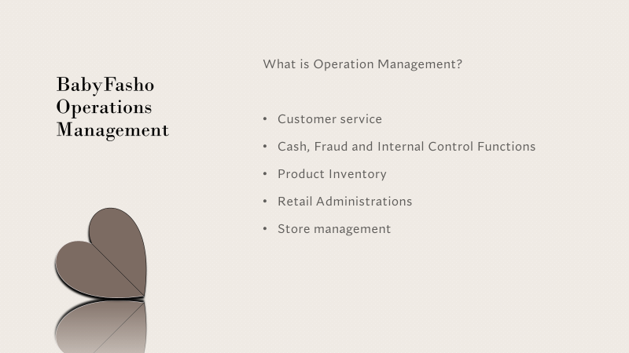
Baby Fasho is a partnership venture that is associated with five business partners who are effectively and thoroughly involved with the establishment and management of the entire business. A partnership can be defined as a formal arrangement between two or more parties that are associated with the management and operations of a business and share the earned profits equally or per their share (Kopp et al., 2021). Since Baby Fasho is a for-profit venture and has been undertaken by five individual entities, general partnership category has been bestowed upon the company. All the five members are considered to share legal and financial liabilities equally. These individuals are equally responsible for the debts that the partnership incurs. The earned profits are also shared amongst one another wherein the specificities of profit sharing will almost certainly be laid out while penning down the partnership agreement. Baby Fasho’s very first outlet was opened in London and also got expanded in digital platform. Baby Fasho also established concrete relationship with their consumers, staffs and other related stakeholders such as the suppliers and investors with the sole agenda of producing high quality products. Various members including both internal and external stakeholders of the company are associated with various designated job roles, and they value their employees and invest purposively upon staff well-being and developmental programs.

Operations Management of the Business
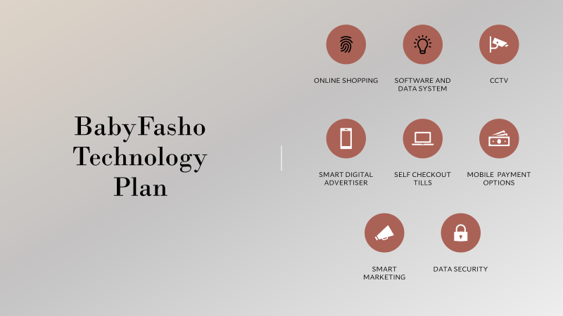
The operations management of Baby Fasho comprises of various significant components such as customer service. This has already been mentioned that the company possesses both brick-and-mortar and online presence in the clothing market of London. Hence, the customer serviceability is bidirectional in every angle.
It becomes easier for the company to associate the consumers both physically and through their website. As for the implementation of cyber security, the company has associated with known IT giants so that effective and breach free transactions can be carried out. As for product inventory, the clothing section is associated with eco-friendly materials and no chemical dyes are used for manufacturing the clothes. Store management of Baby Fasho occurs through efficient and trained staffs so that customer serviceability takes place seamlessly.
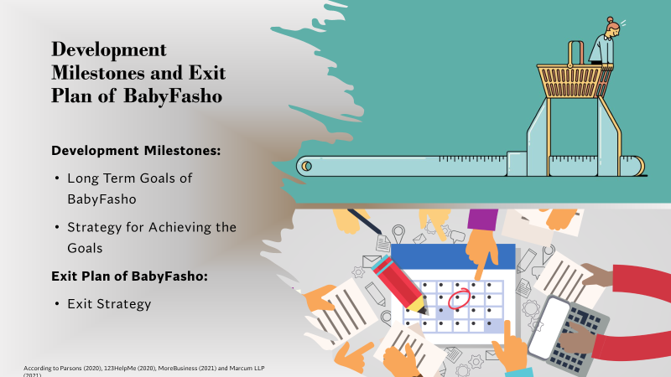
Development Milestones and Exit Plan of Baby Fasho
The long-term goals of Baby Fasho is one of the development plans that has and can effectively enhance and strengthen the company’s operations and business liability in the concerned sector. One of the many astounding goals of Baby Fasho is to provide sustainable clothing to all children living in the UK so that fibre related skin problems can be mitigated without much hassle. On the other hand, strategic action plans for the achievement of these goals also act as development milestones for the company. The company has planned to take periodic feedback from the customers so that their operational issues can be identified within the shortest time span.
As for the exit strategy of Baby Fasho, the company intends to launch and grow by co-owners for many future years. The business also intends to seek an effective partner to buy-out the shares possessed by investors provided they demand payback for their initial contributions. Management buy-out is another exit plan for Baby Fasho that will be decided in advance. As for long-term exit plan, the company also plans to establish a thriving business so that it becomes feasible to be included in a variety of retail chains.
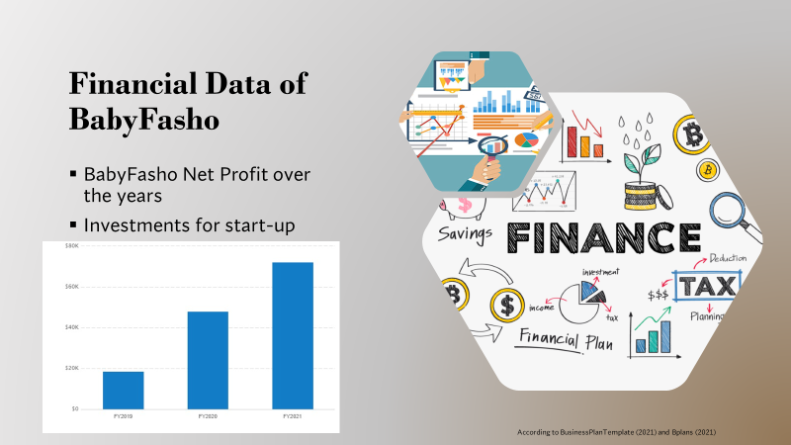
Financial Budget analysis of the Business
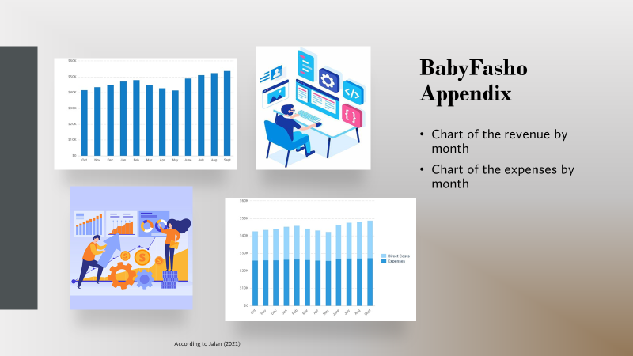
The primary expenditures generated by the company encompass supplier costs for raw materials, salary of staffs and rents for the production facility. The marketing expenditure of the company also has been identified to be substantial in the preliminary phase of its opening after it gets established in the market.
The overall sales of the company have got enhanced in the recent years and this has also been portrayed that the investment done by owners and bank loans are the sole source of funding. On the contrary, rest of the funds have been provided by other investors that have eventually brought the overall fund amount to £100,000 and this amount was needed by the company to set-up the production line.
Conclusion
On a concluding note, this can be stated that the business plan for Baby Fasho comprises of marketing mix strategies as well as the developmental milestones through which the company shall be able to highlight on its production line and come up with new alternatives to achieve its targeted goals.

References
Barrow, C., Barrow, P. and Brown, R., (2018). The Business Plan Workbook: A Step-by-step Guide to Creating and Developing a Successful Business. Kogan Page Publishers.
Blackwell, E. (2011). How to prepare a business plan. 5th ed. London; Kogan Page.
Elvén, B.H. and Wiman, T., (2017). Sulky, Rowdy, Rude?: Why kids really act out and what to do about it. Jessica Kingsley Publishers.
Hayes, A., Khartit, K. and Velasquez, V., (2021). Business Plans: The Ins and Outs. [online] Investopedia. Available at: <https://www.investopedia.com/terms/b/business-plan.asp> [Accessed 28 December 2021].
Kopp, C., James, M. and Munichiello, K., (2021). What Is a Partnership?. [online] Investopedia. Available at: <https://www.investopedia.com/terms/p/partnership.asp> [Accessed 28 December 2021].
McKeever, M.P., (2018). How to write a business plan. Nolo.
Molnar, A., (2018). Giving kids the business: The commercialization of America's schools. Routledge.
Stutely, R. (2012) The definitive business plan : the fast track to intelligent planning for executives and entrepreneurs. 3rd ed. Harlow: Pearson.
Young, P. (no date). Business Plan. Place of publication not identified: Global Media Publications.

