Alternative Propulsion Systems

ACHA5010

By Jacob Gough


Contents
1. Vehicle Choice 3
2. Research and identify the dynamic characteristics of the vehicle. 4
2.1 Technical Specs 4
2.2 Test Mass 4
2.3 Frontal area 6
2.4 Rolling Resistance Coefficient 6
2.5 Coefficient of aerodynamic drag 8
3. WLTP 9
4.Graphs 10
5. (KERS) 13
6. KERS System 13
7. Kinetic Energy Plot 14
8. Explanation 15
Reference list 17

Vehicle Choice

For my choice of vehicle, I have chosen the Porsche 911 GT3 RS. I have chosen this vehicle due to liking Porsche as a manufacturer, and the fact that it’s one of my favourite cars. It also abides by the WLTP regulation for emissions, making it a suitable choice of vehicle, I can use the vehicle to gather various calculations and specifications to create data in excel. The data will then be used to display graphs for given outputs of the vehicle. The already existing Porsche GT3 R is equipped with a preexisting hybrid platform, as I want to produce/ advise a new KERS system to this WLTP suitable vehicle, I will be using the Porsche GT3 Rs.

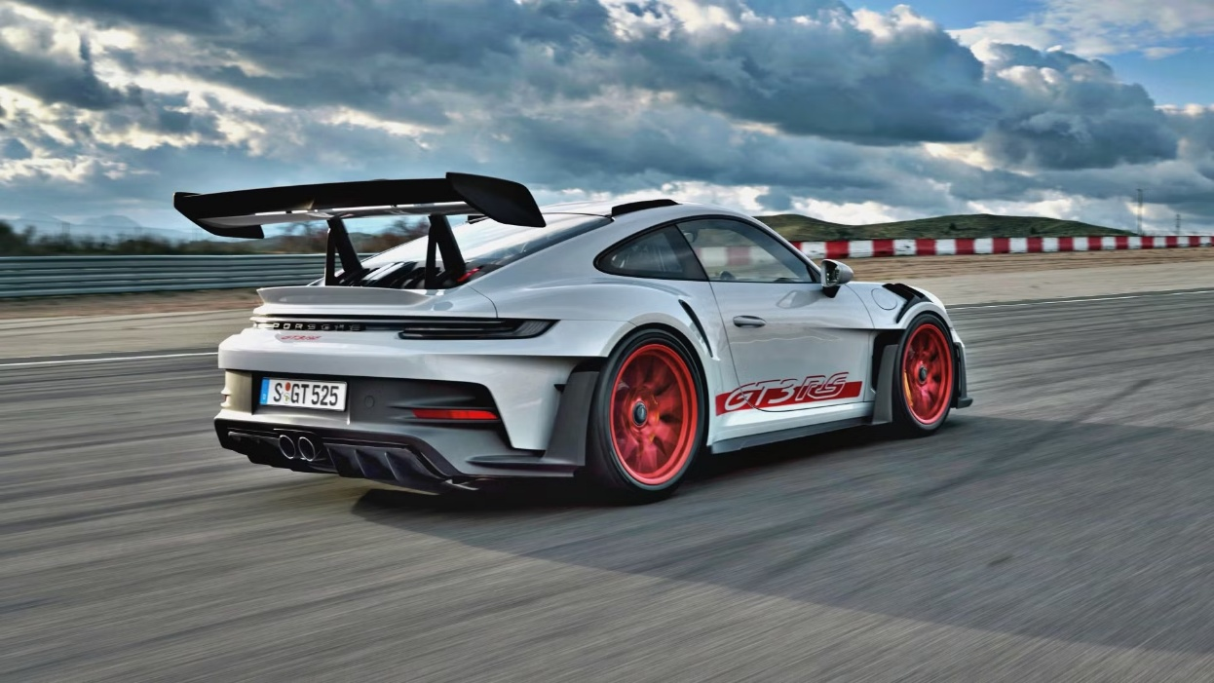

(Gonzales, D. 2022)

- Research and identify the dynamic characteristics of the vehicle.

2.1 Technical Specs
The technical specifications of the vehicle highlight grounding points for force, energy and power calculations created by the run time of the vehicle.

Engine | 4.0l Flat six boxer, naturally aspirated.
Displacement | 3996cm3.
Bore x stroke | 102.0 x 81.5mm.
Power | 525 PS (386kw) @ 8500 rpm.
Torque | 465 Nm @ 6300 rpm.
Max RPM | 9000 rpm.
Transmission | 7-speed PDK dual-clutch auto.
Drivetrain | Rear wheel drive.
Top Speed | 184 mph.
Acceleration | 0-62mph at 3.2s.

(Porsche 911 GT3 Rs. N.d)

2.2 Test Mass

Test Mass equation = UM + Mf + Md + Eqm

Unladen Mass + Mass of Fuel + Mass of driver + Equivalent rotating mass.

Full tank = (64L)

Mf = 64 x (0.75kg/L) = 50.25kg

UM = 1490kg

Md = 80kg

Equivalent masses of rotation.

Wheel mass per wheel = 21kg, radius = 0.34m
Brake disc per wheel = 7kg, radius = 0.16m
Driveshaft + Diff carrier = 12kg, radius = 0.05m
Gearbox rotating parts = 8kg, radius = 0.04m
Final drive R= 3.8, current gear G = 2.6

Inertias:

Wheel/tire per wheel.

I = 21 x 0.34 = 2.43kg x m^2

Brake disc per wheel.

I = 0.5 x 7 x 0.16^2 = 0.09kg x m^2

Rear axle total two wheels.

Iwheels + Discs = 2 x (2.43 + 0.09) = 5.04kg x m^2

Driveshaft + Diff.

I = 0.4 x 12 x 0.05^2 = 0.012 kg x m^2

Upstream sum.

Idrive = 0.017kg x m^2

Meq, wheels = 5.04/0.34^2 = 5.04/0.1156 = 43.6kg

GR^2 = (2.6 x 3.8^2) = 9.88^2 = 97.6

Meq drive = 0.017 x 97.6/0.34^2 = 1.66/0.1156 = 14.4kg

Meq total = 43.6 + 14.4 = 58kg.

So,

Test Mass = 1490kg + 50.25kg + 80kg + 58kg = 1678.25kg

2.3 Frontal area
The frontal area for the Porsche GT3 Rs is estimated to be 2.1 to 2.5 square meters.

Frontal aera calculation

Width = 1.900
Height. = 1.322

Assuming 85-90% effective frontal coverage due to the contours of the car.

Frontal area = width x height x shape factor (0.85 to 0.90)

1.900m x 1.322 x 0.88 = 2.22m^2

2.4 Rolling Resistance Coefficient

The rolling resistance coefficient of my chosen vehicle, the Porsche GT3 RS. Depends on quite a few aspects of the vehicle, some being the chosen tyres of the vehicle, taking into consideration the frictional forces the tyres generate along with the power output of the vehicle, and other forces such as downforce, drag and lift.

The rolling resistance coefficient formula is.

Frr = Crr x m x g
Crr = Frr / m x g

Tm = 1620.25kg
P = 1.225kg/m^3
Cd = 0.35
A = 2.22m^2
V = 56.56m/s
Fd = 1480N

Ftotal = 1480N + 254.31N = 1734.31N

Crr = 254.31 / 1620.25 x 9.81 = 0.16

Frr = 0.016 x 1620.25 x 9.81

Frr = 254.31 N

2.5 Coefficient of aerodynamic drag

Cd = (2 x Fd / p x v^2 x A)

Speed used in calculation = 200km/h/ 55.6m/s

so,

Fd @ 55.6m/s = 0.5 x 1.225 x (56.56) ^2 x 0.35 x 2.22

= 1480N

2 x Fd / p x v^2 x A

2 x 1480N / 1.225 x 55.56^2 x 2.22

= 0.35

- WLTP

WLTP Classification

The Porsche GT3 Rs has a power to weight ratio of 266kw/ton, with a top speed of 296 km/h / 184mph. I can use these technical specifications to determine a suitable WLTP category for the Porsche GT3 Rs. As the top speed of the vehicle is higher than most, it exceeds the 1st and second categories and places this vehicle in the 3rd category for the WLTP cycles.

WLTP Category

The Porsche GT3 Rs falls under the Class 3 test cycle phases, there are 4 phases of this WLTP category, each simulating real-world driving. Given the vehicles high power to weight ratio and road legal design, the WLPT Class 3 cycle is most appropriate for the Porsche GT3 Rs. It indicates the vehicles’ ability to comfortably operate at very high speeds, while still reflecting the urban and suburban phases required for passenger car homologation.

The Class 3 cycle provides a comprehensive evaluation for the fuel consumption, carbon dioxide emissions and the energy efficiency of the vehicle. By providing this cycle as best suited, the performance and environmental impact of the vehicle can consistently be benchmarked against other high-performance vehicles in category M1. However, our study will determine the overall efficiency of the vehicle, force outputs and power outputs of the vehicle, including information based upon run time of the vehicle, showcased in graphs. Other data such as tractive energy and force will be captured and used to determine a suitable KERS system to use.

The class 3 test cycle covers a run time of 30 minutes, covering collected data for each second. Across low, medium, high and extra high-speed phases. This ensures that the vehicle can be tracked using specific data. Whie showcasing the loses of the vehicle, displayed as negative numbers such as, force losses, frictional losses/traction, energy losses and power losses. The negative losses can then be identified through content such as graphs.

4.Graphs

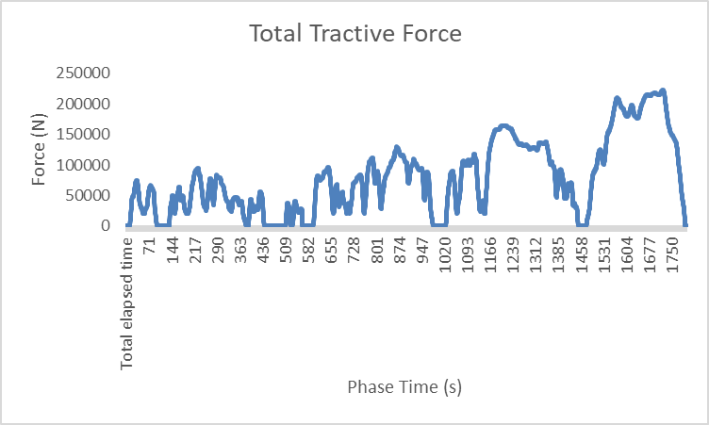

This Grap above represents the vehicles Total tractive force in Nm, over time in seconds. The data acquired is calculated using the low, medium, high and extra high cycles of the process. Using the time intervals between, over a timed period of 30 minutes. The cycles can be visualised in the graph from the stages over time, from small peaks up to high peaks, and back to zero indicating the end of the cycle.
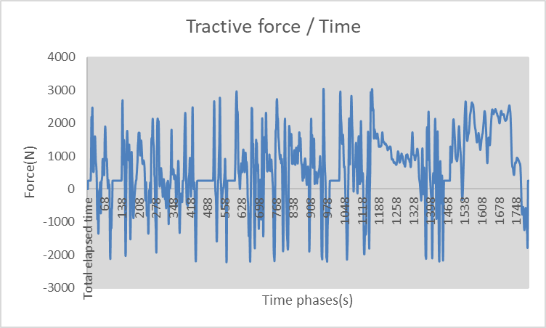

This graph above shows the tractive forces associated with the vehicles run time over a 30-minute period. The graph displays the positive and negative forces along the provided time scale; the negative forces being vehicle braking along with coast down of the vehicle.

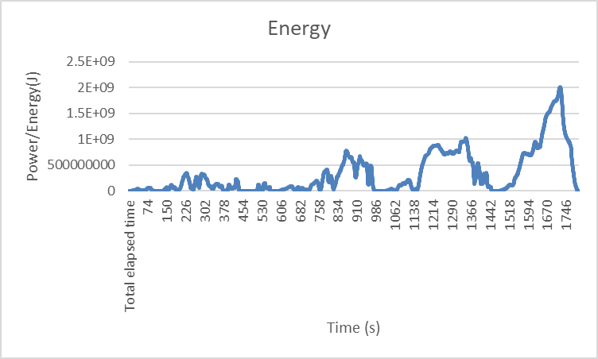

This graph above, displays the start and end of the WLTP cycle, with a steady increase to drop of energy production from the vehicle’s operation. The peaks indicate the midpoint of each stage of the WLTP run cycle. Indicating the acceleration and coast down of the vehicle. The extra high speeds indicate a much higher production/ usage of energy due to due the fuel/energy demand. The energy output in the graph can be used to determine the negatives in braking energy, and study potential redeployment strategies to minimise loss. This will be used to determine a Future KERS system to achieve this.

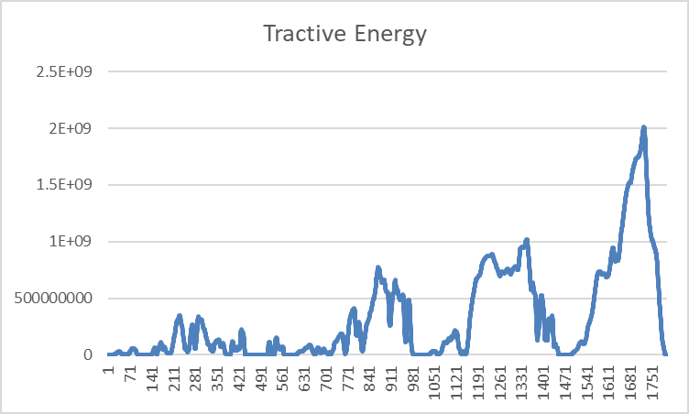

The Graphs above indicate the Tractive energy required at the wheel, and the Braking energy required at the wheel. As the cycles increase in speed and time, the energy required for both increases. This is an expected outcome, as the braking energy required at high speeds is much more demanding than at low speeds. The tractive energy is the same, requiring greater frictional resistance at high speeds compared to low.
The difference between these, indicate the losses before the use of a KERS system in place, the losses can be viewed by following the contours of the peaks/ high and lows on the two graphs. The losses can be regained/ redistributed using a functional KERS system with high efficiency, both being storage and redeployment. If I were to display 4 graphs, before and after KERS applied, you would notice a distinct difference in the way both energies are displaced.

(KERS)

Largest possible KERS power input and energy storage

Power regained =2027.7 kw
Power deployed = 3.6764E+10 kw

Energy storage requirements

- Hybrid electrical KERS; super capacitor buffer (1-5kwh,2-3 MW pulse) + battery pack (50-150kwh) for staged absorption/deployment.
- Efficiencies; 0.80-0.90 round-trip in the supercap path, 0.70-0.95 including battery at high C rates.

KERS System

System recommendation

Based on the calculated values, the power deployed value is too large, this is due to calculation error that can be corrected. A suitable KERS system would need to combine high power acceptance with sufficient energy storage, this being energy collected from braking, rotation of moving parts on the vehicle and frictional gain.

The GT3 Rs would favour a high-powered electrical KERS using supercapacitors to absorb multi-megawatt pulses and a tightly packed, liquid-cooled inverter/MGU. Running at an estimate of 800-1200V, this would keep the currents manageable, the energy storage would be estimated to 0.17kwh and 596kwh depending on the efficiency.

The stored energy of the vehicle, would then be distributed as drive power, converted back into energy as an increase in torque surge. The use of this helps to improve the overall performance of the vehicle, while increasing the fundamental efficiencies of it. In this case, a KERS system operation. Its main aim is to take kinetic energy collected from braking losses of the vehicle and safely store the energy, once stored the energy can then be re-introduced.

Components
Mechanical flywheel KERS for pulse acceptance/ deployment up to 2MW
Composite rotor
Magnetic bearings
Vacuum enclosure
Mega capacitor/ super capacitor

Porsche. Newsroom. 2023
Andrewnoakes.com. 2010

Kinetic Energy Plot
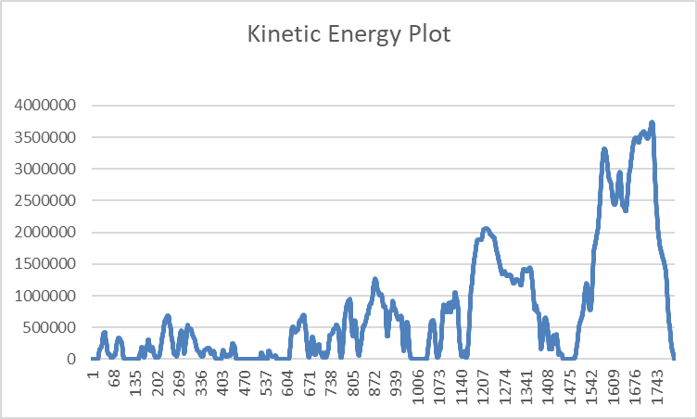

The Kinetic Energy Plot indicates how the energy fluctuates over time within the dynamic system. At the first WLTP cycle low speed, the kinetic energy remains low and stable, indicating minimal motion. At medium speed the energy begins to rise and drop with peaks, suggesting the vehicle gradual acceleration and external forces, the drops in the graph show the braking losses/ energy losses from the vehicle while in coast down.

This process continues through the cycles, with peaks and falls indicating the rise and decline of kinetic energy through acceleration and deceleration of the vehicle. Until reaching the highest point of kinetic energy around the top speed of the vehicle. Then gradually coasting down to a stop on final deceleration.

The Kinetic energy plot is used to determine the efficiency of the chosen KERS system; it can be made more efficient by calculating different ways to store and reapply the energy stored. Higher efficiency rates are important, as it will produce an efficient cycle with less negative losses occurring. The Kinetic energy doesn’t need to be stored, it can also be transmitted using mechanical advantage.

- Explanation

Operation of the KERS system

A Kinetic energy recovery system works by capturing energy during braking phases of the vehicle, that would otherwise be lost as heat in the friction of braking. In the context of the Porsche GT3 Rs, the system would integrate either a flywheel based mechanical KERS or electrical KERS.
During braking, The MGU acts as a generator, converting the kinetic energy from the wheels into electrical or mechanical energy. In a flywheel system, the energy spins a high-speed rotor in a vacuum chamber, where the electrical system, the energy is stored in mega or super capacitors.
During Acceleration, the stored energy is redeployed, the MGU switches to motor mode, delivering torque to the drivetrain. In the GT3 Rs, this would be applied to the front axle as a hybrid variant or blended with the rear ICE output.
The system is managed by powerful electronics and a supervisory controller. It ensures that energy is collected without potential destabilization of the vehicle under braking. It is deployed in a way that maximises run time gain.

Assumptions made in the design

The largest braking events provide sufficient energy to justify a KERS system for motorsport use; this is typically in the range of 1-2MJ per event.
The efficiency achieved by my calculations are incorrect, due to realistic system efficiencies achieving around 70-80% efficiency. The assumption is the losses in conversion, storage and redeployment are minimised through advanced materials, cooling and electronics.
The GT3 Rs is a lightweight, track focused vehicle. This meaning that the KERS system must maintain a lightweight design, not to compromise the weight distribution of the vehicle.

Variations felt by the driver compared to Conventional ICE + Friction brake vehicle.

The GT3 Rs has purely friction-based braking, with pedal feel determined by hydraulic pressure and disc temperature. With the KERS, part of the braking force is regenerative. The pedal may feel slightly different, especially at the start of braking, as the MGU absorbs torque.
The acceleration of this vehicle depends solely on the ICE output. With KERS, the driver can deploy an additional burst of power, up to 2MW in theoretical sizing. Even if capped to realistic values, 60-120kw in FIA context, the driver would feel a surge of torque. This can change the driving strategy as energy deployment becomes tactical.

A conventional driver focuses only on fuel, tire and brake temperatures. With KERS in place, deployment changes balance, giving temporary all-wheel drive characteristics. The driver would feel improved traction and stability under cornering and braking.
With the conventional braking style, braking produces heat and audible squeal. With the KERS setup, braking is quieter and deployment produces a distinct electric whine.

Conclusion

In summary, a KERS equipped Porsche GT3 Rs would capture braking energy and redeploy it as additional power, fundamentally altering the driving experience and efficiencies of the vehicle. The system assumes realistic energy recovery per event, high round trip efficiency, and a compact design to minimise weight distribution alteration. Compared to the conventional ICE and friction brake vehicle, the driver would experience subtle differences in the braking feel while under run time. The driver would also feel a change in power and torque delivery of the vehicle; the energy management would be more complex in ways of storage and distribution. These variations, when applied would make the car feel more responsive.

Reference list
Andrewnoakes.com. (2010). Porsche’s hybrid 911: how it works - Andrew Noakes - Motoring Writer. [online] Available at: https://www.andrewnoakes.com/blog/porsche-911-hybrid-how-it-works.html [Accessed 30 Nov. 2025].
Gonzalez, D. (2022). 2023 Porsche 911 GT3 RS: A Comprehensive Guide On Features, Specs, And Pricing. [online] TopSpeed. Available at: https://www.topspeed.com/cars/guides/porsche-911-gt3-rs-performance-price-and-photos/ [Accessed 26 Nov. 2025].
Porsche 911 GT3 RS. (n.d.). Available at: https://newsroom.porsche.com/dam/jcr:fe2fb6d3-d0e3-44d8-8f2d-d82a66674718/PAG-911-GT3-RS-EN.pdf.
Porsche Newsroom. (2023). Porsche News & Press. [online] Available at: https://newsroom.porsche.com.

