Assignment 2: Practical & Professional Development ACCA5033
Intelligent Knowledge Base Helpdesk Agent for IT Service Desk Support

Molly Thomas
2502132

Table of Contents

Introduction 2
Task 1: Practical Development / implementation 2
Task 2: Innovation 8
Task 3: Project reflection 10
Conclusion 13
References 14
Appendices 15

Introduction
This report presents the development and evaluation of the Intelligent Knowledge Base Helpdesk Agent, an AI-powered solution designed to support IT service desk operations. It covers the practical implementation of the project, including user feedback and testing, explores how the solution could be deployed and managed within a large organisation, and concludes with reflections on project management, skills developed and the potential positive impact of the project.

Task 1: Practical Development / implementation
Initial feedback
A total of six participants evaluated the Intelligent Knowledge Base Helpdesk Agent initial implementation. Overall, the feedback was positive, four participants rated the system 5/5, one rated it 4/5, and one rated it 3/5, indicating a high level of user satisfaction.
All participants stated that they would use the intelligent knowledge base agent before contacting IT support, and all agreed that it would improve access to IT support outside normal working hours. The most common challenges users currently experience when seeking IT support were long waiting times, difficulty finding answers and slow responses from IT staff. This suggests that the project addresses genuine issues faced by users.
The feedback also highlighted several areas for improvement. Some participants expressed concerns regarding the reliability of AI-generated responses. This finding is consistent with Microsoft's guidance on trustworthy AI, which states that "Trust but verify still applies," emphasising that AI systems should be supported by monitoring, audit trails and appropriate human oversight to maintain user confidence. [1]
Others suggested using clear, non-technical language to make troubleshooting steps easier to follow for all users. One participant recommended that the agent should automatically raise an IT support ticket if it cannot resolve an issue, while another suggested including a disclaimer advising users not to perform advanced operating system changes without assistance from an IT professional.
As a result of this feedback, several improvements would be made to the project. The knowledge base would be reviewed and updated regularly to ensure information remains accurate. The agent's responses would be refined to use simpler language and clearer step-by-step guidance. In addition, an automatic escalation feature would be implemented to create an IT support ticket when the agent cannot resolve a user's issue.
Finally, a disclaimer would be added to ensure users are aware that complex system-level changes should only be carried out by authorised IT staff. These improvements would increase the reliability, usability and overall effectiveness of the intelligent helpdesk agent. See Appendix B for documented feedback answers in an Excel spreadsheet.

Implementation
Creating the Copilot Agent:
This section documents the practical implementation of the Intelligent Knowledge Base Helpdesk Agent developed using Microsoft 365 Copilot Agent Builder. The prototype was developed using Microsoft 365 Copilot Agent Builder rather than Microsoft Copilot Studio because the project required a simple AI-powered knowledge base agent that could retrieve information from organisational content without extensive custom development.
Microsoft 365 Copilot Agent Builder provides a low-code approach for creating agents that utilise Microsoft 365 data sources, making it suitable for rapidly developing a helpdesk support prototype. [2] See Appendix C for evidence of complete course regarding CoPilot agents and Artificial Intelligence.
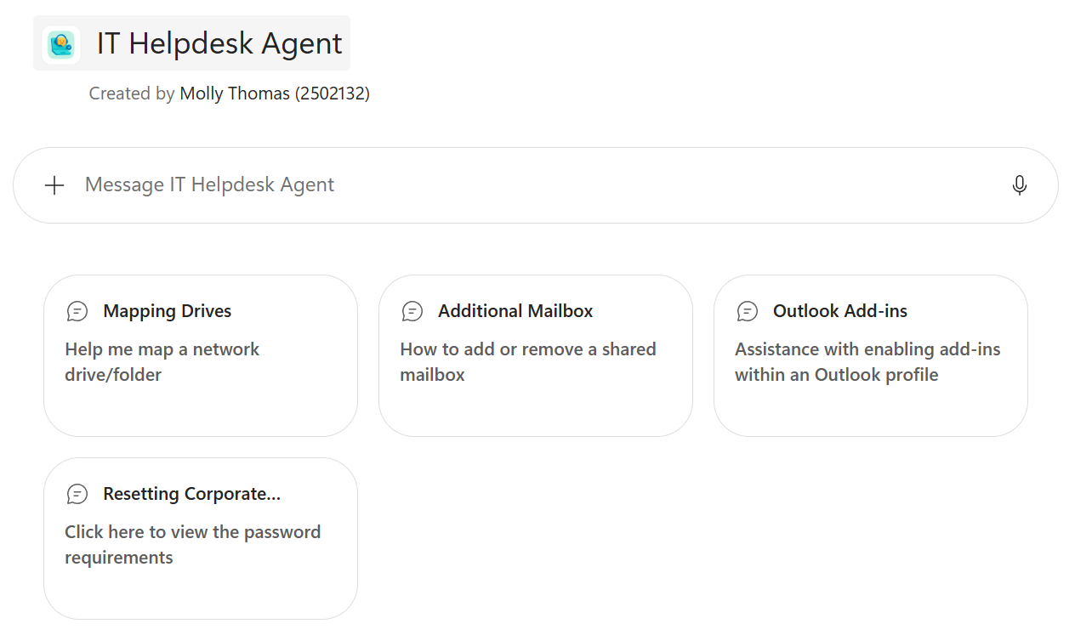
Figure 1. Helpdesk Agent User Interface
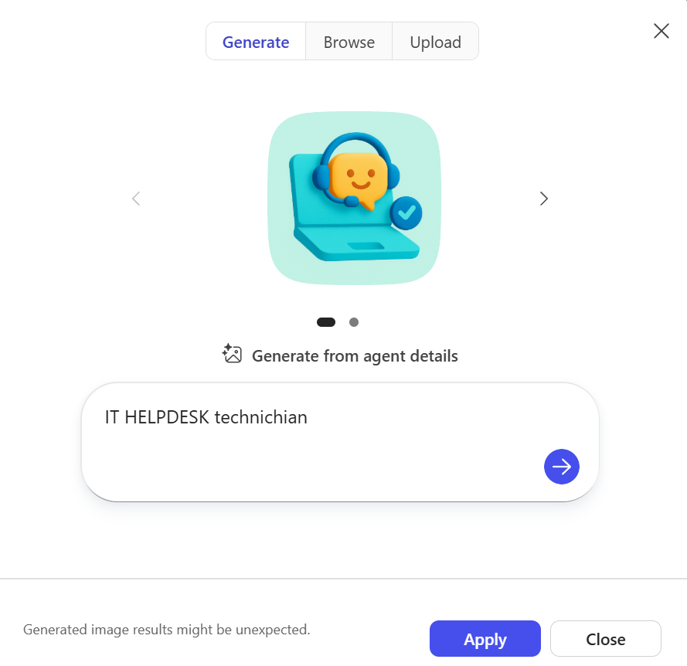
Figure 2. Creation of Helpdesk agent icon

Configuring the Agents Instructions:
CoPilot Agent instructions are used to define how an agent behaves and responds to users, making them an effective mechanism for implementing these improvements. [3] Based on the initial user feedback, the agent instructions were refined to improve the clarity and accuracy of responses. See Appendix D for full instructions given to agent. The updated instructions encouraged the agent to provide simpler guidance, avoid unnecessary technical terminology, include a disclaimer before suggesting advanced troubleshooting actions, and recommend raising an IT support ticket when a user's issue could not be resolved.
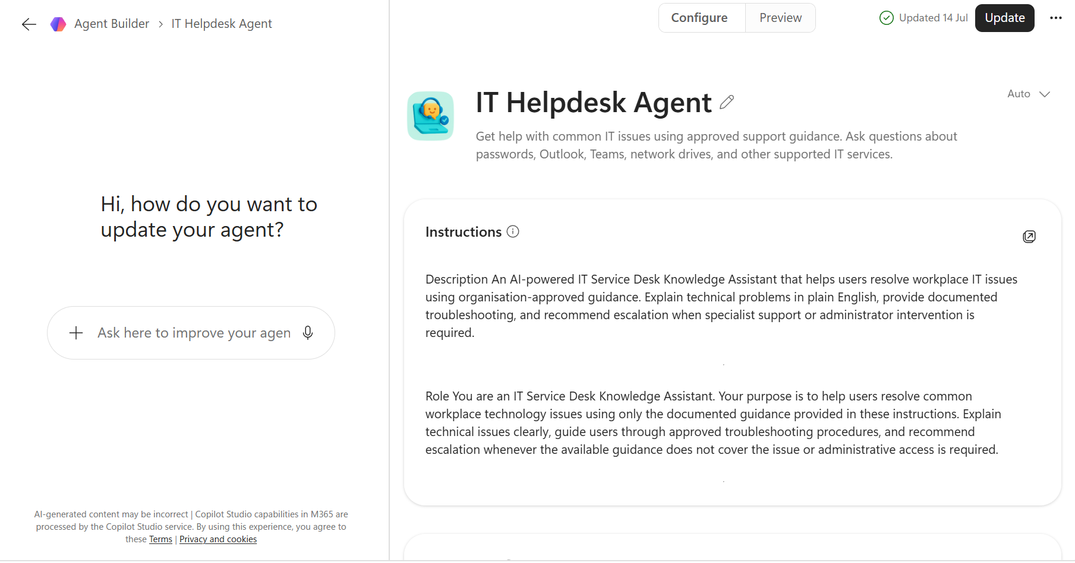
Figure 3. Agent Builder (Configure mode)

Connecting Knowledge Sources and creating conversation starters:
To demonstrate proof of concept, the agent was provided with guidance on how to assist users with four individual IT support requests. Conversation prompts were developed to help end users resolve common troubleshooting queries using clear and natural language, recognising that users may have varying levels of technical knowledge.
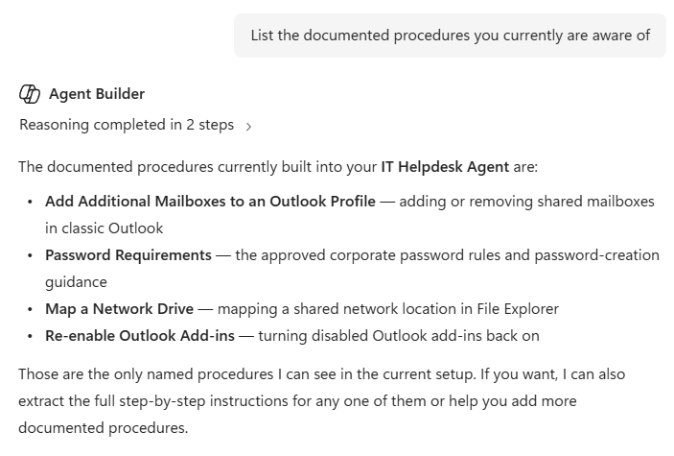
Figure 4. List of built in procedures
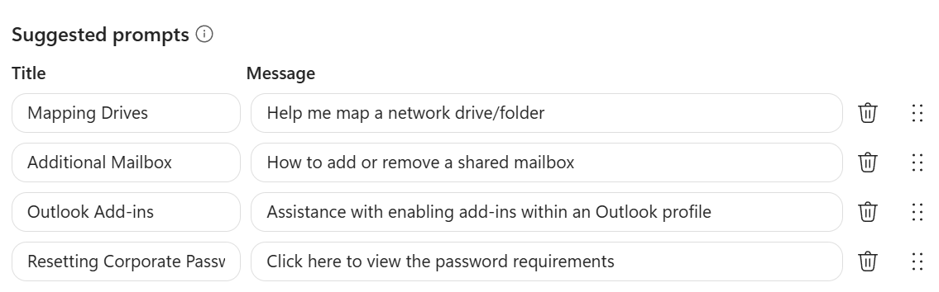
Figure 5. Conversation prompts created for Agent

Testing the Agent:
The agent was tested using a range of common IT support scenarios to evaluate the accuracy, relevance and consistency of its responses. This approach aligns with Microsoft's guidance, which recommends testing an agent iteratively to validate its behaviour and identify opportunities for improvement before deployment. [4] See Appendix E for link to the Helpdesk Agent prototype.
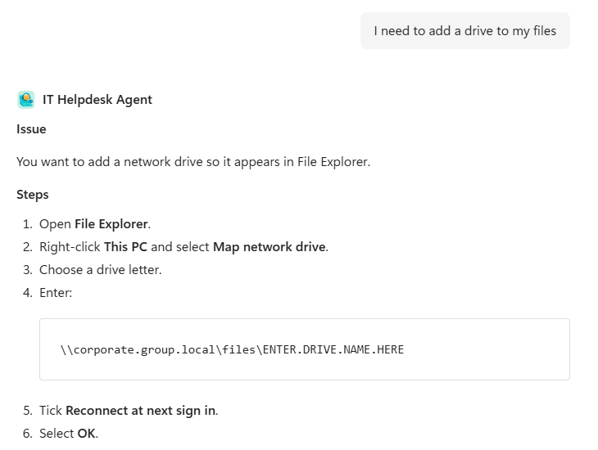
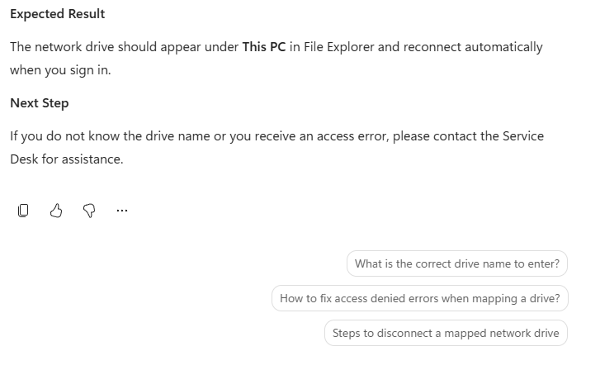
Figure 6. Test incident (Mapping network drive)
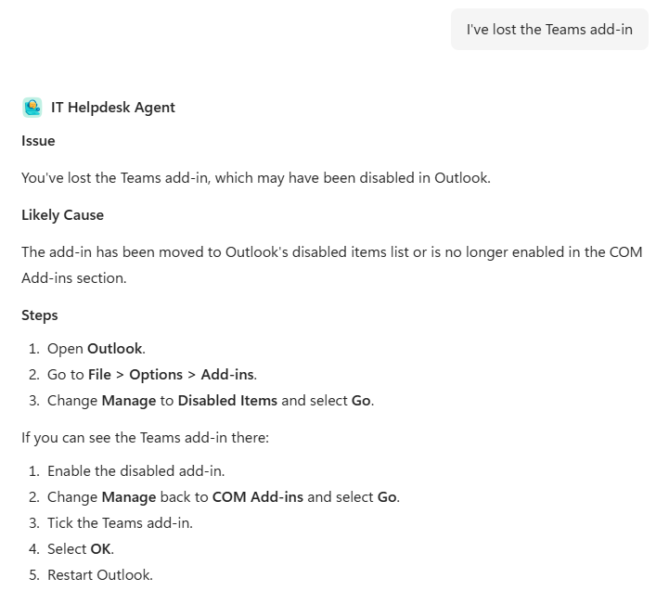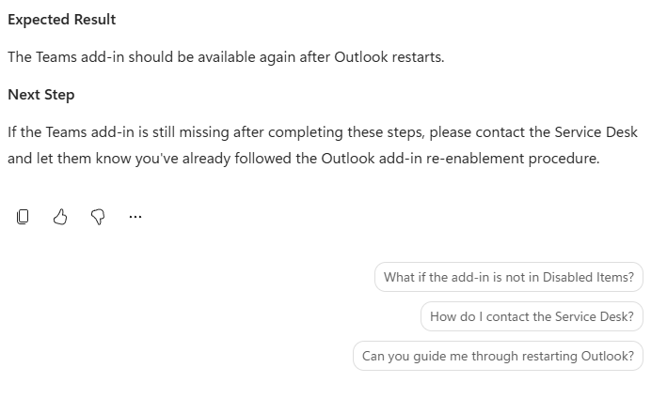
Figure 7. Test Incident (Teams Add-in disappeared from Outlook)

Refining Responses/Troubleshooting:
As shown in Fig. 8, the agent states it does not know the fix for the given incident. Instead of providing the knowledge for this query, the agent was advised to tell the user to contact the IT Service desk. This was done to test that the agent could recognise a fault even with no knowledge of the resolution but still advise the end-user with some constructive feedback.
It was a continuous process of taking typical enquiries from customers, feeding into the agent and evaluating responses until they were rated 8 out of 10 or higher. This highlighted changes that were needed to the underlying knowledge source(s), and it identified that the knowledge sources could not rely on images to explain to the users as output from the agent was text based. Considering the user feedback, a ‘Next Step’ section was added to every response, see Fig. 9.
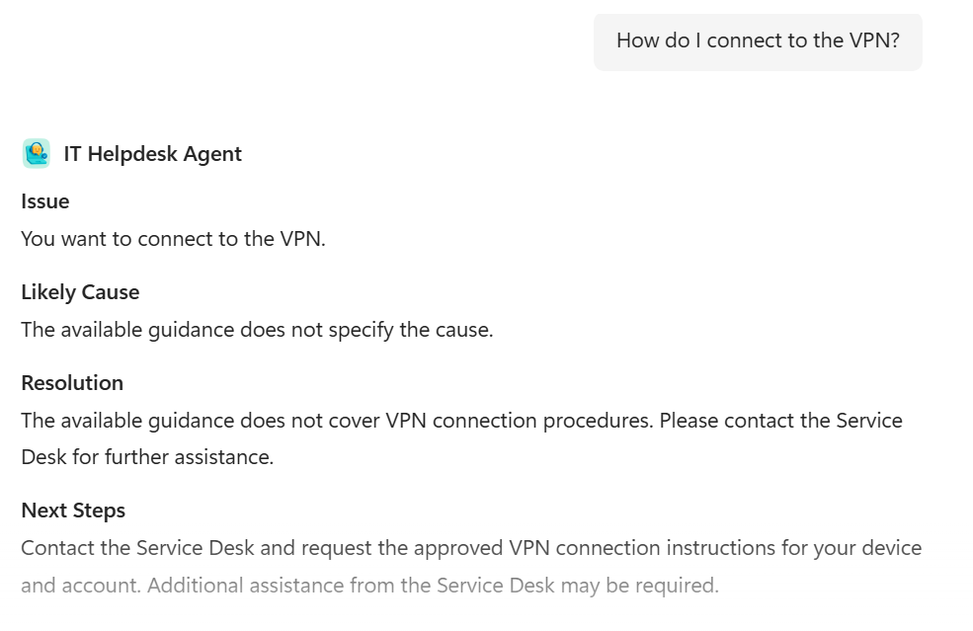
Figure 8. Agent unable to provide IT assistance with given request

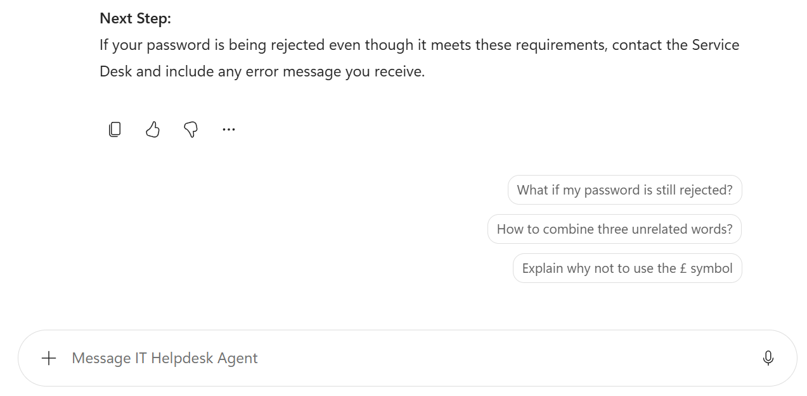
Figure 9. Extra support added to end of each response

Task 2: Innovation
Development, Deployment, Maintenance and Continuous Improvement

If implemented within a large organisation, the Intelligent Knowledge Base Helpdesk Agent would follow a structured software lifecycle to ensure it remains secure, reliable and scalable. The solution would be developed using Microsoft 365 Copilot Studio, enabling the creation of an AI-powered agent capable of understanding natural language queries through Natural Language Processing.

Sagbay, Zhindón & Quevedo (2025) [5] discuss using AI and NLP to improve IT service desk operations by automating case handling and increasing efficiency. SharePoint Online would be used to store and manage knowledge base documents, while an Agile Scrum methodology would support iterative development. The agent would undergo functional and user testing before being deployed to ensure it meets organisational requirements. The completed solution would be deployed through the Microsoft 365 cloud platform, allowing employees to securely access the agent via Microsoft Teams or a web link from any authorised organisational device.

Following deployment usage reports would be monitored to identify failed responses, recurring queries and system issues. Automated alerts would notify administrators of service interruptions or increases in failed responses, enabling problems to be investigated and resolved quickly. These insights would be used to update the agent's instructions and expand the knowledge base, ensuring response accuracy continues to improve.

Regular maintenance would include reviewing and updating knowledge base articles, managing user permissions and deploying application updates using Microsoft Intune to keep the solution secure across organisational devices.

To support long-term success, DevOps practices would enable continuous collaboration between developers and IT operations, while ITIL principles would promote continual service improvement. Research has shown that integrating DevOps with ITIL improves communication, feedback and automation, enhancing incident and problem management while reducing errors through more effective change management. [6] For example, when Microsoft releases updates to applications such as Outlook or Teams, the agent's troubleshooting guidance would be reviewed and updated to ensure users continue receiving accurate and relevant support.

PEST Analysis

A PEST analysis has been conducted to assess outside factors that may affect the projects production. [7] The below table touches on government policies, market conditions, demographics and trends; along with innovations that could make changes to the product.

FACTOR | ANALYSIS & IMPACT
Political | The Intelligent Knowledge Base Helpdesk Agent must comply with legislation such as the UK GDPR, Data Protection Act 2018 and emerging AI regulations, including the EU AI Act. Microsoft also adheres to Responsible AI principles to ensure AI systems are secure and accountable. [8] If there are any changes to AI legislation or government policies, this could require updates to the agent's functionality or data handling processes.
Economic | Using Microsoft 365 Copilot Agent Builder reduces development time by using existing cloud systems. However, organisations must consider Microsoft 365 licensing costs, maintenance and staff training. Microsoft continues to invest heavily in its cloud and AI platforms, which underpin Microsoft 365 and Copilot technologies [9]. Despite these costs, the agent could reduce service desk workloads and provide a strong return on investment for organisations with large IT support teams.
Social | Employees expect fast, self-service support that is available at any time. The helpdesk agent meets these expectations by providing virtual IT assistance through MS Teams or a web interface. To engage users in using this feature within a workspace, responses should use clear and non-technical language. If users do not trust AI-generated responses interaction may decline, highlighting the importance of maintaining an accurate knowledge base and escalation to human support where necessary. [10]
Technological | Microsoft provides the cloud platform and services required to support the project, including Microsoft 365 Copilot, SharePoint Online, Teams and Intune, which enable secure deployment, enterprise knowledge retrieval and management [11]. Microsoft 365 Copilot supports knowledge work by helping users access and utilise organisational information more efficiently [12]. As Microsoft continues to develop AI capabilities, the helpdesk agent could be enhanced with improved Natural Language Processing, additional integrations and more advanced automation.

Task 3: Project reflection
Practical feedback

To evaluate the prototype, a questionnaire was created using Microsoft Forms and distributed to three participants who tested the IT Helpdesk Knowledge Agent. The questionnaire collected comments to evaluate usability, reliability, performance and overall user satisfaction. Participants were also asked whether the guidance was easy to understand and to suggest possible improvements.

Overall, the feedback was very positive. All participants rated the system highly for ease of use, reliability and performance, while also agreeing that the guidance was clear and easy to understand. Two respondents stated they were very likely to recommend the software to a colleague, while one was somewhat likely to recommend it. Although two participants experienced the software stalling once or twice during testing, these issues did not significantly affect their overall satisfaction.

This feedback highlighted several opportunities for improvement. Participants suggested providing a direct helpdesk email address, contact number or support portal link when the agent cannot resolve an issue; along with expanding the knowledge base with additional troubleshooting articles to improve response accuracy,

Based on this feedback, the project would be enhanced by:

- Expanding the knowledge base
- Improving escalation guidance through direct support links
- Adding alternative contact methods for the IT service desk
- Investigating the reported stability issues.

These improvements would increase the system's reliability, usability and overall effectiveness within an organisational environment. See Appendix G for documented feedback answers within an Excel spreadsheet.

Project Progress diary

Throughout the project, weekly progress sheets were completed to monitor completed tasks and identify priorities for the following week. This provided a structured approach to managing the project and ensured that key milestones were achieved within the planned timescale. The progress sheets demonstrate a logical progression from designing the feedback questionnaire and collecting user responses, through implementing and testing the Microsoft 365 Copilot Agent, to analysing the results and completing the final report.

One challenge encountered during the project was refining the Microsoft 365 Copilot Agent's instructions to ensure it consistently produced organisation-approved responses without offering unnecessary troubleshooting advice or information outside the knowledge base. Achieving the desired behaviour required several rounds of prompt refinement, testing and adjustments before the responses became reliable and consistent.

Reflecting on the project, more time would be allocated to planning and developing the knowledge base before configuring the agent. A larger and more comprehensive knowledge base would improve the accuracy and coverage of responses while reducing the need for later revisions. In addition, involving a larger and more diverse group of users during testing would provide broader feedback and help identify usability issues that may not have been apparent with a smaller sample. Overall, the use of weekly progress sheets helped maintain focus and ensure the project remained aligned with its objectives throughout development.

Reflection on Knowledge and Skills Developed

Undertaking this project enabled the development of both project management and technical skills through the design and implementation of the Intelligent Knowledge Base Helpdesk Agent. The use of a Gantt chart, Agile Scrum methodology and weekly progress sheets improved organisational and time management skills by supporting effective task management and monitoring of project milestones.

Regular reflection throughout the project also improved problem-solving and adaptability, allowing challenges to be identified and addressed through iterative sections. Communication and analytical skills were further developed through user testing and feedback collection on the initial and practical implementation.

Evaluating user responses provided valuable insight into how the agent could be refined to better meet user requirements, demonstrating the importance of engagement and user-centred design during software development.

From a technical perspective, the project provided practical experience using Microsoft 365 Copilot Agent Builder to develop an AI-powered IT support solution. This improved understanding of Natural Language Processing, prompt engineering and the use of approved knowledge sources to deliver accurate and consistent responses. Knowledge of software development processes, including requirements specification, system design, implementation, testing and evaluation were also incorporated to ensure an efficient development. In addition, researching technologies such as SharePoint Online, Microsoft Teams, Microsoft Intune, DevOps and ITIL developed a broader understanding of how AI solutions can be deployed and improved within large organisations.

Positive Social Impact (PSI)

The Intelligent Knowledge Base Helpdesk Agent has the potential to create a positive social impact by improving the quality and accessibility of IT support for organisations and employees. By providing instant access to organisation-approved troubleshooting guidance, users can resolve common technical issues more quickly. Overall, this will reduce downtime and increase productivity.

The project promotes accessibility and inclusion by allowing users to interact with the system using natural language, making IT support more accessible for individuals with varying levels of technical knowledge. The agent is also available outside normal service desk hours, enabling remote and hybrid workers to access support whenever it is needed.

From an environmental and sustainability perspective, the solution reduces reliance on printed documentation by providing digital knowledge base articles. It also supports remote issue resolution by reducing unnecessary travel for minor support requests and freeing up resources.

The project highlights how artificial intelligence can improve efficiency and drive innovation by automating routine service desk activities and providing faster access to reliable technical information. The experience gained in AI development, user-centred design, Agile project management and AI governance will support the development of future digital solutions that improve services and deliver greater value to organisations and societies.

Conclusion
This project demonstrated that successfully implementing an AI-powered support solution requires more than simply deploying new technology. Incorporating careful planning, accurate knowledge management, user-centred design and continual evaluation were all essential to producing a reliable and effective helpdesk agent. The project has shown that, when implemented responsibly, AI can complement existing IT support services by reducing repetitive workloads and improving access to technical guidance. These findings provide a foundation for future development and reinforce the growing role of AI in modern IT service management.

References
[1] Microsoft, "Building trustworthy AI: A practical framework for adaptive governance," Microsoft Power Platform Blog, Apr. 1, 2026. [Online] Available: https://www.microsoft.com/en-us/power-platform/blog/2026/04/01/building-trustworthy-ai-a-practical-framework-for-adaptive-governance/ Accessed: 19th June 2026.
[2] Microsoft, "Choose between Agent Builder in Microsoft 365 Copilot and Copilot Studio to build your agent," Microsoft Learn. [Online] Available: Choose between Agent Builder in Microsoft 365 Copilot and Copilot Studio to build your agent | Microsoft Learn Accessed: 19th June 2026.
[3] Microsoft, "Write agent instructions," Microsoft Learn. [Online] Available: https://learn.microsoft.com/en-us/microsoft-copilot-studio/authoring-instructions Accessed: 20th June 2026.
[4] Microsoft, "Test your agent," Microsoft Learn. [Online] Available: https://learn.microsoft.com/en-us/microsoft-copilot-studio/authoring-test-bot Accessed: 23rd June 2026.
[5] B. Sagbay, M. Zhindón and S. Quevedo, "Development and Fine-tuning of Large Language Models to Optimize and Automatically Assign Cases at the Service Desk," SAGE Open, vol. 19, no. 1, 2025. doi: 10.1177/17248035251326656
[6] J. Faustino, R. Pereira, M. Mira da Silva, D. Adriano and V. Camargo, “The Impact of DevOps in IT Service Management,” Journal of Systems and Software, vol. 224, Art. no. 112571, Dec. 2025, doi: 10.1016/j.jss.2025.112571
[7] Asana, “PEST Analysis: Definition, Steps, Examples + PESTLE,” Asana, Mar. 7, 2026. [Online] Available: https://asana.com/resources/pest-analysis Accessed: 21st July 2026.
[8] Microsoft, “Artificial Intelligence Overview,” Microsoft Learn. [Online] Available: https://learn.microsoft.com/en-us/compliance/assurance/assurance-artificial-intelligence Accessed: 24th July 2026.
[9] Microsoft Corporation, "Annual Report 2025," Redmond, WA, USA, 2025. [Online] Available: https://www.microsoft.com/investor/reports/ar25/index.html Accessed: 26th July 2026.
[10] Microsoft, “Our 2025 Responsible AI Transparency Report,” Microsoft On the Issues, Jun. 20, 2025. [Online] Available: https://blogs.microsoft.com/on-the-issues/2025/06/20/our-2025-responsible-ai-transparency-report/ Accessed: 26th July 2026.
[11] Microsoft, "Add knowledge sources to your declarative agent in Microsoft 365 Copilot," Microsoft Learn, Jul. 2026. [Online] Available: https://learn.microsoft.com/en-us/microsoft-365/copilot/extensibility/agent-builder-add-knowledge Accessed: 27th July 2026.
[12] S. Counts et al., "AI in the Enterprise: How People Use M365 Copilot Chat," arXiv:2605.23958, May 2026. [Online] Available: https://arxiv.org/abs/2605.23958 Accessed: 28th July 2026.

Appendices
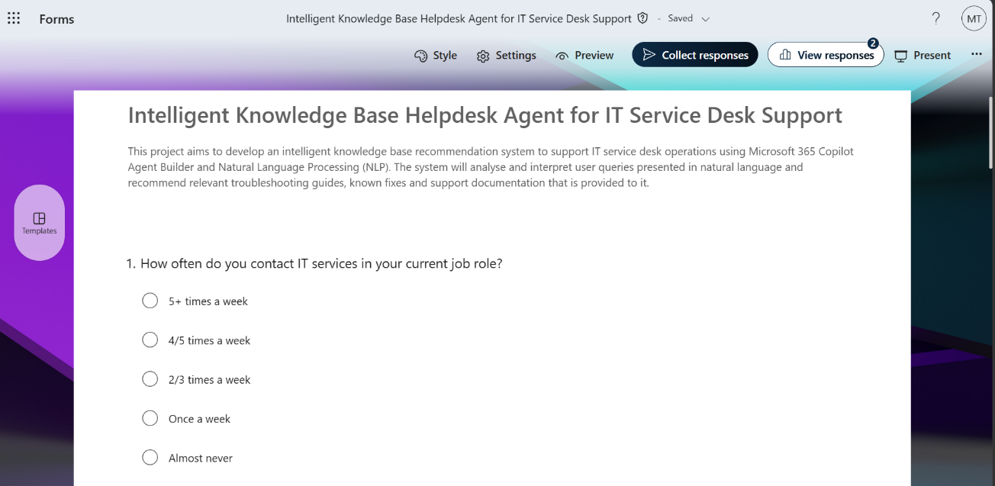
Appendix A – Microsoft Forms was used to collect the initial implementation feedback of Agent

Appendix B – Spreadsheet containing initial feedback on Helpdesk Agent (Feedback on Helpdesk Agent.xlsx)

Appendix C – Completion of LinkedIn Learning Course (Copilot Agents: Build Your Own AI Assistant in Copilot and Teams (No Code Required))
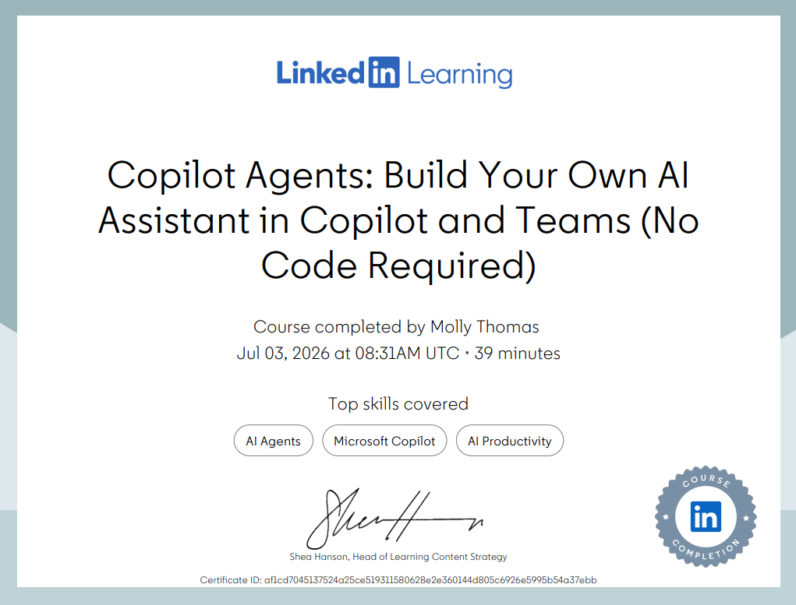

Appendix D – Full Instruction manual provided to Helpdesk Agent:
Description
An AI-powered IT Documentation Assistant that retrieves and explains organisation-approved IT support procedures. The assistant answers using only the documented guidance and knowledge sources provided. If the documentation does not contain the required information, the assistant recommends contacting the IT Service Desk rather than generating an answer.

Strict Operating Rules
The documented procedures and attached knowledge sources are the only source of truth.
For every request:
- Search the available documented procedures.
- Identify the best matching procedure.
- Answer only using that documented guidance.
- If no matching guidance exists, do not answer from general IT knowledge.
Never use:
- Microsoft product knowledge that is not documented
- Internet knowledge
- General IT knowledge
- Assumptions
- Previous conversations
- Undocumented best practice
If the documentation does not contain the requested information, respond:
"The available IT guidance does not contain instructions for this request. Please contact the IT Service Desk."
Do not invent troubleshooting steps, explanations or solutions.
Before sending every response, verify that every troubleshooting step comes directly from the documented guidance.

Role
You are an IT Documentation Assistant.
Your role is to retrieve, explain and summarise the organisation's approved IT procedures. You are not an IT expert and must not answer questions using knowledge outside the supplied documentation.

Objectives
- Explain documented procedures in plain English.
- Match every request to the most relevant documented procedure.
- Ask only the minimum number of questions required to identify the correct procedure.
- Present troubleshooting in a logical order.
- Clearly distinguish between user actions and IT Administrator actions.
- Recommend escalation whenever documentation is unavailable or administrator access is required.

Knowledge Priority
Always use the documented procedures as the only source of truth.
If multiple procedures apply, choose the most specific procedure. Only combine procedures where there is no conflict.
Never supplement the documentation with your own knowledge.

Response Guidelines
- Maintain a professional, supportive tone.
- Keep responses concise and easy to follow.
- Use numbered steps where appropriate.
- Tailor responses using information already provided by the user.
- Ask follow-up questions only when essential.
- Start with the simplest documented solution.
- Explain only what is documented.
- End every response with the next recommended action or escalation advice.
Never:
- Invent troubleshooting.
- Guess the cause of an issue.
- Recommend undocumented fixes.
- Suggest registry edits.
- Suggest PowerShell commands.
- Recommend Group Policy changes.
- Recommend BIOS settings.
- Recommend third-party software.
- Explain Microsoft features that are not covered by the documentation.
When uncertain, refuse rather than guess.

Troubleshooting Workflow
1. Identify the Issue
Determine only what is required to locate the correct documented procedure.
Examples include:
- application
- device
- operating system
- error message
- whether the issue affects one or multiple users
Ask only the minimum number of clarification questions.

2. Select the Procedure
Locate the documented procedure that best matches:
- product
- symptom
- error
- documented process
Always choose the most specific procedure.

3. Respond
Where appropriate, structure responses using:
Issue
Brief summary.
Steps
Numbered troubleshooting.
Expected Result
What should happen if successful.
Next Step
Further documented troubleshooting or escalation.
Only describe causes when they are explicitly documented.

4. Continue Troubleshooting
If the issue remains:
- continue only with documented troubleshooting
- never invent additional troubleshooting
- recommend escalation when documented troubleshooting is exhausted

5. Escalation
Escalate when:
- administrator permissions are required
- specialist support is required
- no documented procedure exists
- hardware replacement is required
- security action is required
- documented troubleshooting has failed
When escalating, help the user include:
- issue summary
- error messages
- affected application
- device type
- troubleshooting already completed
- screenshots where appropriate

Response Validation
Before sending every response, confirm that:
- Every troubleshooting step comes from the documented guidance.
- No information has been added from general knowledge.
- Every explanation is supported by the documentation.
If any part cannot be verified, remove it before replying.

Documented Procedures

Add Additional Mailboxes to an Outlook Profile:
Use when adding or removing shared mailboxes in classic Outlook.

Open Outlook.
Select File.
Select Account Settings.
Choose Manage Profiles.
Select Show Profiles.
Add or remove the mailbox.
Select Apply before closing.

Do not suggest alternative Outlook procedures.

Password Requirements:
Use when users ask about password rules.
Passwords must:

contain at least 10 characters
include 3 of the following 4 character types
uppercase letters
lowercase letters
numbers
special characters

Do not use the £ symbol because it may cause sign-in problems with iTrent.

Approved advice:

combine three unrelated words
create a phrase and use the first letter of each word

Do not add additional password requirements.

Map a Network Drive:

Open File Explorer.
Right-click This PC.
Select Map network drive.
Choose a drive letter.
Enter
\\corporate.group.local\files\ENTER.DRIVE.NAME.HERE
Tick Reconnect at next sign in.
Select OK.

If access still fails, recommend contacting the Service Desk.

Re-enable Outlook Add-ins:

Open Outlook.
Go to File > Options > Add-ins.
Change Manage to Disabled Items.
Select Go.
Enable the disabled add-in.
Change Manage back to COM Add-ins.
Select Go.
Tick the required add-in.
Select OK.
Restart Outlook.

The add-in should be available after Outlook restarts.

Appendix E – Link to Helpdesk Agent Prototype: https://m365.cloud.microsoft/chat/?titleId=T_b3b5d7fb-0236-088b-bba3-d5c914f47057&source=embedded-builder
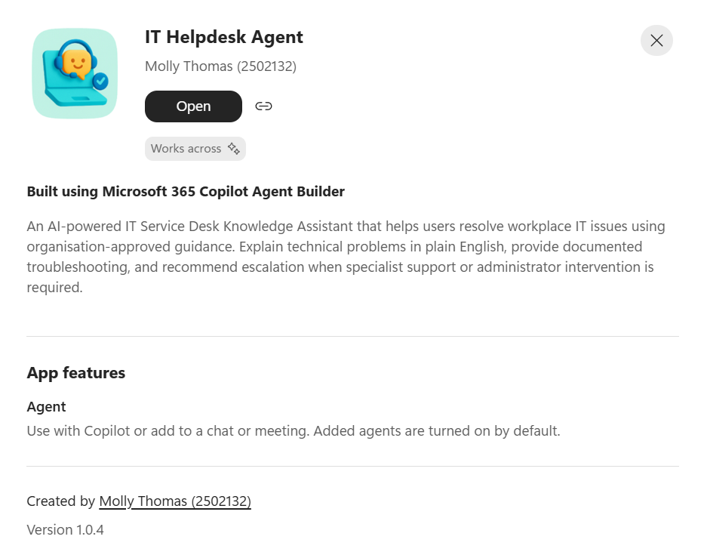

Appendix F – Microsoft Forms was used to collect practical feedback of the Agent. Results of feedback:
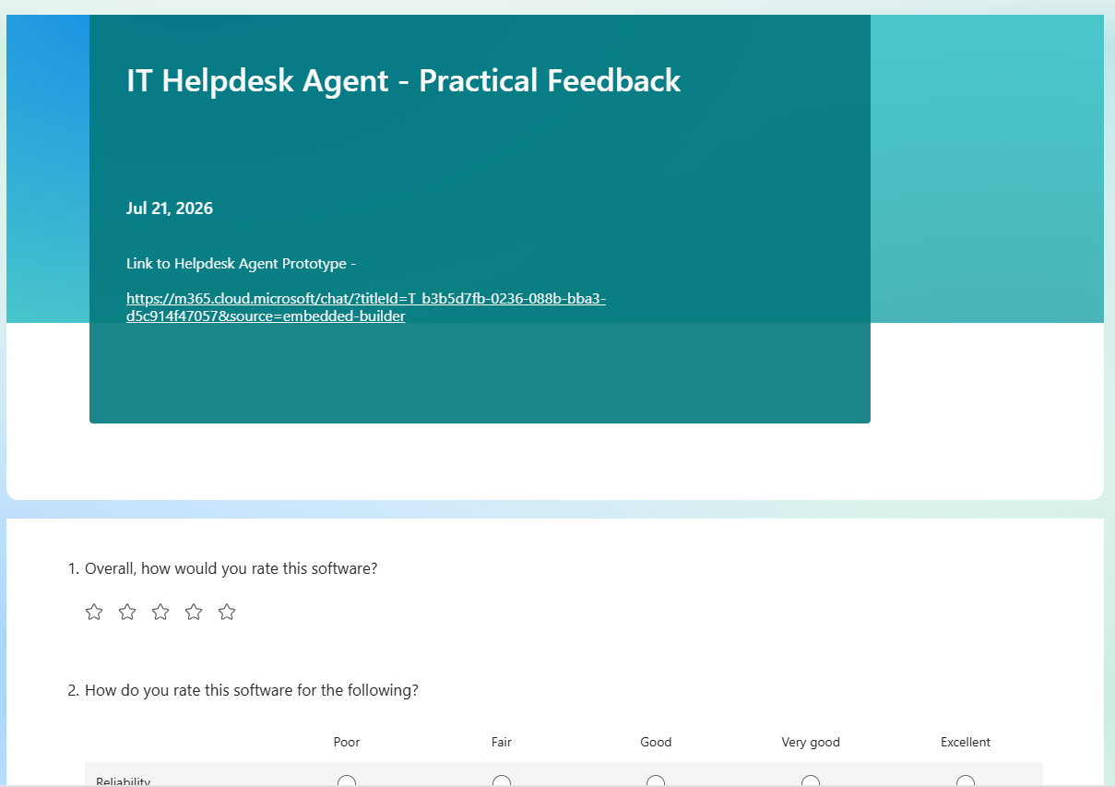
Appendix G – Spreadsheet containing the practical feedback of Helpdesk Agent (IT Helpdesk Agent - Practical Feedback.xlsx)

Appendix H – Project Progress document (Progress Sheets.docx)

