Word Count: 3807

Property law and practice

The application of property & land law report

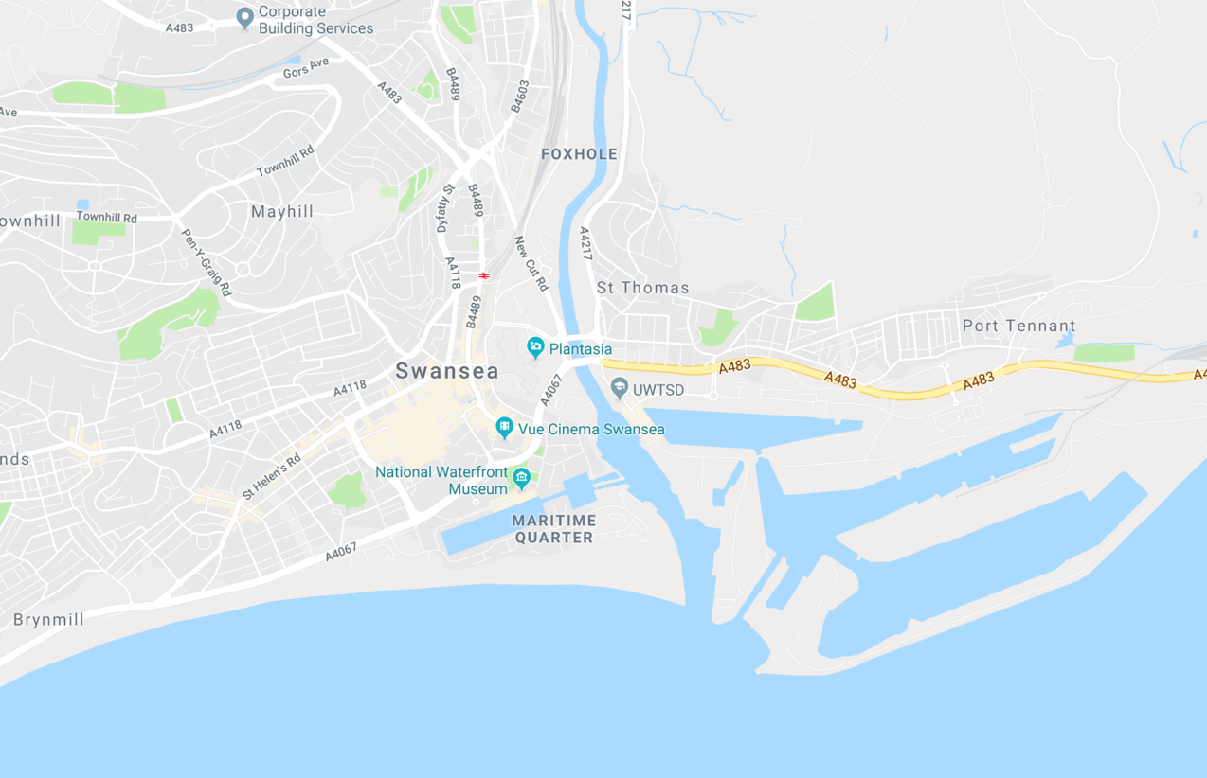
TAble of Contents
1.0 - Introduction Pages 3-3
2.0 - Land law consideration prior purchase Pages 3-3
2.1 - Registry of land Pages 3-3
2.2 - Land covenants Pages 3-4
2.3 - Land contamination Pages 4-4
3.0 - Planning considerations and premissions Pages 5-5
3.1 - Planning premission Pages 5-5
3.2 - Planning application Pages 5-5
3.3 - Planning negotiations Pages 5-5
3.4 - Environmental impact assessment Pages 5-5
3.5 - Neighbourhood concerns Pages 6-6
3.6 - Insurances Pages 6-6
3.7 - Once planning approval is granted Pages 7-7
3.8 - Party Wall etc. Act 1996 Pages 7-7
4.0 - Application of building regulations Pages 8-8
4.1 - What are building regulations? Pages 8-8
4.2 - Who enforces them and how are they enforced? Pages 8-8
4.3 - Relevance to delveopment Pages 8-8
5.0 - Leasing Guidance Pages 9-9
5.1 - What is a Lease? Pages 9-9
5.2 - Leases relevant to client and tenants Pages 9-9
5.3 - How does the lease end? Pages 9-9
5.4 - Dilapidation schedule Pages 9-9
5.5 - Dilapidation considerations for tenants Pages 9-9
5.6 - Dilapidation considerations for client Pages 10-10
5.7 - Disputes Pages 10-10
6.0 - Conclusion Pages 10-10
7.0 - References Pages 11-11

1.0 – Introduction
This report has been compiled together to provide the client with comprehensive guidance regarding property law and practise concerning the plot of land they wish to develop on within Swansea’s city centre. After showing different considerations and regulations that the client will have to follow legally and take into account, they then will be able to have an informed decision on whether they wish to purchase the plot of land and go through with the development knowing what is legally expected of them and what they are expecting in return or not to purchase the plot if they so choose.

2.0 – Land law consideration prior purchase

2.1 – Registry of land

One of the first major steps to carry out before the purchase of any land is to check if the land of interest is registered. Registered land can categorically show the legal ownership of land making the purchase faster and safer than before which also applies to the future sale of the land also the boundaries of land will be shown via a boarder plan. This is important as land more often than not is individuals and businesses most valuable asset, considering the plot for sale which the client is interested in is located in the city centre of Swansea means it is most likely to be valuable as city centre land is more expensive per square meter than land further out from city centres.

If the land isn’t registered, you’ll be legally required to register the land once purchased to Her Majesty’s Land Registry. The owners name, price paid, and land boundary information gets produced online by the land registry making it easy for everyone to tell who owns the land and what exactly is owned with the boundary plan.

2.2 – Land covenants

A covenant is a type of agreement acting like a condition which is bound by law and is found in the purchasing of property within the deeds or alongside them. Covenants dictate what the owner of the property is allowed or not allowed to do in relation to the property purchased. This will be made aware to the client, so they have a full understanding of what is expected of them if there are covenants attached to the property.

There are two types of covenants which are known as positive or restrictive. A positive covenant is one where by the owner has made a promise to carry out something such as putting money towards a maintenance fee to maintain the condition of a party wall between their property shared with their neighbour. Restrictive covenants are the ones to be more aware of as they restrict the owner from carrying out something such as not being allowed to build a fence higher than 5 meters within 3 meters of the front street. When looking into the purchase of the interested land ensure a search for covenants has been carried out and that a clear understanding has been made of them.

Additionally, covenants mainly restrictive ones can be passed along to future owners of the land, this is known as passing the burden. This tends to happen when the covenants benefit the land in some way or another, if the parties whom created the covenant feel if the burden should be passed with the land opposed to an individual endeavour. This is needed to be made aware of as if the client wishes to sell their land in the future, lease it out for office space or for tenants to stay in an accommodation set-up then these covenants will be applied to them as well depending on what they are.

If the covenants aren’t followed as agreed upon once signing the contract and purchasing the property then consequences can occur in the for of a possible injunction enforcing you not to carry out or to carry out a specific task in favour of what the covenant has asked you to follow. If for some reason damage has occurred in the result of not following the legal agreement after breaching it than payments to rectify the damages can be collected from the breaching party.

2.3 – Land contamination

Check If the interested land is contaminated in one way or another by substances such as gases, arsenic, lead and asbestos. This is mainly from done from the health and safety stand point because if the property purchased has asbestos elements such as floor tiles or ceiling boards then the removal of them isn’t as simple as striping them out and removing them from site. This is down to the risk created towards the labours as possible harm can occur in the removal of these substances.

Similarly, this applies to the concern of future tenants that may use the client’s property for living or office work. If these harmful substances are present, then correct and appropriate removal will be needed to keep everyone safe and to prevent possible legal cases against the client if tenants were to contract asbestosis for example. That is why it’s important to find this out hopefully prior to the purchase of land as it benefits everyone more and it doesn’t require much effort on the clients part to find out, either the state of the land should be recorded on the land registry but if that fails to be there a contractor specialised in that field can be hired to inspect the land which once done can give the answer.

3.0 – Planning considerations and permissions

3.1 – Planning permission

The main consideration the client should have towards the planning stage is the actual permission to carry out the desired development. The different countries of the UK have different planning systems in place for the development of land and within them countries it’s down to the local planning authorities to enforce which proposed developments they receive from home extensions to new commercial builds that get to have their permission granted. The sole purpose for the Welsh planning system which is shown on the Planning Portal Wales is to manage which developments get approval to go ahead providing the development is in the interest of the public or doesn’t negatively affect them. The system is also in place to fundamentally provide a positive economy boost, efficiency in the construction sector and to serve as protection towards wildlife and the environment both longstanding and new by providing sustainable practise (Wales, 2019).

3.2 – Planning application

The client will need to know this as they will have to apply for planning permission in order to construct the office space as desired. The client will need to send a detailed application to the local authorities in this case the City and County of Swansea (CCS). The easiest way to carry this out is by submitting the application to the CCS website online as its faster than manually writing all the information out and posting it.

3.3 – Planning negotiations

It is in the client’s best interest to commence negotiations with the CCS preferably before the planning application is sent to show willing to cooperate with the authorities and the planning system but also to maintain contact as larger developments have so much detail involved its possible items may be missed out our the authorities want more information from the client. Therefore, making negotiations prior the applications there will be that connection of communication set up for easier approval of development, providing the proposed application is within the parameters of the CCS planning scheme (SwanseaGov, 2019).

3.4 – Environmental impact assessment

A document known as an environmental impact assessment will be required with the planning application which acts a big part in the deciding factor of granting permission by the CCS. This assessment provides the impact towards the environment of actual land to the wildlife and public operations in the near area which is created from the proposed development. Depending on what the impacts are and whilst negotiations are in motion the client can liaise with the local authority on what outcomes they wish to be present from the EIA and work towards making the development in that scope provided. This is to be taken seriously as the EIA should provide the client and the planning office with actual impacts whatever they may be in order for the development to address for the benefit of the environment which is why this has such a crucial role in the planning stage, one which should be thought over whilst planning starts or even sooner (Gov, 2019).

3.5 – Neighbourhood concerns

Before an application is sent to the local authorities it would be wise to engage with the local community around the development site which can be affected by the development itself directly or indirectly. As the proposed plan for the land is to become an office complex it would also be advised to consult with utility companies in the local area who deal with the control of water and sewage, as a massive use increase in these utilities if the office gets built with possible hundreds of staff working there may result in possible problems. As there is a communal park connected at the rear of the land the client will have to consult any concerns about the development with the authorities for health and safety purposes, as a result of possible materials used on site which have hazarded substances could be harmful and if people especially children are in radius which the park might be then serious concerns can develop. The best contact to get in communication with these concerns would be the local authority.

3.6 – Insurances

Insurances are essential with in the construction industry as so many different possibilities can go wrong resulting in a range of outcomes which don’t tend to be positive. It is always wise and really required that insurances are in place from the planning stages although not actually legally required however, most clients and businesses won’t work unless these are in place creating another health and safety net.. The main two insurances that will be required are professional indemnity and public liability, these insurances must be presented to the client from which contractor that carries out the work.

Professional indemnity is to protect the contractor or business of any size from damage done towards the project or towards the protentional earnings the client could have generated if the job wasn’t delayed most often out of negligence by the contactor (Designingbuildings, 2019). This is important to make sure the contractor chosen has as if the office proposed doesn’t get contracted on time with in the required time frame then the client could result in a serious loss of earning and when developing a project such as an office complex isn’t cheap, the client will want to see his return sooner rather than later.

Public liability is put in place for protection against claims towards a business if that business has caused injury to members of the public and third party people or if damage to their possessions occurs when they are present at the business. This applies to the client as its in their interest to have this cover in the event of an incident towards future tenants of the office development as it will cover the client from the legal costs of perusing the claims and resolving them, which can be very expensive. To put this in perspective of how expensive claims can be the common public liability covers by businesses are up to £1 million to £5 million pounds per claim (Designingbuildings, 2019).

3.7 – Once planning approval is granted

As the clients will find out via the Planning Portal Wales by sending an environmental impact assessment as part of their planning application approval can take up to 16 weeks, normally the process takes around 8 weeks to have granted approval, but the EIA needs intensive care during examination extending the period. The City and county of Swansea can grant the approval with attached conditions such as the change of certain materials being used, if the client isn’t pleased with this then they are able to carry out an appeal with the Welsh Ministers, however this process can take months and is often better to keep the negotiations ongoing from the submission so an agreement can be made by the client and the local authority to speed this part up. When the approval is received by the client the development will need to start with in a fixed period which tends to be a few years otherwise the client will need to apply or planning permission again. Ensure the approval letter has been read over as the date for the planning permission expiry will be mentioned (Wales, 2019).

Under the assumption that client has their planning permission approved without conditions or with but is willing to work with in the parameters of them, then work can commence. The client and contractor may need to liaise with the local council and traffic control of Swansea City Centre if roads need closing or temporary routes need erecting for any works to be done, this may not be the case however also seek advice to be certain.

3.8 – Party Wall etc. Act 1996

An additional consideration to be aware of which can affect the process of the proposed development Is the Part Wall etc. Act 1996. The Part Wall etc Act 1996 should be considered alongside the planning stage as it will make the development run smoother once planning approval has been received.

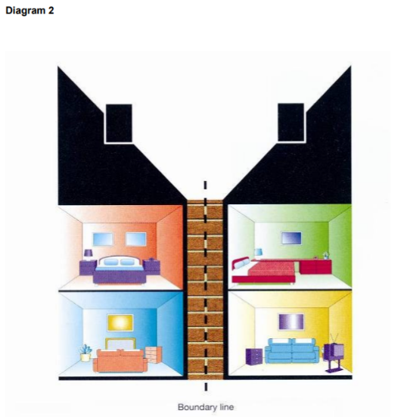
“The Part Wall etc. Act 1996 provides a framework for preventing and resolving disputes in relation to party walls, boundary walls and excavations near neighbouring buildings” (GOV, 2019).

This is relevant to the client as the land they wish to develop on is bound by three sides one at the rear connecting to a communal park and either side of the land by two existing properties. Depending on how the development is carried out this may not need mentioning as it comes down to how the office complex is constructed. Fundamentally if the buildings either side have been built on the boundary line of their property and the client seeks to do the same or build onto the boundary wall then the Party Wall Act ensures it is carried out correctly, fairly and settles any disputes.
Boundary Wall Example – (Anon, 2019)
This is because in order to construct to the wall, alter the wall in anyway or even build off the existing boundary wall both parties will have to provide consent and agreement as they both have shared ownership over it and until agreed upon work will not be able to take place.

4.0 – Application of building regulations

4.1 – What are building regulations?

Health and safety in the work place has become one of the biggest concerns in the last few decades this is due to the construction industry being a dangerous environment with heavy machinery being operated, chaotically busy work sites and buildings not being built correctly creating dangerous structures waiting to collapse. In response to this the British government implemented a system in the form of regulations known as the building regulations which have different sections of construction with in them and required standards for the construction to be carried out at. This helps prevent dangerous practice of construction and helps prevent tragedies such as the Grenfell tower burning down as providing the standards are met the goal is to construct safe, well-built structures that will last safely.

4.2 – Who enforces them and how are they enforced?

Building regulations have been around for decades now with these regulations which must be followed by law and are enforced by health and safety officers. These regulations apply to anybody undertaking building work as they must build with in these required regulations otherwise health and safety officers can legally shut down sites, order for buildings to be deconstructed if built under par of the requirements and hand out fines to offending parties. These officers can have more power than the police because of this and once they turn up to site to inspect work being undertaken, they cannot be turned away. The client will need to be aware of this as they will not want this to happen as a serious loss of money will be involved for them

4.3 – Relevance for development

The client will need to be aware of these regulations so they can ensure that their contractor will carry out the work within the standards in place. Wales does have a number of different standards to England and Scotland with minor differences in certain aspects because from the 1st January in 2012, any revised regulations and new ones are covered by the Welsh government as a result of this ensure the work is carried out to the building regulations relevant to the land which can be discussed with the local authorities (Designingbuildings, 2019).

An example of these differing standards are U-values which in England have a lower threshold to pass them while in Wales the standard is higher, which can be found in the building regulations on the government’s website. This results in buildings with better thermal transmittance which have followed these standards and means the buildings tend to have a higher level of sustainability with reduced energy waste creating a cost saving down the buildings life cycle.

Ultimately the client will be satisfied with the development being constructed to a higher standard of quality making it safe, long lasting and possibility economically and environmentally friendly.

5.0 – Leasing Guidance

5.1 – What is a Lease?

A lease is a type of legal contract which is formed by two parties known as the lessor, whom owns an asset in the client’s case the office property and the lessee, whom is the party granted exclusive possession over the property for a fixed amount of time and price agreed upon with in the contract with covenants attached. Fundamentally a lease acts as a hire purchase agreement over a property but must be agreed and signed by both parties otherwise it doesn’t stand as a valid lease (BusinessDictionary, 2019).

5.2 – Lease relevant to client and tenants

There are several different types of leases but a commercial lease is most likely the type the client will be using with their tenants, this is the contract between the owner (lessor) and the business tenant (lessee) which gives the exclusive access and possession of space provided at the property to the lessee in exchange for payment to the lessor (Lawdepot, 2019). As the client’s development will be commercial office space, this lease seems the most appropriate. The tenant will have exclusive possession of the office space for their business in exchange for payment to the client in the form of rent and the client should make clear to the tenant a covenant will be put in place stating the property Is to remain in same condition meaning no damage to the property throughout their contracted period.

5.3 – How does the lease end?

The end of a lease can occur by the natural end of the agreed upon contract period and then can be renewed if both parties agree. Another way the contact can end is if for example the tenant wishes to terminate the contact before the time dictated by the lease contract however, the tenant must provide a sufficient amount of time before they leave unless the lessor agrees to end it sooner. If the tenant breaches the contract such as not paying rent or not following covenants included within the contract such as not remuddling the property without approval from the lessor then the contract can also be terminated at the clients wish.

5.4 – Dilapidation schedule

A dilapidation report deals with the defects developed from damages or poor maintenance from tenants breaching their lease covenants to maintain good condition over their property during their tenancy term and/or when the lease reaches its natural end of contract (Ricsfirms, 2019). The client will be using these schedules in order to rectify any defects and damages caused by the stay of the tenants at the property.

5.5 – Dilapidation considerations for tenants

The tenant should be made aware of the dilapidation covenants within the lease and if wanting to accept the lease make preparation for the end of the leases term when they will most likely face the dilapidation schedule for building works to take place to restore any damage or alterations that have transpired. If alterations have been made then the tenant can be asked by the client to revert them back before their end of term or face possible claims by the client to sort them out their self (Ricsfirms, 2019).

5.6 – Dilapidation considerations for client
The client can issue the tenants of the property notices to restore the property to the original condition by reverting the alterations and repair any damages caused by them before the lease expires, then provide them with the dilapidation schedule within a 56 day period after the lease has expired (Ricsfirms, 2019).
This process will help the client by providing the tenant with a reminder of the completion of their lease and to ensure they get the dilapidations organised, this will ideally result in a smooth transition of the ending lease agreement.

5.7 – Disputes
Disputes can appear from both parties whom feel like certain defects aren’t relevant to them or that the price of restoration is too great and outlandish. In these instances there is the option to make a claim and go through the court process which may take time and end up costing more than what the dilapidations were, due to this what tends to happen is a alternative dispute resolution is carried out if both parties agree upon the process.
There are a couple different options to take when it comes to the alternate dispute resolution, one being the use of an expert’s determination which is fundamentally the deciding outcome comes down to one individual expert which the lessor and lessee are then after bound by (Ricsfirms, 2019). This option can be the easiest to work with as it down to one individual to make the decision however, this can sound unfair due to the fact of it only being one person making the choice over the other two parties.
The other option is one of mediation where by a mediator tries to resolve the dispute between both parties by having discussions alongside their advisors at a meeting in order to provide an equally suitable agreement which is the attempt to make the process most fair and unbiased (Ricsfirms, 2019).

6.0 – Conclusion

Now the clients four main issues that concerns were developing from have now been addressed. The client may now take the time to decide if the desired development on the land for sale is something they wish to carry out with great haste of excitement now knowing key considerations to have with the process of construction from start to occupation or, after realising the evolvement required to perform such a task that it may not be in their interest after all.

7.0 – References

Anon, (2019). [image] Available at: https://www.google.com/search?q=party+wall+act+1996&rlz=1C1CHBD_en-GBGB846GB846&source=lnms&tbm=isch&sa=X&ved=0ahUKEwjd8r_omP_hAhV4TxUIHenzBXYQ_AUIDygC&biw=1280&bih=578#imgrc=lV_OX7-VcdiUTM: [Accessed 3 May 2019].

BusinessDictionary.com. (2019). What is a lease? definition and meaning. [online] Available at: http://www.businessdictionary.com/definition/lease.html [Accessed 3 May 2019].

Designingbuildings.co.uk. (2019). Building regulations - Designing Buildings Wiki. [online] Available at: https://www.designingbuildings.co.uk/wiki/Building_regulations#Wales [Accessed 3 May 2019].

Designingbuildings.co.uk. (2019). Professional indemnity insurance PII - Designing Buildings Wiki. [online] Available at: https://www.designingbuildings.co.uk/wiki/Professional_indemnity_insurance_PII [Accessed 3 May 2019].

Designingbuildings.co.uk. (2019). Public liability insurance - Designing Buildings Wiki. [online] Available at: https://www.designingbuildings.co.uk/wiki/Public_liability_insurance [Accessed 1 May 2019].

GOV.UK. (2019). Preventing and resolving disputes in relation to party walls. [online] Available at: https://www.gov.uk/guidance/party-wall-etc-act-1996-guidance [Accessed 1 May 2019].

Lawdepot.co.uk. (2019). Commercial Lease Agreement FAQ - United Kingdom-England. [online] Available at: https://www.lawdepot.co.uk/law-library/faq/commercial-lease-agreement-faq-united-kingdom-england/#.XMxX3WhKg2w [Accessed 3 May 2019].

Ricsfirms.com. (2019). [online] Available at: https://www.ricsfirms.com/media/1212/rics-consumer-guide-dilapidations-2018.pdf [Accessed 5 May 2019].

Ricsfirms.com. (2019). RICS Consumer Guide: Dilapidations | Find a Surveyor. [online] Available at: https://www.ricsfirms.com/residential/maintenance/rics-consumer-guide-dilapidations/ [Accessed 5 May 2019].

Swansea.gov.uk. (2019). Swansea - Making a planning application. [online] Available at: https://www.swansea.gov.uk/makingaplanningapplication [Accessed 2 May 2019].

Wales, P. (2019). About the Planning System - Planning Portal - Wales. [online] Planningportal.co.uk. Available at: https://www.planningportal.co.uk/wales_en/info/6/planning/62/about_the_planning_system [Accessed 29 Apr. 2019].

Wales, P. (2019). The decision making process - Planning Portal - Wales. [online] Planningportal.co.uk. Available at: https://www.planningportal.co.uk/wales_en/info/5/applications/57/the_decision_making_process/5 [Accessed 1 May 2019].

