

BA International Hotel Management

Lectures name: Giulia Chifari
Student Name: Viorica Cornelia Lacatas
Student ID:21175000

Table of Contents
Component 1 – Professional Reflection 3
Component-2 Training Title 4
Component-3 Student Self-Reflection 6
Component- 4 Training Presentation 8
Reference 15

Component 1 – Professional Reflection
My job as a front office attendant at a hotel restaurant in the UK got me in touch with a Japanese guest who was distinct from the others because of the cultural difference that we had. The guest asked for a dish to have a very specific look since it was expected to be served instantaneously, exemplifying a cultural element of immediate results in Japanese cuisine. The next day at the dinner service, however, the guest showed all signs of displeasure after being disappointed when the dish he was served was not in his expectations regarding food temperature as the Japanese and British cultures differ much in this area.
Therefore, this case illustrates the significance of being aware of a specific culture's dynamics and norms in any service transaction. It uncovered that in some cases, even the simplest of guests’ needs can be confused by cultural variations, which resulted in the guest receiving the opposite of what they had in their minds and also various misunderstandings (Storti, 2022). As a way of making sure such an occurrence never takes place and developing myself, I have set on my path on areas I can improve.
First off, I would like to acknowledge that learning about different cultures can be extremely significant. The goal here is to have multicultural knowledge or the understanding of various cultures and their preferences exercised together with the awareness that different cultures can be very diverse while carrying inherent variability (Chi, Zhang, and Kulich, 2022). I wish to accomplish this by enjoying such cultural awareness classes & workshops, acquiring knowledge about different customs of the table, and discovering mechanisms that meet guests’ expectations of different countries. Through the course of the internship, I will develop my soft skills by doing the needs assessment of the guests and catering the service according to their needs.
Secondly, in the acceptance of cultural differences, clear communication is the essential key to the resolution of cultural miscommunications. I understand that the right to be heard and the necessity of responding are key to encouraging mutual understanding (Kurdi, Alshurideh, & Alnaser 2020). Instead of seeing things from the filter of my own culture, I will make an effort to listen to guests actively to better understand their unique choices and tastes. Some of them have some special dietary requirements or preferences. Thus, besides asking questions, being attentive is also essential for better food service playing.
Additionally, creating and sustaining empathy is a must for not only dealing with the diversity of cultures but also for creating greater inclusivity. What I want to do is to accept every meeting and have knowledge, that guests might have different backgrounds concerning society. Showing empathetic behavior and the creation of an environment that brings different ethnic groups into this common space will mean more guests having great times at the restaurant.

Component-2 Training Title
Through Culturally Responsive service and training we hope to achieve cultural awareness, gain appreciation for diversity, and build bridges across communities (Abramson, and Moran, 2018).
Objective: This training aims to arm staff members with the essential competence and knowledge to offer a cultured-responsive service guaranteeing no cases of dissimilarities and ensuring the satisfaction of the guest which is the difference.
Training Components:
- Cultural Awareness Workshop: Organize a practical workshop oriented to the staff members mentored by the cultural experts to inform everyone about the cultural code, customs, and standards of people from different parts of the world. Shall share the knowledge of diverse dining customs, languages, and palates concerning dining and beverage service. Support your employees to reflect on the most memorable cultural episodes or a particular place that they have been to create this empathy culture (Stallard, 2020).
- Communication Skills Development: Conduct training courses that aim at the enhancement of communication skills, that is listening actively, asking clarifying questions, and non-verbal communication. Let role-play and case studies be part of the training and how to communicate in multi-cultural settings with optimism.
- Cultural Competency Training: Present the staff on core elements of cultural competence; the enlightenment of cultural humility, self-awareness, and the appreciation of diversity among others. Help guest agents walk through the biases and stereotypes that they may not be aware of and examine the effect of guest failure. Give instructions for culture competence formation, it entails keeping up the process, self-reflection, and never stopping while learning (Christiansen, Branch, and Karmowska, 2020).
- Case Studies and Best Practices: Today the case study will provide implications of culturally related problems encountered in the hospitality industries and the strategies to retire those issues in daily life. Present the best practice activities for providing the culturally sensitive service, therefore, modifying food options, observing dietary regulations, and observing the cultural traditions.
Evaluation and Follow-Up:
The course evaluation and post-training plan will entail pre and post-training evaluation assessments to be done on all staff members to gauge their knowledge and understanding of cultural awareness and responsiveness. The feedback from course participants will surely be welcomed to evaluate the training results and search for development opportunities. Furthermore, the support and resources for the staff will always be made available to them including cultural competency guides, language learning opportunities, and cultural experts. With the use of these measures, our Level 4 Hotel can help make sure that all employees are trained professionally giving them the required skills and knowledge to properly service guests who are from diverse ethnic cultures.

Component-3 Student Self Reflection

As I had a few years of experience working in the hotel business, I became much more aware of cultural differences and their importance. Based on Gibb's (2, 3, and 5) Reflective Cycle, I will reflect critically by discussing various aspects, including change in perception over time of experiences, what I have learned from them, and the importance of cultural awareness in this area of study (Koukpaki, and Adams, (2020).
Description:
My first step into cultural awareness for hospitality was reaching the level of knowledge about the main customs and traditions of different cultures. To me, it wasn't something that I should learn by heart to get a passing grade on an exam. It was instead just a tool to help me interact with customers coming from different parts of the world. Nonetheless, I started to see the changes in my view toward other cultures after I had landed more work in a multicultural environment (Shadiev, Sun, and Huang, 2019). For Example: During my tenure at the Leonardo Hotel Cardiff, my tourists from diverse cultural heritage, for example, there were a Japanese couple who were used to "bow" greetings and a Middle Eastern family whose preferred mode of communication was with male staff members.
Feelings:
Initially, my self-esteem was high and I believed I was capable of bridging cultural gaps, but I felt some sort of fear inside of me because I knew I could have offended people unintentionally. The moment I faced different circumstances I had to take long strides in cases where I did not know what would happen next. However, the blend of feelings, of which empathy as well as curiosity towards the different cultures became a greater part. Example: Along with a busy night at the restaurant, I happened to oblige a big Indian family. Excitement and nervousness were a feeling you experienced at the same time as you wanted their dining experience not to dissipate.
Evaluation:
Language has a unique ability to unite and divide people. Yet, cultural awareness does not merely follow the simple rule of avoiding misunderstandings. Through the cultural diversity introduced in the restaurant services, I realised that this created an atmosphere of vibrance and liveliness in the place for all the guests. I realised that cultural miscommunication becomes very problematic, both with guest experience and the hotel's status, therefore I decided to add continuous development in this field to my list of priorities (Klimova, Klimova, and Dubinka, 2019).
Analysis:
I gained an insight as to how complicated cross-cultural interactions could be and how critical it is to consider different guests and to adapt your way of doing things to meet their specific needs. So, as part of working in a hotel restaurant, I once faced a kind situation when a Chinese guest didn’t want a noisy dining environment that was justified by cultural norms. Though I fulfilled their demand, I gained an opportunity to determine the level of discerning the client and advantageous build rapport. For example: At that time, it turned out to be I who found a notable trait that the social groups from different cultures did appreciate when their customs were acknowledged and well-regarded.
Conclusion:
During this process of self-reflection, the importance of cultural sensitivity is a defining characteristic of my service in the hospitality sector. Such an educational experience shows me that intercultural competence is not a static skill but a dynamic character trait, which requires constant learning and the development of that person. Through valuing cultural diversity as well as providing a conducive environment that is not discriminatory to all, hotels can create memorable experiences for guests and as a result, they will be more famous as a place to visit.
Action Plan:
I plan to prolong this process by attending lectures and workshops on cultural competence and providing assistance to people in need of it. I will be participating in cross-cultural activities and performing a self-reflection exercise which I believe will take my insight and understanding to the next level. Moreover, I will continue my effort to educate people about cultural awareness by integrating the same into the hospitality curriculum and establishing a culture of respect and inclusivity at workplaces in the industry.
Component- 4 Training Presentation
Slide 1


Slide 2
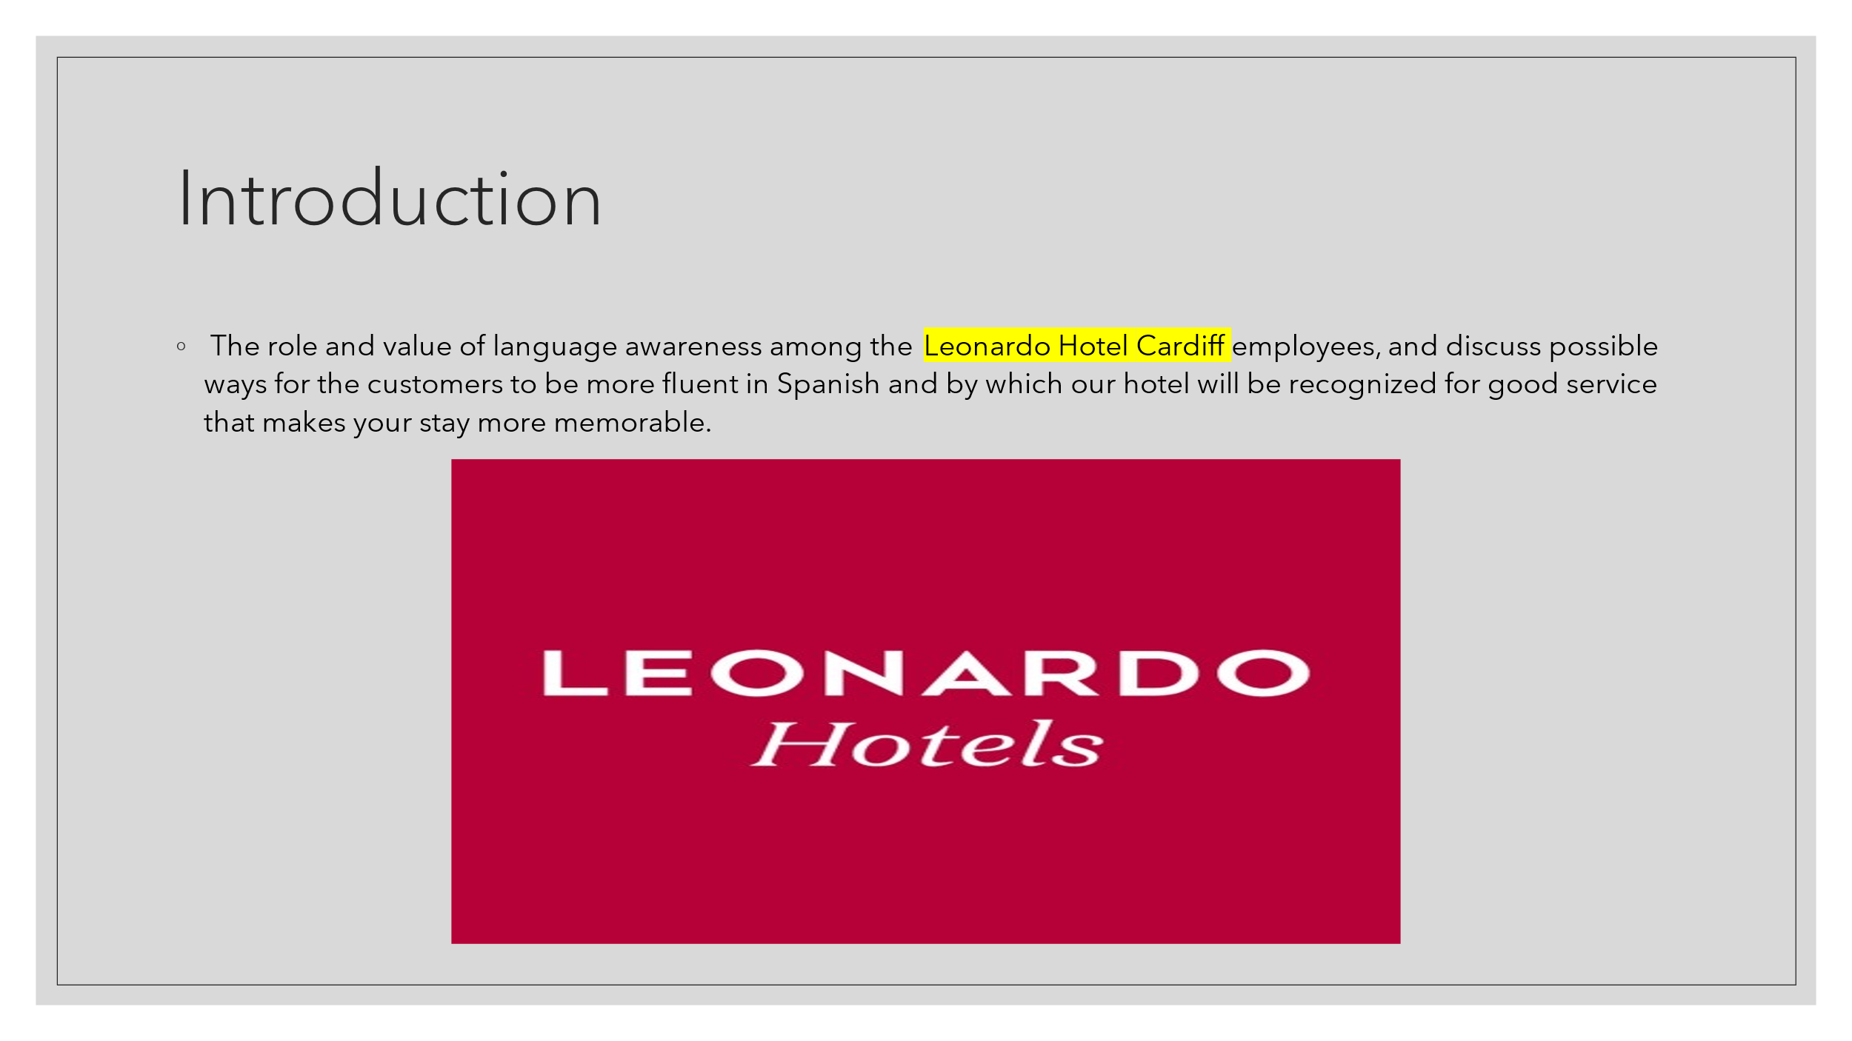
Slide note
The role and value of language awareness among the Leonardo Hotel Cardiff employees, and discuss possible ways for the customers to be more fluent in Spanish and by which our hotel will be recognized for good service that makes you stay more memorable
Speaker Note
The essence of this training seminar lies in the fact that we are going to concentrate on the understanding of the role and influence of the modern European language of Spanish for the increase of the guest satisfaction degree and the enhancement of the brand's reputation.

Slide 3
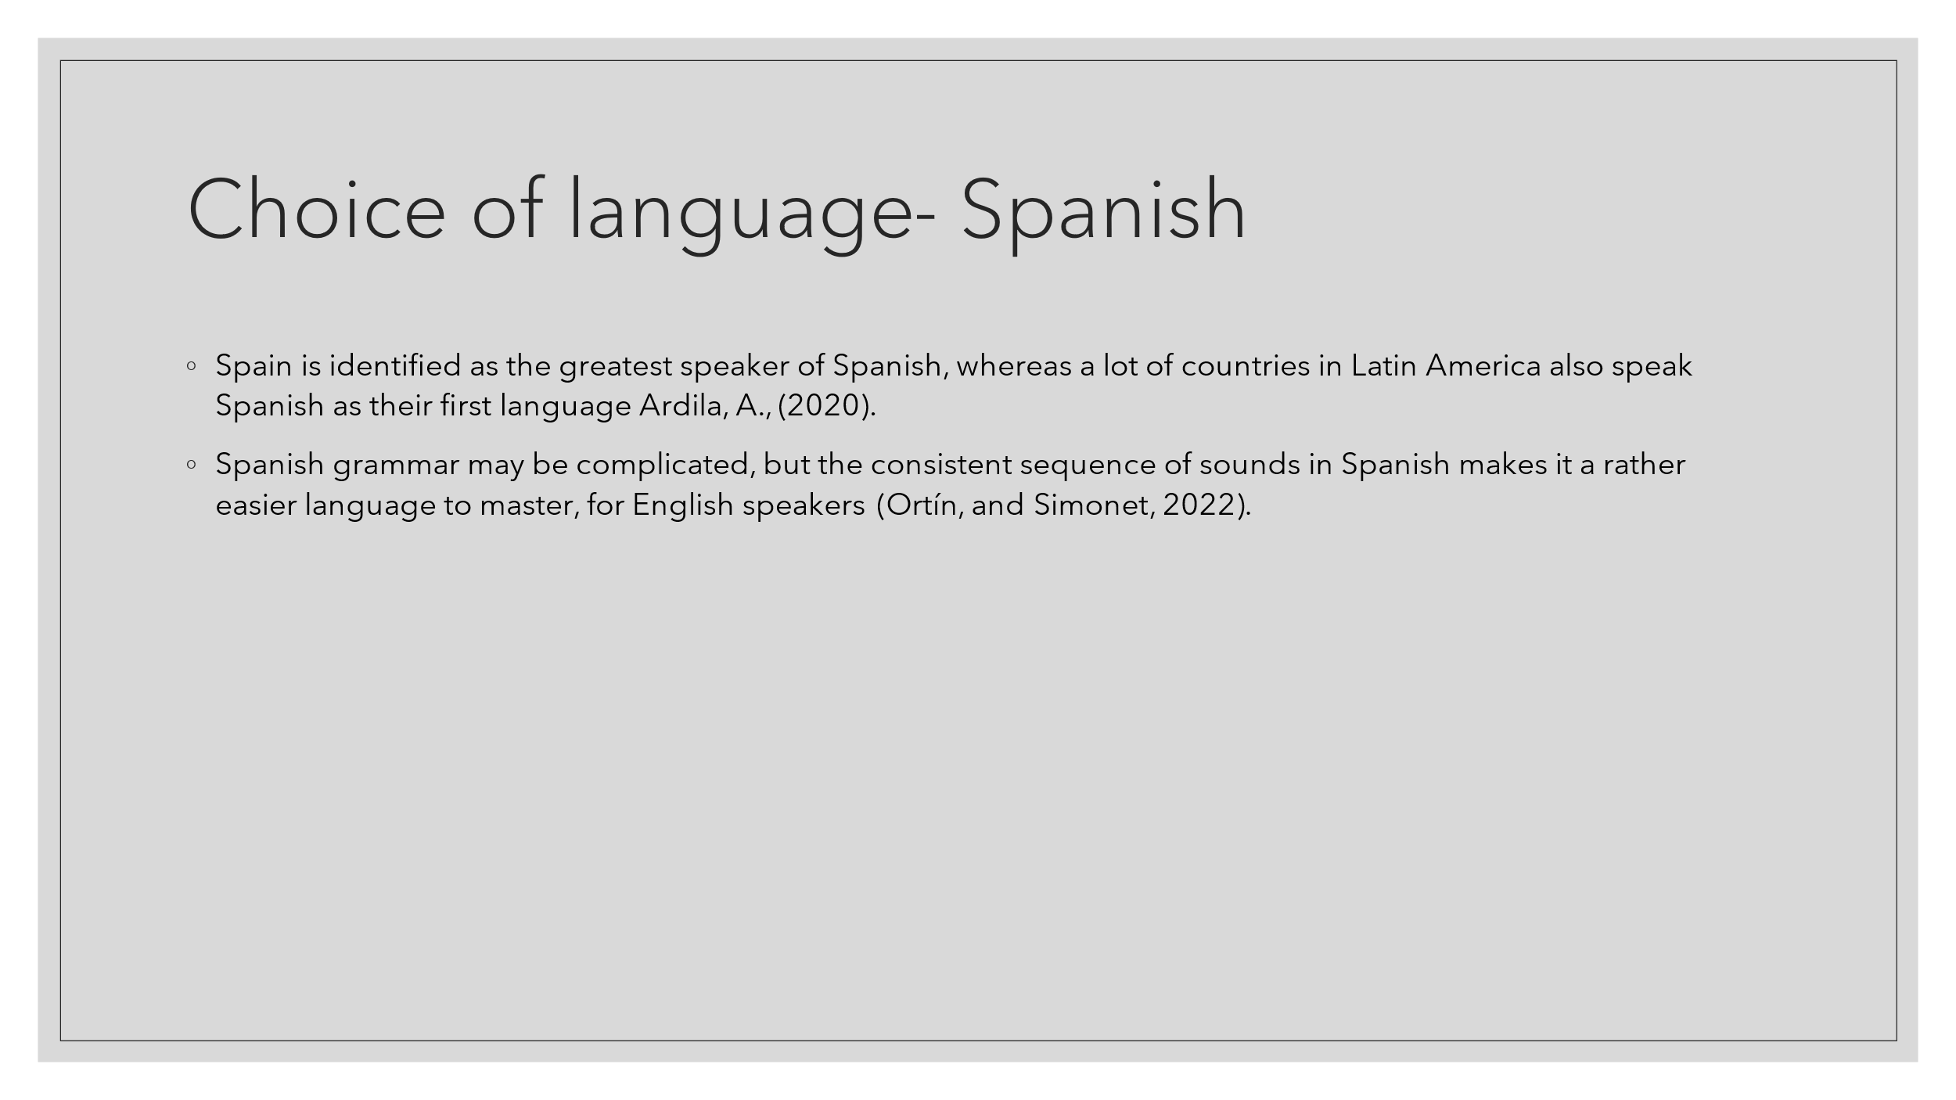
Slide Note
- Spain is identified as the greatest speaker of Spanish, whereas a lot of countries in Latin America also speak Spanish as their first language Ardila, A., (2020).
- Spanish grammar may be complicated, but the consistent sequence of sounds in Spanish makes it a rather easier language to master, for English speakers (Ortín, and Simonet, 2022).
Speaker Note
- Spanish, spoken in Spain and Latin America, gives, in a way, an asymmetrical advantage in the phonetics to English speakers, despite a very difficult grammar. Certainly, in business those forms such as "usted" and titles like "Señor" or "Señora" represent respectability. This, in turn, encourages the guest to participate more thus creating a feeling of being welcome. Such an experience is camouflaged with positive comments that uplift the hotel’s reputation.

Slide 4
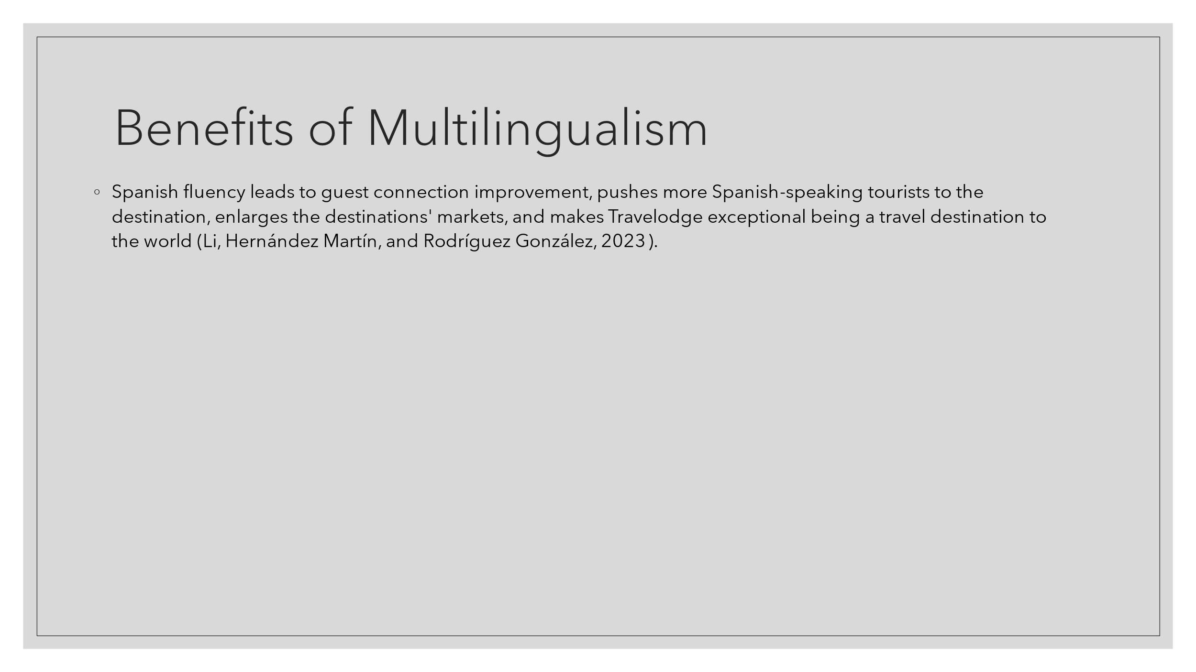
Slide Note
- Spanish fluency leads to guest connection improvement, pushes more Spanish-speaking tourists to the destination, enlarges the destinations' markets, and makes Leonardo Hotel Cardiff exceptional being a travel destination to the world (Li, Hernández Martín, and Rodríguez González, 2023).
Speaker notes
- Communication: Speaking Spanish allows us to develop deep and strong relationships with customers from Spanish areas resulting in guests’ delight and higher customer loyalty.
- Market Diversification: As far as Spanish language competency goes, we could drive also the traffic of Spanish-speaking visitors and get to new markets, thus increasing the number of potential guests.
- Competitive Edge: Providing multilingual services is one of the ways that differentiates us from similar competitors we have and consequently, Leonardo Hotel Cardiff appears to be an extraordinary choice for international guests.

Slide 5
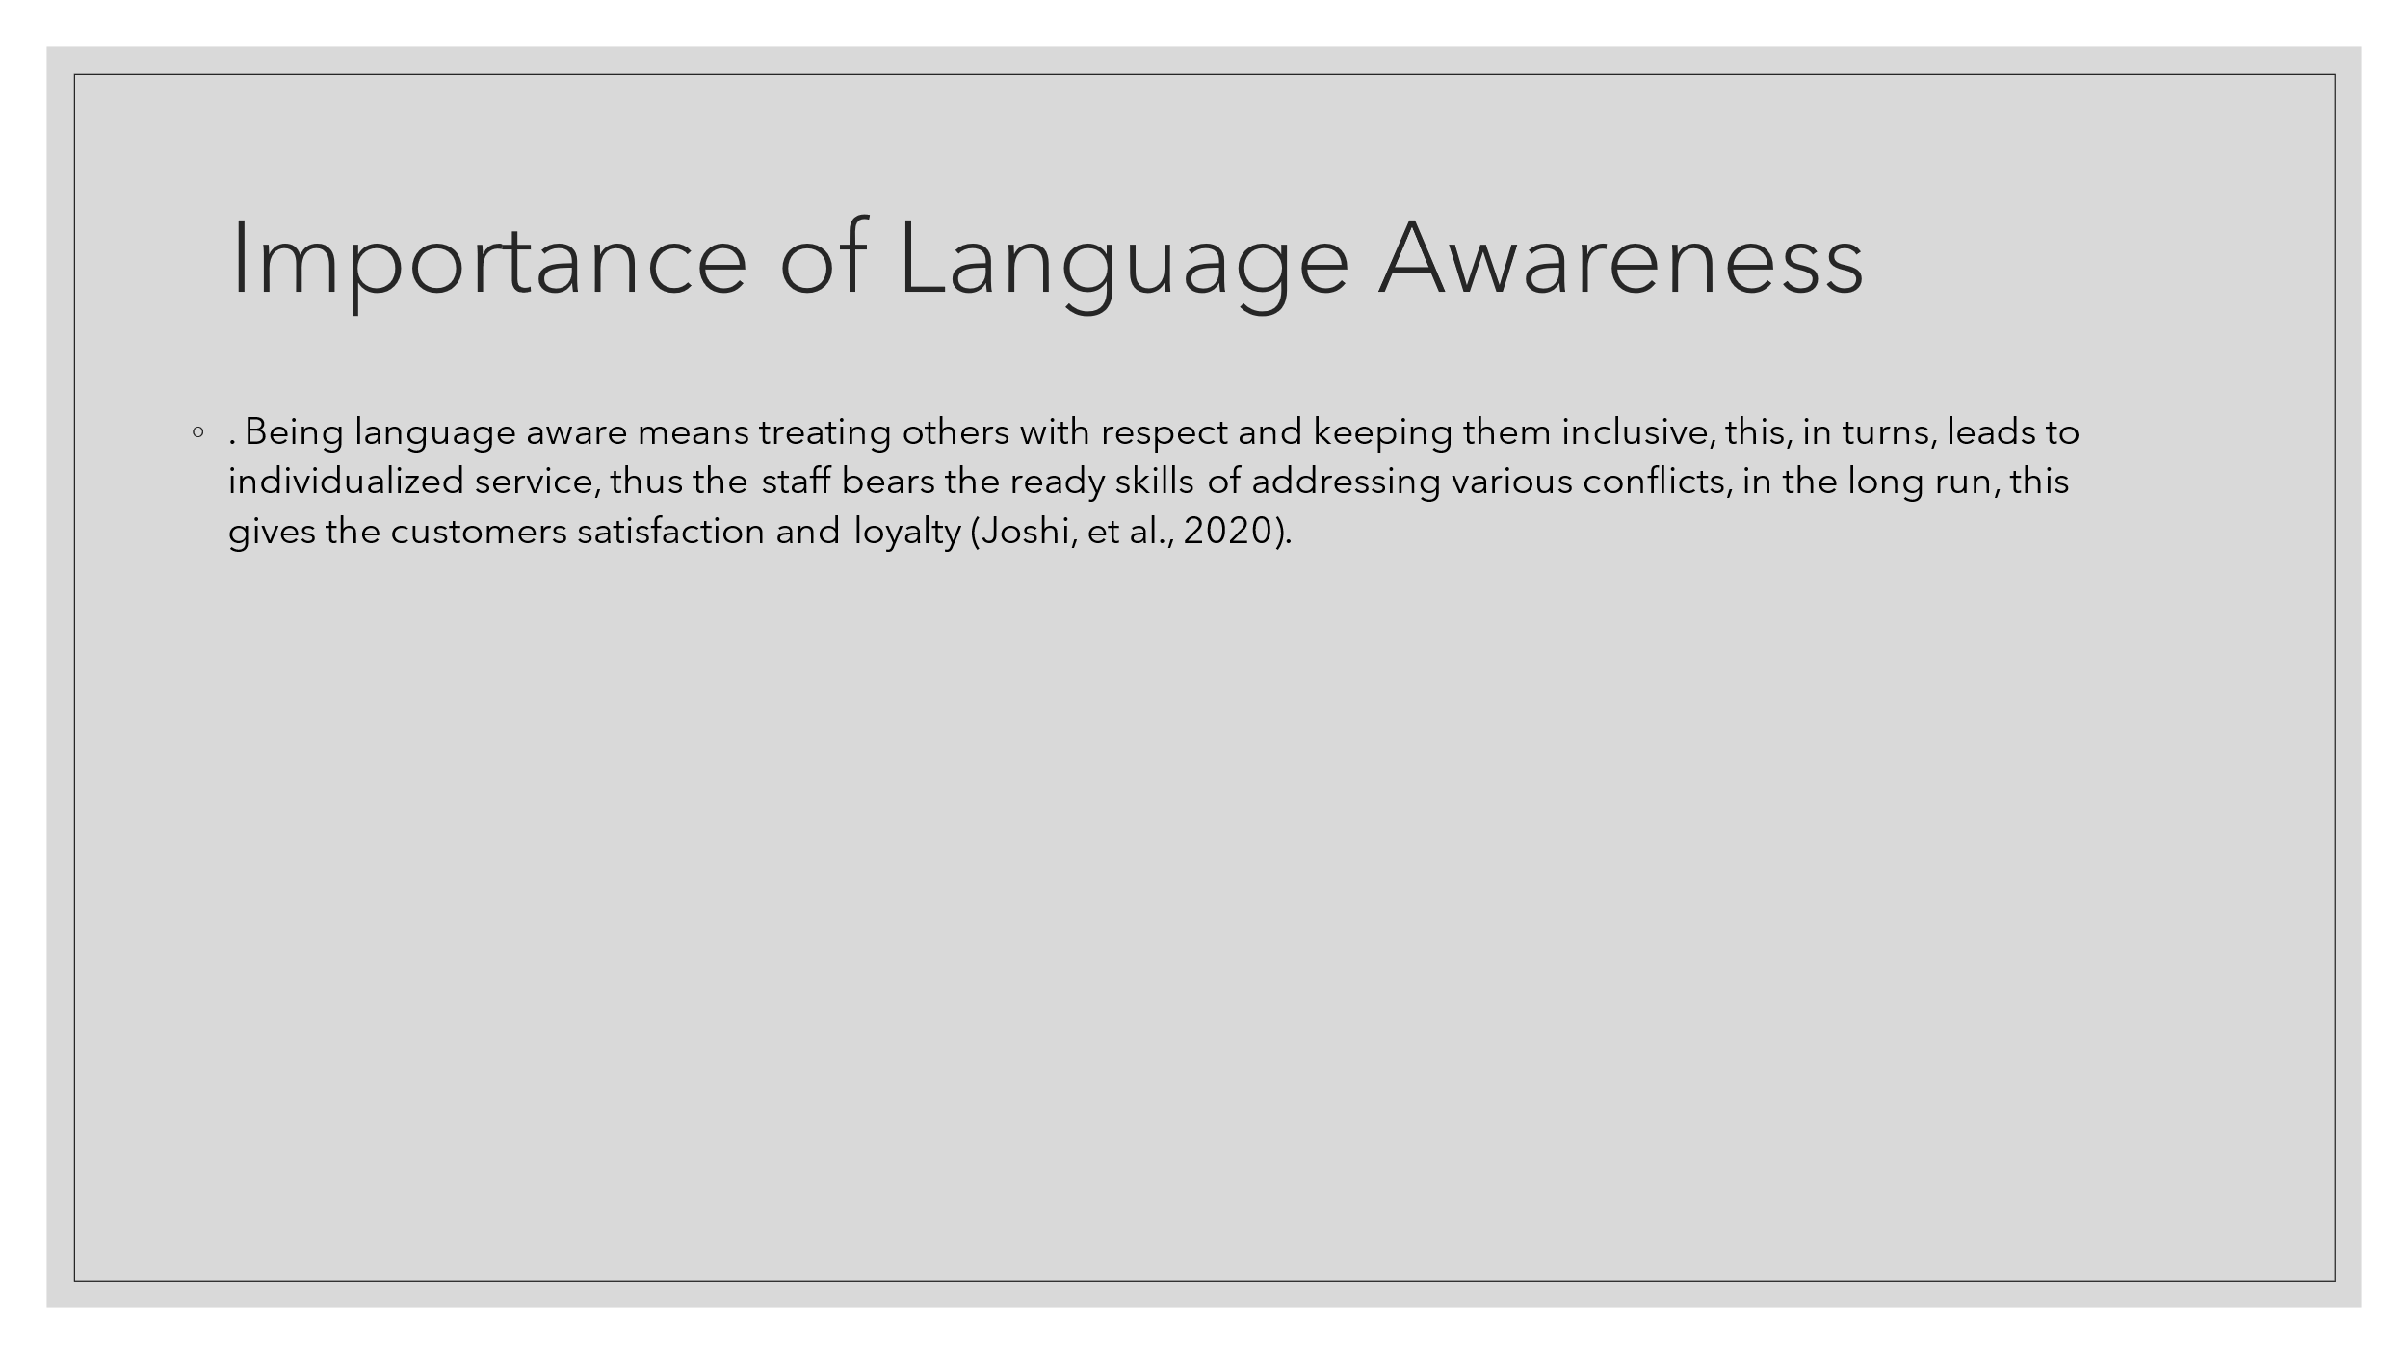
Slide Note
- Being language aware means treating others with respect and keeping them inclusive, this, in turn, leads to individualized service, thus the staff bears the ready skills to address various conflicts, in the long run, this gives the customers satisfaction and loyalty (Joshi et al., 2020).
Speaker Note
- Cultural Sensitivity: Language awareness comprises the ability to understand social norms and communicate in a way that every participant is honored and embraced.
- Personalized Service: Those staves who know languages will be able to adjust their communication to the guest´s preferences and so will be able to make the guest happy.
- Conflict Resolution: Language awareness allows staff to handle disputes and ease of understanding the guests preventing guest dissatisfaction and loss of loyalty

Slide 6
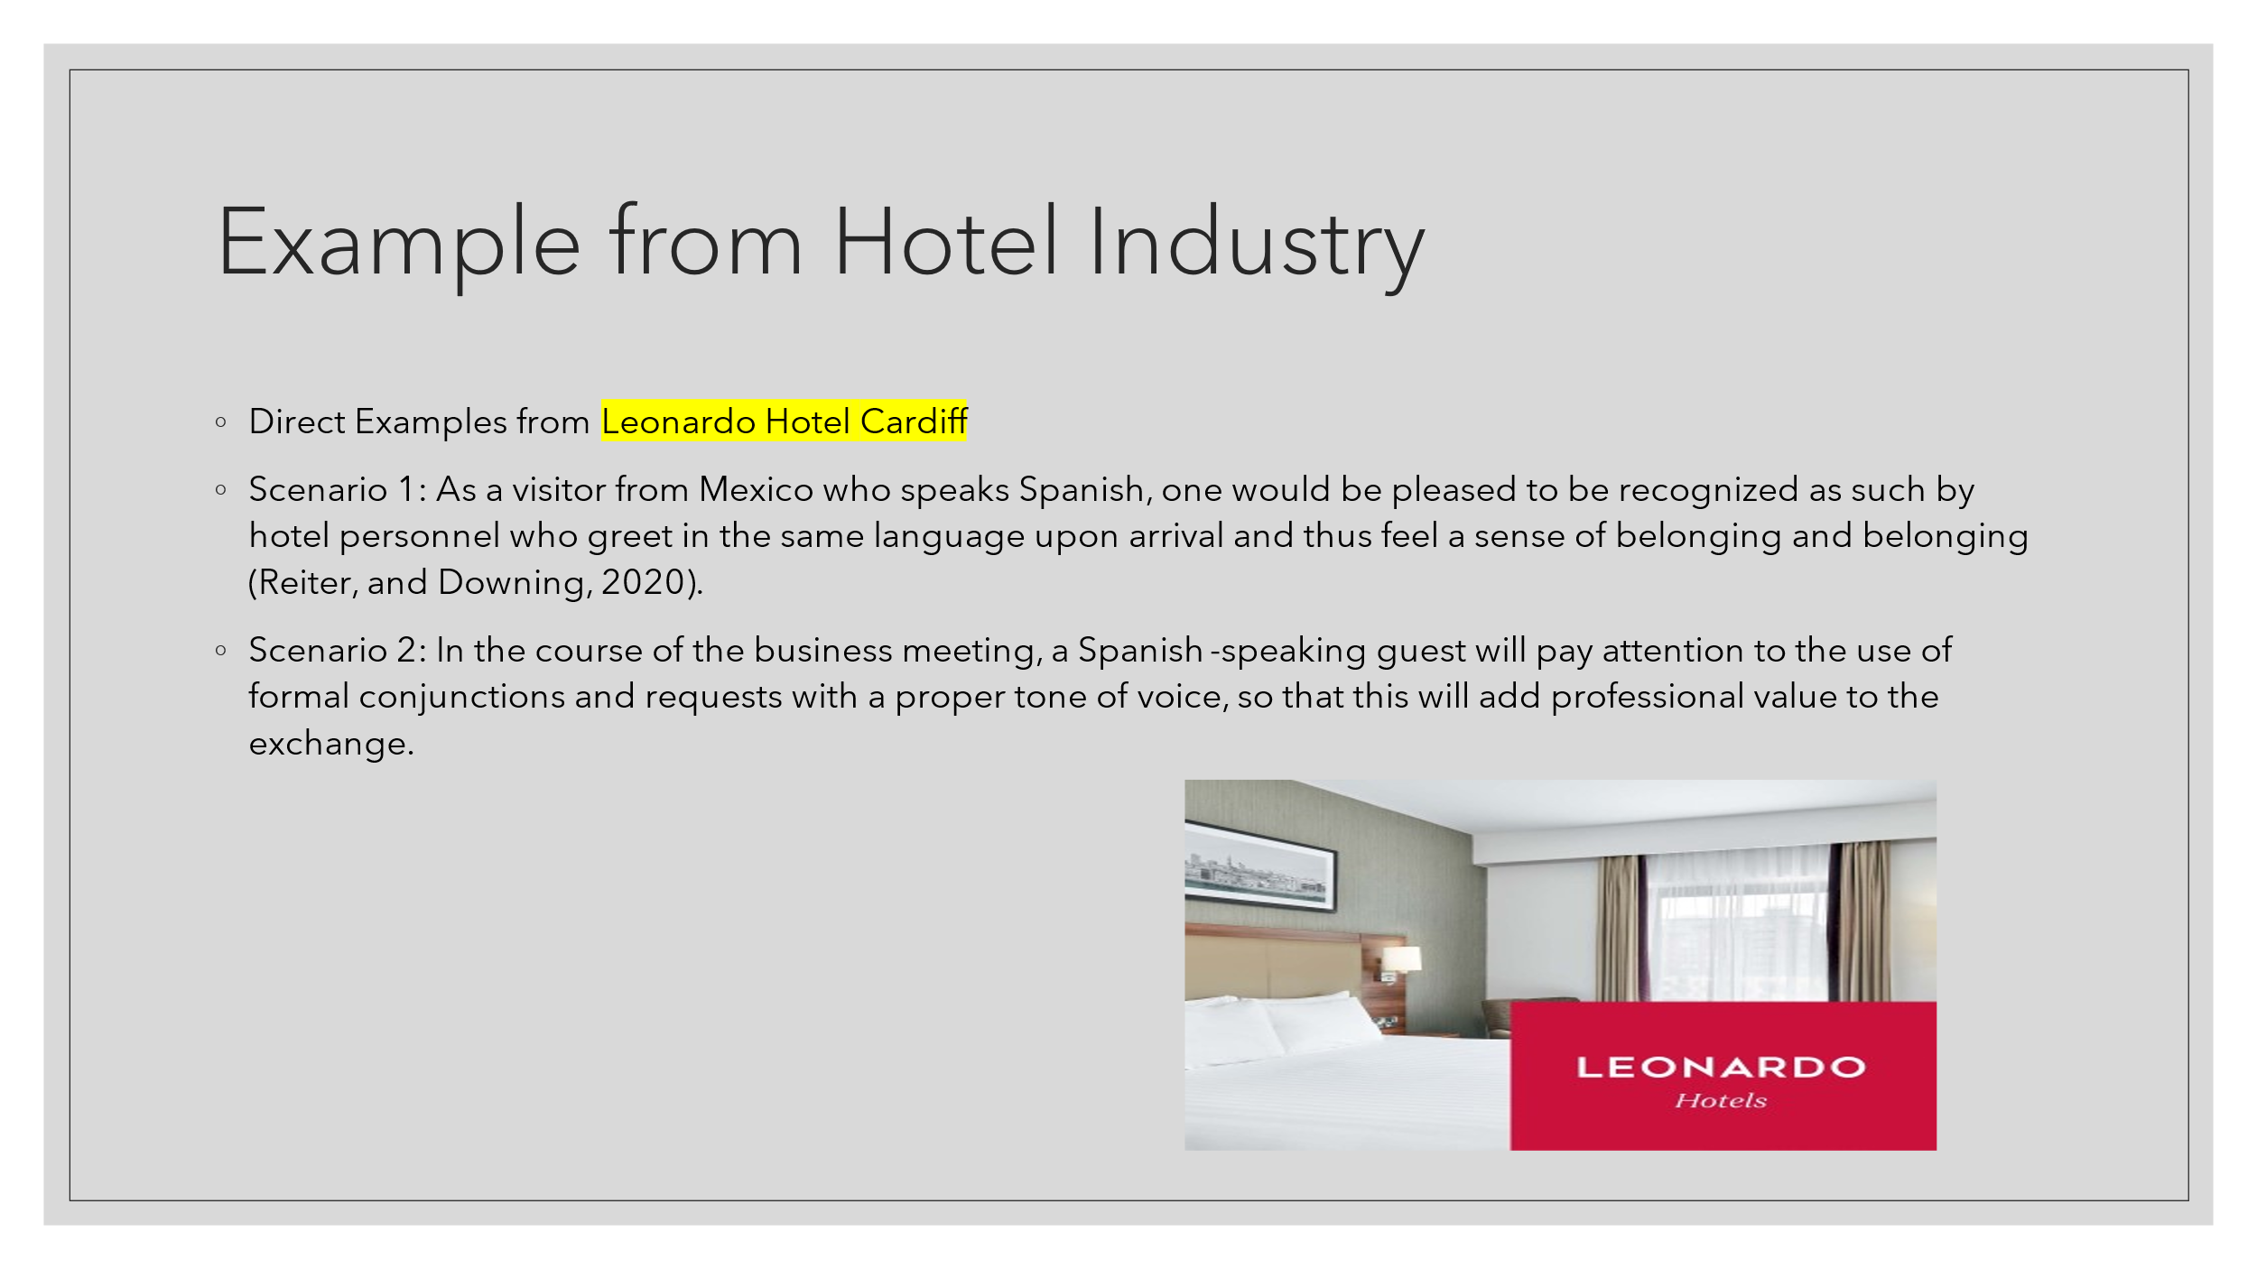
Slide Note
- Direct Examples from Leonardo Hotel Cardiff
- Scenario 1: As a visitor from Mexico who speaks Spanish, one would be pleased to be recognized as such by hotel personnel who greet in the same language upon arrival and thus feel a sense of belonging and belonging (Reiter, and Downing, 2020).
- Scenario 2: In the course of the business meeting, a Spanish-speaking guest will pay attention to the use of formal conjunctions and requests with a proper tone of voice, so that this will add professional value to the exchange.
Speaker Note
- Tzelessi is indeed a guest from Mexico and he feels sort of important and comfortable when he arrives at Leonardo Hotel Cardiff and welcomes him in Spanish. A similar gesture becomes a kind of symbol of the hotel, which assists the guests to feel at home, causing lasting impressions to build and the guests to bind future relationships with the specific establishment. In this scenario, an official language and pleasing polite words of a business meeting with the Spanish-speaker gentleman raise the sign of respect. This demonstrates Leonardo Hotel Cardiff’s ability to adapt its communication methods to diverse languages, ensuring an end-to-end communication service that reflects the perceptible quality of having professional service and hospitality.

Slide 7
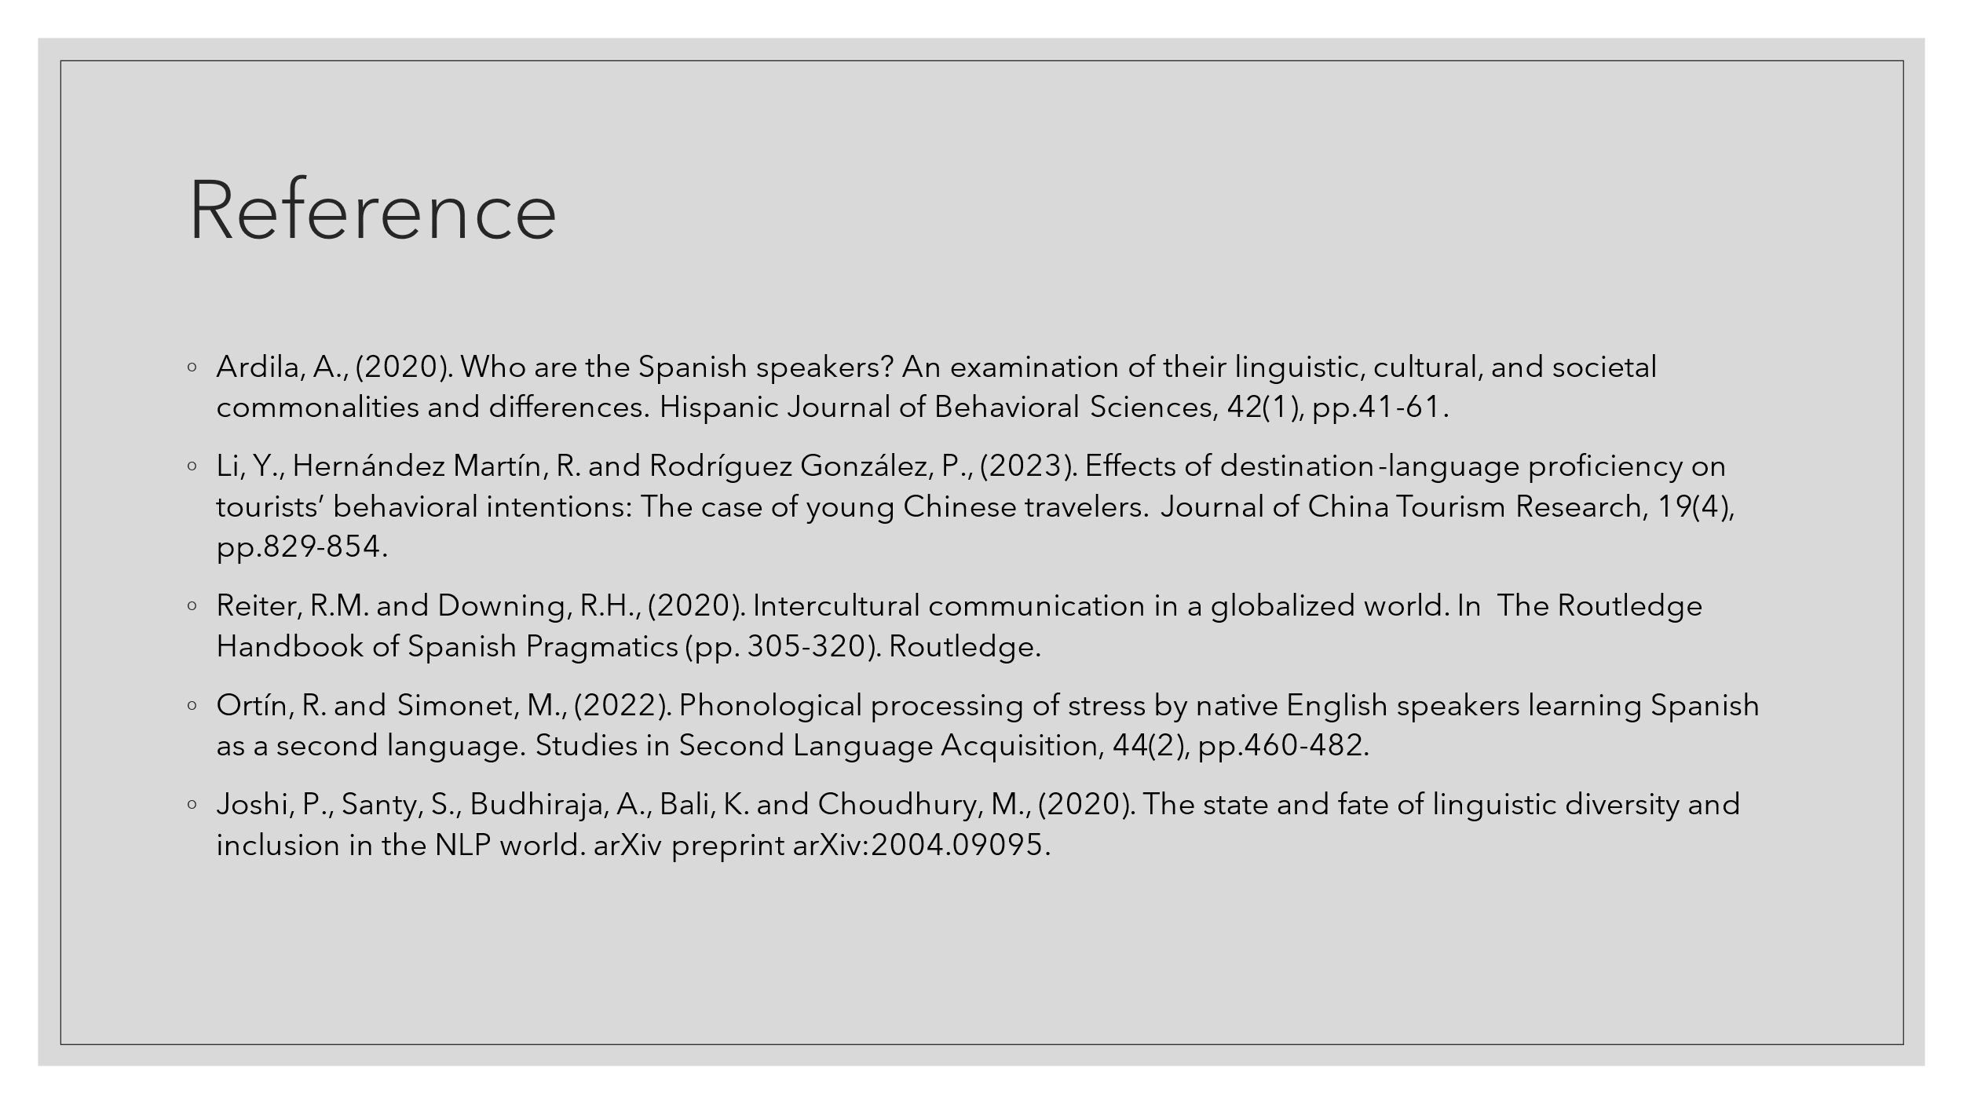

Reference
Abramson, N.R. and Moran, R. (2018) Managing Cultural Differences: Global Leadership for the 21st Century. 10th Ed. Abingdon: Routledge.
Ardila, A., (2020). Who are the Spanish speakers? An examination of their linguistic, cultural, and societal commonalities and differences. Hispanic Journal of Behavioral Sciences, 42(1), pp.41-61.
Chi, R., Zhang, H. and Kulich, S., (2022). A collaborative autoethnography of developing a ‘Cultural Stories’ exercise for intercultural teaching in China. Language and Intercultural Communication, 22(5), pp.519-533.
Christiansen, B., Branch, J.D. and Karmowska, J. (2020) Cultural Factors and Performance in 21st Century Businesses. Hershey: IGI Global.
Joshi, P., Santy, S., Budhiraja, A., Bali, K. and Choudhury, M., (2020). The state and fate of linguistic diversity and inclusion in the NLP world. arXiv preprint arXiv:2004.09095.
Klimova, I.I., Klimova, G.V. and Dubinka, S.A., (2019). Students’ communicative competence in the context of intercultural business communication.
Koukpaki, A.S.F. and Adams, K., (2020). Enhancing professional growth and the learning and development function through reflective practices: an autoethnographic narrative approach. European Journal of Training and Development, 44(8/9), pp.805-827.
Kurdi, B., Alshurideh, M. and Alnaser, A., (2020). The impact of employee satisfaction on customer satisfaction: Theoretical and empirical underpinning. Management Science Letters, 10(15), pp.3561-3570.
Li, Y., Hernández Martín, R. and Rodríguez González, P., (2023). Effects of destination-language proficiency on tourists’ behavioral intentions: The case of young Chinese travelers. Journal of China Tourism Research, 19(4), pp.829-854.
Malik, R., Madappa, T. and Chitranshi, J., (2017). Diversity management in tourism and hospitality: An exploratory study. foresight, 19(3), pp.323-336.
Ortín, R. and Simonet, M., (2022). Phonological processing of stress by native English speakers learning Spanish as a second language. Studies in Second Language Acquisition, 44(2), pp.460-482.
Reiter, R.M. and Downing, R.H., (2020). Intercultural communication in a globalized world. In The Routledge Handbook of Spanish Pragmatics (pp. 305-320). Routledge.
Shadiev, R., Sun, A. and Huang, Y.M., (2019). A study of the facilitation of cross‐cultural understanding and intercultural sensitivity using speech‐enabled language translation technology. British Journal of Educational Technology, 50(3), pp.1415-1433.
Stallard, M.L., (2020). Connection culture: The competitive advantage of shared identity, empathy, and understanding at work. Association for Talent Development.
Storti, C., (2022). The art of crossing cultures. Hachette UK.

