Part 1: Statistical Package for the Social Science (SPSS)

  - Simple descriptive statistics table compiled using data file 1 in SPSS:

Descriptive Statistics
 | N | Minimum | Maximum | Mean | Std. Deviation
high_bp | 94 | 15 | 25 | 19.41 | 2.649
resp_illness | 94 | 8 | 20 | 13.76 | 2.430
mental_illness | 94 | 4 | 14 | 9.62 | 2.338
diabetes | 94 | 3 | 10 | 5.94 | 1.343
health_status_poor_or_fair | 94 | 14 | 34 | 21.47 | 5.054
smoker | 94 | 14 | 36 | 25.37 | 4.207
bmi_overweight_or_obese | 94 | 48 | 63 | 55.81 | 3.952
Valid N (listwise) | 94

  - Forest plot compiled using data file 2 in SPSS:

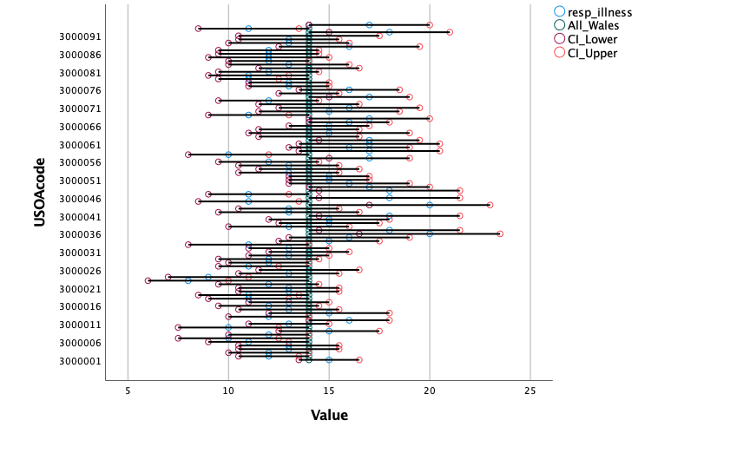
    - An explanation of what both the descriptive statistics table and forest plot are describing about the distribution of disease incidence in Wales:

- Descriptive statistics

The descriptive statistics table shows that in Wales, the percentage of adults who have reported at Upper Super Output Areas (USOAs) level that they are being treated for high-blood pressure, ranges from 15% to 25%; respiratory illness ranges from 8% to 20%; mental illness ranges from 4% to 14% and for diabetes it ranges from 3 to 10 per cent. At USOA level, the percentage of adults who reported their general health status was fair or poor, ranged from 14 to 34 per cent; those that reported smoking ranged from 14 to 36 percent; by weight and height those that were classed as overweight or obese according to the body mass index ranged from 48 to 63 percent. In Wales, 25 percent of adults reported they smoke; 21 percent of adults reported their health status was fair or poor, and 56 percent of adults reported they were overweight or obese.

- Forest plot

The forest plot shows the adults recorded by USOAs who have reported having a respiratory illness and it shows the confidence lower limit and the confidence upper limit. The confidence interval is the mean average taken from the estimated values, plus and minus the variation in the estimate. The horizontal lines illustrate 95% of confidence intervals in the study. The size of horizontal lines are dependent on the size of the study population; the bigger the study the smaller the horizontal line, and the smaller the study the wider the horizontal line. The age-standardisation has been used to compare the difference in age distribution of adults with respiratory illness by USOAs.

    - An explanation of other factors could be analysed from other data to explore patterns or correlations:

Inferential statistics could be used to examine the relationships between two variables, such as the impact of body mass index (BMI) on diabetes using statistical tests like regression analysis, or the chi-square test. Regression analysis estimates the relationship between a dependent variable such as BMI on an independent variable such as diabetes. This analysis could be used for exploring future relationships between BMI and diabetes and identifying whether there is a pattern or relationship between higher and lower BMI and diabetes.

Correlation analysis techniques could be used to identify patterns and relationships between two continuous variables, such as age of population and high blood pressure. The results of these two sets of continuous variables can be used to determine whether the population blood pressure increases or decreases with age. A multiple linear regression could be used to assess the association between age, high blood pressure and body mass index (BMI) to assess if there is a pattern, and whether age and BMI have an impact on high blood pressure.

Developing a Digital Solution to Enhance Medication Support for Older Adults Receiving Social Care in the Community: An Outline of Data Analysis Plan for Dissertation Project.

- Project context:

Medication errors are most likely to occur in community-based social care during the patient’s transition between care settings due to poor inter-professional communication, lack of a standardised process for medication reconciliation, the widespread use of computerised tools, and the inadequate integration of pharmacists into the care team (Dionisi et al., 2022). The World Health Organisation (WHO) stated that medication errors are caused by either a weak medication system or human factors such as fatigue, staff shortages or a poor working environment (World Health Organisation, 2017).
A medication error is "any preventable event that may cause or lead to inappropriate medication use or patient harm while the medication is controlled by the health care professional, patient, or consumer” (National Coordinating Council for Medication Errors Reporting and Prevention, 2015).
Medication errors can be classified as a 'minor error' where there is no harm to the patient or a 'major error' where there is severe harm or patient death, impacting the cost of healthcare. It was estimated that preventable harm from medication errors could cost over £750 million (National Patient Safety Agency, 2007).
Medication adherence is the degree to which a patient follows the recommended course of action. Non-adherence to medication may impair the beneficial effects of medications, leading to a lack of improvement or worsening of health (National Institute for Health and Care Excellence, 2009).
Patient non-adherence to medication regimes can result in nursing home placement for the older population. 30% of hospital admissions of the older population are drug-related, with 11% attributed to medication non-adherence and 10 – 17% attributed to adverse drug reactions. The older population discharged from the hospital with more than five medications are more likely to visit the emergency department and re-hospitalise within six months from discharge (Marek & Antle, 2008).
The medication management process for older adults receiving social care in the community is often complex, fragmented, and prone to errors, resulting in adverse health outcomes and an increased burden on healthcare providers. There is a pressing need to simplify the medication support system and establish seamless coordination between health and social care to enhance the overall care experience for older adults.
- Project scope:
The scope of this research project will focus on older adults aged 65 or above living in their own homes in the community and receiving social care to support them with their medication. A local authority in-house social care provider which uses a paper-based medication support system has been selected for this study. They deliver care and support to 300 older adults and have approximately 160 caregivers working across various teams who will be included in this project: -
- Reablement Services - supporting people in the short term to help people regain independence and to ensure that services, if required in the long term, are tailored to individual needs.
- Dementia Care and Support Teams – supporting people and their carers to stay in their homes, providing support that promotes physical, social, and emotional well-being.
- Extra Care Support Team – supporting people living in supported housing to promote physical, social, and emotional well-being; and
- Community Night Support Teams – supporting people through the night to enable them to stay in their homes.
  - Study participants:
Participants for this study will include older adults receiving medication support, their caregivers, the care managers, healthcare professionals, including general practitioners (GPs), community pharmacists and hospital staff, as well as informal carers, including families.
For older adults to be included in this study, they must receive medication support from a social care provider. Those not receiving medication support and other types of support, such as personal care support, will be excluded from the study.
  - Timescales:
The allocated timescale to complete this project is nine months. It will consist of a systematic literature review of the topic using the Preferred Reporting Items for Systematic Reviews and Meta-Analysis (PRISMA) framework; data collection and applying analytical techniques, which will be discussed in detail in the next section of this paper, and producing a report using the Introduction, Methods, Results and Discussion (IMRAD) framework.
- Project aim:
This research project aims to develop a digital solution that simplifies the medication support system and enables effective communication and collaboration between healthcare professionals, social care providers and older adults. The proposed solution aims to streamline medication management, improve medication adherence, and improve the overall care coordination for older adults in the community.
  - Current vital challenges with the medication support system
Below is a summary of key challenges with the current paper-based medication system used by the social care provider:
- Fragmented communication and information sharing: the existing medication support system needs more effective channels for healthcare professionals and social care providers to share information, without leading to miscommunication and inadequate care coordination.
- Complex medication regimens: older adults often have multiple comorbidities and take numerous medications, making medication management challenging. The lack of a centralised system for tracking medications and scheduling administration further complicates the process.
- Limited integration between health and social care systems: the current systems used by health care professionals and social care providers operate independently, hindering seamless collaboration and holistic care provision.
- Digital literacy and accessibility: older adults may face difficulties in adopting and utilising digital solutions due to limited familiarity with technology or physical limitations requiring the development of inclusive and user-friendly platforms.
The Soft Systems Methodology (SSM) rich picture (Figure 1) aims to describe the problems and the complexity of the medication support system for older adults receiving social care in their own homes.

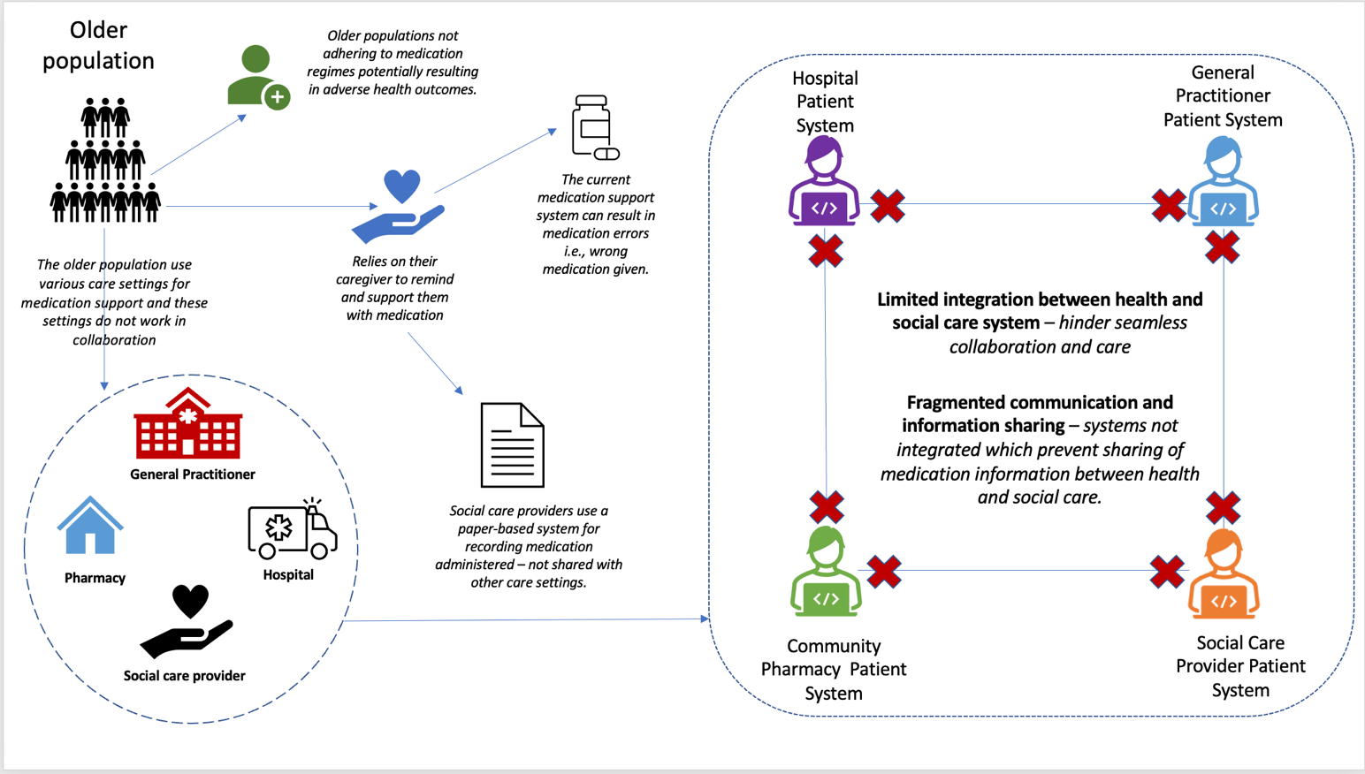
Figure 1: SSM of the problem

  - Proposed solution:
The research project will focus on developing a user-friendly digital solution that addresses the identified challenges and enhances the community's medication support system for older adults. The proposed solution will incorporate the following components:
- Medication tracking and reminders: A digital platform to monitor and track medication regimens, providing timely reminders and alerts for older adults and their caregivers.
- Care coordination portal: An integrated system that enables seamless communication, information sharing and collaboration among healthcare professionals, social care providers and older adults.
- Medication reconciliation: A mechanism to reconcile medication across different care settings, ensuring accurate and up-to-date medication lists.
- Accessibility and user-centric design: The digital solution will focus on accessibility, considering older adults' unique needs and limitations and ensuring intuitive and user-friendly interfaces.
  - Expected outcomes from the research project:
Below are the expected outcomes of developing a user-friendly digital solution that addresses the challenges and issues with the medication system.
- Improved medication adherence: The digital solution will help older adults adhere to their medication regimens by providing reminders and facilitating medication management.
- Enhanced care coordination: Effective communication and collaboration between healthcare professionals and social care providers will lead to streamlined care processes, reduced errors, and improved health outcomes.
- Reduction in adverse drug events: the proposed solution aims to minimise medication errors, adverse drug reactions and duplications through accurate medication reconciliation and tracking.
- Enhanced patient empowerment: By involving older adults in their care management, the digital solution will empower them to actively participate in decision-making and self-care.
- Project research objectives:
This section describes what this research project would like to accomplish and the justifications for pursuing it. The research objectives will guide the project and formulate quantitative and qualitative research questions. The objectives of this research project are: -
- To assess the prevalence of medication errors and health outcomes in the medication support system.
- To understand and determine which factors cause complexity and fragmentation in the medication support system.
- To assess the level of medication adherence and the impacts of this on the health outcomes of older adults.
- To understand the burden that the fragmented and complex medication support system used by social care has on healthcare providers.
- To understand the challenges healthcare professionals face in coordinating medication support for older adults in the community.
- To assess the perception of older adults using the medication support system and understand the challenges.
- To understand the current experience and perspective of older adults, caregivers and healthcare professionals on the current medication support system, including its limitations.
- To assess whether the existing medication support system creates a barrier, or facilitates communication and collaboration between older adults, social care providers and healthcare providers in delivering medication support.
- To determine from social care providers and healthcare professionals’ perspectives how a digital medication system could be designed to improve medication adherence, errors, communication, and collaboration.
- To determine what could be the challenges around privacy and the ethical issues in implementing a digital medication support system.
  - Quantitative research questions:
- What is the prevalence of medication errors and adverse health outcomes among older adults receiving social care in the community?
- What factors contribute to the complexity and fragmentation of the medication management process for older adults in the community?
- What is the current level of medication adherence among older adults receiving social care, and how does it impact their health outcomes?
- What is the perceived burden on healthcare providers resulting from the fragmented medication support system for older adults in the community?
- What are the specific challenges healthcare professionals and social care providers face in coordinating medication support for older adults in the community?
  - Qualitative research questions:
- How do older adults perceive the medication management process and the challenges they face in receiving social care in the community?
- What are the experiences and perspectives of healthcare professionals and social care providers regarding the existing medication support system and its limitations?
- What are the barriers and facilitators to effective communication and collaboration between healthcare professionals, social care providers and older adults in the context of medication management?
- How do healthcare professionals and social care providers envision the ideal digital solution to streamline medication support and enhance care coordination for older adults in the community?
- What are the potential ethical and privacy considerations associated with implementing digital solutions for medication support in the community?
- Data collection and analysis plan:

This section outlines the data collection and analysis plan to meet the research objectives summarised in the previous section. The methods used for analysis in this research project will be mixed and will use both quantitative and qualitative data. Mixed methods will be research approaches with questions requiring real-world contextual understanding, multi-layered perspective and cultural implications (Meissner et al., 2010) as this research project involves looking at the lived experience of those who are involved in the medication support system, as well as looking at data such as the number of medication errors.
Quantitative data collected as part of this research project will include but not be limited to the prevalence of medication errors, adverse health outcomes and medication adherence among the older adults using the medication support system. As part of the research project, quantitative data will be collected around the time involved in each stage of the processes in the medication support system, such as the time taken to prescribe, dispense and administer medication. Other quantitative data will include the cost of the medication support system for both healthcare and social care providers.
Qualitative data that will be collected as part of this research project will include the lived experience of older adults, their caregivers and the healthcare professionals involved to establish the challenges, limitations, barriers, or facilitators of the medication support system, particularly concerning sharing and communicating medication information between care settings. This data will be collected through interviews and focus groups.
  - Quantitative Data Analysis Methods:

For this research project, the following data analysis methods will be used for quantitative data:

- Descriptive statistics are concerned with summarising and describing the main features of a dataset. For example, this could be measures of central tendency (mean, median, mode); or measures of dispersion (range, variance, or standard deviation). For this research project, descriptive statistics will be used as a data analysis method to quantify the prevalence of medication errors, adverse health outcomes, and medication adherence rates among older adults in the community.

- Inferential statistics examine the relationships between variables, such as the impact of medication adherence on health outcomes, using statistical tests like regression analysis, or the chi-square test. Regression analysis is concerned with estimating the relationships between dependent variables and one or more independent variables, for example, health outcomes as a dependent variable and medication adherence as an independent variable. This analysis can help assess the strength of the relationship between medication adherence and health outcomes and modelling future relationships between these two variables. The chi-square test is concerned with determining whether there is a significant association between two comparable variables, in this case, whether there is a significant association between medication adherence and health outcomes.

- Comparative analysis compares medication management processes, the burden on healthcare providers, and coordination challenges across different regions or care settings using statistical techniques like t-tests or Analysis of Variance (ANOVA). The t-tests are concerned with comparing the means between two groups of data to determine if they are significantly different from each other, and will consist of using hypothesis testing to determine whether the medication management processes affect the population when comparing. T-test is concerned with comparing the mean between two data groups, whereas ANOVA is concerned with comparing the mean between three or more data groups.

- Data mining is concerned with looking at large datasets to assess whether there are any anomalies, patterns or correlations which can be used for predicting outcomes. For this research project, data mining will be used as a data analysis method to analyse large datasets from electronic health records or medication databases to identify patterns, associations, or predictors related to medication errors or adherence levels.
The data analysis will be conducted using the Statistical Package for Social Sciences (SPSS) software to analyse quantitative data.
    - Statistical significance
In quantitative research, statistical significance is the probability that a result or finding is not due to chance. In other words, if a result is statistically significant, it is unlikely to have occurred by chance. Statistical significance is usually determined by calculating p-values. The p-value measures the probability of getting a more extreme or extreme result than the observed one, given that no actual effect exists in the population (University of Wales Trinity Saint David, 2023).
Statistical significance means there is evidence that the result seen in the sample also exists in the population. For example, when considering the quantitative data being collected for this research project, medication errors and medication adherence, for this data to be considered of "statistical significance", the result of the sample must also exist within the population being studied.
Determining whether these quantitative data are statistically significant will require statistical hypothesis testing. This tests whether something is true and determines the null hypothesis. Hypothesis means the chance that the whole population is the same is only by chance, and this is referred to as the null hypothesis, and a statistical test is whether something is true. The rejection of the null hypothesis is needed for these quantitative data to be deemed statistically significant.
As part of statistical hypothesis testing, the P-value or probability, the effect in the sample indicates an effect in the population. When the p-value is less than 0.05, the result is statistically significant, which means there is evidence that the effect, for example, medication errors and medication adherence, exists in the population when the null hypothesis is rejected, meaning there is an effect if the result is statistically significant. The low p-value of less than 0.05 suggests that the test is not by random chance and hence is rejected. While a high p-value of greater than 0.05 shows that the null hypothesis cannot be rejected.
    - Operational significance
In quantitative research, operational or practical significance refers to the size and importance of an outcome, or outcome in the real world. In other words, even if a result is statistically significant, it may be insignificant if the size of the effect is small, or if the result has no significant impact on the topic of interest. The difference between statistical significance and operational significance is that statistical significance refers to the likelihood that a result is not due to chance. In contrast, operational significance refers to a result's practical importance or impact in the real world. A finding can be statistically significant but not operationally significant if the effect size is small or if the finding does not have a meaningful impact (University of Wales Trinity Saint David, 2023).
In the context of this research project, the quantitative data that would be captured concerns medication errors and adherence. For this data to be considered operationally significant, it must impact in the real world. For example, the result impacts the older adult population receiving medication support as part of the study for this research project.
  - Qualitative Data Analysis Methods:
For this research project, the following data analysis methods will be used for qualitative data:
- Thematic analysis is concerned with analysing qualitative data through reading through a set of data, for example, an interview transcript, to look for patterns in the meaning of data to find themes. For this research project, the thematic analysis will identify and analyse recurring themes and patterns in qualitative data, such as interviews or focus group discussions relating to experiences, perspectives, and challenges. The consolidated criteria for reporting qualitative research (COREQ) and The Framework Method discussed in the next section will support the study design of interviews, focus groups, and thematic analysis.
- Context analysis analyses textual data from various sources, such as documents, reports, or online forums, to gain insights into the existing medication support system and its limitations. Context analysis is concerned with analysing the medication support system's environment to gather knowledge on the macro environment. The Political, Economic, Social, Technological, Environmental and Legal (PESTEL) could be adopted as a methodology for this research project to undertake a context analysis of the medication support system within the environment it operates.
- Grounded theory is concerned with discovering or constructing a theory from data obtained systematically and using comparative analysis to analyse this data. For this research project, the grounded theory could be used as a data analysis method to develop theories and conceptual frameworks based on empirical data, exploring the medication management process and the coordination between health and social care.
    - Saturation
Saturation is when new data ceases to provide additional insight or information about a research topic. This is the point at which researchers have collected enough data to detect repetition and redundancy in the data. Saturation is usually reached when researchers collect enough data to represent the diversity of experiences, perspectives, and contexts relevant to their research question (University of Wales Trinity Saint David, 2023).

In the context of this research project, saturation will become apparent when no new themes, ideas, or patterns emerge through interviewing and observing participants on their experience and opinion of the medication support system. The Framework Methods could be used to identify when to cease the interview and observations as part of the data capture for this study. The transcripts and notes from interviews and observations will be coded and categorised using the analytical framework, and this process will continue until it becomes apparent that no new codes or categories are emerging indicating that it has reached saturation.
    - Transferability
The extent to which findings from a research project could apply to another setting or context is known as transferability. As qualitative research is based on a small sample size and specific contexts, this can limit the generalisability of research findings applied to different populations, settings, contexts or environments. In order to improve the transferability of research project findings, it is essential to provide a narrative of the study background, strategy used for sampling, and method used for data collection and analysis of the research project. In addition, comparing the findings from a research project with the literature would help identify any similarities or disparities in the research findings (University of Wales Trinity Saint David, 2023).
For this research project, it will be essential to demonstrate to the readers with evidence that the findings from the research into enhancing the medication support system for older adults receiving social care in the community, could apply to other contexts, situations, times, or populations. For example, to demonstrate that the findings from this research project could be transferable to another social care provider that provides support for a different population set and operates in a different environment or context to those studied as part of this research project, such as supporting a population under the aged 65 with different care and support needs than the older population. Another example is that the findings could apply to different care settings, such as hospitals, residential care homes or nursing care homes, with a different population or operating in a different environment or context.
  - Study Design and Methodology for Quantitative and qualitative research

    - Consolidated criteria for reporting qualitative research (COREQ)

As this research project will collect and analyse qualitative data, the consolidated criteria for reporting qualitative research (COREQ) 32-checklist will be used to develop and guide the interview and focus group.

The COREQ checklist has three domains: - domain one, which is the research team and reflectivity; domain two, which is study design and domain three, which is the analysis and findings. The first domain focuses on the personal characteristics of the researcher conducting the interview and focus group and their relationships with the participants in the study. The second domain focuses on the theoretical framework that underpins the research questions; how participants were selected, for example, purposive; convenience; consecutive; snowball; the settings of where the data will be collected, for example, home, clinic, workplace, and the data collection and capturing of data, for example, audio recording/visual recording; field notes. The third domain focuses on data analysis, including how the data is coded and reporting of data from the interview and focus groups (Tong et al., 2007).
    - The Framework Methods
This research project will involve a thematic analysis of interviews and focus groups. The Framework Method (Gale et al., 2013) will be adopted to analyse qualitative data as this tool is helpful for those unfamiliar with conducting qualitative research. There are six stages within the Framework Methods for analysing qualitative data:
- Stage 1 Transcription: this stage requires a verbatim (word-for-word) transcription of the interview.
- Stage 2 Familiarisation with the interview: an essential step in interpretation is familiarisation with the entire interview using audio recordings and transcripts and contextual and reflective notes recorded by the interviewer.
- Stage 3 Coding: after understanding the data, this stage involves carefully reading the transcript line-by-line and inserting paraphrases or labels (“codes”) that explain interpretations that seem important at that point.
- Stage 4 Developing a working analytical framework: a tree diagram could be used to group codes into categories which form an analytical framework, and it could take several interactions of the analytical framework before no new code appears.
- Stage 5 Applying the analytical framework: this is done by indexing transcripts using existing categories and code. Each code is either given a number or abbreviation, and the reason for this is to enable easy identification of data, which could be written directly into the transcripts.
- Stage 6 Charting data into the framework matrix involves ‘charting’ the data gathered from the transcripts into a framework matrix whereby the data for each transcript is summarised by category (Gale et al. 2013).
- Ethical and information governance considerations:

This section outlines the ethical and information governance factors for this research project. It is essential to consider the implications of ethical and information governance and develop strategies for managing these during the planning phase before instigating the research activities, including study data collection, to avoid setbacks.

This research project will require an ethical review application form to be submitted and approved by the University before the collection of study data can commence; a draft version of the ethical review form can be found in appendix one of this report.

- Bias

One ethical factor that must be considered before undertaking this project is recognising and managing bias in collecting, interpreting and reporting the study data. A helpful tool for recognising and managing rather than eliminating bias is to focus on reflexivity, a process of improving awareness of bias. Another factor that needs to be considered is how the evaluation will be undertaken and if it will have ethical implications (Friedman, White & Ash, 2022).

- Personal data

Personal data “means any information relating to an identified or identifiable natural person (data subject). An identifiable natural person is one who can be identified, directly or indirectly, in particular by reference to an identifier such as name, identification number, location data, an online identifier or to one or more factors specific to the physical, psychological, genetic, mental, economic, cultural or social identity of that natural person. Any video or audio recordings of participants are considered as personal data” (Information Commissioner’s Office, [no date]).

To overcome the challenge of sharing personal data in a research project, it would be helpful to consider anonymising the data, and this can be done by removing obvious identifiers, for example, removing personal data such as name, address and date of birth (Friedman, White & Ash, 2022). This research project will involve collecting and interpreting personal data; however, in relation to the reporting of the findings from the study data that will be in the public domain, all personal data that identifies the data subject will be anonymised by omitting data such as subject’s names, location and personal identification numbers like NHS and Social Services numbers.

- Data collection and storage

Another area that needs to be considered concerning ethical implications is how the data will be gathered and stored. As mentioned in the previous section, the researcher must recognise and manage potential bias in the research. With the storage of study data, the researcher must adhere to the ethical and information governance principles of the organisation that is partaking in the research project in order to protect data privacy and confidentiality. There will be a need for arrangements with the organisations and participants involved in the research project around data sharing.

This cross-organisational study project will involve several organisations across health and social care, including the NHS, Local Authorities, Social Care Providers and Pharmaceuticals. It is essential to consider that each organisation will have their own Information Governance framework for handling the information securely and confidentially to allow those organisations and individuals to legally, securely, and effectively manage patient, personal and sensitive information. When gathering study data, it is essential to consider the IG framework of each organisation, and from there, any challenges or obstacles in obtaining data for this study should be factored into the planning phase of the study project.

Developing a methodology for gathering and storing the data collected as part of the study project is essential. This study project will consist of gathering data in an electronic format, and it is vital to consider where the data will be stored electronically to ensure that all personal and sensitive data is stored legally, securely, and effectively. It is proposed that for this research project, all data, including study data and the dissertation draft, will be stored electronically on a Microsoft OneDrive Cloud, hosted by the University, to ensure the security of study data collected and data confidentiality. Accessing the data stored on the Microsoft OneDrive will require using the University login, including username and password, and using a two-factor authenticator.

Another area that needs to be considered is the method of research, moving from face-to-face, to using virtual ethnography and mobile devices as a method for research. As an example, a researcher may want to use a mobile device to record an observation in an environment where there is a member of the public or patients in the background, so a researcher will need to have an awareness of the sensibilities, safety, and security of the members of the public and patients (Friedman, White & Ash, 2022).

This research project is proposing to use Microsoft Teams for interviewing study participants as it provides transcript facilities, including recording the interview. The transcripts will be collected and analysed to identify themes, and all personal data will be anonymised using codes and categories. Before the interview, the study participant will be made aware of this research method and be provided with the option to use the camera. Before the interview, the study participant will be provided with an ethical review form which will require participants to consent to this method of research.

- Selection of study participants

Another ethical factor that needs to be considered when planning the research project is the selection of subjects or participants, which needs to be done purposively. When selecting subjects for the group, it is essential to avoid creating a biased group. The recruitment of subjects for the research project must be done safely, fairly, and equitably. When recruiting subjects for this research project, it is essential to consider the approach to getting consent from subjects and organisations participating in this study project. Another element that needs to be considered when selecting subjects is power differentials, where subjects feel obligated to be included in the study project (Friedman, Wyatt & Ash, 2022).

As mentioned in the previous section, an ethical review form will need to be produced for this research project outlining the aim of the study project and used for obtaining written consent from subjects and organisations. The ethical review form will describe the purpose of the research project, including making participants aware that their participation in this research project is voluntary and they can withdraw at any time. The ethical review form will also explicitly explain that quotations will be used during the transcribing and thematic analysis of findings; when reporting these findings however, all personal data that identifies them will be anonymised.

- Interpretations of study data

Another ethical dilemma that needs to be considered when interpreting transcripts from and notes from interviews and observations; is that the person who undertakes the study project must avoid applying their own interpretations, which could facilitate bias that could infiltrate the result of the study project, and focus on gathering factual data. A strategy to avoid using your interpretations is to share the results gathered from the interviews and observations with the study participants to check if these are factual. Another factor that needs to be considered is the dissemination of findings or results from the study project. It is essential to be open and transparent when providing the recommendations and outcomes of the study project and to be clear about the limitations of the study (Friedman, Wyatt & Ash, 2022).

References:

Dionisi, S., Di Simone, E., Liquori, G., & et al. (2022). Medication errors’ causes analysis in home care setting: A systematic review. Public Health Nursing 39(4), pp. 876–897. doi: 10.1111/phn.13037.

Friedman, C.P., Wyatt, J.C & Ash, J.S. (2022). Evaluation Methods in Biomedical and Health Informatics. Third Edition. Springer.

Gale, N.K., Heath, G., Cameron, E., & et al. (2013). Using the framework method for the analysis of qualitative data in multi-disciplinary health research. BMC Medical Research Methodology 13(1). doi: 10.1186/1471-2288-13-117.

Information Commissioner’s Office. [no date]. What is personal data? Available at: https://ico.org.uk/for-organisations/uk-gdpr-guidance-and-resources/personal-information-what-is-it/what-is-personal-data/what-is-personal-data/#:~:text=“%27personal%20data%27%20means%20any,location%20data%2C%20an%20online%20identifier [Accessed: 23 May 2023].

Marek KD., & Antle L. (2008). Medication Management of the Community-Dwelling Older Adult. Patient Safety and Quality: An Evidence-Based Handbook for Nurses. Available from: https://www.ncbi.nlm.nih.gov/books/NBK2670/

Meissner, H.I., Creswell, J.W., Klassen, A.C., & et al. (2010). Best Practices for Mixed Methods Research in the Health Sciences. Available at: https://obssr.od.nih.gov/sites/obssr/files/Best_Practices_for_Mixed_Methods_Research.pdf [Accessed: 19 May 2023].
National Coordinating Council for Medication Errors Reporting and Prevention. (2015). What is a Medication Error? Available at: http://www.nccmerp.org/about-medication-errors [Accessed: 19 May 2023].

National Institute for Health and Care Excellence (NICE). (2009). Medicines adherence: involving patients in decisions about prescribed medicines and supporting adherence. Available at: https://www.nice.org.uk/guidance/cg76 [Accessed 01 May 2023].

National Patient Safety Agency. (2007). Safety in doses: medication safety incidents in the NHS. Available at: http://data.parliament.uk/DepositedPapers/Files/DEP2008-1788/DEP2008-1788.pdf [Accessed: 19 May 2023].

Tong, A., Sainsbury, P. & Craig, J. (2007). Consolidated criteria for reporting qualitative research (COREQ): A 32-item checklist for interviews and focus groups. International Journal for Quality in Health Care 19(6), pp. 349–357. doi: 10.1093/intqhc/mzm042.

University of Wales Trinity Saint David. (2023). BMD7004 Statistical Concepts Summary. Available at: https://moodle.uwtsd.ac.uk/pluginfile.php/697583/mod_resource/content/1/BMDS7004%20Statistical%20Concepts%20Summary.pdf [Accessed: 01 May 2023].

World Health Organisation. (2017). Medication Without Harm. Available at: https://www.who.int/initiatives/medication-without-harm [Accessed: 19 May 2023].

Appendix one: Ethical Review Application Form



