Module Name: Hospitality and Guest Services
Module Code: BMIH4003
Student Name: Tyron Thomas
Student ID: 2112910

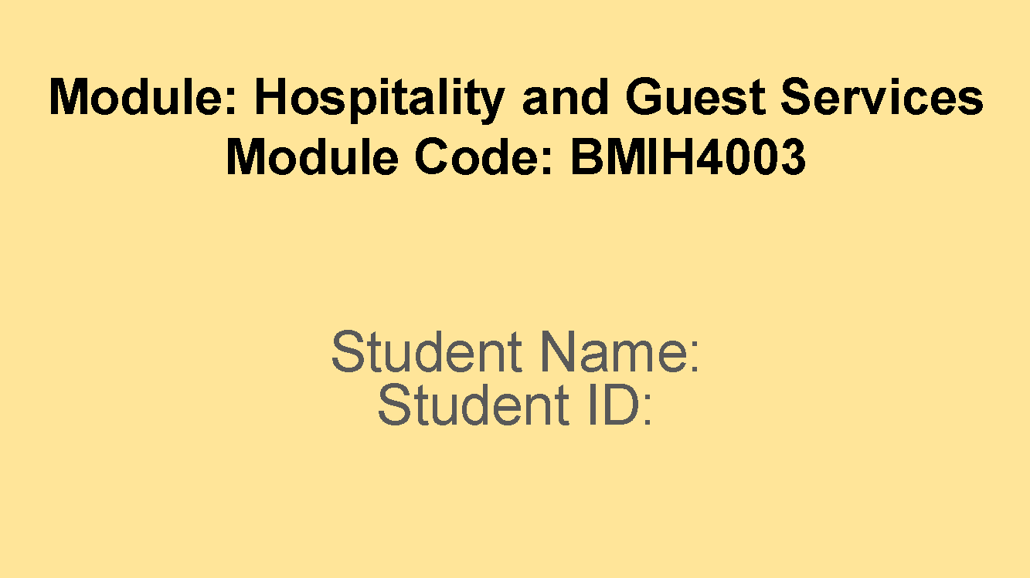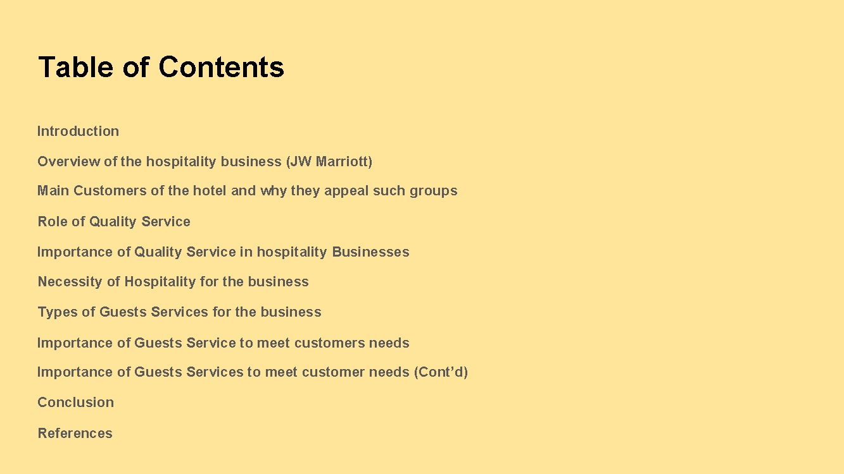

Introduction
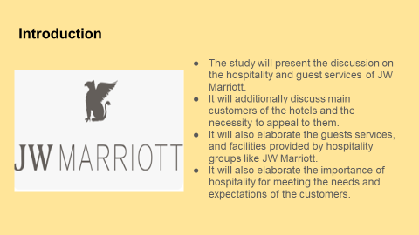
Speaker’s Note: The study will present the discussion on the hospitality and guest services of JW Marriott. It will additionally discuss main customers of the hotels and the necessity to appeal to them. It will also elaborate the guests’ services, and facilities provided by hospitality groups like JW Marriott. It will also elaborate the importance of hospitality for meeting the needs and expectations of the customers.

Overview of the hospitality business (JW Marriott)

Speaker’s Note: JW Marriott is one of the major hospitality businesses operating across the global market. The business was established in 1984 in the United States of America by J. Willard and Alice Marriott (JW Marriott, 2019). The business is inspired by principles of mindfulness and is involved in providing the best experience to its customers. The hospitality group has also designed to let its customers focus on feeling whole such as revitalised in spirit, nourished in body and present in mind (JW Marriott, 2019). Some of the vital services offered by Marriott hotels are flight and hotel packages, timeshare vacations, hotel reservations, accommodations and others.

Main Customers of the hotel and why they appeal such groups
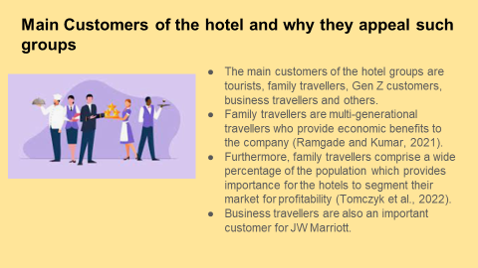
Speaker’s Note: The main customers of the hotel groups are tourists, family travellers, Gen Z customers, business travellers and others. Family travellers are multi-generational travellers who provide economic benefits to the company (Ramgade and Kumar, 2021). Furthermore, family travellers comprise a wide percentage of the population which provides importance for the hotels to segment their market for profitability (Tomczyk et al., 2022). Business travellers are also an important customer for JW Marriott. It is important for the company as such travellers often require the need of accommodations and hotel services. Amenities like co-working spaces and business centres help in appealing to such customers efficiently.

Role of Quality Service
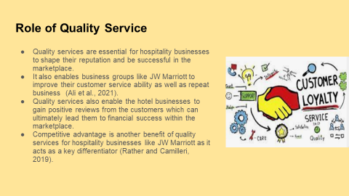
Speaker’s Note: Quality services are essential for hospitality businesses to shape their reputation and be successful in the marketplace. It also enables business groups like JW Marriott to improve their customer service ability as well as repeat business (Ali et al., 2021). Moreover, quality services also enable the hotel businesses to gain positive reviews from the customers which can ultimately lead them to financial success within the marketplace. Competitive advantage is another benefit of quality services for hospitality businesses like JW Marriott as it acts as a key differentiator (Rather and Camilleri, 2019). It can also be helpful for them to gain enhanced levels of loyalty from customers.

Importance of Quality Service in hospitality Businesses

Speaker’s Note: Quality services play a vital role for hospitality businesses like JW Marriott in order to gain maximum customer attraction. Quality services by the businesses offer the business to generate maximum profitability as guests spend on additional services offered by the business (Ford, 2020). It is also vital for the hospitality group in the cost reduction measures. Guests are less likely to make complaints about the services and products offered by the business (Walker, 2021). Satisfaction of the employees is another benefit of quality service as it enables the workforce to be well-trained and motivated within the business.

Necessity of Hospitality for the business
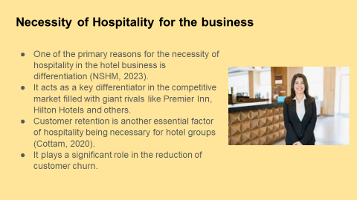
Speaker’s Note: Hospitality in hotel groups like JW Marriott plays an important role in their growth and success. One of the primary reasons for the necessity of hospitality in the hotel business is differentiation (NSHM, 2023). It acts as a key differentiator in the competitive market filled with giant rivals like Premier Inn, Hilton Hotels and others. Customer retention is another essential factor of hospitality being necessary for hotel groups (Cottam, 2020). It plays a significant role in the reduction of customer churn. Further, prioritisation of customers’ comfort and well-being also enables the business to retail their customers for a longer period.

Types of Guests Services for the business
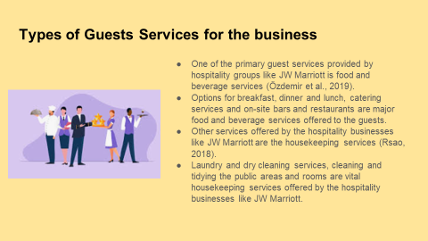
Speaker’s Note: There are different types of services provided by the hospitality businesses for the customers. One of the primary guest services provided by hospitality groups like JW Marriott is food and beverage services (Özdemir et al., 2019). Options for breakfast, dinner and lunch, catering services and on-site bars and restaurants are major food and beverage services offered to the guests. Other services offered by the hospitality businesses like JW Marriott are the housekeeping services (Rsao, 2018). Laundry and dry cleaning services, cleaning and tidying the public areas and rooms are vital housekeeping services offered by the hospitality businesses like JW Marriott.

Importance of Guests Service to meet customers’ needs
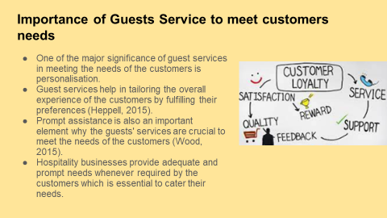
Speaker’s Note: Positive and effective services are critical to meet the needs of the customers. One of the major significance of guest services in meeting the needs of the customers is personalisation. Guest services help in tailoring the overall experience of the customers by fulfilling their preferences (Heppell, 2015). Prompt assistance is also an important element why the guests' services are crucial to meet the needs of the customers (Wood, 2015). Hospitality businesses provide adequate and prompt needs whenever required by the customers which is essential to cater their needs. As a result of this, it assists the business to offer best customer services to their guests during their visit in the hotel group.

Importance of Guests Services to meet customer needs (Cont’d)
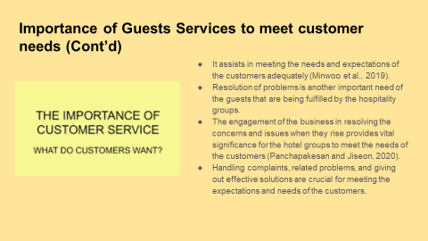
Speaker’s Note: One of the significant elements of guest services is the information and guidance. It offers the guests with the needed information and data of the activities and attractions. It assists in meeting the needs and expectations of the customers adequately (Minwoo et al., 2019). Resolution of problems is another important need of the guests that are being fulfilled by the hospitality groups. The engagement of the business in resolving the concerns and issues when they rise provides vital significance for the hotel groups to meet the needs of the customers (Panchapakesan and Jiseon, 2020). Handling complaints, related problems, and giving out effective solutions are crucial for meeting the expectations and needs of the customers.

Conclusion
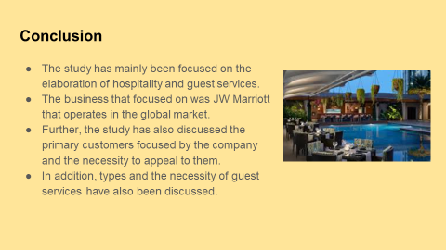
Speaker’s Note: The study has mainly been focused on the elaboration of hospitality and guest services. The business that focused on was JW Marriott that operates in the global market. Further, the study has also discussed the primary customers focused by the company and the necessity to appeal to them. In addition, types and the necessity of guest services have also been discussed. Lastly, the importance of guest services and hospitality to meet the needs of the customers has been discussed.

References


