UNIVERSITY OF WALES
TRINITY SAINT DAVID

STUDENT NAME: SABINA-ANDREEA SABAU

STUDENT NUMBER: 1917334

MODULE CODE: LCBB4004
MODULE NAME: MARKETING FUNDAMENTALS
ASSIGNMENT TITLE: NIKE : PROCESSES AND STAGES OF MARKETING
ASSIGNMENT 1
PROGRAMME: BA BUSINESS MANAGEMENT
LEVEL 4/ TERM 2/ GROUP 1

LECTURER NAME: TUSHARA BALENDRAN

TABLE OF CONTENT
INTRODUCTION 3
WHAT IS MARKETING? 3
MISSION STATEMENT: 4
THE MARKETING PROCESS: 4
1.SITUATIONAL ANALYSIS 5
2.OBJECTIVES 7
3.STRATEGIES 7
4&5.IMPLEMENTATION AND CONTROL 9
CONCLUSION AND RECOMANDATION 10
1. References 10

NIKE – PROCESS AND STAGES OF MARKETING

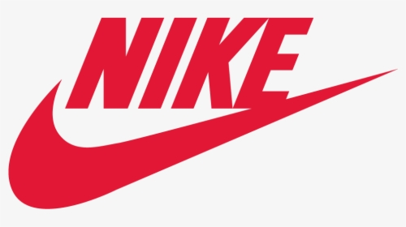

INTRODUCTION
Nike Inc. is an American multinational company that deals with the manufacturing, design, and supply of sports apparel. Nike was founded by University of Oregon track athlete Phil Knight and his coach Bill Bowerman in January 1964. Its original name was Blue Ribbon Sports (BRS). The company initially operated as a distributor for Japanese shoemaker Onitsuka Tiger , which meet Knight's automobile. (Nike Inc., 2016). NIKE, Inc. has been the global leader in sales of athletic shoes for years. The popular brand picture of the business unified competitiveness and encouragement for a competitive, athletic person. NIKE does lose their grasp on the modern, casual racer, however. These athletes exercise and run for leisure or pleasure, while escaping the competitive environment in which many of the latest NIKE brand claims are associated.For the company to be able to maintain its market share in the industry, there is a need to conduct intense marketing activities.

WHAT IS MARKETING?
Marketing refers to all the promotional activities that are conducted to enhance the company's brand. The company's primary focus is on increasing its market share in the industry and edge over competition from competitive firms (Morgan et al., 2019, pp.4-29). However, for this to be achieved, the marketing team needs to understand the company's mission and trace its marketing activities and message to the mission. Further, it is imperative to carry out a situational analysis of the firm that will reveal the company's position concerning other players in the industry and thus facilitate a proper selection of the most suitable marketing positioning strategy.

MISSION STATEMENT:
To inspire and bring creativity to every athlete in the world. The aim of the Nike is to continue its tradition of creative innovation, whether to develop products that enable athletes of every level of ability to achieve their potential, or to build business opportunities that separate Nike from the competition and offer value to their stakeholders.

THE MARKETING PROCESS:
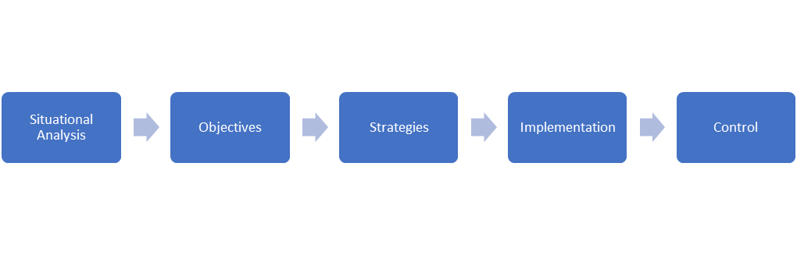
- Situational Analysis Definition: The basis of a marketing campaign is also called a situational analysis. A situation analysis requires a detailed review of the internal and external factors that affect an organisation. It provides an overview of the organisation, which can contribute to a deeper understanding of the factors affecting the future.( Macro Environment,Porters 5 Forces Model,SWOT analysis).
- Objectives Definition: A clear outcome that a individual or a company needs to achieve within a time frame and with the resources available.
- Strategies Definition: A strategy is a general plan or collection of plans that aim to accomplish something, particularly over a long period of time.(Segmentation, targeting and positioning & The marketing mix)
- Implementation Definition: The process of putting a decision or plan into effect or execution.
- Control Definition: Set of practices and procedures employed by firms to monitor and regulate their marketing activities in achieving their marketing objectives and strategy.

1.SITUATIONAL ANALYSIS

PESTLE Analysis
PESTLE is a model of scanning the environment in which a company operates by examining the political, economic, social, technological, legal, and environmental factors which can influence the company's performance favorably or unfavorably. Nike Inc.is a multinational company with a presence in different parts of the world. For the company to make sales in other countries, it means that there must be good political goodwill between the U.S. and those other countries. Currently, the U.S. and some other countries like Iran and Iraq have some sanctions in place. This implies that Nike's products may not be supplied to the latter's national teams, hence the loss of a potential market. Additionally, if the current trade wars with China does not end, the company may end up losing the Chinese market as well. The current economic crisis that has been caused by the Covid-19 situation spells doom for many businesses. Nike has not been spared from the adverse effects that have been caused by the situation. The company is set to experience a drop in sales due to the reduced sporting activities and events that had been planned. As such, the economic crisis is unfavorably affecting the company. Social-cultural factors relate to how the company maintains its relationship with its customers. In doing the marketing activities, the company ought to recognize the diverse cultures in places where it conducts its activities and ensure that it does not contravene the set standards in the society (Priporas et al., 2019, pp.16-43). Moreover, for the company to reach new markets, it has been involved in the production of hijabs that suit the Muslim female customers. This sets a favorable situation for the company.
Concerning the technological aspect of the model, the company recognizes the changes in customer tastes and preferences into footwear that incorporate technology to enhance performance and edge over its competitors in competitions. Therefore, by adopting such in the manufacturing of its products, the company places itself strategically to increase its market share and record improved sales. The legal aspect is in regard to the legal suits that are ongoing against the company. Most of them revolve around the harassment of female athletes. If not well-handled, they have the ability to damage the company's reputation in the market. They thus represent unfavorable aspects of the company. To avoid such a situation, the company ought to comply with the legal aspects of labor relations and also on environmental regulations. As a way to show its concern for the environment, the company undertakes initiatives that are meant to promote environmental sustainability.
Porter's Five Forces Model
Porter's five force's framework shows the attractiveness that exists in a particular industry. An analysis of the market using this model. The model will be helpful in examining Nike's competitive strength as compared to other players in the industry. As such, it can use it as a strategic tool to edge over its competitors in the industry. The five forces examined under this model include supplier power, bargaining power of buyers, threats of a new entrance, rivalry among existing competitors, and the threat of substitution (Lewis, 2017). An analysis of Nike's position in the market in regard to the Porter's Five Forces Model indicates that the company is in an excellent competitive position, and with proper strategies being put in place, it has the potential to improve on its existing market share and increase on its sales in the market.

SWOT Analysis
When firms are trying to compete effectively with other competitors in the industry, it is recommended that they conduct a proper analysis of the factors that may improve or hinder their performance in the market. One of the most useful tools for conducting an analysis is the SWOT model. SWOT model looks at the strengths and weaknesses of the company, which are internal factors that can affect the performance of the company. The management of the organization has control over these internal factors that affect an organization's performance and can influence them (Priporas et al., 2019, pp. 16-43). The model also identifies opportunities and threats that the external environment presents to the company. The main goal is to minimize the weaknesses and threats while at the same time maximizing the strengths and opportunities of the company in order to compete effectively in the industry of operation (Bang et al., 2016, pp.104-117). A SWOT analysis of Nike Inc. revealed the following results:
Strengths: One of the main strengths that are responsible for the company's success is the strong brand recognition that has made it to have a significant market share in the sports apparel industry. The firm's management has to build on this and ensure that they are able to secure more market for the company's products, which will, in turn, increase its market share in the industry.
Weaknesses: Nike's main weakness today is that the company is facing tuff financial times and has many financial debts that it has to repay. This has the ability to weaken the company's financial ability. Additionally, the company has several lawsuits that are ongoing against it in regard to the treatment of its female employees. If not well settled, it threatens to destroy the company's reputation.
Opportunities: The Company is always seeking to add to its existing market share. As such, it can explore the new emerging markets that represent a high potential. The company can also incorporate technology on its footwear in order to enhance its performance because many customers in today's have such tastes. If properly utilized, then it has the potential to change the company's fortunes in the market in a positive way.
Threats: Over the years, there has been increased competition in the market that threatens the market share of the company in the industry. A reduced market share implies reduced sales and thus reduced profitability in the company. In order to avoid being driven out of the market, the company's spending on marketing has increased, and thus increasing the company's operational costs and consequently reducing the company's profits.

2.OBJECTIVES
Objectives of Nike:
Increasing the profitability by 3-4 per cent of each of its product categories (i.e. growing revenue growth by 10 per cent annually)
• Increasing brand communication strategies
• Production of high and low-cost goods
• Meeting target market demands and requirements (sneakers for young and old consumers)

3.STRATEGIES

3.1.Market Segmentation, Targeting, and Positioning
3.1.A .Market segmentation can either be based on geographical, demographic, psychographic, and behavioral segmentation.
On geographical segmentation, the company targets customers from all the world. It has major markets in USA, Asia-pacific Europe, Africa but it has continuous objective to cater markets in other countries as well like North-America, China, Japan, and Middle-East etc. (Nike Inc, 2016)
In terms of demographic segmentation, the company targets the various individuals who are involved in any kind of sporting or even gym activities. This could range from the age of 6 years to 60 years.
Psychographics and behavioral segmentation: Nike has this segmentation to answer that why consumers need its products and what the consumers have interest and purchasing habits.Under psychographic segmentation target customers could be grouped in terms of their interests, for instance, athletes and footballers. Lastly, behavioral segmentation focusses on customers' behavior and coming up with marketing messages that will relate to the behavior observed in order to capture their attention (Andaleeb, 2016, pp.179-207).
3.1.B.Targeting As for market segmentation, Nike has niche market to serve that is Nike focuses and targets athlete or sportsperson segment and provides required products to them as footwear and apparel products, which have quite specific and unique feature as compared to other footwear products.
Its targeting strategies include sponsorship of its products through sports team or celebrities. It has objective of styling its product through psychological tactics on target market by linking triumph with apparel that is products are viewed as victory when sponsorship is done by athlete celebrities (Marketing strategy of Nike)
3.1.C.The company's positioning strategy will remain to be based on producing quality products that meet customers' demands and value for their money. Its slogan ‘Just do it’ has made an appeal to target customers to buy the product with sense of inspiration and confidence and which has made it major competitor in athlete industry. Further, the company can enhance its presence by investing more in online stores that will enhance the distribution process and thus a possibility to increase the overall market share (Kent et al., 2018, pp. 275-298). This will be enhanced further by investing in digital marketing to promote the company's sales (Chernev, 2018).

3.2. Marketing Mix Elements
Marketing mix elements refer to the various factors that the company can control in order to influence consumers to purchase the company's sports apparel. They are typically referred to as the 4ps of marketing. They include product, price, place, and promotion (Resnicket al., 2016)).
Nike has the leading role in marketing and has strongest marketing mix. In particular it depends on Pull strategy; it has established it’s seizing against the big competitors like Reebok and Adidas (Marketing mix of Nike)
3.2.A.On the aspect of the product, the company has maintained the production of its high-quality products, which could influence consumers' choices look for value for their money. Nike offers a wide range of products including shoes, apparel and equipment (Marketing mix of Nike).
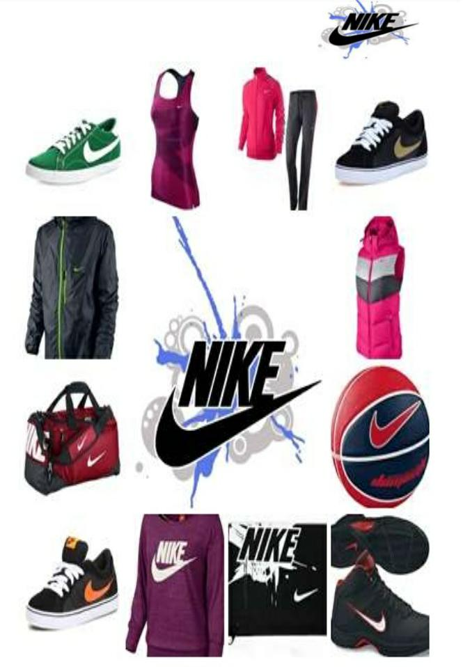
3.2.B. Price: Nike’s pricing strategy is considered to be competitive than other retailer shoe. The pricing is based on the basis of target customers as a premium segment. Nike brand commands a high premium. By offering the product at a price that gives consumers value for their money, the company stands to benefit greatly from potentially increased sales.
3.2.C.Promotion The marketing communications mix is effective because Nike attracts new customers and creates balance between keeping existing customers (Nike marketing communications-mix).As a way to promote more sales, the company could help some discounts on selected items in order to increase sales (Išoraitė, 2016, pp.127-148). There is a need to carry out promotional activities, which is basically marketing activities in order to reach unto new markets and increase the company's sales and profitability.
3.2.D.Place entails ensuring that the company's products are distributed to places where customers need them. Nike has a well-organized distribution channel that ensures that its products are available to the global market all the time (Kotabe and Helsen, 2020). Nike has about 20,000 retail accounts in the US and sells its products in about 200 countries worldwide. It is important for the management of the company to understand the important role that the marketing mix plays in enhancing the company's competitiveness in the market by influencing sales.

4&5.IMPLEMENTATION AND CONTROL
Once the company has selected the strategy to use in order to remain competitive in the market by increasing its current market share, it is critical to see that the same is implemented. It will not be of any help conducting environmental scanning using the various tools and then failing to implement the same (Morgan et al., 2019, pp.4-29). All the aspects that have been identified ought to be implemented and follow-ups made to ensure that every aspect works according to the plan.

CONCLUSION AND RECOMANDATION
Ultimately, an analysis of Nike's current market situation reveals that the various aspects that the company can focus on in order to increase its current market share. There is a need for the company to focus its efforts on new upcoming markets with huge potential. For instance, the company can integrate technology into the production of its footwear. This is a new area that many competitor firms have not explored yet. By being the market leader in this area, the company will have put itself in a strategic position to gain a substantial market share in the industry.

References
Andaleeb, S.S., 2016. Market segmentation, targeting, and positioning. Strategic Marketing Management in Asia, pp.179-207.
Bang, V.V., Joshi, S.L. and Singh, M.C., 2016. Marketing strategy in emerging markets: a conceptual framework. Journal of Strategic Marketing, 24(2), pp.104-117.
Chernev, A., 2018. Strategic marketing management. Cerebellum Press.
Išoraitė, M., 2016. Marketing mix theoretical aspects. International journal of research granthaalayah, 4(6), pp.25-37.
Jurše, M. and Jager, J., 2017. Marketing channel strategy management in international markets. International Journal of Innovation and Learning, 21(2), pp.127-148.
Kotabe, M.M., and Helsen, K., 2020. Global marketing management.
Kent, A., Dennis, C., Cano, M.B., Helberger, E., and Brakus, J., 2018. Branding, marketing, and design: Experiential in-store digital environments. In Fashion and Textiles: Breakthroughs in Research and Practice (pp. 275-298). IGI Global.
Lewis, R., 2017. Porter's Five Forces of competitive advantage.
Marketing strategy of Nike. (n.d.). Retrieved from http://sales-management-slides.com/marketing-strategy-of-nike/ (Accessed on 01.08.2020)
Morgan, N.A., Whitler, K.A., Feng, H., and Chari, S., 2019. Research in marketing strategy. Journal of the Academy of Marketing Science, 47(1), pp.4-29.
Nike ink (2016). Retrieved from https://www.google.com/finance?q=NYSE%3ANKE&fstype=ii&ei=6w68VomINMOnugTC5YW4Cg (Accessed on 02.08.2020)
Priporas, C.V., Kamenidou, I.E., Nguyen, N., and Shams, R., 2019. The impact of the macro-environment on consumer scepticism towards cause-related marketing. International Marketing Review. pp. 16-43.
Resnick, S.M., Cheng, R., Simpson, M. and Lourenço, F., 2016. Marketing in SMEs: a "4Ps" self-branding model. International Journal of Entrepreneurial Behavior & Research.

