Principles of Health and Social Care Practice
BMHP5002
Assignment No: 1
University of wales trinity saint David
Name of the Lecturer: Magdalena Wronska
Name of student: Maria Dandu
Student ID: 1810151

Exploring available support for Mr and Mrs T
Supporting people with complex needs such as those suffering from dementia, learning disabilities, the elderly and other groups is one of the major roles of health and social care practice. Providing support to such individuals requires a person-centred approach which involves support which is specifically tailored for them. Therefore, the health and social care practitioners must have time to ensure that they identify, plan and meet the needs of such individuals since each individual have complex and unique needs which they must be met in their own way. The support provided to such individuals should be holistic in such a way that it does not only meet their health needs but also meet their emotional, social and mental needs (Bent et al., 2002). Mr and Mrs T are both over 85 years old. Mr T has progressive dementia and other chronic conditions. They have always been very independent and able to care for one another until recently. Mrs T had a fall recently and was hospitalised following a hip operation and returned home with a mobility frame. When they reached at this crisis point, Mrs T realised that they needed help if they were to carry on living independently. She was interested in information and support on how to better manage their lives. It includes help with personal care, improve her mobility, domestic chores and any social events that would help them live independently if possible. This essay aims at exploring the support available for Mr and Mrs T based on an organization referred to as Age UK with an analysis, evaluates and describes the principles of support, the services provided, policies and legislations in relation to supporting Mr and Mrs T to have a good quality of life.
Mr and Mrs T have both health as well as social carer needs which must all be met towards promoting their independence and promote their high quality of life. A healthcare need is described as a need which is related prevention, control or treatment of an illness, disease, disability or injury. The healthcare needs of an individual must be met by a qualified health professional. On the other hand, the social care needs are the needs which are focused on assisting the individuals through their daily activities, promoting social interaction, empowering the individuals to participate in various aspects of the society, promoting their independence, guiding them towards managing the complex relationships, to access good accommodation, to access care services such as a care home, ensuring that they are protected in vulnerable situations and other aspects of support (Akhtar, 2013).
Age UK is a charity organization based in UK whose major aim is to support elder people to make the most of their lives during the later periods of their lives. Age UK provide companionship support, general support and advice at the local as well as the national level for people who requires it in their later life such as those suffering from dementia and other aging related issues. Besides that, Age UK stands up and speaks on behalf of the elderly people while protecting the interest of the future generations. It is made up of more than 40 outlets countrywide which provide range of products for supporting the elder people with range of complex needs. Age UK recognizes that many elder people do not have anyone to turn to at their later lives for support and advice and therefore, the organizations exist to help the elder persons at their time of need. The support provided by this organization include information support and advice such as enabling elder persons to understand their rights and information to help them make the most out of their later lives (Age UK, 2020).
Age UK also provides health and care services for elder people towards ensuring that the elder persons are at the centre of the care which they receive while sharing the best practices with others towards improving health and care services provided to such individuals. Besides that, Age UK promotes the wellbeing of the elder persons including those suffering from dementia and other needs by getting the elder persons active, coming up with ways to deal with loneliness and support to them so that they can stay independent for as long as possible. Age UK also carries out research as well as campaigns towards supporting the elder persons to make the most out of their lives every day. Age UK is made up of local and national network, which is supported through income, raising funds and other resources to ensure that they support the elder persons to have high quality of life (Age UK, 2020).
While providing support to elder persons such as Mr and Mrs T to meet their various needs, Age UK is guided by various principles of practice such as person-centred care, promoting equality and diversity, respect, partnership, respecting their rights and dignity, independence, choice and other principles.
Person centred care is one of the major principles which guide support provided to individuals such as Mr and Mrs T in Age UK. In Age UK and the whole of UK healthcare sector, the principle of person-centred care is quickly gaining a lot of popularity and many organizations are adopting it. Person centred care is described as providing individualized care to the persons in need of care which meets all their medical, social, emotional, mental and physical needs (Scie, 2017). People receiving care have their own views, wishes, preferences, priorities and have a good understanding on what is best for them and person-centred care is about providing care in accordance with the needs of the individuals while ensuring that the wishes, the views and the preferences of service users are taken into consideration while providing care to them and that the clinical decisions are made in manner which is not only respectful but also responsive to the service users. Person centred care is where care is provided in accordance with the service user’s needs and not in accordance with the needs of the health and social care service. Person centred care ensure that the service users are involved in their care and they do not just sit and wait to be provided with care (RCNI, 2018).
In this approach, Mr and Mrs T are considered as equal partners with the Age UK healthcare professionals in the process of planning of their care. While the healthcare professionals are planning for the care of Mr and Mrs T, they must respect their views, opinions, wishes and preferences. Mr and Mrs T having various complex needs must be encouraged using various means of communication to air out their views and to fully participate in their care towards ensuring that their needs are met and that they have high quality of life. While doing so, the effect on the care accorded to them on their whole health and wellbeing must be considered in the process.
Age UK is also guided by the principle of safety and safeguarding in practice. The principle of safety and safeguarding aims at protecting health and social care service users from abuse, harm or neglect while raising awareness on any safety or safeguarding concern, to reduce the incidences and to support people to make informed decisions over their care, support and treatment. Every health and social care organization, body or department including Age UK have a legal and a moral obligation towards ensuring that every person associated with the organization whether service user or staff is protected against any form or physical, social, mental or emotional harm. The safeguarding and safety principles majorly apply to the vulnerable groups accessing the care services (Bartley, 2016).
To ensure the safety of service users, the healthcare providers must assess the possible health and safety risks while providing support, care or treatment to the service users and come up with ways to mitigate them accordingly. This also include ensuring that the care professionals are fully qualified, have the skills, competencies and enough experience to promote the safety of the service users (EduCare, 2019). Mr and Mrs T under no circumstances must not suffer from any form of abuse, neglect, harm, limitation of their freedom or provided with degrading treatment.
Age UK provides care and support services in adherence to the principles of safety and safeguarding underpinned under the Care Act of 2014. The care Act of 2014 was introduced with a major aim of improving the independence and general wellbeing of the people. The Care Act of 2014 provides on the roles of the local authorities towards coming up with support strategies towards promoting independence, health and wellbeing of the people to prevent them from developing any health needs or to delay the occurrence of such care and support needs among the people and other provisions to ensure that the wellbeing and the independence of the people is promoted (Gov.UK, 2014).
The Care Act of 2014 provides for various principles of safety and safeguarding which are adhered to by Age UK while supporting the elder persons. The principles of safety and safeguarding underpinned in the care of 2014 aims at bringing out the vulnerable groups as individuals who have needs and wants. The principles emphasize on the involvement of service users in their care while assessing their needs and the process of planning and meeting these needs. The Care Act of 2014 emphasizes that the care professionals must adopt the person-centred approach while providing care to ensure that the service users are safeguarded. The principles of safety and safeguarding provided under this act puts the needs and the wellbeing of the vulnerable persons at the forefront of the safeguarding process (Personal Checks, 2018).
The first principle of safeguarding provided in the Care Act of 2014 is empowerment. Under this principle, the vulnerable adults must be supported so that they can make informed decisions over their care. The expectations of the service user underpin the whole process of providing care to them while ensuring that they have every information and resource to make informed decisions over their care. The second principle is on protection where the care professionals have a responsibility to not only support but also represent the individuals who have the greatest needs. This include taking immediate action to respond to any safety concerns and liberate the individual from any risk of harm (DBS, 2018).
The third principle is on prevention where action must be taken by the health authorities to prevent any harm or abuse from happening in the first place. Even after freeing the person from any harm, neglect or abuse, action must be taken to avoid the problem recurring through protection. The fourth principle is on proportionality where the most unobtrusive means is used while taking the preventive measures while considering that the needs of the vulnerable persons have varying needs and there are no standards of safeguarding that can fit to all of them (DBS, 2018).
The 6 Cs of social care also guides the support services provided to Mr and Mrs T by Age UK. The 6Cs are shown below:
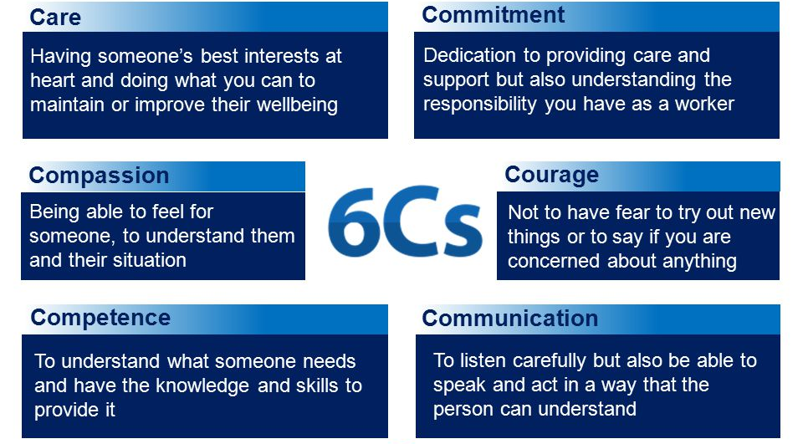
The fifth principle is on partnership where the health and the social care providers such as Age UK should work in collaboration with other organizations or individuals in the process of preventing, detecting and reporting cases of abuse, harm or neglect among the vulnerable individuals. This will make the process of safeguarding fast and efficient thereby improving on outcomes. The last principle is on accountability where every action or practice undertaken towards safeguarding should be transparent. The individuals under the safeguarding process must always be updated and informed in every step and decision undertaken (Liz, 2017).
The other principle guiding the provision of support and care by Age UK is on information sharing. Age UK has a legal responsibility as per the Health and Social Care Act of 2015 to share relevant information to promote the health and wellbeing of the individual under care. This includes sharing the information of Mr and Mrs T with other healthcare providers towards promoting their health and wellbeing. However, the Health and social care act of 2015 provides that the service user must be informed before sharing the information and allowed to object if he/she feels so. The individuals must know how the information shall be used and to give their consent on the same. The care provider must ensure that the privacy rights of the individual are respected, and information kept confidential (NHS, 2019).
Some of the other important legislations which promotes the health, wellbeing and independence of Mr and Mrs T include the putting people first of 2007, the health and social care of 2012 which covers on the many aspects of the roles and responsibilities of CQC, the safeguarding vulnerable groups act of 2006 which ensures that the employees and the volunteers are suitable to work with the vulnerable groups such as Mr and Mrs T. The Equality Act of 2010 which protects Mr and Mrs T against any form of discrimination in the society among other legislations.
The professional values, conduct and behaviour guide the expected behaviour and code of the various health and social care professionals providing support to Mr and Mrs T in various levels of the support process to ensure that the care professionals are always accountable in their cations, uphold privacy, work in a collaborative manner with all stakeholders, promote equality and diversity, communicate effectively and respects the service user’s rights to confidentiality and privacy (Bartley, 2016).
The support and care services provided by Age UK are regulated by various regulatory bodies, one of these bodies is the Care Quality Commission (CQC). CQC is an independent regulator of health and social care in UK. The major role of CQC is to work on ensuring that the health and the social care services provided to the people are not only safe and effective but also that the services are compassionate and are of high quality while always encouraging the health and social care service providers to always improve (CQC, 2020).
The other regulators of health and social care service include the General medical council which is responsible for the protection, promotion and maintenance of the health as well as the safety of the people through controlling the doctors register, removing or suspending its members when need arises. The Health and safety executive on the other hand regulates health and safety in the places of work. The Medicines and Health products Regulatory Agency (MHRA) is another government regulatory agency which works on ensuring that the medical products and the medical equipment in UK are not only acceptably safe but also ensure that they are working properly. There are other local based regulators such as the Health improvement Scotland, Care inspectorate Wales and other regulators. There are also various professional bodies which regulates social care such as the Health and the Care professional's council (HCPC) which regulates the profession of social work as well as the education of social workers in UK (HSE, 2019).
Mr and Mrs T are supported in many ways towards promoting their health, wellbeing and independence. There are many organizations providing support to people with dementia in UK such as Age UK which stands in a great position to support Mr and Mrs T towards living independently for as much as possible. The person-centred approach also provides great support to the family with the support of various policies, legislations, regulatory frameworks and professional code of conduct. However, a specific policy should be developed by the department of health to specifically guide the process of assessing the needs and meeting the needs of elder people with dementia. Besides that, educational programs should be developed to guide elder people living with dementia to live independently and to understand ways to live a high quality of life. This essay explored the support available for Mr and Mrs T based on Age UK with an analysis, evaluation and description of the principles of support, the services provided, policies and legislations in relation to supporting Mr and Mrs T to have a good quality of life.

References
- AgeUK.org, 2020. About us. [Online]. Available at: <https://www.ageuk.org.uk/about-us/> [Accessed 3rd Dec, 2020]
- Akhtar, F., 2013. Mastering Social Work Values and Ethics. Jessica Kingsley: London
- Bartley, M., 2016. Health Inequality: An Introduction to Concepts, Theories and Methods. 2nd Ed. Polity Press; London
- Bent, N., et al., 2002. Team approach versus ad hoc health services for young people with physical disabilities: a retrospective cohort study.
- Burton, L., 2017. What are the 6 Principles of the Care Act 2014? [Online] Available at: < https://www.highspeedtraining.co.uk/hub/principles-of-the-care-act-2014/> [Accessed 4th December 2020]
- CQC, 2020. About us. [Online]. Available at: <https://www.cqc.org.uk/about-us> [Accessed 12th Dec, 2020]
- DBS, 2018. Safeguarding principles in health and social care. [Online]. Available at: <https://www.highspeedtraining.co.uk/hub/principles-of-the-care-act-2014/> [Accessed 22nd Nov, 2020]
- EduCare.co.uk, 2019. Protecting Adults in Health and Social Care. [Online]. Available at: < https://www.educare.co.uk/news/safeguarding-adults-in-health-and-social-care> [Accessed 4th November 2020]
- Gov.UK, 2014. The Care Act 2014. [Online]. Available at: <https://www.legislation.gov.uk/ukpga/2014/23/contents/enacted> [Accessed 23rd Nov, 2020]
- HSE.gov, 2019. Health and social care regulators. [Online] Available at: <https://www.hse.gov.uk/healthservices/arrangements.htm> [Accessed 3rd December 2020]
- NHS, 2019. Quick guide to sharing patient’s information. [Online] Available at: <https://www.nhs.uk/NHSEngland/keogh-review/Documents/quick-guides/Quick-Guide-sharing-patient-information.pdf> [Accessed 26th Nov, 2020]
- Personal Checks, 2018. Safeguarding principles. [Online] Available at: <https://www.personnelchecks.co.uk/info-centre/safeguarding-hub/six-safeguarding-principles/> [Accessed 3rd December 2020]
- RCNI, 2018. The meaning of person-centred care. [Online] Available at: <https://rcni.com/hosted-content/rcn/first-steps/what-person-centred-care-means> [Accessed 4th December 2020]
- Scie.org, 2017. Person centred care [Online] Available at: <https://www.scie.org.uk/person-centred-care> [Accessed 2nd December 2020]

