Phillip Morgan, Hard to Reach Groups, Cults, SJSS4001.

This essay will discuss and describe potential reasons why individuals and groups who are either born in to a cult or have joined a cult can become isolated from family members, friends and society. To understand how cult members can become isolated, how we can prevent this from happening and then to provide the correct support to current and previous cult members we must first understand the cults, the theories and ideologies that different cults have. A cult is often regarded as a new religion that is regarded as slightly unorthodox, possibly a socialist movement, artist movement and even dedicated fans of television shows and films can be classed as a cult movement such as ’Trekkies’ and music fanatics such ‘Biebers’ and ‘Little Monsters’. But it is when a cult becomes completely life changing or detrimental to its members that society takes a different view. This essay will show different cults and the detrimental effects that can and have happened and the help that is offered to cult members.
To define what a cult is can be difficult because it can depend on individual views, on history, religion or just pure common sense. Each of these are individual in themselves. Is it a cult or just a new religious movement? Then who gets to decide the difference?. In the UK Ian Haworth from the Cult Information Centre is the leading specialist on cults and on the centres website a cult is described a group or organisation having these five different traits (see appendix 1). The website also then lists two different types of cults, a Religious Cult and a Therapy Cult (see appendix 2). Haworth says in point 3 (see appendix 1) that the cult leaders can often be ‘Messianic’ and ‘unaccountable’. History has shown this to be true in cults such as The Children of God, The Order of The Solar Temple where leader’s actions were not culpable. Haworth also has a theory on primary motivations such as power and control but research into victims stories show that a clear primary motivation is some sort of sexual misconduct. Sexual conduct that deviates from the norm such as underage sex and rape, for example cult leader David Koresh would openly have under age sex and marry multiple wives. Branch Davidian survivors have openly admitted in interviews after the Waco siege that Koresh had multiple wives and many of those brides were underage. Channel 5’s documentary ‘Waco Inferno; The Untold Story’ show Branch Davidian survivors retelling their version of the Waco Tragedy that ended after a 51 day siege between the Branch Davidians and the ATF. To understand how to keep cult members from being secluded from society and to offer social inclusion society must first understand the help that needs to be offered, to do that society must understand what actually can happen inside a cult. To understand a cult is to understand its leaders, Branch Davidians leader believed he was to be the last coming of Christ. David Koresh was born Vernon Wayne Howell in 1959 but is rumoured to have changed his name to David Koresh after the bible king Cyrus. Before Koresh became the leader of the Branch Davidians he was part of the Seventh- Day Activist Church. Koresh then later joined the sub sect of the church called the Shepherds Rod. Koresh took over the sect when its original leader was jailed for murder, Koresh then swiftly convinced members to move to Waco in Texas and renamed them The Branch Davidians. Once the compound in Waco was founded Koresh convinced members along with his best friend Marc Breault to start recruiting for new members. They openly targeted students and went to universities and held talks aimed at theology students, many already part of The Seventh- Day Activist as they were already open to persuasion. Koresh’s charisma helped to persuade new members to join and to convince the members that the end of the world was coming as that he was the chosen one, that he was the second coming of Christ and that his members should follow his rules. In interviews since the cult ended in the Waco siege in February 1993 that ultimately led to Koresh’s death ex members have now come forward to tell their stories of sexual abuse. It is important to understand the individual abuse cases to offer the correct support needed. Several articles have revealed the sexual abuse at the hands of Brand Davidian leader David Koresh himself and other cult leaders. The stories revealed, tell of the harrowing abuse of power and control. The sexual abuse of young Kiri Jewell was told in court when she was just 14. Jewell testifies that she was sexually abused from the age of 10 (see appendix 3). Society often wonders how cult leaders can get away with the abuses for so long and appear to be unaccountable even to the parents of the abused. Leaders can often use mind control techniques such as love bombing to make the victim almost want the abuse. Love bombing techniques often include literally bombing the intended victim with love, make them feel like your everything, but the moment the victim doesn’t agree to a demand the controlling force rapidly removes the love, thus leaving the victim feeling alone and craving that love back. Victims often agree to different forms of abuse just to feel that love and to belong through Idealization. In the mid-eighties Koresh married his first underage bride Rachel Jones who was just 14 and yet the legal age for marriage in Texas was 17. Mind controlling techniques (see appendix 4) such as love bombing techniques may have well been used, one of the few explanations of how Koresh then married his next 14 year old bride just two years later then followed by her younger sister. Having parents not hold him accountable to marrying their daughters would have worryingly fed in to Koresh’s perverted narassasitic tendencies. Society will still struggle to understand the parents of these clearly influenced young girls. The disturbing part of the cult was that parents did not stop these abuses and other Branch Davidian members have since excused Koresh’s paedophilia. Waco survivor Shelia Martin happily justified and approved Koresh’s actions of underage marriage because Rachel Jones ‘was almost 15, she was a very tall girl, mature, she was nothing at all like a child’ (Sheila Martin, Waco Inferno; The Untold Story, Channel 5,). A clear case that if you believe, your brain will find a justification. Sheila Martin still believes in Koresh even though in the siege she lost her four eldest children and her husband. In a documentary for channel 5 Sheila Martin stands by her children’s grave and says ‘God has a reason for it, so I have to trust him why’ (Sheila Martin, Waco Inferno; The untold story, Channel 5, 03.58secs,). With that level of dedication from Branch Davidian member’s social inclusion is a battle. Society must offer support and remove their judgement before the correct help can be achieved through specialist services. For Koresh’s ex members resources must be made available to help them back in to society. Many will need specialist sexual violence counselling, grief counselling and education as this was held from many. It can be complex to know what support is needed as each cult has its own rules bur one reoccurring factor seems to be that members are brainwashed in to thinking that the outside world is bad and untrustworthy. When strong charismatic cult leaders use ideas similar to Christianity such as The Order Of The Solar Temple which claim to continue the traditions of the Knights Templar it can be even harder to change there thinking as they have had ideas planted from a written text which can be more difficult to deny. So imagine offering help to current and ex cult members when the cults foundation seems to appear like a science fiction story written from a John Wyndam Classic.
It can be hard to imagine the techniques used to recruit members in to a cult that claims an alien called Elohin is the leader (The Raelions ). A cult called Scientology believe that an alien named Xenu is the dictator of the ‘Galactic Confederacy’ who over 75 million years ago brought the human race to ‘Teegeeact’ what we call Earth and placed them around volcanoes and killed them with hydrogen bombs. Their souls ‘Thetans’ remained trapped on earth and Xenu implanted them with false images of historical events that scientology claim never happened. The Scientology cult’s founder L. Ron Hubbard claims that there is a 4th Invader Force on Mars and a 5th Invader Force on Venus. Men are from Mars , Women are from Venus, not exactly an original concept and the idea of’ Invader Forces’ and a ‘Galactic Confederacy’ seem like a fun mix from Star Trek and Star Wars. L. Ron Hubbard is a science fiction writer best known for his book ‘Dianetics; The Modern Science of Mental Health’ 1950. The fact that Hubbard is a known science fiction writer, common sense would tell the average person that his story of Xenu is fiction. Especially as Hubbard can be quoted as saying ‘you don’t get rich writing science fiction. If you want to get rich, you start a religion’ (Hubbard, Eastern Science Fiction Association, 7/ 11/ 1948), and as quoted in a 1994 affidavit by Sam Moskowitz a historian of science fiction.
Yet Scientology spreads across 172 nations and has its main Church in Hollywood USA and boasts famous Church members such as Tom Cruise, Ted Danson and Danny Matherson. Scientology was founded by Hubbard but after his death in 1987 David Miscavige took over as the new leader, Miscavige continues Hubbards message that the basis that Scientology is the ‘Golden age of knowledge for eternity’. Scientologists rarely speak out about how they were recruited and many ex members appear to be afraid to say anything publically bad against the cult for fear of prosecution. British journalist Russel Miller’s book ‘Bare Faced Messiah; The True Story of L. Ron Hubbard’ reveals that Miller had been informed by ex-members that Hubbard was a bigamist, had several mistresses and a claimed Satanist. Could Scientology be another cult that is a convenient cover for sexual deviancy? Sexual claims have been hard to prove, but a few claims have surfaced. Allegations against Danny Matherston of rape have been reported to the LAPD but the case appears to have remained stagnant. The Church of Scientology have given the LAPD a check at their annual holiday party since 1995, this is done on camera so it does not look like a police bribe. The money makes the LAPD appear financially influenced. There are several claims from ex members that the cult tries imitation methods to stop people speaking out against them. Ex-member Leah Remini host of the A&E show has retold her story of sexual harassment, child abuse and parental separation along with other ex-members Saina Kamula and Mirriam Francis. If children did not conform they would be sent to the Apollo Training Academy Building. So with effective methods such as parental separation in place it is easier to understand how abuse can be sustained for so long and why parents and children would be too scared to speak out, especially when there are claims that they are asked to sign ‘Billion year contracts’ and the children either born or brought in to the cult have a limited education. How would they survive in the outside world with no formal qualifications and the label of ex cult member on their backs? Understanding can be harder to give to the parents of the abused children, but as a nation we should remember that most members were recruited through promises of a life without war or conflict. New education and medical care must be made available to all cult members to support them to function in normal society especially were the cult rules dictate that contraception is banned. Medical care for Sexually transmitted diseases, abusive rapes and midwifery should be made welcoming to current and ex members.
Cults such as The Children of God do not permit any kind of birth control as they expect female members to increase the tribe. David Berg who founded The Children of God and who was later known as David Moses taught children lessons about the end of time, what would happen and how to prepare the children for this time. The classes were even filmed, a use of early social media to advertise in 1993. The children in the cult were bombarded with cartoons that taught you how to do what you were told, very controlled, even how much toilet paper you could use ‘Do it cause Daddy says so’ a regular motto and sang in the children’s cartoon (see appendix 5). Berg also produced a sort of newspaper called the ‘Mo Letters’ which encouraged the whole cult to sleep together and to share partners (see appendix 6). If women refused they would be shamed and labelled. There are over 500 cults in the UK according to The Cult Awareness centre so how can the UK government possibly reach so many people and offer help? The simplicity of it is that they can’t, the government offers specialist counselling, psychiatrists and medical care but the Cult Awareness Centre Charity offers help to all cult members and their families. The centre is charity based and raises money through anti-cult talks and book sales. The website offers links to helpful websites and a phone number to call the centre itself.
To keep cult members included, medical care, education and all forms of therapy must be kept open to them. The government cannot ban new cults or religions because of democratic freedom to worship and many regions deemed normal and safe such as Christianity at some point would have been considered a dangerous cult by pagans. But systems could be put in place for them to be monitored more closely to avoid future Waco and Jonestown tragedies. Cults like religions can be a needed crutch, an escape from their reality and they need to belong. The government must help members find the root causes of the need to join these cults and not just help with the aftermath effects. If in schools anti-cult talks were held and feminism classes to tackle some of the abuses that could happen in a cult were held it could be a start. Cult classes could be maid part of the Religious Education classes and show from a young age the detrimental effects. We as a society need to offer social inclusion by being open minded tolerant, understanding, education, medical treatment and inclusion on all social activities. Often after members leave a cult many will fall in to a situation of locus control such as remarrying a controlling person who is always in charge. We need to offer therapists, psychologists, specialist rape recovery treatment, child bereavement counselling and child abuse therapists. Help to family members should also be offered to help reconnect families and ensure there are educational opportunities to help members back in to work and feel like they belong.

Appendixes
Appendix 1
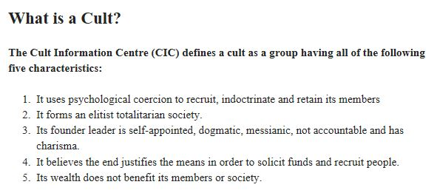
Available to view at ; www.cultinformation.org.uk/question-what-is-a-cult

Appendix 2
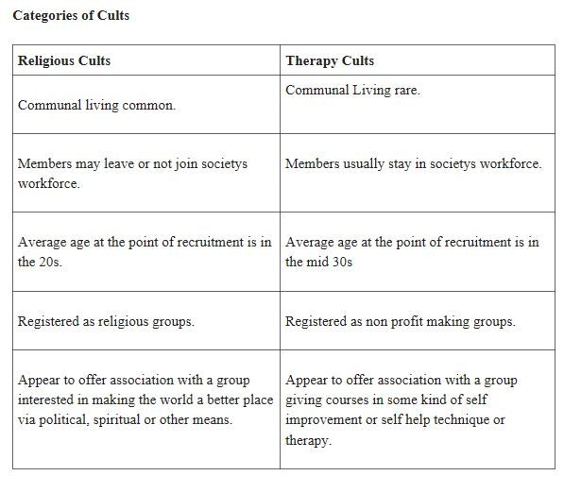

Available to view at; www.cultinformation.org.uk/question-what-is-a-cult
Appendix 3

Available to view at www.washingtonpost.com/archives
Article written by Sue Anne Pressley, July 20th 1995

Appendix 4
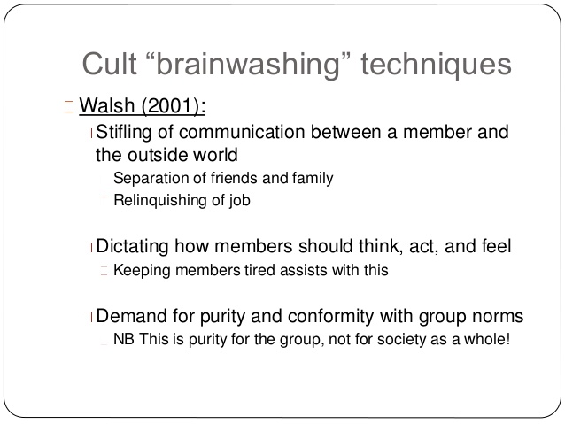

Appendix 5

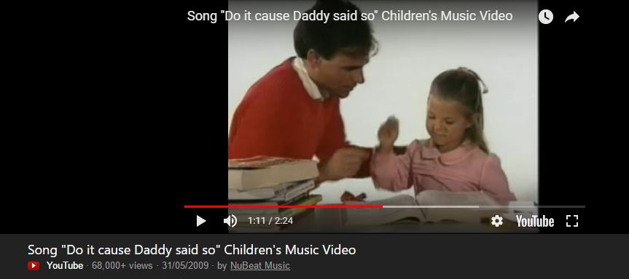
Available at www.youtubecom/.doitcauseDaddysaidso

Appendix 6

Images; Google Images.

Bibliography
Books
Davis, D, Davis, B, (1984) The Children of God; Inside Story By The Daughter Of The Founder , Moses David Berg, Zondervan.
Leppard, D, (1993) Fire and Blood; The true story of David Koresh and the Waco Seige, United Kingdom, Fourth Estate Publishing.
Lifton, Dr.R, (1989 reprint) Thought Reform and the Psychology of Totalism, United States, University of North Carolina Press.
Lifton, Dr.R, (1990) The Genocidal Mentality; Nazi Holocaust and Neclear Threat, United States, Basic Books
McGowan, R (2018) Brave, United States, HQ.
Miller,R (1987) Bare Faced Messiah; The True Story of L. Ron Hubbard, United Kingdom, Michael Joseph.
Reiterman,T , Jacobs, J (1982) Raven; The untold story of the Reverand Jim Jones and his people, United States, E.P.Dutton.
Websites
www.thefamilyinternational.org
www.cultinformation.org.uk
www.icsahome.com
www.google.com (Image search)
www.ranker.com
Documentries
Waco Inferno; The Untold Story (2018) Channel 5
Leah Remini; Scientology and The Aftermath ( 2016) A&E Network

References
Hubbard, L Ron, Eastern Science Fiction Association, 7/ 11/ 1948
Leppard, D, (1993) Fire and Blood; The true story of David Koresh and the Waco Seige, United Kingdom, Fourth Estate Publishing.
Miller,R (1987) Bare Faced Messiah; The True Story of L. Ron Hubbard, United Kingdom, Michael Joseph.
Sheila Martin, Waco Inferno;The Untold Story (2018) 03.58secs, 26.47secs,
https://www.vice.com/en_au/article/wd49g9/uk-cult-information-centre-interview-202, acsessed on 27/04/2018

https://tonyortega.org/2017/11/26/scientology-used-the-same-official-to-interrogate-danny-masterson-and-an-accuser/ acsessed on 27/04/2018
www.foxnews.com/entertainment/2017/12/07/how-church-scientology-seemingly-protected-danny-masterson-amid-rape-allegations.html, acsessed on 27/04/2018

