
Professional career development
A report on Personal Career Development

March 28, 2018
University of Wales Trinity Saint David

Executive Summary

The main purpose of my report is to outline why career development is important for career success. The report will show different methods of self-improvement to achieve my desired professional and personal goals and how I can improve myself for future employment.
The report will identify different learning styles, my personal SWOT and SMART objective. This will help me identify my development needs and guidance for future improvements.

The report will conclude with me putting together a recruitment procedure for a job position as an employer. I will demonstrate different interview techniques alongside a job description with person specification outlining the requirements for the successful candidate.

My research to acquire this information will based on books, websites and journals.

Table of Contents
Executive Summary 1
Introduction 3
Different learning styles 9
Job Recruitment Process 10
Interview Process 16
Assessment centres 17
Conclusion (average of 10% of word count) 19
Recommendations 19
Bibliography 20
Appendices 22
Acknowledgements 23
UPDATE TABLE FREQUENTLY – CHECK IT HAS BEEN UPDATED PRIOR TO SUBMISSION

Introduction

Professional career development is utmost important for career success, the purpose of this is to identify skills, knowledge or competence which can help give direction for future career development. To begin with one must choose primary career interest, then identify long term professional goals (including positions desired in their choice of workplace) lastly what goals is required and an estimated timescale in which this can be achieved. Type of skills that are required are
: Communication – A vital component in any working environment, clear precise communication can lead to better working relationship between clients and colleagues (Worth, 2009)
: Teamworking – Being able to positively work together and implement working strategy together will lead the company further (Morgan, 2017)
: Problem solving - Critical thinking and evaluation of working practice can help make positive decisions (Bee,F. and Bee, R. 2003) (Morgan, 2017)
: Leadership- Showing confidence alongside integrity and guiding your team to success through motivating and inspiring employees shows good leadership (Cottrell, S. 2010)
: Knowledge in Technology- Basic knowledge in IT is essential (Cottrell, S. (2010) Digital skills are highly valued in all employments as we are now surrounded by social media, email communication which is vastly developing every day.
: Flexibility- Being able to manage time accordingly helps have a good work/life balance (mindtools.com, 2018) helping employees improve productivity and efficiency. (Fair Work Ombudsman, 2018)
The above are some of the skills required in a work place. Cottrell, S. (2003), however there are many more.

The aim of my report is to show how I have developed the above skills and knowledge and how they contribute towards working effectively and becoming employment ready. The use of suitable academic research and models, I have learned a lot about my skills and hidden weaknesses that I have not considered to be a concern prior to testing out certain theories such as VARK and my own SWOT analysis.

Lastly, I would be explaining about the recruitment process, the steps it takes for an individual to search for a job to applying and getting ready for the interview process. I would be considering how to apply for a job position, what is the best way to present an individual and what can be expected in an interview as many companies may have verbal interviews and some may require an individual to attend an assessment centre, this usually comprises of many different tests alongside other potential candidates to check aptitude and performance of an individual’s suitability and future development for the job role.

I have designed my own personal SWOT analysis based on a Gym Instructor profession. This will outline my strengths, weakness, Opportunity and threats, the benefits of this can help personal development. (Seth, C.2015,)

Strengths  : I am a very friendly individual and can make friends easily  : I currently hold Fitness Instructor Level 2 and 3, amongst other qualifications (such as, kettle bells, circuits and spin)  : I can provide classes to women only  : I have excellent communication and being able to speak three languages helps break communication barriers with clients  : I am well known within the community so this helps me gain access to current or upcoming events so I can arrange to be part of this.  : I have a large client base from all different parts of the community and having a tactful mindset along with understanding of my client’s needs has helped my base grow vastly over the previous years. | Weaknesses  : Negative work habits for example disorganized  : Cannot meet deadlines on time  : Sometimes shy to speak my mind  : Not enough knowledge in some areas of the industry  : Not many women only sessions available  : Can get stressed if I have too many tasks, learn to prioritise  : Always leave tasks to last minute and feel I have not put in my all.  : Have a lot of family responsibility and sometimes this can hold me back from doing a lot of tasks that I plan, or I must reorganise for a late date.  : Very sweet tooth (Put on a few pounds)  : Not confident in using IT and social media such as Twitter
Opportunities  : Many Gyms are now opening so always opportunity for women only sessions  : Some women will go on maternity leave. Covering their duties while she on leave would be a great career development opportunity for me.  : I attend a lot of community events and enjoy meeting new people, connecting with community and keeping up to date with current health issues individuals or groups are discussing. Health eating is a hot topic, so I always engage in these conversations that many times has led me to signing up a new client  : Attend many courses for different styles of learning such as Zumba, Les mills and Bollywood dance. It is always good to develop own training methods that can then be implemented on others.  : Opportunity to complete Level 3 in Personal training which will help understand clients of all different backgrounds and training needs. | Threats  : Many gyms are far away and I do not have transport  : Unfamiliar with specific types of client, eg pregnant women or older clients  : Feel uncomfortable talking about money and sales process.  : Equipment can be faulty or unavailable at peak times in gym  : Competition from other trainers and high-end gyms in the local area

The implementation of SWOT analysis helped me recognise areas I need to improve on and further my skill level, I will now use this to research available resources to develop these areas further. (Harrison, 2009). However, some will argue that a SWOT analysis is just an evaluation and can depend on how the theory is applied back into the workplace and not always be a solution, but has proven to be effective and systematic way to approach and address a situation. (Tem-journal.com, 2018.

I designed my own self-assessment, this is important to develop for lifelong learning and improvements (Falchikov & Goldfinch, 2000)

Objectives | 1= Very Poor 2= Poor 3= Average  4 = Good  5= Excellent
I have the confidence to try new things and express my ideas  I am organized and can meet deadlines  I am competitive and driven by results  Work as part of a team  Speak clearly  Work on own initiative  Good Time management skill  Use of IT  Confident at preparing and delivering exercise classes  Keen motivator  Understanding and sympathetic  Good memory  Use of my first language- (Bengali)  Work to attention to detail  Delegate and organize  Stick to good meal plans | 3  3  5  5  4  3  4  5  5  5  4  3  5  3  2

Conducting a self-evaluation has allowed me to identify areas of weakness/areas of improvement. Whilst there are various objectives with a low score of 3, the two points that I will discuss further is Time management, and My poor diet plan

Time management: This is important in every aspect of work and life, (Cottrell, S, 2003). Within a gym environment it is essential to be able to manage time effectively, Personal trainers are responsible for conducting group classes throughout the day so it is critical these run on time otherwise it will lead to irritated customers. I have decided that I will now make use of a diary, make small notes if something needs to be done urgently and most of all make use of technology and input information into my mobile phone calendar as this will give hourly notifications of items that’s needing to be completed or that are due to be completed (Training, 2018).

Poor Diet Habit- Coulson and Archer (2008) found approximately 17% of men and 21% of women in the UK are obese due to poor diets and lack of exercise. Nowadays image is how everyone is judged, social networks, and online tools are currently used vastly for projecting things out into the world, but putting yourself out there so prominently makes is easier for people and potential clients to judge you by your cover and make their own conclusion if you can help the achieve their desired goals (Everything, 2018).
Losing weight- I have decided to commit myself to:
: A daily personal calorie intake
: Eat real food
: Less sugar
: Incorporate weights into my workout
: Eat more protein
: Measure my progress

The above objective is utmost important me, because I require to lose this weight for my physical and personal wellbeing. I will implement the SMART objective; these acronyms stand for:
Specific- Choose a specific job/task
Measurable- is the task, meaningful or motivational
Achievable – Is the task attainable
Relevant- Is it relevant to the job
Time- Have you given enough time, time bound.

I have chosen this learning style as It provides clear and precise goals, when implementing a personal change. I am committed to my goal and have a deep inner desire to complete the task I set out to achieve, however some might argue that the SMART objective is not what it says it is, some will argue that the learning style can have a reverse effect on an individual, for example if one is working within a call centre, setting smart goals might make them feel under pressure, they might not be committed to the job as the employer might think (Lawther, 2018) and reflect in poor performance. In conclusion the SMART objective is being used by many organisations and is showing to have a positive effect,

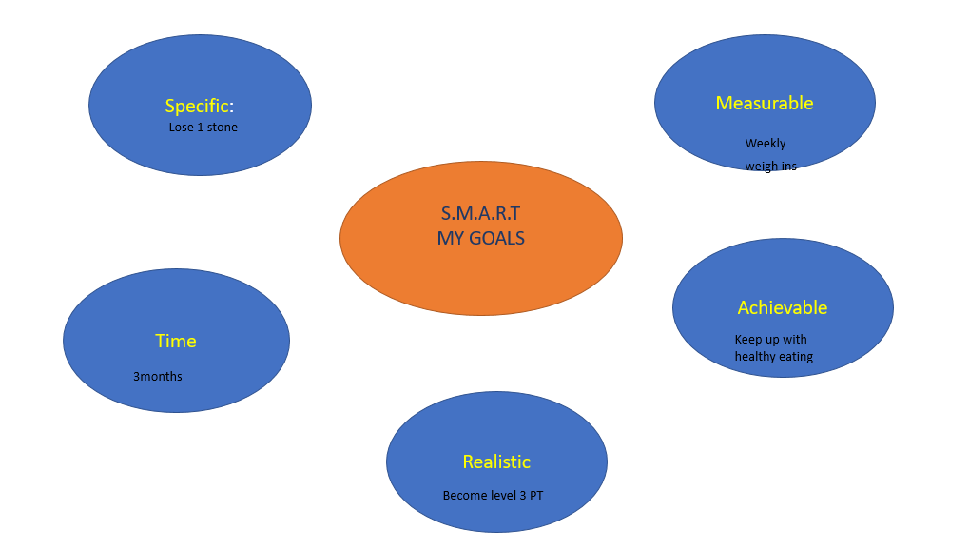

This has now led me to develop my own Personal Development Plan (Cottrell, 2010)

Name: Ranu Begum
Date | Development Need | Action Required | Target Date
22/03/2018 | Qualify in Level 3 Personal training | Attend 2 week intensive Course at David Lloyd to complete | July 2018
22/03/2018- | IT and search engine optimization | Agreed to spend time with IT department on basic use of IT and troubleshooting, learn how to use email and update social media. | June 2018
22/03/2018 | Lose 10 pounds | More weight training and eat less carbs, take part in gym triathlon, lose 4% body fat for this event. | July 2018

The above personal development plan has now put in perspective some of the areas that need improvement’s, by following some the targets. I have set will make it more meaningful and encourage develop myself for the future. This self-awareness is helpful for future CPD, explore ways of building ourselves and exploring new talent. (Megginson and Whitaker, 2007)

Different learning styles
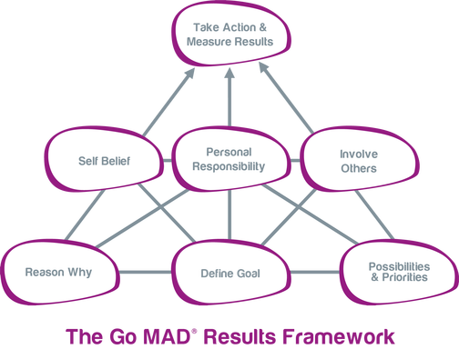
(Maslow and Frager 1987)

The Go Mad framework is designed to clarify your goals, understand possible obstacles and risks. The framework identifies simple steps that one will require to achieve the best they can be, be open and share information, involve family, friends, colleagues and reach the desired goal with clear precise planning.

Fleming (1992) Vark learning style

VARK stands for Visual, Aural, Read/write and Kinaesthetic. Vark questionnaire are a set of multiple choice questions that can assess an individual’s learning style. I took part in a VARK questionnaire and my outcome was Aural preference. I like to be vocal and engage in instructions or order, I find this much easier and clearer way of communication, however some might find other preferences more suitable to them.

An optician might prefer more Visual as their job is more based on seeking information through equipment and verbal communication.

Job Recruitment Process

Job recruitment process can be one of the most difficult tasks within an organisation, the hiring of new staff will reflect on their performance and efficiency within the organisation (Deutsch, 2018). Normally the Human Resources that is situated within the organisation will take ownership for recruitment however in some cases companies will reach out to third party recruiting companies (Reid, 2009) There are simple but critical steps that are taken to ensure that a job is advertised correctly, below a procedure is outlined in how a company will search or a suitable candidate

Process:

1: Identify the required position | Fill a position that is at need within the company
2: Prepare a suitable Job description and Person specification | This will outline basic requirements of the job advertised and skills and knowledge the candidate will need to be able to complete the job correctly
3: Advertising | Advertising in newspapers, local agencies this will give a fair opportunity for candidates from all backgrounds
4: Shortlisting | Sifting through all applications, actively looking for individuals that stand out
5: Arrange interviews | Contact all suitable candidates and arrange interview
6: Decision making | Officially welcome the new candidate on board, and let them meet the team.
Preparing the job description and person specification is utmost important

If only the recruitment process was so simple, there are many times where to fill a role becomes difficult, this could be due to the fact that jobs are not advertised in the correct places, or some individuals might feel that they can do the job, but maybe are not suitable for the environment the job is based in, eg Police force, Many black minority ethnic groups might feel that they will not be chosen for the job, feel victimised, to prevent this companies must look into advertising in more friendly places such as community centres and local pray places, where people from all backgrounds gather, this will make it more fair and promote good practice (Encyclopaedia Britannica, 2018). Having a jobs accessibility for also the disabled (Reid, 2009)
I have designed a suitable job description and Job specification that meets the requirement for the specified job role. The candidate must possess most of these skills to be considered for the job

Candidates will send in Curriculum Vitae, this is a vital document for any job application, this includes all skills and qualifications in place (Open.ac.uk 2018). The CV should include a strong personal statement

Personal Trainer
- Level 3 Personal trainer and Class Instructor

MAIN PURPOSE AND SCOPE OF THE JOB
- To provide safe exercise, encouragement, support and advice to gym members. Confidently devise exercise plans to help individuals achieve their fitness goals and coordinate group exercise classes. You will be working with specialist rehabilitation clients to elite athletes so knowledge of bespoke fitness skills will be required. The City and Guilds diploma in personal training (Level2) will be required accredited on REPS. You must be keen, hardworking and able to demonstrate knowledge and understanding towards the members in gym.

POSITION IN ORGANISATION
Reports To: Gym Manager
Responsible For: Members of the gym and class coordination

DUTIES AND KEY RESPONSIBILITIES
The main tasks that are required for the post are as follows

Class Dashboards

- Running daily fitness classes ranging from body weight to free weight, targeting different parts of the body ensuring the class meets the required goal.
- Develop safe and effective class programs that can be followed easily by other members of staff if on leave
- Ensure all equipment is used correctly, including posture control and
- Adequate warm up and stretching is provided at beginning and end of session.
- Be confident in undertaking inductions for new members of staff and members current and new, be confident in selling our current fitness packages
- Update our weekly android app with any changes to classes or updates on new sessions being provided, such as our six-week fat burn challenge or “Drop a dress size in 4 weeks”.

GENERAL RESPONSIBILITIES
- Engage in conversation with regular gym clients and answer any general questions.
- Liaise with colleagues and keep up to date with any changes, such as shifts etc
- Reply to customer emails at less busy times.
- Demonstrate correct way to use exercise equipment
- Ensure equipment and gym is clean and free of health and safety hazards
- Use general booking in system for day pass users
- Deliver general advice to gym users on diet plans, or explain options available (personal training or workshops available)
- Hourly toilet and showers checks, ensuring meets the safety standards and changing rooms are in good order.

Person specification
Please find below the Skills and qualities that you will require to complete tasks for the above role. You must show and give examples in how you possess these requirements.

 | Criteria | Essential (E) or  Desirable (D)
Skills and Abilities | Clear and concise written and spoken communication skills  Recognised Fitness Instructor Level 2 qualification  Ability to present written information in a structured and balanced way appropriate to meet client’s requirement  Fluent in Welsh language  Experience as working as a Personal Trainer (2 years)  Knowledge of computer systems  Friendly  Dynamic Personality  Passion for Fitness  Listening | E  E  D  D  D  E  E  E  E  E
Experience | At Least 2 year’s work experience in a gym based environment  Provide support and guidance in fitness related matters with members  Knowledge of constructing different types of exercise classes  Working as part of team, being able to follow rules and provide support where necessary.  Confident in working alone at less busy times. | E  D  E  E  E
Knowledge | Designing Exercise classes  NASM or, another National Certificate  Knowledge of Anatomy  Safety Techniques  Current Fitness trends  Confidently demonstrate Exercises  Undertake client Assessment | E  E  D  E  D  E  E
Personal Attributes and other requirements | Wiling to work at other partnership gyms if required  A good team worker, demonstrate positive skills within the workplace, alongside others  Effectiveness with Diverse clients  Keen to learn various training methods eg kettle bells, spin ect | E  E  E  D

Interview Process
There are few types of interviews an employer might consider (Statistics Solutions, 2018), they are
: Unstructured- These are normally verbal interviews, where the candidate is asked a few questions that concerns the job, however sometimes candidates can steer away from the question in play and move on to another topic

: Semi structured interview- This is a mostly guided interview where the participant is asked planned questions to be able to retrieve more in-depth information and targeted requirements. This can be via their opinions, thoughts and feelings

: Structured interview- A more well thought out, constructed questions or tasks. Many organisations or large firms will have candidates undergo tasks in an assessment centre, these have become widely popular and are proving to be useful (Akademaiai.com. 2018).

Assessment centres

Assessment centres are held at company location or hotels, these comprise of a series of tasks held by the employer to test the candidate. Some tests will include
: Written test
: Aural Test
: Psychometric tests
: Team work skills
: Analytical skills
: Presentations

Candidates will work individually as well as part of a team. This is an opportunity for the candidate to stand out from the rest, especially if given the opportunity to present a presentation, as this will show Aural skills, planning, creativity as well many other skills. The employer will be able to select a candidate that shows he/she possess a lot of skill and future potential for the job role.
It is vital for a candidate to do prior research (statistics Solutions, 2018, Akademaiai.com. 2018). The candidate should read the job description, person specification thoroughly and if in doubt, contact the human resources for any further guidance. Practice potential tests with family and friends, this will help build confidence and improve on any flaws that are recognised.

It is also useful to get your outfit ready and catch up on a good sleep, as a clear fresh mind alongside a goodnights sleep can help wonders when standing up and presenting yourself.

Conclusion

Career development is utmost important for career success, some of the skills I have outlined are dominate in the world of success. Looking at my personal goals, I feel I am on the right path, by acknowledging my strengths and weaknesses this is the first step to development. I am confident that I can overcome barriers by using the objectives I have laid out. This can be supported by using the Personal Development Plan I have created for myself, following the goals I have set out for myself. Making use of all available help, such as speaking to my tutors, work colleagues even my partner, as sometimes just verbally talking about any help or support to close ones can help them to understand the barriers we face and provide comforting advice, even words of wisdom.

Using the different learning styles such as VARK or the Kolb theory, these can help personal career development as sometimes as time goes by you might feel you’re learning style preference has changed to continuously checking and testing yourself is good form of self-development. Understanding the interview process for job recruitment it utmost important, I think in my chosen job role as a fitness instructor a more physical assessment interview is necessary as this will reflect on how you will perform in the fitness industry, this brings me to my weight loss goal that I have set out to achieve and will try my best to succeed in the three months so I will be able to perform my work in a more effective manner and make myself a more viable candidate for future jobs.

Recommendations

In future I would recommend that I manage my time more productively, I can adhere to this by keeping a diary, making notes on my phone and arranging realistic goals.

Read more books on exercise and fitness to gain more knowledge on current trends and routines.
Sustain a healthier eating regime, refer to more nutrition books or speak to a professional
Liaise with other members of work team and engage group workouts to increase fitness level
Manage my time more effectively, this will prevent me from rushing and not completing a task to the best of my knowledge and competence.
Create a PDP for myself alongside a SMART objective to meet my current needs

Try and lead a healthy work/life balance which will reflect in generally being happier.

Bibliography

Alchikov, N., & Boud, D. (1989). Student self-assessment in higher education: a meta-analysis. Review of Educational Research, 59(4), 395-430. doi:10.3102/00346543070003287 Retrieved from http://rer.sagepub.com/content/59/4/395.full.pdf+html
Akademiai.com. (2018). Advantages and limitations in the use of impact factor measures for the assessment of research performance | Scientometrics. [online] Available at: https://akademiai.com/doi/abs/10.1023/A%3A1014800407876 [Accessed 28 Mar. 2018].

Cottrell, S. (2010). Skills for success. Basingstoke: Palgrave Macmillan.
Coulson, M & Archer, D. (2008). The Advanced Fitness Instructor’s Handbook. London: Bloomsbury Publishing.
Deutsch, M. (2018). 10 Critical Recruitment Process Steps |Top Echelon. [online] Top Echelon. Available at: https://www.topechelon.com/blog/placement-process/10-critical-recruitment-process-steps/ [Accessed 27 Mar. 2018].

Encyclopedia Britannica. (2018). Fair Employment Practices Committee | United States history. [online] Available at: https://www.britannica.com/topic/Fair-Employment-Practices-Committee [Accessed 28 Mar. 2018].

Everything, 9. (2018). 9 Reasons Why Your Image Is Everything. [online] Business Insider. Available at: http://www.businessinsider.com/why-your-image-is-everything-12-2011?IR=T#it-takes-01-seconds-to-form-a-lasting-impression-of-a-stranger-1 [Accessed 28 Mar. 2018].

Fair Work Ombudsman. (2018). Welcome to the Fair Work Ombudsman website. [online] Available at: https://www.fairwork.gov.au/employee-entitlements/flexibility-in-the-workplace [Accessed 27 Mar. 2018].
Harrison, R. (2009). Learning and development. London: Chartered Institute of Personnel and Development.
Lawther, J. (2018). The SMART Goal Myth. [online] The Squawk Point: Service Improvement. Available at: https://www.squawkpoint.com/2013/12/smart-goals/ [Accessed 28 Mar. 2018].
Maslow, A. and Frager, R. (1987). Motivation and personality. New Delhi: Pearson Education.
Megginson, D. and Whitaker, V. (2007). Continuing professional development. London: Chartered Institute of Personnel and Development.
Mindtools.com. (2018). Time Management: Beat Work Overload. Be More Effective. Achieve More. [online] Available at: https://www.mindtools.com/pages/main/newMN_HTE.htm [Accessed 28 Feb. 2018].
Open.ac.uk. (2018). What is a CV? | Unison. [online] Available at: http://www.open.ac.uk/choose/unison/develop/my-skills/cv-writing [Accessed 29 Mar. 2018].
Reid, M. (2009). Human resource development. Londres: Chartered Institute of Personnel & Development (CIPD).
Seth, C. (2015). Swot analysis. Namur: 50minutes.
Statistics Solutions. (2018). Choosing an Interview Type for Qualitative Research - Statistics Solutions. [online] Available at: http://www.statisticssolutions.com/choosing-an-interview-type-for-qualitative-research/ [Accessed 28 Mar. 2018].
Tem-journal.com. (2018). [online] Available at: http://tem-journal.com/documents/vol1no4/pdf/Strategy%20development%20by%20using%20SWOT%20-%20AHP.pdf [Accessed 27 Mar. 2018]
Training, A. (2018). How Technology Can Improve Time Management Skills. [online] Activia Training. Available at: https://www.activia.co.uk/blog/how-technology-can-improve-time-management-skills [Accessed 28 Mar. 2018].

Appendices

Acknowledgements

