

Programme: Master of Business Administration
Module: Human Capital Management

Module code: LCMB7023
Lecturer: Gladius Kulothungan Eno Maycock

Assignment Title: Assessment component 1: Individual report

Topic: Designing Human Capital Architecture for Strategic Renewal
For Helios Urban Mobility

Student name: Sajan Hareshbhai Vekariya
Student ID number:2529464

Word Count: 2791

Table of Contents
1. Task A: Socialisation, Identity and Business Activism at Helios Urban Mobility 3
1.1 Traditional Onboarding versus Strategic Organisational Socialisation 3
1.2 Structured Socialisation Framework for Helios Urban Mobility 5
1.3 Mechanisms to Cultivate Organisational Identification, Ethical Professionalism and a Business Activist Mindset 6
2. TASK B: Job Design 8
2.1 Innovative job design strategy 8
2.2 Job Crafting Theory 9
2.3 Internal Talent Marketplaces 10
2.4 Proposed Job Design supporting innovation and intrinsic motivation 11
3. TASK C: Reflective report 13
3.1 Using AI as a Decision-Support Tool While Preserving Critical Human Judgement 13
3.2 Personal Capability Development Plan 14
4. Conclusion 14
Reference list 16
Appendices 20
Appendix 1: Organisational socialization theory by Van Maanen & Schein 20
Appendix 2: HUM Job Characteristics Model 21

1. Task A: Socialisation, Identity and Business Activism at Helios Urban Mobility

1.1 Traditional Onboarding versus Strategic Organisational Socialisation
The induction procedure centres on administrative procedure, such as signing contracts, meeting the training requirements, gaining access to IT equipment, and orientation to their role. These activities can be used to initiate people, but they do not have an organisational commitment and cultural integration relationship. At Helios Urban Mobility (HUM), which takes about 8 months for new hires to be productive and is seeing a drop in engagement from 66% to 54%, a transactional onboarding approach is not enough, since it doesn't help accelerate the sharing of knowledge, building identity, or collaboration with geographically dispersed teams.
Strategic OOS is not only carried out in an orientation but it is also done during the employment process, having an influence on the attitudes of the employees, their actions and even the identity of their organisation. Based on organisational socialisation theory by Van Maanen & Schein, uncertainty and role ambiguity can be reduced by institutionalised processes like collective learning, formal mentoring, sequential career development or serial guidance (Refer to Appendix 1) . In the context of the projects regarding AI driven mobility, the structured approaches are particularly relevant for HUM, because of the interdisciplinary collaboration and knowledge transfer between London, Berlin and Singapore, timely (Richardson, 2025).
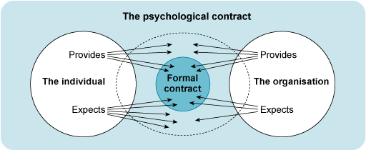
Figure 1: Psychological Contracts
(Source: open.edu. 2026)
Another area in which the theory of Psychological Contracts can help to illuminate the formation of employees' career advancement, support, fairness and recognition expectations is the informal nature of the contract (Safitri, 2026). In such instances, employees will be more likely to remain committed, engaged, and in the company. If expectations are not fulfilled, however, then there is not only displeasure, but also high-potential graduates will be leaving early from the organisation. Therefore it is crucial that HUM establish realistic expectations prior to employment and offer developmental opportunities during this year.
In terms of Identity Construction, membership of the organisation can be seen as an ongoing process and not one induction event (Cornelissen et al., 2021). The values of the organisation start to become embedded within the staff as they work together on projects, see the leadership behaviours and help contribute to the meaningful work of the organisation. As part of sustainable urban mobility and smart city innovation, the HUM staff should not only be a bunch of technical experts, but also a bunch of actors, who are related to environmental sustainability and public value creation.

1.2 Structured Socialisation Framework for Helios Urban Mobility
Helios should have a formalised socialisation system of pre-boarding, first 90 days and year one, consistent learning and cultural embedding and not induction programmes. Pre-Boarding should begin at the time of the acceptance of the offer. Engaging new staff to be introduced to HUM's Mission and Values, the goals and behaviours of sustainability and the innovation strategy of AI through digital learning materials and resources. Providing online learning materials and introducing upcoming colleagues through virtual means, as well as providing a cross-functional mentor prior to the first day of work will help eliminate some uncertainties and build psychological buy-in (Majka, 2024).
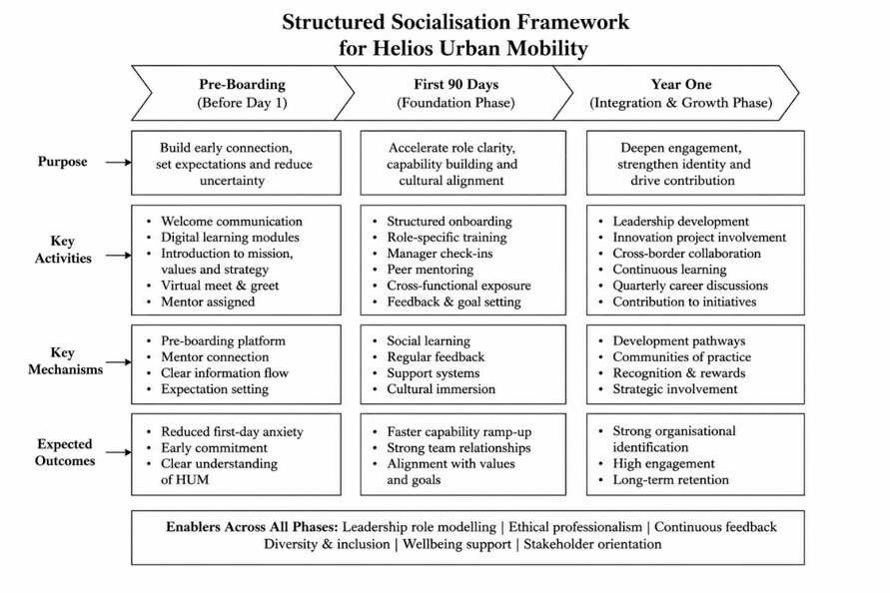
Figure 2: Structured Socialisation Framework
(Source: self-developed)
Technical ability and Cultural integration should be in the first 90 days. New staff should be made aware of the induction workshops, where they will be able to find out how OISC works internationally and will have the opportunity to develop working relationships with staff from all three of the international offices (Majka, 2024). Acknowledge any difficulties with adjustment and double up on reinforcement of organisational expectations with weekly check-ins with manager, peer mentoring and role specific learning plans as well as regular feedback sessions (Saddiqi and Mohmmadi, 2025). Further exposure to each of the engineering and analytical teams, and customer engagement and sustainability teams, would help to build understanding of the organisation and encourage inter-disciplinary collaboration.
All emphasis should be on long-term development and contribution to the organisation during year one. Staff should be invited to be part of innovation projects, leadership coaching, CPD programmes and international secondments to improve international cooperation (Saddiqi and Mohmmadi, 2025). It is an organized approach and legitimate approach as it is a continuous development process of adjustment and it systematically minimizes the adjustment period, improves engagement and promotes international cooperation and increased retention of high potential employees.

1.3 Mechanisms to Cultivate Organisational Identification, Ethical Professionalism and a Business Activist Mindset
The employees have to believe that their values are aligned with the organisation's purpose to boost organisational identification. HUM needs to share its role in sustainable cities, sustainable mobility and responsible use of AI in public innovation, by being a leader in the stories we tell, the projects we implement and the recognition programmes we launch that require behaviours that are congruent with our values (Tourky, Osman and Harvey, 2023). International locations could further enhance the emotional connection and sense of belonging to the whole company with cross departmental collaboration, mentoring and participation in strategic innovation projects (Saddiqi and Mohmmadi, 2025). Ethical professionalism is also key as HUM's AI-powered mobility solutions have a direct impact on the wellbeing of citizens and public infrastructure. Ethical professionalism goes beyond training compliance to practicing responsibly with AI, protecting data privacy, ensuring transparency, promoting sustainability and addressing the stakeholder responsibility in decision making.
A business activist point of view would be required in HUM, as the new strategic role of HRM. In the Ulrich's model of HR Business Partner, apart from technical skills and knowledge to the organisation, the employee should also participate in the change, innovation and value creation to the stakeholders of the organisation (Ahmad et al., 2022). It is important for employees not only to do this in functional terms, but to look for opportunities to improve the performance, sustainability, wellbeing of employees and outcomes of customers of the organisations they are working for.
Stakeholder capitalism is about creating value for employees, customers, governments, communities and the environment as well as financial performance for the organisation to be successful (Shahrokhi et al., 2022). This can be done by embedding this mindset in HUM during the training of their employees, such as having them involved in sustainability innovation challenges, community mobility partnerships, problem-solving teams with different disciplines and continuous improvement teams to tackle larger societal problems.

2. TASK B: Job Design

2.1 Innovative job design strategy
Helios Urban Mobility (HUM) needs to identify and update roles, developing them according to the job characteristics framework from Hackman and Oldham's Job Characteristics Model. Also, a detailed table form of this is highlighted in Appendix 2.
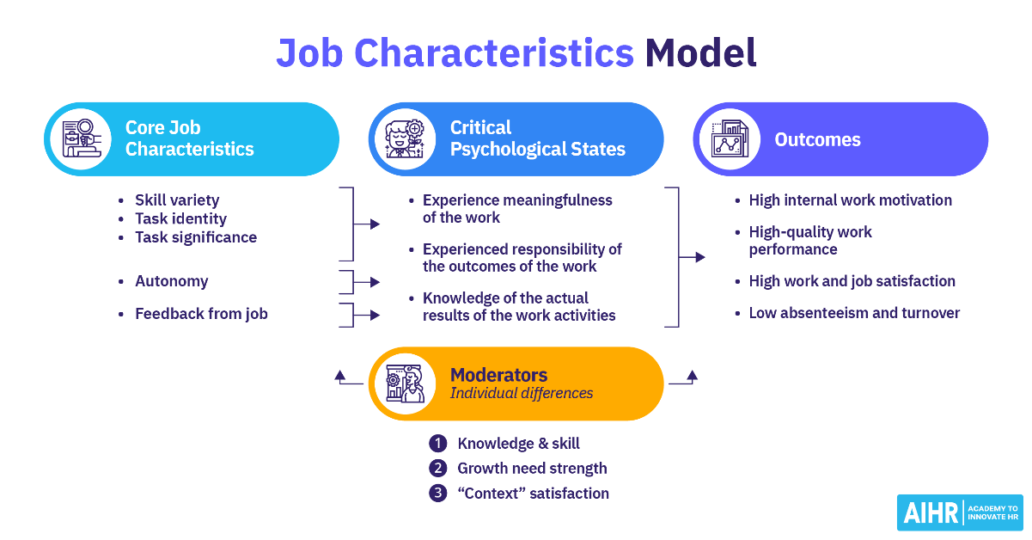
Figure 3: Framework of the Job Characteristics Model
(Source: Lucas, 2026)
Core Job Characteristics: Rotating tasks within projects to provide opportunities to build diversity, such as AI engineering, mobility analytics, and client implementation. Creating task identity through end-to-end project ownership, such as design and implementation. Increasing the significance of tasks by highlighting the impact of tasks on urban mobility, decreasing congestion and building sustainable cities (Caros and Zhao, 2022). Giving more freedom to teams and letting them use their common sense in technical and time planning. Feeding them more feedback at sprint reviews, via AI performance dashboard and coaching.
Critical Psychological States: These psychological states are key factors in HRM and important to their professional lives (Helin, 2024). The job opportunities among them that become more diverse, complete and social mean that there is also increased meaningfulness. The higher the degree of autonomy allowed, the more responsibility is felt.
Moderators: This design is amplified by the moderating factors of employee technical knowledge and skills, growth need, strength and context satisfaction (Gall et al., 2023). These are achieved through continued learning and support of collaborative leadership and modern digital workplaces.
Outcomes: As a result, there will be greater internal motivation for work, higher job performance and satisfaction, and lower employee absenteeism and turnover at HUM. There is research to support the success of the Job Enrichment changes. As per Gall et al. (2023), highly engaged teams increase profitability by 23%, productivity by 18%, and reduce turnover rates by 43%.

2.2 Job Crafting Theory
Helios Urban Mobility (HUM) must be based on Job Crafting Theory, whereby employees are able to modify jobs to suit their skills, interests and career objectives. For employees to engage in innovation projects, cross-functional team projects, or learning and development related to organisational goals, they should be provided with an opportunity to allocate 10% of their time to such projects. One example might be an AI engineer who could devote time to sustainability analytics or innovation initiatives related to smart cities (Helin, 2024).
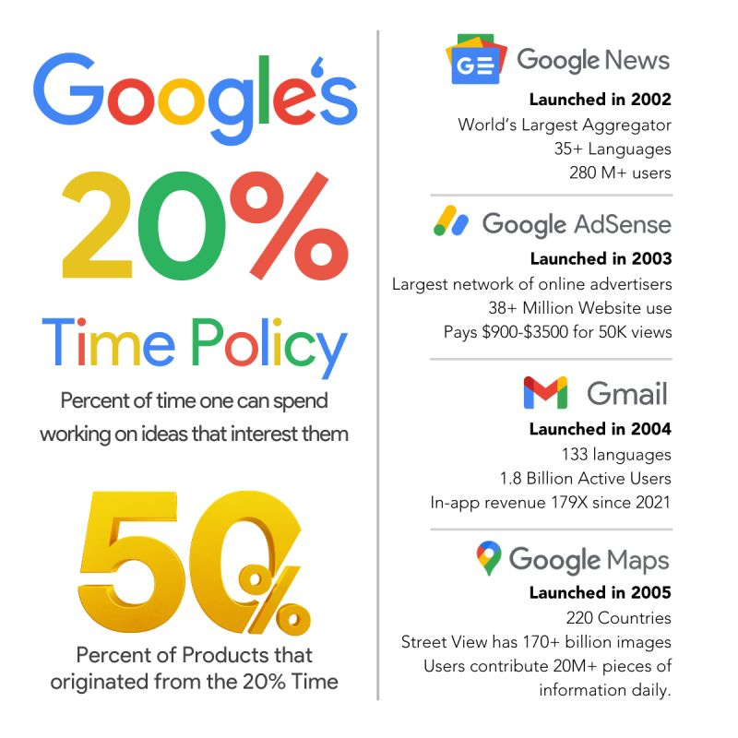
Figure 4: Google’s 20% Policy
(Source: Wali, 2024)
Collaborating with and learning from one another by mentorship and support across disciplines would encourage knowledge sharing. An understanding of how safer and more sustainable modes of transportation can positively influence society could benefit workers. Supporting evidence for job crafting comes from Microsoft's Work Trend Index 2023, showing that workers who have more autonomy and flexibility have higher levels of job satisfaction, as per Wali. (2024), Google's 20%-time policy, such as Google News, Gmail, Google Maps and Google AdSense, led to the creation of new features. In the early 2000s, Google not only redefined innovation but also reimagined how work could be done innovatively.

2.3 Internal Talent Marketplaces
Helios Urban Mobility (HUM) must create an AI-driven Internal Talent Marketplace (ITM) that matches the skills, learning interests, career aspirations, and current projects and assignments of employees. This would unfilled internal opportunities of other internal employees to whom they might provide mentoring assistance. This platform would meet the needs of employees with the opportunity to learn about AI engineering, product development, customer success, and smart-city consulting within the company. This cross-functional mobility will contribute to better skills development, visibility of careers and fewer attributes. Additionally, ITMs enable managers to easily harness the existing workforce by spotting and reaching out to talent from within, thus lowering recruitment expenses and making the workforce more flexible. Some of the other often-cited examples of successful implementation of ITM are Unilever's FLEX Experiences, which have enabled more than 50,000 employee engagements in projects and mentoring. Schneider Electric's Open Talent Market, which helped boost employee mobility internally and minimise the need for hiring externally. Organisations with a low number of internal opportunities offer employees more than two times the retention rate of those with limited opportunities for development.

2.4 Proposed Job Design supporting innovation and intrinsic motivation
The proposed job design will entail using the Job Characteristics Model (JCM), Job Crafting, and the Internal Talent Marketplace (ITM). This is intended to foster intrinsic motivation and innovation within Helios Urban Mobility (HUM). The firm is taking eight months for onboarding, has a 54% employee engagement level, and has a high turnover of graduates (Chen et al., 2024). HUM needs to design a job that will help its employees grow their capabilities and encourage innovation. Moreover, intrinsic motivation can be improved through autonomy, competence, and meaningfulness. The Job Characteristics model applies here at HUM to enhance skill variety by implementing cross-functional AI engineering-related projects and carrying out analytics and client implementation projects (Hernaus et al., 2024). The job can increase task identity because of its ability to manage projects from designing to deploying them, and task significance because of the employee's understanding of how his/her work helps achieve sustainable urban mobility.
Their autonomy with job duties may improve the likelihood of having control over technical choices, and feedback could come in a continuous stream through sprint reviews and performance dashboards. By organising the opportunity, called Job Crafting, the issue of innovation capabilities and interest to employees can be addressed, leading to higher employee motivation (Xu et al., 2022). It offers project-dependent assignment, mentoring and internal promotions in the Internal Talent Marketplace for everlasting learning and to prevent stagnation. They are effective and viable measures that are supported by evidence. ShipIt Days at Atlassian provide employees with 24 hours to think outside the box to propose lots of product enhancements. There have been over 6,000 innovation toolkits given to the employees as part of the Kickbox initiative at Adobe. Companies showing high employee mobility can keep their employees approximately 2.4 times longer than companies with low employee mobility opportunities (Hernaus et al., 2024). This particular integrated job design will allow Helios Urban Mobility to get the reduction in the period of onboarding and increase their engagement rate.

3. TASK C: Reflective report

3.1 Using AI as a Decision-Support Tool While Preserving Critical Human Judgement
I will employ the use of Artificial Intelligence (AI) as a decision-making assistive tool, seeking to improve the quality, timeliness and consistency of decision making, and always remember that the human element is critical when making a decision. AI can assist here by analysing huge amounts of data, detecting patterns, predicting and recommending based on data, for more strategic planning and better operational efficiency (Nweke and Adelusi, 2025). I do understand, however, that AI has to rely on the past and algorithms which can harbour biases, or fail to consider complex organisational, ethical or cultural aspects. Therefore I will think and not take my gut. Final decisions will be made following AI's recommendations and organizational objectives, stakeholder expectations and professional experience. If the health of my employees is involved, if there is an ethic I need to consider, if I want to change the way I do things, if I don't know what the strategy should be, there, I will be guided by the careful use of empathy, contextual understanding and ethical reasoning, which AI cannot do (Ho and Lee, 2025). I will also make an effort to be honest and make sure that I understand how AI is making recommendations and that if it gives me contradictory recommendations from AI, then it gives me recommendations that lack supporting evidence as well. Furthermore, I will seek to deepen my understanding and abilities of data literacy and critical thinking to better understand the information gained from AI without overly depending on technology. The analytical power of AI is crucial, combined with human values and sense of responsibility, and strategic planning all play a role in making balanced, fair and informed decisions that contribute to the success of the company and the long-term value of the company's stakeholders.

3.2 Personal Capability Development Plan
Capability Area | Development Activities | Expected Employability Outcome
Data Literacy | I Will complete the advanced training of Excel, Power BI and HR analytics and will use real-life examples and HR dashboards to practice data interpretation during training. I will also hone my presentation skills of HR metrics and evidence-based information. | Better use of information for decisions on staffing, knowledge of staffing patterns and trends, providing evidence for organisational strategy.
AI Augmentation in HR | I will have real-world experience implementing an AI solution in HR; recruiting analytics, Talent Management Platform and Generative AI solutions (Al-Kfairy et al., 2024). I will also get to learn about the ethical, governance and responsible use of AI for balancing use in HR practice. | Strategic decision-making support of AI - Ethical and fair, putting people at the centre of people management and decision making.
Strategic Influencing Skills | The skills of communication, negotiation, managing stakeholders and presentation skills will be developed in reflection, collaborative projects and leadership workshops. Regular feedback will continue to develop my skills in influencing organisational decision making further. | Increased influence over the actions of senior leaders, influence on collaboration or be able to contribute to strategic HR projects and change (Agu et al., 2024).
Global Mobility Awareness | I will develop my awareness of international HRM, cross-cultural leadership, employment law and international talent management by studying international case studies, through professional qualifications and multicultural team working opportunities. | Improved competencies in communicating with various groups, overseas companies and adjusting to an international organization.

4. Conclusion
Based on the overall analysis of the report the outcomes illustrate how an effectively constructed human capital framework can contribute to the renewal of Helios Urban Mobility by increasing the participation of workers in the work process, innovativeness, and productivity. Implementing a well-established socialisation framework with organizational identification, ethical business conduct, and activism mindset can raise the interest of employees in their work and bring the process of integration to a new level. Moreover, the synergy between the Job Characteristics Model, Job Crafting Theory, and an Internal Talent Marketplace allows one to create exciting jobs aimed at personal development and increasing the level of intrinsic motivation and innovations. Overall, the report also reveals the necessity of strong interlinks between the use of AI technology together with human decisions. The combination of the recommendations enables to create not only an innovative workforce but also helps in providing benefit from the competitive advantage in the long run competitions.

Reference list
Agu, E.E., Iyelolu, T.V., Idemudia, C. and Ijomah, T.I., (2024). Exploring the relationship between sustainable business practices and increased brand loyalty. International Journal of Management & Entrepreneurship Research, 6(8), pp.2463-2475. https://www.researchgate.net/profile/Tochukwu-Ijomah-2/publication/383847817_Exploring_the_relationship_between_sustainable_business_practices_and_increased_brand_loyalty/links/66dc447d2390e50b2c7212e7/Exploring-the-relationship-between-sustainable-business-practices-and-increased-brand-loyalty.pdf
Ahmad, A., Fareed, M., Isa, M.F.M. and Salleh, S.S.M.M., (2022). Revealing the moderating role of organizational support in HR professionals’ competencies, willingness, and effectiveness relationship: Empirical evidence from a developing economy. Frontiers in Psychology, 13, p.756255. https://www.frontiersin.org/journals/psychology/articles/10.3389/fpsyg.2022.756255/pdf
Al-Kfairy, M., Mustafa, D., Kshetri, N., Insiew, M. and Alfandi, O., (2024), August. Ethical challenges and solutions of generative AI: An interdisciplinary perspective. In Informatics (Vol. 11, No. 3, p. 58). MDPI. https://www.mdpi.com/2227-9709/11/3/58
Caros, N.S. and Zhao, J. (2022). Preparing urban mobility for the future of work. arXiv preprint arXiv:2201.01321. https://arxiv.org/abs/2201.01321
Chen, H., Chen, X. and Pan, Y., (2024). Exploring the Mediating Role of Intrinsic Motivation Between Innovation Support and Innovative Behaviour: An Empirical Study Based on a Design Thinking Course. International Journal of Learning, Teaching and Educational Research, 23(6), pp.32-55. https://www.researchgate.net/profile/Fatima-Belkhir/publication/384864418_Vol_23_No_6_June_2024/links/670aaa32ab024170996e43d3/Vol-23-No-6-June-2024.pdf#page=39
Cornelissen, J.P., Akemu, O., Jonkman, J.G. and Werner, M.D., (2021). Building character: The formation of a hybrid organizational identity in a social enterprise. Journal of Management Studies, 58(5), pp.1294-1330.https://onlinelibrary.wiley.com/doi/pdfdirect/10.1111/joms.12640
Gall, T., Vallet, F., Madrigal, L.M.R., Hörl, S., Abdin, A., Chouaki, T. and Puchinger, J. (2023). Sustainable urban mobility futures. Palgrave Macmillan.
Helin, E.M. (2024). Designing the Future of Employment Services: Design choices in a case study project. https://aaltodoc.aalto.fi/items/6b196168-0072-4c77-bd9e-0f88a92befe8
Hernaus, T., Dragičević, N. and Hauff, S. (2024). The necessity of job design for employee creativity and innovation: nothing happens without supervisor support. European Journal of Work and Organisational Psychology, 33(5), pp.583-598. https://www.tandfonline.com/doi/abs/10.1080/1359432X.2024.2348772
Ho, C.S.M. and Lee, J.C.K., (2025). From intuition to action: Exploring teachers’ ethical awareness in the use of AI tools in education. Computers and Education: Artificial Intelligence, p.100502. https://www.sciencedirect.com/science/article/pii/S2666920X25001420
Lucas, S. (2024). Job Characteristics Model: A Practical Guide, AIHR. Available at: https://www.aihr.com/blog/job-characteristics-model/ (Accessed on 15th July, 2026)
Majka, M., (2024). Crafting the perfect onboarding process. HR Future Journal.https://www.researchgate.net/profile/Marcin-Majka-2/publication/387075901_Crafting_the_Perfect_Onboarding_Process/links/675f6e2c2547a96a923c4237/Crafting-the-Perfect-Onboarding-Process.pdf
Nweke, O. and Adelusi, O., (2025). Utilizing AI driven forecasting, optimization, and data insights to strengthen corporate strategic planning. International Journal of Research Publication and Reviews, 6(3), pp.4260-4272. https://www.researchgate.net/profile/Oluwatosin-Adelusi/publication/391704360_Utilizing_AI_Driven_Forecasting_Optimization_and_Data_Insights_to_Strengthen_Corporate_Strategic_Planning/links/6823a896be1b507dce8b0c4f/Utilizing-AI-Driven-Forecasting-Optimization-and-Data-Insights-to-Strengthen-Corporate-Strategic-Planning.pdf
open.edu. (2026). Available at: https://www.open.edu/openlearn/mod/oucontent/view.php?id=50108&section=4.3 (Accessed: 15 July 2026).
Richardson, N., (2025). Building Foundations: The Role of Communication and Onboarding in Academic Advising Training.https://opus.govst.edu/cgi/viewcontent.cgi?article=1659&context=capstones
Saddiqi, M.D. and Mohmmadi, H., (2025). A Review on the Effects of Artificial Intelligence in a Society. Farah Research and Scientific Journal, 2(2), pp.289-311. https://frsj.farau.edu.af/index.php/frsj/article/download/111/90
Safitri, D., (2026). Understanding Psychological Contract Shifts from Employee and Employer Perspectives: The Influence of Organizational Climate as a Moderating Role-Evidence from Indonesia.https://pea.lib.pte.hu/bitstreams/ef44ea8a-e091-4735-a56c-8a365b5cc5d8/download
Shahrokhi, M., Parhizgari, A.M., Hashemijoo, M., Okafor, C.E., Nishikawa, Y. and Dastan, A., (2022). Corporate governance and stakeholder capitalism. Managerial Finance, 48(8), pp.1123-1136. https://www.researchgate.net/profile/Manuchehr-Shahrokhi/publication/358935200_Corporate_governance_and_stakeholder_capitalism/links/624d3dd0b0cee02d69542cfe/Corporate-governance-and-stakeholder-capitalism.pdf?origin=journalDetail&_tp=eyJwYWdlIjoiam91cm5hbERldGFpbCJ9
Tourky, M., Osman, S. and Harvey, W.S., (2023). Aligning employee and organizational values to build organizational reputation. Asian Business & Management, 22(4), pp.1618-1648. https://dspace.lib.cranfield.ac.uk/bitstreams/22f6a12e-ff51-47d5-945d-8fd54eeda452/download
Wali, R. (2024) leadership consulting #google #companypolicy: Ridima Wali, LinkedIn. Available at: https://www.linkedin.com/posts/ridimawali_nyraleadershipconsulting-google-companypolicy-activity-7277300013607628800-NQyb/
Xu, Z., Wang, H. and Suntrayuth, S., (2022). Organisational climate, innovation orientation, and innovative work behaviour: the mediating role of psychological safety and intrinsic motivation. Discrete Dynamics in Nature and Society, 2022(1), p.9067136. https://onlinelibrary.wiley.com/doi/abs/10.1155/2022/9067136

Appendices

Appendix 1: Organisational socialization theory by Van Maanen & Schein
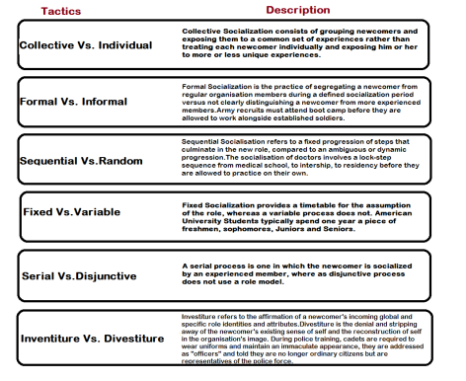
http://zenithresearch.org.in/images/stories/pdf/2012/JUNE/EIJMMS/9_EIJMMS_VOL2_ISSUE6_JUNE2012.pdf

Appendix 2: HUM Job Characteristics Model
JCM Section | Sub-section | Key Points (HUM)
Core Job Characteristics | Skill Variety | Cross-functional project rotation
 | Task Identity | End-to-end project ownership
 | Task Significance | Improve urban mobility & sustainability.
 | Autonomy | Agile team decision-making
 | Feedback | Sprint reviews, AI dashboards & coaching
Critical Psychological States | Experienced Meaningfulness | Meaningful and impactful work
 | Experienced Responsibility | Greater ownership through autonomy
 | Knowledge of Results | Continuous performance feedback
Moderators | Knowledge & Skill | Continuous technical training
 | Growth Need Strength | Career development & learning
 | Context Satisfaction | Supportive leadership & digital workplace
Outcomes | High Internal Motivation | Increased engagement
 | High-Quality Performance | Better productivity & innovation
 | High Work & Job Satisfaction | Improved employee satisfaction
 | Low Absenteeism & Turnover | Higher retention, reduced turnover

