

HEALTHCARE AS A BUSINESS IN THE ERA OF FAST DEVELOPMENT OF TECHNOLOGY AND INNOVATION

Written by Pawel Gminski
Student Number: 1602415
Supervisor: Roisin Mullins

MASTER OF BUSINESS ADMINISTRATION 2020

DECLARATION

This work has not previously been accepted in substance for any degree and is not being concurrently submitted in candidature for any degree.

Signed .........Pawel Gminski................................................ (candidate)

Date ............26.07.2020..................................................

STATEMENT 1
This work is the result of my own investigations, except where otherwise stated.
Other sources are acknowledged by footnotes giving explicit references. A bibliography is appended.

Signed ..........Pawel Gminski.............................................. (candidate)

Date ........26.07.2020......................................

STATEMENT 2
I hereby give consent for my work, if accepted, to be available for photocopying and for inter-library loan, and for the title and summary to be made available to outside organisations.

Signed ................ Pawel Gminski................ ................ (candidate)

Date ..................26.07.2020. ................ ................

Acknowledgement

I would like to express my deep gratitude to Dr Roisin Mullins, my research supervisor, for patient advice, professional guidance, and useful critique.

I would also like to thank to Dr Alex Bell, MBA programme leader for his professional approach throughout the process of learning, and towards the end of my final project.

Finally, I would like to thank my parents and my family for understanding, encouragement, and support.

Table of Content

Chapter One – Introduction………………………………………….. 1
1.1 Introduction………………………………………………………….. 2
1.2 Number of people using healthcare in the United
Kingdom………………………………………………………………. 3
1.3 Healthcare appointments at the General Practitioner
Doctors (GPs) in the United Kingdom…………………………..4
1.4 Diagnostics and Treatment Waiting Time………………………4
1.5 Population and Median Age………………………………………..8
1.5.1 Population and median age in the United Kingdom…….8
1.5.2 Population and median age in the world……………….. .9
1.6 Ageing of population………………………………………………11
1.6.1 Ageing of the population in the United Kingdom……..11
1.6.2 Ageing of the population worldwide……………………..12
1.7 Life expectancy……………………………………………………..13
1.8 Digital transformation…………………………………………….14
1.9 Technological changes that improve healthcare…………….17
1.10 Conclusion………………………………………………………….19
1.11 Objectives of this research……………………………………..19
1.12 Aims………………………………………………………………….20

Chapter Two – Literature review……………………………………21
2.1 Introduction……………………………………………………………….22
2.2 What is health……………………………………………………….22
2.3 Need for health……………………………………………………..24
2.4 What is healthcare………………………………………………….24
2.5 Importance of healthcare………………………………………….27
2.6 Current situation in healthcare………………………………….29
2.7 Innovation…………………………………………………………………30
2.7.1 Disruption of innovation…………………………………….31
2.7.2 Diffusion of innovation………………………………………32
2.8 Innovation in healthcare………………………………………….33
2.9 Consumer behaviour………………………………………………..36
2.10 Future of healthcare………………………………………………38
2.11 Conclusion………………………………………………………….39

Chapter Three – Research methodology…………………………..40
3.1 Introduction………………………………………………………….41
3.2 What is research…………………………………………………….41
3.3 Research design……………………………………………………..41
3.4 Choosing appropriate methods…………………………………..43
3.5 Data gathering methods…………………………………………..44
3.5.1 Survey……………………………………………………………45
3.5.1.1 Target sample…………………………………………….45
3.5.1.2 Sampling methods……………………………………….46
3.5.2 Interview………………………………………………………47
3.5.3 Case study…………………………………………………….47
3.6 Analysis………………………………………………………………48
3.7 Identifying and avoiding biases…………………………………48
3.8 Ethics in business research………………………………………49
3.8.1 Ethical form……………………………………………………49

Chapter Four – Findings and analysis……………………………..50
4.1 Introduction………………………………………………………….51
4.2 Survey analysis……………………………………………………..51
4.2.1 Correlation and chi square analysis of age group and
and awareness of available apps or services to support
healthcare……………………………………………………….65
4.2.2 Correlation and chi square analysis of age group and
skills and knowledge to access healthcare related
products and services online……………………………….67
4.2.3 Conclusion……………………………………………………..68
4.3 Case study……………………………………………………………68
4.3.1 Conclusion……………………………………………………..70
4.4 Interviews……………………………………………………………71
4.4.1 Conclusion……………………………………………………..71

Chapter Five – Conclusion…………………………………………..72
5.1 Conclusion…………………………………………………………..73
5.2 Limitations…………………………………………………………..75
5.3 Recommendations…………………………………………………..75
5.4 Further research questions……………………………………….76

Bibliography…………………………………………………………….78

Appendixes……………………………………………………………….91

List of Figures

Figure 1. Patients Registered at GP Practices in England as on
1 January 2020……………………………………………….4
Figure 2. Patients Registered at GP Practices 1 January 2019…4
Figure 3. Number of the Appointments at GPs between 1
December 2017 and 30 November 2018………………….5
Figure 4. Number of GP Appointments in the United Kingdom
between 1 December 2018 and 30 November 2019…..6
Figure 5. The number of people waiting for treatment…………..7
Figure 6. Patients waiting for Diagnostic Tests……………………7
Figure 7. Population in the United Kingdom 2019………………..8
Figure 8. Population Forecast United Kingdom……………………9
Figure 9. Current World Population………………………………..10
Figure 10. World population forecast up to 2050………………..10
Figure 11. Population by broad age group 2020………………….11
Figure 12. Population by broad age group in United Kingdom.12
Figure 13. Life expectancy……………………………………………13
Figure 14. Digital technologies in the world……………………..14
Figure 15. Use of digital technologies in the United Kingdom.15
Figure 16. Estimated population not connected to internet……16
Figure 17. UK 4G Network Blackspots……………………………..17
Figure 18. Digital Health and Medical Technologies in
Healthcare…………………………………………………..18
Figure 19. Health and care system…………………………………..26
Figure 20. Public spending in the United Kingdom 2019 (in
billions GBP)………………………………………………28
Figure 21. Categories of innovation adopters…………………….33
Figure 22. Innovations in healthcare……………………………….35
Figure 23. Maslow’s Hierarchy of needs…………………………..37
Figure 24. Research Methods Map…………………………………..42
Figure 25. Research survey general information…………………52
Figure 26. Age of survey respondents………………………………52
Figure 27. Usage of home self – check devices………………….53
Figure 28. Use of internet technology devices…………………..54
Figure 29. Usual forms of meeting health care needs (before
Covid 19)……………………………………………………54
Figure 30. Use of internet technology devices to support
Health care needs………………………………………..55
Figure 31. Meeting health care needs during Coronavirus…….55
Figure 32. Respondents with no health care problems during
Covid 19, by age…………………………………………..56
Figure.33. Awareness of apps or services to support health
care needs……………………………………………………56
Figure 34. Skills and knowledge to access health care products
and services online……………………………………….57
Figure 34a. Age 18 – 23……………………………………..58
Figure 34b. Age 24 – 39……………………………………..58
Figure 34c. Age 40 – 55……………………………………..59
Figure 34d. Age 56 – 67……………………………………..59
Figure 34e. Age 67+…………………………………………..60
Figure 35. Help and advice needed to access health care
related products and services………………………….61
Figure 36. During Covid 19 situation have you had to learn
skills and knowledge to access health related
products and services?......................................61
Figure 37. Access to health care related products and services
during Covid 19……………………………………………62
Figure 38. The need to access more technology for health care
related products and services at home……………….62
Figure 39. Would better access to technology for healthcare
improve use of technology overall?....................63
Figure 40. How do you use internet technology to support
your health care needs?....................................64
Figure 41. Can new technology health services be beneficial
in supporting health care needs?.......................64
Figure 42. What would make you use internet technology to
help address your health care needs?...................65
Figure 43. Correlation between the age of participants and
awareness of the health applications available to
support healthcare needs………………………………..66
Figure 44. Chi square Age group and Awareness of the
health applications……………………………………….66
Figure 45. Correlation between age and possessing skills and
knowledge to access health related products and
services online…………………………………………….67
Figure 46. Chi square Age group and possessing skills and
knowledge to access health related products online.68

Abstract

Health and healthcare are inseparable elements in our lives. Our health determines how we live, who we are and what we can do. Bad health would limit our options of our every - day life, or career. In contrast, good health can allow people to do whatever they only want, or are able to do, and therefore can open many opportunities to them.
The field of healthcare is very wide. It involves every - day in use products, to the complicated services that are in use in the sector to save lives. Demand for health care products or services is not driven by the individual’s wants, or fashion, or trends. Good health is one of the major needs thanks to that people can function in the community. Good or bad health would not only affect the individual person, but also can have effect on their families, employers, and all environment that he or she lives in.
During this work, the new disease of Coronavirus has occurred unexpectedly. The outbreak started in China, and then spread all around the world.
The world we know has changed. In the time of a global health crisis, health and healthcare become one of the most important assets, worldwide. Health crisis causes financial stagnancy and recession, and any financial statements, figures, and profits are unimportant. The study findings indicate that technologies and innovations are underused in healthcare in general.
The organisations that operates in various sectors, use their technologies, adapt them, and change their productions to help with the raising demand for the health products to save lives.
Relatively small number (395,000 people on 24.03.2020; Worldometers.org), of people affected by the current disease – coronavirus has already caused global chaos, markets collapse, closure of the companies, rinsing uncertainty, and panic. The outbreak of the new virus has affected individuals, families, businesses, countries, and the world. Danger to the public health has caused financial and social damages, closure of the companies, limits to the public freedom, and the risks of the huge unemployment. Government, organisations, and people must work together regardless of the price. UK government’s continuous savings and cuts for the health sector has eventually proved wrong, and in the face of the crisis caused, any money and sources are available to prevent, help fight and combat the disease.
It is evident from this study that the Healthcare industry proves to be hugely underinvested, or even a forgotten sector from some perspectives, and we witness a wake up action caused at the time when the world faces a global pandemic that can affect anybody despite age, gender, profession, or financial status.
Health and healthcare industry quickly became the most important sector, gaining the world’s attention, financial support, and staff retention, focused on the technological developments that could help to cure, and prevent people falling ill. The findings report that health and healthcare become a big business, with good opportunities, and it concerns everybody.

CHAPTER ONE
Introduction

1.1 Introduction
For many people health remains and is recognised as something taken for granted, is fundamental and unconditional, and one will have it for life.
Often, we do not think much about the importance of our health, until something appears wrong, and we then consumed by health - related issues and realise the costs associated with maintaining good health.
First information about health care comes from the antiquity, when primitive practices and herbs were used to treat changes of health conditions. Later, medics, who developed ‘’careful empirical examination of the patient, including both diagnosis and prognosis’’ (Carrick, 2011, pp.15), were precursors of today’s health professional practices and probably existed as long ago as 3000 B.C. (before our era counted from the year 0 up to now). In 380 BC, Greek philosopher Plato, in his ‘’Gorgias’’ described health as the most important sphere in life (King, 2011).
Within the ‘’biomedical definition health is the absence of disease’’ (King, 2011, pp.2). Living in good health is not appreciated until we experience disease (King, 2011).
Health and healthcare become one of the most important factors in our life. Thanks to the fast development of technologies we gained wider and faster access to the information and knowledge and became more aware about the contemporary world. We learnt that our health is one of the most important assets in our lives, and poor health can have a significant effect to our every – day life and without good health we may be unable to achieve our goals.
Health products and services have become more available, and often simple checks using these can be done by ourselves. Better understanding of the factors that affect our health helps us address the issues earlier and cure them with better results. The new information and knowledge can educate us on how to avoid factors that may have a negative impact on our health, and how to act when it is necessary.
Health related companies and organisations noticed a growing need for healthcare products and services and address the demand in the return of greater profits and increase industry value.
This research considers healthcare as a business in a time of fast developments of technologies and innovations. The study will address health and healthcare, considering its importance and the changes that occurs in the healthcare industry caused by the fast - technological developments and innovations.
‘’Business is an enterprise that is set up to make money through selling goods or services or a mixture of two’’(Trapp, 2011, pp.5). Therefore, we can say that business is any activity of the company or the organisation, or individual people that engages in the purpose of making profit. Business activities involves financing, operating, and investing are focused on creating profits for the shareholders. Therefore, business of healthcare consists of both these main elements, as it involves providing goods and services, and its purpose is to create profit, and benefits to its stakeholders.
‘’In the U.S., healthcare is now strictly a business term. Healthcare organises doctors and patients into a system where that relationship can be financially exploited and as much money extracted as often as possible by hospitals, clinics, health insurers, the pharmaceutical industry, and medical device manufacturers’’(Sawyer, 2017, pp.494). Considering the large number of the potential customers and their rising awareness of the need for living with good health, the healthcare industry is becoming one of the of the biggest and most important industries in the world.

This research will examine the healthcare industry innovations that have helped progress the healthcare industry itself, and its innovative benefits to consumers. The study will evaluate the customers’, readiness and awareness of the available products and services that could improve their health - now and in the future. Through a detailed examination of the healthcare industry, its current innovative products, services, as well as uncovering future trends and predictions for the industry will be reported. While this research study is conducted in the United Kingdom, some of the innovations may be developed in other countries.

1.2 Number of people using healthcare in the United Kingdom
To better address the business of the healthcare it is useful find the number of people, who are registered with the GPs’ (General Practitioner Doctors). The number of people who are registered with their doctors will give us the number of patients, what in business terms would mean customers.
The total number individuals registered at GPs in the United Kingdom as on the 1st January 2020 is 60,323,942 (Figure 1), and this is an increase of 36,366 in comparison to December 2019 (NHS Digital, 2020).

Figure 1. Patients Registered at GP’s Practices in England as on 1 January 2020.
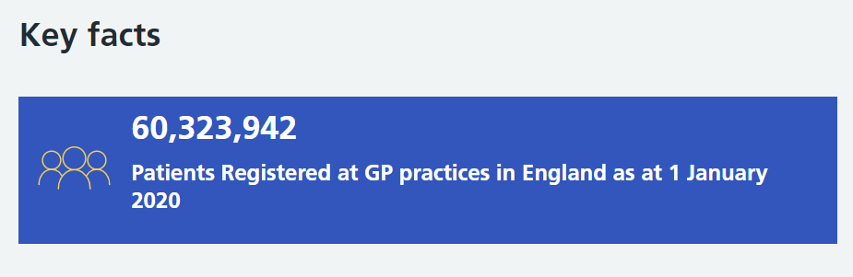
Adapted from: https://digital.nhs.uk/data-and-information/publications/statistical/patients-registered-at-a-gp-practice/january-2020

Figure 2 show us the total number of patients registered with GP’s in January 2019, which was 59,607,191, and it has raised since December 2018 by 32,741 people (NHS Digital, 2019).

Figure 2. Patients Registered at GP Practices 1 January 2019.
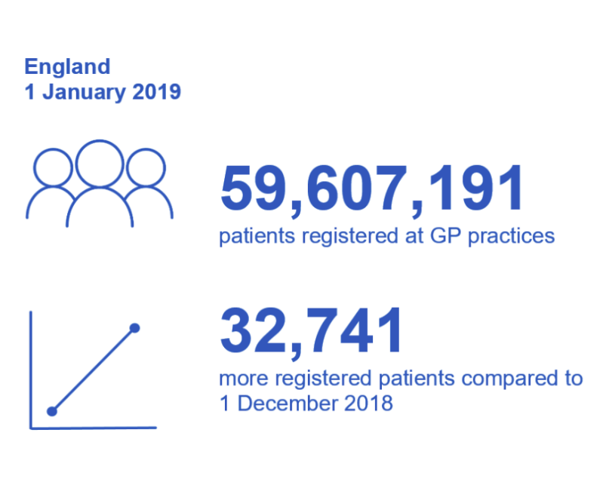 Adapted from: https://digital.nhs.uk/data-and-information/publications/statistical/patients-registered-at-a-gp-practice/january-2019

In comparison the periods between January 2019, and January 2020, we can observe a significant increase of additional 716,751 individuals. In the same period of January 2018, and 2019, this difference is 693,045 (NHS Digital, 2018; 2019).
Therefore, we see that the total number of the patients in the UK is continuously increasing. Increased number of patients requires greater amount of the resources, including workforce, equipment, and funds. This indicates serious potentially profitable business to grow in this sector.

1.3 Healthcare appointments at the General Practitioner Doctors (GP’s) in the United Kingdom
Figure 3 shows the estimated number of appointments at GP’s in the period between 1st December 2017 and 30th November 2018, which was 307 million appointments. 13% of the total appointments were made by the phone, which means some technology was already in use when it comes to primary healthcare. At this point one can say that ‘’primary care is a first point of contact in the healthcare system’’(NHS).

Figure 3. Number of the Appointments at GPs between 1 December 2017 and 30 November 2018.
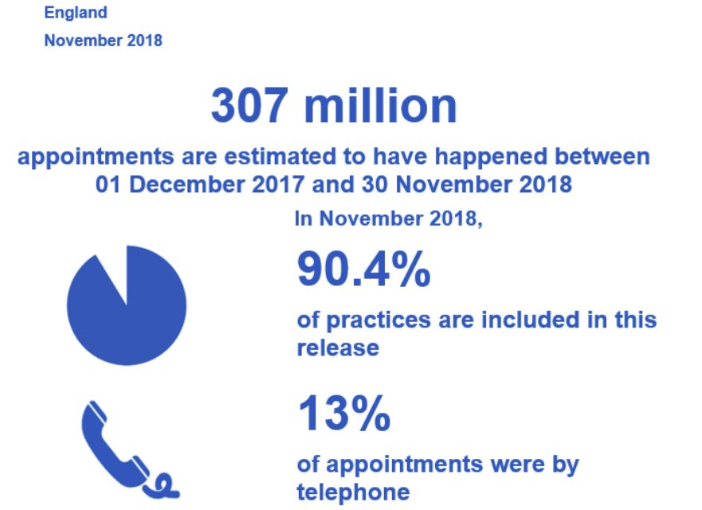
Adapted from: https://digital.nhs.uk/data-and-information/publications/statistical/appointments-in-general-practice/november-2018

Comparing the period but a year later (2018-2019) this number of GP appointments has increased by an estimated 4 million, while the number of telephone appointments remained the same ( Figure 4).

Figure 4. Number of GP Appointments in the United Kingdom between 1 December 2018 and 30 November 2019.
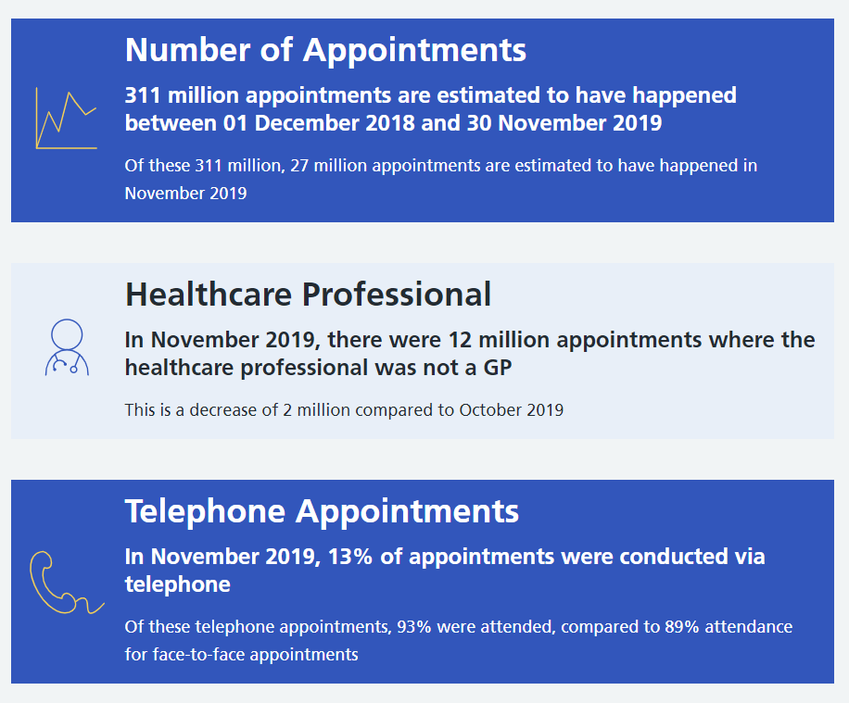
Adapted from: https://digital.nhs.uk/data-and-information/publications/statistical/appointments-in-general-practice/november-2019
With rising appointments by an estimated 4 million means that more health care - staff, and time would have to be involved when providing health related services. However, it is clear that there is no significant improvement of the appointments conducted by telephone in comparison to the previous year.
While the total number of the patients registered at the GP’s (General Practitioner Doctors) in the United Kingdom is raising. Within the same comparable period – 2017-2018, and 2018-2019, the total number of appointments has raised too. Treatment and waiting time for the diagnosis is raising. This could be caused by several factors, including greater number of patients, staff shortages, more appointments needed for the diagnosis, etc.

1.4 Diagnostics and treatment waiting time
Raising issues around the healthcare services are shown in Figure 5 and 6. The number of people waiting for the specialist treatments has been continuously raising since 2012 and is currently 40% higher than in 2012.
Figure 5. The number of people waiting for treatment.
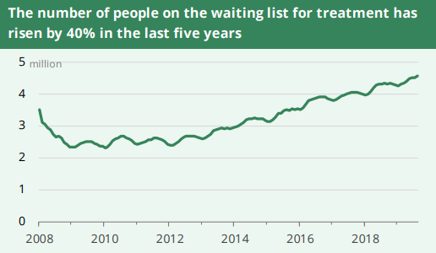
Adapted from: NHS Key Statistics: England October 2019.

Figure 6 shows us raising number of patients waiting for the diagnostics test. It also significantly raised by approximately 3% since 2012.
Figure 6. Patients waiting for Diagnostic Tests.
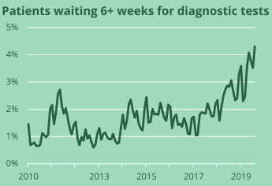
Adapted from: NHS Key Statistics: England October 2019.

Considering all the above, we can assume, that the overall demand for the healthcare is continuously raising, and this trend may cause further delays in waiting time for treatments and diagnosis.
Therefore, to assess the size of the market for the healthcare products and services, we need estimate the total population in the United Kingdom.

1.5 Population and median age
To discuss the factors that have an influence on health, and healthcare and to highlight the need for this research study it is important to look at some of the emerging problems in the world – which are the current size of the population and the future predictions of the changing size of the world population. For the purpose of this research we will look at the data up to 2050, as due to many environmental, socio- economical, and technological changes, the further forecast to that date would be difficult to predict.

1.5.1 Population and median age in the United Kingdom
Figure 7 presents the total size of the UK’s population (Fig.3), as checked today (11.12.2019) is 67,688,910 people, and the median age is currently (2019) 40,1 year (Worldometers.org).

Figure 7. Population in the United Kingdom 2019.
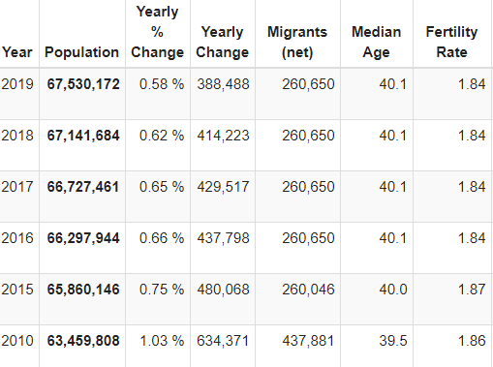
Adapted from: Worldometer.info/world-population/uk-population/

We previously established that the total number of people registered with their GPs (Figure 1) in the United Kingdom is 60,323,942 (1 January 2020). This, in comparison with the total UK population of 67,688,910 (as on 11.12.2019)(Worldometers.org), give us big healthcare market, which counts of almost 90% of the whole population in the United Kingdom.

The future prediction (Figure 8) shows that by 2050 the total number of people may reach 74,081,981, with the median age increasing to 44,5 year.

Figure 8. Population Forecast United Kingdom.
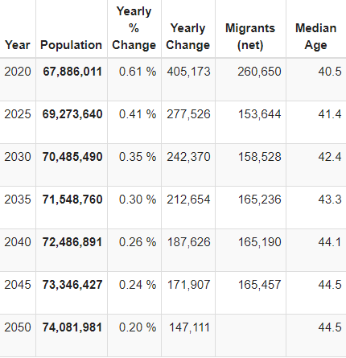
Adapted from: Worldometers.info/world-population/uk-population/
With the population continuously growing, therefore, we can predict that the number of patients, who are customers of the healthcare industry would grow appropriately to these changes.

1.5.2 Population and median age in the world
Although this research is concerned with the United Kingdom, it is important to analyse the current worldwide data, to see overall changes and trend across the globe.
Today (11.12.209) the world’s population has reached 7,749,784,094 people (Worldometers). Future forecast show that the world population is expected to grow (Fig.10), and Figure 9 below, indicate the net growth populations in 2019 was 76,619,277. Worldwide median age is currently at the level of 29.8 years (Worldometers.com) and is on the rise.

Figure 9. Current World Population.
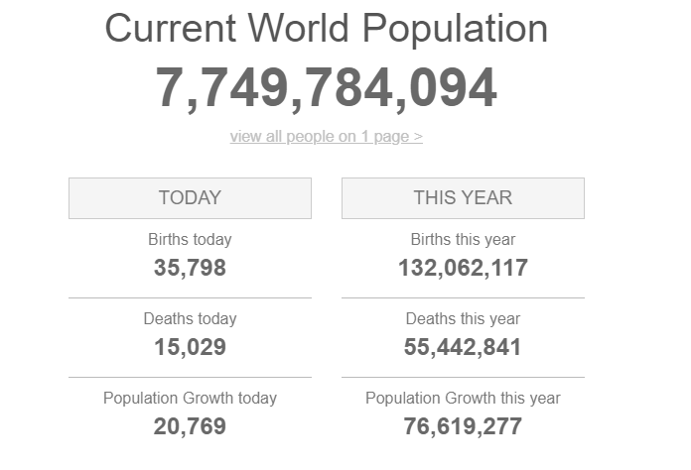
Adapted from: Worldometers.info/world-population/

Figure 10. World population forecast up to 2050.
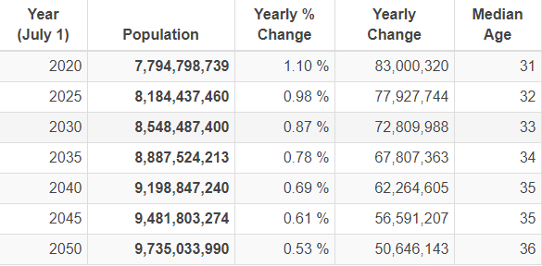
Adapted from: Worldometers.info/world-population/
A future population forecast (Fig.10), predicts continues rising populations. At the same time the median of age is steadily rising, reaching the age of 36 by 2050. This data also shows us that although the world population may be continuously growing, the rate of growth is slowing, and the net change (difference between births and deaths) are on the decline. The reason for the predicted declining changes is not the subject of our research.

1.6 Ageing of the population
Significant factors related to the topic of this research, and responsible for the overall global population growth changes are the rising life expectancy and aging of the population. (WHO).
‘’Maturing populace represents a risk to the economy as it impacts the economy and builds government spending on medical services and annuities’’(Cabral, 2019).
Already established is that the median age is rising (Fig.8 and 10). World Health Organisation reports suggest older people are statistically more prone to any infections, diseases, and illnesses (WHO), therefore it may have significant impact on the healthcare.

1.6.1 Ageing population worldwide
Currently the number of the people aged 65 years and plus is estimated on 9.3% of the total worldwide population (Figure11). The predictions prepared by the United Nations World Populations Prospects, report that by 2050 one in six people would be aged 65 or over, which is responsible for over 16% of the whole population (UN.org). Therefore, there is a rising trend of people aged over 65 worldwide.

Figure 11. Population by broad age group worldwide.
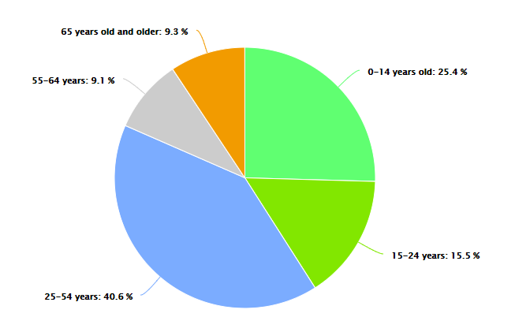
Adapted from https://www.worldometers.info/world-population/

it is important to note that this trend is dependent on geographical locations, and in some regions, such as Europe or North America the figures would reach 25%, being responsible for 1 out of 4 individuals being 65 or older(United Nations). The same United Nation report (United Nations. Ageing) states that the predictable number of people aged 80, or more would triple from 143 million in 2019, to 426 million by 2050. The health needs of individuals in their older years are considerable and complex, and healthcare becomes a daily consideration with a need for a variety of innovative products and services to cater for these customer requirements (United Nations).

1.6.2 Ageing population in the United Kingdom
In the United Kingdom the figure for the 65 years old and more is 18.7%, what means that on average 2 people out of 10 would be seniors by 2020.

Figure 12. Population by broad age group in United Kingdom.
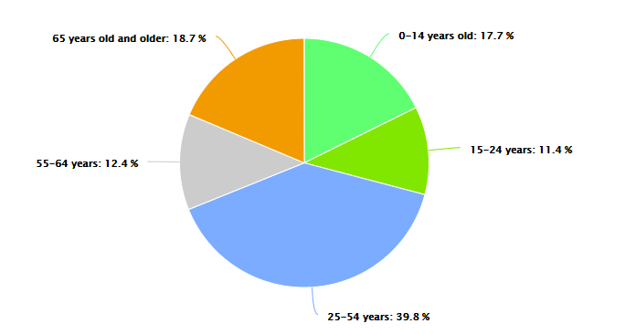

Adapted from: https://www.worldometers.info/world-population/uk-population/
This high number of senior citizens create significant socio – economic issues within the country. Large number of people who retired would create an implication in every sector of society, including labour, finance, housing, care, transport (United Nations). On the other hand, we can observe a greater number of older people who are voluntarily still professionally active and want to remain working despite aging (Dengler, 2018).

1.7 Life expectancy
Life expectancy (Garibaldi, 2010) is the measure that the life organism is expected to live, and is based on various factors, such as geographical location, financial situation, access to healthcare, gender, etc.

Figure 13. Life expectancy.
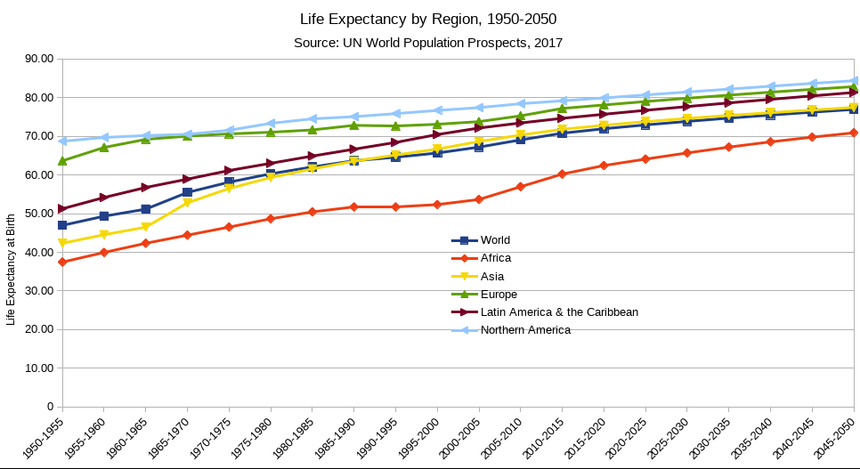
Adapted from: https://en.wikipedia.org/wiki/Life_expectancy

The Figure 13 indicates clearly that life expectancy is continuously rising (Figure 13), and this trend is predicted to continue in the future. ‘’Global average life expectancy increased by 5.5 years between 2005 and 2016’’(WHO). Ageing of the population and increased life expectancy are two of the main challenges in today’s world. Population aging report (WHO) indicates the number of people over 65 years old will grow to 1.5 billion by 2050 worldwide. This not only creates challenges, but also opportunities. Life, and its longevity is directly related to the health. Healthy people usually live longer and experience a better quality of life (WHO). Therefore, because of the rising number of seniors, health and health care becomes more important. Resulting from this, healthcare industry becomes one of the largest and fastest - growing industries in the world, consisting of a wide range of products and services and in some countries becomes a significant part of the countries’ economy (Elton, 2016).

1.8 Digital transformation
Technological changes and innovations are coming into use faster than ever (ACCenture). Currently, technology is present in every area and aspect of our everyday life. Following innovations in the communication (mobile smart phones, internet), housing (efficient and multifunctional home appliances), home entertainment (smart TVs, laptops and computers or game consoles, all in one control over all the appliances in one device), to the improvement in travelling. Modern technology helps to research, find, book, and pay for the wanted trip or the offer of more efficient, smart cars (i.e.) electric cars, and the changes in the health care industry (from the use of the mobile technology, diagnostic tools to the new products that improve life and surgical procedures) (Tech.co). Many innovations, digital improvements and applications (apps) are available and used in our every day life (Greengard, 2015). New things, ideas, products, and solutions are introduced more often and make a significant change to our lives. Starting from simple, daily tasks, simplifying, making them easier, or widely available to everyone, becomes necessarily (Marques, 2016). This shapes our experiences and perceptions (Greenfield, 2018). Technology improves our options regarding education, improves our work, making it easier, and more accessible (Karbegovic, 2019). Technology innovations make our lives more efficient and comfortable, technologies become parts of our existence (Greenfield, 2018).
Figure 14, below shows us the use of digital technologies around the world.
Figure 14. Digital technologies in the world. 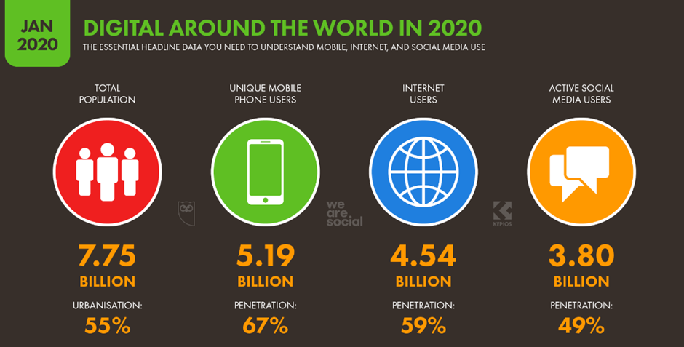
Adapted from: https://datareportal.com/reports/digital-2020-global-digital-overview
This indicates that the use of internet devices is estimated on 59%. Mobile devices users (some still not connected to internet), are estimated at 67%. This is interesting considering that over 40% of the world population have no access to internet.
In the United Kingdom, 96% of the population use the internet (Figure 15 below). This is large part of the population. It indicates that digital devices are widely used and widely popular in the UK.
Figure 15. Use of digital technologies in the United Kingdom.
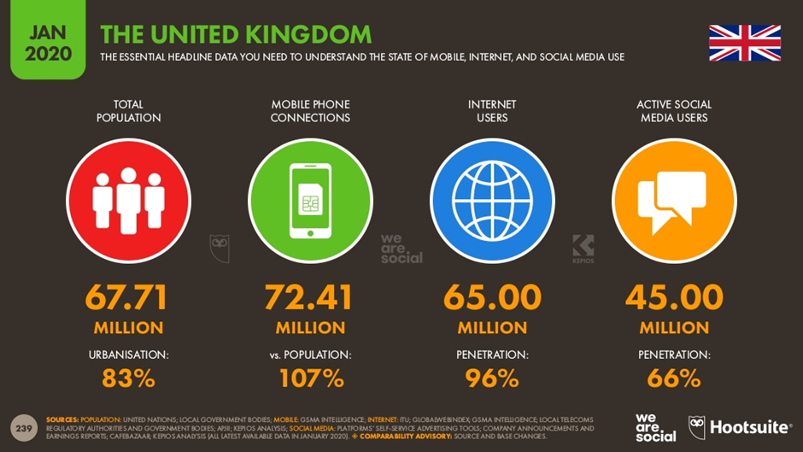
Adapted from: https://datareportal.com/reports/digital-2020-global-digital-yearbook?utm_source=Reports&utm_medium=PDF&utm_campaign=Digital_2020&utm_content=Yearbook_Promo_Slide

Figure 16. Estimated population not connected to internet.
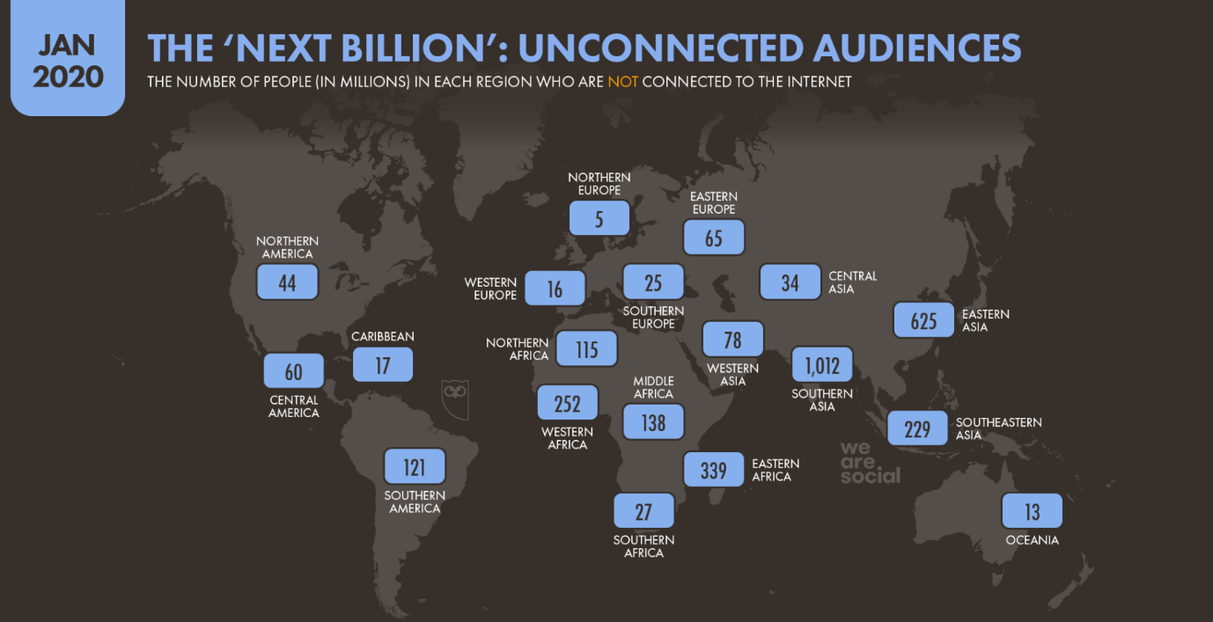
Adapted from: https://wearesocial.com/uk/blog/2020/01/digital-2020-3-8-billion-people-use-social-media
Figure 16 show us that there are significant populations around the world, who are not connected to the internet.

Although many people use internet technology, the technology itself has limitations. In time when world prepares and start using new 5G network, which is faster, more efficient (Marr,2020), and creating new possibilities, it is evident (Figure 17), that almost 1/3 of the United Kingdom’s territory has weak or no mobile 4G network coverage. This creates risks and needs further developments in this field.

Figure 17. UK 4G Network Blackspots.
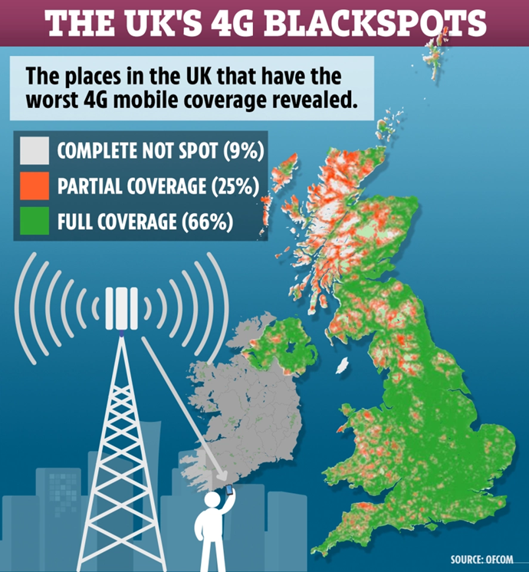
Adapted from: https://www.thesun.co.uk/money/10209469/ee-o2-three-vodafone-end-rural-not-spots/

1.9 Technological changes that improves healthcare
The outbreak of the coronavirus has significantly raised the level of technology used, overall. Due to the changes in the environment such as closing schools, and workplaces (Bishop, 2020). More and new devices and services has been introduced and pushed to use by wider groups of people, starting from children, who would have to carry out their every day school tasks online, to the professionally active individuals who have to work from home, but also elderly citizens, who are isolated, so using technology may be the only way to contact with their relatives, or health professionals (Lloyd - Jones, 2020). During this time, we can observe a significant rise in technological improvements when it comes to our healthcare. From the self GP - booking services, digital prescriptions, to various applications, that help control and maintain our health, or contact healthcare professionals without long queues (Hayre et al, 2019), and speak directly using online services, i.e. LIVI, DoctorLink (Livi.co.uk, Doctorlink.com). More technology in the health industry is used to manage and treat peoples’ health easier and with precision. Therefore, it may improve the quality and longevity of life (Deloitte,2020).
Figure 18. Digital Health and Medical Technologies in Healthcare.
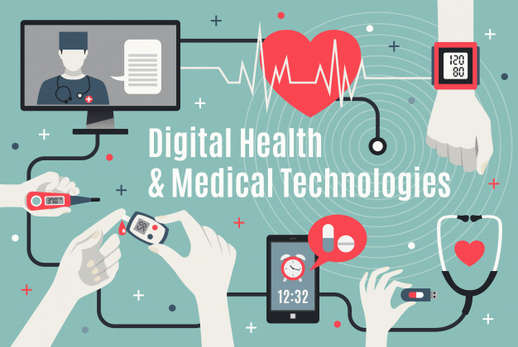
Adapted from: https://www.gigadocs.com/blog/how-to-prepare-for-digital-healthcare-and-telemedicine-doctor-consultation-during-covid-19/
In general, technology does not aim to change the healthcare industry, but ‘’healthcare is just a market for technology where consumers such as hospitals are happy to pay’’(Thimbleby, 2013).Health related organisations invest R&D in developing these new technologies and innovations, in order to make money, save money and time for all participating stakeholders, and also benefit the most interested party – the customers – patients themselves. (Elton, 2016). Healthcare benefits from better monitoring of patients (Prior and McKeown,2019). Data shared between medical professionals helps control the actual state of the patients, analyse, and diagnose changes faster. (Taylor, 2015).

1.10 Conclusion
Factors such as rising population and rising average age can be useful for the health industry for the further product and service developments to meet demands of the future market and consumers. Based on this data, the major concern is whether the healthcare industry is equipped with the products and services to meet the current and future health demands of the growing and ageing populations. Rising life expectancy suggest that we may experience greater demands for healthcare products and services as people would expect to maintain good quality of life.

1.11 Objectives of this research
Healthcare has become one of the most important industries in the world. Continuously rising number of people, rising longevity of life, and therefore rising number of the older people, and the fact that health is one of the basic, priority needs, makes it big business. The fast advancements in technology and innovations, creates new opportunities, possibilities, and solutions that address more health - related issues, making them preventable, faster and easier to treat.
The study intends to question the nature of technology changes in healthcare industry and how users respond to these changes.

The objectives of this research include:
To analyse the awareness and the use of the available health related innovations.
To report the available innovative health care related products and services.
To investigate the readiness of the population to use the technological innovation to improve their health now and in the future.
To evaluate how technology has changed the healthcare industry.

1.12 Aims of this research
This research aims to critically evaluate technological development and innovations in the healthcare industry, its practical use and user readiness. The following areas are addressed to fulfil the aim:
Determine how technological development and innovations changes healthcare products and services.
Explore how these changes affects customers, their experiences, and expectations.
Explore if consumers have appropriate skills and tools and know how to use technology - based tools that are currently available.
Report the current situation of the outbreak of the Coronavirus affected technology development in the healthcare.
How current situation of the outbreak of the Coronavirus changed peoples’ approach to using technology to look after their own health.

CHAPTER TWO
Literature Review

2.1 Introduction
The purpose of this chapter is to evaluate available literature regarding the research topic. Due to the lockdown and movement restrictions caused by the Coronavirus (COVID 19), relevant literature will include textbooks, journals, and any other available sources of the information, including officially recognised and reputable online sources.

2.2 What is health
Philosopher Plato in his work ‘’Gorgias’’ (Cope, 1864) refers to his teacher and mentor – Socrates, and the ‘’skolion’’, which is a traditional dinner song, where ‘’health is described as the greatest human blessing for humankind’’ (King, 2004, pp.1). It is mentioned that health is the most important, and other things may be unworthy without health. The importance of good health is known from the times of antiquity, when primitive practices were used to treat various health issues.
‘’Health is at the top of most wish lists – for governments and individuals alike’’(Bull, 2014, pp.3). World Health Organisation has defined health as "a resource for everyday life, not the objective of living. Health is a positive concept emphasising social and personal resources, as well as physical capacities" (World Health Organization, 1986). Therefore, we can say that our health is a state of the physical and emotional well – being, and it is something that supports people’s functions in society. Individual’s health may depend on various factors, such as: genetics, geographical location, level of education, environment, and the economic status, or income. Due to the nature of health, and to preserve good health, it is necessary that individual live healthy lifestyle, rather than wait until gets sick or ill, and then try to regain good health. We can distinguish two types of human’s health: physical and mental health.
- World Health Organization describes physical health as the condition of the human body, that considers everything from the absence of any illness, or injuries, to the advanced fitness levels. Physical health is necessary for overall individuals’ well- being (World Health Organization).
- Mental health is "a state of well-being in which the individual realises his or her own abilities, can cope with the normal stresses of life, can work productively and fruitfully, and is able to make a contribution to his or her community" (World Health Organization).
’Better health is central to human happiness and well – being. It also makes an important contribution to economic progress, as healthy populations live longer, are more productive and save money’’ (WHO). Both, physical and mental health agility may interact with each other, and poor physical health may cause mental health conditions, as well as poor mental health may be the factor which affects physical health of the individual (World Health).
Health is the most crucial element of life and is one of the basic and fundamental assets of any individual, that may have direct effect on his or her everyday life. Bad health would have significant effect on our own well - being, our performance, self – esteem, but also our work, family, and the whole system. (McMurray, 2011). Therefore, healthcare is becoming more and more important due to the peoples’ awareness about its influence on life and raising life expectancy. Health is something that concerns everybody. 75.5% of adults are in employment, on average spending 1/3 of their working days at work (Office for National Statistics, 2019); In 2017 due to sickness absences lost 131 million days (Office for National Statistics, 2019). Therefore, good health of the individuals will not only interest and benefit themselves, but also the company’s whey work for, and the whole economy.
Healthcare becomes a big business (Makary, 2019), and more people are aware that good health is priceless, and they can invest their money to stay in good health and possibly live longer.
The future of health is likely to be driven by the development of technology. And technology is moving towards the consumers, to consume what they want easier, faster, and cheaper. Health will revolve around maintaining well-being, prevention (Delloite, 2019). Advanced tools will be able to provide early diagnosis of illnesses. The user/patient will be at the centre of all interconnected stakeholders, including hospitals, pharmacists’ companies, medical device manufacturers, doctors, consultants, etc. This new health models will help to collaborate between all the parties, including patients in the decisions and actions concerned their health, and will aim to make treatment available much easier, more precise, and cheaper (Delloite, 2019).

2.3 Need for health
Demand for health care products and services comes from the consumers, who prefer to be in a good health, and are willing to pay for it any price (Babalola, 2017). For many people money spend on their healthcare is recognised as an investment, that will not only benefit them now, but also in the future. ‘’The aging ‘’baby – bloomers’’ are triggering a heightened level of interest in the retardation of the human ageing process’’(Maxwell, 2009, pp.122). Therefore, companies recognising the opportunities focusing on the development of the products or services to increase longevity of life. (Maxwell, 2009). ‘’Health awareness among consumers, with people wanting to take greater control of their health, has increased dramatically in recent years’’(ACCenture, pp.4). We can observe that more common and easiest way that the individuals use more frequently is widely available through online sources of the information, such as Google, to compare and consult health - related issues (Liu, 2018).
Health for many individuals is one of the most important part of our lives, not dependable on our origins, age, profession (Tulchinsky, 2009), and our health may concern all of us (Holtz, 2013). For many people life without health makes no sense: ‘’Without health, life is not life; it is only a state of langour and suffering-an image of death’’ (Rabelais, 2015).
All the factors and facts mentioned before, together with rising number of people, rising number of the older people, rising expectancy and longevity of life, creates a need for the effective recognition, appropriate addressing the treatment of the health related challenges and issues (Delloite).

2.4 What is healthcare
Healthcare, in general is defined as any activities whose purpose is restoration, maintenance or improvement of an individual’s health, wellbeing and preventing diseases (World Health Organization). Healthcare involves ‘’all the activities whose primary purpose is to promote, restore or maintain health’’ (World Health Organisation). Health and the right to the highest standard of the healthcare is one of the fundamental human rights (World Health Organization).
Healthcare and its access are currently considered as a merit good, which means that it is one of the basic needs (Backman et al, 2008). Therefore, healthcare should be provided by the countries’ government for free, and healthcare needs should be met regardless of costs, or anything else (WHO). In fact, healthcare, and access to the best possible health services in many countries is a constitutional right (Our World in Data), (Gov.uk).
‘’Healthcare is the most complex and fast - moving industry that exists’’ (Barlow, 2017, pp.1). Current technological developments are often adapted from the other industries and used in healthcare, where they can create rapid improvements to the health - related services and processes, including understanding, diagnosis, treatments and after care, and health related products (Barlow, 2017).
‘’Global spending on healthcare is projected to continuously raise from $9.7 trillion to $18.28 trillion by the 2040, with a projected worldwide shortage of 12.9 million healthcare professionals by 2035’’ (PWC, 2018). This industry differs from any others, as in many countries of the world the services and health care related products are financed by the governments. This gives the opportunity stable and regular income to companies and organisations that provide such services.
Healthcare sectors includes manufacturing of goods and services, to treat the customers – patients, with their curative, preventative, rehabilitative and palliative care (WHO, 2019). This sector focus on people, their wellbeing, health related products and services delivery, and the health beneficial outcome. From the prevention – manufacturing the wide range of medicines and drugs, for the range of equipment, and the health - related services that range from basic, primary care, specialists' care services, to the medicines and drugs that will cure health related conditions.
Supply and demand for the healthcare products may need to be customer specific, adapted to their individual’s needs. Although simple and easy to use products, such as blood pressure monitors can be relatively cheap, and available to the widely available and easy to use for many customers, other products such as hearing aids, may need individual adaptation. ‘’Personalised medicines are tailored for the therapeutic treatment of the individual patient’’ (Maxwell, 2009, pp.122).

Figure 19. Health and care system.

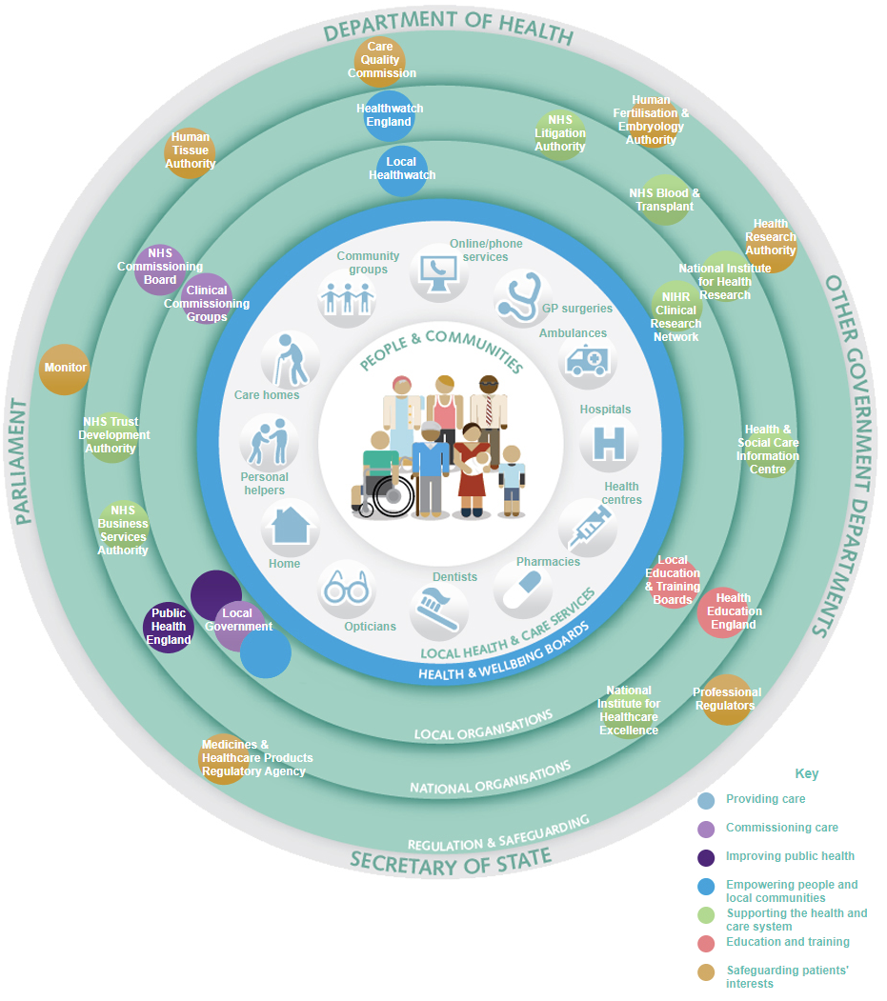
Adapted from: https://www.gov.uk/government/publications/the-health-and-care-system-explained/the-health-and-care-system-explained

Healthcare industry is continuously changing. Previously the focused on volume - based care, now it focus on value - based care, which promotes greater patients’ engagement and involvement for the better health outcome (Dimick and Lubitz, 2020). In April 2013, the new Department of Health (Figure 19) was created in the UK with the purpose ‘’to help people live better for longer’’ (Gov.uk). It aims to make sure that all parties involved in healthcare will work together for the best benefits of the patients. The system assumes better cooperation between all the parties involved and the patients care (Gov.uk).

2.5 Importance of healthcare
‘’Physical and mental well – being makes it easier for people to pursue opportunities to work and study, to remain financially secure, and physically independent, and to maintain strong relationships’’(Bull, 2014, pp.3).
Healthcare and access to the healthcare is part of the human life. Right to health is one of the fundamental Human Rights (1948), which states that all individuals are entitled to the universal minimum standards of health (United Nations).
Constitution of the World Health Organisation, organisation that is concerned with the international public health, defined right to health as ‘’enjoyment of the highest attainable standard of health’’(WHO). ‘’A healthy population is also a productive workforce, and one that would relieve a considerable strain on the public purse by keeping well ’’(Bull, 2014, pp.3). Businesses becomes affected not only by the direct health issues of their employees, but increasingly by the care for their family members. It is estimated that businesses in the United Kingdom lost £3.2 billion in 2018 due to people having to leave or change their working patterns caused by caring for someone within their family with dementia (Gov. UK, 2018). Considering ageing of the populations this cost will only increase, causing only bigger loss to the businesses in the future.

Figure 20. Public spending in the United Kingdom 2019 (in billions GBP).

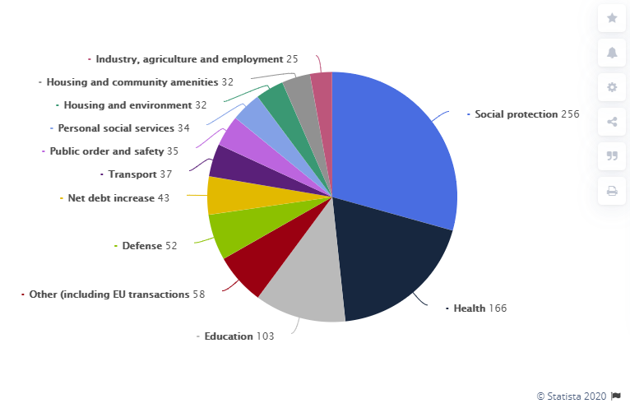
Adapted from: https://www.statista.com/statistics/298524/public-sector-expenditure-as-share-of-gdp-united-kingdom-uk/

Figure 19 show us that health is the second biggest expenditure in the United Kingdom (Statista.com).
The healthcare industry is currently one of the largest and fastest - growing industries of the country (Marlow, et al, 2012), consuming 10 percent of gross domestic products (GDP) of the most developed nations (Statista, 2019). Drouin (2008) suggest that considering the current growth the most developed countries will spend 20% of their GPD on the healthcare by the 2050.
‘’Global spending on healthcare is projected to continuously raise from $9.7 trillion to $18.28 trillion by 2040, with a projected worldwide shortage of 12.9 million healthcare professionals by 2035.’’ (PWC, 2018). This industry differs from any others, as in many countries of the world the services and related products are financed by the governments. This gives the opportunity stable and regular income to companies that provide such services.
To highlight the importance of health, healthcare, and its affection on people, businesses, the countries, and the world, we can analyse the most recent example, and how it affected the whole world:
Currently due to the pandemic of the corona virus, occurred in China in the end of December 2019 (Bryson Taylor, 2020) China’s economy, stopped production, resulting in delays in global supply chains of products made in China. Any international travel has been minimized or even stopped until May 2020 (Davies, 2020).
This is a live example of how virus, has spread around the world within short period of time, and now affecting large numbers of people, many companies and organisations, and even creates a global fear (Watts, R., et al, 2020).
Many scientists and pharmaceutical companies are trying to find the cure, immunisation to solve the problem. And the race to do it first, will produce a positive impact on the greater recognition, reputation, and financial benefits for the successful firms (Prabhala and Hoen, 2020).

2.6 Current situation in healthcare industry
Global epidemic of the Coronavirus shows the importance of the healthcare industry, and its effect on the whole world. It affected all the industries, causing fear, uncertainty, and panic within the global populations around the world (Deloitte, 2020). Healthcare staff became real heroes (Cox, 2020) as a front - line workers who were deployed to face and combat COVID19 disease (Coronavirus). Demand for healthcare services quickly exceeds the possibilities of supply. Therefore, National Health Services announced large scale recruitment to fill the gap in healthcare workforce. Retired industry staff and medical students were called to help (Guardian, 2020).
‘’The foundations for a strong and effective health workforce for the future are being corroded in front of our very eyes by failing to match today’s supply of professionals with the demands of tomorrow’s populations’’(WHO). There is a significant shortage of the health workforce worldwide, considering ageing population and greater need in this sector, and the lack of the proper recruitment, education systems in countries worldwide.
Currently in the UK we can experience a shortage of staff in the health sector in the number of more than 100,000 staff (NHS, 2019), and if the current trend will continue it can reach between 250,00 and 350.000 by the 2030, dependable on the strategies that regards to retaining and recruiting new staff will be applied (NHS). Ministers considering reintroduction of the financial aids for nursing students, which have been abolished in 2015 and caused the yearly fall of 10,000 people applying for nursing degrees. It is one of the steps to financially help students and to attract them to educate and work in health care (Campbell, 2019).
Human resources of the health care related companies must retain current health industry staff through the appropriate pay strategy, training, and other benefits (Henderson, 2011).
The outbreak of the coronavirus has shown another problem, which is shortage of the personal protective equipment (PPE). Lack of the basic single use gloves, face masks, googles became real issue when it comes to the treating and preventing respiratory diseases. This shortage is affecting health care staff as they are more exposed, vulnerable, and more likely to be infected by the virus. (Siddique, 2020), (Royal College of Nursing).

2.7 Innovation
In general, innovation ‘’is something that is new’’ (Smith, 2006, pp.5).
Barlow (2017) says that innovation is an outcome and the process that involves acts of transformation and an adaptation of an idea that can be practically used. In the era of fast development of technology ‘’Innovations are new things applied in the business of producing, distributing and consuming products or services’’(Betje, 1999,p.1) and are closely linked to the new technological developments. These days technology is fast changing through the new advances and breakthroughs with new products and services (Smith, 2006), but any innovation and ‘’information technology won’t be effective, unless it is used’’ (Ahmad, 2014 pp.1).
‘’An innovation is an idea, practice or object that is perceived as new by an individual or other unit of adoption’’(Rogers, 1995, pp.11). We Can distinguish three forms of innovations: product, service, and process innovation:
- Products innovations are is the most obvious one; the new and innovative products or the development of the new technology into existing one, attract customers interest and persuade consumers to buy (Smith, 2019).
- Service innovation involves improvement to the existing service, or the offer of something new, something never existed before. Although this type of innovation is seen as less spectacular, as the products innovation, but may have a huge impact on the users and their experience., making service cheaper, easier to access, or offering the new type of service (Smith, 2019).
- Process innovation can have a great impact on the society, as it may represent innovation in the manufacturing or delivery processes, making them more efficient, easier to deliver, or easier to manufacture. Process innovation helps to improve standard of living in the era of fast development of technology, increasing productivity and efficiency (Smith, 2019).
Types of innovations consists of radical and incremental innovations. Radical innovation is usually a result of the major technological breakthrough, introduction, or the application of the new technology (Smith, 2009). Radical innovation will create a new design, or new concept that will make something novel, new.
Incremental innovation will involve some changes to the existing products or services, in order to exploit the existing ones. It may include some improvements, introduction of the new components, or different application of the existing products or services in the new industry. In this type of innovation, the technology is usually improved, what chance the new application (Smith, 2009).

2.7.1 Disruption of innovation
Fast technological changes require organisations for the adaptations, implementation and use of the new thigs, otherwise they may face extinction. ‘’At least 40% of all businesses will die in the next 10 years…. If they don’t figure out how to change their entire company to accommodate new technologies’’ (John Chambers, Cisco Systems).
Disruption is a process that interrupt the usual way that something works or is organised, affecting the existing functions in the market or industry. In business, it is a force that drives rapid changes to the organisation, creating new markets and value network (Gans, 2016). It is often caused by some sort of innovation, although it may not be radical innovation, but the use of the existed one in the new way or introduced to the new industry. In the business theory, innovative disruption may not necessarily be successful, but may create new opportunities and ideas (Gans, 2016). We can distinguish disruptors, who may be newcomers, and the disrupted, who may be well established and leading organisations in the market. These are important theories in this study.

2.7.2 Diffusion of innovation
‘’Diffusion is the process by which innovations are adopted and used by consumers’’(Smith, 2006, pp.18). It explains the way the way that the new things are adopted and becomes popular and used. (Smith, 2006). ‘’Many innovations require a lengthy period, often of many years, from the time they become available to the time they become widely adopted. Therefore, a common problem for many individuals and organisations is how to speed up the rate of diffusion of innovation’’ (Rogers, 2010, pp.1). Diffusion of innovation theory explains the diversity of factors that help with the introduction of new ideas.
‘’Diffusion is the process by which an innovation is communicated through certain channels over time among the members of a social system’’ (Rogers, 2010, pp.5). ‘’Communication is a process in which participants create and share information with one another in order to reach a mutual understanding’’ (Rogers, 2010, pp.5). Therefore, we can say that diffusion is a special type of the communication between parties, that is concerned with generating new ideas. This may occur as planned and required change, or totally unplanned and spontaneous information exchange about new ideas. (Rogers, 2010). This model is concerned with diversity of innovation, introducing channels of communication, innovation, time, and social system, as factors that help to share the new idea. (Tasherdoost, 2017). Acceptance of the innovation depends on the factors: ‘’relative advantage, compatibility, complexity, trialability, and observability’’ (Tasherdoost, 2017, pp.964).
Because this model focus on the environmental aspects, system characteristics, and organisational attributes. Therefore, we can distinguish four main elements in the diffusion of innovation (Rogers, 1995): innovation, communication channels, time and social system. (See detailed summary in Appendix 1).
Figure 21, below describes innovators and adopters and their readiness to apply new ideas (Rogers, 2010).

Figure 21. Categories of innovation adopters.
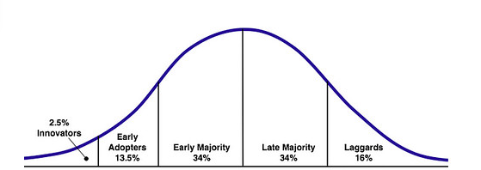
Adapted from: https://web-strategist.com/blog/2010/01/03/social-technology-adoption-curve-benefits-and-risks/

2.8 Innovations in healthcare
Significant technology development of innovations in healthcare helps not only in detections, but also in prevention of the progression of the diseases (Sheaff, 2002) ‘’as evidenced by rapid development of new drugs, medical devices and health management software underpinned by world class scientific research’’ (Maxwell, 2009, pp.117). Healthcare industry can benefit from practices that drive innovation and growth, as ‘’It is now widely recognized that innovation is a key growth driver’’(Maxwell, 2009, pp.1). Artificial intelligence in the healthcare may allow health professionals to process large number of data, to detect abnormalities, and therefore recognize any illnesses, and react faster to implement and determine the most effective treatment (Prior and McKeown, 2019). Based on the collected and stored information, data algorithms can specify what patients may be in greater risk of developing specific disease, and therefore will help to prevent the occurrence of it
‘’Artificial intelligence (AI) is transforming the way we interact, consume information, and obtain goods and services across all industries. In health care, AI is already changing the patient experience, how clinicians practice medicine, and how the pharmaceutical industry operates’’ (Allen, 2019). Artificial intelligence (AI) is the ability of a machine or a computer system to perform tasks or imitate behaviour that would normally require human intelligence – for example, visual perception, speech recognition, problem solving or decision making (Marr, 2018).
While technology aims to reduce the costs, in fact it increases them, due to faster and greater number diseases that have been identified, easier to find the new ones, and the need for their treatment, which also involves new specialistic tools and machines (Timbleby, 2013).
Health Information Technology (HIT) is a new technology that is applied to the healthcare industry, and helps to securely manage the computerized health information, between the providers, consumers and all the parties that are involved in the healthcare processes. This aim to improve the quality, efficiency, cost reduction and safety in the health delivery systems. One of the widely used types of the technologies within the NHS (National Health Services) in the United Kingdom is Electronic Health Record (HER), that connects electronic patients’ information and share it within the parties involved in their care, and aim to reduce any mistakes and errors (NHS).
This system is used locally, providing all the required information between the local hospitals and GPs. Therefore, there is no central (nationalised) system that could share information between any of the interested parties within the any place in the United Kingdom.
NHS open source (freely available and downloadable in order to use and improve) SPINE portal, connects healthcare professionals and patients to improve the efficiency, to reduce costs and improve overall patients experience through the health digital channels (NHS). Currently available online services including online booking system are used only by limited numbers of health centres(Service Search, NHS) only used by the minority of the users/patients. (GP appointments and bookings, NHS). While the shortage of healthcare professionals and the GPs open the suggestion that charging £25 fee for the appointment would help patients to be seen much quicker, it creates a risk that some people would not be able to afford seeing GPs.

Figure 22. Innovations in healthcare
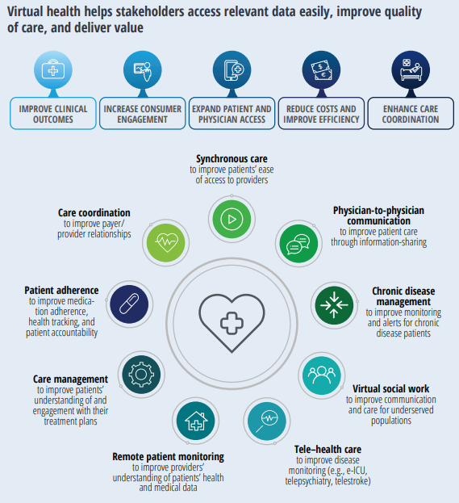
Adapted from: https://www2.deloitte.com/global/en/pages/life-sciences-and-healthcare/articles/global-health-care-sector-outlook.html

The new technologies and innovations connect the healthcare stakeholders to tailor health products and services around patients’ needs and expectations (Figure 22).
‘’Big data and machine learning having an impact on most aspects on modern life, from entertainment, commerce and healthcare’’(Bohr, 2020, pp.25). Better and more intelligent data processors work to determine the individual’s profiles and preferences, and then help to identify the best available options in many aspects of our every day lives. ‘’There is a great optimism that application of artificial intelligence (AI) can provide substantial improvements in all areas of healthcare from diagnostics to treatment (Bohr, 2020).
New fast mobile technology development (5G) will allow faster transfer of data will able precise integration of various devices and protocols, in order to allow all the interested healthcare stakeholders work closely together and for the benefits of all, and especially industry clients – patients (Pattnaik et al, 2020).

2.9 Consumer behaviour
Consumer behaviour, or buyer behaviour is an ongoing process in which the consumers search, select, purchase, use, or dispose product or services to satisfy their needs (Lantos, 2015). Consumers have the power to choose and decide what, when or where they want, and they expect that their needs will be meet (Perkins and Fench,2014).
Customers’ satisfaction is one of the most important factors for the businesses are it determines success of the product or services, and therefore the profits for the organisation.
Within the consumer behaviour we can distinguish between both: needs and wants. When it comes to something we want, we tend to have a greater choice, and our choice may be dependable on the price. When it comes to our needs, consumer may have no choice, and therefore will depend on what is currently available (Kotler, 2010).
‘’The consumer perceptions on the innovative products and technologies are largely influenced by the social and informal networks’’(Rajagopal, 2018, pp.6). The tendency to use new products is usually driven by the opinion and reviews of other, who tried them before and were satisfied.
Due to the widely available sources of the information (i.e. internet reviews) and the awareness of the options, consumers instead of purchasing anything, would have a closer look for the products or services that would solve their existing or potential problems (Rajagopal, 2018). ‘’Consumer behaviour is largely driven by needs and the available solutions to meet the demands of consumers’’ (Rajagopal, 2018, pp.46). Motivating the consumers companies use hierarchical importance of needs, in order of their importance, what helps them to market the product or services, based on the consumers’ needs.
Maslow’s hierarchy of needs (Figure 23), describes that every human being has a hierarchy of own needs, and once individual’s basic needs are met, then can move to the higher level. This is presented as a pyramid and divided into the five groups. The bottom level includes psychological, basic needs, then we have need for security, and after that is belonging to wider society, as a third group of needs. Own ego and the need of self-esteem, power, and the need of the self – actualisation (development and creativity) are on the upper and top levels in the Maslow’s hierarchy of needs. Maslow’s conception explains that every individual has own hierarchy of needs that must be fulfilled. Starting from the bottom ones, for any individual, that primitive and basic needs must be met, and if not – may cause anxiety, or even death, as these are responsible for the basic life functions (Maslow, 1981).

Figure 23. Maslow’s Hierarchy of Needs.
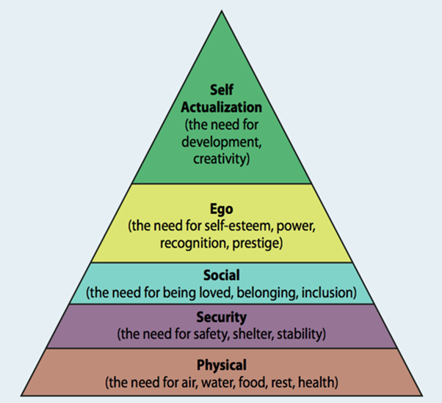
Adapted from: https://www.psychologytoday.com/us/blog/hide-and-seek/201212/our-hierarchy-needs

This research is concerned around health, and healthcare, and as we can see - health in the Maslow’s pyramid is one of the basic, and fundamental needs. Therefore, we can assume, that not being in a good health can cause that the needs from the upper levels may not be as important anymore and attempted to meet, as individual may concern more with meeting their basic need of health (Maslow, 1981).
Maxwell (2009) suggest that demand for healthcare products or services comes from the consumers, who prefer to be in a good health, and are willing to pay for it any price. For many people money spend on their healthcare is recognised as an investment, that will not only benefit them now, but also in the future. ‘’The aging ‘’baby – bloomers’’ are triggering a heightened level of interest in the retardation of the human ageing process’’(Maxwell, 2009, pp.122). Therefore, companies recognising the opportunities focusing on the development of the products and services to increase the longevity of life (Maxwell, 2009).
New technologies connect medicine and technological development and aims to eliminate diseases, what will result in extension of the longevity of life. It creates new business opportunities, such as new products and services. ‘’As consumers adopt and embrace these new technologies, they become empowered, their behaviour and desires can change rapidly, and they can exert tremendous pressure on the technology needs’’ (Newman, 2019,pp.2). Sheaff (2002) suggest that human need is generally ‘finite’(limited), and when it comes to the healthcare there is a generally upper limit of healthcare that each individual can possibly consume, but it is changing due to the new technologies (Moses et al, 2019).
‘’ Consumers are increasingly using technology to engage with brands, searching for information, purchasing products and services, and obtaining help and advice’’(Newman,2019, pp.15). Available technology allows individuals to be more aware about available possibilities and options. Information is the key and reviews already made by others are easily available, what helps to make decisions on what to choose.

2.10 Future of healthcare
Healthcare of the new era will be driven by the customers greater awareness and increased demand for healthcare related products and services. Prevention of disease will be the most important in future and play a major role in healthcare (Bohr, 2020).
New health models will help to collaborate between all the parties, including patient himself in the decisions and actions concerned about their health, and will aim to make treatment to be available much easier, being more precise and cheaper (Allen, 2019).
We can observe the number of devices that control and record our sleeping patterns, our daily activities, and health related checks such as heart rate or blood pressure. In the future, artificial intelligence and health data, and more advanced devices will be able to elaborate the personalized health plan and intervention of every individual user. Health of the individuals will be continuously monitored, so any risks will be identified and addressed early. The intervention of the health professionals therefore will be required only when it would be necessary, and in the serious cases (Allen, 2019).
More futuristic visions involve ‘’2045 Avatar Project’’ (2045.com) (See Appendix 3).

2.11 Conclusion
We live in the world dominated by the technological advances that are affecting every aspect of our everyday life (Marques, 2016). Consumers are more aware of the importance of their healthcare and its effect on their lives and environment. Therefore, expect better products and services.
New technology developments within the healthcare helps with faster recognition and prevention of the diseases, but also create higher costs, due to more and new illnesses being detected. There is significant lack of the healthcare professionals that could be partially solved by introduction of more technology for the primary health check and consultations.

CHAPTER THREE
Research Methods and Methodology

3.1 Introduction
Research methods includes all techniques and methods used during the research. Methodology is the approach in which the research questions are solved (Mishra and Alok, 2017).
This chapter aims to explain all steps that has been used in this research.

3.2 What is research?
‘’Research turns information into knowledge’’(Hair Jr., 2011, pp.XV) and the knowledge is important for any form of business activity. (Hair Jr. et al, 2011). In the era of fast development of technology, with greater competition between organisations - research becomes vital to make faster and accurate decisions. (Hari, JR, 2011).
Research is one of the fundamental pillars in academia, as well as in modern business organisations (Habib et al, 2014, pp.xiii).
In general, research is a process of collection of the information in a systematic manner on an interesting topic, to increase the knowledge (Oliver, 2010). ‘’Research involves the most detailed and thorough study of a problem with a view to gain information to reach its solution’’ (Habib et al, 2014, pp.3).
Although ‘’the major aim of any type of research is to find the reality and facts which is unknown and which has not been exposed’’(Mishra, 2017, pp.2), it may be undertaken to increase the current knowledge and find something new to the same topic.. Different people may have different beliefs, view and understanding on the given topic (Austin and Sutton, 2014).

3.3 Research design
Research design is the plan and the structure of the investigation that are prepared to obtain answers to the research question (Kerlinger, 1986).
This research is focused on healthcare, currently one of the fastest growing industries, with the new technologies and innovations that are adapted and used to improve health related products and services.
Before we establish the way this research is carried out, we should consider the philosophy that is inherent in our life, and determine the way we act, think, perceive or say.(Nuttall, 2013). To appropriately address the way I think and based on that to choose the most appropriate research methods, I introduce the Research Methods Map, that explains the research process (O’Gorman, 2015).

Figure 24. Research Methods Map.
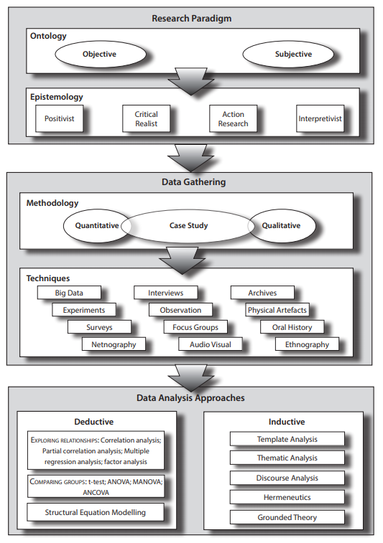
Adapted from: O’Gorman, K.D., MacIntosh, R., (2015). Research Methods for Business Students. Oxford. Goodfellow Publishers Limited

The ‘Research Methods Map’ illustrates the four basics stages in developing the research project. Research paradigm explains the fact that everyone has own norms, views, and beliefs that would have the influence on the research, the knowledge, analyse and interpretation. (O’Gorman, 2015). Within the Paradigm we can distinguish the study of ‘being’ and our way of perception of the reality (ontology), and epistemology, which is concerned about the knowledge and how knowledge is gained (Pasian, 2016).
Ontology is divided into two categories: the objectivism, that describes the reality as external and independent from the researcher existence (Collis, 2009), and subjectivism that limits our knowledge into own experiences and perceptions (Saunders, 2012). As a person who through various experiences and fields of interests is open to the world I don’t perceive things only through my own personal experiences or experiments, but also tend to confirm through the information, observations and the opinions of others.. Therefore, fulfilling both subjective and objective approaches I can construct opinion, or make decision. I have the opinion of a person, although act in my own manners, and time, having first my thought, and ways of motivation and inspiration myself, ‘just do things’ in the end, even despite an adversity that have occurred during the process.
Second component of the paradigm is epistemology. This branch of philosophy describes the nature of knowledge, justification, view, and rationality of the way that knowledge is valid, accepted and the way is used. (Pasian, 2016). Currently, information and knowledge are easily widely available online.
Considering the philosophical approach, and epistemology, I am up to date with various current general, financial, social, and political information. Any internet information is usually confirmed by browsing the various websites, minimum in two languages (Polish and English). Therefore, when confirmed this way, I can say that the information is legitimate and valid.
Techniques for data gathering used in this research includes use of survey, structured interviews, and archives, in the form of available books, articles, and online sources, such as websites, etc. This should give us a wide range of the information, opinions, and views, what will make this research valuable and useful.

3.4 Choosing the appropriate methods
Due to the personal routines, preferences and style, researchers tend to use one approaches more than others (Johnson, 2008). Researchers often use a ‘’mixture of combination of quantitative and qualitative methods, approaches, or concepts in a single research study’’(Johnson, 2008, pp.51). This choice of the research methods can result in gathering more information and minimize the possibility of mistakes. (Johnson, 2008).
Methods that are used in this research are chosen to get as much information and gain as much knowledge as possible to answer our research questions, and all related aspects. Therefore, a mix of quantitative and qualitative methods are good option.

3.5 Data gathering methods
To make research more valid it is relatively common to use mix of the data collection methods , and especially in this research where we consider the issue related to the great number of the population, and the search for the most useful answers, I will use quantitative method, such as survey, to gain as much people responded as possible. The qualitative method in the form of prepared interviews will give us the insight of the professional and their view and opinions on the problem.
The case study, which occurred at the time of writing this dissertation will show us the scale, and issues related to the research topic. Survey will give us quantitative data on the respondents’ experiences, preferences, and opinions.
This must be noted, that due to the current situation (Coronavirus), lockdown of the whole United Kingdom (started on the 24.03.2020) and limitation of the free movement in order to stop spreading the disease, accessibility and availability of the sources of data and its collection has been limited. Community places, universities, health centres have been closed, and the most efficient and available sources of information can be gathered only online, or by telephone (if this form is available).
Primary data, which is new, and unknown previously to researcher will be obtained through chosen methods for this research project (Kara, 2013). Primary data in this research will be collected using survey and structured interviews.
Secondary data, which is pre-existing data, has been collected using various activities, by someone else than the researcher, and can be re – used. It is usually gathered and processed by the government, or various organisations, in the purpose of the research, keeping records or observing changes (Goodwin, 2012). For example, data retrieved from ‘Worldometers’, is updated all the time, live, showing data processed by the computerized algorithms in the real time. The validity of these data is confirmed through the collection from mostly reputable organizations and statistical offices form all around the world (Worldometers.info).
To highlight the contemporary issues in the healthcare, secondary data on the population, and the number of patients has been presented in the first chapter of this research. This sets of data have been accessed, retrieved, and accessed from various sources, including ‘worldometer.org’, ‘NHS’, ‘Wikipedia’, and ‘Statista’. Other secondary data has been accessed through academic textbooks, articles, and recognized reputable online sources.

3.5.1 The survey
To answer the research question and address the issue appropriately a survey has been prepared. A survey is the most popular and often used tools used in purpose of collection of obtaining needed information (Fowler, 2009). This technique is designed to ‘’collect information from people or about people to describe, compare, explain or predict their knowledge, attitudes or behaviours’’ (Philips et al, 2013, pp.1). ‘’Important component of the successful survey is to identify the small subset of the population representative of the whole population’’ (Fowler, 2009, pp.4). Thanks to that we may have a good key to good sampling is to find the way how to give any population member the equal chances of being selected to participate in the chosen sample (Folwer, 2009). The survey is constructed with simple and clear questions to minimise misunderstanding, no need for additional explanations, or encouragement to construct answers (Dillman, 2011).

3.5.1.1 Target sample
It was decided that survey participants will be chosen randomly, using two different survey techniques. One will be the paper-based, given to variously people, to give us opinion within the different age groups who possibly do not use technology devices, or have no access to technology devices.
The second part will be prepared using modern technology tools – electronic survey. After considerations of many currently available tools, Facebook survey (Available at: https://survey-app.co/) has been chosen. This survey is easy to prepare and can uploaded directly to Facebook. Therefore, can be easily published to the sample of population. It also includes advanced options that will help analyse and publish results.
Respondents will be asked to choose to what age group they belong. Due to the topic of this study, and the fact that everybody needs healthcare, age groups has been selected accordingly with the generations, starting from the generation Z, with the respondents over 18 years of age, and finishing with the last group – which starts with the current retirement age in the United Kingdom: 67 years, and more (67+). This separation may help us to determine what age groups may be more aware or are more familiar with the technology, and technology - based health services.
Unpredictable reality and dynamic changes in the environment have thwarted these plans. Due to the coronavirus, restrictions to the free movement and risk of the spreading the disease, it was impossible to identify and reach individuals who have no access to technology devices, and therefore paper one survey has been cancelled. New law has stopped any social contacts, introducing social distancing (Sparrow et al, 2020).
Therefore, target sample for the survey are contacted only through the online social media survey- using Facebook. This unfortunately resulted in the limitation of the opinions of people who may not have access to any technology.
After publishing survey online on the social platform – Facebook, I received relatively low response and lots of questions. Apparently, my survey that concerns the use of technology in healthcare has been published at the same time when United Kingdom’s government announced introduction of the COVID19 Track and Test app (Field, 2020). The new system that has been launched to test on the 8th of May 2020 at Isle of Wight in the United Kingdom (Cellan-Jones, 2020). The app has been widely criticised as unfit for purposes (Boseley, 2020), due to associated technological issues, lack of technology used by the potential users, and security issues, as people are afraid of the lack of privacy and monitoring their private lives (McGee, 2020). One of the open conversations concerning security can be found in appendixes – Appendix 3.

3.5.1.2 Sampling methods
It would be difficult and probably impossible to explore and convince to participate in research whole population. Therefore, the researchers try to identify a diverse group of the individuals in a subset of the population that would represent and reflect the opinion and view of the population on the topic (Daniel, 2011).
In this study due to the environmental situation (Coronavirus), convenience sampling will be used when carried a survey (Gravetter, 2011). In this method we use participants that are easy to reach and are easily available. The probability to response is relatively high. Survey carried out using Facebook will give us a sample from random people representing various views and opinions, and due to the interesting us topic – healthcare and technology we have a great probability of representation of the greater population. Unfortunately, this will limit our results, as we will not have the opinions from people who do not use Facebook, or any media, and cannot participate. Although this method looks like is the only one that is available, we have to note that the sample may be biased due to lack of people who may not be able to use online tool, and therefore technology. We must remember that the use of technology in health care is our main question. Therefore, to make our research valid, we should have the views and opinions from people who do not use technology, do not have access to any social media, and may be not aware of the benefits of the use of technology. Using snowball sampling, which in our current situation of lockdown, may give us access to the hard to get group – who are people without access to any online media, will be a good choice(Saunders, 2012). In this method we ask existing sample (in our case Facebook users), to nominate further subjects. Participating Facebook users will receive a questionnaire (survey) through the messenger (Facebook communication tool) or email, and this will be given to the nominated subjects to fill, and then send back by the person who uses social media.

3.5.2 The interview
‘’An interview is conversation for gathering information’’(Easwaramoorthy, 2006). is usually used when there is a need of in - depth opinion, experiences, thoughts, and can be conducted as face to face meeting, by telephone, or internet conversation. We can distinguish three types of the interviews: structured, semi – structured, and unstructured.
The interview question and structure has been prepared in advance before the interviews, by me. The interviewee has been asked open questions and they would be able to answer as they were wanted to. All the questions will be recorded and then analysed.

3.5.3 Case study
Case study is research method that enables in depth examination of the real - world case, what creates the opportunity for the direct observation in the subject that occurs in the frame of the research topic. (Yin, 2017).
Fortunately for our research, but unfortunately for the people affected, businesses, and all global environment, we currently experience live, ongoing event in the form of the ‘Corona virus’. This newly recognised disease appeared in December 2019 and has already significantly affected global economy. Based on that I will draw a case study, which will highlight how health issues are affecting people and global environment, and how the world responds to solve these issues.

3.6 Data analysis
Data analysis is a process of collecting, transforming, and evaluating collected data in order to find the information and draw conclusion on interested us topic (Hagger – Johnson, 2014). Both qualitative and quantitative data has been used in this research project.

3.7 Identifying and avoiding biases
Accuracy and transparency are crucial elements of any research. In the other words all the steps in conducting research should be carried carefully, truthfully, and transparently, without any false information, intervention, or suggestions. This will give the true view and report on the interested topic. Any deviation from the truth in any step of the research is called bias. Bias may occur intentionally or intentionally, on any part of the research, and can result in misleading conclusions (Lavrakas, 2008). Therefore, the researcher should be aware of biases, and undertake any possible action to minimize any chances for the bias, which may lead to wrong conclusions, and distorted results of the research.
Referring to my positionality, I am a client of the healthcare industry. I am also aware and concerned about the importance of my health, therefore it may have an impact on the way this research is carried out, and then analysed. Additionally, my mother is a nurse, so I was always around the health industry throughout my life.
As a person who is aware about the importance of health, I am interested about the ways the health may be improved. The field of my interests also includes the subject of innovations technological breakthroughs, in the way that I often test new things, and new devices. Therefore, I am also interested about the new ideas that can be adapted and used in the healthcare industry, and this way they may cure conditions, improve the quality and longevity of life.
Considering above, having my own opinion and experiences regarding the research topic it is important that I have to remember to be impartial, and objective, in order to avoid any influence in any step of the data collection, analyse and conclusion. Any wishful or negative thinking should be avoided and all the ways that data is collected, survey questions, interview, findings, analyse and conclusions should be accurate as they are, without any suggestions.
It must be noted that due to the country’s lockdown some methods, such as planned paper style survey cannot be done. Therefore, only online survey may be recognised as bias, due to the lack of opinions from people who may not have access to the internet connected devices.

3.8 Ethics in business research
Ethics in general are ‘’sets of the moral principles that are generally accepted and recognized in the particular society (Needham, 2000, pp.29). In business ethical code would cover all business activity, and would cover transparency, fair trading and treating customers and suppliers, or not involvement in any bad practices (Needham, 2000).
The conduct of ethical behaviour applies to everyone involved in the research project, and should be considered in each stage of the research project, in order to identify the facts, promote the true and aims of the research, but also to minimise the errors, eliminate falsifying, and misrepresentation of the collected data (Hair Jr., 2011).
3.8.1 Ethical form.
For the purpose of this research Ethical Form has been signed and submitted at the same time with the submission of research proposal (Appendix 6).

CHAPTER FOUR
Findings and Analysis

4.1 Introduction
This chapter aims to analyse and discuss data that has been collected using methods and techniques described in Chapter 3 (Methodology).
Originally planned use of SPSS software to analyse collected data, has been replaced by the analysing tool that was available together with the survey, available through ‘’Survey for Pages’’, which is designed to use on Facebook, and all data can be automatically converted and visualized in charts. This proves that technology is continuously developing, helping and simplifying operations, and as a result offering more options, and saving us time.
During this research we witnessed how unpredictable environment can be, and experienced new disease – COVID 19, that has affected all world. Therefore, to support my work case study has been prepared and derived as useful to present aims of this project.
Interviews were conducted to gain qualitative data, either form the individuals involved in technology development processes, and technology users.
The overall aim of this survey is to find the answer how new technologies used in healthcare affects individuals’ lives and their healthcare.

4.2 Survey analysis
The online survey yielded 209 respondents, of whom 185 completed the survey. It can be assumed that some respondents could not be sure how to answer some questions or left the survey for some reason.
At the beginning of the survey it was explained that participation is free, anonymous, and can be stopped at any time. Survey consist 16 questions, the mix of the single and multiple answers, dependable on the nature of question.

Figure 25. Research survey general information.
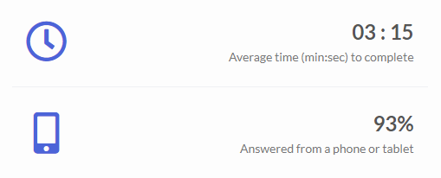
Figure 25 inform us that 93% respondents used their mobile devices or tablets to participate in this survey. This conform that the most popular internet technology devices are mobile devices, which becomes highly advanced personal computers, that can be used anywhere. Average time to complete is 3 minutes and 15 seconds.

Question 1 is about demographic and aims to collect age of the participants, to make sure that all are withing targeted group. This also separate the official generations in case for the deeper analysis of the technology use by different generations.
Figure 26. Age of survey respondents.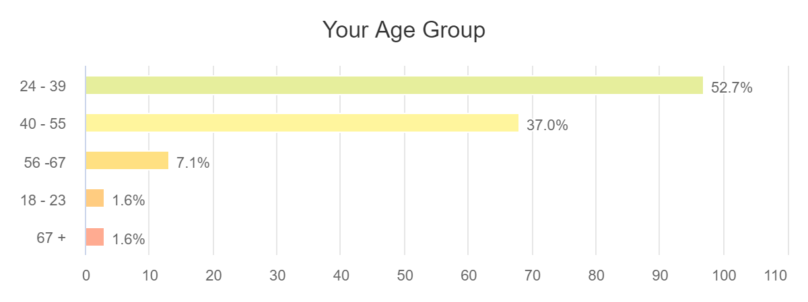

There is a wide group of test sample within all age groups. We can see the highest number of the responders is with the age 24 – 39, which are Millennials. What is interesting we received 3 answers from the group 67+, which may be a good sign that older people use internet technology too.

Question 2 is of the nature of use any self - check health control devices, such as blood sugar monitor, blood pressure monitor, digital thermometer, etc.

Figure 27. Usage of home self – check devices.
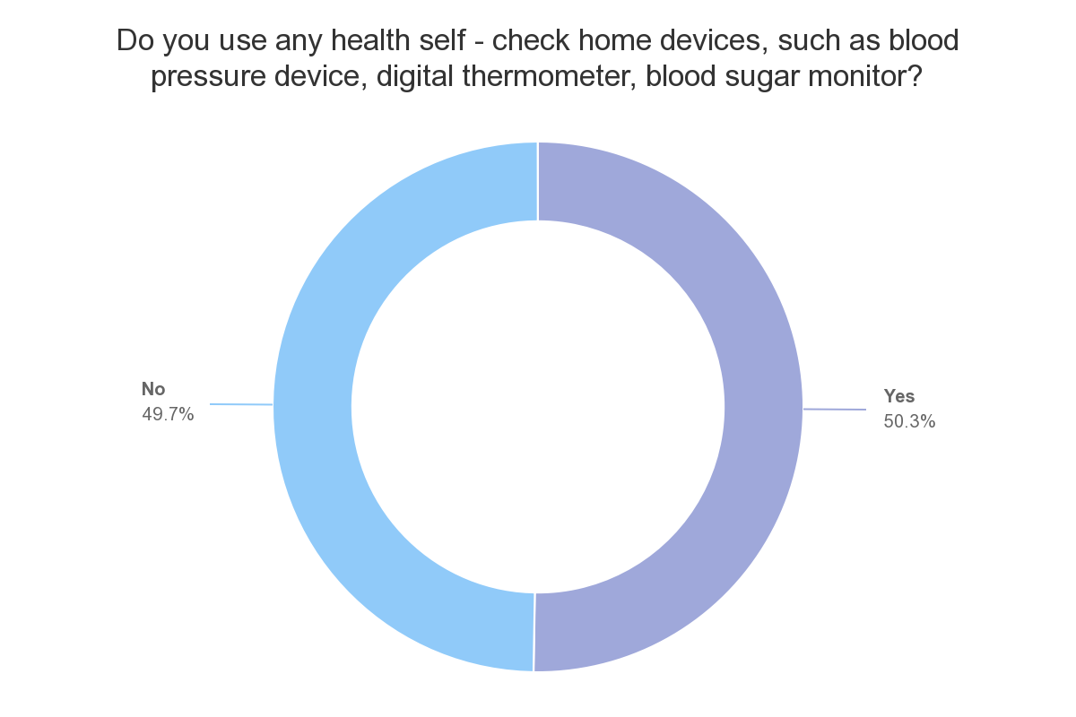
50.3% respondents answered ‘Yes’ to the question. Remaining 49.7% respondents stated that do not use any of the mentioned devices above, which may be surprising, as these are self – check healthcare instruments, easy to use, easily affordable and widely available. Having them at home would save time and help direct next steps. This indicates a gap in the use of the basic health instruments that should be the first point of health control.

Question 3 moves to explore the aim of this research. All the participants own and use internet technology device and answer how they use them in general.

Figure 28. Use of internet technology devices.
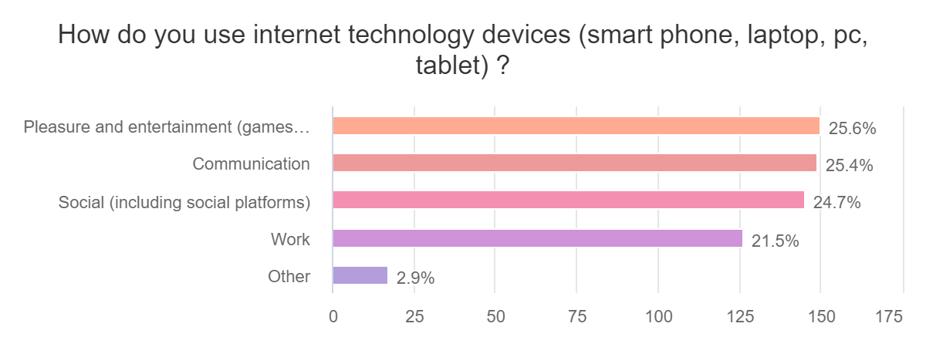
We can see that internet technology devices are used for pleasure and entertainment, communications, social (including social platforms), in a similar degree by all respondents. Relatively high number (21.5%) use devices to work. This suggest that many professions may be dependable on the use of technology.

Figure 29. Usual forms of meeting health care needs (before Covid19).
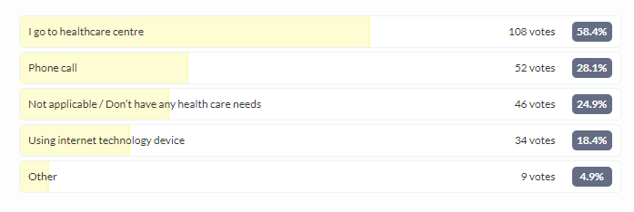
In question 4 participants were asked how they usually fulfil their healthcare needs. It is explained – ‘usually’ means - before COVID19 pandemic, to be clear, as survey was conducted during the Coronavirus pandemic.
The most chosen answer is the health centre – 58.4%. This proves that the physical attendances to the health centres are still the most popular forms of looking after own health. This is understandable, because this way we can have direct and face - to face contact with health professional. Some respondents use phone calls (28.1%), and 18.4% said that usually use internet technology device. 24.9% answers stating that this is not applicable/do not have any healthcare needs, and 4.9% says ‘other’.
We can see that the use of internet technology devices to support health needs before COVID19 were in the minority, and people prefer direct and physical face to face contact.

Question 5. Do you use any of your internet technology devices to support your health care needs?

Figure 30. Use of internet technology devices to support health care needs.
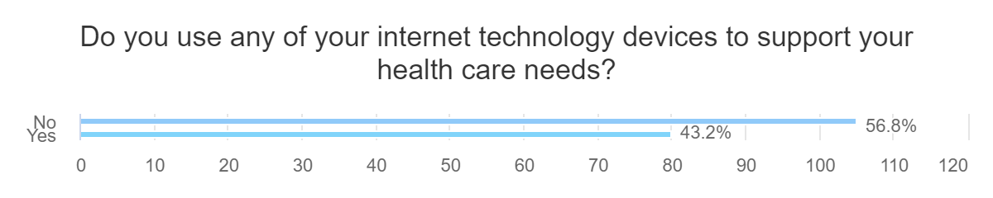
Although internet technology devices are used by large group of respondents to support healthcare needs, is still not popular. 42.3% ,which represents 80 responders use it. As we found in the question 4, most people prefer fact – to face contact. The majority (56.8%) answered ‘No’. This indicates us the gap that we will try to explain its reason in the further questions of this survey.

Question 6. During the pandemic of the Coronavirus, health centres are closed, therefore question 6 aim to find the way respondents fulfil their health care needs during this time.

Figure 31. Meeting health care needs during Coronavirus.
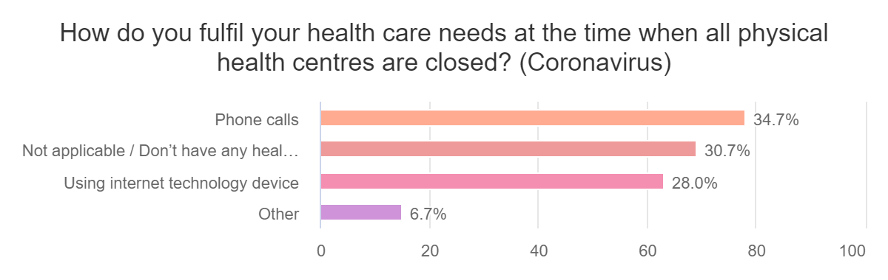
Majority use phone calls, and 28% confirmed that they use internet technology devices.
What is interesting, 30.7% says that they don’t have any healthcare issues. This includes mostly young respondents but includes individuals from all age groups (Fig.32 below).
Figure 32. Respondents with no healthcare problems during COVID19 by age.
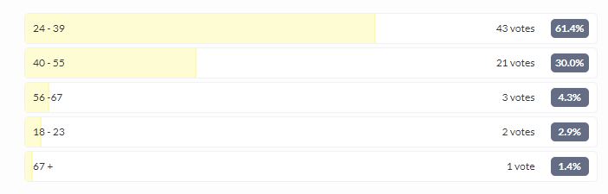

Question 7. Awareness of available healthcare applications to support health care.
Figure 33. Awareness of apps or services to support health care needs.
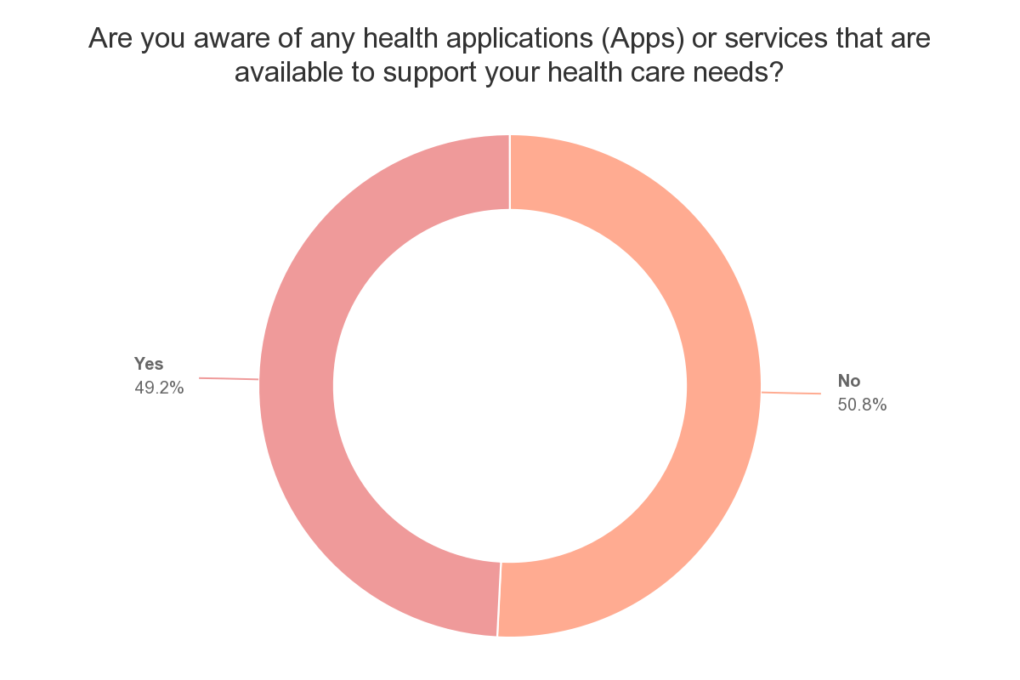
Similarly, to question 2, is balanced response, with 50.8% representing those who are not aware of any online apps, or other services to support healthcare needs. The remaining 49.2% says that they are aware of the available apps and/or services.

Question 8. Skills and knowledge to access health related products and services online. The majority of respondents answered ‘Yes’.

Figure 34. Skills and knowledge to access health care products and services online.

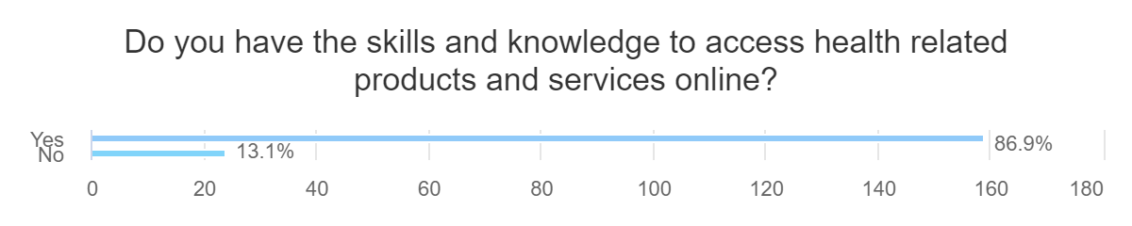
We are not sure if respondents know or only think that they have skills and knowledge to access online health related products, as many of them is not aware of any online healthcare apps (question7), and 56.8% said that they do not use internet technology devices to support their healthcare needs (question 5). Additionally, majority – 58.4% preferred usual face – to face contact with health professionals (question 4). This indicate that some respondents may think that because they use technology devices in general, it should not give many problems to use them for health care needs.
Examining the issue deeper, we should consider age of the responders:

Figure 34a. Age 18-23
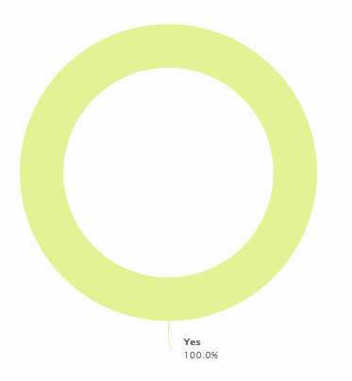
Figure 34b. Age 24-39.

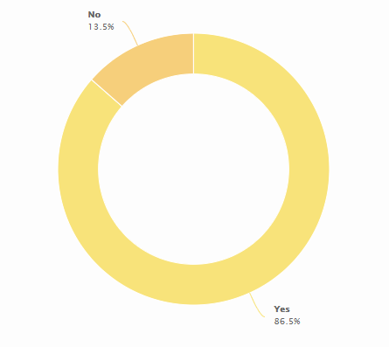

Figure 34c. Age 40 – 55.
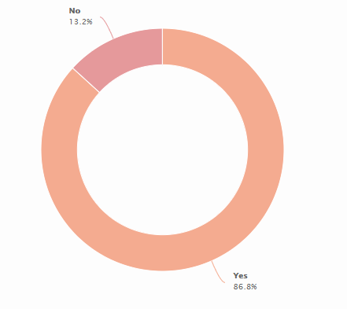

Figure 34d. Age 56- 67.
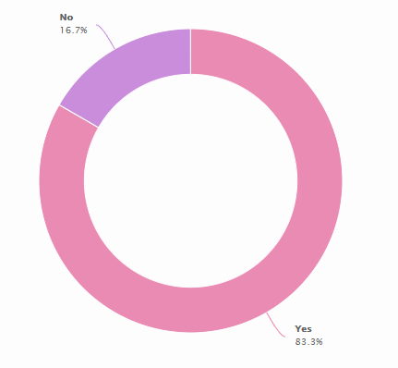

Figure 34e. Age 67+
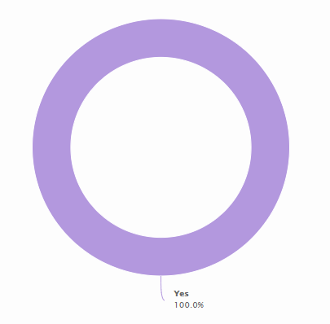

Analysing all above charts, considering particular age groups, we note that most of the responders said – yes - in every age group says to possession skills and knowledge - yes, but at this point we have to add that 50.8% of the respondents answered that they are not aware about healthcare related products or services available online (question 7). This may be caused by the false recognition of the web search (google, Yahoo, etc.) as healthcare related services to confirm, or check symptoms. Most of the older responders said that they have skills and knowledge to access health related products and services online. It may be the outcome of the greater awareness of the self - care, and promotion of available services by the healthcare professionals as the direct and faster first point of action when it comes to healthcare.

In questions 9: Do you need help and advice to improve your skills and knowledge to access health related products and services online (Fig.28), majority respondents said ‘No’.

Figure 35. Help and advice needed to access health care related services online.
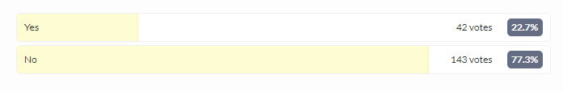
At this point we do not know if majority of respondents do not need any help and advice, because they don’t want to use any health - related products and services online, or they know how to use them. Relating to the previous question (Question 8), it was stated that they have skills and knowledge to access health related products and services. Therefore, in can be assumed that individuals in majority feel comfortable and familiar with the contemporary technology devices. 22.7% answered that they would need some help. This relatively high number, considering that technology is around us long and relates to many aspects of our every - day lives.
Although majority of the sample acknowledged their skills, there is still relatively high number (22.7%) who lacks skills of how to use online healthcare services.

Question 10.
Figure 36. During COVID19 situation have you had to learn skills and knowledge to access health related products and services online?
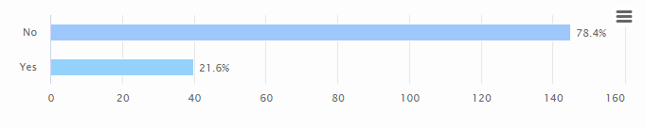

Majority of the surveyed responded they did not have to learn any new skills or knowledge to use or access health care related products or services during COVID19. We do not know the reason why they didn’t have to learn anything new. 21.6% represent individuals who said that they had to learn something new.
We notice that the majority of responders didn’t have to learn any new skills to use internet supported services, but we have to consider those who do not have any health related issues (Q6), and question 5, where 56.8% participants says that do not use internet supported device in regard to their health care.

In question 11 respondents were asked if they have access to any health care related products and services online that they need during COVID19.
Figure 37. Access to health care related product and services during COVID19.
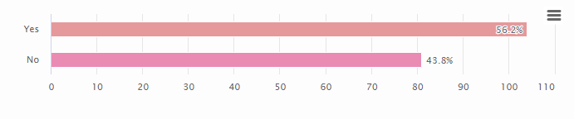
Majority – 104 individuals stated that they have access to the health care products that they need. Remaining 81 which is 43.8% of the whole sample stated ‘No’. We must remember that this may include 49 (24.9%) participants who responded that they do not have any healthcare needs (question 4).

Figure 38 Represent question 12. The need to access to more technology for health care purposes at home.
Figure 38.
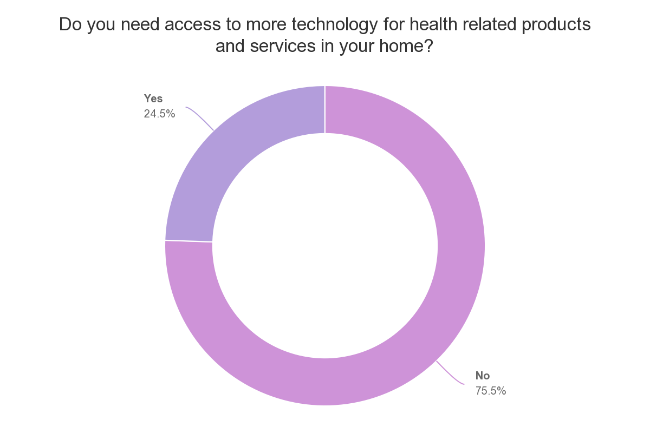
Majority of respondent stated that they have sufficient home access to technology devices supporting their health. This is individual perception, as we have to remember that 30.7% respondents stated that currently do not have any healthcare problems (Question 6), and therefore do not need access to more technology for healthcare products or services at homes.

Question 13 considers if greater access to technology for the healthcare products and services would improve overall use of the technology. Majority of respondents stated that ‘no’. As we examined in previous questions majority of respondents feel that they have enough knowledge and skills to use technology for health care. However only 44.3% responded ‘Yes’, therefore we can see that respondents may feel that they can still learn something new, and use internet technology to support their health needs would improve their use of technology.

Figure 39. Would better access to technology for health hcare improve use of technology overall?
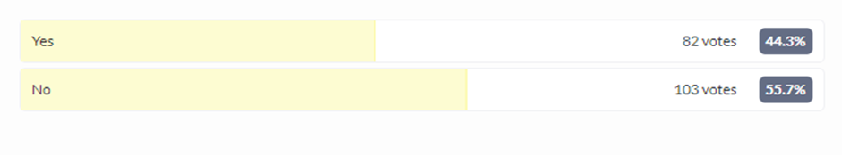

14th Question determine the ways of use the internet technology devices in supporting health care needs. This is multichoice question, so respondents could choice few options, to meet their needs.

Figure 40. How do you use internet technology to support health care needs? 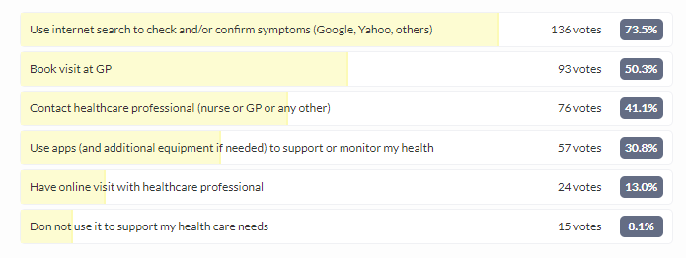
Majority of the surveyed (73.5%) stated that they use popular web browsers to check, or confirm any symptoms of illnesses, or diseases. This is one of the easiest and widely available way and is usually used as the first point to check health care uncertainties.
41.1% responded that they contact healthcare professionals, and 30.8% use health acre apps. Apps confirmed by the 1/3rd of the sample indicates us a gap and the need of improvement. Only 13% organize online meetings.
We notice that despite many available online services that allow individuals to have online visits (Doctorlink, Livi, ect.) with the healthcare professionals, it is still very rarely used.

Question 15 looks for the answer if using new technology health services can be beneficial in supporting participants basic health care needs.
Majority (75%) stated that they think that it is beneficial.

Figure 41. Can new technology health services be beneficial in supporting health care needs?
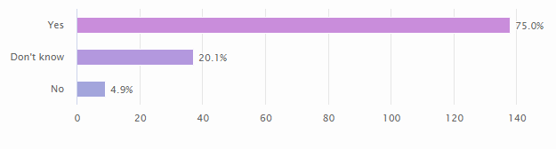
20.1% respondents do not know if using new technologies to support healthcare needs may be beneficial for their health. 4.9% says that it is not beneficial.
Some people still do not use any technology devices to support their health care needs. As we found earlier, part of the participants prefer face to face contact, therefore they would think that this is the only way they can solve their health issues. It could be the case of trying and testing how heath care technologies work and what benefits they would give.

Question 16.

Figure 42.
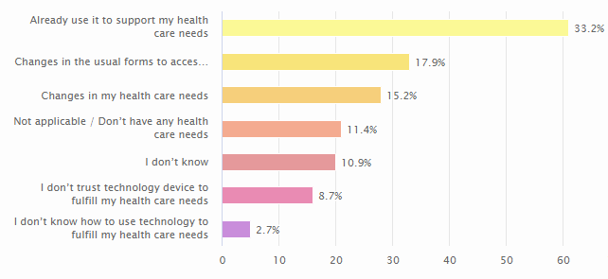
Last question in this survey ask participants what would make them use internet technology to help address their health care needs.
Majority of the respondents (33.2%) answered that they use technology to support their health needs. Changes in the usual forms to access healthcare services and changes in individual’s healthcare needs are the main reasons to start use the technology supported services. 8.7% respondents say that they don’t trust technology devices when it comes to support their health care needs. Small number – 2.7% do not know how to support their healthcare using technology. 10.9% respondents are not sure, or do not know how to answer this question. There are respondents – 11.4% who stated that they do not have any healthcare needs, but it is hard to predict what kind of healthcare they will use if they need to.

4.2.1 Correlation and Chi square analysis of age group and awareness of available apps or services to support healthcare
Figure 43, below show us correlation between the age of participants and awareness of the health applications available to support healthcare needs.
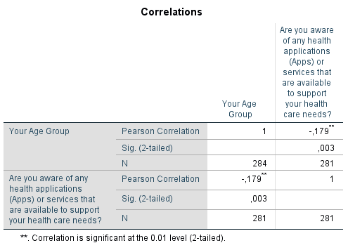

Pearson’s correlation is a statistical tool that represents relationship between two variables (Weaver et al, 2017). As we can see from the test, the correlation is negative, therefore there is no correlation between age of the respondents and awareness of the available health applications.
Figure 44. Chi square Age group and Awareness of the health applications.
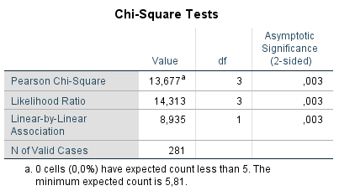
Chi square test independence of the variables and tell us about correlation coefficient (statistical relationship) (Verma, 2012). The value of 0.003 indicates that there is evidence of significant association between the age a group and awareness of the available applications (Apps) and services to support healthcare needs.

4.2.2 Correlation and chi square test of age and possessing skills and knowledge to access health related products and services online
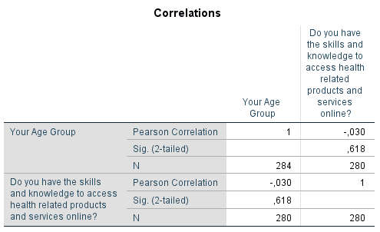
Figure 45 above, shows negative correlation. This says that there is no correlation between the two variables. It indicates that with the rising age group possessing skills and knowledge to access health related products and services are on the decline.
Figure 46. Chi square Age group and possessing skills and knowledge to access health related products online.
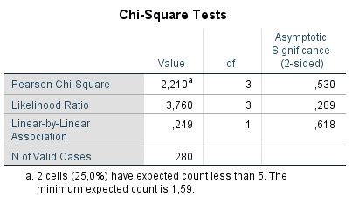
The significance value (P) is more than 0.05, therefore there is no significant relationship between age group and possession of skills and knowledge to access health related products and services online. However, we have noted – ‘a’ information below the table: the information that 2 cells (25%) have expected count of less than 5, and this violate our assumption. This could be due to gaps in our processed by SPSS data. Data retrieved from Excell includes all individuals, including those who clicked on the survey, but didn’t complete, or left when progressing to the next questions.

4.2.3 Conclusion

Survey sample gives us relatively broad view of the population, including participants from the age of 18, and to over 67. Although internet technology devices are widely used, it is noticeable that there is a significant gap in use internet technology devices to support health care needs. We see that older participants are more willing to use new technologies for the online contact with health professionals. It can be caused by their needs, known conditions and the promotion this type of service by their healthcare professionals. Almost 50% of the respondents stated that they are not aware about available online services to support their healthcare needs. The majority – 73.5% respondents says that use internet search to confirm their health symptoms, which is seen as the first point of self – check these days. Overall, one can speculate that technology used on an every day basis becomes useful and helpful when it comes to monitor and control our health. Outbreak of COVID 19 and associated restrictions resulted in use of more healthcare products and services to contact health professionals and to control and monitor health. There is no correlation between the age and use of the new healthcare services, or the skills needed to use new technologies. Participants within any age group were able to use services they want to. There is significant space for improvement of use more technology to support healthcare. The results indicate that some people do not trust technology to support their healthcare. There are associated issues with the security, or lack of skills.

4.3 Case Study
This case study is based on current outbreak of the Coronavirus, which is a disease similar to the common flu, and has been diagnosed in China in December 2019 (WHO). Since then it has spread almost all over the world and affected 10,321,689 people worldwide (WHO). Disease has been presented in 216 countries and is responsible for 507,435 deaths (WHO). In the United Kingdom it had confirmed 312,645 people affected and 43,730 deaths (Gov.uk). All above data is accurate on the 1 July 2020.
Virus caused the disruption in nearly every industry and is currently at the pandemic stage, what means that it ‘’is the worldwide spread of a new disease’’(World Health Organization).
As a part of the information available through the online services, NHS advice website ‘’NHS 111 online’’ has been giving out of date advices to the patients, which resulted in disinformation to the public, caused by lack of the on - time review of the information (Taylor, 2020).
Limited number of insights and small number of reports on the new disease confirms how dynamically changeable and unpredictable the health care environment is.
Coronavirus situation has forced introduction and use more technologies than before to fight the disease. Coronavirus occurred recently, therefore there is not much available information, apart from the ones from online sources such as Forbes, or Business Insider, and other online news websites. Technology companies such as Baidu, Alibaba, or Huawei, with the cooperation with governments, clinicians and academics works together to activate technology that would help to recognize, control and combat disease (Marr, 2020).
New technology applications available to use during the outbreak of coronavirus:
- Artificial intelligence is used to identify, diagnose, detect, track and forecast outbreak of the diseases (Yang,2020).
- Deep Mind (Google), and BenevolentAI uses big data and artificial intelligence to analyse and understand disease and develop treatment. Benevolent AI proposed existing drugs that could be helpful in fighting coronavirus (Benevolent.ai).
- ‘’Terra Drones’’ are used to collect and deliver medical samples, medication and food supplies to people that are under quarantine. (Terra-drone.net) Drones equipped in additional devices are also patrolling public spaces, collecting thermal imaging (Doffman, 2020).
- Various robots are used to reduce the human – to human contact, and risk of the catching diseases. Dependable on programmed or human – remote controlled robots are deployed to complete different tasks, such as: live contact with the patients, cleaning, sterilizing, checking temperature, taking, analysing and monitor observations (Morgan, 2020).
- Various communicators, websites and mobile applications (apps) which have been developed previously to help people access online consultation and advices form health professionals has been used more often as people have no other choice (Livi.co.uk),(Doctorlink.com).
- National Health Services provider – NHS, lack of the ventilators that in the (NHS). In response, companies totally not connected with the healthcare industry, but having teams of specialists, and technologies came up with the idea to help, and produce required equipment. Dyson, which is a British technology company focused on production patented household appliances such as vacuum cleaners, hand dryers, bladeless fans, heaters, hair dryers, etc., has come up with the idea of producing and supplying 15,000 ventilators in a short period of time (Pooler, 2020). Another, British motor industry company – Prodrive, that specialize in high performance rally and racing cars (Prodrive.co.uk), has announced that they are able to help healthcare industry and will produce ventilators (Leggett, 2020). Heavy duty building machines producer (JCB.co.uk), said that they may be able to help with the production too (Grimshaw, 2020).
- National Health Service, and its NHSX created in 2019 for the purpose of the technological development announced the app to track people who could possibly have the coronavirus, their movement and contacts that would possibly been affected too (Nhs.nhs.uk). This plan has been reviewed, and despite the established NHSX app, British Government considers now use the app developed by the global technology firms: Google and Apple (Hern, 2020). Additionally, tracking apps has been widely criticised as not prepared for the purpose and causing personal security concerns (Donelly, 2020).

4.3.1. Conclusion.
Case study shows that relatively simple, flu – like disease has quickly affected the whole world, causing economic, political, and social issues. It has disrupted economies, and countries tried to prevent further damages had to step in, and financially help to save own people in order to save their countries. through fast innovation and manufacturing the adaptation of existing technology allowed companies from many industries to produce health care equipment. All above confirms Timbleby’s (2013) statement that technology from different sectors can be adapted and used in healthcare industry, and that innovations existed somewhere else may play new role when used for the different purpose (Rogers, 1995), (Smith, 2009).

4.4 Interviews
Due to nature of this research, interviews were divided into 2 parts. First part involves individuals involved in introduction, or developments of the technology into the healthcare.
Second part includes interviews with individuals who are users of the technology.
Therefore, we can have a broad view from both sides – users and developers, their views, and issues they may face.

4.4.1 Conclusion
First part of the interview with the professionals related to the development of healthcare products and services suggest that the future of the basic healthcare will be based using new online tools. Individually tailored services will serve individuals directly and more precisely. Associated issues are existed within the limitations of the technology itself, and associated difficulties in use by individuals. Security is one of the main strong concerns within use the technology.
Second part, with the individual who use internet technology, indicates that people use and can get used to use of the new healthcare services. Evidence suggest that new services are very useful especially when people had limited choice, as during the Coronavirus outbreak and lockdown of the country. Issues concerns over good internet connection, and difficulties when use internet supported devices. Some individuals may still not use it, as prefer old style physical contact with eh healthcare professionals.

CHAPTER FIVE
Conclusion

5.1 Conclusion

Technologies becomes more visible and useful in our lives. Internet connection is one of the basic things that is used every day on regular basis. Thanks to it we can organize our live, buy and order things, communicate with anybody, regardless their geographical location.
Literature review shows that there is currently more active mobile phone, than the country’s population (Figure 15). This technology is widely available and relatively easy to use. At the same time, we can witness underdevelopment of good network coverage (Figure 17), which is one of the basic requirements when it comes to use digitally supported healthcare products and services.
McMurray (2011) suggest that bad health would have a negative impact not only on people, but also on the industries, countries, and the whole world. We have witnessed outbreak of the Coronavirus, and once again, health and healthcare industry show how environmental forces that easily affect human are unpredictable and changeable. In a relatively short period of time our health issues can affect many people, countries, and the whole world. These days when human life is in danger, and we realised that health and human are in the centre of everything, government is able to do anything - ‘’whatever it takes’’ - despite anything to help to restore health, and now investing heavily in healthcare and people.
This situation caused disruption in every aspect of our lives, from the limited freedom of movement, closed businesses, uncertainty of the employment, education, and social panicking.
The coronavirus is an example of a pandemic where rapid development of ventilators and creating the Trace& track App as well as requiring patients to use phone, online tools to communicate with healthcare professionals are examples to determine how technological development and innovations changes healthcare products and services. Diffusion of innovation, which ‘’is the process by which innovations are adopted and used by consumers’’(Smith, 2006, pp.18)has been adopted into use in not seen before speed. Technology related services has been disrupted, used more frequently and developed faster, and transferred into new industries and channels of use, as there were no other solutions available, and no time to wait. Thanks to the innovative ‘’idea, practice or object that is perceived as new by an individual or other unit of adoption’’(Rogers, 1995, pp.11), we could notice increased activities of non - healthcare related companies, that relatively easily switched and adapted their technologies to produce needed equipment. It turned out, that the technology and skills of the people in various industries may be useful in the joint agenda to help protect health and improve healthcare.
Healthcare business will benefit from the Coronavirus pandemic, as can will use more available technology and use other industries technology and knowledge to change and adapt to the healthcare industry requirements. We can see greater role of the artificial intelligence in monitoring and accessing healthcare. This aims to help health professionals in faster service and recognition, faster accurate diagnosis, and to choose appropriate treatment.
Evidence suggest that despite its novelty, great number internet devices are in use in the UK for the healthcare purposes (Figure 30). Good awareness of the available online healthcare services (Figure 33) is a good sign. Populations present relatively high level of skills and knowledge of how to use them (Figure 34), at the level of 86.9%. We noted that there is no correlation, and this is not dependable on the age, as exist within all the surveyed age groups (Figures 34a,b,c,d,e). Demand for the healthcare products and services comes from the consumers who recognise importance of their health as a merit (Backman,2008) and one of the basic needs (Maslow, 1981) that must be fulfil for the normal existence. ’’Consumer behaviour is largely driven by needs and the available solutions to meet the demands of consumers’’ (Rajagopal, 2018, pp.46).
Only 56.2% of the population sample said that they had access to the health care related products and services (Figure 37), therefore there is a large group that didn’t have, or didn’t need them at the time. Better access (Figure 39) and better technologies (i.e. 5G connections) would improve use the new products and services for health care purposes by the individuals. Majority of the survey sample recognise importance and benefits of the online healthcare products and services, and nearly 1/5 is not sure. ‘’Security, as people are hacking, therefore patient’s data may be at risk’’(Participant 2, Interviews, Appendix 5 ).There is significant lack of the available information, and fear of the data protection, recognised by the users and the service providers (Interviews).

This research has proved that despite some technology existed in the healthcare industry, there is still lack of the information about the availability, instruction of how to use, or even accessibility to the technology devices thanks to which new type of health care needs can be meet. Current situation of the Coronavirus has shown that healthcare industry is very complex and failed with simple and basic things such as inexpensive, personal protective equipment, which should be relatively easy to solve as inexpensive and standard items usually available in large number of items.
Overall, we have to say, that despite ubiquitous technology that play significant part of our lives, healthcare is still underdeveloped when it comes to standard tools that should be available to the wider number of public. Large group of the populations still preferer usual physical contact with healthcare professionals (Figure 29). The facts of growing and ageing number of the population, rising longevity of life, and rising waiting time for treatments (Figures 4,5,6,12,13), together with lack of health professionals (2.6 Current situation in healthcare industry) should make healthcare industry in cooperation with the government to make changes and respond faster to meet rising demand for its services. Artificial intelligence and individually tailored healthcare would benefit consumers and industry in prevention, faster recognition, and accurate treatments (2.10 Future of healthcare). Government, that is mainly responsible for the healthcare and its access in the United Kingdom, should stop making savings and cuts, but plan to progressively improve this field (Participant 1, Interviews transcripts, Appendix 5).

5.2 Limitations

The main one is Coronavirus outbreak, which has limited survey research method to be published online only. Having sample of non - technology users would give us wider view on the research topic. Due to lockdown some interviews were carried only through the mobile phone conversations.

5.3 Recommendations

To fulfil gaps in supply of the healthcare products and services during Coronavirus many industries decided to adapt their technologies and produce required equipment that would save lives. This proves that technologies and innovations, staff skills and knowledge that not been used in the healthcare can be switched and useful in the healthcare. Collaboration between healthcare organisations and companies from the other industries would benefit in faster and more efficient development of the new healthcare ideas, products, and services.
Greater awareness and widely available information about the benefits regarding available technology supported products and services would benefit in more customers who will use them. Government and healthcare professionals should promote and encourage people to try to switch from the usual physical forms of contact, to the online services, especially when it comes to the basic primary care and consultations. It would save time and money. Lockdown caused by Coronavirus proved that it could work.
More investments in healthcare industry would benefit to the whole population, as recently proved that the whole country can suffer because of the healthcare issues of its citizens.
Qualified healthcare workforce, including new professions such as cyber security, and cyber/online development would benefit industry in advanced but at the same time simple and more friendly to the consumers products.
System similar to the one existing in Estonia, where all the patients’ data is easily accessible by all involved in healthcare stakeholders, would be possible the best option and solution most beneficial for the United Kingdom patients( https://e-estonia.com/solutions/healthcare/).

5.4 Further research questions

We did not have the opportunity to survey sample of the population that do not use any technology, due to movement limitations caused by Coronavirus pandemic, and restrictions. Finding the ways that those people fulfil their healthcare needs, or issues they must face, and how they solve them, especially during COVID 19 would be beneficial to research topic.
This research shows that there is still large number of individuals among the technology users that do not use technology for healthcare purposes. These people are aware that this could be beneficial but still are not convinced to use. Finding the ways how to encourage them to do it would benefit for the overall technology use for the healthcare purposes.
Technology is continuously changing. Therefore, expectations among users what they expect from the technology supported healthcare products and services could be also the topic for the further research.

Bibliography

AFP. (2020) Coronavirus the worst global crisis since the WW II, says UN chief. [Online] Available at: https://www.msn.com/en-us/news/world/coronavirus-the-worst-global-crisis-since-ww-ii-says-un-chief/ar-BB11Z1h7?li=BBnbcA1#image=BBZaM5o|1 [Accessed 06.04.2020]
Agyemang, E., Barrett, C., (2020) HMRC launches coronavirus income support scheme for self-employed. Financial Times. [Online] Available at: https://www.ft.com/content/b913e58d-63a4-4945-a22a-1223fbb8b392 [Accessed 01.07.2020]
Akin, J.S., Birdsall, N., De Ferranti, D. M., (1987) Financing Health Services in Developing Countries: An Agenda for Reform. Volume 34. USA. World Bank Publications
Allen, S., (2019) 2020 global health care outlook. Laying a foundation for the future. Deloitte. [Online] Available at: https://www2.deloitte.com/content/dam/Deloitte/cz/Documents/life-sciences-health-care/2020-global-health-care-outlook.pdf [Accessed 04.04.2020]
Allen, S., (2019) 2020 Global Healthcare Outlook. Laying a Foundation for the Future. Deloitte Insights [Online] Available at: https://www2.deloitte.com/content/dam/Deloitte/cz/Documents/life-sciences-health-care/2020-global-health-care-outlook.pdf [Accessed 20.04.2020]
Bachman, D., (2020) The economic impact of COVID-19 (novel coronavirus). Deloitte. [Online] Available at: https://www2.deloitte.com/uk/en/insights/economy/covid-19/economic-impact-covid-19.html [Accessed on 07.04.2020]
Backman, G., et al. (2008) Health systems and the Right to Health: An assessment of 194 Countries. Right to Health. Lancet. Available at: https://www.thelancet.com/action/showPdf?pii=S0140-6736%2808%2961781-X [Accessed 10.03.2020]
BBC News, (2020) Budget 2020: Chancellor pumps billions into economy to combat coronavirus. [Online] Available at: https://www.bbc.co.uk/news/uk-politics-51835306 [Accessed 14.04.2020]
BBC News. (2020) More than one in four UK workers now furloughed. [Online] Available at: https://www.bbc.co.uk/news/business-52977098 [Accessed 01.07.2020]
Benwell, S., (2019) Get Connected EE, O2, Three and Vodafone promise to end rural ‘not-spots’ by 2025 meaning 95% of UK will have phone reception. [Online] Available at: https://www.thesun.co.uk/money/10209469/ee-o2-three-vodafone-end-rural-not-spots/ [Accessed 20.04.2020]
Bishop, K., (2020) We're embracing tech during lockdown – but can it replace the classroom. The Guardian. [Online] Available at: https://www.theguardian.com/technology/2020/apr/24/remote-learning-classroom-technology-coronavirus [Accessed 01.06.2020]
Bohr, QA., Memardzedeh, K., (2020) Artificial Intelligence in Healthcare. United Kingdom. Academic Press
Boseley, S., (2020) England's test-and-trace system not fit for purpose, say scientists. The Guardian. [Online] Available at: https://www.theguardian.com/politics/2020/jun/09/uks-test-and-trace-system-not-fit-for-purpose-say-scientists [Accessed 12.06.2020]
BRIEF-Alibaba Launches AI System For Fever Screening Amid Coronavirus Outbreak – Xinhua. Reuters. [Online] Available at: https://www.reuters.com/article/brief-alibaba-launches-ai-system-for-fev/brief-alibaba-launches-ai-system-for-fever-screening-amid-coronavirus-outbreak-xinhua-idUSFWN2AD1HG [Accessed 07.03.2020]
Bryson Taylor, D., (2020) A Timeline of the Coronavirus Pandemic. The New York Times. [Online] Available at: https://www.nytimes.com/article/coronavirus-timeline.html [Accessed 08.07.2020]
Cabral, T., M., (2019) Market Analysis 2020 on Health Economics and Informatics. Journal of Health and Medical Economics. [Online] Available at: https://health-medical-economics.imedpub.com/market-analysis-2020-on-health-economics-and-informatics.php?aid=25225 [Accessed 20.06.2020]
Callan-Jones, R., (2020) Coronavirus: Isle of Wight contact-tracing app trial - a mixed verdict so far. BBC News. [Online] Available at: https://www.bbc.co.uk/news/technology-52709568 [Accessed 12.06.2020]
Campbell, D., (2019) U-turn as ministers reconsider financial aid for student nurses. The Guardian. [Online] Available at: https://www.theguardian.com/society/2019/sep/26/u-turn-as-ministers-reconsider-financial-aid-for-student-nurses [Accessed 07.03.2020]
Cobb, C., G., (2015) The Project Manager's Guide to Mastering Agile: Principles and Practices for an Adaptive Approach. New Jersey, John Wiley and Sons
Collis, J., Hussey, R., (2009) Busines Research: A Practical Guide for Undergraduate and Postgraduate Students. Basingstoke, UK. Palgrave Macmillan.
Cope, E., M., (1865) Plato’s Giorgias. Literally Translated, With an Introductory Essay Containing a Summary of Argument. Cambridge. Deighton, Bell, and Co.
Cox, C. L., (2020) ‘Healthcare Heroes’: problems with media focus on heroism from healthcare workers during the COVID-19 pandemic. Journal of Medical Ethics. [Online] Available at: https://jme.bmj.com/content/early/2020/06/16/medethics-2020-106398 [Accessed 05.07.2020]
Daniel, J., (2011) Sampling Essentials. Practical Guidelines for Making Sampling Choices. United Kingdom. Sage Publications
Davies, R, (2020) How Coronavirus is affecting global Economy. The Guardian. [Online] Available at: https://www.theguardian.com/world/2020/feb/05/coronavirus-global-economy [Accessed 12.02.2020]
Delloite. (2020) The Future of Artificial Intelligence in Healthcare. Emerging Application of AI in Healthcare. [Online] Available at: https://www2.deloitte.com/us/en/pages/life-sciences-and-health-care/articles/future-of-artificial-intelligence-in-health-care.html [Accessed 20.03.2020]
Dengler, P., (2018) Lifelong Employability: Thriving in an Ageing Society. Switzerland. Springer Gabler
Dillman, D., A. (2011) Mail and Internet Surveys. The Tailored Design Method. 2nd Edition. New Jersey. John Wiley and Sons
Dimick, J.B., Lubitz, C.C., (2020) Health Services Research. 2nd Edition. USA. Springer
Doffman, Z., (2020) This New Coronavirus Spy Drone Will Make Sure You Stay Home. Forbes. [Online] Available at: https://www.forbes.com/sites/zakdoffman/2020/03/05/meet-the-coronavirus-spy-drones-that-make-sure-you-stay-home/#56051c7b1669 [Accessed 12.06.2020]
Donnelly, L., Wright, M., (2020) Government's coronavirus tracing app facing questions on cyber security and privacy. The Telegraph. [Online] Available at: https://www.telegraph.co.uk/news/2020/05/04/revealed-governments-coronavirus-tracing-app-failed-key-tests/ [Accessed 01.07.2020]
Easwaramoorthy, M., Zarinpoush, F., (2006) Interviewing for research. Imagine Canada. [Online] Available at: http://sectorsource.ca/sites/default/files/resources/files/tipsheet6_interviewing_for_research_en_0.pdf [Accessed 10.03.2020]
Elton, J., O’Riordan, A., (2016) Healthcare Disrupted: Next Generation Business Models and Strategies. New Jersey. John Willey and Sons
Field, M., (2020) What’s behind the delay in the UK’s contact-tracing app? The Telegraph. [Online] Available at: https://www.telegraph.co.uk/technology/2020/06/10/behind-delay-uks-contact-tracing-app/ [Accessed 12.06.2020]
Fishwick, S., (2020) Meet the apps and websites using data to track the spread of Covid – 19. Evening Standard. [Online] Available at: https://www.standard.co.uk/tech/coronavirus-apps-data-software-a4402561.html [Accessed 04.04.2020]
Fowler Jr., F., J., (2009) Survey Research Methods. United Kingdom. Sage Publications
Garibaldi, P., Martins, J., O., Jan van Ours, (2010) Ageing, Health, and Productivity. The Economics of Increased Life Expectancy. Oxford. Oxford University Press
Goodwin, J., (2020) SAGE Secondary Data Analysis. London. Sage Publications Ltd
Gov.uk (2018) Dementia: applying All Our Health. [Online] Available at: https://www.gov.uk/government/publications/dementia-applying-all-our-health/dementia-applying-all-our-health [Accessed 07.03.2020]
Gov.uk (2020) Coronavirus cases in the United Kingdom. Accessed at: https://coronavirus-staging.data.gov.uk/ [Accessed 01.07.2020]
Gov.uk (2020) The Health and Care System Explained. Department of Health and social Care. [Online] Available at: https://www.gov.uk/government/publications/the-health-and-care-system-explained/the-health-and-care-system-explained [Accessed 04.03.2020]
Gov.uk, (2020) Coronavirus (COVID19). Available at: https://www.gov.uk/coronavirus [Online] [Accessed 05.04.2020]
Gov.uk. (2020) Business Support. [Online] Available at: https://www.gov.uk/coronavirus/business-support [Accessed 01.07.2020]
Gravetter, F., J., Forzano, LA., B., (2011). Research Methods for Behavioural Sciences. 4th Edition. USA. Cengage Learning
Greenfield, A., (2018) Radical Technologies: The Design of Everyday Life. London. Verso
Grimshaw, J., (2020) JCB joins Dyson to help end the ventilator shortage. Manufacturing Global. [Online] Available at: https://www.manufacturingglobal.com/technology/jcb-joins-dyson-help-end-ventilator-shortage [Accessed 12.06.2020]
Grisham, J., (2020) JCB joins Dyson to help end the ventilator shortages. Manufacturing Global. [Online] Available at: https://www.manufacturingglobal.com/technology/jcb-joins-dyson-help-end-ventilator-shortage [Accessed 07.04.2020]
Hagger – Johnson, G., (2014) Introduction to Research Methods and Data Analysis in the Health Sciences. London. Routledge
Hair Jr., et al. (2011) Essentials of Business Research. 2nd Edition. London. M.E. Sharpe Inc.
Hancock, M., (2020) 'Surprising and worrying': Test and trace fails to reach thousands infected with coronavirus. ITV News. [Online] Available at: https://www.itv.com/news/2020-06-25/nhs-test-and-trace-fails-to-reach-thousands-of-people-infected-with-coronavirus/ [Accessed 28.06.2020]
Haroon, S., (2020) What is the situation with the personal protective equipment in the UK? The Guardian. [Online] Available at: https://www.theguardian.com/world/2020/apr/14/coronavirus-what-is-the-situation-with-ppe-personal-protective-equipment-in-the-uk [Accessed 03.05.2020]
Hayre, C.M., et al. (2019) Everyday Technologies in Healthcare. London. CRC Press
Hern, A., Covid – 19 Could Cause Permament Shifts Towards Home Working. The Guardnian. [Online] Available at: https://www.theguardian.com/technology/2020/mar/13/covid-19-could-cause-permanent-shift-towards-home-working [Accessed 15,04.2020]
Hern, A., Proctor K., (2020) UK may ditch NHS contact-tracing app for Apple and Google model. The Guardian. [Online] Available at: https://www.msn.com/en-gb/news/coronavirus/uk-may-ditch-nhs-contact-tracing-app-for-apple-and-google-model/ar-BB13KNb1?li=BBoPWjQ&ocid [Accessed on 09.05.2020]
Hern, A., Proctor, K., (2020) UK may ditch NHS contact-tracing app for Apple and Google model. The Guardian. [Online] Available at: https://www.theguardian.com/technology/2020/may/07/uk-may-ditch-nhs-contact-tracing-app-for-apple-and-google-model [Accessed 01.07.2020]
Holtz, C., (2013) Global Health Care: Issues and Policies. USA. Jones and Bartlett Publishers
Jakovlejic, M., Souliotis, K., Groot, W., (2016) Healthcare Financing and Affordability in the Emerging Global Markets. Frontiers Media
Kara, H., (2013) Collecting Primary Data: A Time-Saving Guide. United Kingdom. Policy Press
King, H., (2005) Health in Antiquity. London and New York. Routledge
Kleinman, M., (2020) KPMG chair warns of pandemic's 'economic disaster' fallout. MNS [Online] Available at: https://www.msn.com/en-gb/money/news/kpmg-chair-warns-of-pandemics-economic-disaster-fallout/ar-BB12Yqmn?li=AAwnS0s&ocid=mailsignout [Accessed 13.05.2020]
Kuensberg, L., (2020) Coronavirus: Strict new curbs on life in the UK announced by PM. BBC News. [Online] Available at: https://www.bbc.co.uk/news/uk-52012432 [Accessed 24.02.2020]
Lakovleva, T., Oftedal, E. M., Bessant, J., (2019) Responsive Innovation in Digital Health: Empowering the Patient. UK. Edward Elgar Publishing
Lantos, G. P., (2015) Consumer Behaviour in Action. Real Life Applications for Marketing Managers. London. Routledge
Lavrakas, P., J., (2008) Encyclopedia of Survey Methods. United Kingdom. Sage Publications Ltd.
Leggett, T., (2020) The Prodrive Motorsport company it switching its factory to ventilators. BBC News. [Online] Available at: https://www.bbc.co.uk/news/av/business-52006907/the-prodrive-motorsport-company-it-switching-its-factory-to-ventilators [Accessed 12.06.2020]
Leggett, T., (2020) The Prodrive Motorsport it switching its manufacturing into ventilators. BBC NEWS. [Online] Available at: https://www.bbc.co.uk/news/av/business-52006907/the-prodrive-motorsport-company-it-switching-its-factory-to-ventilators [Accessed 16.05.2020]
Liu, D., et al. (2018) The Challenges of Health Disparities. USA. Jones and Bartlett Publishers, Inc
Lloyd – Jones, H., (2020) Living in lockdown: How people are using technology to adapt. District. [Online] Available at: https://district-tech.com/living-in-lockdown-how-people-are-using-technology-to-adapt/ [Accessed 10.04.2020]
Makary, M., (2019) The Price We Pay. What Broke American Healthcare and How to Fix it. New York. Bloomsbury Publishing
Marlow, E., et al. (2012) The Breakdown of Hierarchy: Communicating in the Evolving Workplace. London. Routledge
Marques, O., (2016) Innovative Technologies in Every Day Life. Switzerland. Springer
Marr, B., (2018) The Key Definitions Of Artificial Intelligence (AI) That Explain Its Importance. Forbes. [Online] Available at: https://www.forbes.com/sites/bernardmarr/2018/02/14/the-key-definitions-of-artificial-intelligence-ai-that-explain-its-importance/#523405d54f5d [Accessed 04.04.2020]
Marr, B., (2020) Coronavirus: How Artificial Intelligence, Data Science And Technology Is Used To Fight The Pandemic. Forbes. [Online] Available at: https://www.forbes.com/sites/bernardmarr/2020/03/13/coronavirus-how-artificial-intelligence-data-science-and-technology-is-used-to-fight-the-pandemic/ [Accessed 04.04.2020]
Marr, B., (2020) Tech Trends in Practice: The 25 Technologies that are Driving the 4th Industrial Revolution.UK. John Wiley and Sons
Maxwell, I.E, (2009) Managing Sustainable Innovation: The Driver for Global Growth. New Zealand. Springer
McGee, P., Murphy, H, Bradshaw, T., (2020) Coronavirus apps: the risk of slipping into a surveillance state. Financial times. [Online] Available at: https://www.ft.com/content/d2609e26-8875-11ea-a01c-a28a3e3fbd33 [Accesses 12.06.2020]
Mishra, S., B.; Alok, S., (2017) Handbook of Research Methodology: A compendium for Students and Researchers. New Delhi. Educreation Publishing
Mishra, S.B., Alok, S., (2017) Handbook of Research Methodology. India. Educreation Publishing
Morgan, B., (2020) 10 Examples of Robots Helping to fight COVID. [Online] Available at: https://www.forbes.com/sites/blakemorgan/2020/04/22/10-examples-of-robots-helping-to-fight-covid/#17b989dbf4bf [Accessed 12.06.2020]
Nixon, G., (2020) What we think of as 'valuable' is changing amid coronavirus and firms will be judged on how they behaved, says former BoE governor Mark Carney. This in Money. [Online] Available at: https://www.thisismoney.co.uk/money/news/article-8225053/Mark-Carney-Coronavirus-shows-value-public-health-economy.html [Accessed 20.04.2020]
Nuttall, J., (2013) An Introduction to Philosophy. UK. John Wiley and Sons
Pattnaik, P.K., et al, (2020) Smart Healthcare Analytics in IoT Enabled Environment. Switzerland. Springer
Pasian, B., (2016) Designs, Methods and Practices for Research of Project Management. UK. Routledge
Perkis, B., Fench, C., (2014) Growing Power of Consumers. Deloitte. [Online] Available at: https://www2.deloitte.com/content/dam/Deloitte/uk/Documents/consumer-business/consumer-review-8-the-growing-power-of-consumers.pdf [Accessed 04.03.2020]
Phillips, P.P., Phillips, J. J., Aaron, B., (2013) Survey Basics. USA. ASTD Press
Pooler, M., Hollinger, M., (2020) Dyson to produce 15,000 ventilators from scratch ‘in weeks’ Financial Times. [Online] Available at: https://www.ft.com/content/4cc667f2-6ee2-11ea-89df-41bea055720b [Accessed 12.06.2020]
Prabhala, A., Hoen, E., (2020) We'll find a treatment for coronavirus – but drug companies will decide who gets it. The guardian. [Online] Available at: https://www.theguardian.com/commentisfree/2020/apr/15/coronavirus-treatment-drug-companies [Accessed 17.04.2020]
Rabelais, F.; (2015) Thoughts On The Business Of Life. Forbes. [Online] Available at: https://www.forbes.com/quotes/3049/ [Accessed 04.05.2020]
RCN, (2020) Community based nursing staff are being failed by lack of PPE. [Online] Available at: https://www.rcn.org.uk/news-and-events/news/uk-rcn-demands-personal-protective-equipment-ppe-community-nurses-covid-19-010420 [Accessed 11.04.2020]
RCN. Guidance for members: refusal to treat due to lack of PPE during the pandemic. [Online] Available at: https://www.rcn.org.uk/-/media/royal-college-of-nursing/documents/publications/2020/april/009-231.pdf?la=en [Accessed 11.04.2020]
Robert, L.; Donelly L., (2020) The NHs Test and Trace system explained. The Telegraph. Available at: https://www.telegraph.co.uk/news/2020/06/10/nhs-test-trace -uk/ [Accessed 10.06.2020]
Saunders, M., Lewis, P., Thornhill, A., (2012) Research Methods for Business Students. 6th Edition. Harlow, UK. Pearson Educational Limited
Saunders, M., Lewis, P., Thornhill, A., (2012) Research Methods for Business Students. Harlow. Pearson.
Sekaran, U., Bougie, R., (2016) Research Methods for Business. A Skill – Building Approach. 7th Edition. United Kingdom. John Wiley and Sons Ltd.
Sheaff, W.,R. (2002) The Need for Healthcare. London. Routhledge
Siddique, H., (2020). What is the situation with personal protective equipment in the UK? The Guardian. [Online] Available at: https://www.theguardian.com/world/2020/apr/14/coronavirus-what-is-the-situation-with-ppe-personal-protective-equipment-in-the-uk [Accessed 25.05.2020]
Sparrow, A., et al. (2020) UK coronavirus: Boris Johnson announces strict lockdown across country – as it happened. The guardian. [Online] Available at: https://www.theguardian.com/politics/live/2020/mar/23/uk-coronavirus-live-news-latest-boris-johnson-minister-condemns-people-ignoring-two-metre-distance-rule-in-parks-as-very-selfish [Accessed 15.04.2020]
Statista. (2019) Health expenditure as a percentage of gross domestic product in selected countries in 2018. [Online] Available at: https://www.statista.com/statistics/268826/health-expenditure-as-gdp-percentage-in-oecd-countries/ [Accessed 06.04.2020]
Taylor, W., (2020) NHS 111 service is giving out of date coronavirus advice. Msn. [Online] Available at: https://www.msn.com/en-gb/news/coronavirus/nhs-111-service-is-giving-out-of-date-coronavirus-advice/ar-BB10ZHOs?li=BBoPWjQ [Accessed 14.03.2020]
Terra News. (2020) Terra Drone business partner Antwork helps fight coronavirus in China with medical delivery drones. Terra Drones. [Online] Available at: https://www.terra-drone.net/global/2020/02/07/terra-drones-group-company-antwork-helps-fighting-corona-virus-with-drones/ [Accessed 10.03.2020]
Thimbleby H. (2013) Technology and the future of healthcare. Journal of Public Health Research ; 2(3): e28. [Online] Available at: https://www.ncbi.nlm.nih.gov/pmc/articles/PMC4147743/ [Accessed 15.03.2020]
Tisdall, S., (2020) Covid-19 has changed everything. Now we need a revolution for a born-again world. Guardian. [Online] Available at: https://www.theguardian.com/commentisfree/2020/may/24/covid-19-has-changed-everything-now-we-need-a-revolution-for-a-born-again-world [Accessed 13.05.2002]
United Nations. Universal Declaration of Human Rights. [Online] Available at: https://www.un.org/en/universal-declaration-human-rights/ [Accessed 20.03.2020]
United Nations. (2019) World Populations Prospect 2019. [Online] Available at: https://www.un.org/development/desa/publications/world-population-prospects-2019-highlights.html#:~:text=World%20Population%20Prospects%202019%3A%20Highlights,-17%20June%202019&text=The%20world's%20population%20is%20expected,United%20Nations%20report%20launched%20today. [Accessed 04.02.2020]
United Nations. (2020) Digital technologies critical in facing COVID-19 pandemic. [Online] Available at: https://www.un.org/development/desa/en/news/policy/digital-technologies-critical-in-facing-covid-19-pandemic.html [Accessed 04.05.2020]
Verma, J.P., (2012) Data analysis in Management with SPSS software. New Delhi. Springer
Walker, P. (2020) Retired and student medics may be called in to tackle Covid-19 in UK. [Online] Available at: https://www.theguardian.com/world/2020/mar/17/retired-and-student-medics-may-be-called-in-to-tackle-covid-19-in-uk [Accessed 05.072020]
Watts, R., et al. (2020) Coronavirus in maps and charts: how the outbreak has spread. The Times. [Online] Available at: https://www.thetimes.co.uk/article/coronavirus-in-maps-and-charts-how-the-outbreak-has-spread-j9rpzr3nw [Accessed 20.03.2020]
Weaver, K.F.,et al, (2017) An Introduction to Statistical Analysis in Research: With Applications in the Biological and Life Sciences. USA. John Wiley and Sons
World Health Organization (2020) Coronavirus cases worldwide. [Online] Available at: https://www.who.int/emergencies/diseases/novel-coronavirus-2019 [Accessed 01.07.2020]
World Health Organization (2019) Primary Healthcare. World Health Organization. [Online] Available at: https://www.who.int/news-room/fact-sheets/detail/primary-health-care [Accessed 21.07.2020]
World Health Organization (2020) Timeline of WHO’s response to COVID-19. WHO. [Online] Available at: https://www.who.int/news-room/detail/29-06-2020-covidtimeline [Accessed 04.07.2020]
World Health Organization (2020) What is pandemic? World Health Organization. [Online] Available at: https://www.who.int/csr/disease/swineflu/frequently_asked_questions/pandemic/en/ [Accessed 15.04.2020]
Yang, Y., Zhu, j., (2020) Coronavirus brings China's surveillance state out of the shadows. Reuters. [Online] Available at: https://www.reuters.com/article/us-china-health-surveillance/coronavirus-brings-chinas-surveillance-state-out-of-the-shadows-idUSKBN2011HO [Accessed 25.02.2020]
Yin, R., K., (2018) Case Study. Research and Applications. Design and Methods. 6Th Edition. Los Angeles. Sage Publications, Inc.

Websites:
BenevolentAI. Retrieved from: https://benevolent.ai/
BlueDot Risk Software. Retrieved from: https://bluedot.global/
Blue Ocean Robotics. Retrieved from: https://www.blue-ocean-robotics.com/
Deep Mind. https://deepmind.com/
E-estonia.com/solutions/healthcare/
Pudu Robots. Retrieved from: https://www.intelrealsense.com/pudu-delivery-robot/, https://www.pudutech.com/
Sensetime AI. Retrieved from: https://www.sensetime.com/en/
Worldomoteres.org
2045.com

Apps:
Tracktogether.co.uk
Letsbeatcovid.net
Covid.joinzone.com
Doctorlink.com
Livi.co.uk

Appendixes

Appendix 1. Diffusion of innovation detailed theory.
a. Innovation.
• The main element is an innovation. It must exist first. As we previously established, innovation is ‘’an idea, practice, or object perceived as new by an individual, or other unit of adoption’’(Rogers, 2010, pp.11). Any new solution, innovation involves some uncertainty, ‘’(…) innovation creates one kind of uncertainty (about it expected consequences) in the mind of potential adopters, as well as representing an opportunity for reduced uncertainty in another sense (reduced by the information(…)’’(Rogers, 2010, pp.13), therefore in this theory we try to explain how uncertainty may be reduced, and therefore can result in quicker adoption.
• The following characteristics help to explain different rate of adoption:
• Relative advantage means that innovation may be adopted in a reasonably quick period when is perceived as better that the idea it replaces and advantageous.
• Compatibility is when the innovation can be easily adopted, considering existing values and norms, experiences and needs of the adopters. Adoption of incompatible innovation can be a slow process, as may need to adopt new value system.
• Complexity is a degree that the new idea is recognized as complicated and difficult to understand and to use. The higher complexity, the idea will be adopted slower.
• Triability is when new idea can be tried, experimented in limited reality t check its usability and easiness to adopt in the future for the wider number of users.
• Observability is about real and visible changes that the innovation will make. If the visibility is greater to the users, the ideas are more likely to adopt quicker. (Rogers, 2010).
New ideas, innovations that are perceived as have greater characteristics explained above, have opportunities to be adopted quicker.

b. Communication Channels.
‘’Communication must take place if innovation is to spread.’’ (Rogers, 2010, pp.17). We said it previously that diffusion is a special type of the communication, where one can spread the information about existing the new idea. Although the interpersonal channels ‘’are more effective in persuading an individual to accept the idea’’ (Rogers, 2010, pp.18), mass media are recognized as more efficient and faster to have greater opportunity to get the audience of many people. (Rogers, 2010).
The research on the diffusion shows that subjective evaluation, based on the own or the experience of other who adopted it already, is more important to the individual than the objective evaluation, that is based on the scientific experiments. (Rogers, 2010).
‘’An obvious principle of human communication is that the transfer of ideas occurs more frequently between two individuals, who are similar or homophilous.’’(Rogers, 2010, pp.18). Homophily is the principle that a contact between similar people occurs at a higher rate than among dissimilar people. (…) constrains on people’s social worlds, with strong implications for the information they receive, for the attitudes they form, and the interactionist become involved.’’ (Jensen, 2015, pp.37). Therefore, the best and most effective communication is when it happens between people who belong to the same group, share similar beliefs, work in the same firm, or industry, have the same beliefs, social status, or education, etc.

c. Time.
Time is the important element in the process of diffusion of the innovation, as it is involved in decision making process, categories of adopters and rate of adoption:
• Decision making process creates attitude towards innovation, its adoption or rejection, and practical use. This stage contains five steps: knowledge, persuasion, decision, implementation, and confirmation.
• Categories of adopters (Figure 21) describes innovators and adopters and their readiness to apply new ideas (Rogers, 2010)

Figure 21. Categories of innovation adopters.
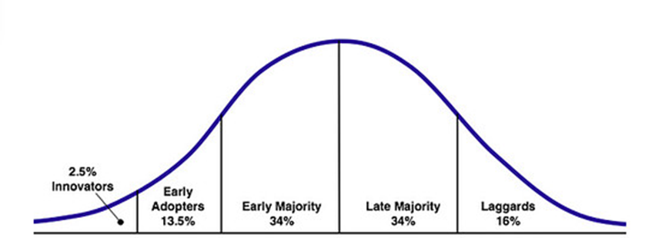
Adapted from: https://web-strategist.com/blog/2010/01/03/social-technology-adoption-curve-benefits-and-risks/

Innovators who are visionaries and risk takers, as first group they decide to adopt and experience innovations, often influencing others. Next group – early adopters are more critical to the new things, but are willing to try at the earliest stage of the existence of innovation. Early majority is the main group on the market, that adopt innovation based on the experience and opinion of the 2 previous groups, waiting for idea to be recognised as useful and successful first. Late majority, the same size as early majority, is the group which is the hardest to influence, or persuade. Individuals who are included in this group usually adapt new solutions only if they are forced to do it. Laggards, are the last group when it comes to adaptation of the new things. These individuals have very negative attitude towards any changes, and can do it only if it is unavoidable.
• Rate of adoption describes the time that is needed by the members of the society. There are usually different periods of time when the same new things are adopted between different social systems, between the people who have different norms, and beliefs. Innovation that presents greater relative advantage and compatibility are adopted quicker.

d. Social system.
‘Social system is a set of interrelated units that are engaged in joint problem solving to accomplish a common goal.’’ (Rogers, 2010, pp.23). Systems may contain a group of individuals, small groups, and organizations, which may affect diffusion of innovation in various ways, through setting formal regulations, rules and norms, boundaries, that may speed up, delay, or even reject adoption of the new idea. (Rogers, 2010). Decisions within the social systems may be undertaken through various ways:
• Optional innovation decisions are made on the independent individual basis but may be affected by the norms and standards within the system.
• Collective innovation decisions are made by consensus among the members of the group. Once the decision is made by the most members, others must agree.
• Authority innovation decision are choices that are made by the individuals who hold the most decision - making power within the community system. The rest of the community have no influence and must comply with the decisions. The fastest decisions within the social systems regarding adoption of the new ideas are usually made by the authorities, as it involves less members to vote and decide.

Appendix 2. Avatar Project.
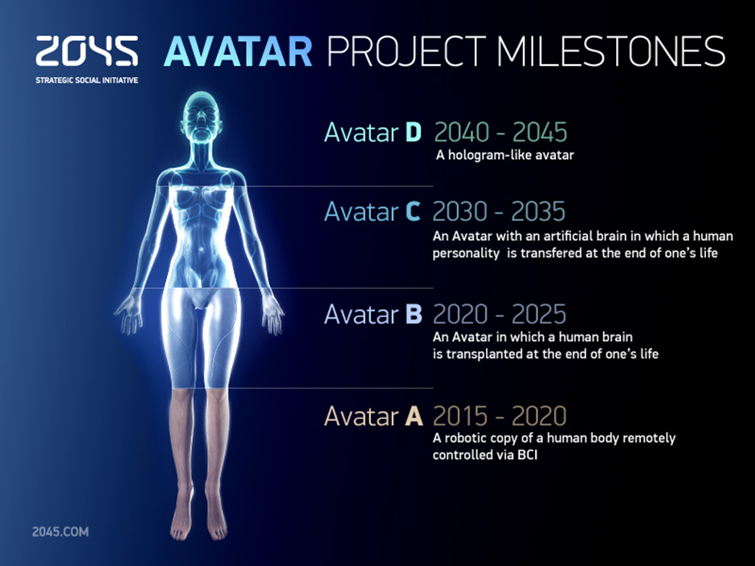
Adapted from: http://2045.com/
This project founded by the Russian billionaire Dmitry Itskov, aims to create a human avatar, that would replace organic body. The idea is that our brain is responsible for us, then if that would be possible to make our brain, and its electronic version live forever, in the artificial body, people theoretically could live forever. This super – human could live as long as want, without any issues (245.com). This is not the aim of this study but a health related innovation.

Appendix 3. Concerns over the security when using new track & trace apps.
The following note has been published on the Facebook’s user main page – ‘wall’ (original text):
‘’ PLEASE NOTE: To all Facebook friends who intend to install the COVID-19 app for tracking: I am asking you to please delete me and my details from your phone contact list & any other app, as well as unfriend me on Facebook before installing the tracking app on your smartphone.
This app will ask permission to access all of your contacts.
You Do Not have my Consent in either written, oral or " assumed" format to use my phone number or Facebook contact in connection with your app to identify, track, or locate me without my prior knowledge or written & signed consent.
Think about it carefully before installing the Track and Trace app, you are not a Parcel, but you could be a Prisoner to this app
You can copy and paste this to your status if you don't want to be tracked by this app (Spyware)
Thanks in advance’’ L.B.
After the explanation by one of the nurses who is involved in the process of introducing the app at her hospital, the same person has said: ’’ oh right , i get that for ur job . (…) copied n pasted the status and just saw access being gained to my account . (…)thanks for explaining’’.

The person who has explained how the new apps works:
‘’ I didnt think you'd be one of the anti-appers! I am having it and I am one of the nhs track and trace nurses, doing it around my main job, I just spent 12 hours on my weekend off doing it. It breaks my heart for this country that people are resisting something that worked so well elsewhere.’’
‘’ its an app that picks up if you have been near someone who tests positive for covid19. So they will have the app too and they will put in it that they tested positive then you will get an alert telling you to self isolate because you have been close to a positive case in past few days. It will save me having to ring the positive person and manually get all the details of the people they have been near’’. P.Mc.

Appendix 4. Survey information.
Healthcare as a Business in the Era of Fast Development of Technology and Innovation.
This survey is part of the MBA research on the topic: Healthcare as a Business in the Era of Fast Development of Technology and Innovation. Participation in this survey is voluntary and anonymous, therefore I ask you for openness and honesty. Your feedback will help to identify weaknesses, strengths, and the areas of the further development. You have the right to withdraw from participation in this survey at any time.

Data collected through this survey will be analysed and used in my MBA research project.

You are a technology user in general. You have access to the internet via technology supported device ( laptop, tablet, smart phone, PC ).

In the ‘footer’ there is an information:
Healthcare is changing. People want to live healthier and longer. Recent Coronavirus pandemic proves that healthcare industry needs more changes and improvements.
Please take part in this survey as it may help in the future development in the healthcare industry.
At the end:
Thank you for filling out this survey. Your feedback is highly appreciated!

Appendix 5. Interviews transcripts.
Interview 1.
With Interviewee 1 (Participant1) who is Head of Health Informatics at NHS Digital, based in Northern England. P1 was appointed on the 24.20.2019 at NHS Digital office. P1 is responsible for developing Information technology strategy, and improvement of the performance management, making sure all the standards has been met. The goal of his department is to create integrated patient records. This is difficult, as many different health centres use different systems and he encourage to convert it into the one 1 system that would be universal and used by all parties involved.
P1 said that the biggest challenges he faces is the money shortage, due to the governments limited funds given to the whole National Health Service. Achieving strategic consensus (all parties involved agreed to the group decision), and communication between people and departments is the usual ongoing problem.
The biggest issue mentioned that healthcare services are currently not agile. (Agile means that in software developments there is a common set of principles (Cobb, 2015)). There are issues in cooperation, collaboration, and therefore coordination and progress, as it’s not agile.
I: What are the benefits of using technology in healthcare?
P1: Makes staff working effectively. It allows personalise health plans and predict individual’s health.
I: What issues may individuals face when adapting, using new technologies related to their health care?
P1: Personal health may involve very sensitive issues; therefore’ it is connected with emotions. Not easy for everybody to share it for example online.
I: I: What are the biggest issues with currently used technology related to human health?
P1: Lack of skills, lack of IT systems, lack of the investments from the corporation level. There is lack, or complex connections between the healthcare departments.
I: What is the future of the technology and healthcare?
P1: AI (artificial intelligence) helps with prevention, easier procedures, tailored treatment. Review of the personal DNA, so we can see what diseases person will be affected with. It may prevent them before occurring. It all goes towards prevention of diseases, rather than treatment.

Interview 2.(Participant 2)
With individual who is involved in design and delivery of the online healthcare services (app)
I: What are the benefits of using technology in healthcare?
P2: It can source a reasonable amount of information quickly. Can get same day information. It helps to see/speak to healthcare team same day to assess patients.
I: What issues may individuals face when adapting, using new technologies related to their health care?
P2: It is sometimes scary for patients to try new things - to give their details out to people, companies they don't know much about, and also to see someone virtual rather than physically. Some people prefer the physical contact with Dr's also they like to follow up with the same GPS. Also small things such as I. D, passport, driving licence, in some areas people don’t have these to confirm who they are.
I: What are the biggest issues with currently used technology related to human health?
P2: It may be hard to see patients’ problems over video chat. Some GPS may miss urgent care problems due to video telephone apps. Good internet connection is needed, and it is often a problem too. Security, as people are hacking, therefore patient’s data may be at risk.
I: .What is the future of the technology and healthcare?
P2: People may be more open to use internet but I don't think it will last for long. GPs may prefer video calls as it is quick and easy, but this way are not giving correct or best care they can. For the proper care needed, small things may be missed too. It also makes easy prescribing, but over prescribing too.

Second Part.

Interview with the online health care services users.

Participant 3. Age of the participant: 41 Profession: Nurse
I: Are you using any internet technology device, and if you do, how?
P1: Usually I use it to communicate with family abroad, searching for news and information, watching movies online.
I: Do you use any internet supported technology for the health care purposes?
P1: I never had to, until the recent Coronavirus outbreak. I had to contact doctor using app: book appointment, then have online meeting. After given diagnosis I had prescription given, which was send straight away to pharmacy. Everything has been done automatically.
I: What in your opinion are the challenges and issues when using these services?
P1: The first thing is the issue with the reception. At my house, despite living in city, having fibre broadband, there are some spots without any connections. Therefore, in order to carry internet based video chat, I need to be in place where there is good coverage.
I think some people who are not familiar too much with the technology may have some issues, and concerns when not using traditional face to face forms of contact.
I: What do you think are benefits of using technology in supporting health?
P1: I think it’s brilliant. Despite being not sure at the first point, it came out as straight forward and easy to use. Although I had to use it during the coronavirus, when health centres were closed, I don’t know why I didn’t use that before…… Maybe I just got used to the usual forms of contacting health professionals. There may be also lack of information and encouragement of using new available services. But for sure I may use it again, as it saves time, and in general it is more convenient.

Participant 4. Age of the participant: 76 Profession: ‘’Retired, but physically active’’
I: Are you using any internet technology device, and if you do, how?
P2: Yes, I do. I use it to talk to my family, grandchildren, friends, especially those abroad.
I: Do you use any internet supported technology for the health care purposes?
P2:. Oh yes, it is one of the main channels of the communications with my GP.
I: I: What in your opinion are the challenges and issues when using these services?
P2: Challenges? You have to get used to it, as it is a bit weird, but I already use technology to communicate, so no difference for me. The only issue I can think is that I have to recharge my mobile phone so often………..(laugh).
I: What do you think are benefits of using technology in supporting health?
P2: Considering my age it is very helpful. It helps to quickly address and check any issues of my concern. I rise when we didn’t have much to do with any technology. Having black and white televisions, if someone actually had it, or telephones, and now we can use something we carry with us anywhere, and we can use it to do practically everything. This new things are very helpful.

Participant 5. Age of participant: 36 Profession: Driver
I: are you using any internet technology device, and if you do, how?
P3: I use mobile phone to for contact purpose and online web search.
I: Do you use any internet supported technology for the health care purposes?
P3: No.
I: How do you fulfil your healthcare needs?
P3: I usually call healthcare centre to book appointment. And then go to see nurse or GP.
I: Do you think you could start using internet supported device to save your time, and for example contact your health professional online?
P3: Not sure, I prefer to have physical contact. I want to see them in real.

Appendix 6. Ethical Form.
Section J: Data Protection and Storage
Before completing this section it is necessary to read the University’s Research Data Management information. The questions that follow are designed to ensure compliance with the Data Protection Act as well as established research protocols.

Many research activities will involve electronic transfer of data and use of data management systems in the summarisation and analysis of data. You will need to explain these in relation to compliance with the Data Protection Act.
Think carefully about who will have access to your data, this will include supervisors and examiners. Also that a thesis will be made available via the University library and the British Library system. If you are seeking an access bar for a period of time after completion then mention it here. If you will provide a copy of your findings, or intend to give a presentation, to a facilitating/ supporting/accessing organisation then explain that in this section. But also think about the general principle of data sharing, as explained in the Research Data Management information.
In terms of storage of data please ensure security, and also mitigate against loss of data.

Section K: Declaration
Ensure the appropriate countersignatures have been provided
Look carefully at the checklist and ensure that you comply with and tick all that are relevant to your research.

