

An Assignment On
“Pioneers vs. Followers: Strategic Advantages and Product Life Cycle Management in Competitive Markets"

Module Name: Marketing Management
Module Code: LCMB7024
Student Name: Mahdi Hasan Chowdhury
Student ID: 2419612
Lecturer’s Name: Dr Laila Maazouz
Word Count: 2741

Table of Contents
Introduction 3
Advantages of Being a Pioneer Company 4
Definition and Characteristics of Pioneer Companies 4
Strategic Advantages of Being First in the Market 4
Case Studies of Successful Pioneer Companies 5
Advantages of Being a Follower Company 8
Definition and Characteristics of Follower Companies 8
Strategic Advantages of Entering Later 9
Case Studies of Successful Follower Companies 10
Product Life Cycle (PLC) Strategies in Growth and Maturity Stages 10
Brief Overview of the Product Life Cycle 10
Strategies in the Growth Stage 11
Company Examples 11
Strategies in the Maturity Stage 12
Company Examples 13
Conclusion 15
References 16

Introduction
In the dynamic landscape of business, companies often grapple with the strategic decision of entering markets as pioneers or followers. Pioneer companies are the first to introduce innovative products or services, aiming to capture significant market share and establish strong brand recognition (Uli Wildan Nuryanto et al., 2024). For instance, a study analyzing 371 mature consumer goods businesses revealed that market pioneers held an average market share of 29%, while early followers and late entrants secured 17% and 12%, respectively (Robinson, Kalyanaram and Urban, 1994). Conversely, follower companies enter the market after pioneers, leveraging the groundwork laid by the first movers to refine offerings and cater to existing demand. This approach allows followers to mitigate risks associated with untested markets and capitalize on established consumer awareness.​ The timing of market entry significantly influences a company's competitive strategy. While pioneers gain first-mover advantages and set industry standards, they also face higher risks and development costs. Followers can learn from pioneers' experiences to craft better strategies but may struggle to stand out in markets dominated by early entrants. The Product Life Cycle (PLC)—comprising introduction, growth, maturity, and decline—requires distinct marketing approaches at each stage (MailChimp, 2024). For example, awareness-building is key in the introduction stage, while differentiation and retention are critical in maturity. This essay examines the advantages of pioneer and follower companies, supported by real-world examples, and analyzes their PLC strategies during the growth and maturity stages
.​

Advantages of Being a Pioneer Company

Definition and Characteristics of Pioneer Companies
New market entry firms known as pioneer companies establish products or services before any competing businesses (Markides and Sosa, 2013). Such businesses combine innovation excellence with risky investments and consumer taste education and market preference development. Pioneer companies bring new solutions into the market and spend resources on product research and marketing operations to build and determine new business sectors. The pioneer position allows these companies to create industry norms and drive consumer expectations and obtain first-mover advantages in discovering new customer groups.

Strategic Advantages of Being First in the Market
Brand Recognition and Customer Loyalty
companies who launch first gain the ability to build enduring brand fame along with dedicated customer relationships (Mooncamp, 2024). Companies who enter a market first achieve a status where customers automatically think of their brand as the representative category which creates a barrier to competition from future market entrants. Market pioneers demonstrate superior market share performance than companies which follow their initial entry (Mooncamp, 2024). Pioneers gain better market positions when they enter manufacturing sectors with intense advertising according to Robinson and Fornell (1985) in their investigation of diverse industrial sectors.
Technological Leadership and Innovation
First movers often gain a competitive edge through technological leadership (Baer, 2017). By investing in research and development, these companies can introduce groundbreaking technologies that set them apart from competitors. This technological advantage not only differentiates them in the market but also allows them to set technological trends and standards. Early adopters of technology can influence the direction of industry innovation, making it more challenging for competitors to catch up (Suntsova, 2025).
Market Control and Standard-Setting
Pioneer companies often have the advantage of setting market standards and controlling critical resources (Zahra, Nash and Bickford, 1995). By being first, they can establish benchmarks for quality, pricing, and customer expectations, which followers must adhere to. This control extends to securing prime locations, favorable supplier agreements, and exclusive partnerships, creating barriers to entry for competitors. For example, first movers can pre-empt assets, making it more difficult for later entrants to access essential resources (Baer, 2017).

Case Studies of Successful Pioneer Companies
Coca-Cola – Pioneering the Soft Drink Industry
Coca-Cola is a leading example of a pioneer company that transformed the global beverage industry. Introduced in 1886, it quickly became synonymous with soft drinks due to its early market entry and iconic branding (Ridder, 2025). In its most recent fiscal year, Coca-Cola reported a global net operating revenue of $47.06 billion, with 39.6% coming from North America, its most profitable region (Ridder, 2025). The brand’s value is estimated at $98.7 billion (Ridder, 2025). Coca-Cola’s success stems from continuous product innovation, a vast distribution network, and impactful advertising, with annual ad spend exceeding $5 billion. Its first-mover advantage enabled it to shape industry standards, foster brand loyalty, and maintain global dominance.
Apple – Innovating the Smartphone Market
Apple offers another compelling case of pioneering through innovation, particularly in the smartphone market (Giachetti, 2018). With the launch of the first iPhone in 2007, Apple redefined mobile technology and user experience. In 2023, Apple shipped 234.6 million smartphones, capturing a 20.1% share of the global market, and for the first time, overtaking Samsung, which had held the top position for over a decade (Koetsier, 2024). While the global smartphone market declined by 3.2% in 2023, Apple grew by 3.7%, signaling its resilience and brand strength (Koetsier, 2024). Apple’s continued success stems from its vertical integration, user-focused innovation, and strong ecosystem of devices and services, all of which originated from its pioneering role in reshaping mobile communications.
Amazon – Transforming E-commerce
Amazon’s pioneering of e-commerce has similarly transformed global retail. Starting as an online bookstore in 1995, Amazon quickly expanded into a global e-commerce and logistics powerhouse (Carreno, 2024). In 2023, Amazon generated a record $574.8 billion in revenue, a massive leap from $232.9 billion in 2018 (Edwards, 2024).
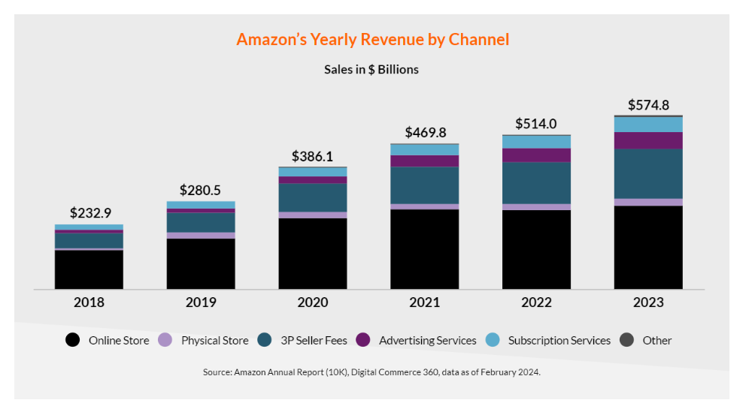
Source: (Edwards, 2024)
With over 2.48 billion monthly site visits and 470.2 million unique users, Amazon commands an unparalleled presence in online retail (Edwards, 2024).
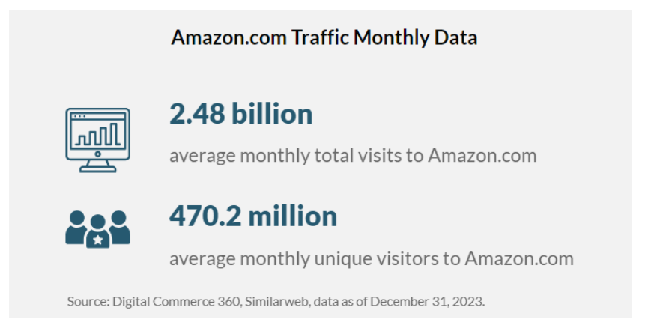
Source: (Edwards, 2024)
Its early adoption of customer-centric services such as one-click shopping, Prime delivery, and cloud computing (AWS) enabled it to dominate the U.S. e-commerce market, with net sales reaching $73.75 billion in 2019—over three times that of Walmart, its closest competitor (Richter, 2020).
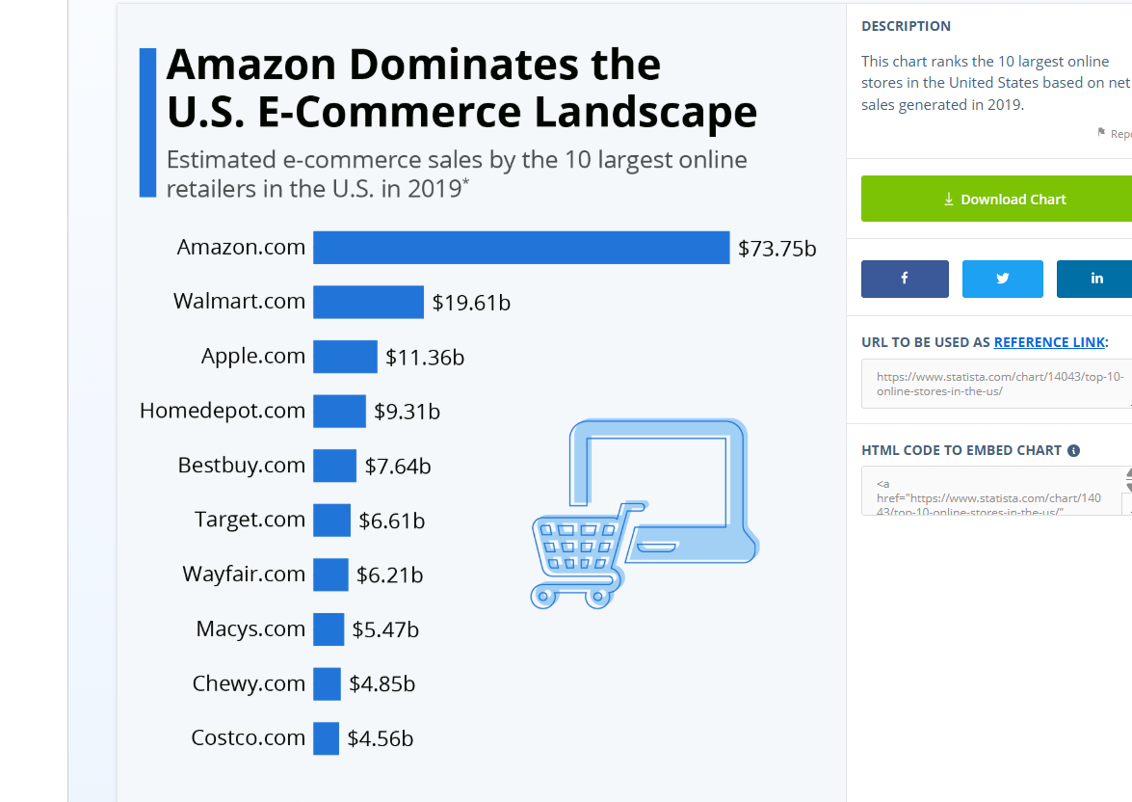
Source: (Richter, 2020)

Advantages of Being a Follower Company

Definition and Characteristics of Follower Companies
In the competitive landscape of business, companies often face the strategic decision of when to enter the market. While pioneering firms introduce innovations first, follower companies that enter the market after pioneers—can capitalize on several strategic advantages (Suntsova, 2025). These advantages include reduced risk and cost savings, opportunities for product and process improvement, and enhanced competitive agility and adaptability.

Strategic Advantages of Entering Later
Reduced Risk and Cost Savings
A follower company can reduce risks in new market ventures through observing how pioneers succeed and fail (Chen, Yang and Wei, 2024). The market feedback to pioneer products helps followers choose better strategies that prevent high-cost missteps in new market entry. Followers need to spend less on research and development since they perform reverse engineering of existing products instead of investing in original innovations. Extensive resource efficiency becomes possible because following the pioneer model allows for substantial cost reductions. ​
Product and Process Improvement
The late market entry offers companies a chance to upgrade both their existing products and processes (Chen, Ishida and Mukherjee, 2023). Fast followers can improve their offerings by evaluating pioneer products to find ways to address customer needs through better technologies and feedback solutions. Followers can achieve better product performance through this strategy that enables them to better fulfill consumer requirements. Samsung demonstrates how being a fast follower means surveying competitor innovations before releasing better versions of products to secure major market shares (Birkinshaw and Brewis, 2016). ​
Competitive Agility and Adaptability
Follower companies often exhibit greater flexibility in adapting to market changes. Without the burden of pioneering investments, followers can swiftly pivot strategies in response to evolving consumer preferences or technological advancements (Park and Yi, 2023). This agility enables them to implement best practices and avoid the pitfalls experienced by first movers. For instance, companies adopting a fast-follower approach can observe market dynamics and rapidly adjust their offerings, thereby maintaining competitiveness. ​

Case Studies of Successful Follower Companies
Samsung – Competing as a Fast Follower
Samsung’s rise in the smartphone industry is largely due to its fast-follower strategy—quickly adopting and enhancing technologies pioneered by others. This approach has enabled Samsung to offer a wide range of products across various market segments. In Q2 2024, Samsung held an 18.9% global market share, affirming its leadership (StatsUp, 2025). However, a drop from 20% to 18% in Q3 highlights the ongoing need for innovation to sustain its position (Samsung Electronics, 2023). ​
Facebook – Dominating the Social Networking Space
Facebook succeeded by entering the social media market after early platforms like MySpace and offering a more refined user experience (Press, 2018). By 2024, it had over three billion monthly active users, attracting a wide age range, particularly 18–34-year-olds. Its vast user base has made it a top choice for advertisers, helping Meta Platforms earn over $134 billion in revenue in 2023 (Jo Dixon, 2024).​
Google – Outperforming Early Search Engines
Google learned from early search engines and gained dominance through its superior PageRank algorithm. By February 2024, it held a 91.62% market share in global search (Panayotov, 2024). However, a recent dip below 90% suggests rising competition and signals the need for continued innovation to retain leadership (Rao, 2025).

Product Life Cycle (PLC) Strategies in Growth and Maturity Stages

Brief Overview of the Product Life Cycle
The Product Life Cycle (PLC) is a fundamental concept in marketing that describes the stages a product goes through from its inception to its withdrawal from the market (Iveson, Hultman and Davvetas, 2022). These stages include the Introduction, Growth, Maturity, and Decline phases. In the Introduction Stage, products are newly launched, requiring heavy marketing to build awareness and generate initial demand. Conversely, the Decline Stage occurs when consumer interest fades, sales drop, and firms may choose to discontinue the product, reduce costs, or innovate to extend its lifespan. Understanding these stages helps businesses develop appropriate marketing strategies.

Strategies in the Growth Stage
Market Penetration and Expansion
Market penetration involves increasing a product's market share within existing markets, while market expansion seeks to enter new markets (Boumedyen Shannaq, Saleem and Shakir, 2024). Tesla exemplifies these strategies by broadening its global footprint, particularly in China and Europe. The establishment of manufacturing facilities and service centers in these regions has enabled Tesla to better serve customers worldwide, driving further growth. ​
Product Enhancement and Innovation
Continuous product enhancement and innovation are vital during the growth stage to differentiate from competitors and meet evolving consumer demands (Sarkar et al., 2024). Tesla's focus on product innovation and differentiation has been a core marketing strategy, constantly pushing the boundaries of electric vehicle technology by introducing new features and improvements to its vehicles (Pereira, 2024). ​
Marketing and Promotion Intensification
Intensifying marketing and promotional activities is crucial to reinforce brand presence and attract a broader audience. Spotify's marketing mix includes a focus on promotion, utilizing various channels to reach its target audience. The company leverages social media, partnerships, and personalized advertising to engage users and promote its services.

Company Examples
Tesla – Driving Innovation and Growth
Tesla's growth is driven by its relentless focus on product innovation and differentiation. The company constantly strives to push the boundaries of electric vehicle technology, introducing new features and improvements to its vehicles. In 2023, Tesla's vehicle deliveries reached a record 1.8 million units, reflecting its global presence and market penetration. ​
Spotify – Freemium Model for Expansion
Spotify's freemium model, offering both free (ad-supported) and premium (subscription-based) services, has been pivotal in its expansion strategy (strategyzer, 2023). This approach allows users to experience the platform without initial cost, encouraging conversion to paid subscriptions over time. In 2024, Spotify reported its first annual operating profit since its launch 16 years ago, fueled by an increase in paying subscribers and cost reduction measures. Annual operating income reached €1.4 billion, with paid subscribers increasing by 11% to 263 million (Stassen, 2025). ​
Xiaomi – Disrupting Established Markets
Xiaomi’s rapid growth stems from its innovative marketing strategies and diverse product offerings. The company emphasizes cost-effective distribution, community engagement, technological innovation, and online marketing to maintain its competitive edge (Buildd, 2024). In Q4 2024, Xiaomi’s revenue rose by 48.8% to 109 billion yuan ($15.1 billion), with adjusted net profit up 69.4% to 8.32 billion yuan (Pan and Goh, 2025). After entering the EV market, Xiaomi increased its 2025 delivery target from 300,000 to 350,000 units. It also plans to expand its global presence by opening 10,000 new Mi Home stores internationally and growing its retail network in China (Pan and Goh, 2025).

Strategies in the Maturity Stage
Differentiation and Value Addition
To stand out in a saturated market, companies enhance their products by adding unique features or improving quality. For instance, in the smartphone industry, manufacturers continually innovate by introducing advanced camera systems, foldable displays, and 5G connectivity to differentiate their offerings. This approach not only attracts new customers but also encourages existing ones to upgrade, thereby extending the product's lifecycle. ​
Brand Loyalty and Customer Retention
In the Maturity stage, it is important to maintain a loyal customer base. Unlike the previous method, companies then employ strategies like loyalty program, personalized marketing, and exceptional customer service to retain existing customers. Starbucks’s Rewards program aligns it with such personalised discounts and early access to their new products to develop a sense of exclusivity and appreciation amongst its plan members. The initiatives that such initiatives have also helped to bring up customer satisfaction while at the same time encouraging repeat purchases and hence leading to sustained revenue.​

Company Examples
McDonald's – Adapting to Global Markets
McDonald’s uses a dual marketing strategy that blends global standardization with local adaptation. While core products like the Big Mac remain worldwide staples, the company tailors its menu to local preferences—offering items like the McSpicy Paneer in India and Teriyaki Burger in Japan. This approach has fueled global success and customer connection. In 2023, McDonald’s reported $25.49 billion in revenue, a 9.96% increase from the previous year (Statista Research Department, 2024), with over 41,800 restaurants worldwide under a franchised model (McDonald's Corporation, 2023). To boost retention, McDonald’s leverages digital platforms through mobile apps, exclusive deals, and loyalty programs. ​
Microsoft – Subscription-Based Product Lifecycle Extension
Microsoft has shifted from traditional software sales to subscription models like Microsoft 365 to extend product lifecycles and ensure steady revenue. This strategy drove annual revenue to over $245 billion in FY 2024, a 16% year-over-year increase (Microsoft, 2024). Microsoft 365 Consumer subscribers rose 10% to 82.5 million in Q4 2024 (Microsoft, 2024). The company’s focus on cloud services and AI has kept it competitive in a mature market, with its Intelligent Cloud segment earning $87.9 billion in FY 2023, up 17% from the previous year (Microsoft, 2024). This strategic pivot has reinforced Microsoft’s leadership in the tech industry.​
Samsung – Managing Maturity in a Competitive Market
Samsung operates in the highly competitive smartphone market, which is characterized by rapid technological advancements and shifting consumer preferences. To maintain its market position during the maturity stage, Samsung focuses on continuous innovation and diversification. The company invests heavily in research and development, introducing new features and technologies to its devices to differentiate from competitors.

Conclusion
This essay has analyzed the implications of market entry timing and the suitability of Product Life Cycle (PLC) strategies in terms of their strategic value. The point was that most of these pioneer companies, like Coca-Cola, Apple, and Amazon, enjoy brand recognition, technological leadership and market-setting. By controlling when they enter a market and early entering, companies can define expectations among the consumers, and they control and dominate their markets. Follower companies like Samsung, Facebook and Google have shown that the same means of success exists when firms take the opportunity to learn from pioneers, drive down costs, and improve on existing products or services when they enter later. This analysis has brought out the point that both pioneer and follower companies can gain sustainable competitive advantage by making their strategies appropriate to their position in the market and at the product life cycle stage. At this stage, growth is what companies should emphasize, increasing market share, improving the range of their products and strengthening their promotional activities. In the maturity stage, differentiating, retaining customers, and being efficient are the cards that make success. This shows how tailored PLCs can grow corporate profits in the long run via the examples of Tesla, Spotify, Xiaomi, and McDonald’s, as well as Microsoft. However, the ultimate success is not only hinged on being first in the market but, rather, in how a company innovates, adapts and executes its strategies in the product’s lifecycle. With a right strategic vision and a right timing, both pioneers and followers can prosper.

References
Baer, J. (2017). First movers: How to make the most of an early advantage. [online] Julius Baer. Available at: https://www.juliusbaer.com/en/insights/wealth-insights/business/first-movers-how-to-make-the-most-of-an-early-advantage/.
Birkinshaw, J. and Brewis, K. (2016). Lessons from the world’s best-known fast-follower: Samsung. [online] London Business School. Available at: https://www.london.edu/think/diie-innovation-icons-samsung.
Boumedyen Shannaq, Saleem, I. and Shakir, M. (2024). Maximizing Market Impact: An In-Depth Analysis of the Market Penetration Strategy and Its Effective Tools for Sales Growth and Brand Expansion in the E-commerce Markets of Oman and Bahrain. Studies in systems, decision and control, pp.277–291. doi: https://doi.org/10.1007/978-3-031-54379-1_25.
Buildd (2024). Xiaomi Marketing Strategy: Unveiling The Blueprint for Global Dominance. [online] buildd. Available at: https://buildd.co/marketing/xiaomi-marketing-strategy.
Carreno, A.M. (2024). Analyzing Amazon’s Evolution from an Online Bookstore to a Global Tech Giant. [online] Researchgate. doi: https://doi.org/10.5281/zenodo.14261927.
Chen, C.-H., Ishida, J. and Mukherjee, A. (2023). Pioneer, early follower or late entrant: Entry dynamics with learning and market competition. European Economic Review, 152, p.104360. doi: https://doi.org/10.1016/j.euroecorev.2022.104360.
Chen, X., Yang, Y. and Wei, J. (2024). How do New Ventures Thrive in Ecosystem Venturing: The Impacts of Alliance Strategy and Technology Interdependence. Journal of Management Studies. doi: https://doi.org/10.1111/joms.13063.
Edwards, K. (2024). Key Takeaways & Statistics about Amazon E-commerce [Digital Commerce 360 Data]. [online] E-commerce Germany News. Available at: https://ecommercegermany.com/blog/key-takeaways-statistics-about-amazon-e-commerce-digital-commerce-360-data.
Giachetti, C. (2018). Explaining Apple’s iPhone Success in the Mobile Phone Industry: The Creation of a New Market Space. Smartphone Start-ups, pp.9–48. doi: https://doi.org/10.1007/978-3-319-67973-0_2.
Iveson, A., Hultman, M. and Davvetas, V. (2022). The product life cycle revisited: an integrative review and research agenda. European Journal of Marketing, [online] 56(2), pp.467–499. doi: https://doi.org/10.1108/ejm-08-2020-0594.
Jo Dixon, S. (2024). Social Media - Statistics & Facts. [online] Statista. Available at: https://www.statista.com/topics/1164/social-networks/#topicOverview.
Koetsier, J. (2024). Apple No. 1 In Global Smartphone Market For First Time Ever. [online] Forbes. Available at: https://www.forbes.com/sites/johnkoetsier/2024/01/16/apple-1-in-global-smartphone-market-for-first-time-ever/.
MailChimp (2024). What Are the 4 Stages of a Product Life Cycle. [online] Mailchimp. Available at: https://mailchimp.com/resources/product-life-cycle/.
Markides, C. and Sosa, L. (2013). Pioneering and First Mover Advantages: the Importance of Business Models. Long Range Planning, [online] 46(4-5), pp.325–334. doi: https://doi.org/10.1016/j.lrp.2013.06.002.
McDonald's Corporation (2023). Annual Report A Year Powered by Strength and Resilience. [online] Available at: https://corporate.mcdonalds.com/content/dam/sites/corp/nfl/pdf/2023%20Annual%20Report_vf.pdf.
Microsoft (2024). Microsoft 2024 Annual Report. [online] microsoft.com. Available at: https://www.microsoft.com/investor/reports/ar24/index.html.
Mooncamp (2024). What is a First-Mover Strategy? | Mooncamp. [online] Mooncamp.com. Available at: https://mooncamp.com/glossary/first-mover-strategy.
Pan, C. and Goh, B. (2025). Xiaomi raises EV sales target, plans new overseas stores as Q4 revenue jumps. Reuters. [online] 18 Mar. Available at: https://www.reuters.com/technology/xiaomi-reports-48-rise-fourth-quarter-revenue-2025-03-18/.
Panayotov, J. (2024). Search Engine Market Share 2023-2024. [online] Proceed Innovative. Available at: https://www.proceedinnovative.com/blog/search-engine-market-share-2023-2024/.
Park, G. and Yi, S. (2023). Why do leaders help followers follow? Technology Analysis & Strategic Management, pp.1–14. doi: https://doi.org/10.1080/09537325.2023.2242505.
Pereira, D. (2024). Tesla Marketing Strategy (2025). [online] Business Model Analyst. Available at: https://businessmodelanalyst.com/tesla-marketing-strategy/?srsltid=AfmBOoqTq3hcopuxNJnqTLrM_4j8F6JCtSUNCuMRbtXweMYJxQjNOaOa.
Press, G. (2018). Why Facebook Triumphed Over All Other Social Networks. Forbes. [online] 8 Apr. Available at: https://www.forbes.com/sites/gilpress/2018/04/08/why-facebook-triumphed-over-all-other-social-networks/.
Rao, P. (2025). Charted: Is Google’s Search Product Still a Monopoly? [online] Visual Capitalist. Available at: https://www.visualcapitalist.com/google-search-still-monopoly-in-2025/
Richter, F. (2020). Infographic: Amazon Dominates the U.S. E-Commerce Landscape. [online] Statista Infographics. Available at: https://www.statista.com/chart/14043/top-10-online-stores-in-the-us/.
Ridder, M. (2025). Coca-Cola sales figures | Statista. [online] Statista. Available at: https://www.statista.com/statistics/264423/revenue-and-financial-results-of-coca-cola/.
Robinson, W.T. and Fornell, C. (1985). Sources of Market Pioneer Advantages in Consumer Goods Industries. Journal of Marketing Research, 22(3), p.305. doi: https://doi.org/10.2307/3151427.
Robinson, W.T., Kalyanaram, G. and Urban, G.L. (1994). First-mover advantages from pioneering new markets: A survey of empirical evidence. Review of Industrial Organization, 9(1), pp.1–23. doi: https://doi.org/10.1007/bf01024216.
Samsung Electronics (2023). Samsung electronics sustainability report 2023. [online] Samsung Electronics. Available at: https://www.samsung.com/global/sustainability/media/pdf/Samsung_Electronics_Sustainability_Report_2023_ENG.pdf.
Sarkar, A.S., Hazhar, O.M., Rawa, A.M. and Fayaq Othman Rezhwan (2024). The importance of product innovation in maintaining a competitive advantage. Mednarodno inovativno poslovanje = Journal of Innovative Business and Management, [online] 16(2), pp.1–15. doi: https://doi.org/10.32015/jibm.2024.16.2.4.
Stassen, M. (2025). Spotify posts $1.5bn annual operating profit for 2024, as subscriber base grows to 263m in Q4. [online] Music Business Worldwide. Available at: https://www.musicbusinessworldwide.com/spotify-posts-1-5bn-annual-operating-profit-for-2024-as-subscriber-base-grows-to-263m-in-q41/.
Statista Research Department (2024). McDonald’s: revenue 2005-2022 | Statista. [online] Statista. Available at: https://www.statista.com/statistics/208917/revenue-of-the-mcdonalds-corporation-since-2005/.
StatsUp (2025). Discover Latest Samsung Statistics (2025) | StatsUp. [online] Analyzify.com. Available at: https://analyzify.com/statsup/samsung.
strategyzer (2023). Spotify Business Model. [online] www.strategyzer.com. Available at: https://www.strategyzer.com/library/spotify-business-model.
Suntsova, O. (2025). SSRN Electronic Journal. [online] doi: https://doi.org/10.2139/ssrn.5125609.
Uli Wildan Nuryanto, None Basrowi, Icin Quraysin and Ika Pratiwi (2024). Harmonizing Eco-Control and Eco-Friendly Technologies with Green Investment: Pioneering Business Innovation for Corporate Sustainability in the Indonesian Context. Environmental Challenges, pp.100952–100952. doi: https://doi.org/10.1016/j.envc.2024.100952.
Zahra, S.A., Nash, S. and Bickford, D.J. (1995). Transforming technological pioneering into competitive advantage. Academy of Management Perspectives, 9(1), pp.17–31. doi: https://doi.org/10.5465/ame.1995.9503133481.

