
Dissertation
LCBB6000
Topic: The role of talent management in assessing organization success: A case pandemic study of Grosvenor cleaning company.

Student name: Bilyana Todorova
Student number: 2010307
Supervisor name: Dr. Hassan Amar

Contents
1. Introduction 2
1.1 Background of the Research 2
1.2 Research problem 2
1.3 Aim and Objectives of the Research 3
1.4 Significance of the Research 3
1.5 Structure of Research Methodology 4
1.6 Structure of the Dissertation 4
1.7 Summary of the Chapter 5
2. Literature Review 6
2.1 Concept of Talent Management 6
2.2 Talent Management Theory 6
2.3 Effective Role of HR Planning Process 7
2.4 Employee Relationship Management Process 8
2.5 Hierarchy of Needs 9
2.6 Talent Management-Resource based view 10
2.7 Summary 10
3. Research Methods and Methodology 12
3.1 Research Philosophy and Research Paradigm 12
3.2 Research Approach 12
3.3 Research Strategy 12
3.4 Data Collection Method 12
3.5 Sampling Method 13
3.6 Data Analysis Method 13
3.7 Ethical Consideration 13
3.8 Summary 13
4. Data Analysis and Findings 14
4.1 Introduction 14
4.2 Generation of Codes 14
4.3 Generating Themes 15
4.4 Findings 17
5. Conclusion and Recommendations 20
5.1 Recommendations 21
References 22
Appendix 1: Questionnaire 25

Topic: The role of talent management in assessing organization success: A case pandemic study of Grosvenor cleaning company

Introduction
Employees are important for the business organizations to achieve set goals of the business organization but talented employees are more effective in managing not only productivity targets but the quality parameters so their management is more important for business organization to sustain operations effectively (Beardwell & Claydon, 2007). The basic focus of the research is to evaluate the role of talent management in promoting the success of business organization and the selected case study is based on Grosvenor cleaning company. Evaluating the role of talent management has become important to evaluate as employees considered as the most important asset of the business organization.

1.1 Background of the Research
Talent management is the science of using strategic human resource planning to add value to business operations (Disanferdinand, 2018). Soft skills considered as the important skills for the talented employees as it is the basic source for creativity, teamwork, adoptability, organization and willingness to learn (Albrecht, et al., 2015). Evaluating how soft skills play important role in adding value to the success of business organization has become a major question to answer in the intense competitive business environment (Brewster, et al., 2018). Having the right number of employees at the right time for the right job is important but more important is to have employees with relevant skills and competencies for better base of talented human resource (Huselid, 2011). Talent management has become important aspect of the business organizations in current dynamic nature of business environment (Brewster, et al., 2018).

1.2 Research problem
The basic research problem is based on the integration of the role of talent management for the success of business organization. Talent management is not a new practice but not much focused by business organizations till date so it is important to evaluate its effectiveness in promoting organizational success (Bratton & Gold, 2017). Having skilled and talented workforce has become essential for the business organizations to have specifically in the United Kingdom as the result of BREXIT as UK is facing skilled shortage issues (Brewster, et al., 2018). Having long term orientation of the human resource is a major problem in UK as employees look for opportunities to grow their career rather than working with specific organization for longer period of time (Crosta, et al., 2021).

1.3 Aim and Objectives of the Research
The study is limited to the selected case study in hand as the focus is to evaluate how talent management is adding value to the success of the business organization. Study is more related to the academic purpose but by having real time example to put theories into practices.
The basic aim of the research is to evaluate the role of talent management in promoting organization success for Grosvenor cleaning company
Related objectives of the research are:
- To explore the significance of key skills supporting in achieving organizational goals
- The evaluate the similarities and differences between talent management and conventional concepts of HR that play a role in the organizational success
- The explore the implications of talent management in organizational success by reviewing the case company
- To recommend organizations how to improve certain talent management issues by having effective action plan

1.4 Significance of the Research
The current research is important as it is based on evaluating the key concepts of talent management and to analyze its relevance to the success factors for business organizations. It is important to evaluate how talent management is important based on the binding between management and employees in business organizations to achieve the set objectives of the business organizations. Research is not only significant for the academic purpose but also important to evaluate current talent management theories in practice by focusing specific case study. Talent management has become the key requirement for the business organizations to sustain long term competitive advantage so evaluating its role has become important for the business organizations in the intense competitive business environment (Bratton & Gold, 2017).

1.5 Structure of Research Methodology
Detailed research methodology has been outlined in the third chapter but the key terms are:
Research approach: Deductive
Research philosophy: Interpretivism
Research Strategy: Current research strategy is to have qualitative data as the main focus of data collection
Data Collection Method: Interview
Sampling: Random sampling to collect interview from five managers working in Grosvenor cleaning company using semi structured questionnaire
Data Analysis: Thematic analysis

1.6 Structure of the Dissertation
Chapter 1: Introduction based on the background information about the research topic along with setting aim and objectives for the research.
Chapter 2: Literature review to have better understanding of the key terms associated with the research topic in hand. Evaluating the findings of the researchers and scholars is the main focus.
Chapter 3: Well defined research methodology outlining each layer of the research onion step by step.
Chapter 4: Data analysis and findings based on the interview conducted from the managers of the selected case study in hand.
Chapter 5: Conclusion and recommendations well integrated with the set aim and objectives.

1.7 Summary of the Chapter
First chapter has provided base for the overall research project by defining the research topic and setting aim and objectives for the research process. It has provided the required guideline for the research to follow in systematic way while having literature review, research methodology and data analysis as important components of the research. Better understanding of the research topic was important and current chapter provided it with the help of background information.

Literature Review
The basic focus of the critical review of literature is to have better understanding of the key terms associated with the research topic in hand. Evaluation of the concepts such as soft skills, hard skills and talent management based on the findings of the researchers and scholars is the main focus of critical review of literature.

2.1 Concept of Talent Management
Talent management was the term first used in 1997 by McKinsey and it became a relevant practice in the dynamic nature of business environment (Bratton & Gold, 2017). The practice of talent management is not much different as compared to HR planning process as the basic focus of both practices is on gaining better engagement level of human resource (Albrecht, et al., 2015). Talent management is more associated with the management of employees having effective soft skills including dependability, creativity, teamworking, adaptability, organization, and willingness to learn (Gössling, et al., 2021). Hard skills are effective to add value to job description but management of soft skills has become more effective to have long term orientation of business (Beardwell & Claydon, 2007). Recruitment and selection are important processes that any business organization use to have better management of the gap between required and actual human resource (Amanda Shantz, 2011). But the more important practice is to have talented and skilled employees who could add value to the productivity and quality standards rather than creating liability for the business organization (Albrecht, et al., 2015). Focus of the business organizations in recent pandemic situation has shifted towards having talented workforce who could add more value to the strategic planning and implementation phase rather than employees who create liability for the business organization while managing the dynamic nature of operations as being carried out during pandemic period (Gössling, et al., 2021).

2.2 Talent Management Theory
There have been some convergent as well as divergent practices of the business organizations to have talented employees to work for the business organization to provide base for the sustainable competitive advantage (Armstrong, 2012). Attracting and selecting the most intelligent and capable talent has become important for the business organizations based on the parameters such as experience, knowledge, skills, qualification and competences (Busse, 2014). Talent management theory is based on planning, attracting, developing, retaining and transitioning phases to have optimal workforce (Russell & Cohn, 2012). Performance of the organization depends on the performance of the employees in term of having required productivity and quality standards met by the talented employees based on the effective implementation of the talent management theory into practice (Patrick M. Wright1, 2011). Succession planning, internal mobility, and knowledge management are the key elements to turn employees into talented and well-trained employees to sustain operations of the business organization more effectively (Ahlowalia, et al., 2014). Talent management means having optimal workforce to meet the set objectives of the business organization by having effective management of set productivity and quality standards as being outlined in the talent management theory (Albrecht, et al., 2015).
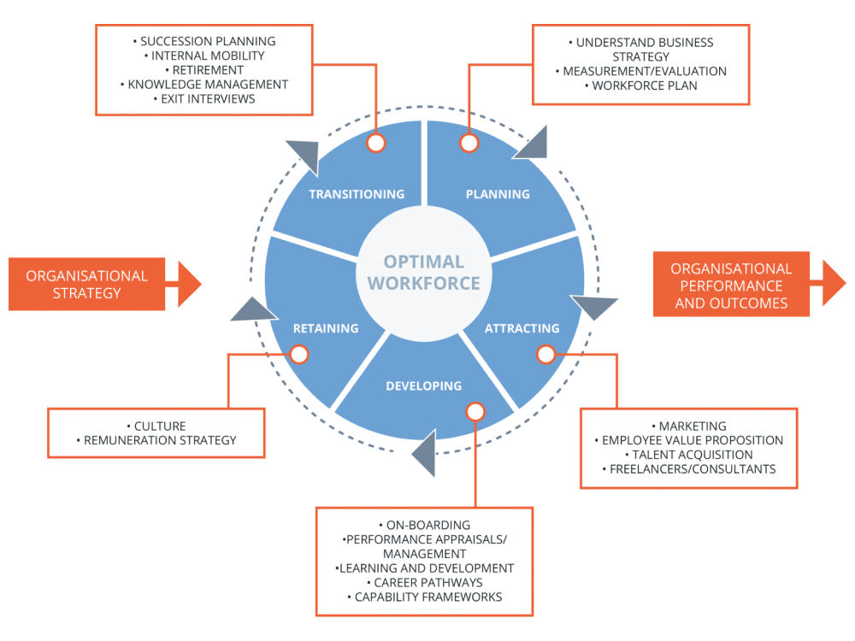
Source: (Albrecht, et al., 2015)

2.3 Effective Role of HR Planning Process
Human resource management is the main idea of having better management of the human resource to have right number of employees at the right time at the right job with relevant skills and competencies (Alshammari, 2015). It is more relevant to HR planning process but talent management is the value addition to the HR planning process as retaining the skilled and talented employees are more important to have better management of set goals of the business organization (Monica C. Gavino1, 2012). Talent management has gained focus of the business organizations as having skilled and experienced employees with relevant soft skills are important to add value to the practices of innovation, creativity and better management of operations of the business organization (Albrecht, et al., 2015).
Pandemic has changed the practices of human resource management as having proactive approach became more important rather than reacting on the situation (Ekwoaba, et al., 2015). Having lockdown situation and other related restrictions for the movement of people made it difficult for the business organizations to sustain operations as alternative option was to let the employees work from home (Gössling, et al., 2021). Turnover rate for employees increased dynamically and it became a major challenge to manage talented employees with the business organization for longer period of time. Strategic management practices became hard to sustain and the basic reason was the uncertain situation caused by pandemic (Dajani, 2015). HR planning becomes more effective once the database of employees is based on talented and experienced employees who have the ability to transform to any situation at any workplace settings as the result of current pandemic situation (Crosta, et al., 2021).

2.4 Employee Relationship Management Process
Developing strong psychological contract between employees and management is the key to have engaged and motivated employees working for the organization for long run (Guest, 2014). Talent management is the practice well integrated with the process of relationship management and the main focus is on retaining skilled and talented employees to achieve set goals of the business organization effectively (Busse, 2014). Employees are considered as the most important assets of the business organization as their role for putting strategies into practice is the key to have better management of the goals of the business organization (Albrecht, et al., 2015). Talented employees are effective in providing better control on the processes such as innovation and creativity so developing strong and long-term relationships with talented employees is important focus of employee relationship management process (Busse, 2014).
Recruitment and selection of employees is the key to have right number of employees at the right job at the right time (Ilyasa, et al., 2018). Such practices help in minimize the gap of supply and demand of the human resource at particular period of time but more important for the business organizations is to have engaged and motivated employees well integrated with the business organization for longer period of time (Albrecht, et al., 2015). Employee engagement depends on the employee relationship management process as having strong psychological contract between employees and management is the key requirement to provide better management of the talented employees (Russell & Cohn, 2012). Strong psychological contract not only helps in keeping talented employees engaged but also helps the management in fulfilling the basic as well as psychological needs of employees to keep them motivated and engaged for longer period of time (Patrick M. Wright1, 2011).

2.5 Hierarchy of Needs
Having talented employees play important role for the success of the business organization so fulfilling not only the basic but psychological needs of the employees become essential (Crosta, et al., 2021). Maslow’s hierarchy of needs give a good idea about the practices that are effective in managing employees specifically talented employees within the workplace (Kazimoto, 2016).

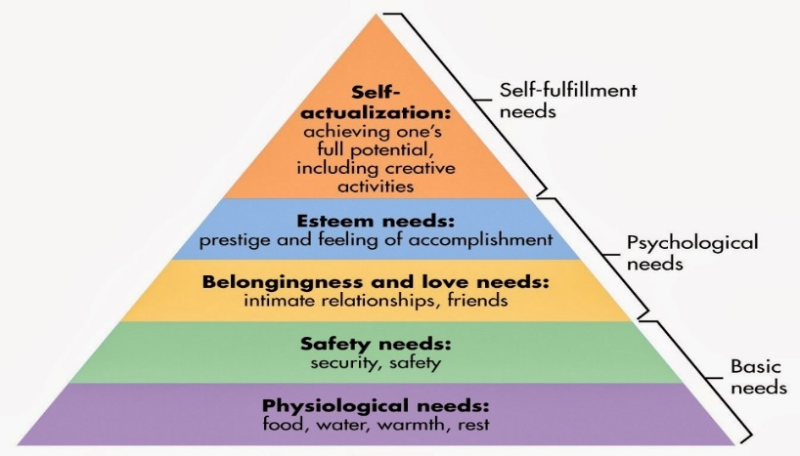
Source: (Russell & Cohn, 2012)
There is clear difference between psychological and safety needs of employees as talented employees work for the organization until they got what is essential as a part of psychological needs in term of food, water and required time for sleep (Guest, 2011). Once the psychological needs have been fulfilled, next important requirement is to have better management of the safety needs such as job security, health, and other safety needs (Tohidi, 2011). Fulfilment of such needs provides the base for effectiveness belongingness of employees with the business organization to develop self-esteem, confidence and achievement (Russell & Cohn, 2012). Self-actualization is the last phase of the hierarchy of needs and it is based on the fulfillment of the other needs in hierarchy. Creativity and problem-solving skills improve for talented employees once other needs in hierarchy have been fulfilled (Albrecht, et al., 2015).

2.6 Talent Management-Resource based view
Resource-based view is the relevant theory that provides the base for the effective talent management practice (Muethel, et al., 2012). Theory gives a good idea that organization can only sustain competitive advantage if the resources and sources have been used effectively and efficiently (Yoon, 2020). Utilization of scarce and inimitable resources are important to add value to the talent management practices of the business organization to have effective management of the talented human resource (Albrecht, et al., 2015). Resource based view is based on the concept that human resource of any business organization is the most important and valuable resource of the organization to put strategies into practices (Brewster, et al., 2018). Utilization of resources by having right number of people at the right job with relevant skills and competencies is the key to success for the business organization based on the resource-based view (Busse, 2014). Talent management means having the right employees with effective hold on relevant skills to keep the business organization on the right track as the part of talent management practices while having resource-based view. Employees are important to build competitive advantage based on their skills and competencies (Albrecht, et al., 2015).

2.7 Summary
Evaluation of the key terms associated with talent management has given a good idea that talent management is the practice well integrated with traditional HR planning process but the focus has shifted towards retaining employees with relevant skills and competencies rather than employees creating liability for the business organization. Employee engagement is the key requirement for business organizations to keep the talented employees well connected with the operations of the business organization while working in the intense dynamic and competitive business environment.

Research Methods and Methodology
Keeping the research on the right track is important for the researcher so research methodology is the relevant process to add value to the research process. Having research onion based on different layers and unfolding each layer after other is the main focus of current research process.

3.1 Research Philosophy and Research Paradigm
Research paradigm provides the method or pattern to conduct research. Research philosophies such as interpretivism play important role in giving a good idea of the research paradigm (Abutabenjeh & Jaradat, 2018). Interpretivism is the research philosophy more focused towards interpretating the social meaning of the specific concept in subjective way (Saunders, 2003). Having subjective data is more important to get a good idea of the relevant information based on in-depth qualitative data collection method and it is more relevant to the interpretivism research philosophy. Focus of current research is on using interpretivism as the selected research philosophy (Kothari, 2004).

3.2 Research Approach
Focus of current research is generating new theories rather than testing existing theories so there is a need to explore new theories that could help in adding value to current research topic in hand (Abutabenjeh & Jaradat, 2018). It shows that current research approach is inductive.

3.3 Research Strategy
Research strategy is important aspect of any research process as it provides better management of the planning and execution phase of the research based on the selection of relevant methods and approaches. Current research strategy is to have qualitative data as the main focus of data collection (Kothari, 2004).

3.4 Data Collection Method
Current research is focused towards collecting data from the selected case study in hand. Qualitative data is the main focus so the relevant data collection method for current research is based on interview technique. The basic idea of using a specific case study is to keep the research within specific parameters to analyze the relevant theories and models using in-depth interview approach.

3.5 Sampling Method
Selection of the five of the managers working in Grosvenor cleaning company is the main focus of the research based on the interview as the selected method and the sampling technique is convenient random sampling. Using semi-structured questionnaire based on the key terms learned from literature review is the main focus of the interview approach.

3.6 Data Analysis Method
Focus is on qualitative data so SPSS is not the relevant tool to use. Focus of current research is on using thematic analysis. Coding is the initial phase of the process followed by themes generated on the basis of themes by analyzing the qualitative data gained from the sample population. Coding to be done on the basis of response gained from the managers. Focus of the thematic analysis is on evaluating the each of the objective stated by using the relevant themes generated from coding process (Abutabenjeh & Jaradat, 2018).

3.7 Ethical Consideration
Providing information sheet and consent form to the managers before conducting interview is important as it is a way to gain their consent for the use of information for the academic purpose. It provides better management related to ethical consideration. Questionnaire will be based on in-depth literature review that will be a part of next phase of the report once the proposal has been accepted. Taking ethical approval is important from the University and relevant way is to fulfill the basic requirements for the ethical approval including the information sheet and consent form that will be added to questionnaire at the time of data collection.

3.8 Summary
Current phase of the research was effective in providing a good idea of the overall methods that have been focused for current research. Having a guideline for the research was really important and current chapter helped in shedding light on the relevant choices and the selection of most relevant choice for current research process. Keeping the research within specific parameters was important and it was the main focus of current phase of the research.

Data Analysis and Findings

Introduction
The basic focus of the phase is to make sense of the collected data. The sample is based on five managers working in the selected organization to provide a good idea of the talent management practices of the business organization. The method used for the analysis is based on thematic analysis and the focus is on generating codes of the data being collected to develop themes for the analysis.

Generation of Codes
Questionnaire has been added to Appendix 1 and response of the managers has helped in providing a good idea of the relevant codes that shed light on the practices of talent management in the business organizations along with evaluating the importance of talent management for the business organization.
Based on the response of the managers about different questionnaire, here are the basic codes generated and one of the relevant examples is given on the basis of response given for the first question:
“Role of HR planning is effective as it provides better engagement of the talented workforce by providing them effective career growth opportunities based on fair practices”
“Role of HR planning is effective as it gives equal opportunities for diversified workforce by not only providing job security but also enough career growth opportunities to minimize the employee turnover rate”.
Role of HR Planning Process: Effective career growth, equality, diversity, fair practices, job safety, and low employee turnover rate
Process of retaining talented employees: On the job training, career growth, attractive salary, competitive workplace, encouraging innovation, equal employment opportunities and strong psychological contract
Value added by talented employees: Improved productivity, improved quality, competitive workplace, motivation for workforce, achieving KPIs, managing vision and mission
Difference between talent management and HR management: Quality, reward management, PayScale
Training Parameters: More competitive, High productivity targets, Strong Key Performance Indicators and effective performance appraisal
Talent value chain: Teamwork, effective communication, competitive workforce, SMART objectives, effective KPIs
Productivity and Quality Standards: Improved, Well addressed, easily achieved
“Rewards are the main element of the performance appraisal system as it helps in keeping the talented employees well motivated to achieve set KPIs and to have target-based rewards to focus on”.
Performance appraisal system: Financial and non-financial rewards, target-based rewards, KPIs, equality, fairness
Creator or Destroyer: Creator
Effectiveness of current talent management practices: Productive, innovative, opportunities for improvement

Generating Themes
HR planning Process and Talent management: To make sense of the collected data, codes have been generated that have given a good idea that effective HR planning process is the key to manage talented employees. “Role of HR planning is effective as it gives equal opportunities for diversified workforce by not only providing job security but also enough career growth opportunities to minimize the employee turnover rate” (Manager 1). Providing them enough opportunities for career growth and having fair treatment in term of promoting equality and diversity is the key to have better management of the talented employees in the workplace as job safety is the key to have low turnover rate. On the job training, career growth, attractive salary, competitive workplace, encouraging innovation, equal employment opportunities and strong psychological contract are the key elements associated with the HR planning process that has helped in managing the talented employees for Grosvenor cleaning company. There is a basic difference between HR planning and talent management as talent management is more associated with practices that are out of the box as the quality along with productivity parameters set for the talented employees differ in nature as compared to remaining workforce. It provides a good idea how HR planning process and talent management are well integrated but there are different parameters to meet for both processes.
Value Added by Talented Employees: “Having effective hold on relevant skills is the key to add more value to the productivity parameters is the basic differentiation of talented employees” (Manager 3). Talented employees have better skills and competencies to rely on so the quality and productivity parameters differ for the talented employees. Talented employees work as the role model in Grosvenor cleaning company by setting and achieving higher productivity and quality standards. Talented employees are the source of motivation for the workforce as they are more focused towards achieving the set KPIs to add value to the mission and vision of the business organization by adopting innovative practices rather than looking for the instructions passed on by the management.
Training and Development: Training and development is important for the workforce as it helps in letting them ready to change according to the dynamics of the external business environment. Evaluation of the current practices in Grosvenor cleaning company gives a good idea that training and development for the talented employees differ in nature as compared to remaining workforce as the quality as well as productivity parameters differ in nature. Training and development are one of the ways to retain talented employees as it adds value to the skill and competencies of the talented employees to get them ready for the challenges in the external business environment. Performance appraisal is the key that helps in evaluating the gaps in current performances of the workforce to motivate talented employees to show more interest in the training and development programs to improve gaps in their skills and competencies as it is one of the ways to retain them for longer period of time.
Talented Value Chain: Evaluation of the primary data collected from the managers also helped in outlining that talented employees are important to provide better management of the productivity and quality standards but other main reasons to have talented employees is to improve the skills and competencies of current workforce by letting them work in the team with talented employees. Providing current workforce an opportunity to learn from others is a way to have talented value chain that is required for Grosvenor cleaning company to manage its set KPIs with efficiency and effectiveness. Managers also highlighted that workplace becomes more competitive once there are talented employees showing better productivity and quality performances to provide a source of motivation for others.
Talent Management: Having talented employees play important role for the success of any business organization but more important is to retain talented employees with the operations of the business organization for long run. Having effective appraisal system is the key to retain talented workforce as being outlined by the managers as the pay scale differ for talented employees according to their skills and competencies and performance appraisal is the key to evaluate the quality standards well addressed by the talented employees in Grosvenor cleaning company. The relevant components of managing talent are based on Financial and non-financial rewards, target-based rewards, KPIs, equality and fair management of the workforce. Overall evaluation of the current practices has given a good idea that Grosvenor cleaning company is more focused towards supporting talent rather than destroying talent but there are still enough gaps to fulfill for the management as being outlined by the managers. Current methods are innovative, productivity and well managed by there are always opportunities to improve current practices as highlighted in the primary data collection.

Findings
Evaluation of the primary and secondary data has helped in making sense of the process of talent management. Critical review of literature outlined that having effective management of the hierarchy of needs is important to retain employes for long run as it adds value to the self-esteem practices and same has been evaluated based on the primary data collection (Crosta, et al., 2021). Having enough opportunities for growth, job security and competitive pay scale are the key components to retain not only employees but talent for Grosvenor cleaning company. Critical review of literature given a good idea of having optimal workforce while managing the workforce in systematic way. Talent management theory is based on planning, attracting, developing, retaining and transitioning phases to have optimal workforce (Russell & Cohn, 2012). Evaluation of the primary data also helped in giving a good idea that HR planning is important along with attractive rewards management system to develop and retain talented employees with the business organization for long run. It has helped in developing effective integration between the theory and practices in Grosvenor cleaning company. Managing talent has become important as employees are considered as the most important asset of the business organization to put strategies into practices as being outlined in the critical review of literature (Albrecht, et al., 2015). Current practices in Grosvenor cleaning company also highlighted the importance of managing talent to have better management of the productivity and quality standards set by the business organization in the form of KPIs.
Resource-based view is the relevant theory that provides the base for the effective talent management practice. Theory gives a good idea that organization can only sustain competitive advantage if the resources and sources have been used effectively and efficiently (Bratton & Gold, 2017). It has been well addressed in Grosvenor cleaning company as well as the management believe that talented employees are considered as the key resource to motivate and encourage remaining workforce to show more potential to achieve higher productivity and quality standards to add value to the performance of the business organization. Sustaining long term competitive advantage is important for the business organization while working in the intense competitive business environment so having resource-based view is more important by considering the talented employees as the most important asset as being outlined by the managers of Grosvenor cleaning company. Current themes generated from the codes based on the primary data has helped in outlining that Grosvenor cleaning company is well focused on retaining employees by providing them higher pay scale and enough opportunities to grow their career based on the effective implementation of the resource-based view. Fulfilling the basic needs of talented employees is important for Grosvenor cleaning company but more important is to focus psychological needs as well to have satisfied workforce well engaged with the workplace settings to provide better management of the employee turnover rate for the management. Having strong psychological contract is the key focus of Grosvenor cleaning company to have better management of talent.
Having right number of employees at the right job with relevant skills and competencies is important for the better management of the human resource and operations (Albrecht, et al., 2015). Evaluation of the current operations at Grosvenor cleaning company gives a good idea that not only HR planning process is effective to manage the workforce but also talent management processes as effective teamwork of talented employees with workforce has helped in setting high productivity and quality standards in Grosvenor cleaning company. Managers have given a good idea that Grosvenor cleaning company is well focused on creating and retrieving talent rather than destroying talent as developing strong and long-term relationships is more important by providing employees what they deserve to have strong psychological contract in place. Themes developed from the codes based on the primary data also outlined that the relevant components of managing talent are based on Financial and non-financial rewards, target-based rewards, KPIs, equality and fair management of the workforce. It shows that talent management is the key process in Grosvenor cleaning company to have sustainable competitive advantage for long run in the intense competitive business environment.

Conclusion and Recommendations
Overall evaluation given a good idea that talented employees add more value in term of productivity and quality as compared to remaining workforce so management of talent in the business organization is essential to have sustainable long term competitive advantage. Talented employees are more focused towards developing integration between their own interest and interest of the business organization to add more value in term of meeting the required productivity standards and to add value to the overall performance of the business organization. Developing strong psychological contract is really important for the management for the better management of talent in the business organization as being outlined during the critical review of literature along with primary data analysis phase. Talent management has become important in current dynamic nature of business environment as employees are the basic component of the business organization to put strategies into practices. Evaluation of the case study in hand given a good idea that the focus of the management is on retaining and engaging talent in the workplace settings to improve the productivity of workforce by providing opportunities for other employees to work together with talented employees as a part of the team.
Not only the critical review of literature highlighted the importance of talent management for the success of the business organization but also the management of the selected business organization outlined the importance of managing talent for the success of business organizations. Talent management is more associated with the management of employees having effective soft skills including dependability, creativity, teamworking, adaptability, organization, and willingness to learn. Productivity targets become easier to achieve once having talented employees to achieve such targets within the give timeframe to motivate workforce as well. It has been well addressed in Grosvenor cleaning company as well as the management believe that talented employees are considered as the key resource to motivate and encourage remaining workforce to show more potential to achieve higher productivity and quality standards to add value to the performance of the business organization. So, overall evaluation has outlined that talent management is the key to success for the business organizations while working in the intense competitive business environment. Retaining talent within the business organization is the key to have sustainable operations for long run based on the skills and competencies of the talented employees as compared to employees who create liability for the business organization. Talent is the key element for the business organizations to manage to have better management of operations as compared to competitors while working in the intense competitive business environment.

Recommendations
- Talented employees are important to recruit for the business organization by setting effective recruitment criteria but more important is to retain employees by fulfilling their basic as well as psychological needs. Developing training and development opportunities by keeping the skill gap of talented employees rather than only focusing average workforce skills.
- Developing strong psychological contract between talented employees and HR planning process is important so it is important to have effective communication process while setting career growth targets based on the skill levels of workforce to let other employees perform more competitive rather than only letting talented employees getting the promotional opportunities.
- Evaluation of the productivity standards given a good idea that such standards are easily achievable for the talented employees so there is a need to have more competitive targets to have optimal use of skill level of employees in the workforce.

References
Abutabenjeh, S. & Jaradat, R., 2018. Clarification of research design, research methods, and research methodology: A guide for public administration researchers and practitioners. Sage Journal, 36(3), pp. 237-258.
Ahlowalia, S., Tiwary, D. & Jha, A., 2014. Employee Engagement: A Structured Theoratical Review. The International Journal of Business and Management, 2(6).
Albrecht, S. L. et al., 2015. Employee engagement, human resource management practices and competitive advantage: An integrated approach. Journal of Organizational Effectiveness: People and Performance, 2(1), pp. 7-35.
Alshammari, H., 2015. Workplace Productivity through Employee Workforce Engagement: A Review Study. International Journal of Business and Social Science , 6(12), pp. 156-162.
Amanda Shantz, a. L., 2011. The effect of primed goals on employee performance: Implications for human resource management. Human Resource Management, 50(2), pp. 289-299.
Armstrong, M., 2012. Armstrong's Handbook of Human Resource Management Practice. 12 ed. UK: British Library.
Beardwell, J. & Claydon, T., 2007. Human Resource Management: A Contemporary Approach. s.l.:Prentice Hall/Financial Timea.
Bratton, J. & Gold, J., 2017. Human Resource Management: Theory and Practice. 6th ed. Basingstoke: Palgrave.
Brewster, C., Mayrhofer, W. & Farndale, E., 2018. Handbook of Research on Comparative Human Resource Management. 2nd ed. s.l.:Edward Elgar Publishing.
Busse, R., 2014. Corporate culture, organizational change and meaning at work - linking human resources with business ethics. Human Systems Management, 33(1/2), pp. 47-50.
Crosta, A. D. et al., 2021. Psychological factors and consumer behavior during the COVID-19 pandemic. National Library of Medicine, 16(8).
Dajani, M. A. Z., 2015. The Impact of Employee Engagement on Job Performance and Organizational Commitment in Egyption Banking Sector. Journal of Business and Management Sciences, 3(5), pp. 138-147.
Disanferdinand, A., 2018. Human Resource Management. International Journal of Scientific and Research Publications, 8(9), pp. 180-190.
Ekwoaba, J. O., Ikeije, U. .. & Ufoma, N., 2015. The Impact Of Recruitment And Selection Criteria On Organizational Performance. Global Journal of Human Resource Management, 3(2), pp. 22-33.
Gössling, S., Scott, D. & Hall, C., 2021. Pandemics, tourism and global change: a rapid assessment of COVID-19. Journal of Sustainable Tourism, 29(1), pp. 1-20.
Guest, D., 2014. Employee engagement: a sceptical analysis. Journal of Organizational Effectiveness: People and Performance, 1(2), pp. 141-156.
Guest, D. E., 2011. Human resource management and performance: still searching for some answers. Human Resource Management Journal, 21(1), pp. 3-13.
Huselid, M. A., 2011. Celebrating 50 Years: Looking back and looking forward: 50 years of Human Resource Management. HumanResource Management, 50(3), pp. 309-312.
Ilyasa, Madhakomala & Ramly, M., 2018. The Effect of Organization Culture, Knowledge Sharing and Employee Engagement on Employee Work Innovation. International Journal of Scientific Research and Management , 6(1), pp. 2321-3418.
Kazimoto, P., 2016. Employee Engagement and Organizational Performance of Retails Enterprises. American Journal of Industrial and Business Management, Volume 6, pp. 516-525.
Kothari, C. R., 2004. Research Methodology: Methods and Techniques. s.l.:New Age International.
Monica C. Gavino1, S. J. W. a. B. E., 2012. Discretionary and transactional human resource practices and employee outcomes: The role of perceived organizational support. Human Resource Management, 51(5), pp. 665-686.
Muethel, M., Gehrlein, S. & Hoegl, a. M., 2012. Socio-demographic factors and shared leadership behaviors in dispersed teams: Implications for human resource management. Human Resource Management, 51(4), pp. 525-548.
Patrick M. Wright1, a. G. C. M., 2011. Exploring human capital: putting ‘human’ back into strategic human resource management. Human Resource Management Journal, 21(2), pp. 93-104.
Russell, J. & Cohn, R., 2012. Maslow's Hierarchy of Needs. s.l.:Book on Demand.
Saunders, M., 2003. Research Methods for Business Students. s.l.:Pearson Education India.
Tohidi, H., 2011. Human resources management main role in information technology project management. Procedia Computer Science, Volume 3, pp. 925-929.
Yoon, T., 2020. Goal Ambiguity in Public Organizations: A Grounded Theory Analysis of State Government Employees. s.l.:Florida State University.

Appendix 1: Questionnaire
- What was the basic role of HR planning process in your company for managing talented employees during recent pandemic period?
- What procedure HR department follow in your company to retain talented employees for long run?
- What value talented employees have added to the performance of your company during pandemic as compared to other employees?
- What difference have you seen between talent management practices and Human Resource management practices during pandemic period?
- How training parameters are different for talented employees as compared to other employees in your company?
- What is the procedure of creating talent value chain in your company?
- Do you believe talented employees in your company raise the bar for productivity and quality standards during pandemic?
- What performance appraisal system your company use to keep talented employees engaged?
- Is your company a support talent management?
- Are you satisfied with current talent management practices in your business organization?

