Executive Summary
This report presents a general background of Nestlé and specific analysis about both external
and internal environments for the company from the aspects of Porter’s five forces and the
company resources with capacities as well separately. Since Nestlé has been facing
challenges due to its subcontracting and outsourcing strategies according to the SWOT
analysis about the company, two new strategies are put up with. Specifically, Growth Strategy
and Best-cost Strategy, which recommend Nestlé adopt self-planting of coffee beans to obtain
stable supply sources and offer low-price products with great differentiation. And a detailed
implementation plan is also given in the end
Executive Summary
This report will carry out a comprehensive strategic analysis regarding the Accor company. It provides an overview of Accor Hotels and the strategic management tools employed by the organization. The conceptual aspect of the research paper contains data pertaining to strategic planning, as well as the approach to assess was divided into improvement creation, SWOT analysis, Ansoff Matrix analysis, PESTE analysis, and omnichannel. The study's final recommendations demonstrate that the hotel in question is maintaining its excellent name and customer service. Despite the tools for strategic management appeared to have been a vital component of the growth of the business, they may be viewed as detrimental for the same.

Introduction
The study evaluates the Accor Hotel Group, a hospitality business with operations throughout many different regions of the globe. A report has been carried out to highlight its growth improvement, SWOT, and PEST. The summary of the study also evaluates the business's operation regarding each of the stages of the strategic planning methods.
According, Alfred D. Chandler, Jr (1962), “"the choice of a company's basic objectives and targets for the future, in addition to the implementation of programs to follow as well as the provision of resources to achieve these objectives." While Kenneth Andrews (1980) stated strategy to be sequence in choices of business which establishes as well as shows its aims, goals, or targets, generates the main plans and procedures to accomplish these targets, as well as determines the type of operations the business plans to follow, the type of human and financial structure it is or aims to become, as well as financial and other benefits it plans to provide for its owners, staff, and creditors. Whereas, John Bryson, (1996) defines strategy as “a set of goals, procedures, initiatives, behaviours, choices, or distributions of resources which define a company's identity, what it does, and the reason it does it.
On the other hand, Ansoff H. (1972) described strategic management;
Because the new managerial position necessitates leaders to be innovative and directive to arranging and overseeing the company's modification to an inconsistent and unstable future. It needed the creative development of fresh firm methods, the establishment of new organizational strengths, along with the direction for the company's growth into a brand-new important position. The term "strategic management" refers to the integration of all these company-changing initiatives. (p. 7).
Whereas, Stonehouse and Pemberton (2002), The term strategic management may characterized in an assortment in concepts as well as structures, complemented by methods and instruments that are intended to help leaders in organizations formulate strategies as well as perform effectively. While Johnson and Scholes (1984) argued that strategic management;
It has to do with developing an approach and determining the way that plan of action will be implemented. It is composed of three major components...It involves strategic analysis, whereby the analyst requires to gain insight into the company's tactical position. There is a decision-making phase that deals with the creation of prospective plans of action, their assessment, and choosing of one of them. Lastly, there is a tactical execution phase, and this is concerned in organizing the way the strategy that has been selected will be implemented. (p. 10).

On the other hand, the strategic management resources, and methods, constitute essential components of the procedure for strategic management. Any process, theory, skills, tool, technology, structure, procedure, or conduct utilized for assisting the execution of strategies is referred to as a plan of action tool. (Stenfors, Syrjänen, Seppälä and Haapalinna, 2007). Even Gunn and Williams (2007) explained strategies tools are ideas which aid managers of strategy make decisions. While Clark (1997) claims that tactical instruments may be used throughout all phases of the procedure for strategic management, including circumstance evaluation, strategic evaluation of choices, and execution of strategies.

Main Findings
The execution of a combined entity method drives Accor's development system. According to Sudarsanam (1995), a merger occurs when multiple businesses join forces to offer and exchange assets to accomplish common goals. According to Sherman and Hart (2006), a merger is an arrangement of more than one business whereby the acquiring businesses financial resources and assets are taken over by the company that purchases them. According to Gaughan (2002), a merger is a procedure in wherein two businesses blend until just one continues to exist while the merged business becomes extinct. It is also appropriate to say that occasionally an agreement among two businesses occurs, in which both stop functioning while an entirely different business is formed. Sudarsanam (1995) defines acquisition as a "arms-length agreement" in which a single business buys the stock from a different business while the newly acquired business ceases to owns the business in question. This has assisted Accor enhance its position in new economies, which included when the initial Novotel block was placed in Beijing, China in 1984 (2022). Furthermore, according to Gaughan (2002), mergers and purchases have been beneficial deals wherein the top leadership for both businesses bargain the specifics for the purchase, and the terms are subsequently put forward before the owners of the newly acquired business to earn go-ahead. This strategy has also resulted in the company achieving a 3% net revenue increase in 2021; the business's 2021 growth rates had been especially powerful in Europe, China, and the Middle East. Given one hundred and fifty three additional hotels contracted, Europe being Accor's principal marketplace, corresponding to a +20% increase over 2020. (Accor, 2022). Therefore, the business's expansion is fueled through the outstanding client service this offers, the outcomes that in client inquiries being quickly settled and guests being satisfied not merely about the experience, but additionally with all that the resorts are able to provide. As a result, once someone staying in the hotel is satisfied with their stay, they grow into advocates who promotes beneficial word of mouth regarding the facilities and amenities of the establishment. As a result, it broadens the limits and deepens its bottom line.
Nevertheless, the analysis of SWOT is a tried-and-true strategic tool that allows a business-like Accor Hotels to compare its very own effectiveness to that of its competitors. Accor Hotels is a global leader in tourism and hospitality. SWOT analysis, according to Kotler and Armstrong (2012: 53-54), is a methodical evaluation of multiple variables to develop a business's approach by considering the business's strengths, weaknesses, opportunities, and threats to evaluate the outside as well as inside marketing circumstances.
However, as stated by Rozmi et al., 2018; Wu, 2020, SWOT analysis has evolved into a fundamental tool that allows businesses to assess their competitive edge and is frequently utilized for assessing both the internal and external surroundings of businesses throughout periods of uncertainty. Even though Aldehayyat and Anchor (2008), Fleisher and Bensoussan (2003), Lee and Lin (2008), and Shrestha et al. (2004) stated that four elements recognize both external and internal factors to consider. The internal aspects of a business which aid in accomplishing its objective are referred to as strengths, whereas inside factors which hinder the company's achievement are now referred to as weaknesses. Opportunities—external factors which assist a business achieve its goals—include a variety of beneficial external variables, as well as prospects to fill discrepancies and launch new initiatives. Threats, on the contrary, have been elements of the outside world of the company that pose a risk or could be obstacles to achieving its objectives.
The advantages in the Accor hotels SWOT analysis consist of decades of experience and understanding within the tourism industry. Furthermore, it has accepted technological advancement and has begun to concentrate upon sales through the internet, and this will attract consumers. Moreover, based on classification, the business provides its clients with efficient and cost-effective financial planning. Furthermore, excellent interaction with customers as well as service to clients constitutes one among the establishment's most significant resources while they aim to keep those who stay satisfied. The following appears to have become the company's main objective, ensuring clients truly have a connection with the business.
Due to of the attraction of the rewards program, a couple among every five tourists coming from hotel chains chose to reserve a reservation at that accommodation (Barsky & Nash, 2002; O'Neill et al., 2008). While O'Neill and Carlback (2011) stated the fact getting larger business accounts within rewards programs offered greater certainty of use for branded accommodations throughout financial crises while business and authorities are searching for worth and reliability. Within the choices available to guests are economically viable loyalty programs, that can be awarded using the loyalty reward being an active member of ALL Accor Live Limitless, its a lifestyle loyalty program, according to Accor Plus (2022).
On the other hand, loyalty programs provide, along with the benefits they offer differ based in the hotel where you stay. For example, Hilton Hotels' loyalty program is known as Hilton Honors. The participants can take advantage of fantastic benefits such as the most affordable room rates, free internet access, as well as being able to regulate the booking as well as unlocking their rooms via the Hilton mobile app. The participants are also awarded points whenever they book a booking at a Hilton hotel as well as utilize a Hilton credit card. When points are accumulated, access is gained to additional amazing perks via Hilton's elite status tiers. Points will be able to utilize to receive complimentary accommodations in Hilton properties that include affordable brands like Hampton by Hilton to opulent hotels such as Waldorf Astoria Hotels and Resorts. (Wack.M, 2022).
Additionally, Online check-in, on the contrary, involves an electronic request for carrying out the online form a couple of days beforehand. By utilizing the ALL card, the visitor will conserve additional valuable time. The visitor's data is already filled in. On the actual day of getting here, the visitor gets a text message with transportation-related details. Check-in will be available also the rooms department will meticulously set up the arrival of the guests, as well as their room key will be prepared. Additionally, the visitor can drop off the key without needing to worry about guest check out. (All Accor, 2022) Additionally, the hotel keeps every aspect for interaction, from reservations to departure, managed and diligently chosen for ongoing enhancement of quality.
While this represents an excellent effort by the Accor group, it does have some drawbacks. According to the President's Identity Theft Task Force 2007, the crime of identity theft is defined as "the improper utilization of someone else private data to engage in deception." This implies that resorts frequently are attacked based on their guests' identities as well as banking data. In the words of Stephens M.2018, the Federal Trade Commission (FTC) submitted a complaint toward Wyndham hotels at the month of June 2012, stating Wyndham distorted its security measures to avoid hacking through hacker groups. According to the FTC, Wyndham subjected consumers' information under an inadequate security, resulting in several incidents in Wyndham hotels as well as several branches. Starting in the year 2008, the resort chain as well as its affiliates were subjected to several crimes, the initial one of which damaged five hundred thousand credit card information saved by the business, which was then further attempts which harmed a different fifty thousand as well as sixty-nine thousand accounts on additional branches.
As a result, the internet check in as well as swift check out save time as well were necessary when the pandemic struck for reasons of social distance as well as encourage protection, they come with drawbacks that could make clients believe it’s risky and consider multiple times before reserving a booking.
The weakness of an organization is said to be capable to strengthen or to boost its positioned more significantly. According to Investopedia (2022), Accor Hotels' shortcomings include creative internet-based companies which include Airbnb, that operates a website which links those that are interested in renting off their residences to individuals that are searching to stay at new locations. Secondly, clients who use the Accor Hotels brand have difficulty connecting to the company given that it is tailored for segments. According to Economic Times (N.A), segmentation is the breakdown for a sector in sections, or as categories, that are easily definable, readily available, useful, lucrative, and possess an opportunity for development.
Opportunities have been techniques for an organization to enhance itself. For example, Accor might can create additional training programs within several nations to offer those who graduate a well-rounded hospitality training, allowing everybody to gain advantages in global-level customer service. According to Accor (2018), the Group is dedicated to developing prospective employees who would like to become part of AccorHotels. INSPIRE provides numerous possibilities for leaders of the future. The program is geared to enthusiastic, inspired, as well as adaptable students, which gives them the chance to begin their professional development with AccorHotels, laying the groundwork for developing a managerial foundation by means of meaningful endeavors.
Any business's weakness may include problems which are having an unfavorable impact on the way it runs. One of the major challenges for the company has been the state of the world's economy, which might impose a negative effect in revenues within what are known as the luxury and upscale segments. According to IMS Marketing (NA), when advertisers utilize market divisions, it renders executing a campaign effortless because it assists in concentrating the business on clientele rather than focusing on the general consumer base. Marketing professionals can be more productive regarding labor, capital, and additional things by using segmentation. Segmented market enables businesses to understand those they serve. The company develop an improved knowledge of their consumers preferences and requirements, allowing them to customize initiatives to specific audiences.
According to Abbasov. N, 2019 SWOT analysis cannot be utilized for assessing the achievement of a company. As a result, the effectiveness of a business may serve as its weakness, and an organization's opportunity may pose a challenge. An additional variable which may impact the SWOT analysis's limitations involves its ability to identify circumstances that are beneficial and end up biased to specific interests.
According to CIPD (2021) A PESTLE analysis investigates the main exterior influences which impact a company (political, economic, sociological, technological, legal, and environmental). This will be utilized in an assortment of circumstances and may assist individuals as well as executives make choices that are strategic. Whereas the Pestle analysis serves to be a tool for contextual assessment for company assessment goals and constitutes one for the approaches most frequently employed in evaluating for an especially dynamic outside world of business (Gupta, 2013). As a result, the advantages of this kind of structure for an organization are enormous (Dwyer & Tanner, 2002). However, restrictions ought to be indicated, as well as actions are required to lessen any gaps within what the model produces for efficient evaluation usages. (Thomas, 2007).
The Pestle implementation in the Accor group benefits the business in general. As a result, the political factor can be beneficial or a challenge in the company. Accor is a global brand that has encountered a few difficulties of politics because of its participation in governance. Political factors such as the government regulation labor laws, taxation prices, all have an impact on the hotel industry. Mind Tools (2012) While, being one of the globe's biggest hotel operators, AccorHotels creates and employs a total of 230 thousand hospitality professionals in 100 and 10 (110) countries (Accor,2022).
In contrast, Shaw,A. 2022 describes the negative aspects of pestle analysis as the business being able to execute the research using little information and consumers oversimplifying things whilst making decisions. Second, if too much information is made accessible, the business might get confused about all the information. Third, the investigation focuses on speculations instead of real uncertainties and challenges they could encounter. Fourth, the business is required to execute the investigation on an ongoing schedule, instead of just sometimes, because it can be challenging to estimate an approaching advancement and how it will affect the company. As a result, the PESTLE analysis is an excellent tool for companies that can benefit from an array of resources. It contains details regarding how effectively unforeseen events may affect a company. As a result, businesses can simply prepare for any issues caused through the PESTLE factors, while they are capable to come up with options.
Market penetration, market development, product development, and diversification are four main stages of the development of business identified by the Ansoff matrix (Mukherjee 2016; Lawley & Schure 2017). Therefore, the first stage, a business seeks to broaden its presently available products in the current market to thrive. If groups desire to broaden their customer base into abroad, they enter an additional phase in expanding its market. This is frequently achieved once a company expands its product throughout various market categories, enters new segments or parts of the industry, or plans to branch out into unfamiliar territories (Kim & Mauborgne 2015). The creation of goods and services is being represented by the product growth phase of the Ansoff matrix (Lawley & Schure 2017).
Accor's product development stage consists of expanding its brand. In the year 2021, Accor's team of developers accomplished several achievements, especially in China, in which the number of project agreements attained a record high, resulting in a total of 520 hotels now open in the area as well as a further 350 in progress. The initial agreement was reached for the construction of an amazing hotel in Guizhou province for Accor's newest hotel, Emblems Collection: Guiyang Art Centre Hotel, Emblems Collection (Accor press, 2022).
Although the Ansoff Matrix is a useful tool for businesses in planning their expansion strategies. Businesses ought to be conscious of the Ansoff Matrix's drawbacks. These involve knowing that the Ansoff matrixes are impossible for predicting about their effect on the business revenue and sales, as well as that an evaluation of costs and benefits is required to defend its selected approach. (2022, Innovolo). One of the most important disadvantages for the Ansoff Matrix, according to Innovolo (2022), is the fact that other businesses are overlooked.
This matrix only depicts the approach while maintaining the organization's goods and customer base in mind. In actual life, other companies are present for each good and consumers. As a result, they play an important role in determining whether an organization's approach is effective. Second, the Ansoff Matrix fails to consider the cost-benefit comparison of different methods; therefore, if a business considers diversifying or creation of products strategy, it has to consider both the advantages and disadvantages of every possibility prior to deciding. To put it simply, a cost-benefit assessment is required for defending the business's selected approach.
After all, every business choice is made to boost revenue and sales. It can be hard to predict the achievement of an approach without conducting an evaluation of costs and benefits. Third, the Ansoff matrix is a straightforward method for mapping out business development strategies. However, predicting the effect of Ansoff matrixes on business revenue and sales is difficult since one are unable to forecast customer and market responses with 100% accuracy.
As a result, every analysis can be thrown out. Businesses should remember this prior to making any choices according to Ansoff matrices. Ansoff matrices can be useful, however they ought not to be utilized thoughtlessly. Businesses ought to utilize them to begin more study and evaluation. Only after that will they have the capacity to make sound decisions regarding their expansion strategy. (2022 Innovolo) As a result, while the Ansoff matrix is a helpful and advantageous tool for every business, including Accor, when assessing their approach to marketing, it is critical to think about every factor before deciding.
In the Accor organization, omnichannel is a powerful tool. According to Juaneda-Ayensa et al. (2016), omnichannel can be described as a combination of technological systems," therefore from the international evolution of digital marketing. With an aim to offer ideal experiences while spending and are free from obstacles or functioning impact that can happen in many prevalent buying procedures. The approach will be enable through the combination of both digital plus physical channels via an involved combination of functional, technological, and operational systems, which is supplemented by the accessibility of easy-to-use consumers connection programs (Rigby, 2011).
After decades of depending on old-fashioned telephone and electronic mail channels, Accor Plus had been prepared to implement a case management solution which incorporated voice assistance as well as released agents from handwritten reservations. They aim to provide a more comprehensive package with features which could expand in company development as well as enhance customer experience.
AREA 17 and Accor collaborated through a new developing method to provide a seamless customer experience that is being used to enhanced hospitality. (Area 17 2020) On the hand, the Marriott Group stated through its launch of the Marriott Media Network, of an omnichannel multi-platform marketing, which is considered the solution for advertisers who promote brands, which allows customized experiences to visitors throughout their vacation. Marriott partnered with Yahoo, a dignified marketing platform, to manage its network. The Marriott Media Network will start by offering marketers in the United States and Canada, as well as to include over 164 million loyal guests who are members of Marriott Bonvoy, the organization's distinguished travel program. When fully established, the network is projected to offer exclusive content across its channels, through shows, mobile messages, video, emails, and magazine advertisement. (Marriott International,2022).
Despite understanding the advantages of an omnichannel strategy as well as its advertising resources and capabilities, marketing teams struggle to create an effortless visitor experience. This indicates a lack of ability for combining the elements together, according to Sripur, A. (2022). The reason for this implies that advertisers have struggled with incorporating information from multiple sources to offer an effortless client experience. They are unable to create an individual interaction for the guests because of their incapacity to join the components together.
Furthermore, competitive businesses struggle to keep consumers on their websites, particularly if other companies provide similar services at cheaper costs. As a result, implementing differentiation gets difficult. Also, clients anticipate personalized service. A universal approach encounters are no longer available. If the services don't feel personalized for them, a client will not hesitate to move to a another website. Advertisers have to act like customers, a skill which many individuals have yet to learn. Lastly, the incorrect utilization of information provided by users. When guests communicate with the hotel, they leave a record of personal information that includes contact numbers, email addresses, this information can be stolen through identity theft. Finally, while omni-channel provides exceptional possibilities for growth, it also presents unprecedented challenges.

Conclusion
The paper's concept is to offer the audience with a straightforward yet broad look at the tools for strategic management that have been utilized to evaluate and contrast how well they worked. Also, it improved reader's comprehending because the paper included instruments for analysis utilized by the management of strategy. The findings led to a situational assessment in which, tactical instruments may be helpful for any business, they may also be ineffective. The information that was gathered will allow this business to evaluate its potential issues and identify areas for enhancements. It provides a great structure and foundation for its own official evaluation and comparison.

Reference
Accor - Our history (2022) available at https://group.accor.com/en/group/who-we-are/our-history
Accor (2022) Accor advances its global development strategy with robust line-up of signings, openings, and the world's most diverse brand portfolio: Accor – Newsroom available at https://press.accor.com/accor-advances-its-global-development-strategy-with-robust-line-up-of-signings-openings-and-the-worlds-most-diverse-brand-portfolio/?
Aldehayyat, J. S., & Anchor, J. R. (2008). Strategic planning tools and techniques in Jordan: Awareness and use. Strategic Change, 17(7‐8), 281-293
All Accor (2022) online check in fast check out. (n.d.). https://all.accor.com/gb/online-check-in-fast-check-out/index.shtml.
Andrew Sherman and Milledge Hart. 2006. Mergers & acquisitions from a to z, second edition. Amacom, USA.
Andrews, Kenneth (1980). The Concept of Corporate Strategy, 2nd Edition. Dow-Jones Irwin
Ansoff, H. I. ‘The Concept of Strategic Management’, Journal of Business Policy, 2, No. 4, Summer, 1972.
Barsky, J., & Nash, L. (2002). Evoking emotion: affective keys to hotel loyalty. The Cornell Hotel and Restaurant Administration Quarterly, 43(1), 39-46.
Be the future (2018). https://group.accor.com/en/Actualites/2018/10/inspire-programme-students-hospitality
Brost, M. A., & Kleiner, B. H. (1995). New developments in corporate diversification strategies. Management Research News, 18(3-5), 24-33. http://dx.doi.org/10.1108/ eb028402.
Bryson, John M. (1995). Strategic Planning for Public and Nonprofit Organizations. Jossey-Bass
Chand, S. (2014, February 24). Advantages and Disadvantages of Market Segmentation. Your Article Library. https://www.yourarticlelibrary.com/marketing/marketing-management/advantages-and-disadvantages-of-market-segmentation/27955
Chandler, Alfred Jr. (1962). Strategy and Structure: Chapters in the History of the American Industrial Enterprise. MIT.
CLARK, D. N. 1997. Strategic management tool usage: a comparative study. Strategic Change, 6(7): 417 – 427.
Dwyer, F. Robert, Tanner, John F.. (2002). Business Marketing: Connecting Strategy, Relationships, and Learning Second Edition (E-Book) . New York: McGraw-Hill.
Fleisher, C. S., & Bensoussan, B. E. (2003). Strategic and competitive analysis: Methods and techniques for analyzing business competition. Prentice Hall.
Gaughan, P., 2002. mergers, acquisitions, and corporate restructurings. New York: Wiley, pp.1-10.
Group Accor, (2022) About Accor, available at https://group.accor.com/en/group/who-we-are/about-us
GUNN, R. and WILLIAMS, W. 2007. Strategic tools: an empirical investigation into strategy in practice in the UK. Strategic Change, 16(5): 201 – 216.
Gupta, B. (2013). Human Resource Information System (HRIS): Important Element of Current Scenario. IOSR Journal of Business and Management, 13, 41-46.
How Airbnb Works. (2022, July 8). Investopedia. https://www.investopedia.com/articles/personal-finance/032814/pros-and-cons-using-airbnb.asp
IMS Marketing (NA) The Importance of Market Segmentation. IMS Marketing. https://www.imsmarketing.ie/business-strategy/the-importance-of-market-segmentation
Innovolo (2022) The Advantages and Disadvantages of the Ansoff Matrix. https://www.innovolo.co.uk/article/the-advantages-and-disadvantages-of-the-ansoff-matrix
Johnson G. and Scholes, K. Exploring Corporate Strategy, Prentice Hall, London, 1984.
Juaneda-Ayensa, E., Mosquera, A., & Sierra Murillo, Y. (2016). Omnichannel Customer Behavior: Key Drivers of Technology Acceptance and Use and Their Effects on Purchase Intention. Frontiers in Psychology, 7, 1117.
Kotler, P., & Keller, K. L. (2016). Marketing Management (15th ed.). Pearson. Retrieved 2020
Lee, K. L., & Lin, S. C. (2008). A fuzzy quantified SWOT procedure for environmental evaluation of an international distribution center. Information Sciences, 178(2), 531-549
Marriott International Introduces Travel Media Network, Powered by Yahoo. (2022, May 16). Marriott International Newscenter (US). https://news.marriott.com/news/2022/05/16/marriott-international-introduces-travel-media-network-powered-by-yahoo
More Rewards. (2022, September 16). Accor Plus. https://www.accorplus.com/benefits/more-rewards/
Namiq Abbasov ( 2019). What are the limitations of SWOT analysis(es), Retrived From-https://www.researchgate.net/post/What_are_the_limitations_of_SWOT_analysises
O’Neill, J. W., & Carlbäck, M. (2011). Do brands matter? A comparison of branded and independent hotels’ performance during a full economic cycle. International Journal of Hospitality Management, 30(3), 515-521.
Omnichannel (2020). Area 17 avaliable at Accor. https://area17.com/work/accor-live-limitless
Pechlaner, H & Smeral, E 2014, Tourism, and leisure: current issues and perspectives of development, Springer, New York, NY.
PESTLE Analysis Factsheets. (n.d.). CIPD. https://www.cipd.co.uk/knowledge/strategy/organisational-development/pestle-analysis-factsheet
Reference
Rigby, Darrell (2011) The Future of Shopping. Harvard Business Review. December 2011. p.64-76.
Rozmi, A. N. A., Nordin, A., & Bakar, M. I. A. (2018). The perception of ICT adoption in small medium enterprise: A SWOT analysis. International Journal of Innovation Business Strategy, 19(1), 69-79.
Shaw, A. A. (2022). Importance of Pestle Analysis, Uses, Advantages & Disadvantages. Business Management & Marketing. https://swotandpestleanalysis.com/importance-of-pestle-analysis-uses-advantages-disadvantages/
Shrestha, R. K., Alavalapati, J. R., & Kalmbacher, R. S. (2004). Exploring the potential for Silvopasture adoption in South-Central Florida: An application of SWOT–AHP method. Agricultural Systems, 81(3), 185-199.
Sripur, A. (2022). 7 Major Challenges in Omnichannel Marketing and How to Fix Them. MoEngage. https://www.moengage.com/blog/7-biggest-mistakes-in-omnichannel-marketing-and-how-to-fix-it/
STENFORS, S., TANNER, L., SYRJÄNEN, M., SEPPÄLÄ, T. and HAAPALINNA, I. 2007. Executive views concerning decision support tools. European Journal of Operational Research, 181(2): 929 – 938.
Stephens, M. (2018). Hotel Liability for Guest Information -What You Need to Know and How to Avoid Liability. Insights. https://insights.ehotelier.com/news/2014/03/17/hotel-liability-for-guest-information-what-you-need-to-know-and-how-to-avoid-liability/
STONEHOUSE, G. and PEMBERTON, J. 2002. Strategic planning in SMEs‑some empirical ﬁndings. Management Decision, 40(9): 853 – 861
Sudarsanam, P.S. (1995) Essence of Mergers and Acquisitions, Great Britain. Prentice Hall International, Upper Saddle River.
Thomas, A.R. (2007) The End of Mass Marketing: Or, Why All Successful Marketing Is Now Direct Marketing. Direct Marketing: An International Journal, 1, 6-16.
Wack, M. (2022). Guide to the Hilton Honors rewards program. Bankrate. https://www.bankrate.com/finance/credit-cards/guide-to-hilton-honors-rewards-program/
What is Segmentation? Definition of Segmentation, Segmentation Meaning. (n.d.). The Economic Times. https://economictimes.indiatimes.com/definition/segmentation
Wu, Y. (2020, February 17). The marketing strategies of IKEA in China using tools of PESTEL, Five Forces Model and SWOT Analysis [Paper Presentation]. International Academic Conference on Frontiers in Social Sciences and Management Innovation, Beijing, China
Zendesk. (2022). Accor Plus drives more revenue with a conversational strategy. https://www.zendesk.nl/customer/accor-plus/#georedirect

Appendices
Appendix 1

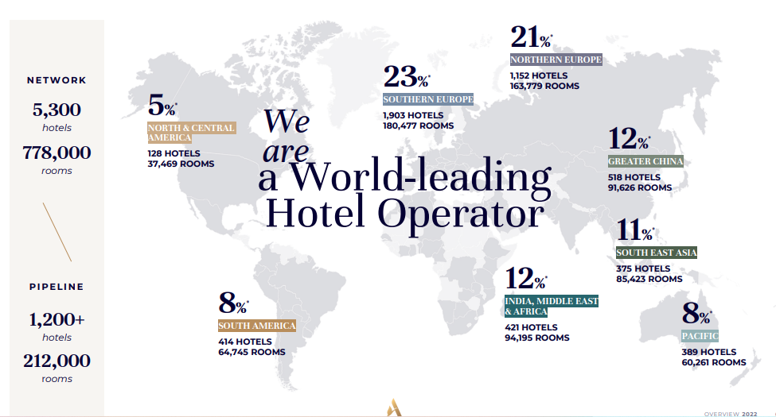
Figure 1: shows the number of hotels in the Accor company.

Appendix 3
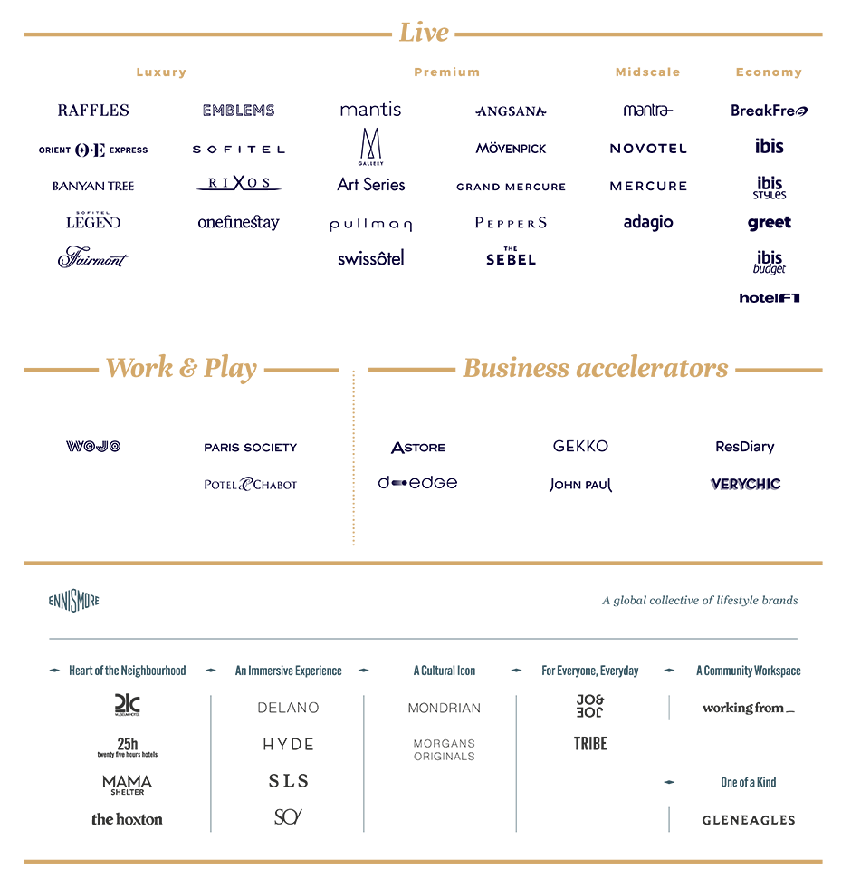

Figure 2 Show the segmentation of hotels in the Accor company.

Appendix 3
Background of Accor

Accor all began as a pair of buddies, Paul Dubrule and Gérard Pélisson started their first hotel called Novotel in the year 1967, while nobody in France had hoped of this concept hotel business model. They achieve the limits that defined what could be accomplished with their innovative thinking as well as bravery. Presently their hospitality dream is known as Accor. The company continues to spread, which include more than five thousand places in more than 110 nations. Daily, nearly 230 thousand skilled individuals keep on creating the hospitality of the future, bringing reality to their passion for the guest and fostering an dedication for service and success beyond boundaries.
There is a lot more creative ways of life experiences, whether for living, working, or playing. With over 40 hotel brands, 5300 hotels, and 110 countries. The company's goal is to established a redefining hospitality as well as promote fresh approaches of interacting globally by capitalizing on the capabilities of its staff along with an ecosystem of leading brands, customized support, and specialist solutions.(Accor, 2022).

