Digital Skills and Research Methods
The impact of Virtual Learning Environment on the learning experience of the students at UWTSD London campus
Abstract
The research has shed light on the VLE and its effectiveness in UWTSD London campus. It has been identified that the concerned University provides opportunity to the students in terms of taking admission into different postgraduate and undergraduate courses along with selecting the virtual learning sessions according to their convenience which has enhanced the scope of learning among students.

Table of contents

Introduction 4
Rationale 4
Research Objectives 4
Literature Review 4
Research Methodology 6
Research method and the methodology 6
Qualitative, Quantitative and combined approach 6
Data, Primary and secondary data 6
Data collection process 7
Population, Sample and Sample size 7
Ethics in data collection 7
Results/Findings, analysis and discussion 8
Conclusion and Recommendation 8
Recommendations 8
Conclusion 9
References 10
Appendices 12

Introduction
Virtual learning environment is considered as the educational technology which is associated with a web-based platform for the purpose of providing education to the students. Virtual learning has significantly increased from the era of covid situation. Virtual learning has also helped students to cope up with the studies during the situation along with enhancing their experience in terms of gaining information regarding different aspects as per their own convenience. In this regard, the UWTSD London campus has incorporated a VLE for their students for the purpose of providing enhanced experience to the students which is going to be discussed in this assessment.

Rationale
The research has demonstrated that the VLE has significantly increased in the London campus of University of Wales Trinity Saint David (UWTSD). In this context, there are several students who are facing issues related to virtual learning in terms of issues in their health due to which the concerned research is going to be done for the purpose of analyzing the experience of a student. In this context, the learning environment can be effectively enhanced according to the requirements of the students and enhance the situation of virtual learning (Acosta-Medina et al. 2021).

Research Objectives
- To understand the concept of VLE
- To analyze the significance of VLE of students learning
- To evaluate the impact of VLE on the learning experience of students at UWTSD London campus
- To recommend strategies for enhancing VLE

Literature Review
Concept of VLE
VLE is associated with learning and teaching tools that are designed to enhance the learning experience of the students by including internet and computer systems in the learning process (Alayne Larissa et al. 2020). It is identified that VLEs provide opportunities to students regarding accessing the digital resources so that it can be used by students for their educational enhancement. VLEs also include messages from forums and boards of the universities in which the students can communicate with each other and ask questions with their professors. This has been enhancing the collaboration on projects along with enhance the learning experience of students.
Analyzing the significance of VLE
VLEs have been very useful for the purpose of providing students a chance to opt for digital training and classes according to their convenience. VLEs also provide opportunity to the students in terms of participating in the class according to their time (Albina et al. 2022). In this context, students can be able to access the resources within the digital platform during the VLE. It is also useful to enhance the relationship between students and professors that can be useful for communicating with the professor as per students' needs and requirements. VLE is also beneficial for the purpose of saving cost as it provides opportunity to gain information from different platforms free of cost. However, the VLE also improves the technical skills of the students.
Evaluating the impact of VLE on the learning experience of the students at UWTSD London campus
VLE is created within the London campus of UWTSD for the purpose of providing proper information and education to the students. UWTSD London campus is ranked 6 in the UK for student satisfaction. In this context, all the courses have been designed in such a way that students will be able to pursue the courses as per their convenience and interest. This university is also inspiring students towards learning as well as gaining information related to innovation so that the information can be used in the practical lives of the students (Antón-Sancho et al. 2022). The virtual learning platform has been created in UWTSD in such a manner that it provides opportunity to the students in terms of exploring and experiencing the education as per their interest. This has been helpful to enhance the learning experience of the students. This university creates a unique experience by combining the teaching and learning environment of the students. Difference postgraduate and undergraduate courses are provided within the university according to the interest of students that has also been enhancing the learning experience of students.
Analyzing strategies for enhancing VLE
Incorporation of surveys can be done within the university that can consist of different questions related to enhancement of the VLE as well as analyzing the experiences of the students (Burç and Taşkın Nazım, 2022). This can be useful to provide proper information related to factors of the VLE that needs to be enhanced. In this context, the technical professionals of the concerned University can effectively opt for different strategic incorporation for enhancing those factors of the VLE. Feedbacks can also be taken from the students after each virtual learning session so that the factors of the VLE can be enhanced.

Research Methodology

Research method and the methodology
Combined methodology has been chosen for this research through collection of primary and secondary data. This method has been very useful for the purpose of collecting the data appropriately in an accurate manner through gathering only authentic information related to the topic (Chia-Chen and Liang-Yu, 2022). The information can also be used for the purpose of enhancing the VLE in the concerned University.

Qualitative, Quantitative and combined approach
Combined approach has been used in this research for the purpose of collecting qualitative and quantitative data for this research. The collected data is very useful for enhancing the quality of this research through authentic information that has been included in the research (Evangelista, 2021). Primary data has been collected from surveys of people whereas the secondary data have been collected from authentic sources of information such as Google scholar ProQuest and website of the university.

Data, Primary and secondary data
Primary and secondary data have been collected for this research. Primary data has been collected from surveying students of the university in terms of analyzing their responses related to experience in learning (Flavin and Bhandari, 2021). Experience of students in a VLE have been involved in the questions of the survey for analyzing the experience of the students in their learning. However, the secondary data have been collected from authentic sources of information such as Google scholar and ProQuest. The data have been collected from authentic sources of information such as the BBC. In this context, primary data has been very useful for providing unique data related to the research that has enhanced the overall research quality whereas secondary data has helped to enhance the quality of the research in an appropriate manner through including authentic sources.

Data collection process
For the purpose of collecting primary data for the concerned research at first different questions have been designed that were based upon analyzing the learning experiences of the students. However the questions have been included in a form of survey followed by creating a survey by using Google forms (Nasir and Ngah, 2022). In this context, the link of the survey that has been generated by using Google form has been provided to the students followed by collecting the responses of the students and analyzing them. On the other hand the secondary data have been collected through including different themes based upon the topic of the concerned Research. The selection of different sources of information that are authentic have been done for the purpose of collecting the data. In this context, the themes that have been made according to the tropic of this research have been searched into the authentic sources of information that were selected for the purpose of collecting secondary data. In this context, different journals that have been collected for this research have been penetrated for analyzing the accurate information and including it to the research.

Population, Sample and Sample size
The population is 200 that has been used in this research where the sample is 150 in the research who has been included within the research for the purpose of collecting information related to their experiences with the VLE of the UWTSD London campus. The sample size is 50 that have been included in this research.

Ethics in data collection
Ethics related to informed consent have been effectively considered at the time of completing this research. This has been illustrated as the students who have been involved with the survey have provided a consent form in which different questions were there related to the consent of the students. After receiving the signature of all the students the survey has been conducted which is the sign of proper ethical maintenance within the data collection procedure of the research (Neacsu et al. 2022). Ethics related to anonymity and confidentiality have also been maintained in this research at the time of collecting the data. However no animal and human being have been harmed in the research while collecting data for the research. Only authentic sources of information happen included in this research at the time of data collection and authentic data have been collected from it.

Results/Findings, analysis and discussion
• Primary data analysis
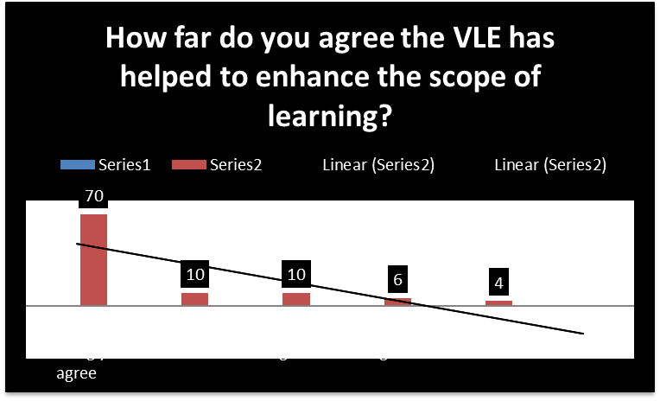
Figure 1: VLE and scope of learning
(Source: self-developed)
As for the questionnaire that has been designed and the responses that have been collected, it is identified that 70% of students have highly agreed with the first question that is associated with enhancement of scope of learning with the help of a VLE.
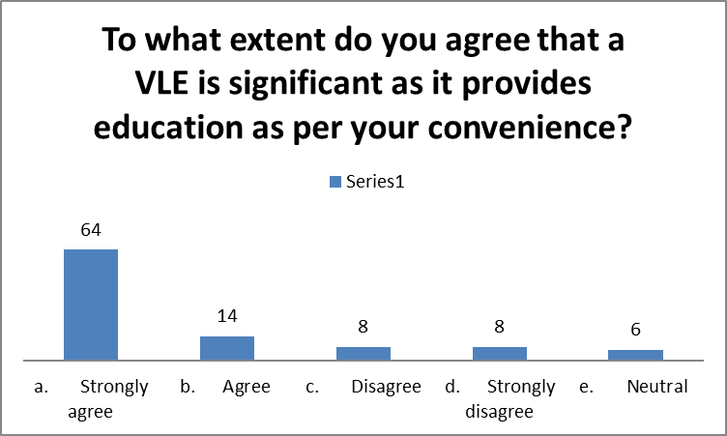
Figure 2: VLE and convenient education
(Source: self-developed)
65% of students have responded that they highly agree with the convenience of learning in a VLE.
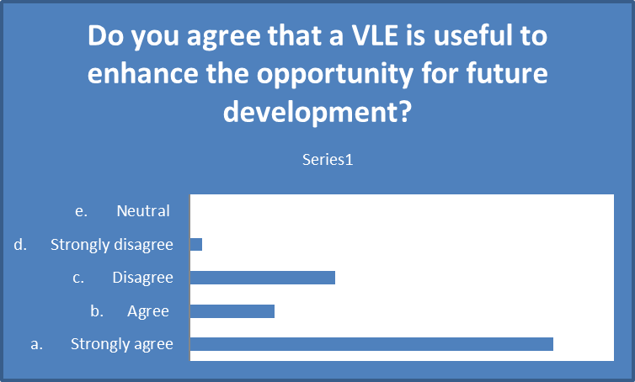
Figure 3: VLE and opportunity for future development
(Source: self-developed)
60% of students have strongly agreed with the statement that a VLE provides the opportunity for future development.
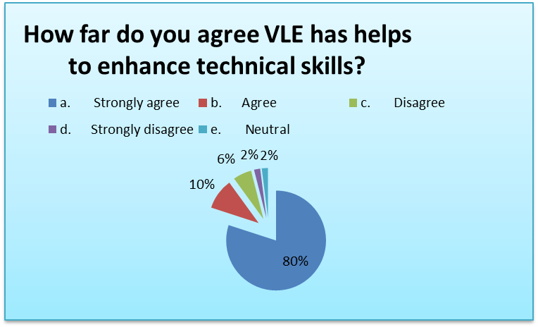
Figure 4: VLE and technical skill enhancement
(Source: self-developed)
80% of students have strongly agreed with the response for the enhancement of technical skills with the help of a VLE.
• Secondary data analysis
According to the secondary data that has been collected from different sources of information it has been identified that the VLE is very significant for enhancing the technical skills among students as well as enhancing the scope of future development. This is illustrated as students can be able to opt for virtual learning platforms for the purpose of acquiring training related to different fields with the help of which it can become easier for them to enhance future development (Sapkaroski et al. 2022).
• Summary of the findings
According to the analysis it has been identified that students have gained different knowledge from VLEs with the help of taking part in virtual classes to get trained without any additional cost which has helped to enhance their future scope (Solé-Beteta et al. 2022). However, there are some students who are also facing issues related to the VLE in terms of increased depression and stress. In this context, it can be demonstrated that the VLE is having both positive and negative consequences in terms of negative impact on health.

Conclusion and Recommendation

Recommendations
- Adoption of Artificial intelligence can be done to analyze the factors that could enhance satisfaction among students
- Feedbacks can also include at the end of every virtual learning session to enhance the VLE in the organization

Conclusion
It can be concluded that a VLE is very significant for the purpose of providing knowledge in a digital platform. It can also be concluded that the VLE has enhanced the scope of learning among students within the concerned university.

References
Acosta-Medina, J., Torres-Barreto, M. and Andrés Felipe Cárdenas-Parga 2021, "Students' preference for the use of gamification in virtual learning environments", Australasian Journal of Educational Technology, vol. 37, no. 4, pp. 145-158.

Alayne Larissa, M.P., Casandra Genoveva Rosales Martins,Ponce Leon, Laiane, M.R., Brasil, G.D.C., Karen Karoline, G.C., Géssica, B.V., Yuri Gustavo De, S.B., Izabel Cristina Rodrigues, D.S. and Funghetto, S.S. 2020, "Web-Based Virtual Learning Environment for Medicine Administration in Pediatrics and Neonatology: Content Evaluation", JMIR Serious Games, vol. 8, no. 4.

Albina, C.L.J., Doris, W.C., Noemi, R.R.C., Enrique, B.Z.C. and Jaime, V.G. 2022, "Ambiente virtual en el aprendizaje de las ciencias sociales en los estudiantes de una institución educativa", Revista Ibérica de Sistemas e Tecnologias de Informação, , pp. 208-218.

Antón-Sancho, Á., Nieto-Sobrino, M., Fernández-Arias, P. and Vergara-Rodríguez, D. 2022, "Usability of Memes and Humorous Resources in Virtual Learning Environments", Education Sciences, vol. 12, no. 3, pp. 208.

Burç, Ç. and Taşkın Nazım 2022, "Multimedia learning principles in different learning environments: a systematic review", Smart Learning Environments, vol. 9, no. 1.

Chia-Chen, C. and Liang-Yu, C. 2022, "Exploring the Effect of Spatial Ability and Learning Achievement on Learning Effect in VR Assisted Learning Environment", Journal of Educational Technology and Society, vol. 25, no. 3.

Evangelista, E. 2021, "A Hybrid Machine Learning Framework for Predicting Students’ Performance in Virtual Learning Environment", International Journal of Emerging Technologies in Learning (Online), vol. 16, no. 24, pp. 255-272.

Flavin, M. and Bhandari, A. 2021, "What We Talk About When We Talk About Virtual Learning Environments", International Review of Research in Open and Distributed Learning, vol. 22, no. 4, pp. 164-193.

Nasir, M.K. and Ngah, A.H. 2022, "The Sustainability of a Community of Inquiry in Online Course Satisfaction in Virtual Learning Environments in Higher Education", Sustainability, vol. 14, no. 15, pp. 9633.

Neacsu, G.C., Pascu, I.G., Nitu, E.L., Ionescu, L., Gavriluta, A.C. and Belu, N. 2022, "Development of a “Virtual Learning Factory” for learning and applying specific Lean manufacturing methods", IOP Conference Series.Materials Science and Engineering, vol. 1235, no. 1, pp. 012078.

Sapkaroski, D., Mundy, M. and Dimmock, M.R. 2022, "Immersive virtual reality simulated learning environment versus role‐play for empathic clinical communication training", Journal of Medical Radiation Sciences, vol. 69, no. 1, pp. 56-65.

Solé-Beteta, X., Navarro, J., Gajšek, B., Guadagni, A. and Zaballos, A. 2022, "A Data-Driven Approach to Quantify and Measure Students’ Engagement in Synchronous Virtual Learning Environments", Sensors, vol. 22, no. 9, pp. 3294.

Appendices
• Appendix 1
- How far do you agree the VLE has helped to enhance the scope of learning?
- Strongly agree
- Agree
- Disagree
- Strongly disagree
- Neutral
- To what extent do you agree that a VLE is significant as it provides education as per your convenience?
- Strongly agree
- Agree
- Disagree
- Strongly disagree
- Neutral
- Do you agree that a VLE is useful to enhance the opportunity for future development?
- Strongly agree
- Agree
- Disagree
- Strongly disagree
- Neutral
- How far do you agree VLE has helps to enhance technical skills?
- Strongly agree
- Agree
- Disagree
- Strongly disagree
- Neutral

