
LEARNING IN THE DIGITAL ERA
CRISTINA ILIES (2239774) | SUBMISSION DATE-22nd JUNE | E-PORTOFOLIO

Executive summary
In this report I will provide an overview of the key features of academic writing. It explores several types of academic writing, such as essays, research papers, and dissertations, and offers practical tips and strategies for planning, researching and writing these types of assignments. The report also highlights the importance of critical thinking, analysis, and citation in academic writing, and provide guidance on how to avoid plagiarism.

Contents
Executive summary……………………………………………………………………………………1
Terms of references…………………………………………………………………………………..2
Procedure…………………………………………………………………………………………………….2
Introduction………………………………………………………………………………………………..3
Main finding……………………………………………………………………………………………….4
Academic writing……………………………………………………………………………………….5
Similarity check………………………………………………………………………………………….6
Critical thinking………………………………………………………………………………………….7
Video on sense of place and identity………………………………………………………8
Conclusion…………………………………………………………………………………………………..9
Reference list………………………………………………………………………………………………10

Terms of references
This report was requested by Christian Felices on 23rd June 2023.The purpose of the E-portfolio is to show the understanding of academic writing, for the purpose of continuing study. This report was written by me, and submitted on the 22^{nd of} June 2023, and will cover the following toppings of academic writing: critical thinking, sense of place and identity.

Procedure
Textbooks, websites, and journal articles.

INTRODUCTION

In an academic report, the introduction serves as a road map for the
reader, providing a short and clear summary of what the report comprises. The purpose of an introduction is to set the tone for the report by providing context for the research topic, objectives, and methods. It should also explain why the issue is important and how the report will help the field of research. The introduction should be written in an entertaining and informative manner, which grab the reader’s attention and encourages them to read further. According to Smith and Jones (2018), a well-written introduction can help to set the tone for the rest of the report, while Brown and Lee (2019) suggest that the introduction should be concise and to the point.

MAIN FINDING

The main finding in an academic report’s objective is to provide a clear and summary of the research done. It should highlight the study’s important findings and conclusions, as well as give evidence to back up these claims. The major finding is critical in communicating the significance of the study to the reader and should be presented in an accessible and understandable manner. As noted by Bitchener and Basturkmen(2018),’’the main finding should be clearly stated and supported by evidence from the study, and should be linked to the research question. This ensures that the reader can appreciate the importance of the research and its contribution to the field.
ACADEMIC WRITING
Writing for academic purposes it is a style of writing commonly found in academic environments such as universities, research institutions, scholarly publications. It is distinguished by a formal tone, the use of arguments supported by evidence, and adherence to specific formatting and citation style. Academic writing’s goal is to present a clear and brief account of research findings, theories, or arguments, as well as to contribute to the body of knowledge in a certain field.
According to Murray and Moore (2006), academic writing should be clear, concise, and well-organized. It should present arguments and evidence in a logical and coherent manner, and should be free of errors in grammar, syntax and spelling. Academic writing should also and technical vocabulary to communicate complex ideas.
Aside from clarity and arrangement, academic writing necessitates the use of reputable sources to back up arguments and claims. As noted by Swales and Feak(2012),academic writing requires the use of evidence -based arguments, which are supported by credible sources such as journal articles, books, and other scholarly publications. These sources should be cited using a specific citation style to ensure the reader can locate the original source of the information.
Finally, academic writing should be tailored to a specific audience. As noted by Lillis and Curry (2010), academic writing is written for a specific audience, which may include other researchers, scholars, or students in a particular field. Writers should be mindful of their audience’s conventions and expectations, and modify their writing style, tone and language to match those expectations.
In conclusion, academic writing is a formal kind of writing that is used in academic settings to explain theories, arguments, and research findings. It requires clarity organisation, credibility, and audience understanding. Writers can produce excellent academic writing that contributes to the body of knowledge in their field.

SIMILARITY CHECK

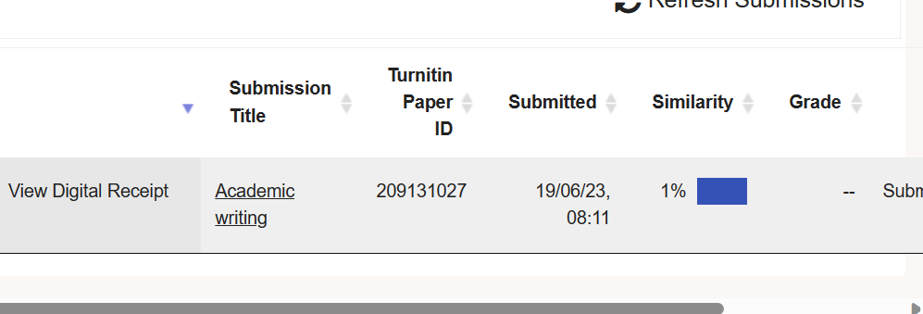

This task is for similarity check, and according to similarity check up my score is 1 %, this means I have a good understanding of paraphrasing, and I need to continue this quality of work. Whatever I will expect to see at least same percentage of similarity based upon of my references list on the completed work.
Similarity checks are essential in academic writing because they help to ensure the work is original and free from plagiarism.
According to Pecorari (2003), plagiarism occurs when students present someone else’s works as their own.

CRITICAL THINKING
Critical thinking is necessary for academic writing; it is not sufficient to simply explain or summarise the evidence; you must also analyse and evaluate information’s in order to utilise it to support your own claims. Academic report requires critical thinking since it enables students to create well-supported arguments and steer clear of logical fallacies.
According to Paul and Elder (2001), critical thinking is a process that requires students to question assumptions and evaluate evidence. Critical thinking helps students to develop a deeper understanding of the topic and to identify areas where further research needed. Additionally critical thinking assists pupils in avoiding confirmation bias and considering alternate points of view.
Facione(2011) argues that critical thinking is essential for academic success because its helps students to evaluate the quality of information. There is a multitude of information available online in the modern digital world, but not all of it is trustworthy, Students who posses critical thinking abilities can discriminate between reliable and unreliable knowledge sources.
Finally, Ennis (1985) emphasizes the importance of critical thinking in academic writing. He argues that critical thinking is essential for constructing well-supported arguments. Students who lack critical thinking skills may struggle to develop a coherent argument or to identify flaws in their own reasoning.
In conclusion, critical thinking is a vital skill for a academic success. As Paul and Elder (2001) argue, critical thinking requires students to inquire and evaluate evidence. Facione (2011) emphasizes the importance of critical thinking in evaluating the quality of information. Finally, Ennis (1985) argues that critical thinking is essential for constructing well-supported arguments.

VIDEO ON SENSE OF PLACE AND IDENTITY
https://www.canva.com/design/DAFmYJPX_Fc/ehsAkkGWKJZxQrKpMoJm8g/view?utm_content=DAFmYJPX_Fc&utm_campaign=designshare&utm_medium=link&utm_source=recording_view

CONCLUSION
Any academic report must include a conclusion. It summarises the key ideas and conclusions of the report and offers suggestions for additional study or action. The conclusion must be brief and direct, and it shouldn’t include any new information that wasn’t already included in the report.
As Smith (2017) argues in The Art of Writing Academic Reports, effective reporting requires careful attention to detail and a clear understanding of the report’s purpose and audience.
The final conclusion of this E-portfolio has demonstrated to the author the significant contribution that can be added to employability skills if we understand the first steps in developing them, according to the notes that were taken while taking the course Learning in the Digital Era, information provided by the lecturer, Christian Felices, and the others module teachers, as well as the research that was done.

REFERENCE LIST
-Basso,K.H.(Eds.),Senses of place (pp.53-90).
-Bitchener, J., & Basturkmen,H.(2018). Guidelines for reporting quantitative research in second language studies. Routledge.
-Brown.R & Lee,S.(2019). The art of writing introductions. Journal of Academic Writing, 9(1), 1-10.
-Ennis,R.H.(1985). A logical basis for measuring critical thinking skills. Educational Leadership, 43(2), 44-48.
-Facione,P.A.(2011).Critical thinking: What it is and why it counts. Insight Assessment.
-Lillis, T., & Curry, M.J. (2010). Academic writing in a global context: The politics and practices of publishing in English. Routledge
-Murray,R.,& Moore, S. (2006). The handbook of academic writing: A fresh approach. McGraw-Hill Education (UK).
-Paul,R.,& Elder,L.(2001).Critical thinking: The nature of critical and creative thought. Journal of Developmental Education, 25(2),40-41.
-Pecorari,D.(2003). Good and original: Plagiarism and patchwriting in academic second-language writing. Journal of Second Language Writing, 12(4),317-345.
-Proshansky, H.M., FABIAN,A.K.,& Kaminoff, Psychology, R(1983). Place-identity: Physical world socialization of the self. Journal of Environmental Psychology, 3(1),57-83.
-Relph,E.(1976). Place and placelessness. London: Pion Limited.
-Smith, J.& Jones,P .(2018) Writing academic reports: A guide for students. London: Routledge.
-Smith,J.(2017). The Art of Writing Academic Reports. London: Academic Press.
-Stokols,D., & Shumaker, S.A.(1981).The psychological context of residential mobility and well-being. Journal of Social Issues, 37(3),149-171.
Swalees, J.M., & Feak,C.B.(2012).Academic writing for graduate students: Essential tasks and skills. University of Michigan Press.

