

IKEA-main products and services

Name:Nikola Nikolov
Student ID:2014060
Date:09/01/2023

Table of Contents
Introduction 3
Description of the business and its products 3
Business- Ikea 3
Product: Billy Bookshelf 4
Demand and Market Equilibrium 5
Price of Substitutes 5
Price of Complements 6
Consumer Income 7
Consumer tastes and preferences 9
Consumer expectations of price 10
Demographics 11
Billy Bookshelf’s Demand- Elastic or Inelastic 11
Substitution effect 11
Income effect 13
Recommendation on pricing policy 13
Conclusion 15
References 16

Introduction
Management economics is applied to solve business challenges logically; cost, demand, manufacturing, and promotional concerns are developed in plans. The finest part regarding management economics is offering a rational answer to every issue that may emerge throughout company management, and it does so while adhering to the microeconomic principles of the organisation. This report will use a company called Ikea. The following is a Swedish firm that manufactures home furniture. To describe its products, in this case, Billy's bookshelf, and explain the reason for selecting the product. The report will also identify the market and demand equilibrium for the factors that impact the demand for Billy bookshelf. Further, discuss whether the factors that increase or decrease the demand for the product. Lastly, for each factor that impacts the price elasticity of demand, the report will describe how Billy's bookshelf is affected and whether the factor indicates demand is more inelastic or more elastic.

Description of the Business and its Products

Business- Ikea
The Swedish international firm IKEA is situated in the Netherlands. It was established in 1943 as a mail-order company, and in 1948 it started selling furniture. In 1958, Sweden's Smland welcomed the first IKEA retail location. Being known for its Scandinavian design, it is currently the most significant furniture retailer in the world. With more than 250 stores spread out across the continent in 2019, Europe had the most IKEA locations worldwide. Only about 100 stores were present in any other region (Pereira, 2022).
Over the previous 20 years, IKEA's annual income has increased consistently. In 2020, the business saw a fall in income for the first time, totalling 39.6 billion euros, due to the coronavirus outbreak. The following year, income increased and surpassed 40 billion euros (Pereira, 2022). The core value of the IKEA company strategy is low prices, and the company constantly strives to operate as effectively and economically as possible. The company has developed new materials that are more environmentally friendly, affordable and use the most up-to-date techniques for handling, managing, and shipping commodities. As a result, IKEA was by far the most profitable furniture retailer in Europe in 2020, demonstrating the viability of its business strategy.

Product: Billy Bookshelf
Billy's bookshelf from IKEA has been chosen for this report. Among Ikea's most popular items is the Billy bookcase. It is hardly surprising that many have been sold globally, given their classic style and simple makeup. They are a perfect example of the stereotypical American bookcase, with their straightforward construction, crisp colours, and basic designs.
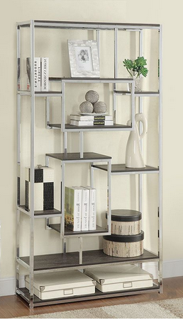

Figure 2: Billy Bookshelf (White, 2021).
The Billy bookshelf from Ikea is a job a new homeowner can complete, despite the installation procedure occasionally being slow. The standard Billy bookcase, which has measurements of 31.5" x 11" x 79.5", only costs consumers £59 on the Ikea website (Pereira, 2022); hence the bookshelf is so popular. There are a few distinct reasons for this item's cheap cost, but they all work together to provide the classic Ikea aesthetic of affordability and stylish design. The reason for selecting Billy bookshelf is that the worldwide sales of these bookcases have reached over 60 million, or just under 1% of the population. The Ikea firm states on its website that a Billy bookshelf is purchased every five seconds. Furthermore, bookcases are trendy because they are affordable, have been around for a while, and are easy to assemble.

Demand and Market Equilibrium

Price of Substitutes
A similar product that can be utilised instead of another is a substitute product. Furinno Pasir 31.5" three-shelf bookcase is an excellent substitute for the Ikea Billy bookshelf. From 2014 to 2016, the cost of a Billy bookshelf was higher than a Furinno Pasir 31.5" three-shelf bookcase (Codenotti et al., 2019). As a direct result, they generated less money than Amazon; however, starting in 2016, as of right now in 2022, a Billy bookshelf costs £89.99, while Furinno Pasir 31.5" three-shelf bookcase costs £74.99 (Hanaysha, 2018). It is recognised that when the cost of a substitute product decreases, more people will demand it, notwithstanding a decline in demand for the product it is intended to replace. However, the replacement item is less expensive than its substitute due to the goods and services they offer.
Furthermore, Amazon's competitors in the United Kingdom market are incredibly competitive in terms of pricing. Additionally, Amazon can generate a total income of £23.19 billion in its operations in the U.K. in 2021. On the other hand, IKEA was the most valued furniture retail brand in 2021, valued at more than 21 billion dollars, and the sixth most valuable retailer in the world.

Price of Complements
A product purchased along with the primary product is a complimentary product. Complementary products frequently add little value or cannot be used individually because these goods are employed in conjunction with each other (Crouch, 2020). For example, doors to make a gorgeous showcase cabinet, display shelves, and additional shelves are ideal with the Billy bookshelf. The market's supply and demand curves are commonly equalised to determine the market's price (P) and quantity (Q). While the S.S. curve has an upward slope, on the other hand, the D.D. curve has a downward slope. The S.S. curve shows a variety of links between the price and the quantity supplied (Q.D.), while the D.D. curve shows a variety of links between the quantity and price demanded (Q.D.) (Q.S.). When factors except the price change, there is a shift in the demand curve, also referred to as D.D. Customer taste, income, environment, and complementary and substitutable products are a few of these factors (Stewart and Davis, 2019). Only the quantity requested changed due to the price change (Q.D.). We say that two items are complementary to one another when consumed simultaneously, at the same time and when the cost of one good complementary changes, the D.D. for different complementary goods also varies, and vice versa. Below is a graph showing the prices of complementary products and the demand curve.
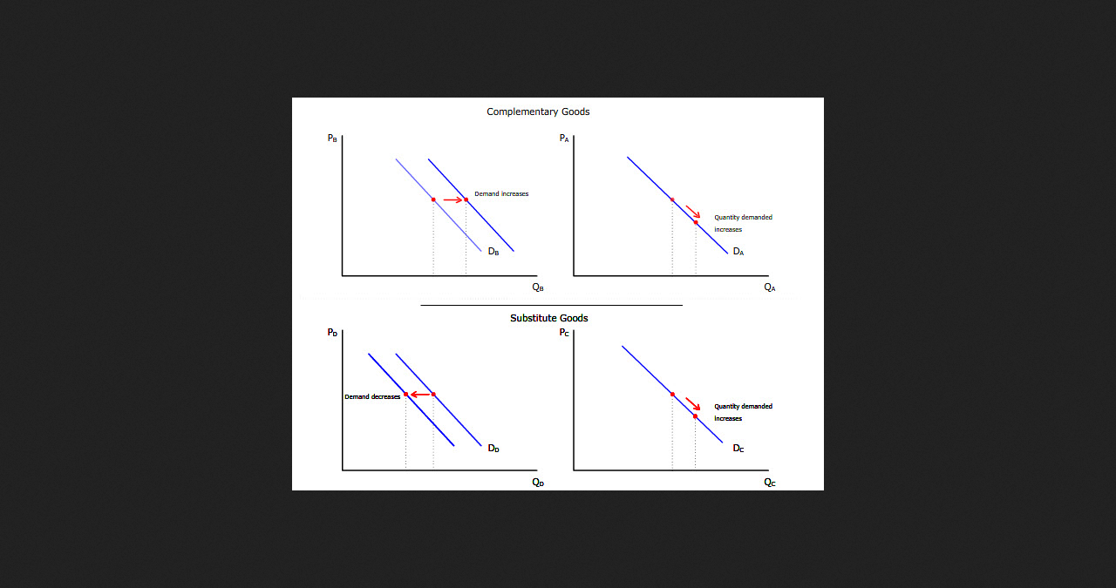
Figure 3: Complementary goods prices and the demand of goods curve (Turvey, 2022).
Display shelves and Billy bookshelf are two items that pair well together. Hence, they are typically consumed together. When this happens, the number of display shelves produced will rise while the amount needed for display shelves will reduce. On the other hand, the D.D. for Billy's bookshelf will also decrease. The shift in the Billy bookshelf D.D. curve will result from a non-price impact caused by the price change of a complementary good. The D.D. curve will shift to the left or the inside, and the Billy bookshelf will have a generally lower D.D. Billy's bookshelf will remain readily available in the same quantity (S.S.), which will cause suppliers to lower their prices. As a result, both the available amounts and the price will rise when the market is in equilibrium.

Consumer Income
In the fiscal year ending (F.Y.E.) 2021, which covers the beginning of the coronavirus (COVID-19) pandemic, the average household income in the U.K. will be £31,400. The rise from the previous year is 2%. The average income increased by 2.0% from F.Y.E. 2020 to F.Y.E. 2021 (Codenotti et al., 2019). The average income increased by 14.2% throughout the ten years from F.Y.E. 2012 to F.Y.E. 2021. Between F.Y.E. 2020 and F.Y.E. 2021, the average income decreased by 0.6%.
However, from F.Y.E. 2012 until F.Y.E. 2021, it increased by 10.1%. Below is a graph of the average and mean real equivalised household disposable income of people in the United Kingdom from 1977 to the financial year ending 2021.

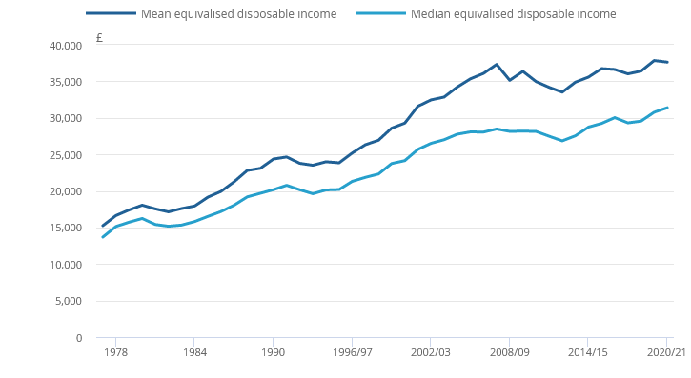
Figure 4: Median and mean real equivalised household disposable income in the U.K (Anderson, 2018).
We can therefore conclude that the U.K. population's income is rising. Furniture companies' production is seen as "regular products" by those with earnings below the average income and as "cheaper goods" by those customers with above the average income. Therefore, the rising income will significantly affect the need for Billy's bookshelf due to the various demand degrees. Demand and income are closely associated with standard products. Hence, a rise in income will lead to greater demand, while a reduction in income will lead to less demand.
Income variations can be both beneficial and negative. Most customers assume commonplace things, including consumer products, technological innovations, and leisure activities (Anderson, 2018). Whenever it regards inferior goods, demand and income are inversely connected. The graph below shows that while an increase in earnings reduces demand, a decline in income increases demand.
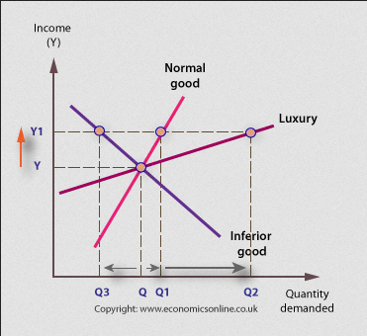
Figure 5: Consumer demand and income (Crouch, 2020).

Consumer tastes and preferences
In the modern world, many individuals nowadays use online journals and books in their research and study. Consumers' preferences constantly change, and advancements have influenced the technology revolution. As a result, individuals are increasingly more selective about the items they select for their homes (Stewart and Davis, 2019). Modern buyers carefully analyse the furniture quality available on the market before buying it for their houses. Due to concerns over their space, consumers are rethinking their purchases on Billy's bookshelf.
However, customers are willing to pay extra for products of better quality when it comes to furniture. In that case, Billy's bookshelf sales volume and other items at Ikea are unaffected by the level of interest in these items (White, 2021).

Consumer expectations of price
Customers always inspect a price drop. However, all goods' costs, including the price of a Billy bookshelf, are rising due to inflation
Therefore, the demand curve moves to the left because most customers expect the furniture cost to decrease (K.I.N.S.E.Y. and COLLINS, 2017). However, we are aware that customers would put off buying an item now if they thought the price might drop in the future, which would reduce the demand for that product right now. On the other hand, if a customer believes the price will rise in the future, the current demand for the goods will rise. It would, however, increase demand for the product because it is furniture and demand for Billy's bookshelf will significantly fall if costs keep rising at this rate.
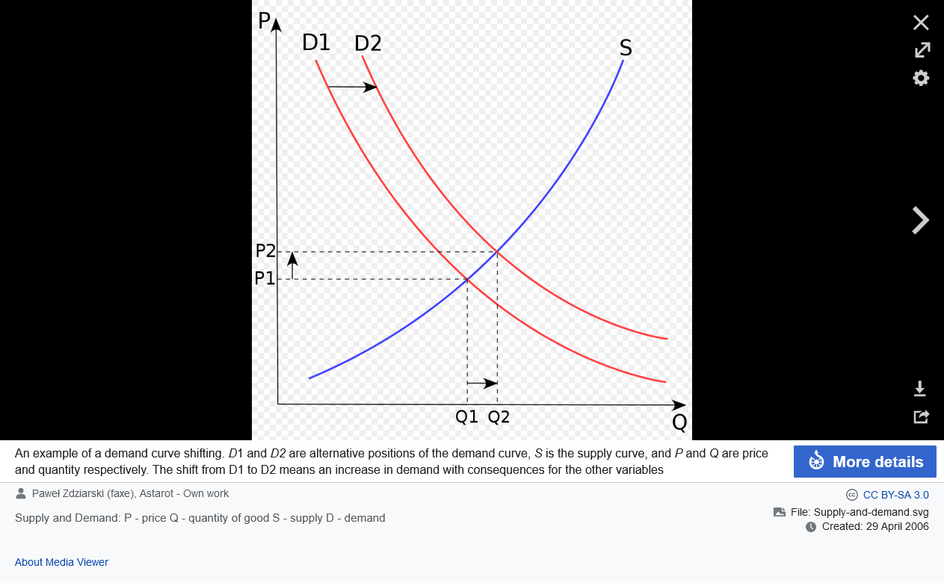
Figure 6: Price and Demand Curve (Turvey, 2022).

Demographics
Businesses use demographics, a population's socioeconomic characteristics, to determine customer preferences and purchase patterns. For example, in the entire world, it is believed that IKEA sells Billy's bookshelf every 5 seconds, which translates to about 6.5 million bookcases sold yearly. Also, research gathered from 40 nations shows that the average cost of a Billy bookshelf is £36. Therefore Billy's bookcases create over 200 million euros annually for IKEA (K.I.N.S.E.Y. and COLLINS, 2017).

Billy Bookshelf's Demand- Elastic or Inelastic

Substitution effect
Here, the basic principle of demand elasticity in connection to price is changed. Demand for commodities would be more adaptive due to the ease with which a suitable substitute product could be found if a commodity's price rose (Ford, 2022). The demand for a product will be relatively elastic when there are few or no substitutes. It is not a choice, but an obligation that is fulfilled, no matter the cost. Anything one wishes they had but is not necessarily needed in daily life is considered a luxury. The less elastic or inelastic a product is, the greater its demand because fewer alternatives exist. The less elastic or inelastic it is, the higher the need for the item. When the item in concern is more luxurious, the market is more sensitive and elastic.

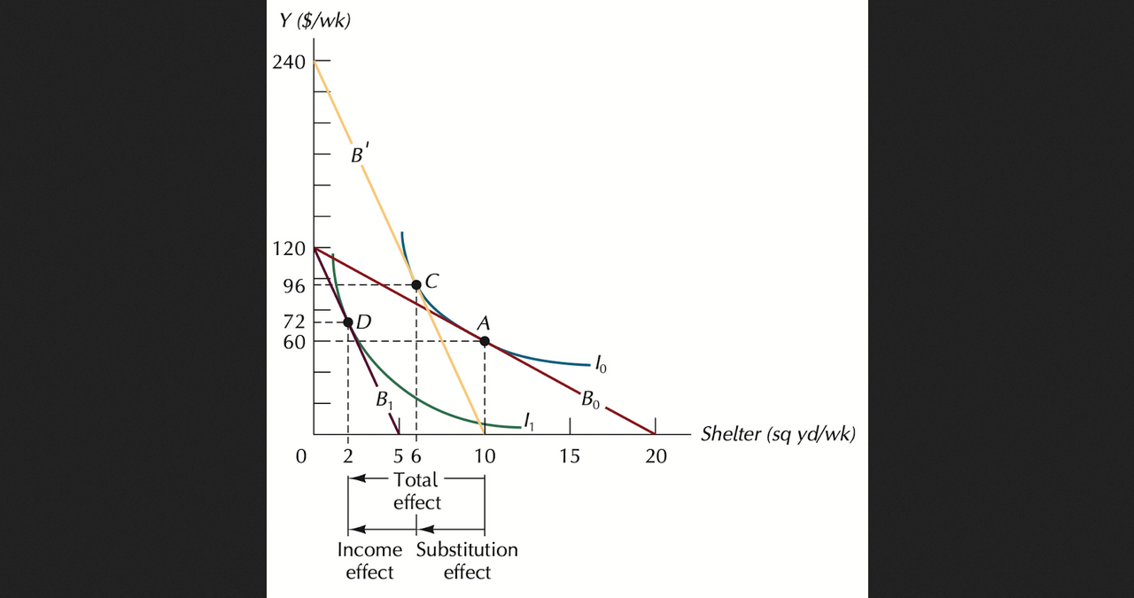
Figure 7: Substitution effect (Ford, 2022).
Products with inelastic demand can only be produced by one producer, whereas those with an elastic market force operate in an atmosphere that encourages company innovation. The price elasticity of supply is frequently lower in the short term than in the long term because consumers have more time to adjust. Therefore, a change in production that is roughly equal to a change in pricing does not always follow. Price inelastic growth may be expected to rise when a person spends a lower portion of their overall budget on a specific item. This is because customers have more options when there is intense competition.
In our case, Billy bookshelf is a luxury product that competes fiercely in its markets. Therefore, if they were to elevate their prices too much, this would cause a decline in demand that would be greater than the increase in revenue (K.I.N.S.E.Y. and COLLINS, 2017). Therefore, businesses will increase prices as much as possible until demand reaches an elastic point if demand is inelastic. On the contrary, the pricing of elastic goods should be reduced to increase revenues as an outcome of growth in demand. We can therefore say that Billy's bookshelf demand is generally more elastic.

Income effect
Any service tends to have a lower elasticity of demand for those with higher incomes because wealthy people are immune to the effects of changes in the prices of various goods. (Crouch, 2020). However, the most susceptible to their effects are significantly impacted by fluctuations in commodity prices. Therefore, demand from people with lesser incomes is highly elastic. For example, if there is a significant employment reduction when the British market is experiencing a downturn. Then, the annual incomes of most people are price elastic, also impacted by price size. Since it is so responsive to changes in the market, demand for products like Billy's bookshelf and others sold at furniture companies is unusually elastic.
An elastic demand will exist for the goods or services if a sizeable share of funds is spent on them (Hanaysha, 2018). Price changes and periods are frequently associated. Demand is frequently inelastic in the near term. It happens when customers can not quickly adjust their choices to match a change in the cost of a specific product. Long-term supply seems to be more flexible, making it simpler to switch to alternative options when the cost of a particular item rises. It could be a year, a quarter, per week, one day, or even a few years before the decline causes a significant drop in the market for Billy bookshelf.

Recommendation on pricing policy
Pricing is the procedure of determining the worth that a producer will receive in exchange for their goods and services. It is usually established when it is suitable for both the producer and the consumer. Marketing experts give pricing top consideration since it represents their perception of how much customers are willing to pay for a good or service (Anderson, 2018). Product prices, either excessively high or low, may restrain the economy's growth. If the products are priced wrongly, it could anticipate lower sales and a drop in the available financial flow.
The manufacturer of Billy's bookshelf, IKEA, can set its prices based on actual expenses. Therefore, a company should implement the cost-plus pricing model. They calculate the fixed and variable costs associated with a product. Possible using the cost-based purchasing methodology.
Managers may develop pricing strategies after analysing corporate price objectives like boosting short- and long-term profitability, stabilising spending, improving working capital, and predictions. A sound pricing strategy considers the item, the rivalry, and the different customer types to be market competitive. As an alternative, pricing frequently involves determining the price premium customers are willing to pay for a commodity before determining how much product to produce (Anderson, 2018).
When IKEA's board creates prices, they decide whether they should prosper in the strong market, where buyers are concerned with service and quality, or the limited market, where buyers are concerned with cost. The company uses these strategies to choose which market to target. (K.I.N.S.E.Y. and COLLINS, 2017).

Conclusion

Billy bookshelf is a popular product offered at IKEA. However, other factors impact the demand for the product apart from its price. Some factors include the income of the consumers, the price of supplements, consumers' tastes and preferences, consumer expected prices, and the rivals' prices. The factors have different impacts on the demand for the Billy bookshelf. Some cause a decrease in demand, while others result in a rise in demand. Demand for a good or service that changes in opposition to how much it costs is said to have high elasticity of demand. The impact of a price adjustment is not necessarily continuous, however. Even for slight price changes, the demand for a product might occasionally vary significantly. However, for some products, price changes do not significantly impact demand. Therefore, the bookshelf price can be considered elastic.

References
Anderson, J.E. (2018) Public finance: Principles and policy. Australia: South-Western Cengage Learning.
Codenotti, B., McCune, B. and Varadarajan, K. (2019) "Market equilibrium via the excess demand function," Proceedings of the thirty-seventh annual A.C.M. symposium on Theory of computing - S.T.O.C. '05 [Preprint]. Available at: https://doi.org/10.1145/1060590.1060601.
Crouch, M. (2020) "Empirical assessment of energy-price policies: The case for cross-price elasticities," Energy Policy, 32(8), pp. 989–1000. Available at: https://doi.org/10.1016/s0301-4215(03)00043-0.
Ford, E. (2022) Price elasticity, Corporate Finance Institute. Available at: https://corporatefinanceinstitute.com/resources/economics/price-elasticity/ (Accessed: December 29, 2022).
Hanaysha, J. (2018) "Furniture business location and price fairness as key determinants of brand equity: A study on furniture industry," Business and Economic Research, 6(1), p. 310. Available at: https://doi.org/10.5296/ber.v6i1.9352.
K.I.N.S.E.Y., J.E.A.N. and COLLINS, M.I.C.H.A.E.L.I. (2017) "Index of consumer expectations: Furniture price effects and durable goods expenditures," Journal of Consumer Affairs, 28(2), pp. 255–277. Available at: https://doi.org/10.1111/j.1745-6606.1994.tb00851.x.
Pereira, D. (2022) IKEA, Encyclopædia Britannica. Encyclopædia Britannica, inc. Available at: https://www.britannica.com/topic/IKEA (Accessed: January 2, 2023).
Stewart, H. and Davis, D.E. (2019) "Price dispersion and accessibility: A case study of furniture business," Southern Economic Journal, 71(4), p. 784. Available at: https://doi.org/10.2307/20062080.
Turvey, R. (2022) "The relative prices of different manufactured goods," Demand and Supply, pp. 105–112. Available at: https://doi.org/10.4324/9781003283225-8.
White, H. (2021) Billy Book Shelf, Furniture Palace. Available at: https://furniturepalacekenya.com/product/billy-book-shelf/?gclid=Cj0KCQiAnsqdBhCGARIsAAyjYjQqF9NlM1I_grihM1JmifE68dMy40iu0884yuxMNAW4gmRa95duBG8aAkLbEALw_wcB (Accessed: January 2, 2023).

