Andreea Petronela Zapodianu
Student Number 2215053
Learning in Digital Era
E-portfolio

TASK 1. a)
Essential skills are listening, speaking, writing, leadership, teamwork, spelling, grammar, positivity and more. If you want to study or to work in a field, it is always important to have some skills which will help you understand more what you are going to do. These skills are essential for study and for employment. I am going to define some of them below.
Listening: Listening is the most important key in the communication. If you do not have the ability to listen, messages are misunderstood. Listening is the ability to receive messages and interpret them.
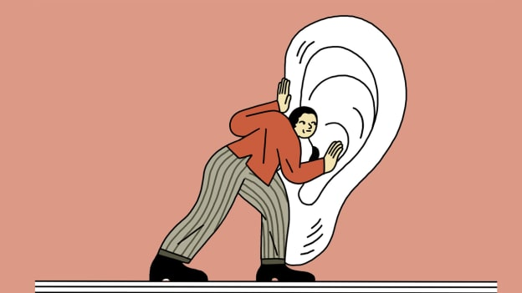
Imagination: This is what you use to create and strengthen the associations needed to create effective mnemonics that are potent for you. The more strongly you imagine and visualise a situation, the more effectively it will stick in your mind for later recall. [1]
Writing: Writing is the skill which allow you to communicate your message. To have a good skill of writing is important because you can “tell” your ideas with clarity to a larger audience. In this way you will be able to achieve your purpose. [2]
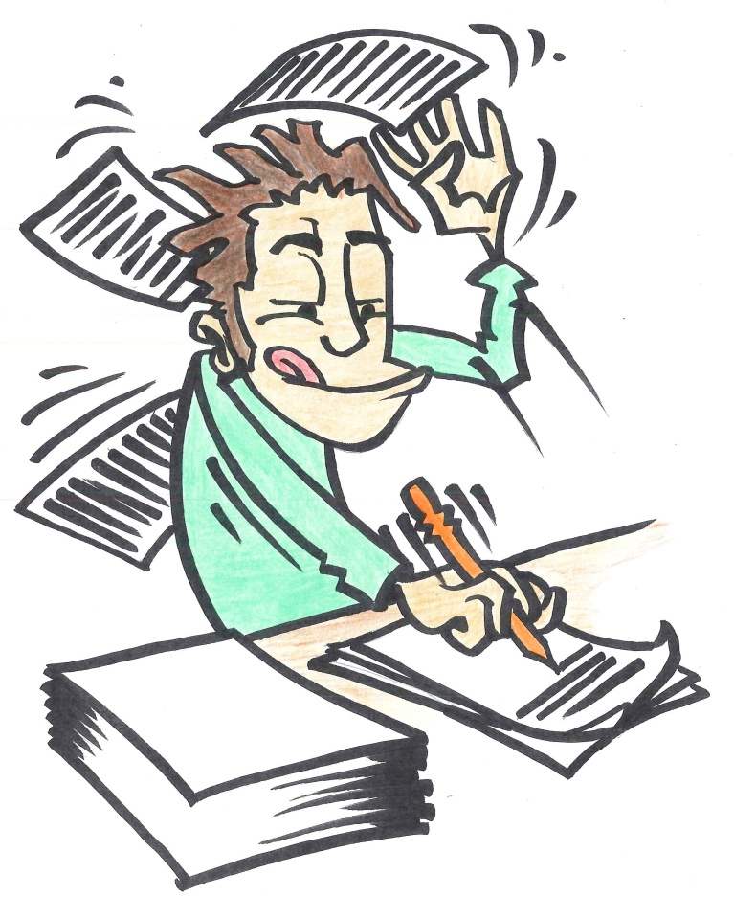
Leadership: Leadership means to organise a group of people to accomplish desired business goals and to coordinate a group of people from school as from the workplace. A leadership know how to speak with people and how to treat them. A leadership must be confident, and they must lead other people to wonderful things. [3]


Positivity: If you suffer from negative thinking or if you feel inferior to others, then probably you suffer negative outcomes. You must have self-confidence, and the power to make your life the way you desire it. Just thinking in a positive way, everything will become more clear and easier to do. Just do it. [4]
TASK 1. b)
My similarity is 23% which is satisfactory. I should be more careful when searching fore references: they must be from a credible and secure source and must indicate what I wrote down in the document. I have some omissions and errors on my text so I should be careful on how I write the text and to pay attention to all the details which are included in the task. Writing good grammar and providing good references should be the way to improve my similarity.
23% similarity. I will say it is satisfactory and it is a pass. I award myself with satisfactory. I have credible sources on my references and my text is clear and understandable.

TASK 2.

