UNDERSTANDING AND ENGAGING IN THE CUSTOMER EXPERIENCE
BMSW5103
ROMEO MAKIADI
1906720
NANDISH PATEL

EXCUTIVE SUMMARY

In this report, I emphasise the critical values and requirements that must be met for customers to be happy, not just by monitoring what occurs, but also by leveraging the data to drive action across the organisation. It's less important what kind of measure is utilised than how it's used. Consumer Journeys (consumer contact points) are at the centre of any customer evaluation system that links them to everything else. Customer relations management is the full focus and how the models benefit internal and external situations especially throughout covid. This report will consist of CRM models and theories from various scholarly professionals to assist in my evaluation with references. It consists of which model is best suited to Sainsburys infrastructure and how to improve on existing elements of CRM and its counterpart’s customer experience management and total quality management? Furthermore, distinguishing the problems that have been caused by the pandemic and how to find solutions and continue providing adequate service to all stakeholders and partners using customer relations management.

TABLE OF CONTENTS

- INTRODUCTION
- ORGANISATION
- CUSTOMER RELATIONS MANAGEMENT (CRM)
- MODELS REVIEW
- MODEL SELECTION
- APPLICATION
- RECOMMENDATIONS
- CONCLUSION

INTRODUCTION
The content and purpose of this report is to critically analyse the effects of covid 19 to organisations and their customer relations including a further analysis and broader understanding of the change in the customer experience as consumers are now more interactive online. Generating a long-term business advantage requires customer experience to be always positive and a reflection of the company, However the effect of Covid-19 has caused the word to rapidly evolve.as well as shifts in consumer behaviour, has compelled organisations to utilise CRM as a strategic role to increase customer experience and engagement. therefore, consumers' expectations have altered, relations with companies have changed, and interactions are transitioning exclusively online. Assessing the customer satisfaction might not be at the forefront of many firms' list of concerns, therefore, circumstance has brought the true worth of a business to the forefront of consumers' thoughts. A tailored Customer Experience is important and essential to a company's growth. The Models and scientific theories that will be within this report follows as Total Quality Management, Service Experience, CRM Value Chain IDIC Model, Five Forces Model and QCI model evaluating and understanding their benefits to the chosen organisation.
Understanding the key concepts in customer relations management (CRM) is fundamental to access the additional benefits from the process. When utilising CRM, the key areas should be examined, as well as how CRM may be utilised to save resources. Having a successful CRM system in place will allow more data to be transparent, potentially delivering cost savings strategies for analytics marketing and customer service requirements. A CRM system will enhance revenues in terms of higher sales volume, larger order quantity's, expanding in size and frequency, and ultimately more profitability from consumer’s Depending on the scale of the organization, the cost of CRM software must be configured as an investment to improve the company's image. (Bergeron, 2002) Therefore, taking these concepts into consideration a managerial team can effectively use the process which can ease external matters and allow business continuity through unforeseen circumstances.

ORGANISATION

Sainsburys is a leading supermarket company in the United Kingdom with 189 thousand workers, 600 branches, and a continuing expansion into more remote regions (Sainsburys , 2021). Sainsburys generate value for shareholders through capitalising from their food business's legacy and size, as well as their attributes. It is critical being a "sustainable business”, they have a main goal to achieve "Net Zero" by 2040 throughout all their activity. Transformation is the necessity, and they are making a promising headway. (Sainsburys, 2021)
Expanding around their identity and assets will let Sainsburys generate value for stakeholders by leveraging their food company's tradition and growth and utilising strong resources. Technological innovation and knowledge retention influence all Sainsburys decision making processes. Exceptional operational cash flow, Customer base that is appealing, Nectar cards, digital investment, and innovation, Scale and capabilities on the internet, Second-largest food retailer on a scale, Service reputation, branches are geographically structured improving convenience strength (Sainsburys, 2021). According to Sainsburys annual report it has been a refreshing year and the executives are pleased on the development through the crisis and quick responses and adaptation to assist consumers, employees, and stakeholders adding value to the company and customer experience. Health and safety have been the company's main concern and the swift responses throughout the year to new information updates concerning the virus. Achieving this task required managing product inventory and collaborating with external suppliers allowing a successful transition of product availability (Sainsburys , 2021)
As an employee I was intrusted with various occupations and could see differences within the cycling months throughout covid. I was apart of the CRM process and was required to give feedback online on my wellbeing as an employee monthly. This information was then used by hierarchy positions to implement the correct procedures in CRM. However, the issues were complicated as parking was no longer available for many customers and staff due to backlog of consumers due to health and safety queues that were installed to reduce virus outbreaks. Bad weather was an issue for consumers in lines outside the branch, plus this encouraged disadvantaged people to harass consumers for funds. The mandatory regulations provided by the government for PPE masks or valid medical grounds for all operational facility’s had to be regulated for confirmation of safety by Sainsbury’s (Gov.co.uk, 2021) often causing disruption as some do not carry coronavirus beliefs and will not adhere to these rules. Lastly the future pressures and dilemma of vaccinated and the unvaccinated customers coming into contact and the beliefs they carry.

CUSTOMER RELATIONS MANAGEMENT

CRM is thought of as a concept that may be converted into a strategy. A knowledge of components of CRM systems, which leads to the addition of Tacit Knowledge, leading to greater understanding of how marketing works. Customer relationship management refers to a company's relationship with its consumers (Francis Buttle, 2008). Consumers will participate with the organisation’s enterprises building a connection therefore developing a need for return this can be accommodated by reduced price sales and socially moral business ethics reflecting a sense of value. Consumers will demand more business and attract more lucrative custom transforming into company loyalty (Bergeron, 2002).
CRM was created in 1997 to restructure the service relationship using computer-based technologies. Every customer-business contact may be recorded, allowing an organisation to provide the greatest customer service potential while establishing a database of consumer behaviour that sales teams, marketing, and managerial staff can analyse. The data may then be utilised to cut costs and boost staff productivity. (Bergeron, 2002) The requirement for sainsburys to portray a consistent image is a crucial component of any customer corporate interaction. The company Disney maintains the idea that its characters owned are genuine. By forbidding them from appearing publicly unless completely costumed. A discrepancy in behaviour might permanently alter a person's or character's viewpoint. Organisations are sometimes compared like individuals by stakeholders and are assessed on their actions rather than their accomplishments. (Payne & Frow, 2005)
Customer requirements are rising, but one must ask if this is a temporary occurrence due to COVID19. Customer dissatisfaction with the endless cycle of voicemail assistance is increasing. It is arguable that dissatisfaction stems from increasing pressures or the inefficiency to productively operate within strained conditions. CRM is about determining whether clients are positive or negative in a timely manner, moving customer care professionals from phone to email assistance should improve the financial performance. The important questions to answer are before CRM application is “what is are our competitors doing to maintain business, and what can we do better”. Sainsburys may have to look at different connection points or produce one. In addition, how to find different measuring tools to utilise for profitability evaluations. The suggestions of answers to find will also contribute to assessing the potential benefit of adopting a CRM system to better meet the service needs of consumers.
CRM’s interpretation has a huge impact on how a company adopts and implements CRM, is not plainly a technology alternative for acquiring and growing a consumer base from a strategic standpoint. It entails a deep formation of tactical vision, an organisational understanding of the nature of consumer satisfaction in a multichannel environment, use of appropriate information management. CRM applications are high-quality procedures that require time for fulfilment, and customer support. As a result, CRM should be placed in the wider strategic framework of any business. (Payne & Frow, 2005) The strategic strategy potential to increasing shareholder value by cultivating suitable relationships with important customers and customer groups is very beneficial and will raise profitability to shareholders.
CRM combines the power of relationship marketing and information technology to build lucrative, long-term connections with customers and other important stakeholders.
The requirements for a cross-functional, method strategy to CRM establishes it in a strategic position A strategy formulation process, a value generation process, a multichannel integration process, an information management process, and a performance evaluation process are the five major cross-functional CRM procedures identified. Five processes must be within the procedure of building CRM to have the best outcome. Upholding valued data and being able to transmit the information is essential, the suggestion of General data-mining packages provide the analytical techniques that allow efficient usage of the data centre. As well as software application bundles. From analysing vast amounts of data for example, discusses important patterns and linkages. (Payne & Frow, 2005). These are software applications that are more specific-primary components: shareholder outcomes, which gives a micro perspective of the underlying connections that drive performance, as well as routine tracking progress, which gives you a clear picture of how well you're doing. a more comprehensive, micro-perspective on measurements and key performance indicators (Francis Buttle, 2008). Enhancing the company information technology and data processing systems and CRM.

Total Quality Management

One of the most important positioning strategies for marketing is product quality. Quality has a positive influence on the effectiveness of a product or service. as a result, it is directly related to consumer value and satisfaction. Total quality management (TQM) is a method of continually enhancing the quality of a company's goods, services, and business processes by including all the company's employees. TQM is a structured approach to company management that attempts to enhance product and process quality by benefiting from objective statistical input from key stakeholders such as consumers. (Kristensen, et al., 2007)
Factors Influencing Customer Satisfaction
The standard of the product, Quality of service, Price, Features of a certain product or service, Emotions of customers, Success or failure of a service can be attributed to a variety of factors. Fairness or equitable perceptions, Other customers, relatives, and colleagues, Personal characteristics, Situational variables. This analysis Provides a basis to close the various spectrum of gaps within customer relation. (Dahlgaard, et al., 2002)
The Five Dimensions of Service Quality
Reliability-Ability to provide the promised service with consistency and accuracy.
Assurance-Employee politeness and knowledge, as well as their capacity to inspire trust and confidence.
Tangibles-Staff appearance, physical facilities, and equipment
Empathy-The firm's consumers receive caring, customised care.
Responsiveness-Willingness to assist clients and deliver quick service
The table below gives more of a descriptive formed comparison to the five dimensions.
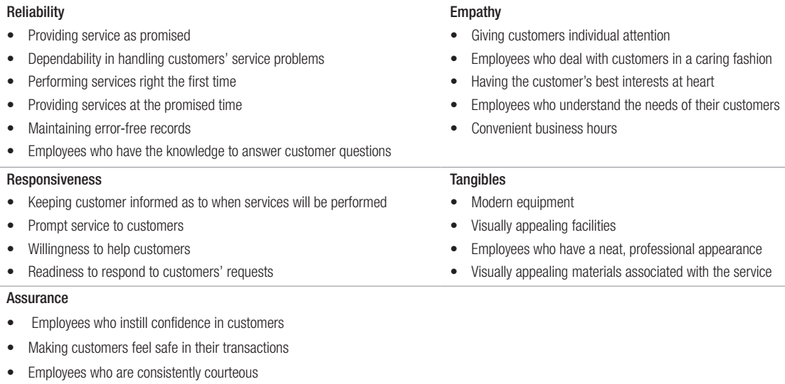
When assessing these variables, the outcomes become clearer as these are attributes, all humans admire and expect when purchasing products from a retailer. occurring in return of customer experience (Ertekin, 2018)

Service Experience

The end-to-end collection of customer encounters that provide value to a service is referred to as the service experience. From the consumer's viewpoint, this is generally regarded as a process through which a consumer learns, consumes, experiences, and interacts in a service. Consumers' expectations play a huge part in how they rate and review services. Organisations must understand the impacts of each service interaction to effectively manage service quality. The 7Ps engaged in service delivery make a significant impact to the quality of service received.

- Product: The ideal product adds value to the customer's experience. This value is subjective; we must provide our consumers with what they want they desire, not what we believe they desire. (Ertekin, 2018)
- Price: Everything the consumer views — packaging, surroundings, marketing items, webpage, printed materials, receipts, and so on — must meet these heightened quality standards.
- Promotion: The advantages that consumers obtains from products are beneficial. Explore new channels, there are now a plethora of options to consider.
- Product Distribution: Customer studies reveal that the most significant factors in choosing a supplier is dispatch effectiveness. it also refers to how you present your goods to different client groups. This might be in a store or on the internet.
- People: Your brand's reputation is in the hands of your employees. They need to be well-trained, motivated, and have the proper mindset. Customers that are pleased with your services are fantastic ambassadors for your company.
- Physical Evidence: Some businesses connect with consumers and request input to produce reference materials. When new consumers see these testimonies, they are more inclined to make a confident purchase.
- Process Make sure your systems are built for the advantage of the client, not for the comfort of the organisation. (CIM, 2015).

Development, marketing, and consumption all happen at the same time in this process, which moves from continuous sequence to simultaneous. These functions are not separated by time or location. The result, interacting employees execute the dual roles of production and marketing by creating services for consumers in the service system while they are there. (Vishahka, 2021)

Altering the company from the customer's perspective.
Pioneers in customer experience begin with a purpose and prioritise addressing the most key consumer path first. Stages that are identified within the path are then improved. They develop supporting procedures with customer psychology in mind to manage expectations. They change their digital profile to eliminate friction in interactions and to establish the culture of constant innovation that will allow them to undertake more fundamental organisational changes. Behavioural psychology, which is employed as a layer of the design process by major consumer-experience organisations, is one technique they use. Combining multiple stages of encounters to reduce estimated length and create a sense of achievement. They have straightforward alternatives that give clients a sense of power and option. Set up metrics to track information from the customer. Set up metrics to track client feedback.
Customers must be satisfied this cannot just be done simply measuring what transpires, but also through using the information to deliver change throughout the company. Journeys are at the heart of the ideal customer-experience assessment system, tying experiences to other key components like business results and efficiency improvements. Exceptional professionals begin at the very top, with a statistic to track their progress. Consumer experience comes first, followed by a downhill spiral. In-depth look at valuable consumer journeys and results Using employee feedback as a source of indications to seek out chances for development. (McKinsey & Company, 2017)
(Skedsoft, 2021)
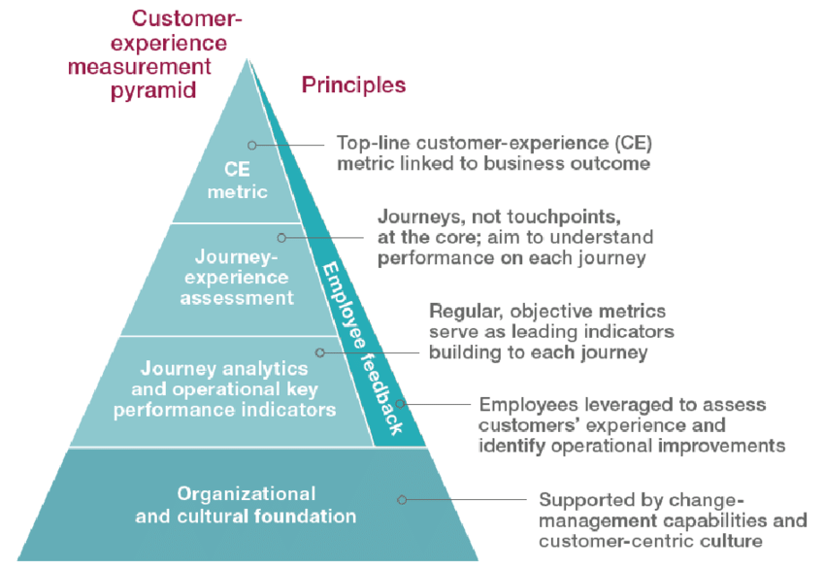

With the aid of Joharry's New Window Method, categorisation the cause of mistakes can be identified:

1. The foundation of continual development is standardisation.2. Conventional procedures for defect prevention and management are really used by everyone who is affected. Standardisation is not enough on its own.3. Communicating and encouragement are the foundations for everyone to follow the established techniques and for everyone to strive to enhance current standards. 4. It would be pointless to strive to develop better techniques until everyone has access to the present knowledge. (Skedsoft, 2021)
Step 1: Clearly describe the basic operation and convey it to all parties involved.
Step 2: Defined standard operation must be put into proper practise
Step 3: if a sufficient quality level is not attained, enhance the production technique.
Step 4: Review the usual procedures. (Dahlgaard, et al., 2002)
(Fakuda,1983) explains the model in the following manner (Faadooengineers, 2021)

The various classifications indicate the opponents Section A's and Section b's interaction.
Individuals, parties, teams, corporate sectors, and so on can all be referred to using these
wordsThe relevant party in the "knownpractised" category understands how to avoid faults
and conducts them effectively. The “knownunpracticed” section, the relevant participant is ware of the proper procedures but does not carry them out adequately or at all.
The appropriate party in the "unknown" category does not know the proper techniques yet for defect prevention.

As seen in category 1, anyone in either parties understand and accurately executes the quickest and most effective action available now. This category must cover all standard operations. Category 2 shows, parties from both sides are aware of the usual processes, yet someone fails to carry them out appropriately. This covers cases where someone is negligent and fails to follow established procedures by looking at category 3, awareness of the correct procedures for preventing faults is known by one party, but the other is unaware of them. Category 4, neither side has a complete understanding of the appropriate approaches. This category still has unresolved technological problems that create faults. (Dahlgaard, et al., 2002)
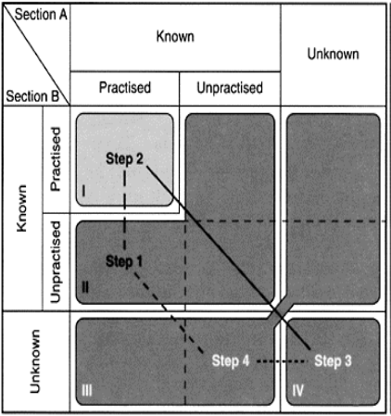

(Skedsoft, 2021)

MODELS REVIEW

Payne’s five forces model - The concept has two major parts: cross-functional CRM procedures and essential CRM implementation features. Strategy formulation, value generation, multichannel integrating, data management, and performance measurement are the five processes outlined in Payne's approach. For a CRM deployment to be effective it must include CRM preparedness, Change management in CRM, Project management for CRM and Employee supervision. Organisations must undertake a CRM evaluation before establishing a CRM solution to evaluate how equipped they are to execute a new CRM procedure. Considering CRM demands a significant cultural and operational shift, organisations need engage in CRM change management and project management as new strategies are implemented and the challenges of CRM projects increase. Ultimately, commitment of employees is essential for CRM sustainability. Verify that company workers are aware of the techniques and systems, as well as the new consumer culture. (Payne & Frow, 2005)

Total quality management- The first principle is to put the customer first. Leadership is the second principle. Participation of people is the third principle. The fourth principle is to use a process-oriented approach. The fifth principle is to have a systematic approach to management. Continual improvement is the sixth principle. Principle seven Take a Fact-Based Approach to Making Decisions and lastly the eight principle is Supplier Relationships That Benefit Both Parties this is a summary of information on total quality management applied earlier through the report

IDIC Model

In 2004, Peppers and Rogers developed the IDIC model an important strategic methodology for CRM. It is divided into four operational phases. To identify consumers and gain a thorough insight of them, as well as to distinguish customers who are more prospective. Communicate with consumers to learn about their expectations and how they compare to rivals, and tailor services and product lines to meet their needs developing a more personal interaction with consumers

Identification

First stage is to establish your consumers, which can be done by gathering data such as a contact number, residence details, and buying behaviour at each point of contact throughout the organisation. The aim is to gather all types of data as possible about each consumer so that you can further understand their requirements, wants, and purchasing habits.

Differentiate
This stage is to segment or distinguish your customers depending on their present and anticipated loyalty. Keep in mind that not all consumers are equal in terms of company value.

Interaction
In the third step, you'll put your CRM ideas into action by connecting with your consumers. Once your consumers have been evaluated and classified, you can create personalised encounters for them—for instance, you might provide membership perks or prizes to valued customers to encourage retention and ongoing expenditure.

Modify
evaluate your consumer interactions once you've recorded them in order to build better personalised one-to-one service. The objective is to meet your consumers' requirements and expectations while also ensuring that you have identified them uniquely.

QCI model - Acquisition, retention, and penetration are the three major initiatives that the Competitive Index model centred on. The QCI process typically begins with the customer's external environment—their difficulty areas, organisational objectives, and other variables will influence if there prepared to purchase or engage with sales representatives, affecting the customer experience. Many actions are involved in acquiring and keeping consumers.

CRM value chain model-A value chain is a theory created by Michael Porter which describes the processes a company employs to generate an ending goods or services for its customers. Determine and prioritise the company's most important operations while also improving procedures to achieve a competitive edge. This idea is applied to customer connections through the CRM value chain model. This CRM model tracks all the processes and actions involved in establishing a client connection. (Barnes, 2001) the concepts that will need to be applied begin with two departments. primary and support, beginning with the primary needs.

Consumer knowledge examination: the study enables enterprises comprehend its consumers' requirements and expectations, as well as build techniques to increase consumer sustainability.

Customer intimacy: this stage is to interact with consumers and expand upon that information in the database. Organizations should gather data upon every contact at each touchpoint to truly comprehend and meet their expectations. maintaining customer loyalties for a significant period

Network development: All stakeholders in the value chain are included in the network, covering partnerships, producers, service and support, shareholders, and others. Its objective is to leverage consumer data to guide operations at every department of the network so ensure all attributes are in alignment and works simultaneously to improve your consumers' experience.

Value proposition development: generate value for your target consumers using customer data and interaction information gained previously. The purpose is to transform the attention away from the commodity and onto your service, while also lowering process expenses to provide greater value to the consumer.

Relationship management: Managing your consumer's sustainability is the final phase of the value chain model. This step entails assessing your corporate infrastructure processes and organisational structure to better manage consumer acquisition, retention, and progression.

The five supporting requirements that must be met to successfully implement the primary strategic initiatives consists of Culture and leadership, Processes of procurement, Processes for HR management, Processes for managing information technology and data retention, infrastructure designs, such critical inputs must be created and developed for a CRM value chain deployment to be effective. (Lucidchart, 2021)

MODEL SELECTION

The models that I have researched and analysed for this report, contain the same attributes but adjust to suit different busines aspects and structure considering Sainsbury’s a well organised establishment containing commodity’s implementing one form of CRM framework was not adequate therefore, I have come to conclude, two methodologies are needed to cover the variety of departments and add more value to customer experience and staff. Payne’s five forces model and CRM chain value methodology are both needed and suited.
CRM Chain value model is a more simplified version of porters five forces model considering it covers most of the information but does not contain the know how or the in-depth strategies needed to commit to CRM. I believe the benefits is the simplicity the bullet point type form and basic chart. Allowing critical thinkers within the organisation to evaluate their positions within stakeholders regards, and structure the beginning of their CRM model.
The basics will be formed and transmitted through company touch points within infrastructure like employee feedback, shift briefings, electronic dialog via email and Sainsburys employee electronic forums. (Dahlgaard, et al., 2002) Furthermore, through warehouses and staffrooms to establish awareness and transparent values and objectives, in addition to verify clarity of information and communication as multiple cultures and diverse communities hold occupations within Sainsburys. Once it has been established, hierarchal positions can then start to implement a more specified CRM approach involving the Five Forces method.
When CRM has been identified, it will be more efficient to install extra initiatives giving the organisation another edge on competitors like Relationship management, Customer intimacy, value proposition, and development. Regarding the issue’s employees and consumers were facing outside the exterior of Sava Centre branches and others security and supervisors became key assets to CRM Sainsburys. The exterior was monitored, staff was formed to assist consumers in queues and a section was formed for staff in the car park protective personal equipment was issued to anybody entering the establishment free of charge, and security was briefed on Sainsbury guidelines and values and coronavirus legislation, (Gov.co.uk, 2021). These factors would not have been addressed without both CRM models as the organisational structures need to comply to make to process effective.
APPLICATION

Following the five-step implementation process applying these methodologies at the start I would need both concepts strategy formulation from five forces and a consumer knowledge examination. Accessing the company data bases and reviewing past complaints via staff in COVID19 conditions, a document can be constructed to show awareness to maintain staff retention. Sharing knowledge within the organisation will bring a sense of togetherness and validity. relations management from chain value and data management from five forces will allow the process to be recorded and gathered to be installed for further development to further please the stakeholders and understand their needs.
Using relations management from the value chain to source specific and the most detrimental issues keeping in mind of the five-step implementation plan construct a plan considering all the data. Once this has occurred, the next step would be to implement the project foundations. Due to the importance of exterior staff governance structure was implemented by Sainsburys which included incentives and a new parking framework for staff, new goals that the company added on to their agenda to prevent further company disapproval. Identifying and acknowledging where management change is needed, this entailed more security, management supervision and unemployment of staff specifically for these conditions.
As staff parking was an issue, employees that drive were asked to inform their management whether they commute to work via a vehicle to establish the number of employee parking spaces needed each shift. This was one of the most successful programme management tasks to be carried out through COVID19.

Needs Specification and Partner Selection

When establishing the data review, understanding, considering all the factors that influence the situation we can assess pros and cons of the programme management. Enhancing the programme management and maintaining success and longevity is key to customer experience. Analysing this data, the project can be categorised and broken down into smaller components, furthermore, bridge the necessary gaps. In addition, a RPF would have already been dispatched creating employee awareness. The request for proposals (RPF) will also be sent to partners, suppliers, and stake holders to ensure the values of Sainsburys and their employees have been attended to.
Considering, Sainsburys as an established organisation, professional IT and CRM providers that specialise in the following areas: corporate strategy, CRM strategy, customer experience the information systems procedure allows for the transmission of important consumer data and other information around the organisation, as well as "recreating the thinking of the customer."
To guarantee that technological solutions complement CRM, Technology planning should be done from the standpoint of offering a complete customer experience rather than preparing for functional or product-centric needs. Data mining is a computerized technology that uses complicated algorithms to find relationships and trends in large data bases, real or perceived, previously unknown to the retailer, to promote decision support. (McKinsey & Company, 2017)

Project Implementation

Re-evaluate and assess management project and tweak when needed. Also, another successful way to implement the project is by redefining IT requirements from the information sourced from warehouse data.

Performance Evaluation

The project outcomes can only be evaluated after a measurement of time, to assess all possible variables that can influence a negative effect on the project. In view of a minimal problematic programme evaluating feedback and recent productivity can lead managers to the conclusion of a positive outcome considering customer experience, employee satisfaction, productivity and profitability which has a huge impact on the business outcome.

RECOMMENDATIONS

Sainsbury have continued to show stakeholders their strengths with consumer value by continuing developing the CRM model’s business should continue to prosper and be able to withstand another external environmental matter like covid as things are now put in place to aid business aims through such calamities from commencing. The topic content, time monitoring, audience, and aim of CMR and CEM are comparable, but they are not the same.
In brief, both CRM and CEM boost consumer connections, but CRM promotes relationship-building for the company, whereas CEM focuses on customer experience monitoring and improvement. CRM and CEM are both responsible for all aspects of the consumer experience and interactions. CRM is procedural, recording data including why and how much a consumer expenditure ordinarily every transaction and what types of products they buy, but CEM is conceptual: did the consumer have a pleasant time spending or browsing in the store or making an order on the website. (Meyer & Shwanger, 2007) understanding the difference is essential
Continuous evaluation and enhancement need to be carried out to confirm operations are progressing and contributing to business profitability and overall customer experience.

CONCLUSION

To conclude my report, the variety of strategies and models needed to improve Sainsburys productivity was vital to CRM and the COVID19 predicaments. Without a full understanding and comprehension with critical thinking insight it will be difficult for the CRM model to be effective. From the research that was carried out through journals, books, and websites I have concluded, that without CRM Sainsburys would not have been an efficient organisation throughout COVID19. Sainsburys conducted frameworks to the management project which aided morality which made an affect throughout the company and contributed towards a good annual report 2020/21. (Sainsburys , 2021)I believe the correct model must suit the issues given CRM allows you to better understand your customers and co-create value with them by leveraging data and information. This necessitates the cross-functional integration of processes, people, operations, and marketing capabilities, which is made possible by information, technology, and applications. (Francis Buttle, 2008)

REFERENCES

Barnes, D., 2001. Understanding Business Processes. David Barnes ed. London and New york: The Open Universty.
Bergeron, B., 2002. Essentials of CRM: customer relationship management for executives. Newyork : Wiley-Blackwell.
Bergeron, B., 2002. Understanding the values of CRM. In: Essentials of CRM: customer relationship management for executives. Newyork: Wiley-Blackwell, pp. 8,9.
CIM, 2015. 7ps of brief summary of marketing and how it works, Birkshire United Kingdom : The Chartered Institute of Marketing.
Dahlgaard, J. J., Khanji, G. K. & Kristensen, K., 2002. Quality Managment Systems and Standardrisation . In: Fundamentals of Total Quality Management. London,New York : Taylor and Francis , pp. 46,47,48.
Ertekin, N., 2018. Production & Operations Management.. Immediate and Long Term Benifits of In-Store Return Experience , 27(1).
Faadooengineers, 2021. Joharrys New Window On Standardization And Causes Of Quality Failures. [Online]
Available at: http://www.faadooengineers.com/online-study/post/me/total-quality-management/20/joharry-s-new-window-on-standardization-and-causes-of-quality-failures
[Accessed 1 september 2021].
Francis Buttle, 2008. In: 2nd, ed. Customer relationship management: concepts and technologies. s.l.:Butterworth-Heinemann.
Gov.co.uk, 2021. Coranavirus Legislation. [Online]
Available at: https://www.legislation.gov.uk/coronavirus
[Accessed 25 august 2021].
Kristensen, K., Kanji, G. & Dahlgaard, J. J., 2007. In: Fundamentals of Total Quality Management. london,: Taylor & Francis, pp. 8,12,13.
Lucidchart, 2021. 4 models that boost CRM. [Online]
Available at: https://www.lucidchart.com/blog/crm-models
[Accessed 30 August 2021].
McKinsey & Company, 2017. The ideal customer-experience measurement system puts journeys at the center . In: B. Javetski, ed. Customer Expierence New capabilities, new audiences, . s.l.:McKinsey & Company, pp. 8,9,11.
Meyer, C. & Shwanger, A., 2007. CEM vs CRM. In: hbr.org, ed. Understanding customer experience. Califonia : Harvard Business Review, p. 120.
Payne, A. & Frow, P., 2005. A Strategic Framework for Customer Relationship Management. Journal of Marketing, 69(4), p. 168.
Purcărea, T., 2016. Customer Experience Mearsurment Pyrimid. [Online]
Available at: https://www.researchgate.net/figure/Customer-experience-measurement-pyramid-Source-McKinsey-analysis-The-CEO-guide-to_fig3_308077580
[Accessed 27 August 2021].
Sainsburys , 2021. Annual report, london : Sainsburys .
Sainsburys , 2021. Values and Culutre/Working at sainsbury/sainsburys jobs. [Online]
Available at: https://sainsburys.jobs/working-at-sainsburys/values-culture/
[Accessed 26 august 2021].
Sainsburys, 2021. Food at the heart. [Online]
Available at: https://www.about.sainsburys.co.uk/food-back-at-heart
Skedsoft, 2021. Joharry's new window on standardization and causes of quality failures. [Online]
Available at: https://www.skedsoft.com/books/total-quality-management-tqm-/joharry-s-new-window-on-standardization-and-causes-of-quality-failures
[Accessed 27 august 2021].
Sonawane, N., 2002. Enhanced Decision Making using. Textile Apparel Technology Management , 2(3), pp. 2,3.
Vishahka, B., 2021. 7 P’s of Service Marketing. [Online]
Available at: https://www.economicsdiscussion.net/marketing-2/service-marketing/7-ps-of-service-marketing/32395
[Accessed 26 august 2021].

