Asthma

Long-Term Management Through Evidence, Integrated Care and Personalised Support

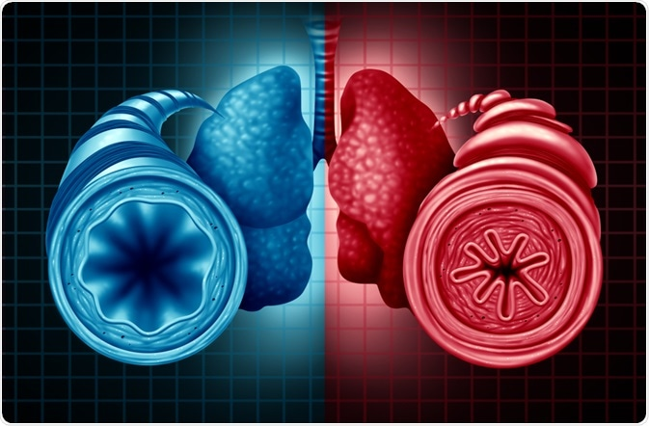

Student ID: 2312156
Student Name: Shabnam Khan
LCHS 7003 - Community Care and Management of Longer-term Conditions
Lecturer: Dr Aishat Bakre

Table of Contents
Understanding Asthma 3
Why it is a long-term condition 3
Global and UK burden 4
Aetiology and risk factors 5
6
Physical, psychological and social impact 6
Physical impact 6
Psychological Impact 6
Social Impact: 7
Critical synthesis 7
EVIDENCE-BASED NHS TREATMENT AND MONITORING 7
Diagnosis and assessment 7
Medication and Technique 8
Responding to deterioration 8
House of Care Model: UK Application 9
Overview 9
Professional partnership 9
Informed and engaged people 9
Organisational and clinical processes 9
Commissioning and system support 10
Chronic Care Model: International application 10
Model overview 10
Health system organisation 10
Delivery System Design 10
Decision support 11
Clinical Information Systems 11
Self-management support 11
Community Resources 11
Critical Evaluation 11
Local and National Political Health and Social Care Agendas 12
National Political Health, Social Care Agendas 12
Local Political Health and Social Care Agendas 12
Self-management, family support and end-of-life considerations 13
Supported self-management 13
Family and carers 13
End-of-life care 13
Recommendations And Conclusion 14
Priorities for practice 14
Concluding message 14
References 15

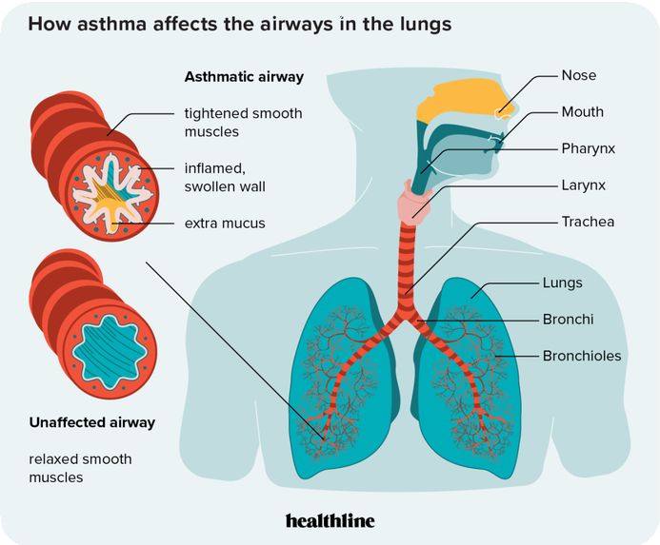

Understanding Asthma
Asthma is a complex chronic inflammatory condition of the airways in the lungs with variable symptoms including the lungs, which cause reduced expiration flow and variable exacerbation (World Health Organisation, 2026). There is a relationship between bronchoconstriction, airway inflammation and excess mucus production all of which can lead to wheezing, coughing, breathlessness and chest tightness (Agache et al., 2024a). It is possible to have symptoms at times and not at others, but do not assume that one would not get a bad break when you feel fine. Clinical evaluation, combined with objective testing, is thus needed for diagnosis, as far as possible. There is individual variation in asthma age of onset, allergic sensitisation, symptom patterns and treatment response. Such differences are important as a one-size-fits-all pathway of care could fail to consider environmental triggers, comorbidities, and practical challenges to effective care (National Institute for Health and Care Excellence, (NICE), 2024); Global Initiative for Asthma (GINA), 2025).

Why is asthma a long-term condition
Although asthma symptoms can be occasional, there is still a need for constant monitoring, preventive treatment, education and reassessment. According to WHO, (2026) It is the most prevalent chronic disease among children. Long-term follow-up is crucial as exacerbations can happen even when asthma is well managed. Control of future attacks, maintenance of lung function and participation in normal activity should therefore be the aim of long-term management (, (WHO, 2026).

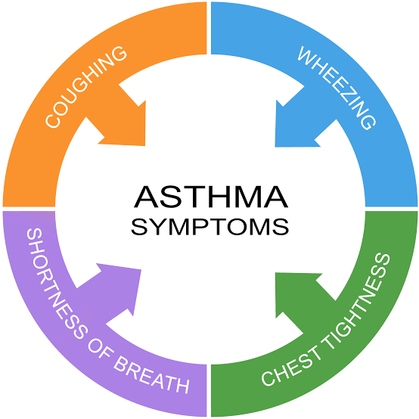

(ASAP, 2021)

Aim
This brochure aims to teach people with asthma, their families, and caregivers how to effectively manage their condition. Asthma symptoms, typical triggers, recommended treatments, proper inhaler usage, and the significance of medication adherence will all be covered. Additionally, the guide will teach how to prevent asthma attacks, identify deteriorating symptoms, and create efficient self-management techniques. The pamphlet seeks to improve asthma control, improve quality of life, and lower the risk of complications and hospital admissions by encouraging awareness, confidence, and educated decision-making.

Global and UK burden
Worldwide burden
The World Health Organisation (2026) estimates, around 363 million people, worldwide, suffered from asthma in 2023, resulting in 442,000 deaths. These estimates reveal a significant public health problem in the face of the existence of effective inhaled treatments (WHO, 2026). WHO also notes that underdiagnosis and undertreatment are serious issues in low income and lower middle-income countries (Agache et al., 2024b). However, global figures mask considerable variations in diagnostics access and exposure trends and in health system reporting. A high prevalence record may be an indicator of the improved recognition of the disease and not necessarily of poor prevention (Global Initiative for Asthma, 2025).

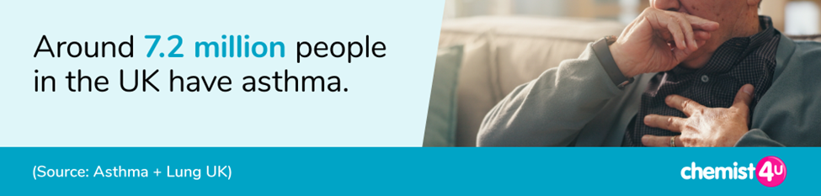
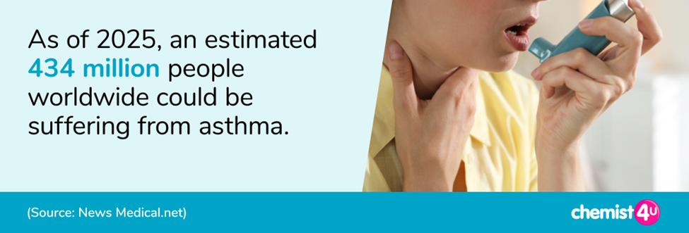
Asthma + Lung UK (2025)
Asthma + Lung UK (2025)

United Kingdom Prevalence
In the United Kingdom, there were about 6.5% of people diagnosed with the condition as of 2023/24, with a total of 3,886,879 reported in the House of Commons Library (House of Commons Library, 2025). The estimate of recordings of diagnosed asthma in England is not to be confused with the figure of about 5.4 million people in the United Kingdom who are treated for asthma (Gajjar, Rough and Burnett, 2025). Aside from the immediate impact, the parliamentary briefing also shows that preventable outcomes occurred, with 1261 deaths resulting from asthma in England in 2020 (Agache et al., 2024d). The figures represent different populations and periods of reporting and cannot be compared with each other directly without some methodological adjustments (House of Commons Library, 2025).

The prevalence of asthma in the UK is roughly eight in every 100 people, equating to approximately 7.2 million people. (Source: Asthma + Lung UK). The burden must be understood both in terms of prevalence, and in terms of severity and mortality, as well as through lack of access to treatment. More than the number of cases the burden must be interpreted in terms of prevalence and also in terms of severity and mortality, and also in terms of unequal access to treatment (Agache et al., 2024c). Some undiagnosed people are not included in the recorded diagnoses and hospital information also depends on the availability of services as well as the severity of the disease. Both International and national evidence agrees on the importance of investing in earlier recognition and periodic reviews of access to preventive medication, and that this access must be equated.

Aetiology and risk factors
Modifiable Risk Factors
Global Initiative for Asthma [GINA], (2025) suggests that, modifiable factors are exposures or behaviours that can be decreased or controlled to help better control asthma. Firstly, smoking and vaping may cause airways irritation and worsen breathing symptoms. Secondly, air pollution and pollen can lead to inflammation of the airways and to exacerbations of asthma. Thirdly, mould and dust mites are allergens that can cause respiratory symptoms to be exacerbated as well as dampness in the home, especially in poorly maintained buildings. Additionally, obesity is also associated with an increased risk of asthma symptoms. Furthermore, not using the inhaler with the correct technique may reduce medication delivery to the lungs and cause higher exacerbation risk, so it is important to review preventive treatment and inhaler technique. Lastly exposure to irritants of the respiratory system like strong perfumes, and cleaning sprays may trigger asthma (Agache et al., 2024a).

Non-modifiable Risk Factors
An individual's vulnerability to asthma is increased by inherited genetic factors if there is a family history of the condition (Ober and Yao 2011). NHS (2024) says Asthma can strike at any age, but it usually manifests in childhood. Due to immunological and hormonal variations, asthma is more common in women as adults and in boys as children (Chowdhury et al., 2021). According to NICE (2024), an elevated chance of developing allergic asthma is linked to a hereditary propensity to allergy disorders, including hay fever and eczema. Environmental and socioeconomic factors may be linked to variations in asthma prevalence and outcomes among ethnic groups (ONS 2022).

Almutairi et al., (2023) stresses the genetic-environmental interactions whereas Agache et al. (2024a) focuses on the role of environmental exposures on asthma outcomes. Likewise, the GINA (2025) outlines the need to consider the individual risk factors in treatment planning. But socioeconomic inequalities often play a role in environmental exposure, so that people might not be able to control their housing conditions or their polluted environment. This is because asthma management should not be the responsibility of the patient alone, but should be accompanied by other public health initiatives and interventions in the individual's clinical management.

`Physical, psychological and social impact
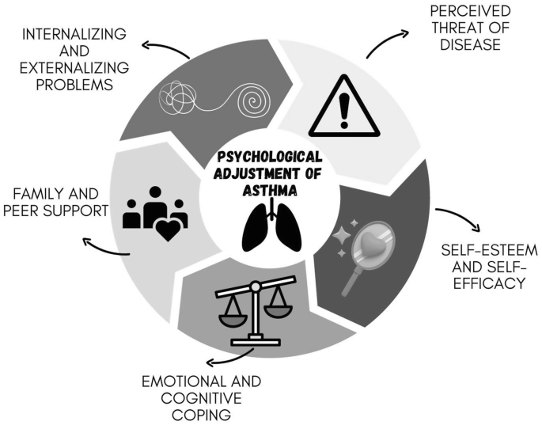
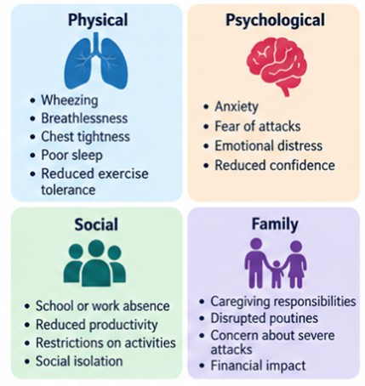

Physical impact
Asthma that is not controlled can lead to breathlessness, disrupted sleep, tiredness and limited physical activity. Severe exacerbations can mean hospitalisation and impact on daily functioning and quality of life (NICE, 2024).

Physical, Psychological and Social Impact of Asthma (Source: NICE, 2024)

Psychological Impact
Living with asthma can cause anxiety and emotional upset and lower confidence, especially if asthma symptoms are not stable. There can also be psychological struggles that can impact on treatment adherence and wellbeing (Asthma + Lung UK, 2025).

(Springer Nature, 2023)

Social Impact
Asthma can impact family finances, employment, social and school attendance. Parents might feel uncertain when their child is having a symptom at night or requires urgent care. Family member support for prescription collection, trigger for ID and emergency response. However, participation by family members must be based on consent and developmental appropriateness, especially for adolescents who desire more independence (Cavalcante et al., 2023). The apparently simple advice for self-management, can be undermined by structural disadvantages, such as having little space or living in wet conditions. Physical, psychological and social effects of asthma are related. The above challenges are highlighted by NICE (2024), Asthma + Lung UK (2025) and Cavalcante et al. (2023). However, clinical interventions are not sufficient to tackle broader socio-economic inequalities, and the need for holistic and integrated care is stressed (Centers for Disease Control and Prevention, 2023).

EVIDENCE-BASED NHS TREATMENT AND MONITORING

Diagnosis and assessment
Characteristic symptoms and objective confirmation are key to the 2024 joint guidance from NICE, BTS, and SIGN. Fractional Exhaled nitric oxide (Feno) at or above 50 parts per billion is suggestive of diagnosis in adults and at or above 35 parts per billion in children 5 to 16 years of age. There are two ways to show bronchodilator reversibility in adults: FEV1 improvement of at least 12% and 200 milliliters after bronchodilator use (after two weeks), or a peak-flow variability of at least 20% over two weeks (Chukwuka Elendu et al., 2025). These thresholds must be included in a diagnostic sequence and not as a standalone test.

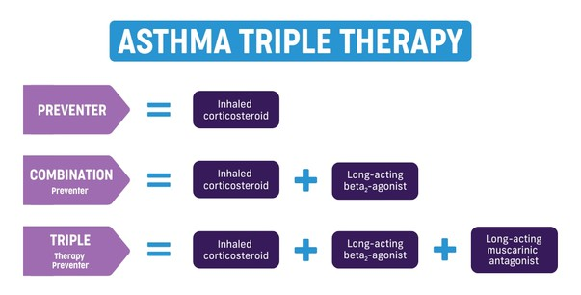
2025)
Single Inhaler Triple Therapy

(Springer Nature Asthma 2025)

Medication and Technique
Accoding to NICE, (2024), using a corticosteroid inhaler will help the underlying inflammation that causes asthma, whereas using a reliever alone will not. Age, severity, previous attacks and current guideline pathway will influence treatment selection (Dekhuijzen et al., 2022). Inhalers and devices used should be demonstrated and observed by healthcare professionals, and corrected at subsequent reviews. Exacerbations can be caused by instructions for inhaling that were incorrectly followed, poor adherence, problem with affordability or continued exposure to the medication (GINA 2025; NICE 2024).

Responding to deterioration
Impaired breathlessness, build-up of reliever usage, waking during the night and falling peak-flow levels should be assessed and evaluated promptly in relation to the individual written action plan. Severe symptoms, exhaustion, confusion or inability to speak normally require emergency medical attention (GINA, 2025). A plan should define escalation steps, emergency contact and follow up plans, and should not leave any room for ambiguity and confusion for families (NHS, 2024).

British Guideline on the Management of Asthma, 2019 (Source: Practice Nurse Journal, 2019)

House of Care Model: UK Application

Professional partnership
Then it's important that the clinician asks about concerns, shows an inhaler, and sets achievable targets and revisits decisions as the situation changes (Lee et al., 2024). Consideration should be given to the patient who might be concerned about adverse effects of steroids and may need to be discussed, not judged, as nonadherent. The role of pharmacists, nurses, GP's and specialist working together are essencial.

Overview
The House of Care sees effective LTC management as a partnership, based on clinical practice, organisational systems and commissioning arrangements. Four interdependent elements focus on the importance of individual behaviour not being detached from resources and relationships surrounding care (NHS England, 2025). When incorporated in asthma, the model moves a focus from prescription to prevention and responsiveness.

Person-centred collaborative care
Person centered care motivates asthmatics to actively manage their illness. It emphasises personalised asthma action plans, appropriate inhaler use, treatment preferences, and individual needs. This enhances people's quality of life, helps them control their symptoms, and helps them avoid asthma attacks (NHS, 2025).
The House of Care Model (Source: Alliance)

Informed and engaged people
Patients should be provided with information that is easy to understand, such as what asthma is, how it works, triggers and what to do when asthma begins to deteriorate, as well as their inhalers. Written action plans should be co-created and tailored to language and health literacy and age. According to the briefing report by Asthma and Lung UK, just 32% of the people surveyed with asthma received the three basics of care an annual review, check on inhaler technique and a written action plan (Global Initiative for Asthma, 2026).

Organisational and clinical processes
Agreed plans can become ongoing care with structured registers, recalls, regular post attack reviews and appropriate documentation. Assessment of control, exacerbations, inhaler technique and personalised action plan within 12 months of her review indicator is included in NICE's Higher Risk group for asthma (Marko and Pawliczak, 2025). The processes should facilitate and not prompt the superficial completion of administrative boxes (NICE, 2025) to support clinical judgement.

Commissioning and system support
Integrated care systems and commissioners have an impact on access to respiratory nurses, interpreters, diagnostic testing and community pharmacy services. Spending on preventive capacity can lead to a reduction in preventable acute demand, though budget restrictions can lead to the creation of short-term incentives that can have a negative impact on the maintenance of support (Monteiro et al., 2022). Equity and patient experience need to be a part of the outcome monitoring, along with activity volumes.

Chronic Care Model: International application

Model overview
The Chronic Care Model links together 6 elements which are organised health care systems, planned service delivery, clinical decision support, information systems, self-management support and community resources. This model is based on the core concept of engaged and educated conversations between patients and their medical teams (Muhammad et al., 2025). This was created over an extended period of time due to chronic diseases. however, it is still a helpful model to compare arrangements for asthma care internationally.

Chronic Care Model: A Framework for Managing Chronic Diseases

Health system organisation
The effective prevention of asthma requires a strong leadership, provision of resources and quality improvement in healthcare organisations. For instance, NHS services can put into place asthma care pathways, track emergency admissions and ensure access to respiratory specialists. Clinical audits can be carried out regularly to reveal any weaknesses in preventive treatment and can help enhance the safety of patients (NICE, 2024).

Delivery System Design
For asthma management to be effective, there should be clearly defined roles of professionals and planned follow up appointments. Treatment reviews and patient education should be coordinated by a GP, respiratory nurse, pharmacists and specialist team. For instance, patients who are having frequent exacerbations should have their inhaler technique, adherence to inhaler medicines and the effectiveness of their treatment reviewed in time (GINA, 2025).

Decision support
Evidence-based guidelines and individual patients should be considered when making clinical decisions. NICE (2024) guidance can be used by healthcare professionals to make a decision about symptom control, to prescribe the right anti-inflammatory treatment to review exacerbation risk. Shared decision making also helps patients to grasp treatment options and to become involved in the design of realistic treatment plans.

Self-management support
Educating patients about asthma triggers, inhaler technique, monitoring of symptoms, and what to do if their asthma gets worse. Having an asthma action plan (written) can help identify worsening symptoms early (Wagner et al., 2001). For instance, when teaching inhaler instruction to patients, respiratory nurses can model inhaler skills and employ a teach-back approach to ensure understanding. Frequent professional assistance boosts confidence and promotes adherence to treatment (GINA, 2025).

Clinical Information Systems
Monitoring and continuity of care is facilitated by Electronic health records, prescribing alerts and asthma registers. For instance, if a patient is prescribed with a reliever inhaler for a frequent pattern, or an annual review is missed or the patient has multiple emergency attendances, automated alerts can be set up to flag these (NHS England, 2021). Such systems can help healthcare professionals identify those who need further support, but there are issues of data protection and interoperability to consider (NICE, 2024).

Community Resources
Community services to work alongside clinical asthma management, focusing on environmental and social factors that impact health and wellbeing. Housing services can tackle dampness and mould exposure, schools can help children with an asthma action plan, and pharmacists can assist with inhaler technique assessments. Workers from the health care system working in collaboration with, schools, and community groups can help minimise obstacles (Clements et al., 2023).

Evaluation
The Chronic Care Model offers a comprehensive approach by integrating clinical care, self-management and community support. But, if it is to become a reality, it requires sufficient funding and capacity to use the system, as well as access to digital systems and the ability for systems to work together. Structured follow-up and patient education can enhance asthma management, but inequalities in housing, health literacy, and accessing healthcare may hinder effectiveness (Bosnic-Anticevich et al., 2023).

.

Local and National Political Health and Social Care Agendas

National Political Health, Social Care Agendas
The priorities outlined in national health and social care policies in England are focused on reducing inequalities in health, early diagnosis, integrated services and prevention. services and prevention. The NHS Long-term Plan, 2019 improves Asthma management by shifting towards personalised care, eco-friendly inhalers and the Blue to New approach. It also emphasises pediatric asthma bundles and self-management tools. Furthermore, The NHS Long term plan determines respiratory as one of the clinical priority areas (NHS, 2025). The National Institute for Health and Care Excellence (NICE, 2024) has recommended the following guidelines: asthma should be diagnosed objectively; clinical reviews should be carried out regularly; action plans should be tailored to the individual patient; and effective anti-inflammatory treatment should be used. Additionally, The NHS England's Core20PLUS5 agenda focuses on tackling inequalities in health service delivery for disadvantaged groups, such as children and young people with asthma (Brewster et al., 2024). These efforts help with earlier intervention and coordinated management, which may help decrease unnecessary exacerbations and hospital stays. However, inconsistent policy implementation may be hampered by workforce scarcity and financial constraints or if access to respiratory care services is unequal (Endalamaw et al., 2024).

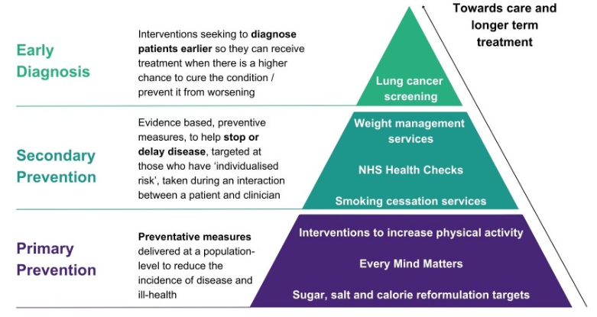

Definitions and examples of different types of preventative healthcare interventions (Source: GOV.UK, 2025)

Local Political Health and Social Care Agendas
Integrated Care Boards (ICBs) are responsible for local coordination of healthcare priorities, based on population need (Cherry, 2023). For instance, Greater Manchester Integrated Care Partnership encourages prevention, early disease identification, integrated neighbourhood services and reducing health inequalities (Greater Manchester Integrated Care Partnership, n.d.). These priorities help promote partnership between GP, respiratory nurse, community pharmacist, schools, housing services in the context of asthma. Local authorities can also respond to environmental factors such as damp and mouldy homes and air pollution. However, Trivedi et al, (2022) argues that social determinants of health in asthma through the life course in asthma outcomes can depend on local funding, capacity, and socioeconomic factors. However, appropriate implementation will necessitate some coordination, availability of community service and ongoing monitoring of patient results (Canino et al., 2009).

lo

Effectiveness of Digital Health Tools for Asthma Self-Management: A Systematic Review and Meta-Analysis of Clinical Trials (Source: MDPI)

Self-management, family support and end-of-life considerations

Supported self-management
Self-management involves a personalised written action plan, symptom recognition, the correct use of the inhaler planned review and having access to urgent support if needed. Evidence from the Khatoon et al., (2026) review backs regular professional contact, not one-off information provision. Treatment should be repeated and adapted whenever treatments, confidence or living situation changes. Digital reminders are effective for some patients, however, could be detrimental to other patients with poor connectivity or lack of digital skills (Wagner et al., 2001).

Family and carers
According to World Health Organisation, (2026) families can help increase understanding of the progressive nature of the disease and more effective scheduling of appointments, especially when dealing with children or vulnerable adults. Asthma can affect an individual's ability to participate in social activities, education, employment and community life. For example, a child may miss school because of symptoms or hospital appointments or psychologically a child may feel embarrassed to use their inhaler in front of peers in a sports lesson when needed. Families with an asthmatic parent may find it more difficult to handle childcare, domestic chores, or paid work due to symptoms.
However, family engagement might be beneficial. Supportive family members can assist identify triggers, promote medication adherence,Carers might require advice relating to the procedure for responding to the emergency and/or support and reassurance with respect to normal physical activity. However, privacy and individual choices must be respected and cannot be waived at the cost of relatives (Gavison, 2025).

End-of-life care
Asthma will typically be compatible with long, active life and palliative care cannot be seen as routine asthma management. Fatal exacerbations are rare, but it is important to remember the need for prevention and emergency readiness. If severe asthma is present in an individual's life-threatening illness, care needs may appropriately include discussions about breathlessness, emotional distress and end of life preferences and the type of medical and family support (Abramson et al., 2014).

Recommendations And Conclusion

Priorities for practice
Reliable diagnostic evaluation, access to anti-inflammatory treatment, technique evaluation, written plans of action and prompt review following attacks should be given priority. Organisations in the healthcare sector need to recognise if those prescribing relievers are doing so in excess, share information and monitor if disadvantaged groups are being treated equally for prevention (Zha et al., 2025). Shared decisions and considerate exploration of adherence barriers should be emphasised in professional training.

Concluding message
Aligned clinical care, individual circumstances and healthcare systems are required in order to prevent the occurrence of preventable attacks; asthma is a perfect example of the complexity of managing a long-term condition. This is because the available evidence indicates that there are many more people affected than WHO has recorded in the UK the figures for people with asthma who do not have good basic care are still high at 30% and globally the figure is 363 million World Health Organisation (2026).

References
Agache, I., Annesi-Maesano, I., Cecchi, L., Biagioni, B., Chung, K.F., Clot, B., D’Amato, G., Damialis, A., del Giacco, S., Dominguez-Ortega, J., Galàn, C., Gilles, S., Holgate, S., Jeebhay, M., Kazadzis, S., Nadeau, K., Papadopoulos, N., Quirce, S., Sastre, J., Tummon, F., Traidl-Hoffmann, C., Walusiak-Skorupa, J., Jutel, M. and Akdis, C.A. (2024a) 'EAACI guidelines on environmental science for allergy and asthma: The impact of short-term exposure to outdoor air pollutants on asthma-related outcomes and recommendations for mitigation measures', Allergy, 79(7), pp. 1656–1686. Available at: https://doi.org/10.1111/all.16103
Agache, I., Canelo-Aybar, C., Annesi-Maesano, I., Cecchi, L., Biagioni, B., Chung, F., D’Amato, G., Damialis, A., Del Giacco, S., De las Vecillas, L., Dominguez-Ortega, J., Galàn, C., Gilles, S., Giovannini, M., Holgate, S., Jeebhay, M., Nadeau, K., Papadopoulos, N., Quirce, S., Sastre, J., Traidl-Hoffmann, C., Walusiak-Skorupa, J., Sousa-Pinto, B., Salazar, J., Rodríguez-Tanta, L.Y., Cantero, Y., Montesinos-Guevara, C., Song, Y., Alvarado-Gamarra, G., Sola, I., Alonso-Coello, P., Nieto-Gutierrez, W., Jutel, M. and Akdis, C.A. (2024b) 'The impact of indoor pollution on asthma-related outcomes: A systematic review for the EAACI guidelines on environmental science for allergic diseases and asthma', Allergy, 79(7), pp. 1761–1788. Available at: https://doi.org/10.1111/all.16051
Agache, I., Canelo-Aybar, C., Annesi-Maesano, I., Cecchi, L., Rigau, D., Rodríguez-Tanta, L.Y., Nieto-Gutierrez, W., Song, Y., Cantero-Fortiz, Y., Roqué, M., Vasquez, J.C., Sola, I., Biagioni, B., Chung, F., D’Amato, G., Damialis, A., del Giacco, S., Vecillas, L. de, Dominguez-Ortega, J., Galàn, C., Gilles, S., Giovannini, M., Holgate, S., Jeebhay, M., Nadeau, K., Papadopoulos, N., Quirce, S., Sastre, J., Traidl-Hoffmann, C., Walusiak-Skorupa, J., Sousa-Pinto, B., Alonso-Coello, P., Salazar, J., Jutel, M. and Akdis, C.A. (2024c) 'The impact of outdoor pollution and extreme temperatures on asthma-related outcomes: A systematic review for the EAACI guidelines on environmental science for allergic diseases and asthma', Allergy, 79(7), pp. 1725–1760. Available at: https://doi.org/10.1111/all.16041
Agache, I., Ricci-Cabello, I., Canelo-Aybar, C., Annesi-Maesano, I., Cecchi, L., Biagioni, B., Chung, K.F., D’Amato, G., Damialis, A., del Giacco, S., De Las Vecillas, L., Dominguez-Ortega, J., Galán, C., Gilles, S., Giovannini, M., Holgate, S., Jeebhay, M., Nadeau, K., Papadopoulos, N., Quirce, S., Sastre, J., Traidl-Hoffmann, C., Walusiak-Skorupa, J., Salazar, J., Sousa-Pinto, B., Colom, M., Fiol-deRoque, M.A., Gorreto López, L., Malih, N., Moro, L., Pardo, M.G., Pazo, P.G., Campos, R.Z., Saletti-Cuesta, L., Akdis, M., Alonso-Coello, P., Jutel, M. and Akdis, C.A. (2024d) 'The impact of exposure to tobacco smoke and e-cigarettes on asthma-related outcomes: Systematic review informing the EAACI guidelines on environmental science for allergic diseases and asthma', Allergy, 79(9), pp. 2346–2365. Available at: https://doi.org/10.1111/all.16151
Almutairi, M., Marriott, J.F. and Mansur, A. (2023) 'Effect of monitoring adherence to regular inhaled corticosteroid (ICS) alone or in combination with a long-acting β2-agonist (LABA) using electronic methods on asthma outcomes: A narrative systematic review', BMJ Open, 13(8), e074127. Available at: https://doi.org/10.1136/bmjopen-2023-074127
Alyas, S., Hussain, R., Ababneh, B.F., Ong, S.C. and Babar, Z.-U.-D. (2024) 'Knowledge, perceptions, facilitators, and barriers towards asthma self-management among patients: A systematic review of the literature', Exploratory Research in Clinical and Social Pharmacy, 17, 100558. Available at: https://doi.org/10.1016/j.rcsop.2024.100558
Abramson, M.J., Perret, J.L., Dharmage, S.C., McDonald, V.M. and McDonald, C.F., (2014). Distinguishing adult-onset asthma from COPD: a review and a new approach. International journal of chronic obstructive pulmonary disease, pp.945-962.
ASAP (2021) Asthma - ASAP Illinois, ASAP Illinois. Available at: https://asapillinois.com/asthma/ (Accessed: October 15, 2026).
Asthma + Lung UK (2025) Life with a lung condition (2025). Available at: https://www.asthmaandlung.org.uk/blog/research/life-lung-condition-2025 (Accessed: 9 October 2026).
Brewster, L., Brennan, L., Hindocha, A., Lunn, J. and Isba, R., (2024). Understanding responsibility for health inequalities in children’s hospitals in England: a qualitative study with hospital staff. Bmj Open, 14(4), p.e081056.
Bosnic-Anticevich, S., Bakerly, N.D., Chrystyn, H., Hew, M. and van der Palen, J., (2023). Advancing digital solutions to overcome longstanding barriers in asthma and COPD management. Patient preference and adherence, pp.259-272.
Canino, P.G., McQuaid, P.E.L. and Rand, P.C.S., (2009). Addressing asthma health disparities: a multilevel challenge. Journal of allergy and clinical immunology, 123(6), pp.1209-1217.
Cavalcante, G., Xavier, D., Gomes, L., Ferri-Guerra, J. and Enrique, R. (2023) 'Effects of tezepelumab on quality of life of patients with moderate-to-severe, uncontrolled asthma: Systematic review and meta-analysis', Current Allergy and Asthma Reports, 23(6), pp. 287–298. Available at: https://doi.org/10.1007/s11882-023-01085-y
Centers for Disease Control and Prevention (2023) Asthma surveillance data. Available at: https://www.cdc.gov/asthma/asthmadata.htm (Accessed: 10 October 2026).
Cherry, L., (2023). Patients at the centre: integrating primary and community care.
Clements, J., Bowman, E., Tolhurst, R., Savage, M., Piwko, A., Chen, C., Lyons, E., Leung, N., Mulholland, S. and d'Ancona, G., (2023). The role of the clinical pharmacist in the respiratory or sleep multidisciplinary team. Breathe, 19(4), p.230123.
Dekhuijzen, P.N.R., Levy, M.L., Corrigan, C.J., Hadfield, R.M., Roche, N., Usmani, O.S., Barnes, P.J., Scullion, J.E., Lavorini, F., Corbetta, L., Kocks, J.W.H., Cosio, B.G., Buhl, R. and Pedersen, S.E. (2022) 'Is inhaler technique adequately assessed and reported in clinical trials of asthma and COPD therapy? A systematic review and suggested best practice checklist', The Journal of Allergy and Clinical Immunology: In Practice, 10(7). Available at: https://doi.org/10.1016/j.jaip.2022.03.013
Elendu, C., Amaechi, D.C., Elendu, T.C., Amaechi, E.C., Elendu, I.D., Joseph, M.C., Ajakaye, A.A., Ansong, S.O., Tyagi, V., Anukam, L.I. and Oguoma, C.O. (2025) 'Guideline-driven and dependable management of asthma: An evidence-based systematic review', Annals of Medicine and Surgery, 87(8), pp. 5153–5164. Available at: https://doi.org/10.1097/MS9.0000000000003491
Endalamaw, A., Khatri, R.B., Erku, D., Zewdie, A., Wolka, E., Nigatu, F. and Assefa, Y., (2024). Barriers and strategies for primary health care workforce development: synthesis of evidence. BMC primary care, 25(1), p.99.
Gajjar, D., Rough, E. and Burnett, H. (2025) World Asthma Day. House of Commons Library. Available at: https://commonslibrary.parliament.uk/research-briefings/cdp-2025-0104/ (Accessed: 10 October 2026).
Gavison, R., (2025). Information control: Availability and exclusion. In Public and private in social life (pp. 113-134). Routledge.
Global Initiative for Asthma (2025) Summary guide for asthma management and prevention for adults, adolescents and children 6–11 years. Available at: https://ginasthma.org/wp-content/uploads/2025/11/GINA-Summary-Guide-2025-WEB_FINAL-WMS.pdf (Accessed: 9 October 2026).
Global Initiative for Asthma (2026) Archived reports. Available at: https://ginasthma.org/archived-reports/ (Accessed: 10 October 2026).
Lee, S., Tian, D., He, R., Cragg, J.J., Carlsten, C., Giang, A., Gill, P.K., Johnson, K.M. and Brigham, E. (2024) 'Ambient air pollution exposure and adult asthma incidence: A systematic review and meta-analysis', The Lancet Planetary Health, 8(12), pp. e1065–e1078. Available at: https://doi.org/10.1016/S2542-5196(24)00279-1
Marko, M. and Pawliczak, R. (2025) 'Inhalation technique-related errors after education among asthma and COPD patients using different types of inhalers – systematic review and meta-analysis', npj Primary Care Respiratory Medicine, 35(1). Available at: https://doi.org/10.1038/s41533-025-00422-0
Monteiro, C., Maricoto, T., Prazeres, F., Simões, P.A. and Simões, J.A. (2022) 'Determining factors associated with inhaled therapy adherence on asthma and COPD: A systematic review and meta-analysis of the global literature', Respiratory Medicine, 191, 106724. Available at: https://doi.org/10.1016/j.rmed.2021.106724
Muhammad, Kaur, M., Teo, C.H., Sir, S., Siew, P., Selvaraj, C.S. and Ramdzan, S.N. (2025) 'Effectiveness of online asthma training programmes to improve asthma management among school staff: A systematic review using the Kirkpatrick evaluation model', npj Primary Care Respiratory Medicine, 35(1). Available at: https://doi.org/10.1038/s41533-025-00450-w
National Institute for Health and Care Excellence (2021a) Shared decision making (NG197). Available at: https://www.nice.org.uk/guidance/ng197 (Accessed: 10 October 2026).
National Institute for Health and Care Excellence (2021b) Tobacco: Preventing uptake, promoting quitting and treating dependence (NG209). Available at: https://www.nice.org.uk/guidance/ng209 (Accessed: 10 October 2026).
National Institute for Health and Care Excellence (2023) Asthma (QS25). Available at: https://www.nice.org.uk/guidance/qs25 (Accessed: 10 October 2026).
National Institute for Health and Care Excellence (2024) Asthma: Diagnosis, monitoring and chronic asthma management (BTS, NICE, SIGN) (NG245). Available at: https://www.nice.org.uk/guidance/ng245 (Accessed: 9 October 2026).
National Institute for Health and Care Excellence (2025) Medicines optimisation: The safe and effective use of medicines to enable the best possible outcomes (NG5). Available at: https://www.nice.org.uk/guidance/ng5 (Accessed: 10 October 2026).
National Institute for Health and Care Excellence (2026) Air pollution: Outdoor air quality and health (NG70). Available at: https://www.nice.org.uk/guidance/ng70 (Accessed: 10 October 2026).
NHS England (2019) Universal personalised care: Implementing the comprehensive model. Available at: https://www.england.nhs.uk/publication/universal-personalised-care-implementing-the-comprehensive-model/ (Accessed: 9 October 2026).
NHS England (2014) Asthma Available at: https://www.nhs.uk/conditions/asthma/ (Accessed: 9 October 2026).
NHS England (2025) Respiratory disease. Available at: https://www.england.nhs.uk/ourwork/clinical-policy/respiratory-disease/ (Accessed: 10 October 2026).
Ober, C. and Yao, T.C., (2011). The genetics of asthma and allergic disease: a 21st century perspective. Immunological reviews, 242(1), pp.10-30.

Office for National Statistics (2022) Ethnic group, England and Wales: Census 2021 Available at: https://www.ons.gov.uk/peoplepopulationandcommunity/culturalidentity/ethnicity/bulletins/ethnicgroupenglandandwales/census2021 (Accessed: 10 October 2026).
Pearce, C.J., Chan, A.H.Y., Jackson, T., Fleming, L., Foot, H., Bush, A. and Horne, R. (2022) 'Features of successful interventions to improve adherence to inhaled corticosteroids in children with asthma: A narrative systematic review', Pediatric Pulmonology, 57(4), pp. 822–847. Available at: https://doi.org/10.1002/ppul.25838
Silvestro, O., Ricciardi, L., Catalano, A., Vicario, C.M., Tomaiuolo, F., Pioggia, G., Squadrito, G., Schwarz, P., Gangemi, S. and Martino, G. (2023) 'Alexithymia and asthma: A systematic review', Frontiers in Psychology, 14, 1221648. Available at: https://doi.org/10.3389/fpsyg.2023.1221648
Trivedi, M., Pappalardo, A.A., Udoko, M., Garg, A., Phipatanakul, W., Szefler, S.J. and Nyenhuis, S.M., (2022). Social determinants of health in asthma through the life course. The Journal of Allergy and Clinical Immunology: In Practice, 10(4), pp.953-961.
Tyris, J., Keller, S. and Parikh, K. (2021) 'Social risk interventions and health care utilisation for pediatric asthma', JAMA Pediatrics, 176(2), e215103. Available at: https://doi.org/10.1001/jamapediatrics.2021.5103
Vaz, B.L., Marrinhas, D. and Pereira, A. (2025) 'Biologic therapies and quality of life in pediatric patients with asthma: A systematic review', Healthcare, 13(22), 2824. Available at: https://doi.org/10.3390/healthcare13222824
Vos, R. de, Hicks, A., Lomax, M., Mackenzie, H., Fox, L., Brown, T. and Chauhan, A. (2023) 'A systematic review of methods of scoring inhaler technique', Respiratory Medicine, 219, 107430. Available at: https://doi.org/10.1016/j.rmed.2023.107430
Wagner, E.H., Austin, B.T., Davis, C., Hindmarsh, M., Schaefer, J. and Bonomi, A. (2001) 'Improving chronic illness care: Translating evidence into action', Health Affairs, 20(6), pp. 64–78. Available at: https://doi.org/10.1377/hlthaff.20.6.64
World Health Organisation (2026) Asthma. Available at: https://www.who.int/news-room/fact-sheets/detail/asthma (Accessed: 9 October 2026).
Zha, Z., Zhang, Y., Tian, C., Huang, D., Shen, T. and Wang, S. (2025) 'The effect of exercise on asthma in children: A systematic review and meta-analysis of randomized controlled trials', Current Allergy and Asthma Reports, 25(1). Available at: https://doi.org/10.1007/s11882-025-01219-4

