Mathis Villa (2501611)

cyber security

Table of Contents
Introduction 2
Identification of Modern Threats 2
Modern Security Policies 3
Technical Mitigation Measures 5
Proactive Monitoring and Incident Response 6
Continuous Training and Awareness 7
Conclusion 8
Sources 9

Introduction
In recent times, Vigilant Trust & Asset Management has been hit by a significant number of cyber security attacks that have negatively impacted not only workers and staff, but also our clients. These cyber security attacks have ranged from phishing to an attempted ransomware. This series of events has shown how vulnerable we are, and also how increasingly complex these threats are to deal with and mitigate. In response, new policies based on the principles of Zero Trust will be implemented to mitigate these attacks. The main concept of Zero Trust is to never trust and always verify information, where companies now enforce strict access controls, strong authentication protocols, and ongoing monitoring of all user systems [1]. This report will therefore outline the potential cyber-attacks and propose an updated security policy that aligns with the industry standards. We will also identify strategies to mitigate them and present a proactive monitoring and training approach with reference from leading authorities including NIST, CISA, and ENISA.

Identification of Modern Threats
In the past, threats were traditionally carried out through direct hacking, where only highly experienced individuals were able to cause harm to organisations or even individuals. These attacks were often conducted using malicious coding, which limited who was able to carry out these threats. However, in today’s world, cyber threats have evolved significantly, becoming increasingly accessible due to the commercialisation of attack tools.
It is important to also take into account that cyber-attacks can now be external. Even individuals with limited knowledge can now carry out large scale attacks using platforms such as Ransomware-as-a-Service (RaaS). RaaS has been one of the most damaging external threats where 20% of all cyberattacks have been conducted using this technique [2]. This new tool has become a scalable industry where individuals can now work in organised groups to target specific people or organisations, increasing both the frequency of attacks and impacts it has on people. These attacks put light on the accessibility of these modern cybercrime tools, where multiple threats can now be carried out.
Another growing issue is AI-powered social engineering, which includes phishing and vishing attacks. Attackers can now create convincing emails and even generate fake voice messages impersonating individuals. These attacks are particularly dangerous as they are highly believable. For example, in one reported case, an individual in France transferred a substantial amount of money to an attacker after being deceived by an AI-generated voice impersonation [3]. This example highlights the vulnerability of individuals online who have little awareness of such scams. In addition to that, public environments with unsecured WiFi, and weak passwords are increasingly targeted by attackers as it is a simple way of getting people’s private information.
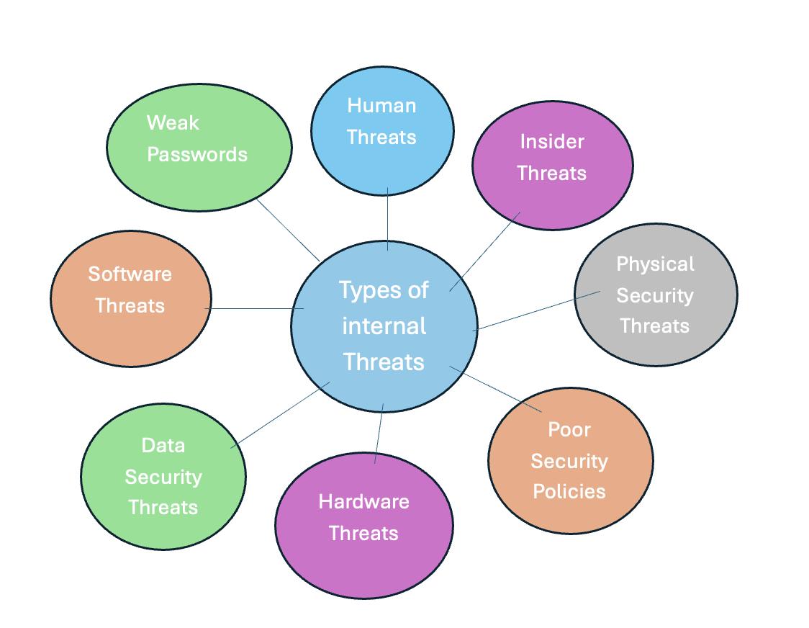
Figure 2 shows different types of internal threats
On the other hand, internal threats are still a critical concern. These include errors made by employees as well as malicious insiders. Internal threats often come from excessive access to systems, weak passwords, and fake applications that mimic the legitimate ones as seen in Figure 2 [4]. Without proper control, these risks can lead to large data breaches and can also make external attacks easier. Internal threats are harder to monitor as it is hard to decipher whether the user is authorised or not.

Modern Security Policies

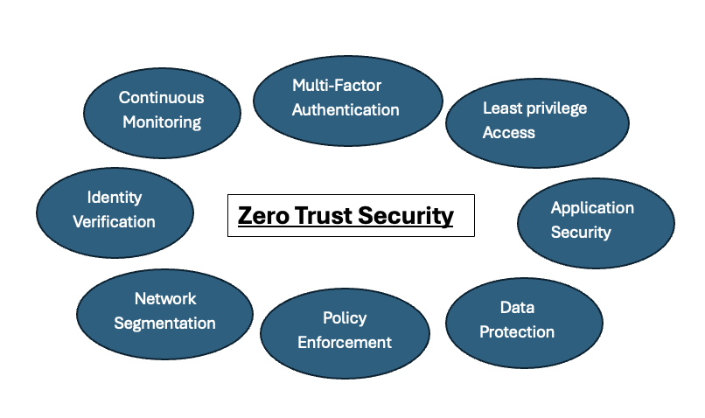
Figure 3 shows the Zero trust security model
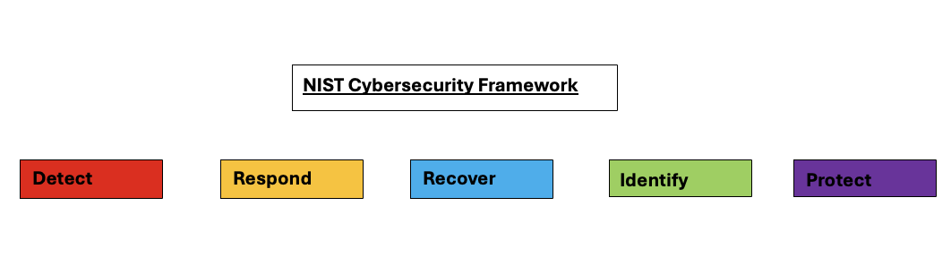
Figure 4 shows the NIST Cybersecurity Framework
To address these issues, Vigilant Trust & Asset Management will need to update its existing policies and align them with a new, secure framework based on Zero Trust principles (see Figure 3), as well as other frameworks such as the NIST Cybersecurity Framework (see Figure 4) and ISO 27001. The new policy will enforce strict user access control, ensuring that all users only have access to resources relevant to their role. Multi-factor authentication (MFA), for example through Microsoft Access, will be mandatory for all employees, particularly those with administrative privileges.
The use of external devices will no longer be authorised. Instead, company issued devices with limited access will be provided. All devices will be equipped with endpoint detection and response (EDR) systems, which will detect and respond to malware and threats in real time. Devices will also be regularly updated to make sure they have the latest security patches and antivirus protection [5]. In addition, some breaches occur due to third-party involvement. In the past, contracts were signed without the consideration of cyber security requirements. In the future, all contracts with clients and external organisations will include strict security requirements. Regular monitoring will also be conducted to assess whether third-party systems pose any risk.

Technical Mitigation Measures

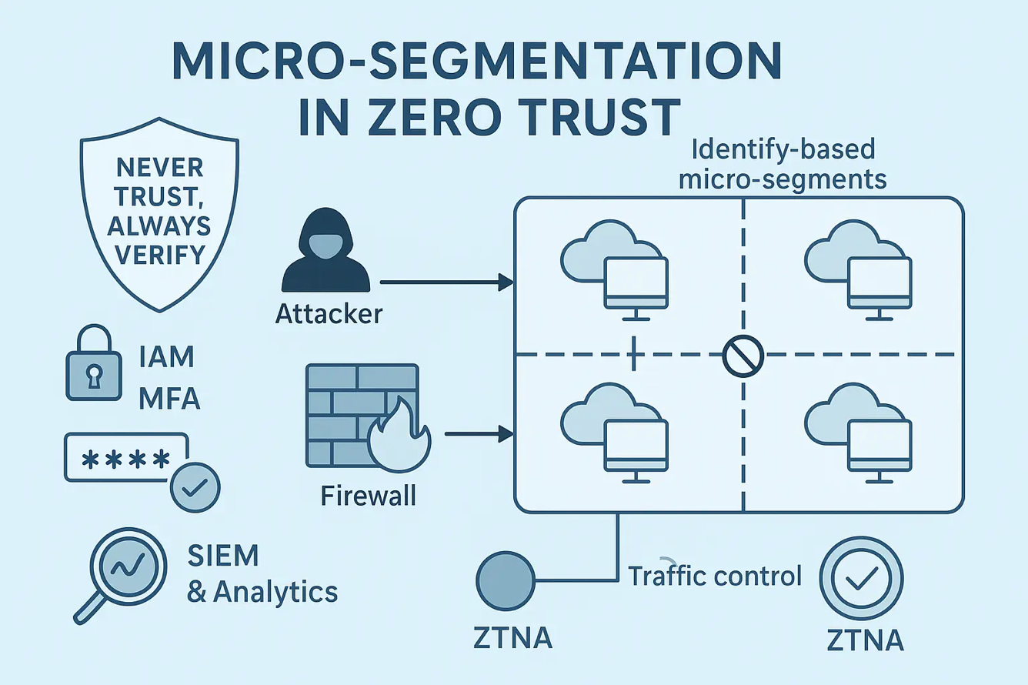
Figure 5 shows Micro-Segmentation architecture
In the 21st century, hackers have also increasingly targeted networks. In response, traditional network perimeters will be replaced with newer and safer technology known as micro-segmentation as seen in Figure 5. This ensures that if a hacker gains access to one part of the network, they cannot move easily across it. All network traffic will also be monitored. Access to certain websites will also be restricted to prevent exposure to malicious content.
To implement these policies, a range of administrative controls will be introduced. As mentioned, multi-factor authentication will be implemented across all systems, and a single sign-on (SSO) solution will improve usability. In addition, privileged access management (PAM) will be used, making sure that administrative access requires proper authorisation. PAM access will give the desired user temporary access, and all activity will be recorded, reducing the risk of attacks and unauthorised changes, also known as virtual private networks [6]. VPNs will be installed on all machines to provide a secure connection. This will help protect system IP addresses and reduce the risk of tracking and certain types of attacks. Furthermore, automated regular backups will be put in place, including offline backups, to eliminate the risk of data loss from ransomware attacks. These backups will also be tested regularly to ensure reliability

Proactive Monitoring and Incident Response

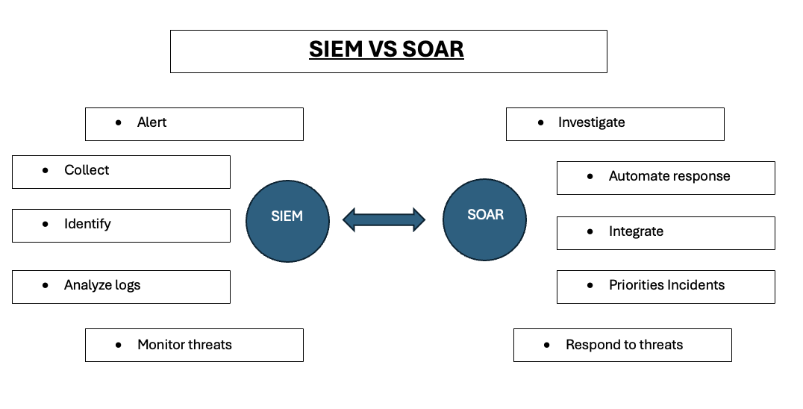
Figure 6 shows Siem and Soard incident response

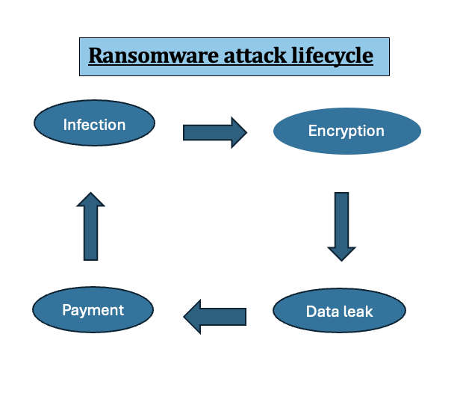

Figure 7 shows ransomware attack life cycle
A proactive approach to monitoring incident response is essential for maintaining security. As a result, the organisation will establish a 24/7 Security Operations Centre (SOC), which will continuously monitor systems and respond to incidents. In addition, this will be supported by a SIEM (Security Information and Event Management) that will collect and analyse the data, and finally an automation response (SOAR) system be automate responses to threats as seen in Figure 6. The incident response will follow a specific structure which includes: detection, triage, investigation, containment, eradication, recovery and learn from mistakes (see Figure 7) [7] . This will ensure that all incidents are handled correctly. In addition, threats like misconfigured cloud systems can also pose a big issue if breached. To mitigate this, a cloud security posture management can be set in place to monitor cloud risk.

Continuous Training and Awareness

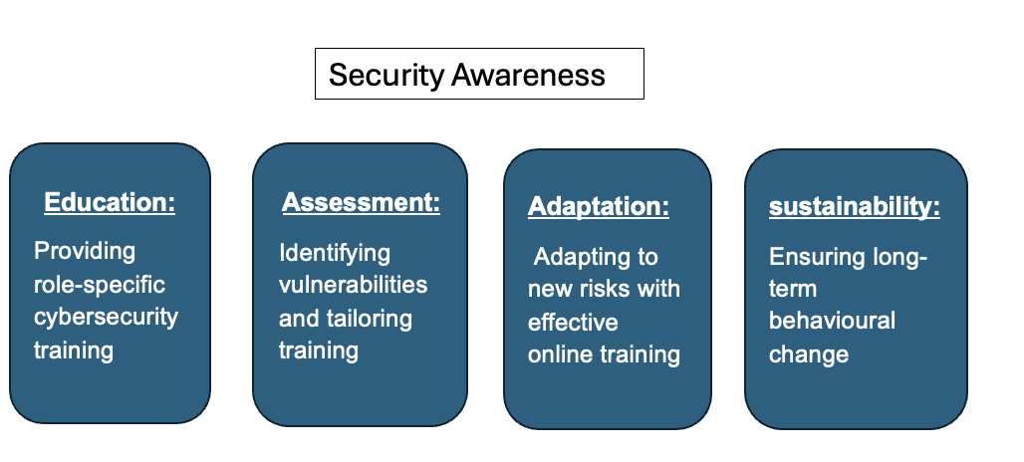
Figure 8 shows security awareness cycle
While implementing new systems is important, one of the leading causes of security breaches is human error. Although it is not possible to eliminate this entirely, continuous training programmes will be introduced to raise awareness among employees. For example, regular phishing simulation exercises can be conducted to assess employee knowledge. If an employee falls for a simulated attack, such as a fake email, they will receive additional training and immediate feedback, and the necessary steps found in the security awareness cycle (see Figure 8 ) will be implemented.
Furthermore, with the rise of AI, employees will also be trained to recognise deepfake voice attacks, known as vishing. These exercises will simulate suspicious requests and real world scenarios. Training will also be tailored to specific roles within the organisation; for example, finance staff will receive specialised training on fraud prevention. To measure progress, metrics such as phishing click rates and incident reporting rates will be monitored. These insights will be used to continuously improve the training programme over time.

Conclusion
To conclude, implementing a Zero Trust security framework will significantly improve protection against cyber-attacks at Vigilant Trust & Asset Management. By focusing on security, introducing new technical controls, training employees, and improving their security awareness, these changes will significantly reduce the company’s risk of cyber-attacks and data exposure.
In addition, the adoption of recognised frameworks such as NIST, CISA, and ENISA will help mitigate threats such as ransomware, deepfake videos, and targeted attacks. With a team in place to continuously monitor systems, respond to incidents, and train employees, the organisation will experience fewer attacks and improved staff awareness of cyber risks.
As a result, company assets will be better protected, helping to maintain client trust and potentially attract new clients, as the organisation will meet modern online safety and security requirements.

Appendix

PowerPoint Presentation:

https://uowtsd-my.sharepoint.com/:p:/r/personal/2501611_student_uwtsd_ac_uk/Documents/cybersecurity%20v2.pptx?d=w08b1f06a72154a298b48ee02fddbd130&csf=1&web=1&e=HqEc7M

Cisco packet tracer course:

Sources

[1] Microsoft, “Zero Trust overview,” Microsoft Learn, Feb. 27, 2025. [Online]. Available: https://learn.microsoft.com/en-us/security/zero-trust/zero-trust-overview

[2] IBM, “What is ransomware-as-a-service (RaaS)?,” IBM Think, [Online]. Available: https://www.ibm.com/think/topics/ransomware-as-a-service

[3] BBC News, “French woman scammed out of €830,000 by fake Brad Pitt,” BBC News, Jan. 2025. [Online]. Available: https://www.bbc.co.uk/news/articles/ckgnz8rw1xgo

[4] IBM, “X-Force 2025 Threat Intelligence Index,” IBM Reports, 2025. [Online]. Available: https://www.ibm.com/reports/threat-intelligence

[5] Bitdefender, “GravityZone Extended Detection and Response (XDR),” Bitdefender Business, [Online]. Available: https://www.bitdefender.com/en-gb/business/products/gravityzone-xdr

[6] National Cyber Security Centre, “Use privileged access management,” NCSC, Sept. 15, 2020. [Online]. Available: https://www.ncsc.gov.uk/collection/secure-system-administration/use-privileged-access-management

[7] Microsoft, “What is a security operations center (SOC)?,” Microsoft Security, [Online]. Available: https://www.microsoft.com/en-gb/security/business/security-101/what-is-a-security-operations-center-soc
Figure 5 – Netwise Technologies, “Micro-segmentation Zero Trust: Complete Guide 2026,” Netwise Technologies, Sept. 22, 2025. [Online]. Available: https://netwisetech.ae/micro-segmentation-zero-trust

