Process Engineering Practice Assignment 2: Operation of processes.

Task 1 (LO4)
For this task you are required to describe process equipment operation and an awareness of physical hazards present at a facility.

You could demonstrate your ability by describing a key item of process equipment at your facility. For example:
- Column,
- Compressor,
- Turbine,
- Pump,
- Heat exchanger.

Your report should include the following detail for the equipment chosen;
The technology and theory associated with the equipment.
- The principle of operation of the equipment in service.
- The conditions that could lead to failure for the chosen equipment including process, physical, mechanical and operational abnormalities and hazards. For example:

- Pressure,
- Temperature,
- Flow,
- Contamination,
- Vibration,
- Deterioration mechanisms and indication of deterioration,
- Abnormal combustion conditions and operational conditions.

- You should also include details on the framework in place to eliminate the risk posed by the hazards identified through application of the HSE framework present.
Task 1
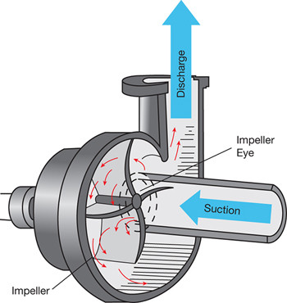
A pump is one of the most common piece of process equipment you could find at a refinery, its primary use is to increase flow of a fluid passing through it, this is achieved by having a driver to produce rotational energy for the shaft of the pump, attached to this shaft is a set of impellers which come into contact with the process fluid and increase it’s velocity and pressure and as the fluid is released from the higher pressure of the pump housing it produces a flow. There are many types of pumps available for different applications, I will explain the working principle of a centrifugal pump, see below (Figure 1) is a simple illustration of a centrifugal pump with directional arrows showing the flow of a fluid as it would pass through the equipment during normal operation, the low pressure side of the pump is known as the suction and the high pressure side is known as the discharge, the impeller is coupled to a driver (usually either an electrical motor or steam turbine) and is spun at high rpm to produce great centrifugal force that displaces fluid within the pump, this displacement draws more fluid through the suction if the suction pressure can overcome the any forces acting on the process fluid such as gravity if the pump is located geographically above what it is taking fluid from, such as a storage tank or process vessel. One example of the application of this pump are the crude feed pumps, these provide the motive force for crude feedstock to be moved through the CDU into various heat exchangers, the crude desalters, fired heaters and into the main fractional distillation column, it is vital that these pumps are in the best working order at all time to ensure the flow of feed into the CDU remains constant so that the process can be controlled to ensure the most amount of product can be processed safely.
A pump can fail for a variety of reasons one being an overpressure, if for instance the pump’s discharge line is pinched in meaning reduced flow is being allowed to pass through it will cause an increase in pressure as the flow is being reduced if this effect is serious enough the pressure on the discharge pipework and the internal of the pump it could lead to a mechanical failure of the pump casing and seals or at weak points along the pipework such as areas with wear or at pipe flanges, this occurring in reality is unlikely as pressure relief systems are always installed on pump discharge lines and these safety valve would lift and relieve pressure well before a mechanical failure would occur.
A thermal failure could occur when a pump is being run with improper lubrication to key internal parts such as the shaft bearings and seals, if these are left with no lubrication the pump will fail within hours. Another simple failure mode would be if the pump’s manufacturers guideline value for operating temperature was exceeded for an extended period of time which would accelerate wear and lead to a failure, this could occur if the process fluid’s temperature increased due to an altered process and now is a higher temperature than the pump can effectively operate with.
A lack of flow for a pump would cause a failure by the process of cavitation, this is when air pockets are formed from the fluid being pumped as a result of dry running or dead heading the discharge of the pump, this is when the discharge line is constricted to reduce flow, the cavitation is the pitting of the inside of the pump casing and the impeller causing damage and would lead to debris being trapped within the pump and causing further damage and eventual failure.
Excessive vibrations are another potential failure mode, excessibe vibrations can occure when mechanical parts within the pump begin to wear over time and become out of tolerance and need to be replaced if they are not the vibration will become continually worse and will lead to failure, another way excessive vibration can occur is during installation if the pump is not bolted to the plinth correctly it will leave gaps between the base of the pump and the plinth it is mounted on this will lead to more vibrations as there will be unrestricted movement in the pump this will allow for potential for the alignment of the pump and the driver to become askew which would cause excessive wear on bearings and other internal parts of both the driver and the pumps internal parts.
If a change in process fluid is made for a pump it is vital that the pump is made of the correct materials to be able to operate normally with any new potential chemical changes to the fluid for example a gasoline product pump is in normal operation however the chemical makeup of the gasoline has been changed due to an unknown error in the process and the gasoline now has acid carryover from a faulty process, if this standard gasoline pump is left in this service it is certain that the inside of the pump will be corroded at a much higher rate than it would be expected normally, this could if not spotted lead to an unexpected failure and cause a stop to the process so that the pump could be repaired or replaced.
The HSE has many safety systems that must be installed on various equipment types in all types of service for pumps for example it is required to have a safety pressure relief system in place on the discharge side of the pump to be online at all times, this is to eliminate the risk of an overpressure to occur and for a pipeline or pump to seriously fail as the PSV would lift to alleviate pressure and send it to either atmosphere if the fluid was harmless to life and the environment such as clean water or steam, or to the flare header which leads to the flare which will burn any emitted substance at a safe location away from the process units. The HSE also has limits on safe working pressures for pumps in specified services and so a mitigation idea for dealing with overpressure is a safety trip, this will turn off the affected equipment and remotely shut or open valves for the pressure build up to be halted or reduced.

Task 2 LO3
You are required to demonstrate a knowledge and understanding of the units that make up an industrial process. With this in mind, you should include a description of the main process units at your facility. You should consider the chemical and physical transformation processes occurring in at least one unit at your facility.

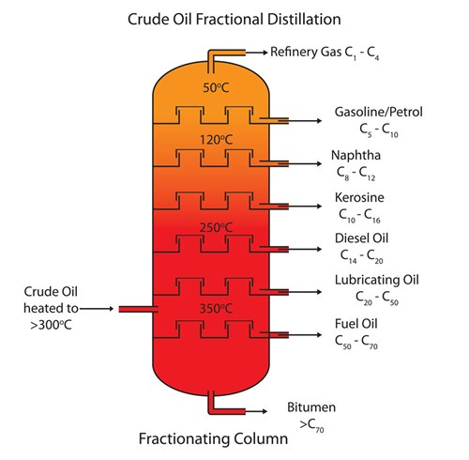
CDU, The Crude Distillation Unit is first unit that crude feed is processed in, the crude is blended into a feedstock to ensure the proportions of each component hydrocarbon are what is required for the refinery to meet production quotas and provide enough product for subsequent processes to be able to take place and full rate. In the CDU before the blended crude feedstock enters any vessel to be separated it must first be brought up to temperature by making several passes through fired heaters to ensure that correct separation can occur and a level is not built up within the vessel, the vessel being a distillation column, this vessel has several side draw offs at various levels up the vessel which correspond with the temperature each product condenses at, this separates these products into forms that they can then be taken forward into further processing. The process of fractional distilliation is a physical transformation process that occurs due to the varying boiling points of each hydrocarbon within the crude oil feed mixture, the process allows for a basic separation of the products into groups based on their boiling points, (see Figure 2 below) this process will however cause some carryover from heavier molecules into lighter molecules’ side drawers, to reduce this as much as possible reflux circuits are used to recycle feed into the column, this also helps to keep the column within the right temperature range without requiring too much heating of the feed before entering the column.
VDU, Vacuum Distillation Unit is another unit that specialises in making useful, valuable products from less valuable products, the unit does this by taking a blended fuel oil which mainly consists of crude residual oil that remained at the bottom of the crude column, this product is very viscus and has an extremely high boiling point, so high that it cannot be cost effectively processed by the crude column, however the Vacuum column is held at a negative pressure to greatly reduce the boiling point of any fluid within it, this allows for further processing of the residual oil into useful and valuable components such as kerosene and diesels, that otherwise would have been sold as blended fuel oil. However still not all products can be processed and the chemically heaviest product settles to the bottom of the vacuum distillation column and is taken away as “Vac Resid”.
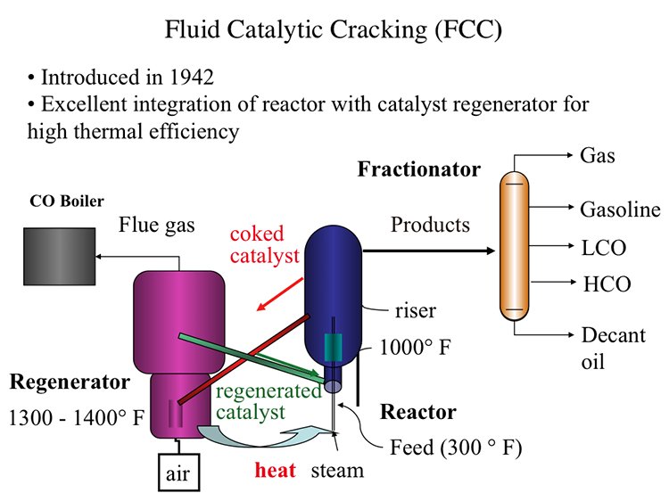
FCCU, the Fluid Catalytic Cracking Unit is another vital processing unit to give value to the industrial process, this unit utilises a chemical reaction with the introduction of oxygen and a catalyst to further process very chemically heavy and unreactive products to get “cracked” products ranging from propane and butane to diesels and naptha. One of the most important products that is created from the FCCU is isobutane which is recover from the overhead vapours of the fractionator in the FCCU, this isobutane is a vital feedstock for the alkylation unit to produce alkylate which has a very high octane and greatly improves quality of blended gasoline.
The FCCU is an example of a process unit that changes the chemical profile of its feed product to produce products of a higher value and usability, (see Figure 3above) the FCCU unit uses heat, steam and a catalyst to alter the chemical profile of its feed to produce useful products, the hot feed meets with steam in the riser along with catalyst, here a reaction takes place which removes carbon atoms from the feed and deposits them onto the surface of the catalyst causing them to become “coked” this spent catalyst is separated from the product stream by use of cyclones to sperate the heavier catalyst from the product, where it goes onto the regenerator to be reused in the reaction again. The products are then sent to a fractional distillation tower which separates them into fractions through side drawers much like the crude column, however these products have been cracked meaning their chemical structure is changed one example of this the product isobutane, which is an isomer of butane, meaning it is physically the same C4H10 compound but it’s chemical structure is changed and has given the product a different set of properties. Benzene and other aromatics are also produced during this process which are high octane gasoline components that can improve the quality of a gasoline blend.

References/Bibliography
Figure 1: Pump principles and image: https://www.esru.strath.ac.uk/EandE/Web_sites/19-20/Offshore%20H2/projects/hydrogen-production-mechanism/auxiliary-systems/index.html
Pump Failure Modes: https://www.jeepumps.com/understanding-pump-failure-causes-symptoms-and-mitigation/
HSE Pump Guidelines: https://www.hse.gov.uk/comah/sragtech/systems11.htm
Figure 2: Fractional Distillation Fundamentals: https://www.philipharris.co.uk/blogs/experiments/fractional-distillation-of-petroleum-experiment
Figure 3: FCCU fundamentals: https://www.e-education.psu.edu/fsc432/content/fluid-catalytic-cracking-fcc

