Electronics Assignment
Curtis Rees
Student number - 2003711

Introduction
This report will showcase an AC response of an RLC network, more specifically it will be a true LR-C parallel circuit with an alternating current supply. The capacitor within this circuit acts as a power correcting capacitor and in this report the before and after power factor corrections will be shown. Proteus will be used for the construction of the circuit, while giving current and voltage readings, as well as showcasing the power factor graphs. Additionally, how the power factor affects both the voltage current and maximum power transfer will be in the contents of this report.

The main objective of this report is to showcase power factor and the use of a capacitor to ‘power correct’. A high power factor indicates that the electrical system is using energy efficiently, which can result in lower electricity bills and a reduced environmental impact. A poor power factor leads to an increase in the current flow, which in turn causes the voltage drop in the conductor to be increased. For example low voltage can cause serious damage to electrical components and electric motors, so in machinery its vital that the voltage doesn’t drop due to a poor power factor. Power factor correction will reduce the voltage drop at the conductor, thereby increasing the voltage at the equipment. As a result, equipment runs more efficiently, it’s safer, and you experience fewer maintenance problems.
Before power factor correction
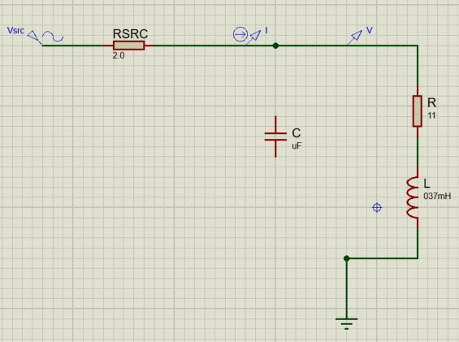

Figure 1

Figure 1 is the circuit that was constructed in proteus. As you can see it’s an LR-C parallel circuit however, the capacitor is not yet connected as the power factor is not yet known. Before calculating the power factor correction capacitor value and incorporating it into the circuit, a graph will be made showing the waveform of both the voltage and the current in circuit, from where the voltage and current probes are placed which will showcase the phase difference before power factor correction.
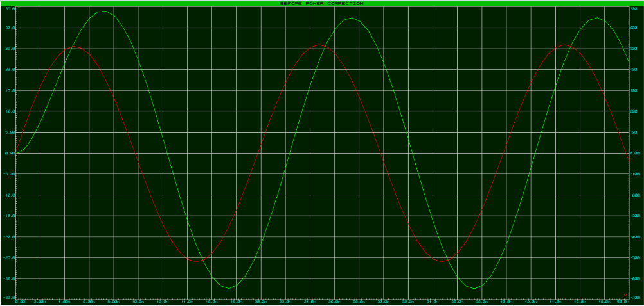
Figure 2

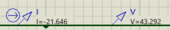
Figure 2 shows the phase difference before the power factor correction has been applied. The red line on the graph identifies the voltage and the green line identifies the current. It shows that the voltage is not in phase with the current, meaning the power factor is not equal to or above 0.95, which is what was expected as the power factor correcting capacitor has not yet been calculated or applied to the circuit as previously shown.

Figure 3

Another interesting point is that, as figure 3 shows, the voltage is peaking at around 44v and the current is peaking at 22A. With the purpose of power factor correction being to reduce current and in return reduce voltage therefore, making it more efficient. Also the measurements of both voltage and current will be taken after the applied power factor correction.

After power factor correction
Next is to calculate the active power, which is the result of resistive components, along with reactive power, which is the result of capacitive/inductive components and finally the apparent power which is both these powers combined. Once I have done those calculations I will calculate the power factor and choose an appropriate capacitor value to correct the power factor of the load to more than or equal to 0.95.
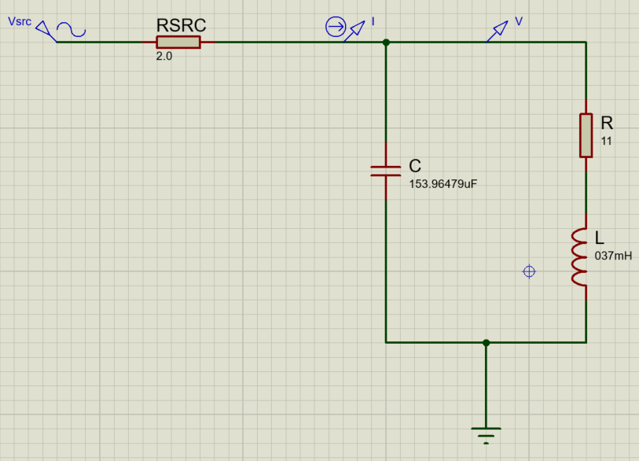

Figure 4

Figure 4 shows the circuit that was constructed on proteus now with the power factor correction connected in parallel with a value of 154uF. Later in the report will be the working out and calculations used to calculate this value.

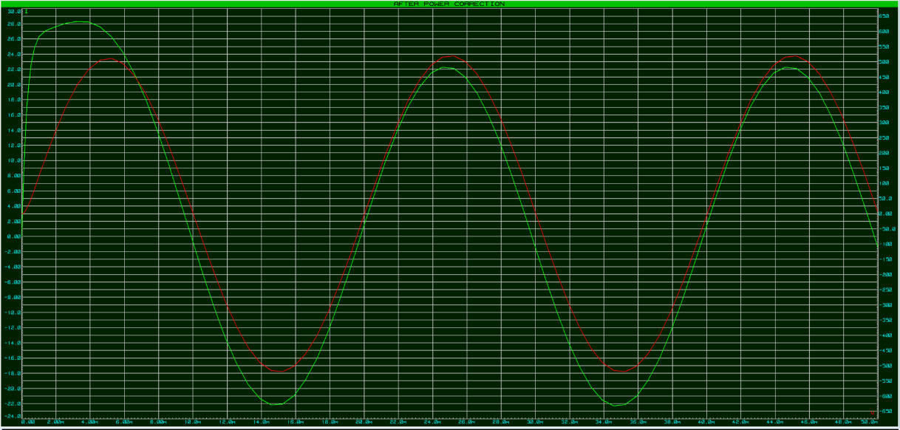

Figure 7

Figure 7 shows the phase difference after power factor correction is applied. Similarly to figure 2, red line shows the voltage waveform and the green line shows the current waveform. Its now clear that the voltage and current are now in phase with each other. The value of the power correcting capacitor I used corrected the power factor to 0.95 which is why on the graph if inspected it shows that’s its slightly out of phase.
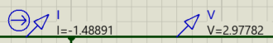

Figure 8

Figure 8 now shows the current and voltage within the circuit after the power factor correcting capacitor is connected in parallel. In comparison to figure 3, showing the voltage and current before the power factor correction, its clear that after the values of both the current and voltage is a lot lower. This is what would be expected as the purpose is to make the circuit more efficient.

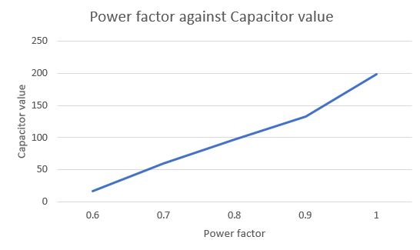

Figure 5
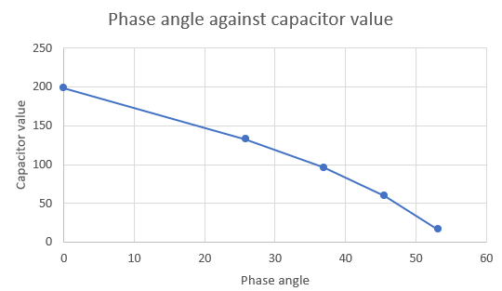

Figure 6

Figure 5 and 6 are the graphs which show power factor against capacitor value and the phase angle against capacitor value. Although the results calculated in figure 4 went below a power factor of 0.5, I did not showcase this the graphs. By having a power factor below 0.5 it means the load is inductive and therefore shouldn’t be plotted on a graph showing capacitor value. The phase angle between voltage and current in an AC circuit is inversely proportional to the capacitance. Basically, as the capacitance increases of the capacitor, then the phase angle between voltage and current decreases.

Energy stored in the capacitor and inductor at power factors close to 1
At power factors close to 1, the energy stored in the capacitor and in the inductor is continuously exchanged between the two components. This means that the energy stored in the capacitor and inductor is being transferred back and forth between them, resulting in a continuous oscillation of energy. This oscillation of energy results in a reactive power flow that does not contribute to useful work. Therefore, a low power factor means that a significant amount of the supplied energy is not being used efficiently.
Finding current in my circuit
I = V/Z Z = $\sqrt{R^{2}+{XL}^{2}}$

Find XL
XL=2$πFL$ =2 x $π$ x 50 x 0.037 = 11.6238Ω

So ‘Z’ then equals Z = $\sqrt{{(11)}^{2}+{(11.6238)}^{2}}$ = 16.0035Ω

Sub ‘Z’ in I
Z= $\frac{565.7}{16.0035}$ = 35.3485 A

Power consumed
P= V I cos θ
P= 565.7 x 35.3 cos θ
Θ = $\tan^{-1}(\frac{XL}{R})$ $\tan^{-1}(\frac{11.623}{11})$ = 46.577 degrees

Active power
P = V I cos θ Vrms = $\frac{1}{ \sqrt{2}}$ x Vpk
=400 x 22.91 cos(46.57) =$\frac{1}{ \sqrt{2}}$ x 565.7 = 400 V
P= 6299.96watts Irms = $\frac{Im}{ \sqrt{2}}$
=6.3KW =$\frac{2.4}{ \sqrt{2}}$ = 22.91A

Reactive power
Q = V I sin θ
=400 x 22.91A sin (46.57)
=6655.03watts
=6.7 VAR

Apparent power
S = V I
Apparent power S = $\sqrt{{(Active power)}^{2}+{(Reactive power)}^{2}}$
= 9164VA

Power Factor
Power factor = $\frac{Active power}{ Apparent power}$
=0.687468 BEFORE POWER FACTOR CORRECTION

Calculate new phase angle
Θ = $\cos^{-1}$ Power factor
New Power factor = cos θ= 0.95
$\cos^{-1}$ (0.95) ≈ 18.19487 degrees

Calculate new reactive power
New reactive power = Real power x tan θ
Real power = P = $I^{2} R$
= ${35.3485}^{2}$ x 11
=13744.68 watts
New reactive power = 13744.68 x tan(18.19487)
=4517.65VAR

Calculate change in reactive power =
S = V I
565.7 x 35.3485 = 19996.64
=19996-4517.65 = 15478.996VAR

Calculate capacitive reactance needed for this change in reactive power
Q = $\frac{{|V|}^{2}}{ X}$
X = $\frac{{|V|}^{2}}{ Q}$ = $\frac{{565.7}^{2}}{ 15478.996}$ = 20.6742… =20.67Ω (cap)

Calculate required capacitor value
XC = $\frac{1}{ 2πFC}$ C = $\frac{1}{ 2πFX}$

C = $\frac{1}{2π x 50HZ x 20.6742}$
=1.5396479 x ${10}^{-4}$ F
=0.00015396479 F
=153.96479 µF

Resonant Frequency
Fr = $\frac{1}{ 2π} x \sqrt{\frac{1}{ LC}- \frac{R^{2}}{ L^{2}}}$
Fr = $\frac{1}{ 2π} x \sqrt{\frac{1}{ {0.037x10x154}^{-6}}- \frac{{11}^{2}}{ {0.037}^{2}}}$
Resonant Frequency = 46.974Hz

Reactance of the inductor
XL = 2 π F L =2 π x 46.974 x 0.037 = 10.92Ω

Reactance of capacitor
XC = $\frac{1}{2π F C}$ = $\frac{1}{2π x 46.974HZ x 154x10-6}$ = 22.00Ω

Resonant frequency occurs when the inductance and capacitance in the circuit are balanced, resulting in minimum impedance and maximum current flow. We determine the resonant frequency from the values of the inductance and capacitance within the circuit.

phasor diagrams showing the component voltages and current for the circuit in task 1
This report now shows the phasor diagrams showing the component voltages and currents for the circuit in task 1 at different frequencies. Phasor diagrams are graphical representations of the phase relationship between voltage and current in an AC circuit. In a resonance circuit you would expect to see the voltage and current in phase. As you can see from the resonance phasor diagram, the current and voltage and both in phase. The calculations along with the phasor diagrams are shown below for the resonance frequency, 25Hz above resonant frequency, 25Hz below resonant frequency and finally at 50Hz.

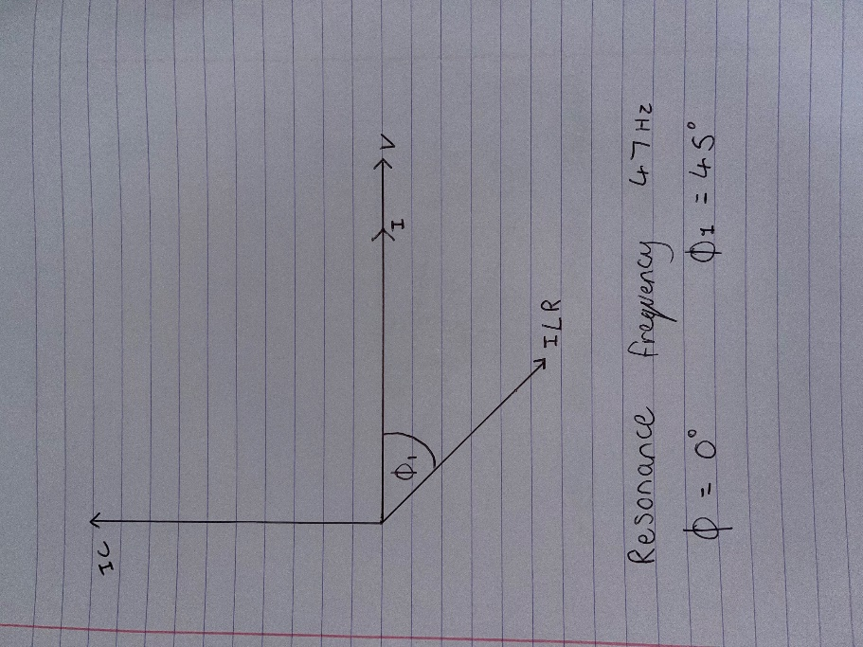
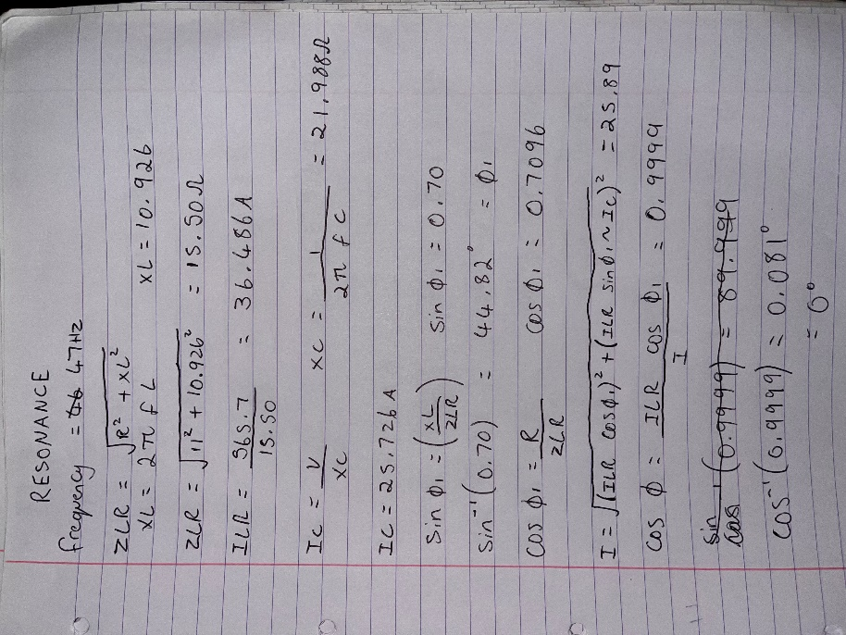

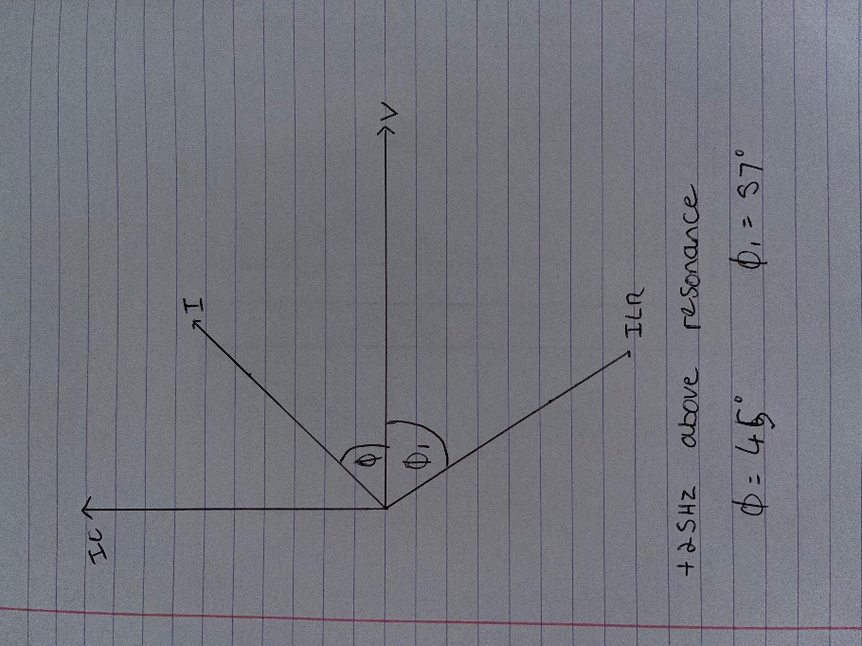
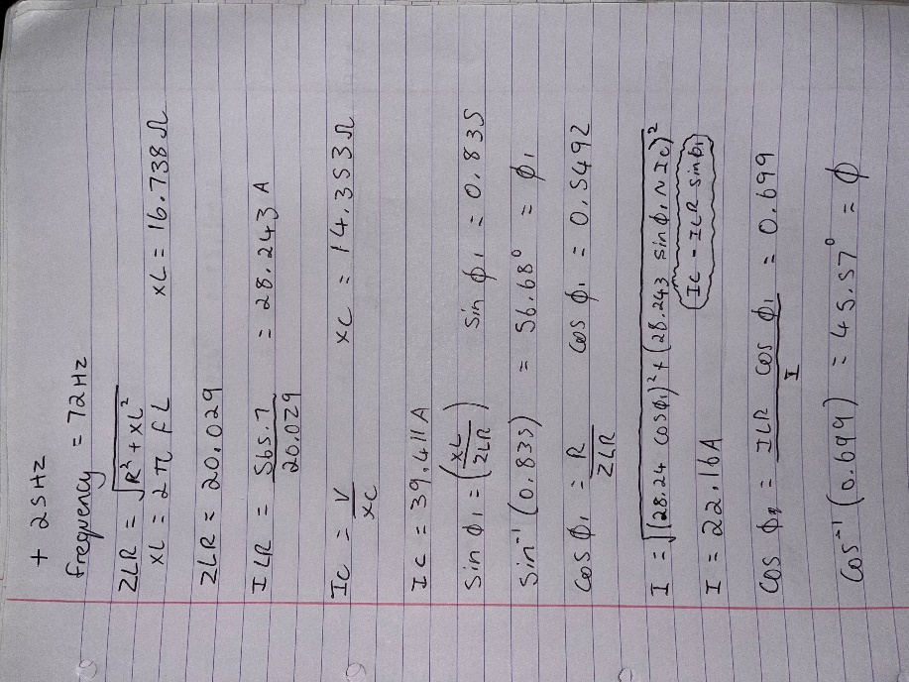

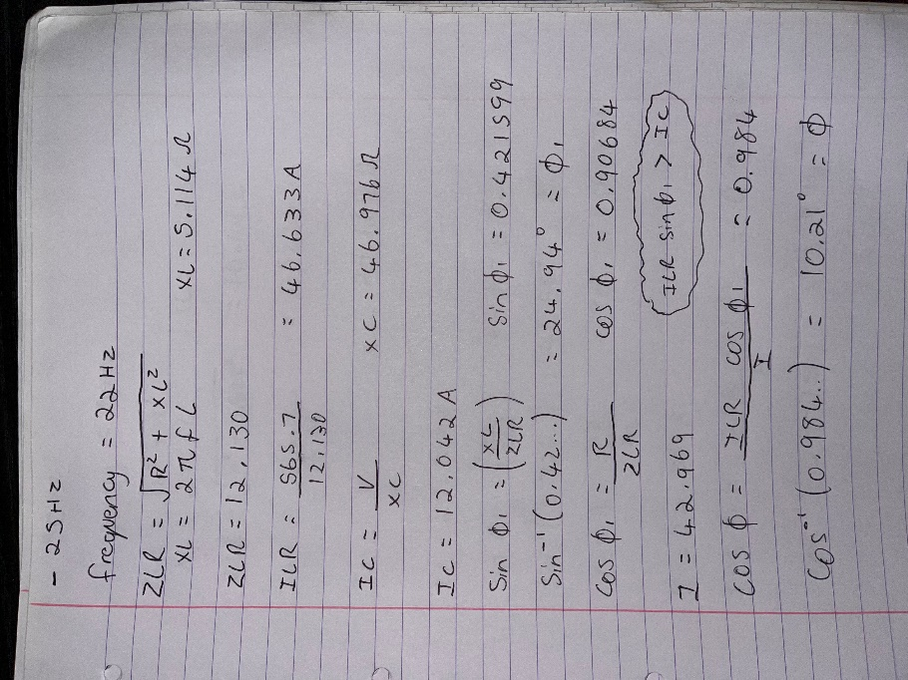
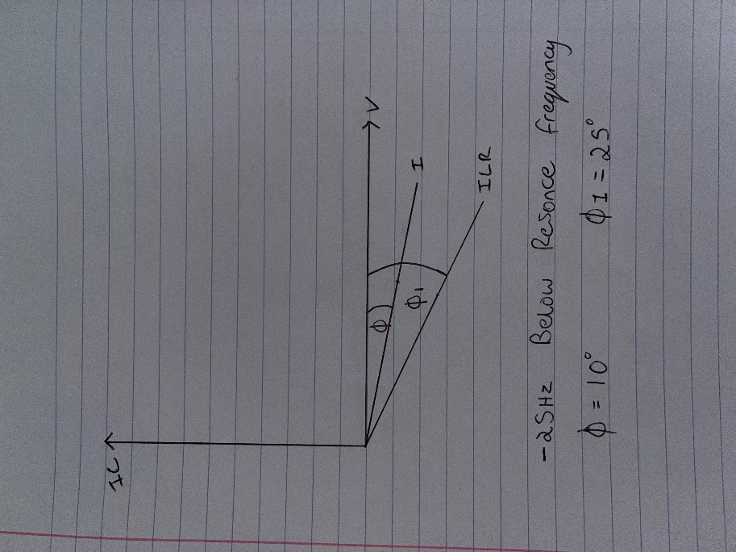

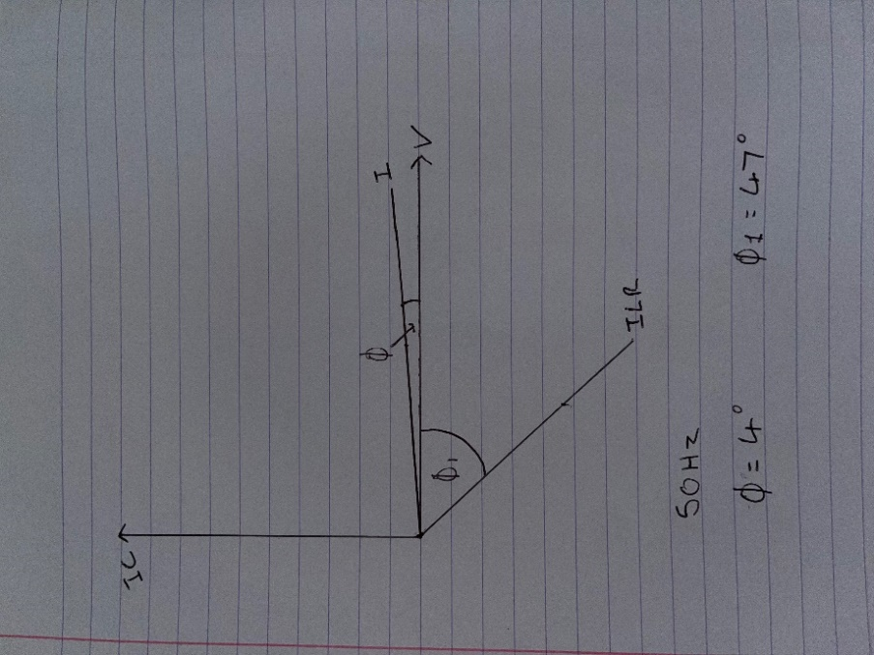
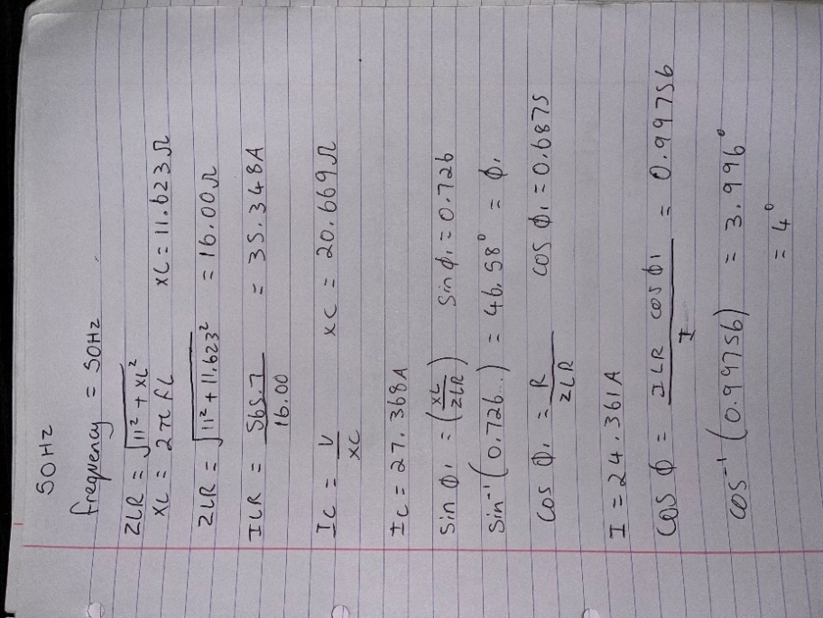

How power factor relates to resonance and maximum power transfer
In task 1, a suitable capacitor value was calculated and used to correct the original power factor to a new power factor of 0.95. Active power generation directly affects the frequency and the reactive power generation directly affects the voltage. Active power is a result of resistive components, reactive power being the result of capacitive/inductive components and apparent power the combination of both the real power as well as the reactive power. If active power generation increases so does the frequency, according to the ratio, therefore the power factor increases. That is the ratio between power factor and frequency.
When resonance occurs in the circuit, the result is extremely high voltage and current flowing at the resonant frequency. The use of power factor correction capacitors is to act as a low impedance device to the resonant currents. By having the power factor 0.95 or greater is means the capacitor is larger and therefore ‘absorbing’ more of the resonant currents. While reducing current it does not reduce voltage meaning the voltage can stay at the same value which only bringing down the current.

Maximum power theorem states that the maximum power that can be transferred from source to load is 50%, this occurs when the source impedance is matched with the load impedance. By having a high power factor it directly affects the maximum power transfer by allowing greater power to be transferred. Basically having a low power factor will decrease the maximum power transfer and having a high power factor will increase the maximum power transfer. Maximum power is achieved when the power factor is 1. In other words, maximum power transfer occurs at the unity power factor, that being when the reactive (useless) power is zero.

Conclusion
In conclusion this report shows the importance of power factor correction and why it is used in electronic circuits. Making the circuit more efficient and use less power is beneficial in many ways such as, reducing electricity costs, saving the planet and ensuring parts don’t overheat and cause damage to machinery etc. Additionally, phasor diagrams are very important as they allow you to work out many different things such as the relative phase angle between the different components as well as the magnitude and phase of the voltage and current for each component.

