
MSc Public Health and Social Care in Practice
Module Code and Title: Practice-Based Research (LCHS7008)
Lecturer’s Name: Muhammed Khan

A Systematic Review of Factors Influencing Disease Management and Health Outcomes Among Adults with Type 1 Diabetes in The UK

Student Name: Kashyapkumar Jaiminkumar Kansara
Student Number: 2505251

Table of Contents
1. Prevalence and Public Health Burden in the UK 3
2. Introduction and Literature-Based Background to the Study 3
Inequalities and Management Challenges 4
Literature-Based Background 5
Disease Management Approaches 5
Quality of Life & Psychosocial Impact 6
Health Inequalities 6
Policy Context (UK)NICE guidelines 7
3. Rationale & Research Question/Aims 7
Rationale 7
Research Question 8
Aim 8
Objectives 8
4. Research Methodology 9
5. Research Design 10
6. Recruitment, Sampling & Study Participants 10
7. Data Collection Method 11
8. Data Analysis Technique 11
9. Ethical Considerations 12
10. Implications of Research 12
11. Plan of Work and Time Schedule 13
References 15

1. Prevalence and Public Health Burden in the UK
The UK has over 400,000 Type 1 Diabetes with a prevalence rate that is rising year after year making it a significant public health problem in the country. Gregory et al., (2021) national audits reveal that the percentage of adults who attain the suggested HbA1c goals is less than 30% which means that the population lacks glycaemic control. The monetary price is enormous, and complications linked with diabetes impose approximately 10% of the total NHS expenditure, a significant portion of which is linked to unnecessary readmission to hospitals. It has severe complications such as cardiovascular disease, kidney failure, diabetic ketoacidosis (DKA), and vision impairment that contribute to morbidity and mortality (Boden et al., 2022).
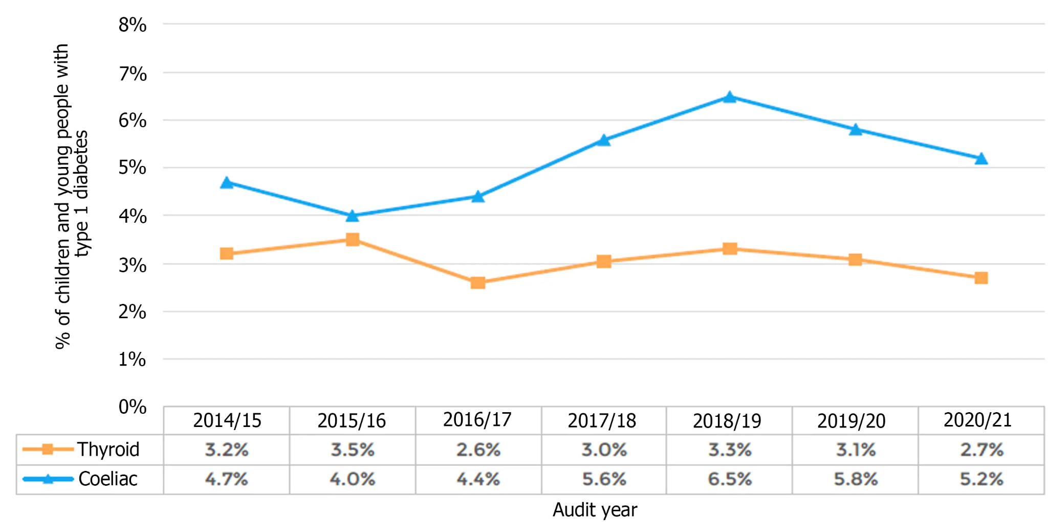
Figure 1: Trend of T1D prevalence in the UK (last 10 years)
(Source: Sze May Ng and Soni, 2023)

2. Introduction and Literature-Based Background to the Study
Type 1 Diabetes (T1D) is defined as an insulin production that is small or absent and which has to be managed in the long-term by insulin therapy and monitoring (Quattrin et al., 2023). This state is coupled with complicated daily self-management behaviours, such as blood glucose control, dietary, and physical activity, which play a significant role in health outcomes (Shiel et al., 2023). It is shown that poor self-management can lead to an increased risk of serious complications and worse quality of life in the long term (Farooqi et al., 2022).
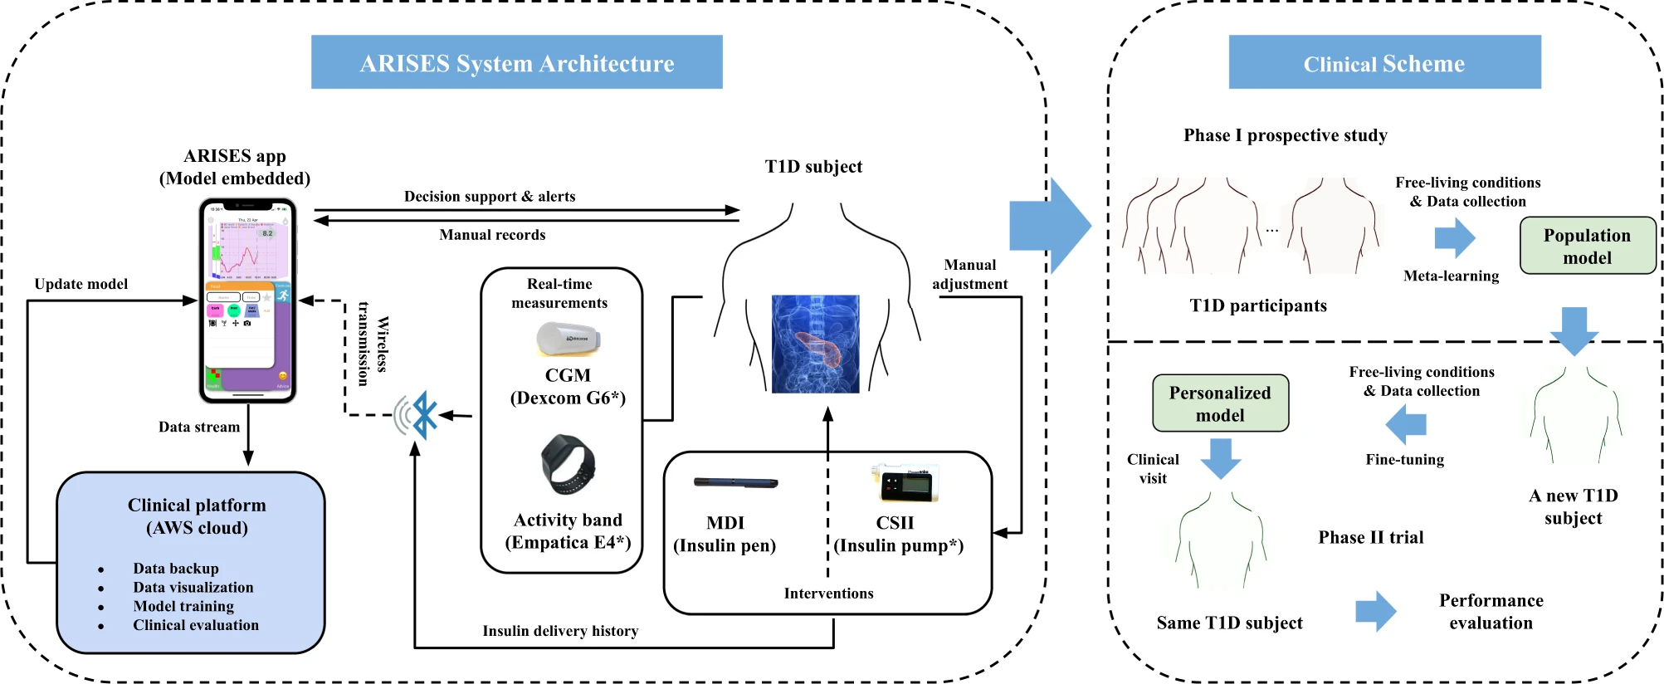
Figure 2: Daily Self-Management Components in T1D (Monitoring, Insulin, Diet, Activity)
(Source: Zhu et al., 2022)

Inequalities and Management Challenges
Socioeconomic and structural inequalities are impacting the health outcomes of T1D, access to care, education, and improved technologies like continuous glucose monitoring (Song and Lee, 2021). People with a deprived background have a higher probability of poor glycaemic control and hospitalisation, which is a manifestation of inequality in access to healthcare and support. Even with improvements in therapy and policy models, there are still major disparities between clinical guidelines and clinical outcomes, which means that there are still issues with managing the disease in practice (Chan et al., 2021).
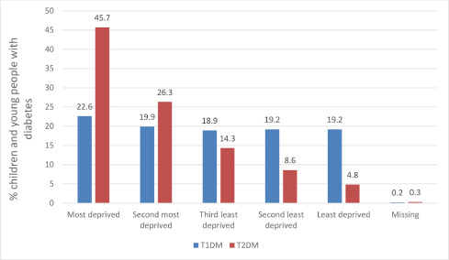
Figure 3: Percentage of Children and Young People with T1DM and T2DM
(Source: Catherine, Russell and Peter, 2021)

Literature-Based Background

Disease Management Approaches
The management of disease in Type 1 Diabetes is mainly based on insulin therapy that instrumental in the maintenance of glycaemic control and the prevention of acute complications (Chiavaroli et al., 2021). New technologies like Continuous Glucose Monitoring (CGM) are demonstrated to raise the HbA1c levels by about 0.5-1.0% and decrease the number of hypoglycaemic events with real-time glucose measurements (Jacob et al., 2022). Self-management education programmes are recognized as the crucial things in achieving patient compliance, decision-making, and long-term outcomes with the assistance of digital health interventions (Xiong et al., 2023).
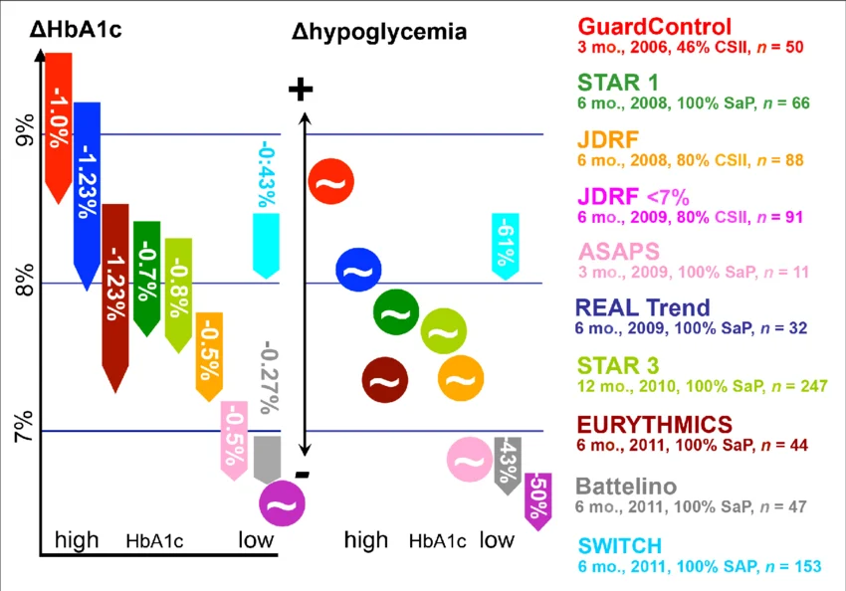
Figure 4: HbA1c Reduction
(Source: Liebl et al., 2013)

Quality of Life & Psychosocial Impact
There is a significant psychosocial load of Type 1 Diabetes, as patients have to endure unceasing stress connected with glucose levels, insulin intake, and fear of complications (Farooqi et al., 2022). The burnout and anxiety related to diabetes have adverse effects on adherence to treatment, resulting in worse glycaemic control and poorer quality of life (Regeer et al., 2022). The emotional burden and social constraints among adults with the condition are also increased by lifestyle restrictions, such as dietary control and physical activity management (Bennett et al., 2022).
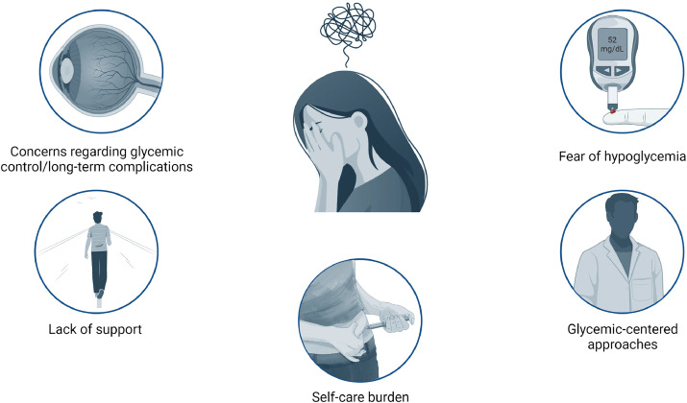
Figure 5: Main Factors Associated with Type 1 Diabetes-Related Distress
(Source: Rodríguez-Muñoz et al., 2024)

Health Inequalities
The socioeconomic status has a considerable impact on healthcare resource availability, and individuals in deprived regions have a higher hospitalisation rate and worse glycaemic outcomes (Song and Lee, 2021). The disadvantaged population does not gain from modern treatment because access to the updated technologies, such as CGM and insulin pumps, is uneven (Alessy et al., 2022). Ethnic and social inequalities also add to the lack of equality in health, and marginalised groups are more likely to be blocked in education, support, and access to healthcare (Hinneh et al., 2024).
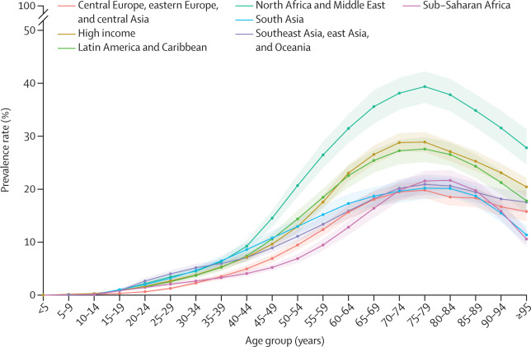
Figure 6: Prevalence of Total Diabetes by Age and GBD Super-Region in 2021
(Source: Ong K et al., 2023)

Policy Context (UK)NICE guidelines
The healthcare policies in the UK, such as NICE guidelines and the NHS Long Term Plan, facilitate the systematic management of diabetes and the wider use of digital technologies to enhance outcomes. Patient-centred care and integrated services are highlighted in policy frameworks to decrease long-term costs and complications (Laforgia et al., 2024). Nevertheless, even with these improvements, there is a visible paradox, with the advancement of technologies enhancing clinical outcomes, but the disparity in access to technologies continues to increase health discrepancies between various groups of people (Eberle and Stichling, 2021).

3. Rationale & Research Question/Aims

Rationale
This study is necessitated by the growing epidemic of Type 1 Diabetes in the UK, with more than 400,000 already affected, and the prevalence increasing yearly. According to Gregory et al., (2021) improved treatment and care pathways, less than 30% of adults is reach recommended HbA1c levels, which shows that there are still gaps in effective disease management Healthcare policies facilitate the use of modern technologies, like continuous glucose monitoring that can decrease the level of HbA1c by about 0.5-1.0% but access is not even among socioeconomic groups (Chan et al., 2021). The current studies continue to be disjointed, with clinical studies concentrating on biomedical results, whereas behavioural and social studies is independently discussing patient experiences and inequalities (Shiel et al., 2023). This dissection is restricting the knowledge of the combined effect of clinical, psychological, and socioeconomic factors on the actual disease management.
Moreover, no systematic reviews, based in the UK, exist that combine these areas into one analytical framework. In the absence of this integration, the healthcare strategies might not be effective in dealing with underlying inequalities and inefficiencies in service delivery. Thus, quality studies are necessary to critically synthesise to have a comprehensive picture of the problem. This gap is covered by this study through synthesising evidence on the factors that affect the disease management and health outcomes in adults with Type 1 Diabetes in the UK.

Research Question
What factors influence successful disease management and improved health outcomes among adults living with Type 1 Diabetes in the UK?

Aim
The aim of this study is to critically examine the key clinical, behavioural, and socio-economic factors that influence successful disease management and improved health outcomes among adults with Type 1 Diabetes in the UK.

Objectives
- To analyse the influence of socioeconomic status and health inequalities on access to healthcare services and disease outcomes among adults with Type 1 Diabetes in the UK.
- To determine the major issues affecting adults with Type 1 Diabetes in their management within the UK setting.
- To evaluate the effectiveness of existing treatment methods and support services to adults living with Type 1 Diabetes within the UK healthcare system.
- To assess the physical, psychological and social consequences of Type 1 Diabetes in adults in the UK and measures taken to control the condition.

4. Research Methodology
The study takes a secondary research design, which is based on the existing academic and clinical literature on the management of Type 1 Diabetes in UK, in order to provide a thorough and evidence based study. To explore patterns, meanings and experiences of disease management, a qualitative research strategy is implemented to provide an in-depth understanding of behavioural, social and clinical factors.
The research adheres to inductive approach, where themes and insights are created based on the data, but not on a priori hypotheses, which is appropriate in synthesizing various types of evidence. The study is based on an interpretivist philosophical approach that focuses on the lived experiences, behaviours of the patients and the social environment that can affect disease management outcomes. The method allows comprehending intricate interactions between health care systems, personal behaviours and socioeconomic factors outside of the quantitative measures.
It employs a descriptive research design, which entails a systemic process of summarising and interpreting the available evidence to give a systematic overview of the current practices, challenges and outcomes. The research involves analysis about 20-30 peer-reviewed journal articles and this gives it adequate depth and helps in thematic saturation in qualitative research. Key academic databases such as PubMed, Scopus, Google Scholar and ScienceDirect are also used to collect data, which provide access to a wide variety of high-quality sources.

5. Research Design
The study used a descriptive research design to explore patterns, trends, and correlations in the available literature on Type 1 Diabetes management in the UK in a systematic way. The design is useful in determining prevalent themes based on clinical outcomes, behavioural practices and socioeconomic factors, in order to come up with a systematic interpretation of the disease management. It enables the examination of the most important variables, including the level of HbA1c, complication rates, and access to healthcare services, and these levels are different among various population groups.
The descriptive design is considered to be adequate when one is working on a systematic literature review since it allows synthesizing the findings on the basis of selected works. It allows to organise and summarise a considerable amount of evidence, and helps to discover common patterns and gaps in the literature. The level of clarity in the development of relationship between management strategies and health outcomes is also increased through this method and findings are comprehensive and analytically meaningful.
The systematic literature review with thematic synthesis best fits a phenomenological orientation as the literature review aims to analyse the lived experiences of adults with Type 1 Diabetes and their perception and management of the condition on their daily life. The reason why phenomenology is appropriate is that it aims to examine subjective meaning, especially in regards to self-management, emotional burden, and adherence to treatment, as opposed to causal relationships (van Manen, 2016). Phenomenological focus on perception and lived reality is relevant in this study as the patient experiences of glucose monitoring, insulin use, and lifestyle adaptation are central themes. Unlike grounded theory, which aims to generate a new theory, or ethnography, which focuses on cultural immersion within a specific group, phenomenology prioritises experiential understanding across contexts, making it suitable for synthesising diverse UK-based studies. According to Neubauer, Witkop and Varpio (2019), phenomenological approaches are effective in healthcare research for capturing the depth of chronic illness experiences and interpreting meaning across multiple qualitative sources.

6. Recruitment, Sampling & Study Participants
No direct recruitment of human subjects is done, as the present study is purely a systematic literature review. Rather, the sampling includes the identification of the pertinent scholarly works in electronic databases based on a structured search plan. All articles are identified, and research is sifted using a predetermined list of inclusion and exclusion criteria.
To select high-quality articles that are used to select adults aged 18 years and above with Type 1 Diabetes, the purposive sampling method was employed in identifying relevant articles for inclusion. The selected studies represent a diversity of clinical, behavioural, and socioeconomic contexts, which ensure a full and balanced evidence base to analyse.

7. Data Collection Method
Data is collected through a systematic search of electronic databases (PubMed, Scopus, Google Scholar, and ScienceDirect), which help cover the literature on the topic comprehensively. A systematic approach to keywords is created based on the keywords Type 1 Diabetes, disease management, health outcomes and UK with the help of Boolean operators (AND, OR, NOT). Initial records generated in a search process were reduced to a multi-stage screening process.
This screening is completed in three stages, namely title screening, abstract screening, and full-text screening, which result in the selection of approximately relevant studies. All data is extracted in a standardised table of data, and this contains valuable information such as the author, date of publication, research results and limitations of the study. This is a systematic method that helps to guarantee the data collection and organisation process can be analysed as it is reliable and transparent further.

8. Data Analysis Technique
Thematic analysis is used to analyse the data, as opposed to the systematic review itself, which uses thegeneral methodology. The articles located are analyzed to discover the typical patterns, associations, and insights connected with the disease management among adults with Type 1 Diabetes. An inductive coding method is used, whereby themes naturally come out of the data instead of being predetermined.
The analysis of the findings is based on the major themes that include barriers to effective management, effectiveness of treatment, health disparities, and quality of life outcomes. The results of the studies are systematically coded and categorised, which enables the comparison of the results of the different sources and the identification of similar patterns. Interpretation of meaning is rooted in the interpretation of the combination of clinical, behavioural and socioeconomic factors to influence health outcomes. The approach is to ensure that evidence synthesis is systematic and comprehensive, which is useful in gaining more insights into the real-world disease management challenges.
Braun and Clarke’s thematic analysis is a widely used qualitative method for identifying, analysing, and reporting patterns within data. In this study, it is applied to systematically examine literature on Type 1 Diabetes management in the UK by coding recurring ideas related to self-management, health inequalities, psychological burden, and treatment effectiveness. The approach follows a structured six-phase process, which includes familiarisation with data, generating initial codes, searching for themes, reviewing themes, defining themes, and producing the final report (Bennett et al., 2022). The approach is flexible and yet rigorous and transparent in synthesizing qualitative results of multiple studies.

9. Ethical Considerations
There are no human subjects in this study because the study is a systematic review of secondary data obtained from publicly available academic sources. No collection of personal or sensitive data takes place, and therefore, the research is classified as low risk in line with institutional ethical standards. Peer-reviewed publications are used to obtain all information, and ethical considerations are maintained through proper citation and referencing to avoid plagiarism. The research adheres to applicable data protection regulations, including the General Data Protection Regulation (GDPR).

10. Implications of Research
This research has important policy, practice impacts and research implications, and NHS implications. Regarding policy issues, the study raises the necessity of better equal access to technologies like Continuous Glucose Monitoring (CGM) that lowers the HbA1c levels by about 0.5-1.0% and decreases the risk of complications. In practice, the results would be used in multidisciplinary care models that involve clinicians, dietitians and mental health professionals, which enhance patient outcomes and self-management.
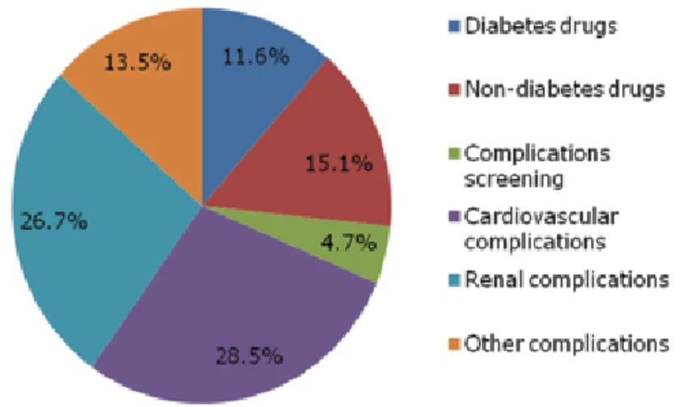
Figure 7: Distribution of Spending on Diabetes-Related Complications
(Source: Malhan et al., 2014)
In terms of research, the study lays emphasis on integrated models that integrate clinical, behavioural and socioeconomic factors to enhance the comprehension of disease management. In the case of the NHS, there is better management initiatives which minimize unnecessary complications and hospitalization and this is in response to the around 10 percent of the NHS expenditures on diabetes care. All these implications enhance health outcomes and save long-term costs in the UK healthcare and facilitate the national diabetes management strategies and resources allocation planning in healthcare systems in England.

11. Plan of Work and Time Schedule
The 16-week plan provides a systematic development of literature identification to final reporting. The first weeks are dedicated to sourcing and screening, and the middle phase is dedicated to data extraction and thematic analysis.
Table 1: Gantt Chart
Activity | W1–2 | W3–4 | W5–6 | W7–8 | W9–10 | W11–12 | W13–14 | W15–16
Literature search
Screening & selection
Data extraction
Thematic analysis
Writing draft chapters
Final review & editing

References
Alessy, S.A., Alhajji, M., Rawlinson, J., Baker, M. and Davies, E.A., (2022). Factors influencing cancer patients’ experiences of care in the USA, United Kingdom, and Canada: a systematic review. EClinicalMedicine, 47.
Bennett, G., Bardon, L.A. and Gibney, E.R., (2022). A comparison of dietary patterns and factors influencing food choice among ethnic groups living in one locality: a systematic review. Nutrients, 14(5), p.941.
Boden, I., Bernabeu, M.O., Dhillon, B., Dorward, D.A., MacCormick, I., Megaw, R. and Tochel, C., (2022). Pre-existing diabetic retinopathy as a prognostic factor for COVID-19 outcomes amongst people with diabetes: A systematic review. Diabetes Research and Clinical Practice, 187, p.109869.
Catherine, J.P., Russell, M.V. and Peter, C.H. (2021). The impact of race and socioeconomic factors on paediatric diabetes. EClinicalMedicine, 42(42), p.101186. doi: https://doi.org/10.1016/j.eclinm.2021.101186.
Chan, K.S., Wan, E.Y.F., Chin, W.Y., Cheng, W.H.G., Ho, M.K., Yu, E.Y.T. and Lam, C.L.K., (2021). Effects of continuity of care on health outcomes among patients with diabetes mellitus and/or hypertension: a systematic review. BMC family practice, 22(1), p.145.
Chiavaroli, L., Lee, D., Ahmed, A., Cheung, A., Khan, T.A., Blanco, S., Mirrahimi, A., Jenkins, D.J., Livesey, G., Wolever, T.M. and Rahelić, D., (2021). Effect of low glycaemic index or load dietary patterns on glycaemic control and cardiometabolic risk factors in diabetes: systematic review and meta-analysis of randomised controlled trials. Bmj, 374.
Eberle, C. and Stichling, S., (2021). Impact of COVID-19 lockdown on glycemic control in patients with type 1 and type 2 diabetes mellitus: a systematic review. Diabetology & metabolic syndrome, 13(1), p.95.
Farooqi, A., Gillies, C., Sathanapally, H., Abner, S., Seidu, S., Davies, M.J., Polonsky, W.H. and Khunti, K., (2022). A systematic review and meta-analysis to compare the prevalence of depression between people with and without type 1 and type 2 diabetes. Primary Care Diabetes, 16(1), pp.1-10.
Gregory, J.M., Slaughter, J.C., Duffus, S.H., Smith, T.J., LeStourgeon, L.M., Jaser, S.S., McCoy, A.B., Luther, J.M., Giovannetti, E.R., Boeder, S. and Pettus, J.H., (2021). COVID-19 severity is tripled in the diabetes community: a prospective analysis of the pandemic’s impact in type 1 and type 2 diabetes. Diabetes care, 44(2), pp.526-532.
Hinneh, T., Boakye, H., Metlock, F., Ogungbe, O., Kruahong, S., Byiringiro, S., Dennison Himmelfarb, C. and Commodore-Mensah, Y., (2024). Effectiveness of team-based care interventions in improving blood pressure outcomes among adults with hypertension in Africa: a systematic review and meta-analysis. BMJ open, 14(7), p.e080987.
Jacob, C., Sezgin, E., Sanchez-Vazquez, A. and Ivory, C., (2022). Sociotechnical factors affecting patients’ adoption of mobile health tools: systematic literature review and narrative synthesis. JMIR mHealth and uHealth, 10(5), p.e36284.
Laforgia, A., Inchingolo, A.D., Piras, F., Colonna, V., Giorgio, R.V., Carone, C., Rapone, B., Malcangi, G., Inchingolo, A.M., Inchingolo, F. and Palermo, A., (2024). Therapeutic strategies and genetic implications for periodontal disease management: a systematic review. International Journal of Molecular Sciences, 25(13), p.7217.
Liebl, A., Henrichs, H.R., Heinemann, L., Freckmann, G., Biermann, E. and Thomas, A. (2013). Continuous Glucose Monitoring: Evidence and Consensus Statement for Clinical Use. Journal of Diabetes Science and Technology, 7(2), pp.500–519. doi: https://doi.org/10.1177/193229681300700227.
Malhan, S., Öksüz, E., Babineaux, S.M., Ertekin, A. and Palmer, J.P. (2014). Assessment of the Direct Medical Costs of Type 2 Diabetes Mellitus and its Complications in Turkey. Turkish Journal of Endocrinology and Metabolism, 18(2), pp.39–43. doi: https://doi.org/10.4274/tjem.2441.
O'Mahoney, L.L., Routen, A., Gillies, C., Ekezie, W., Welford, A., Zhang, A., Karamchandani, U., Simms-Williams, N., Cassambai, S., Ardavani, A. and Wilkinson, T.J., (2023). The prevalence and long-term health effects of Long Covid among hospitalised and non-hospitalised populations: A systematic review and meta-analysis. EClinicalMedicine, 55.
Ong K, Stafford L, McLaughlin S et al., Global, regional, and national burden of diabetes from 1990 to 2021, with projections of prevalence to 2050: a systematic analysis for the Global Burden of Disease Study 2021. The Lancet, 2023; 402, 203-234. https://www.thelancet.com/article/S0140-6736%2823%2901301-6/fulltext
Quattrin, T., Mastrandrea, L.D. and Walker, L.S., (2023). Type 1 diabetes. The Lancet, 401(10394), pp.2149-2162.
Regeer, H., van Empelen, P., Bilo, H.J., de Koning, E.J. and Huisman, S.D., (2022). Change is possible: How increased patient activation is associated with favorable changes in well-being, self-management and health outcomes among people with type 2 diabetes mellitus: A prospective longitudinal study. Patient Education and Counseling, 105(4), pp.821-827.
Rodríguez-Muñoz, A., María José Picón-César, Tinahones, F.J. and José Ignacio Martínez-Montoro (2024). Type 1 diabetes-related distress: Current implications in care. European journal of internal medicine. doi: https://doi.org/10.1016/j.ejim.2024.03.030.
Shiel, E.V., Hemingway, S., Burton, K. and King, N., (2023). Self-management of type 1 diabetes in young adults: Is it impeded by aspects of everyday life? A scoping review. Diabetes & Metabolic Syndrome: Clinical Research & Reviews, 17(12), p.102918.
Song, K. and Lee, A., (2021). Factors influencing the effective management of diabetes during humanitarian crises in low-and middle-income countries: a systematic review. Public Health, 199, pp.110-117.
Sze May Ng and Soni, A. (2023). Ten-year review of trends in children with type 1 diabetes in England and Wales. World Journal of Diabetes, [online] 14(8), pp.1194–1201. doi: https://doi.org/10.4239/wjd.v14.i8.1194.
Xiong, S., Lu, H., Peoples, N., Duman, E.K., Najarro, A., Ni, Z., Gong, E., Yin, R., Ostbye, T., Palileo-Villanueva, L.M. and Doma, R., (2023). Digital health interventions for non-communicable disease management in primary health care in low-and middle-income countries. NPJ Digital Medicine, 6(1), p.12.
Zhu, T., Uduku, C., Li, K., Herrero, P., Oliver, N. and Georgiou, P. (2022). Enhancing self-management in type 1 diabetes with wearables and deep learning. npj Digital Medicine, [online] 5(1), pp.1–11. doi: https://doi.org/10.1038/s41746-022-00626-5.

