/

Design and Analysis of Electromagnetic systems

L5 Electromagnetic Radiation

ACDC5009
Embedded Electronics Systems

Samuel Peppard
2308344
Contents
Table of Figures 3
Abstract 4
Task 1 – Rectangular waveguide model 5
1. Introduction 5
2. Methodology 6
3. Results & Discussion for both Vacuum and Teflon 8
4. Conclusion 22
Task 2 – Halfwave dipole Antenna 23
1. Introduction 23
2. Methodology 23
3. Results & Discussion 24
4. Conclusion 25
Task 3 – Detecting UAV’s with Radar 26
1. What is a Radar? 26
2. Practical Applications of Radar 26
3. Current Challenges with Radar 27
4. Technological advancements in Radar 28
5. Conclusion 29
References 30

Table of Figures
Figure 1 - An image of the rectangular waveguide design. 6
Figure 2 - A graph to show the cut off frequencies of the 3 modes 8
Figure 3 - Port Field display of mode 1 9
Figure 4 - An image of a half wavelength 9
Figure 5 - Port field display of mode 2 10
Figure 6 - Image of a full Wavelength 10
Figure 7 - Port field display of mode 3 11
Figure 8 - An image of a wavelength of $32 λ$ 11
Figure 9 – Vector electric field overlay for mode 1 12
Figure 10 – Magnitude electric field overlay for mode 1 12
Figure 11 – Vector electric field overlay for mode 2 13
Figure 12 – Magnitude electric field overlay for mode 2 13
Figure 13 – Magnitude electric field overlay for mode 3 14
Figure 14 - Vector electric field overlay for mode 3 14
Figure 15 – Magnitude magnetic field overlay for mode 1 15
Figure 16 –Vector magnetic field overlay for mode 1 15
Figure 17 – Magnitude magnetic field overlay for mode 2 16
Figure 18 –Vector magnetic field overlay for mode 2 16
Figure 19 – Magnitude magnetic field overlay for mode 3 17
Figure 20 –Vector magnetic field overlay for mode 3 17
Figure 21 - A graph to show the cut off frequencies of the 3 modes for a Teflon waveguide 18
Figure 22 - Port Field display of mode 1 for Teflon 18
Figure 23 - Port Field display of mode 2 for Teflon 19
Figure 24 - Port Field display of mode 3 for Teflon 19
Figure 25 – Vector electric field overlay for mode 1 for Teflon 20
Figure 26 – Magnitude electric field overlay for mode 1 for Teflon 20
Figure 27 – Vector electric field overlay for mode 3 for Teflon 20
Figure 28 – Magnitude electric field overlay for mode 3 for Teflon 20
Figure 29 – Vector electric field overlay for mode 2 for Teflon 20
Figure 30 – Magnitude electric field overlay for mode 2 for Teflon 20
Figure 31 –Vector magnetic field overlay for mode 2 for Teflon 21
Figure 32 –Vector magnetic field overlay for mode 1 for Teflon 21
Figure 33 –Vector magnetic field overlay for mode 3 for Teflon 21
Figure 34 – Magnitude magnetic field overlay for mode 3 for Teflon 21
Figure 35 – Magnitude magnetic field overlay for mode 1 for Teflon 21
Figure 36 – Magnitude magnetic field overlay for mode 2 for Teflon 21
Figure 37 - An image of the simulation antenna 23
Figure 38 - S11 Parameters for the halfwave dipole antenna 24
Figure 39 - Radiation pattern of the antenna 24
Figure 40 - Robin Radar 28
Figure 41 - An image to show Artificial Neural Network vs Deep Neural Networks 28

Abstract
Within this report multiple different topics are covered ranging from looking into two separate waveguides. One Teflon and one Vacuum. Additionally, half wave antennas are researched to see how to create an optimal antenna. At the end principles of Radar and how they interreact with drones is covered in detail.

Task 1 – Rectangular waveguide model

Introduction
A rectangular waveguide guides Electromagnetic waves in a certain direction. Typically, these are hollow metallic tubes that act as a medium to transmit or transfer power [1]. An example of a waveguide would be a fibreoptic cable. There is 2 main different types of waveguide, these are rectangular and circular. This task will be focusing on rectangular waveguides.

The advantages of rectangular waveguides is that they are easy to make and highly efficient at specific frequencies depending on the dimensions of the waveguide. They are commonly used in Radars and satellite communications [2].

Some negatives of rectangular waveguides could be:

- They are rigid so not effective when flexibility is needed
- They are larger in size
- The manufacturing costs are high

Methodology
When designing a rectangular waveguide, the first main task is to simulate. To do this you have to decide what length and width you will need. This was decided by the university numbers, as mine is 2308344 and using the method to calculate what dimensions this would be; as in the assignment brief. The width x height will be 23mm x 4 mm.

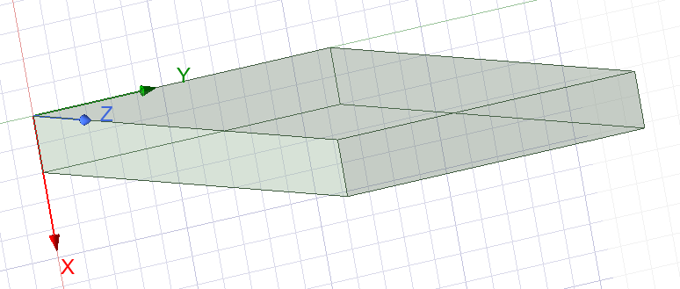
The next stage is to design the waveguide in a simulation software. For this task the decision was taken to use Ansys. The simulation model of the rectangular waveguide can be seen below in figure 1.
Figure 1 - An image of the rectangular waveguide design.
The next step is to run the simulation, this consisted of running frequencies from 2 GHz to 30 GHz. This then will be able to show us the nodes and cut off frequency within the waveguide. For this simulation 99 passes was decided, therefore it . will be cutting the sweep into 282 MHz chunks which for this simulation will be accurate enough to give us reliable results.

To have a theoretical understanding of what the cut off frequency a task within the method was to calculate the cut off frequency. This was done by using the equation:

$$f_{c}=\frac{c}{2}\sqrt{{\left(\frac{m}{a}\right)}^{2}+{\left(\frac{n}{b}\right)}^{2}}$$

Mode 1:

$$f_{c}=\frac{c}{2}\sqrt{{\left(\frac{m}{a}\right)}^{2}+{\left(\frac{n}{b}\right)}^{2}}$$
$$f_{c}=\frac{{3×10}^{8}}{2}\sqrt{{\left(\frac{1}{0.023}\right)}^{2}+{\left(\frac{0}{4}\right)}^{2}}$$
$$f_{c}={1.5×10}^{8}\sqrt{\frac{1}{529}}$$
$$f_{c}={1.5×10}^{8}×\frac{1}{529}$$
$$f_{c}=6.522 GHz (3dp)$$

Mode 2:

$$f_{c}=\frac{c}{2}\sqrt{{\left(\frac{m}{a}\right)}^{2}+{\left(\frac{n}{b}\right)}^{2}}$$
$$f_{c}=\frac{{3×10}^{8}}{2}\sqrt{{\left(\frac{2}{0.023}\right)}^{2}+{\left(\frac{0}{4}\right)}^{2}}$$
$$f_{c}={1.5×10}^{8}\sqrt{\frac{2}{529}}$$
$$f_{c}={1.5×10}^{8}×\frac{2}{529}$$
$$f_{c}=9.223 GHz (3dp)$$

Mode 3:

$$f_{c}=\frac{c}{2}\sqrt{{\left(\frac{m}{a}\right)}^{2}+{\left(\frac{n}{b}\right)}^{2}}$$
$$f_{c}=\frac{{3×10}^{8}}{2}\sqrt{{\left(\frac{3}{0.023}\right)}^{2}+{\left(\frac{0}{4}\right)}^{2}}$$
$$f_{c}={1.5×10}^{8}\sqrt{\frac{3}{529}}$$
$$f_{c}={1.5×10}^{8}×\frac{3}{529}$$
$$f_{c}=11.296 GHz (3dp)$$

Results & Discussion for both Vacuum and Teflon

4.1 Vacuum waveguide
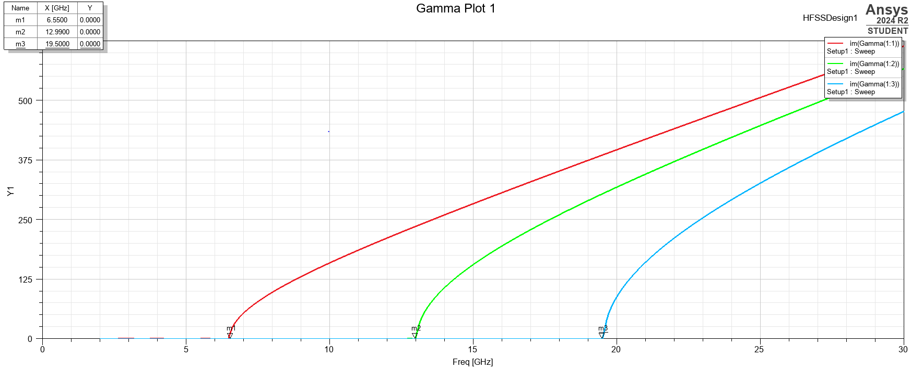
After running the Simulation, it was then time to look into the results. The first part of the results that was the cut off frequencies. The graph below in Figure 2 can show us the results.
Figure 2 - A graph to show the cut off frequencies of the 3 modes
After doing the simulation the cut off frequency value for mode 1 can be seen as
6.55 GHz. If we compare this to the calculated value of 6.522 GHz. This is quite similar as it is only out by 30 MHz which in the grand scheme is very close and accurate. This is due to mode 1 looking at a lower frequency in comparison to mode 2 and mode 3. Typically, with electromagnetic waves accuracy decreases when frequency increases due to higher frequencies being harder to measure. Therefore, with modes 2 and 3 the accuracy starts to decrease and the calculated values will differ more from the measured values.

Looking at mode 2, the cut off frequency is measured at 12.99 GHz this is largely different to the calculated value which was predicted to be 9.223 which has a difference of 3.767 GHz out which is around 40% difference between the two values. There are many factors that could cause this, for example; the waveguide is made for specific frequencies and internal materials are not accounted for.

Mode 3 follows a similar path to mode 2 where the calculated and measured values have a large difference where the calculated value is 11.296 GHz and the measured is 19.5 GHz. Again, this could be factored in when looking into the materials and the design of the waveguide.

The next result to look at the Port field displays. Port field displays shows you the half wavelength which enter/exit the waveguide. For mode 1 this should be $\frac{1}{2} λ$.
As you can see below in Figure 3 the red lines show the peak/trough of the wave therefore by looking at figure 3 you can see there is one peak which can prove that ad mode 1 there is one peak. This can validate that we are looking at the first mode due to being a half wave length.
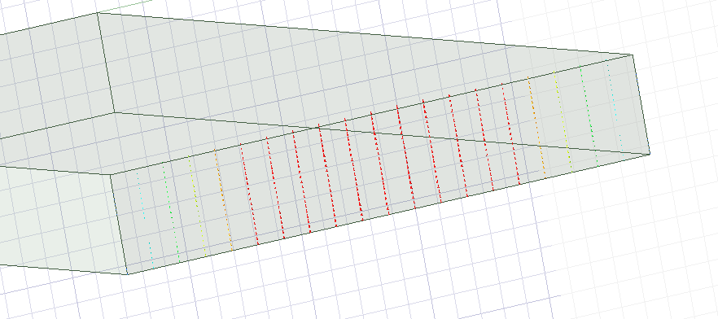
Figure 3 - Port Field display of mode 1
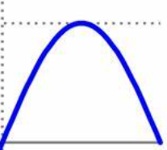
When looking at the figure above you can then infer that the wave entering the waveguide would look something like figure 4 below.
Figure 4 - An image of a half wavelength

For Mode 2, the wavelengths in the port will be $1 λ$. Therefore, within the port there will be 1 peak and 1 trough. Looking into figure 5 below you can see that there are 2 red sections with a peak at the left and trough at the right.
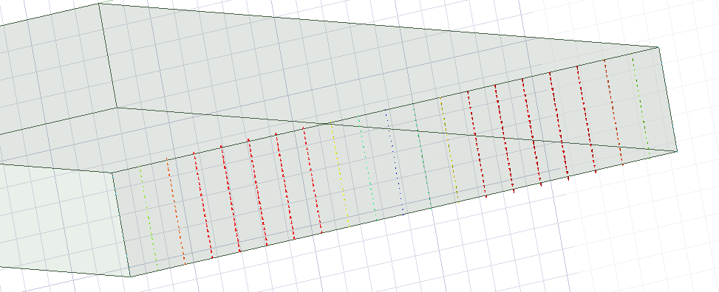
Figure 5 - Port field display of mode 2
From looking at Figure 5 you can then infer that the wave at the port will look very similar to 1 wavelength; similar to Figure 6 below.
Figure 6 - Image of a full Wavelength

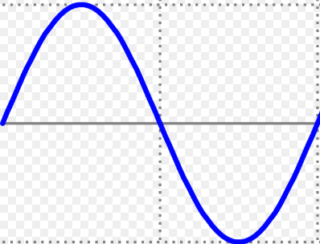

Finally, with mode 3 you can see ,in figure 7, that there are 3 peaks/troughs. This can validate that this shows us the 3rd mode with wavelength of $\frac{3}{2} λ$ .
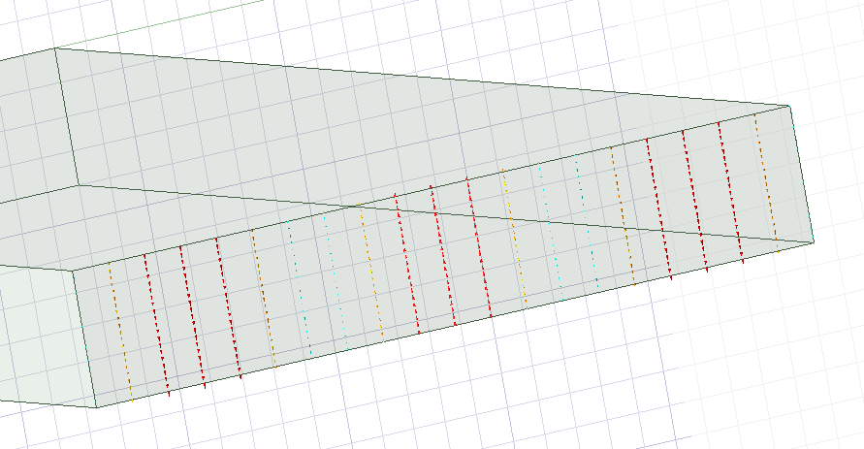
Figure 7 - Port field display of mode 3

Mode 3 at the port will look something similar to Figure 8 below.
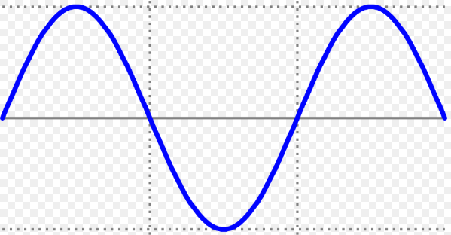
Figure 8 - An image of a wavelength of $\frac{3}{2} λ$

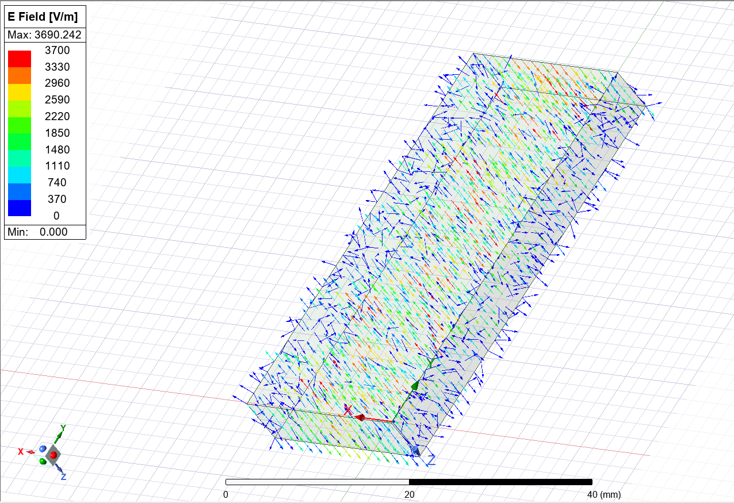
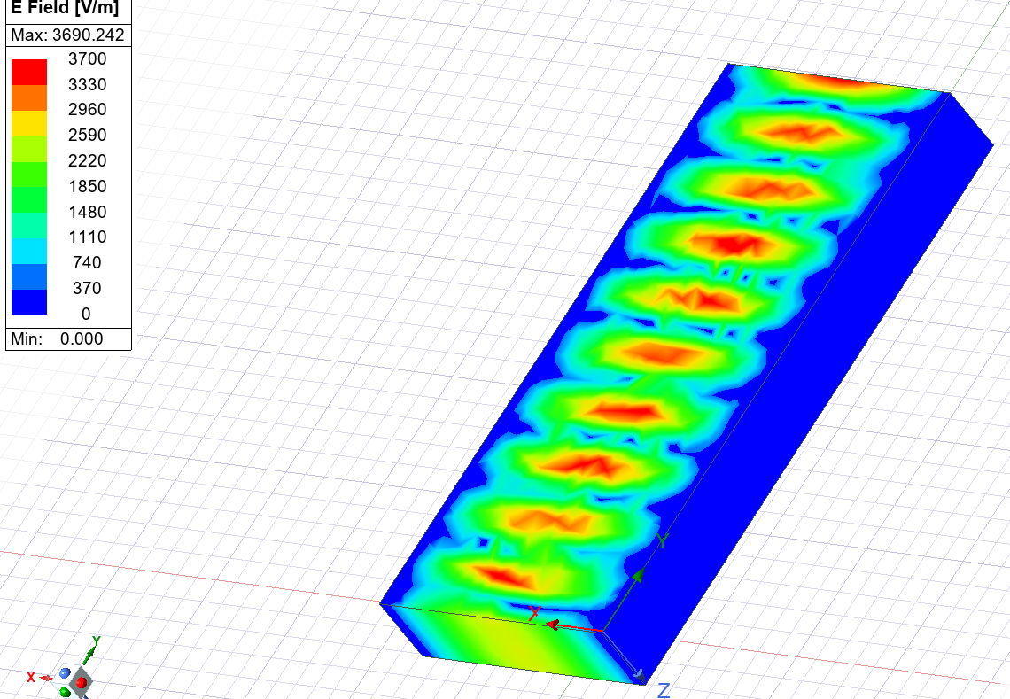
The next area of results to look into is the field overlays. the field overlays can show you the intensity of the Electric field. Working very similar to a heatmap you can see the intense spots (red) and the null spots (blue). There are two different types of field overlay. Vector and magnitude. The magnitude overlay can show you where the highest values lie and the vector overlay shows where the direction of the magnitude is going to better understand how the RF interreacts within the waveguide if you look below at the Figures 9-14 you can see the magnitude and vector overlays of the electric field for mode 1,2 and 3.
Figure 9 – Vector electric field overlay for mode 1

Figure 10 – Magnitude electric field overlay for mode 1

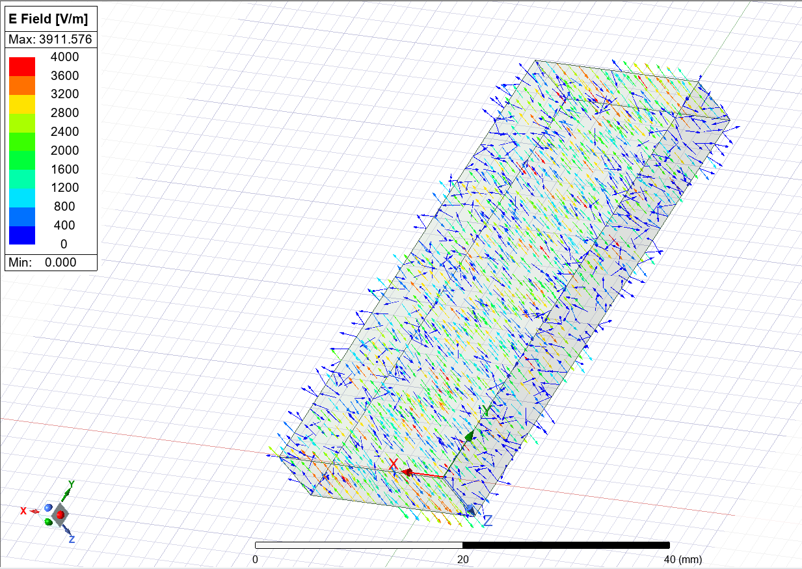
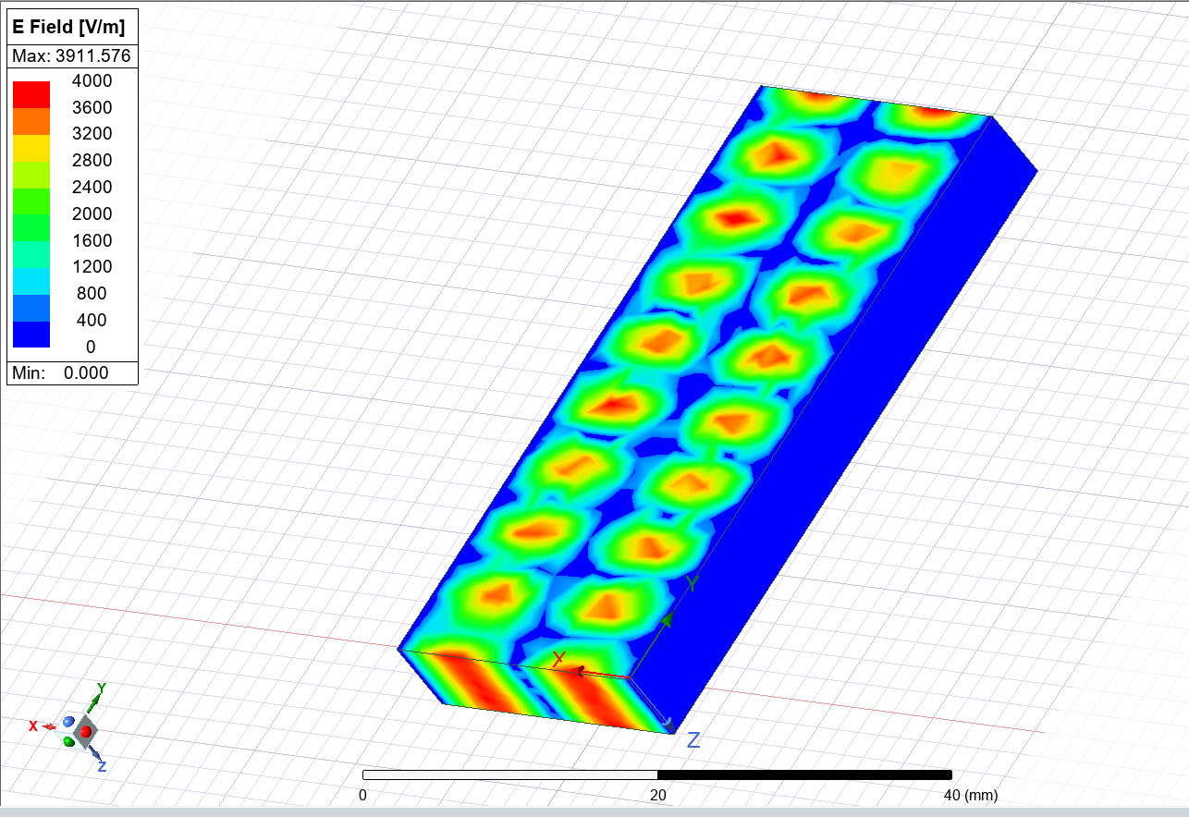
Figure 11 – Vector electric field overlay for mode 2
Figure 12 – Magnitude electric field overlay for mode 2

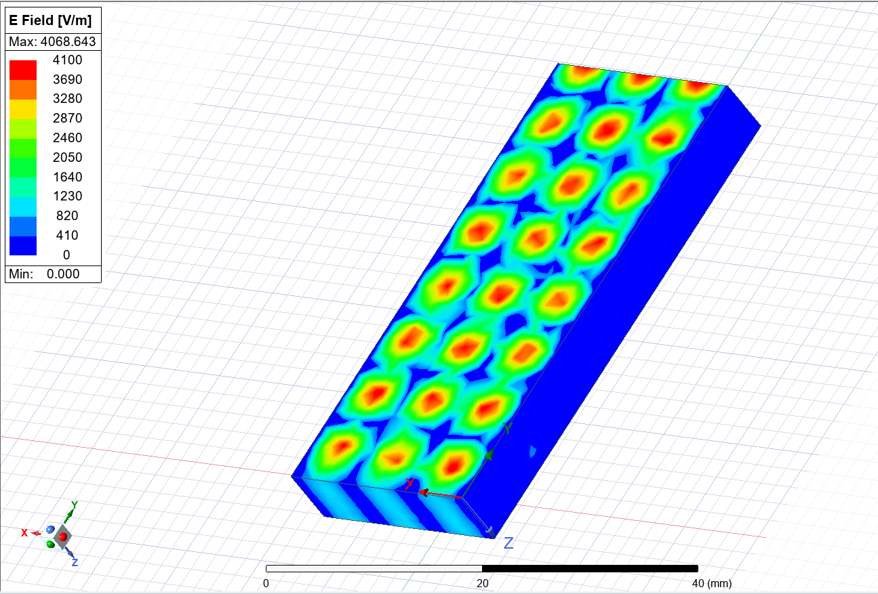
Figure 13 – Magnitude electric field overlay for mode 3

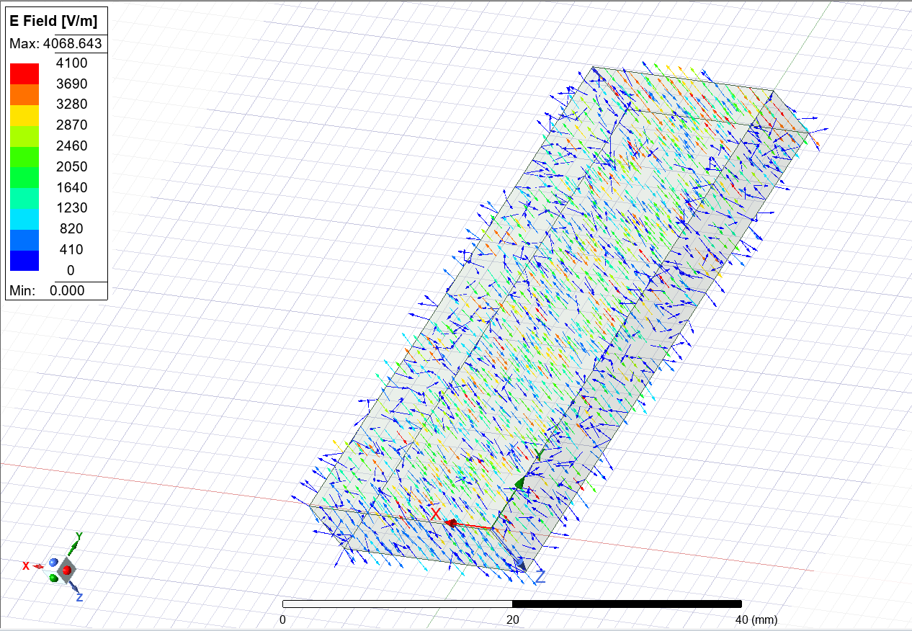
Figure 14 - Vector electric field overlay for mode 3

Additionally to electric fields, you can also look into the magnetic field overlays, the principles of the diagrams is the same with the main difference is that it shows you magnetic field strength not the electric field strength. As seen below in figures 15-20.
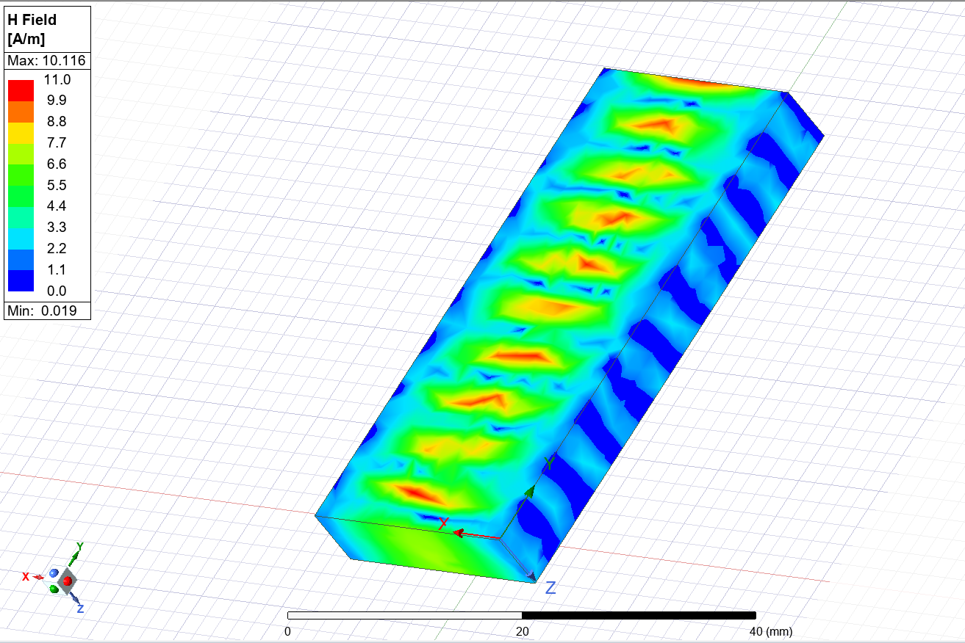
Figure 15 – Magnitude magnetic field overlay for mode 1
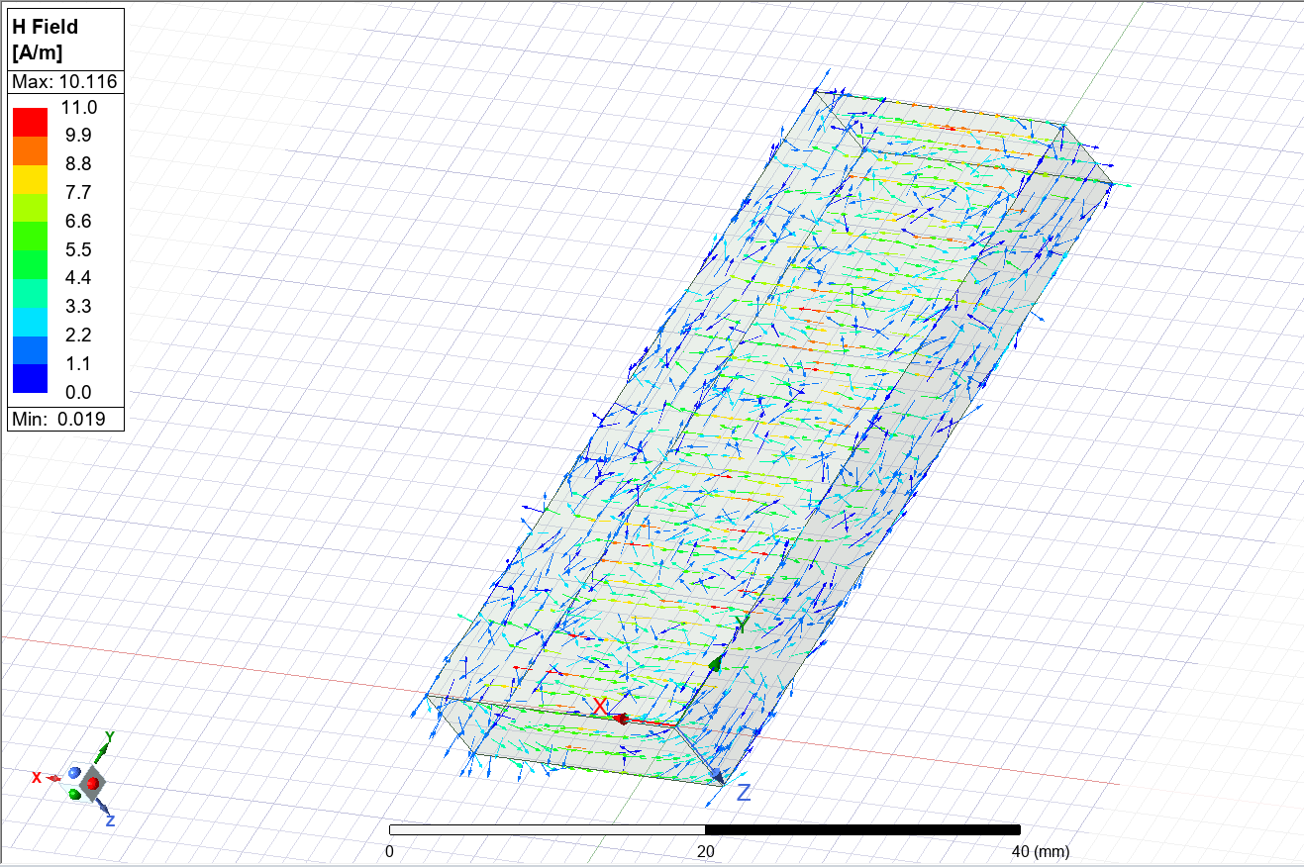
Figure 16 –Vector magnetic field overlay for mode 1

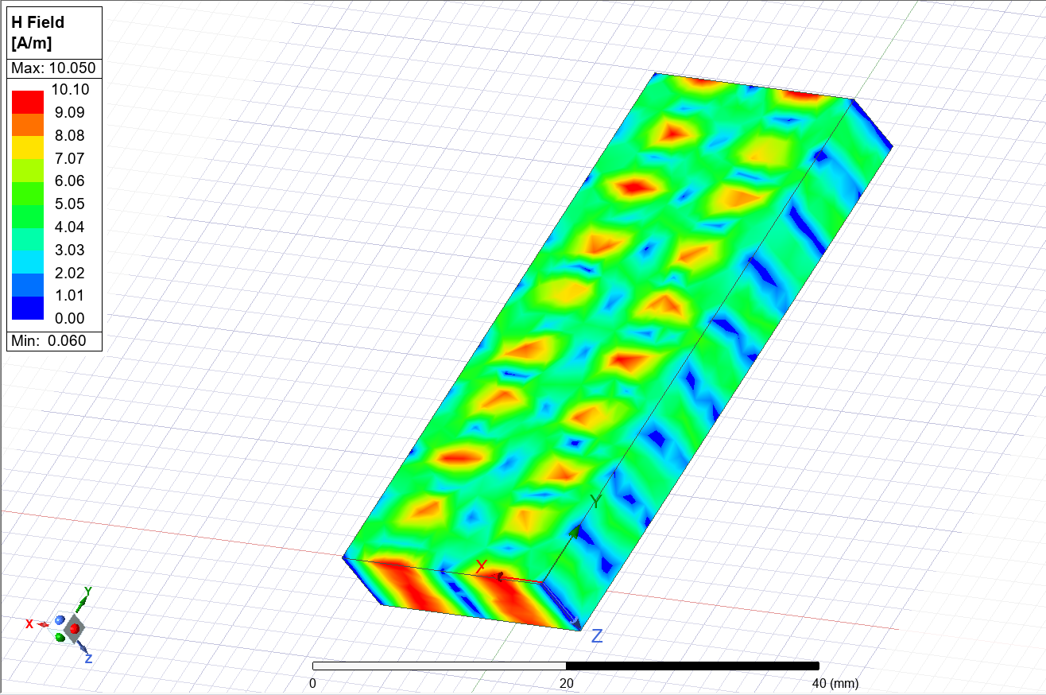
Figure 17 – Magnitude magnetic field overlay for mode 2

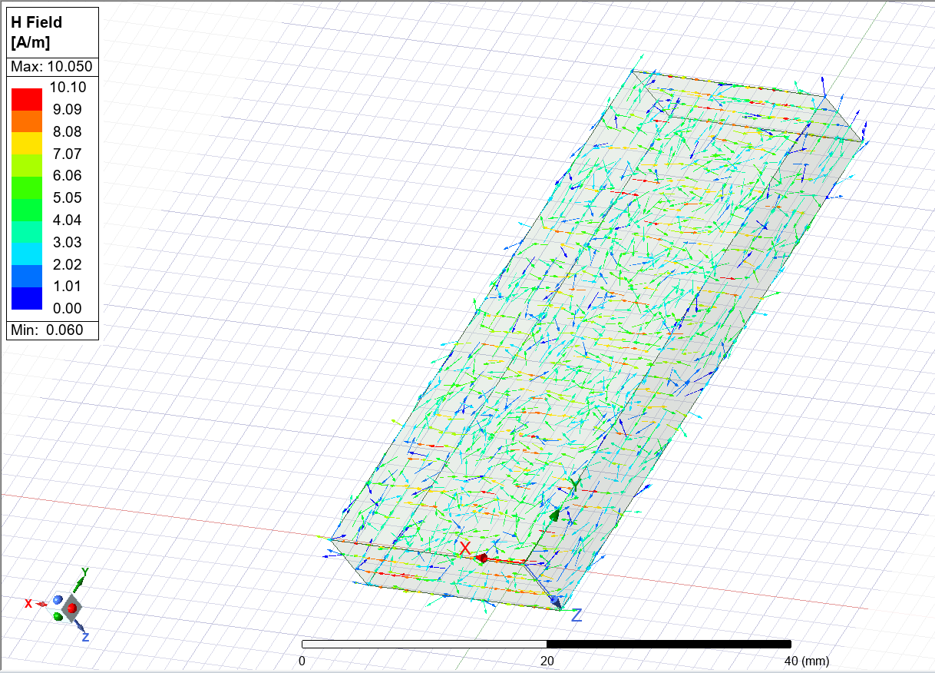
Figure 18 –Vector magnetic field overlay for mode 2

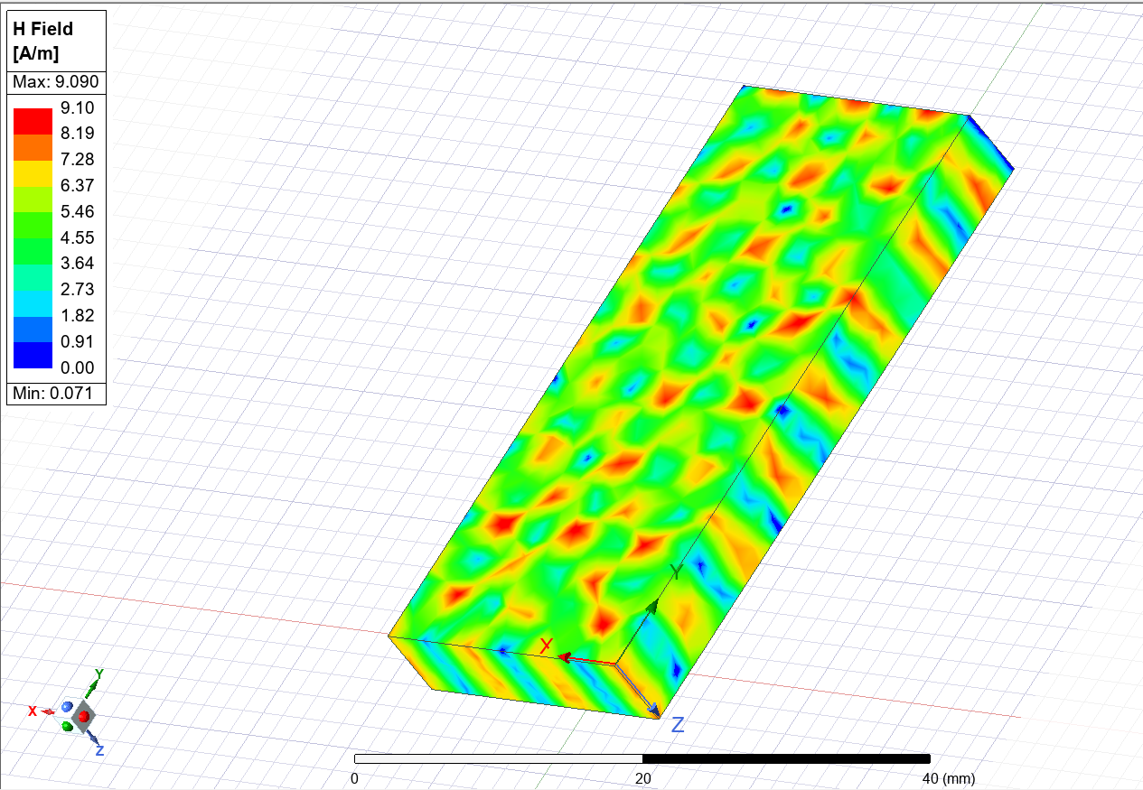
Figure 19 – Magnitude magnetic field overlay for mode 3

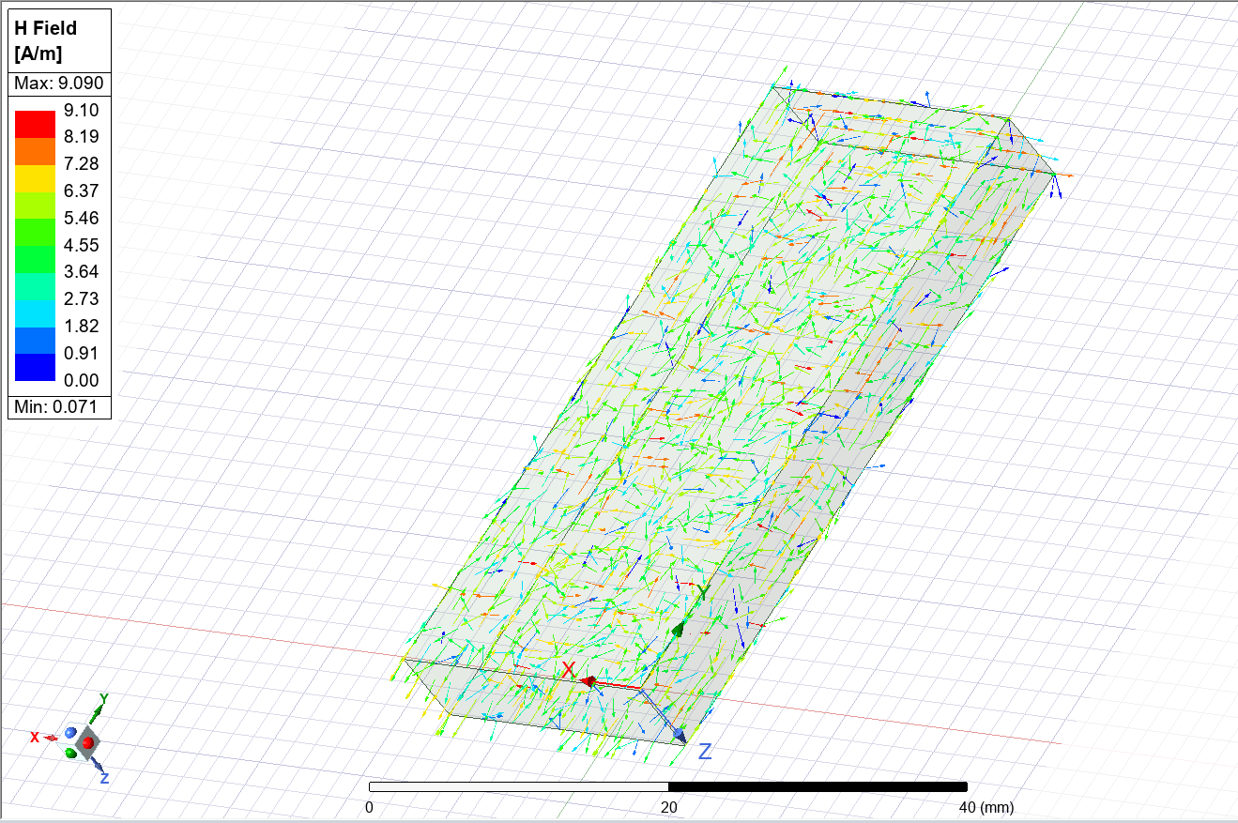
Figure 20 –Vector magnetic field overlay for mode 3

Teflon Waveguide
After looking at the results for the vacuum waveguide it was then time to look into a waveguide with a different internal material. To do this the vacuum centre was changed out for a Teflon centre. Theoretically the main difference between the two would be the cut off frequencies due to different materials having different properties.

As you can see below the cut off frequencies are much lower therefore the waveguide would only work up to a smaller frequency. Again, this is a different value to the calculated. This could be due to the calculation did not consider the materials used within the waveguide.

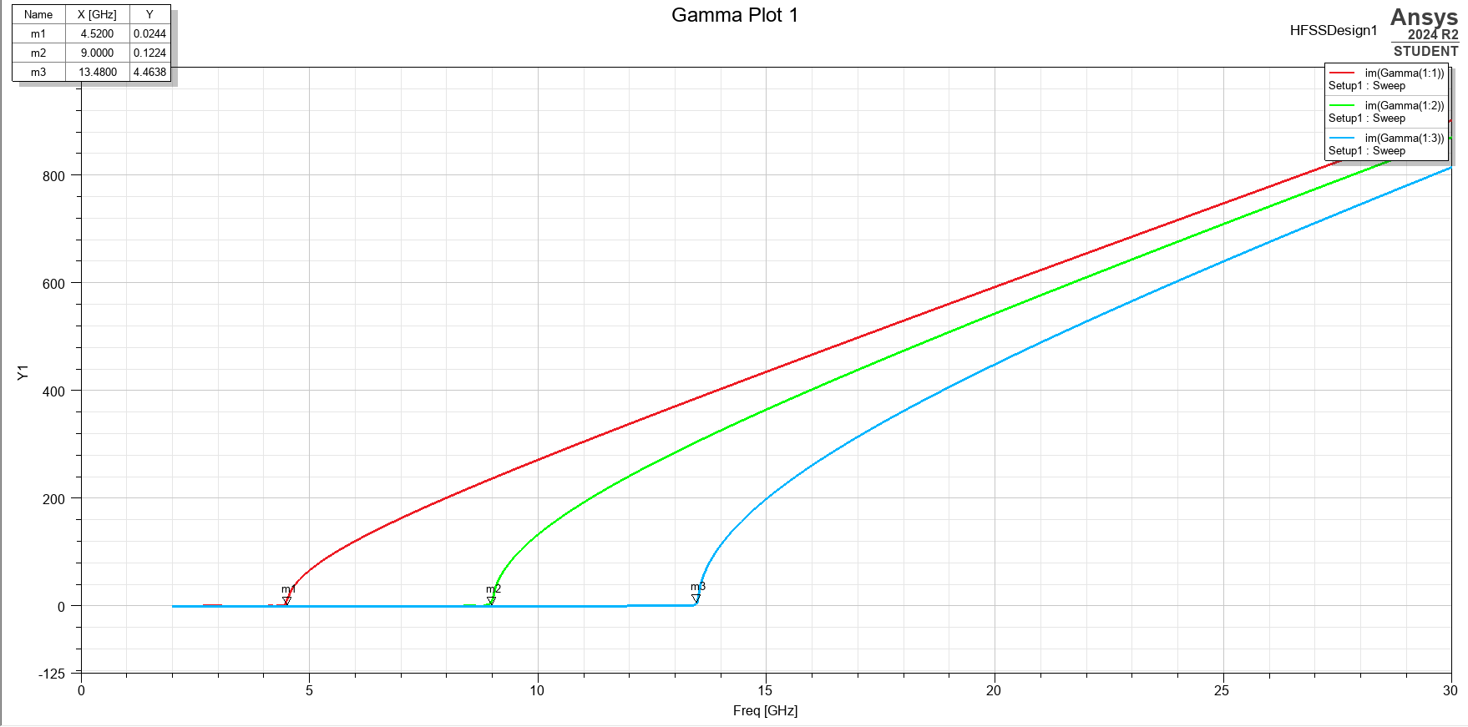
Figure 21 - A graph to show the cut off frequencies of the 3 modes for a Teflon waveguide
With regards to the port field displays. Both the Teflon and Vacuum waveguides have near identical displays. This is most likely due to the material not affecting the ports. As you can see in figures 22-24 below.
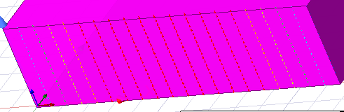
Figure 22 - Port Field display of mode 1 for Teflon
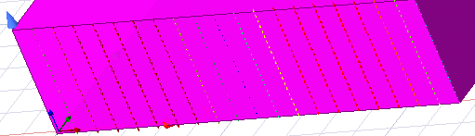
Figure 23 - Port Field display of mode 2 for Teflon
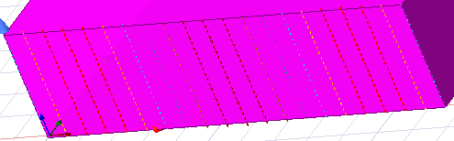
Figure 24 - Port Field display of mode 3 for Teflon

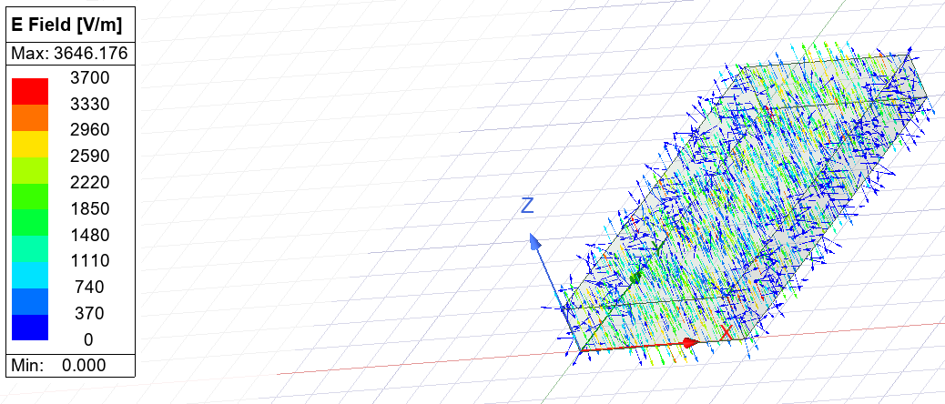
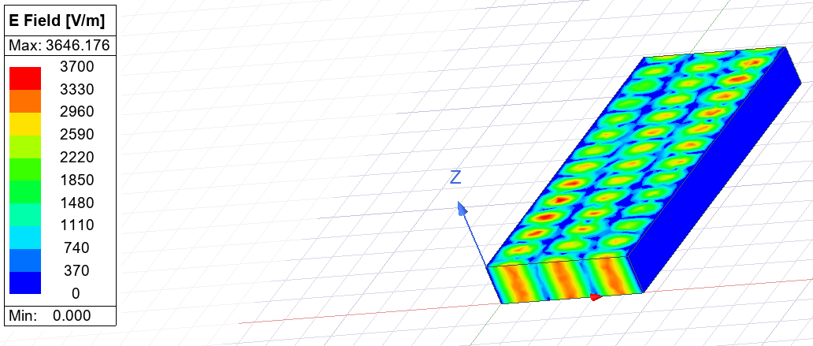
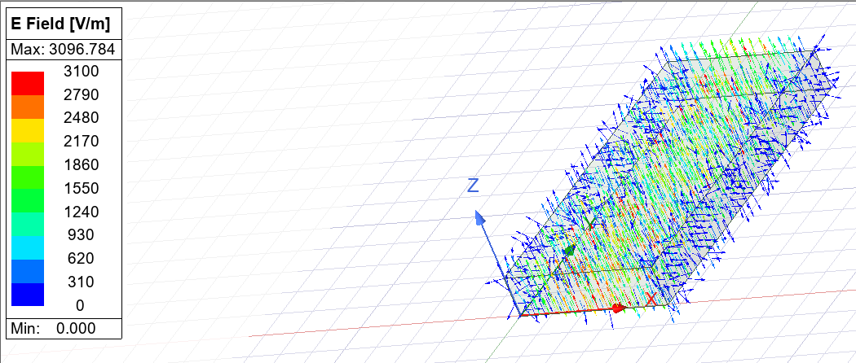
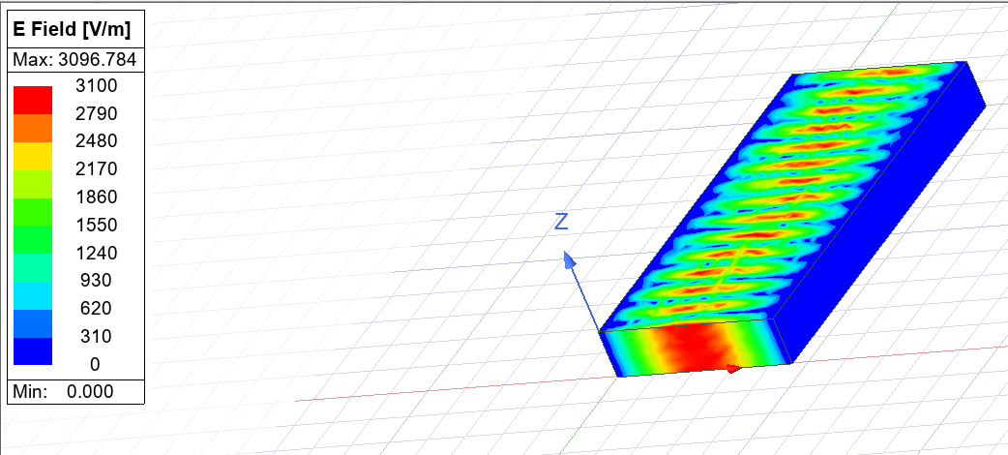
The magnetic and electronic field overlays of the Teflon waveguide are very similar in looks to the vacuum waveguide. The main difference is the intensity where the electric and magnetic field within the Teflon is much weaker than in the vacuum. As you can see in figures 25-36
Figure 25 – Vector electric field overlay for mode 1 for Teflon
Figure 26 – Magnitude electric field overlay for mode 1 for Teflon
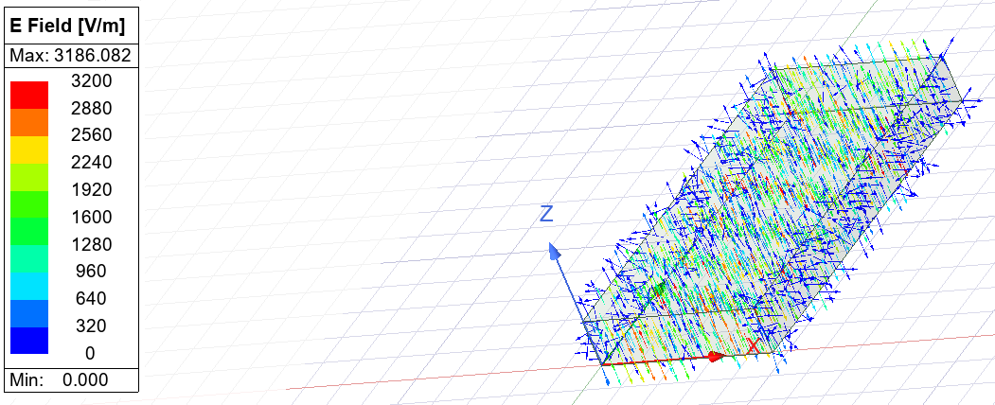
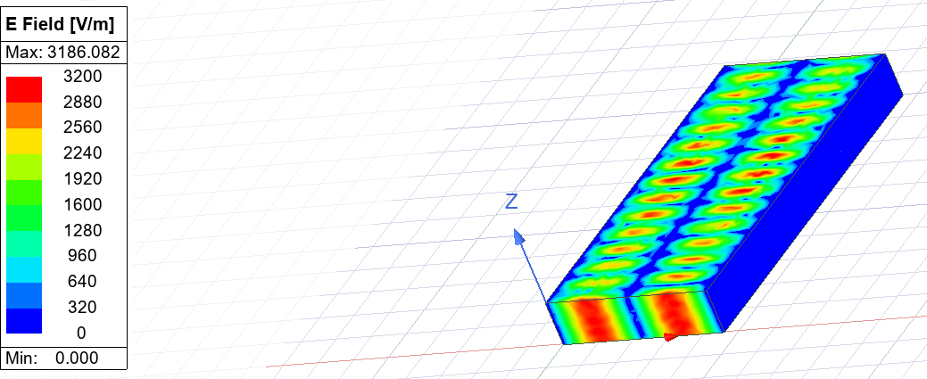
Figure 27 – Vector electric field overlay for mode 3 for Teflon
Figure 28 – Magnitude electric field overlay for mode 3 for Teflon
Figure 29 – Vector electric field overlay for mode 2 for Teflon
Figure 30 – Magnitude electric field overlay for mode 2 for Teflon

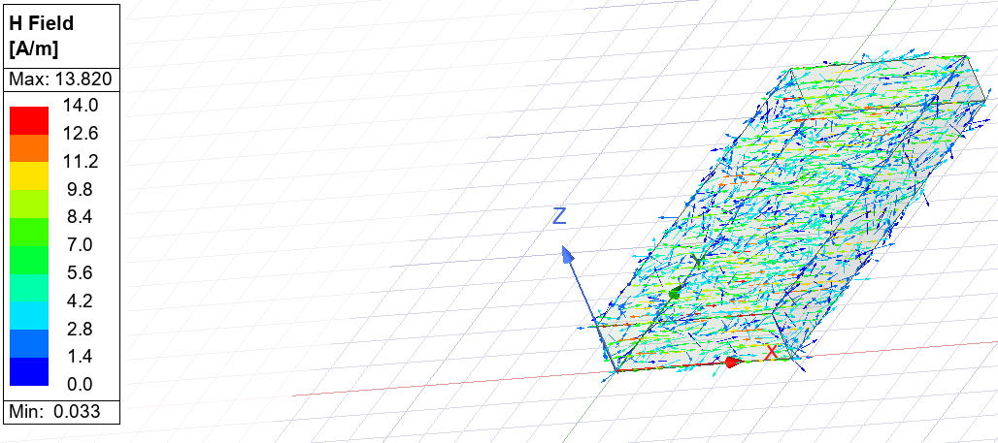
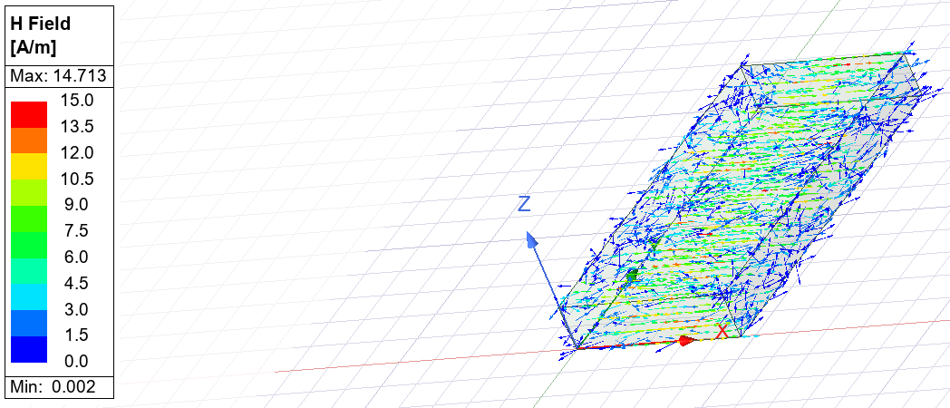
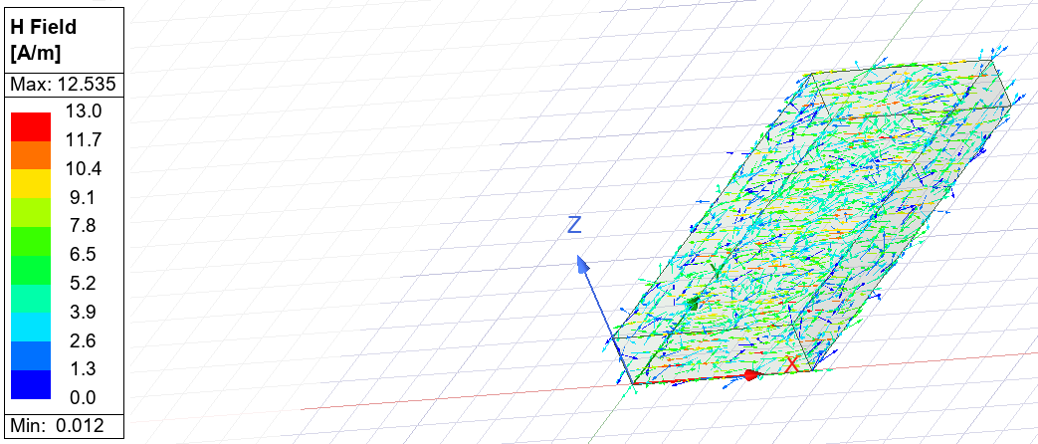
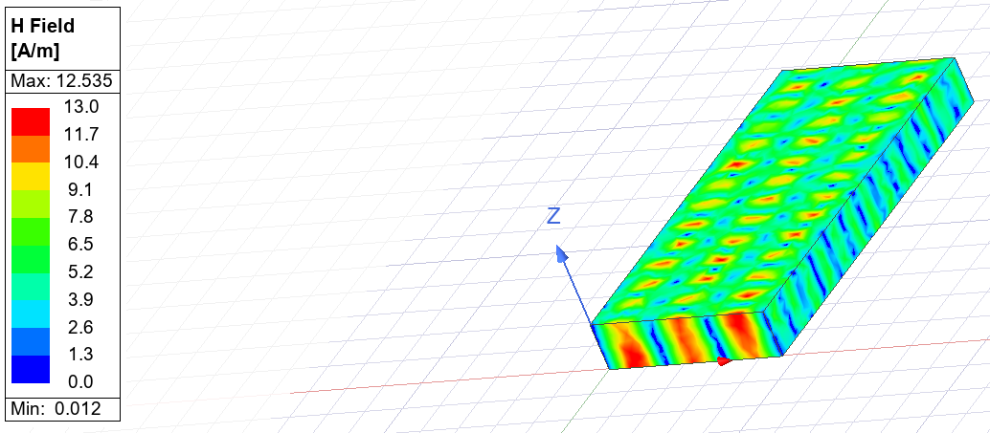
Figure 31 –Vector magnetic field overlay for mode 2 for Teflon
Figure 32 –Vector magnetic field overlay for mode 1 for Teflon
Figure 33 –Vector magnetic field overlay for mode 3 for Teflon
Figure 34 – Magnitude magnetic field overlay for mode 3 for Teflon
Figure 35 – Magnitude magnetic field overlay for mode 1 for Teflon
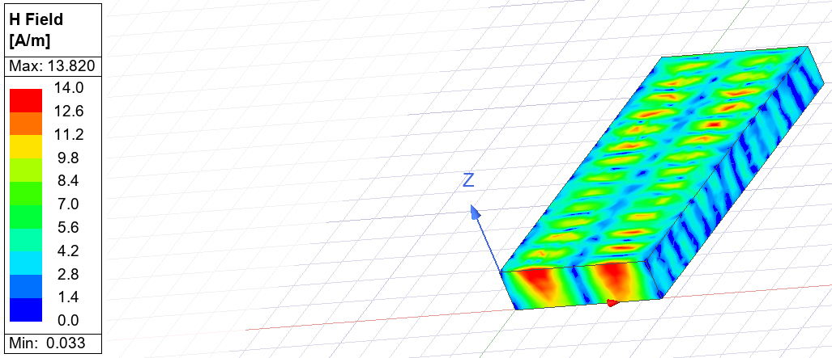
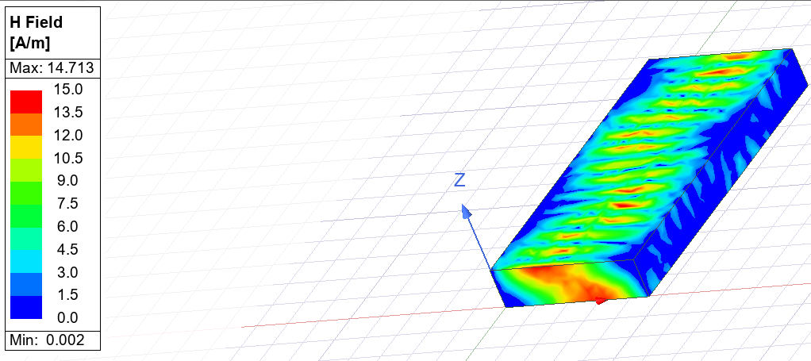
Figure 36 – Magnitude magnetic field overlay for mode 2 for Teflon

Conclusion
In summary the Teflon and Vacuum waveguides act very similar. The Vacuum waveguide is more effective as a waveguide but it can pose as a challenge to create in the real world as making vacuum dielectrics is difficult.

After looking into the field overlays and the cut off frequencies you can also see that theory and practical results can be more different due to real world errors such as there being no such thing as a perfect vacuum.

Task 2 – Halfwave dipole Antenna

Introduction
The next task within this report is to create a halfwave dipole antenna with an operating wavelength of the first 3 digits of our student numbers for the antenna in this report it will be a wavelength of 230 λ. To calculate the length of the antenna you will need to divide this number by two as it uses a halfwave. Therefore, the length of the antenna would be 115 m. this will be using a Perfect Electrical Conductor (PEC).

Methodology
The first task is to calculate the operating frequency, to calculate this you can use the equation:
$$c=fλ$$

$$f=\frac{c}{λ}$$
$$f=\frac{3×{10}^{8}}{115×{10}^{-3}}$$
$$f=2.61 GHz$$
The next stage was designing the antenna on the Ansys simulation software, to do this the values calculated for the antenna length will need to be used. To create the antenna as seen below in Figure 37.
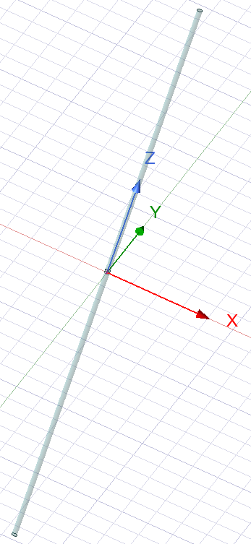
Figure 37 - An image of the simulation antenna
After creating the simulation, it was then time to run the simulation so that the radiation pattern and S-parameters can be calculated.

Results & Discussion
After running the simulation, it was then time to look into the results. The first section of results to look into is the S-Parameters. For this we will look into S11 parameters, this is due to it being able to show the return loss over a frequency range. As seen below in Figure 38.
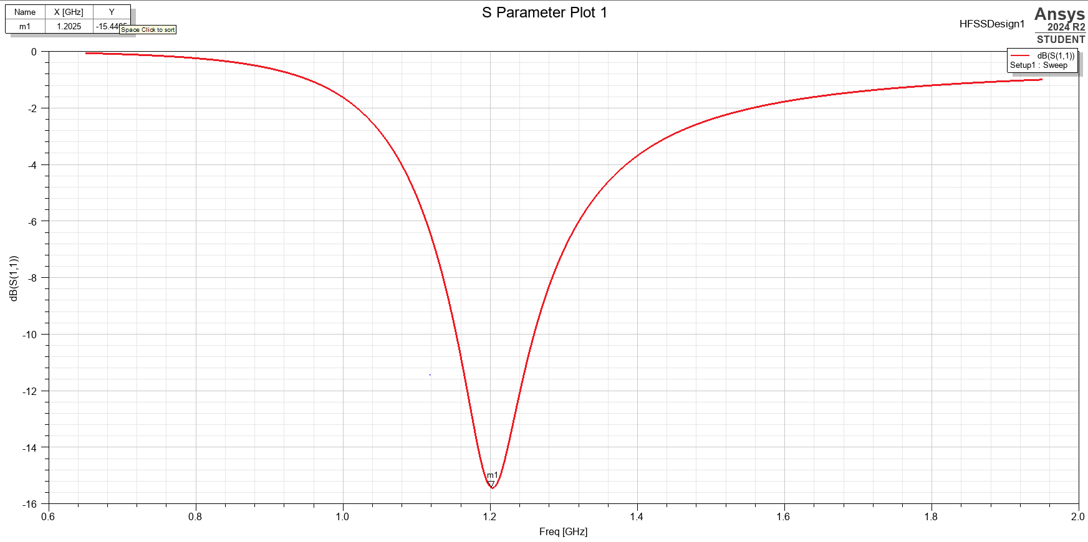
Figure 38 - S11 Parameters for the halfwave dipole antenna
If you look at the S11 Parameter the minimum is at 1.2 GHz this frequency is where the antenna will radiate the best. This isn’t the same as the intended 2.61 GHz. This is due to a theory called impedance matching as this then will ensure that maximum power is being transferred at the correct frequencies. The optimal impedance for this antenna would be 73 Ω instead.

The next part of the results is looking at the radiation pattern. As seen below in figure 39.
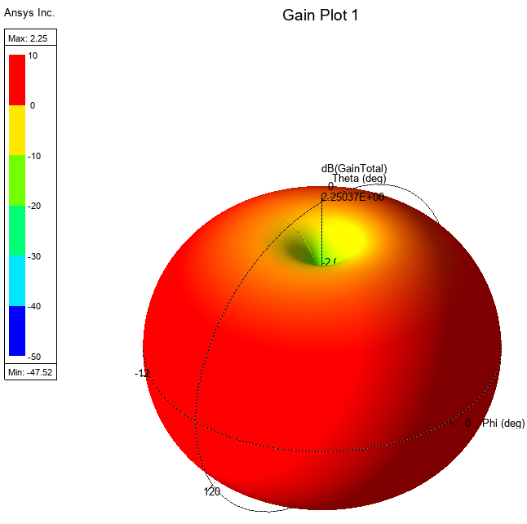
Figure 39 - Radiation pattern of the antenna
If you look at the pattern you can see it is a perfect sphere. This is due to the simulation running a perfect antenna plot. In the real world the pattern will not look like this due to factors such as physical objects in the way and manufacturing errors.
There is a null at the top and bottom end due to a lack of radiation at the top and bottom end of the antenna.

Conclusion
In conclusion the antenna in the simulation radiates perfectly due to it being a simulation although the frequency is not correct due to impedance matching. For future designs this can be considered to ensure that an optimal antenna is created.

Task 3 – Detecting UAV’s with Radar

What is a Radar?
A radar is an electromagnetic sensor that is used to detect, locate, track and recognise objects. [1] In simple terms a Radar will send out an electromagnetic wave which will then reflect off a specific object and be received back at the Radar. This signal will then be displayed on the screen. Radars can be used to detect where an object is and even more modern Radar can also detect the speed and direction of a vehicle by using Doppler shift. Doppler shift is the change in frequency or wavelength to an observer moving relative to the source of the wave. [2] therefore if the electromagnetic wavelength is decreased the vehicle will be travelling towards you.

Practical Applications of Radar
There is plenty of applications of Radar, including:

- Weather
- Space
- Air traffic control
- Biological research
- Space
- Military capability

This isn’t every use of Radar as there is a surplus of uses. But this can show us that improving the modern technology on Radar is vital for the enhancement of science and technology. Without Radar the Air and space travel will never be accessible as it would be unsafe and dangerous to the public due to not having situational awareness of what is around you.

Radar is not just used for Aircraft, it can also be used to track animals and wildlife. This can help biologists track and record where animals are travelling and nesting to better understand the lifecycle of specific animals and also help endangered animals by ensuring that they are recorded and tracked to keep them safe.

Current Challenges with Radar
One key issue with Radar is within the airspace domain. With modern advancements to Aerial Systems; radars can be forgotten about and not improved to keep up with these technological advancements. Therefore, one thing that is vital in science and technology is to continue the development of all radar to keep up with the modern airspace.

One big threat is Unmanned Aerial Systems (UAS). The proliferation of UAS technology has made Counter UAS (C-UAS) a ubiquitous weapon in UAS conflicts. [3] UAS can be a major challenge to Radar due to its Radar Cross Section (RCS) being so small this can mean that the current Radars used may not be able to pick up a system as small as a drone.

On top of this some of the future UAS has an AI driven system which has the ability to counter Radar using real time adaptations [4]. As symmetrical warfare continues to increase in the real world so does the use of AI and high-level technology. Therefore, meaning that warfare continues to become a game of who can create a device which can counter the other. So therefore, it is vital that as a country we enhance our detection and countermeasure techniques.

UAS systems typically use low-power Radio Frequency (RF) for signal and communication which leads to these signals being a challenge to detect due to blending in with the array of electronic noise in public and on the battlefield.

UAS systems are light and fast which can lead to Radars struggling to keep up and track their movements. Therefore, posing a bigger risk to people. And leading to an increase in the duty cycle of a radar. Which leads to radars having to be upgraded and improved constantly.

With all of these requirements to assist with tracking drones there also can be some physical challenges with Radar, for example to increase the effectiveness of a radar. You will also need to increase its physical size to account for all of the internal technology. This can pose a challenge specifically to military due to size and weight being a key factor into the transferability of the asset.

Technological advancements in Radar
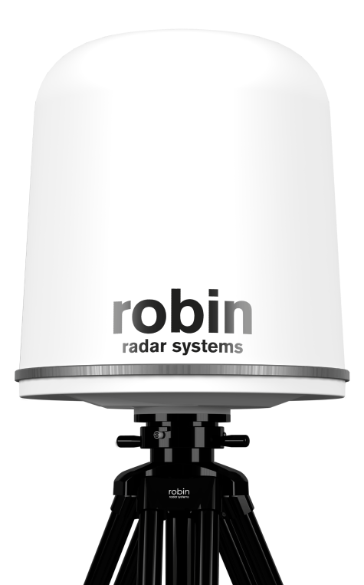
All of the challenges raised above have been comprehended by radar experts and have already been looked into to allow for the detection of drones. And already there is commercial assets which can detect drones. An example of this would be the Robin Radar [5].
Figure 40 - Robin Radar

The Robin Radar can detect up to speeds of 100 Km/Hr with 360˚ and 60˚ elevation.
This uses Deep Neural Network (DNN). This is an AI network which can solve trivial tasks with a network outline. Consisting of 2 or more layers with each layer consisting of nodes which can operate together [6].

DNN Technology allows the Radar to detect lades and rotating parts which allows the radar to detect the difference between a bird and a UAS.
Figure 41 - An image to show Artificial Neural Network vs Deep Neural Networks
High resolution Radar in current use have the ability to characterise drones. This is using a previously stored database which therefore reduces the chance of false positive detection of a UAV [7].

Conclusion
In summary, Radars work by sending and receiving electromagnetic waves which can be a challenge when you are trying to detect smaller objects such as UAV’s therefore technological advancements need to be worked on to ensure that they can keep up with the air domains technology. This is already being done; for example, with the Robin Radar. Although there is still areas that need improvement to ensure that all UAV’s can be detected it is still a correct step in the correct direction.

References

[1] | R. Y, “Waveguides,” Electronics desk, [Online]. Available: https://electronicsdesk.com/waveguides.html. [Accessed 26 April 2025].
[2] | “Rectangular vs. Circular Waveguides: Key Differences,” RF Wireless World, [Online]. Available: https://www.rfwireless-world.com/terminology/waveguide/rectangular-vs-circular-waveguides. [Accessed 26 April 2025].
[3] | M. I. Skolnik, “Radar,” Britannica, 21 March 2025. [Online]. Available: https://www.britannica.com/technology/radar. [Accessed 26 April 2025].
[4] | D. o. t. N. Headquaters, “Principles and applications of underwater sound,” US Navy, Washington DC, 1968.
[5] | A. D. Brown, “Radar Challenges, Current Solutions, and Future Advancements for the Counter Unmanned Aerial Systems Mission,” IEEE, 2023.
[6] | N. Knight, “The evolving battlefield: How radar technology is advancing in the age of advanced electronic warfare and C-UAS,” Military Embedded Systems , 11 February 2025. [Online]. Available: https://militaryembedded.com/radar-ew/rf-and-microwave/the-evolving-battlefield-how-radar-technology-is-advancing-in-the-age-of-advanced-electronic-warfare-and-c-uas. [Accessed 26 April 2025].
[7] | “Radar systems that have you covered,” Robin Radar Systems, [Online]. Available: https://www.robinradar.com/. [Accessed 26 April 2025].
[8] | B. K, “Introduction to Deep Neural Networks,” Datacamp, 4 July 2023. [Online]. Available: https://www.datacamp.com/tutorial/introduction-to-deep-neural-networks. [Accessed 26 April 2025].
[9] | “Detecting drones using radar sensors,” Airsight , [Online]. Available: https://www.airsight.com/en-us/knowledge-hub/drone-detection/radar. [Accessed 26 April 2025].

