

Master of Business Administration (MBA)
International Business Concepts (LCMB7034)
Assessed Report
International Market Entry Analysis:
A Strategic Evaluation of IKEA's Prospective Entry into Pakistan
Student Name: | Kavad avadh laljibhai
Student ID Number: | 2531867
Programme: | Master of Business Administration
Module: | International Business Concepts
Module Code: | LCMB7034
Lecturer: | Akshay Narayanan Mansoob Murshed
Assignment Title: | Report
Word Count: | 5000
Submission Date: | 14th August 2026

Table of Contents
1 Introduction 3
2 Organisational Classification and Global Strategy 3
2.1 Strategic Categorisation using Bartlett and Ghoshal (1989) 3
2.2 Global Configuration, Competitive Advantage and Value Creation 4
3 Macro Environment Appraisal and Market Attractiveness 5
3.1 Economic Environment 5
3.2 Political Environment 7
3.3 Legal and Regulatory Environment 7
3.4 Cultural Environment 8
4 Market-Entry Synthesis: Dunning's Eclectic (OLI) Paradigm 10
4.1 Ownership (O) advantages 11
4.2 Location (L) advantages 11
4.3 Internalisation (I) advantages 11
5 Entry-Mode Strategy and Strategic Synthesis 12
5.1 Historical Pattern Recognition 12
5.2 Strategic Fit and Justification for Pakistan 13
5.3 Conclusion and Recommendations 15
6 Reflective Account (Gibbs' Reflective Cycle) 16
6.1 Description 16
6.2 Feelings 16
6.3 Evaluation and Analysis 16
6.4 Conclusion and Action Plan 17
7 References 18

Introduction
The internationalisation process of the modern multinational corporation (MNC) is one of the most significant strategic decisions facing the firm as the location, timing and mode of entry into a foreign market ties up limited resources and involves a considerable and not always familiar risk for the firm (Dunning and Lundan, 2008). This report critically analyzes the entry of IKEA, a Swedish-based, Netherlands-headquartered global Home and Furniture retailer, into Pakistan, where IKEA is not currently present in the country either as a subsidiary, a franchise or a production unit as yet, on 1st June 2026 (Mappr, 2026). IKEA, which has grown at a much faster pace in South Asia and the Gulf, makes no mention of the lack of stores in the fifth most populous country in the world (Business Model Analyst, 2026). So, Pakistan is not only a potential market but also an entry opportunity without being exploited by IKEA indirectly.
The report is organised according to the requirements of the brief. First it categorises IKEA's global approach based on the Bartlett and Ghoshal, 1989 framework and evaluates its geographical set-up. It then proceeds towards a focused macro-environmental assessment of Pakistan with a specific focus on political, economic, legal and cultural aspects which are most pertinent to a value driven furniture retailer and then synthesises these findings using Dunning's eclectic (OLI) approach. Lastly, it analyzes the pattern of IKEA's entry modes in the past, assesses their strategic viability in Pakistan and provides an evidence-based recommendation. The submission is complimented by a reflective account.

Organisational Classification and Global Strategy

Strategic Categorisation using Bartlett and Ghoshal (1989)
Bartlett and Ghoshal (1989) have introduced a typology that classifies international organisations into four types: international, multi-domestic, global and transnational, depending on the extent to which they are pressured to globalise and the extent to which they are pressured to localise. IKEA could be best described as having a transnational approach which is close to the global-integration end of the quadrant. It's "IKEA Concept" (cited in Ali and Nadeem, 2020) is emulated in very similar manner across the globe, and offers the benefits of a global player (Klavins, cited in Ali and Nadeem, 2020) in terms of lower costs. However, it does this in a calibrated manner across different regions, as was clearly evidenced by its market-specific, long-term entry into Indian markets (The Reformist, 2024).
This is by design, and not a coincidence. After poor sales in some countries in the 1990s, IKEA intentionally moved towards a mix of the interdependency of the headquarters and the local retailers and looking out for global efficiency (StudySmarter, 2023). According to Rugman (2000) cited in Marked by Teachers (n.d.), while the furniture industry usually presses companies to adopt a multi-domestic strategy (as furniture items tend to be large and customer preferences are diverse), IKEA's unique business model ensures that it is able to operate much more globally than other companies in the industry. The integration-responsiveness grid is used to position IKEA (Figure 1).
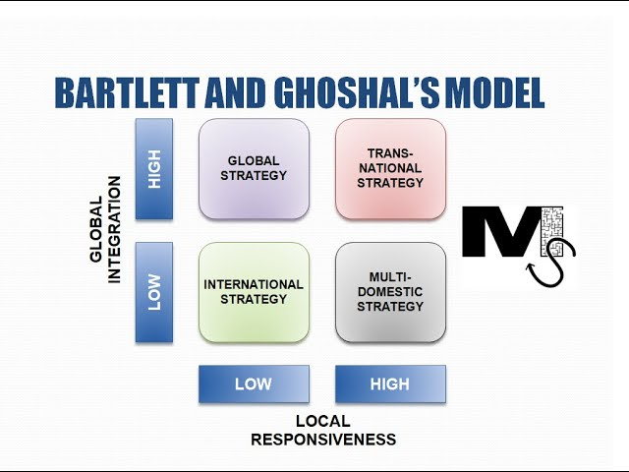
Figure 1: IKEA positioned on the Bartlett and Ghoshal integration–responsiveness grid.
Source: Bartlett and Ghoshal (1989) and Bartlett and Beamish (2018).
Most importantly, the term transnational ought not to be exaggerated. IKEA's local adaptation is constrained: The basic catalogue, price structure, and format of the stores remain under central control, allowing only limited variations ‘where it doesn't affect scale economies'. This allows the firm to reap much of the benefit of a pure global strategy, but still have the flexibility to enter culturally different countries like Pakistan, as long as the entry mode maintains concept control, an argument that will be developed in Section 5.

Global Configuration, Competitive Advantage and Value Creation
The geographical distribution of IKEA is very skewed toward Europe, the region where the company is based, and is expanding throughout Asia, the Middle East and the Americas (Mappr, 2026). It is now running over 500 units in 64 franchise markets, and is continuing with its rapid rate of capacity expansion, such as 10 new units in the US alone in 2026 (Independent, 2026). Importantly, it is not just one company but a franchise system with IKEA being the brand owner or franchisor, and the Ingka Group being the largest franchisee, running the majority of stores in 31 markets, paying a franchise fee of 3% of net sales (Business Model Analyst, 2026).
This set-up is a competitive advantage in itself. The ownership model of the foundation protects the company from the pressure of short-term shareholders and enables the company "to think in generations, not quarters", meaning that the majority of the profit, 85% of FY25 net profit, is reinvested into the business (Business Model Analyst, 2026). Value is added primarily by having a vertically co-ordinated global supply chain, which focuses the design on Sweden, the manufacturing in low cost countries and logistics around the concept of flat-pack efficiency, thus creating economies of scale that cannot be replicated by its competitors (Ali and Nadeem, 2020). Moreover, by separating the brand from the retail operation, IKEA has a low capital investment platform, or a franchise, to expand into the more risky frontier markets without eroding the balance sheet of the parent company, which is directly relevant to Pakistan.
The other important side of IKEA's value proposition is its differentiation-versus-cost leadership: the combination of these two is hard for competitors to copy. The logic of generic-strategies would say that competing on a price design combination is mutually exclusive. Cost discipline is never left out of the process, from designing around a target cost to engineering material and assembly out of products, to shifting labour to the customer by offering flat-pack self-assembly, IKEA reconciles the two, whilst investing heavily in the store experience, catalogue and brand that conveys quality (Ali and Nadeem, 2020). It's a strategic middle ground for a price sensitive market like Pakistan, as it creates a two-fold opportunity for IKEA to sell and reach two types of customers: the middle-class consumers who are aspiring for a modern and branded lifestyle, and the lower-income families who are price-sensitive, where cost is always a major consideration.
There is also a governance element from the franchise structure that directly impacts the Pakistan call.The franchise structure also has a significant governance implication that is directly linked to the Pakistan call. The good news is that Inter IKEA Group is not responsible for strategic decisions but rather for a codified and standardised concept; this means it can bring the brand to an unknown and risky market while keeping contractual control over the key ingredients of the customer proposition. This 'split' of concept ownership from local operation allows the use of the local market-specific knowledge of the franchisee to offset the disadvantage a firm may face when operating in an unfamiliar institutional environment, namely the liability of foreignness (Business Model Analyst, 2026). This is not just an operational arrangement, but a deliberate mechanism to manage risk and it is this capacity that is making the frontier-market opportunity in Pakistan – reachable, not reckless.

Macro Environment Appraisal and Market Attractiveness
The following section assesses the external environment of Pakistan and focuses on the political, economic, legal and cultural factors that are relevant to a value-driven, big-box furniture retailer as opposed to providing a comprehensive description of all macro factors. The analysis is deliberately selective: For IKEA, the key questions are: Is there a size and price of the demand that is high enough and affordable enough? Are the operating conditions secure and predictable? Is foreign retail investment legal and has the right terms? Is the concept of a self-service Scandinavian idea culturally fit?

Economic Environment
The economy of Pakistan is a lower-middle income economy with an estimated population of 240-257 million and nominal GDP of approximately US$452 billion in 2026 (Wikipedia, 2026; LiveGDP, 2026). The economy has stabilised following a near default in 2022–23, with successive IMF programmes, after a recovery in manufacturing was expected to boost investment, improving the growth rate and reducing inflation in FY2025 (the Asian Development Bank estimates real GDP growth at 3.5% in 2026 and 4.5% in 2027 against 3.1% in 2025). The current crisis of inflation has subsided significantly — by the World Economic Forum (2025), it had eased back to around 4% and foreign direct investment had increased by about 20% during the first half of the fiscal year 2025. The macroeconomic recent course is summarised in Figure 2.
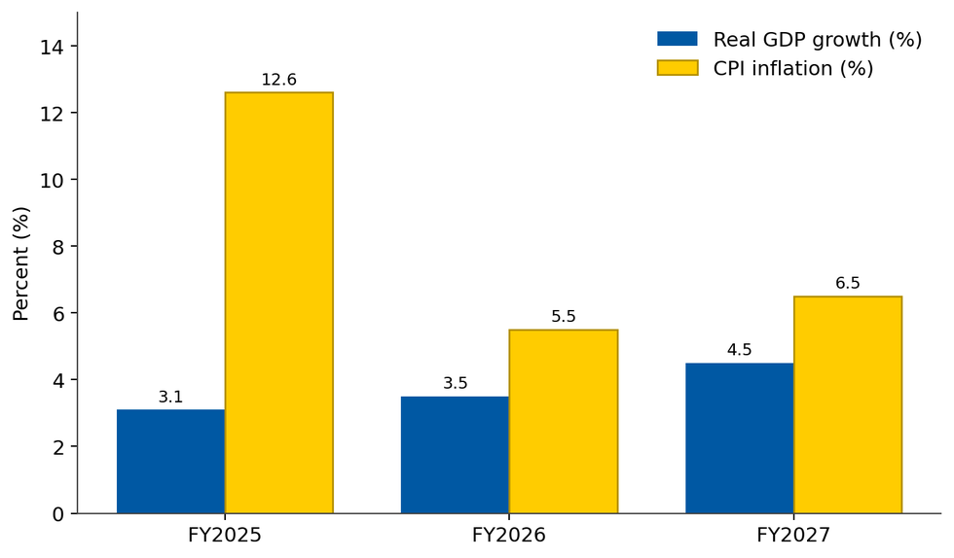
Figure 2: Pakistan real GDP growth and CPI inflation, FY2025–FY2027 (forecast).
Source: Asian Development Bank (2026) and World Economic Forum (2025).
For IKEA three economic aspects are important. First, the demand fundamentals are favourable: wide and young population, fast urbanisation and an expanding middle class are fueling the home-décor market, which will expand at a compound annual rate of 6.4% from 2025 to 2031 (6Wresearch, 2025). Second, price sensitivity is an important constraint as GDP per capita is about US$1700-1900 and poverty rate is around 44.7%, which makes cost a critical factor for even the incumbent Chinioti furniture clusters that compete on craftsmanship and cost (nmfurnisher, 2026; Wikipedia, 2026). Third, macro-volatility is a very real risk: FocusEconomics (2026) highlights currency pressures, double-digit inflation and supply disruption, which suggest any resource commitment should be staged and hedged against exchange-rate and repatriation risks.
These are the headline indicators but the structure of Pakistani consumption will further confirm a need for a well calibrated entry. Household expenditure is still mainly directed towards essentials and discretionary spending on durable home goods is still limited to the urban upper-middle and middle class in the metro catchments of Karachi, Lahore, Rawalpindi and Islamabad, which IKEA needs in terms of size, purchasing power and relative safety. Demographic factors are also positive over a longer horizon: 40% of the population is under the age of 18, which means that many will be entering this life stage in the next 10 years, at the point where demand for affordable, self-assembled furniture is greatest. The 6.4% annual forecasted growth rate in the home-décor market is likely to have a structurally solid basis as opposed to a mere cyclical basis (6Wresearch, 2025).
Concurrently, there may be a cost factor to consider as a factor in determining the format and range. The GDP per capita is well under US$2,000 and a significant portion of the population live below the poverty line, meaning the potential customer base for a full size IKEA store is only a part of the population, and even for that group, expectations are set by the very competitive local producers (Wikipedia, 2026). This has two implications. IKEA's entry segment would first have to be targeted at more affordable segments than what is found in more developed markets, perhaps by emphasising smaller, and/or modular, formats that might appeal to smaller urban home sizes. Secondly, the macroeconomic fragility highlighted by FocusEconomics (2026) – frequent currency depreciation and inflationary periods – justifies the strategic rationale for local purchases, and a gradual rather than a drastic rollout of inventory, allowing for a gradual down payment of the margin risk.

Political Environment
Pakistan's political climate is the biggest concern for a big investment in fixed assets. The governance indicators of political stability and rule of law show a constant trend of being among the lowest performers in the world over the last decade, while the political system features frequent changes of government, contested elections and a strong military and weak civilian institutions (Bibi et al., 2026; BTI, 2026). This chronic volatility means that policies can't be continued, and investors' confidence is undermined, which is just what the multi-decade retail investment needs.
Security is another issue. According to the Global Terrorism Index 2026, Pakistan was the most impacted nation in the world in 2025 as 1,139 people were killed and 1,045 terrorist incidents were reported in the province of Khyber Pakhtunkhwa and Balochistan – the highest since 2013 (The Friday Times, 2026). As a rule, the major urban commercial centres of Punjab and Sindh (Lahore, Karachi and Islamabad-Rawalpindi) IKEA's natural catchment areas — are much more secure than the western border regions, the reputational and operational "security tax" on foreign investment is real and must be taken into account when choosing a site and preparing insurance offerings. The federal government is actively seeking FDI against these risks; the Special Investment Facilitation Council and the reforms under the slogan of 'Uraan Pakistan' indicate the government's seriousness in enhancing the investment climate, with a number of foreign companies like Aramco, BYD and Samsung having invested in the country recently (World Economic Forum, 2025).

Legal and Regulatory Environment
The legal aspect is key to the decision on entry mode. According to the Investment Policy, foreign ownership up to 100% is allowed in most sectors except four sectors reserved for Pakistani ownership, and under the Investment Act 2022, profit repatriation and freedom from expropriation are guaranteed (Lexology, 2022; US Department of State, 2024). It is, however, two provisions that are directly pertinent to IKEA. Secondly, retail trading outside SEZs is generally considered reserved to or available only to local businesses, which usually means that a foreign retailer will not be able to set up a network of wholly-owned retail stores without going through other approval processes (foreigncompanyregistrationinpakistan.com, 2025). Second, there are limits on franchise investments: The State Bank requires US$100,000 for the initial investment and a maximum royalty of 5% of net sales for 5 years (US Department of State 2024). These constraints are important factors in the internalisation calculus from Section 4, which help to direct IKEA towards the partnership structure.
Table 1: Key regulatory parameters affecting IKEA's entry into Pakistan.
Regulatory dimension | Provision | Implication for IKEA
Foreign ownership | Up to 100% permitted in most sectors; four sectors reserved | Broadly open, but retail is a sensitive case
Retail trade | Generally reserved for/restricted to local firms outside SEZs | Discourages pure wholly-owned store entry
Franchise investment cap | US$100,000 initial-investment limit; royalty capped at 5% of net sales for 5 years | Shapes franchise fee structure and returns
Profit repatriation | Guaranteed under the 2022 Investment Act, subject to SBP exchange rules | Reduces but does not eliminate transfer risk
Investor protection | Protection against expropriation; investment ombudsman | Improves institutional assurance
Source: US Department of State (2024), Lexology (2022) and foreigncompanyregistrationinpakistan.com (2025).

Cultural Environment
Cultural distance between Sweden and Pakistan is substantial and shapes both consumer behaviour and the governance of any local partnership. Applying Hofstede's dimensions, Pakistan scores high on uncertainty avoidance (≈70) and moderately high on power distance (≈55), is strongly collectivist (individualism ≈14), and is moderately masculine (≈50) (Hofstede Insights, cited in Farhat, 2022). Sweden, by contrast, is highly individualist, strongly feminine and low on uncertainty avoidance. Figure 3 contrasts the two national profiles.
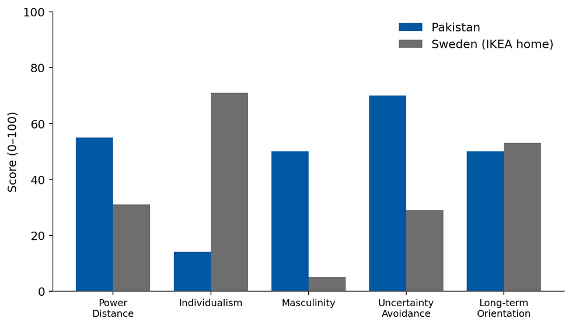
Figure 3: Hofstede cultural dimensions — Pakistan versus Sweden.
Source: in Farhat (2022) and Hofstede's cultural dimensions theory (Hofstede, Hofstede and Minkov, 2010).
Thus, there are several implications arising from IKEA's concept. Because furniture is a purchase that must be made as part of a family, larger room-sets and furniture that demonstrate status and are more durable than utilitarian items are more likely to be bought than simple furniture items. They might be initially wary of the IKEA model of flat-packs and self-service and self-assembling, which is the core of the IKEA experience, and thus would appreciate a greater amount of assembly services and in-store demonstration, and a generous returns policy, to lessen perceived risk. The high power distance and moderate level of masculinity will further reinforce the importance of aspirational, quality signaling positioning. Thirdly, the culture of going through relationships and collectivism makes it as important as well as convenient to use a local partner to navigate supplier relationships, real estate, and officialdom — once more, towards a partnership-based entry mode.
Hofstede's national averages, however, do not provide a definitive picture of behaviour, but merely a starting point, as significant intra-country differences exist. In fact, the individualism of the national score (≈14) does not apply to the cosmopolitan, large, and urban elite of Pakistan, who are often more individualistic, more internationally exposed and more comfortable with self-service retail than the national score (≈14) would indicate (Farhat, 2022). The aggregate uncertainty-avoidance score does not necessarily mean that younger, urban, digitally connected consumers will be more likely to embrace the flat-pack, self-assembly model. This heterogeneity is important to be aware of, as an overly literal interpretation of the cultural distance information might cause IKEA to adapt the concept too much, and thus "water down" the standardisation that is central to IKEA's cost advantage.
The cultural analysis also directly affects marketing and human-resource practice. As a result of high power distance and collectivism, consumer trust is likely to be built through relationship-based communication, word of mouth and family recommendation, and visible in-store service rather than the impersonal and transactional communication which is common in IKEA's Western markets. In the same way, because IKEA has a very flat, informal and consensual organisational culture, working with a Pakistani team will need sensitivity – workers who are used to a more hierarchical model will likely find it strange to work in a flat hierarchy, and a local partner who has experience of this mix of the international and domestic norms might help the process along (Ali and Nadeem, 2020). The cultural evidence does not only support a partnership based on network access, it also supports a partnership based on the grounds of organisational and marketing legitimacy.

Market-Entry Synthesis: Dunning's Eclectic (OLI) Paradigm
In Dunning's eclectic paradigm, the above findings at the macro-level are combined into one decision framework and examined not only for the question of whether a firm should invest abroad, but also on how (Dunning, 2000; Dunning and Lundan, 2008). According to the paradigm, foreign production is desirable under three conditions: the firm has ownership (O) advantages which are greater than the liability of foreignness; the target location (L) has advantages that make it desirable to produce there or operate the process; and the internalisation (I) advantages make it more efficient to exploit these advantages within the firm than by arm's-length contracts (Wall Street Oasis, 2024). Though it has been recognised as having some drawbacks such as its static and somewhat generalised character (Wall Street Mojo, 2025), the OLI paradigm is the most influential framework used to analyse FDI and entry modes and is well suited to the case of IKEA's decision to enter into Pakistan. The three advantage sets are mapped to the resulting mode choice in Figure 4.
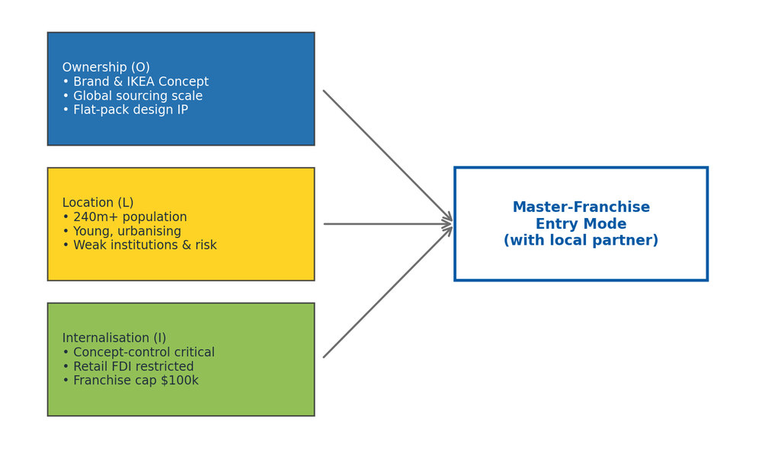
Figure 4: OLI advantages mapped to IKEA's recommended entry mode for Pakistan.
Source: Dunning (2000).

Ownership (O) advantages
IKEA's buyer benefits are very powerful, and they could be very transferable. They consist of a well known brand, the exclusive IKEA Concept, an unrivalled scale in global sourcing, which backs its low-price claims and a unique product IP based on design and flat-pack solutions, along with deep experiential and organisational know-how accumulated in 64 markets (Business Model Analyst, 2026; Ali and Nadeem, 2020). These are the asset-based advantages (Oa) - brand, design - and the transaction-based advantages (Ot) - coordinating a complex international supply chain at a lower cost than the market. The benefits of these outweigh liability of foreignness in Pakistan, if they are not weakened by dilution.

Location (L) advantages
Pakistan's location features are a complex but overall positive one. On the positive side is the presence of a very large and youthful consumer base, rapid urbanisation, a home-décor market that is growing at 6.4 % per annum, an established domestic furniture-manufacturing ecosystem in Chiniot and Gujrat with the potential to provide localised and low-cost production inputs as well as the Government that is actively liberalising to encourage foreign direct investment (6Wresearch, 2025; nmfurnisher, 2026; World Economic Forum, 2025). Weak institutions, security risk, macro-volatility and acute price sensitivity are the other points against which. The presence of a well-developed local supply base is especially notable: it provides IKEA a real advantage in efficiency in terms of proximity — a local source of materials which reduces landed cost and exposure to currency — over market seeking entries in Pakistan.

Internalisation (I) advantages
Internalisation is the pivotal consideration. The IKEA Concept is a fragile kind of knowledge that can be easily lost if this knowledge is not tightly controlled and is loosely licensed; this is the argument for internalising more knowledge and controlling it more — the argument that is the basis for IKEA's choice of wholly-owned subsidiary in India (CliffsNotes, 2025). However, high political and security risk, along with regulatory constraints on retail and its franchise caps in Pakistan, make the full ownership option more costly and risky (US Department of State, 2024). The solution is to have these key factors — brand standards, range, store format, supply-chain governance — internalised, while the activities related to real estate, government liaison and last mile operations are externalised to a competent partner. This is exactly what a master franchise arrangement would meet.
It is an intermediate resolution that can be described more formally as a solution to the transaction-cost problems of a free market contract. A loose form of licensing would leave IKEA's most valuable asset, its codified IKEA Concept open to the dangers of opportunism, quality degradation and reputational spill-over effects, which Dunning and Lundan (2008) identify as the main arguments for internalising an activity. Those risks would be eliminated, but would also be transferred to IKEA's balance sheet if it were to become a wholly-owned subsidiary of Pakistan. A master-franchise agreement strikes the optimal balance: it codifies brand standards, range and supply-chain management into detailed contractual specification and monitoring; it externalises the activities, real estate acquisition, regulatory navigation, and last-mile logistics, which are topically embedded and risk-laden, to a partner who is better suited to handle them (Global Marketing Professor, 2022). The OLI configuration for Pakistan is thus not just a configuration that allows for a shared-control mode, it is a configuration that requires a shared-control mode.
Table 2: OLI assessment summary for IKEA's entry into Pakistan.
OLI component | Key factors in the Pakistan context | Net assessment
Ownership | Global brand; sourcing scale; flat-pack design IP; multi-market experience | Strong (+). Advantages transferable and defensible.
Location | Large young market and 6.4% décor growth vs. instability, security, price sensitivity; strong local furniture supply base | Moderate–positive (±). Attractive demand, offset by risk.
Internalisation | Concept-control critical, but retail restricted and franchise capped; high country risk raises cost of full ownership | Partial (◐). Favours a shared-control mode.
Source: Dunning (2000)

Entry-Mode Strategy and Strategic Synthesis

Historical Pattern Recognition
There have been two ways of entering into the world that IKEA has relied upon and which has been a major part of its strategy for expansion – these are deliberate choices. At its core, the organisation is a franchise system, in which every IKEA store operates under a franchise agreement with Inter IKEA Systems B.V., with a 3% royalty being paid on net sales, and Ingka Group as the dominant franchisee, while independent franchisees own many of the markets, particularly across the Middle East and North Africa where groups based in the country own the stores (Business Model Analyst, 2026; Global Marketing Professor, 2022). When it comes to its most challenging recent ventures, however, IKEA has chosen the fully owned subsidiary. The most telling example is India, where IKEA took more than a decade to allow 100% FDI in single-brand retail (SBR), and only after investing some US$1.9 billion did it decide to venture into a market as big and complex as India as a WTO compliant single-brand operation, rather than a franchise (The Case Centre, 2019; The Reformist, 2024; Cliffs Notes, 2025).
In the latter, there is no single pattern, just a contingent logic: IKEA franchises when a suitable partner and an environment open enough and supportive enough to a concept is found, and an environment where the ecological risks to the concept are too high is not. Figure 5 allocates the main modes in the control–commitment continuum.
Two aspects of this contingent logic are highlighted as they frame the Pakistan judgement rightly. First, the mode chosen by IKEA has traditionally mirrored the openness of the host regulatory regime – the 10-year delay before entering India was due to the company’s unwillingness to compromise on control; it only entered after 100 per cent single-brand retail FDI became legal (The Case Centre, 2019; CliffsNotes, 2025). When this is not the case, IKEA has always turned to franchising, particularly in the Middle East and North Africa (Business Model Analyst, 2026), where IKEA stores are run by local groups that are independent. Secondly, the mode has followed the firm's reassessment of partner associated risk when compared to the risk for the country where the firm operates in terms of the country level risk of 100% ownership. In Pakistan, where retail trade is under state regulation, the regulatory stance is rather franchise-friendly, and the political and security risk is higher, it is clearly the same setup that has historically led to the development of a franchise, not a departure from it.
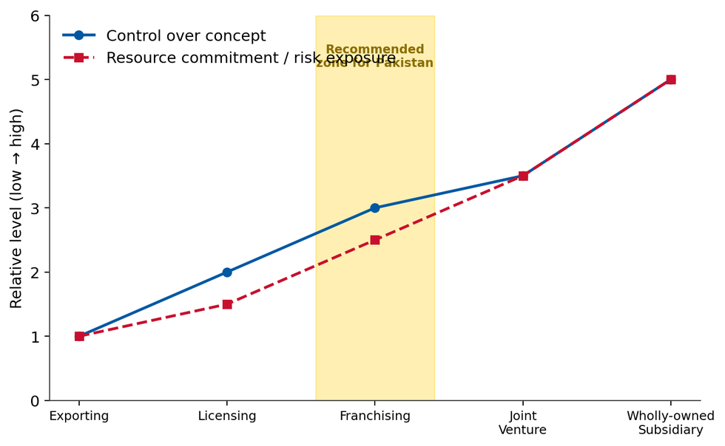
Figure 5: Entry modes on the control–commitment–risk continuum, with the recommended zone for Pakistan.
Source: Dunning and Lundan (2008) and Hill (2011).

Strategic Fit and Justification for Pakistan
In Pakistan, this conditional approach is not apt, as it failed in India for three reasons. Firstly, regulatory challenges: Pakistan, in contrast to the final 100% single brand retail policy of India, does not allow foreign retail trading outside SEZs, meaning that a 100% foreign ownership store network would have to go through extra approval and uncertainty (foreigncompanyregistrationinpakistan.com, 2025). Second, risk exposure: Pakistan's political instability and first ranked impact of terrorism along with macro volatility makes the massive investment of fixed assets of full ownership, unadvised and risky at point of entry; the resource commitment must be staged and not front loaded (The Friday Times, 2026; ADB, 2026). Third, local embeddedness: A local partner's networks in the real estate sector, supplier relationships and government connections are an asset that can be significant and a drawback for a 100 percent foreign-owned player in a high power-distance business culture (Farhat, 2022).
Under uncertainty, as a result of the Pakistani environment, the Master franchise would also have an added advantage in terms of real option value. The mode provides a gradual commitment and a sort of receding relationship: the company could penetrate the market, gain brand recognition and knowledge, while allowing the option to increase the commitment – either by forming a joint venture or by becoming a wholly-owned subsidiary – if the political stability, security and treatment of retail improves (ADB, 2026). This sequencing directly addresses the central tension of the case: an attractive but volatile market, by committing resources to the market resolution over time, instead of attempting to place a big, non-reversible bet at the most uncertain time. It also reflects the incremental internationalisation strategy that IKEA displayed in India, where gradual and staged engagement eventually superseded investment (The Reformist, 2024).
However, a light-touch export or just simple licensing is not enough: giving away the IKEA experience, at the core of the company's competitive edge, would be a fatal blow and allowing the concept to be diluted in a market that IKEA cannot be closely controlled would cause a severe loss of sales. The evidence is thus suggestive of an intermediate shared-control mode. The suggested entry model would be to enter as a master-francise with a strong and well-capitalised local partner (as IKEA does in the rest of the Gulf and MENA, with local entities running stores under strict concept governance, 2026, Business Model Analyst). This is achieved by incorporating the strategically important components (brand, range, format, supply chain standards) into the franchise contract, combined with the 3% royalty paid to the partner which externalises the locally based capital intensive and risk-bearing activities. It thus ensures control and flexibility, minimises risk for IKEA in an uncertain market, makes use of local expertise in the marketplace and supply chain, and leaves a clear roadmap for further development: once the market is more stable and mature, IKEA could eventually add a joint venture or even a full ownership stake, as they did in India when the market demanded it.
Table 3: Comparative evaluation of candidate entry modes for IKEA in Pakistan.
Entry mode | Control over concept | Risk / commitment | Strategic fit for Pakistan
Exporting | Low | Very low | Poor – sacrifices in-store experience
Licensing | Low–medium | Low | Poor – risks concept dilution
Master-franchise | Medium–high (via contract) | Moderate – staged | Strong – recommended entry mode
Joint venture | Medium–high | High | Possible later-stage option
Wholly-owned subsidiary | Very high | Very high | Premature given risk and retail restrictions
Source: Dunning and Lundan (2008), CliffsNotes (2025.

Conclusion and Recommendations
This report has suggested that Pakistan is a true and appealing opportunity for IKEA but comes with some risk. The demand fundamentals are strong: a large, youthful and urban population, a home décor industry expanding at 6.4% annually and backed by a maturing economy and a government that is a veritable magnet for foreign investment. Contrary to this, the political, security and regulatory landscape is one of caution and more importantly, a massive irreversible investment of the IKEA kind in India.
A synthesis of the OLI paradigm of the macro-environmental appraisal provides a clear recommendation. IKEA could approach Pakistan with a master-franchise agreement with a local partner, based on a successful model for the Middle East and North Africa, but with the same contractual oversight over the IKEA Concept. Specifically, IKEA recommends a market review point to exit the venture at which, if the market gets stable, IKEA can turn to a joint venture or a full-fledged business, as it would deepen its commitment to the market, along with (i) seeking a well-capitalised partner with real-estate and retail expertise and networks in Punjab and Sindh, (ii) launching in the first few secure metropolitan catchments (capital-light rollout, such as smaller format and omni-channel stores to manage risk and reach price-sensitive consumers), (iii) developing local sourcing from the Chiniot–Gujrat furniture ecosystem to reduce landed cost, and (iv) hedging currency exposure through an explicit review point. This staged, partnership-driven approach enables IKEA to reap the benefits of a large new frontier market, while at the same time mitigating the risks of being in one of the world's more volatile operating environments.
Lastly, a detailed risk-mitigation and performance plan should be included with the recommended approach to ensure the staged commitment is disciplined. Repatriation risk and currency can be mitigated to some extent by sourcing locally from the manufacturing clusters in Chiniot and Gujrat and this will not only help in lowering landed cost but will also reduce reliance on imported stock which is priced in hard currency (nmfurnisher, 2026; FocusEconomics, 2026). The risks of security and reputational exposure can be mitigated by proper selection of the sites in the more stable catchments of Punjab and Sindh, and by insurance provisioning (The Friday Times, 2026). Careful selection of partners, thorough operating instructions and ongoing audit can help to protect the concept integrity, and externalising operations can turn into externalising control (Business Model Analyst, 2026). Clear review milestones, linked to tangible progress in political stability, security and the regulatory environment for foreign retail, would create a testing mechanism for escalating commitment and turn the entry into a truly evidence-based and adaptive strategy instead of a ‘reliance on an uncertain market.

Reflective Account (Gibbs' Reflective Cycle)
The Gibbs (1988) reflective cycle is used in this reflection to discuss my process of research, analysis and preparation of the previous report (Gibbs, 2020, cited in University of Edinburgh).

Description
This involved picking an MNC and a country it did not have a strong presence in, and examining the MNC's entry decision in terms of the known international-business models. I have selected IKEA and Pakistan, developed an organisational classification, followed by a focused macro-environmental appraisal, an OLI synthesis and an entry-mode recommendation, with the help of academic and credible secondary sources.

Feelings
Initially, I was sure that the frameworks are sound, but I was not sure about what country to select — I felt it would not serve the purpose if IKEA already had some sort of influence in Pakistan in an indirect way. It was comforting to come back to the 2026 and get confirmation from the current 2026 that IKEA, indeed, did not have a store there. As the research progressed, I found myself struck by a favourable balance between the enticing possibilities of Pakistan's market and the magnitude of its dangers, which helped make the decision on the mode of entry feel more meaningful, and sometimes even vital.

Evaluation and Analysis
The good thing is that the frameworks were used to frame the enquiry and they each provided an answer to a different question, forcing them together to make one report would have been more of a descriptive report. The problem was the amount and the monetary worth of information. The macro environment in Pakistan is very dynamic and at times contradictory, as the GDP-growth data from various sources varied slightly. The solution was to focus on authoritative, recent sources (the ADB, IMF and World Economic Forum) and not on aggregators, to cross-check numbers, and to cite ranges, rather than falsely claiming precision, wherever there was real ambiguity. A second challenge was not to be tempted to include all of the PESTLE factors as I was told to only include factors that were relevant to the industry. This helped to make the argument more pointed. Analytically, it was important to understand that the legal detail (the retail restrictions and the franchise cap) was not an incidental fact, but rather the fulcrum on which the internalisation decision was made; the macro analysis directly connected to the entry-mode recommendation.

Conclusion and Action Plan
I decided that both strong and recent evidence and the careful use of theory leads to a defensible strategic judgement and that the theory/evidence matrix is best used to question a situation instead of tagging it. I was very influenced by the lecture and readings done in the module on internationalisation strategy, cultural distance and entry modes as it helped me formulate my understanding of what I believe IKEA would do in Pakistan, in relation to the India case. My action plan for future work is to develop a source-verification log from the outset, being able to trace every figure back to its source; to be more time-efficient in reconciling conflicting data at an early stage; and to give a critical evaluation of the frameworks themselves – for example, recognising that the OLI paradigm has static limitations. These measures should increase my postgraduate practice to be more efficient and more analytically sound.

References
6Wresearch (2025) Pakistan home decor market (2025–2031): trends, outlook and forecast. Available at: https://www.6wresearch.com/industry-report/pakistan-home-decor-market-2020-2026 (Accessed: 3 August 2026).
Ali, S. and Nadeem, M. (2020) 'Comparative international management: comparing cultures in IKEA — Sweden vs China', ResearchGate. Available at: https://www.researchgate.net/publication/341992691 (Accessed: 4 August 2026).
Asian Development Bank (2026) Pakistan's economy poised to grow, but downside risks significant. Manila: ADB. Available at: https://www.adb.org/news/pakistan-economy-poised-grow-downside-risks-significant-adb (Accessed: 2 August 2026).
Bartlett, C.A. and Beamish, P.W. (2018) Transnational management: text and cases in cross-border management. 8th edn. Cambridge: Cambridge University Press.
Bartlett, C.A. and Ghoshal, S. (1989) Managing across borders: the transnational solution. Boston, MA: Harvard Business School Press.
Bibi, M., Ud Deen, Q., Azam, G., Hayat, H. and Phool, R. (2026) 'Political stability and security challenges: implications for governance in Pakistan', Academy of Social Sciences and Applied Research, 5(1). Available at: https://assajournal.com/index.php/36/article/view/1403 (Accessed: 9 August 2026).
Bertelsmann Stiftung (2026) BTI 2026 country report: Pakistan. Gütersloh: Bertelsmann Stiftung. Available at: https://bti-project.org/en/reports/country-report/PAK (Accessed: 10 August 2026).
Business Model Analyst (2026) IKEA organizational structure analysis (2026). Available at: https://businessmodelanalyst.com/ikea-organizational-structure-analysis/ (Accessed: 9 August 2026).
CliffsNotes (2025) IKEA's strategic entry into India's home furnishing market. Available at: https://www.cliffsnotes.com/study-notes/27696341 (Accessed: 12 August 2026).
Dunning, J.H. (2000) 'The eclectic paradigm as an envelope for economic and business theories of MNE activity', International Business Review, 9(2), pp. 163–190.
Dunning, J.H. and Lundan, S.M. (2008) Multinational enterprises and the global economy. 2nd edn. Cheltenham: Edward Elgar.
Farhat, K. (2022) Hofstede cultural dimensions and their applicability to the Pakistani context. Available at: https://www.linkedin.com/pulse/hofstede-cultural-dimensions-applicability-pakistani-contexts-farhat (Accessed: 10 August 2026).
FocusEconomics (2026) Pakistan economy: GDP, inflation, CPI and interest rates. Available at: https://www.focus-economics.com/countries/pakistan/ (Accessed: 12 August 2026).
foreigncompanyregistrationinpakistan.com (2025) Foreign ownership in Pakistan: top rules and regulations 2025. Available at: https://foreigncompanyregistrationinpakistan.com/foreign-ownership-in-pakistan/ (Accessed: 12 August 2026).
Global Marketing Professor (2022) International strategy of IKEA. Available at: https://globalmarketingprofessor.com/international-strategy-of-ikea/ (Accessed: 12 August 2026).
Hofstede, G., Hofstede, G.J. and Minkov, M. (2010) Cultures and organizations: software of the mind. 3rd edn. New York: McGraw-Hill.
The Independent (2026) 'IKEA is opening 10 new US stores in 2026', The Independent. Available at: https://finance.yahoo.com/news/ikea-opening-10-us-stores-170624311.html (Accessed: 5 August 2026).
Lexology (2022) In brief: regulation of inbound foreign investment in Pakistan. Available at: https://www.lexology.com/library/detail.aspx?g=d0b76ef1-47b7-4349-ac10-f132503e6b73 (Accessed: 5 August 2026).
LiveGDP (2026) Pakistan GDP 2026: live GDP, growth rate and historical data. Available at: https://livegdp.com/pakistan-gdp/ (Accessed: 6 August 2026).
Mappr (2026) Countries with IKEA stores in 2026: all 64 markets. Available at: https://www.mappr.co/countries-with-ikea-stores/ (Accessed: 7 August 2026).
Marked by Teachers (n.d.) Critical evaluation of the international strategy of IKEA and its re-entry into the Japanese market. Available at: https://www.markedbyteachers.com (Accessed: 8 August 2026).
nmfurnisher (2026) Home furniture in Pakistan: smart buying guide 2026. Available at: https://nmfurnisher.com/home-furniture-in-pakistan-buying-guide/ (Accessed: 10 August 2026).
The Case Centre (2019) IKEA in India: market entry strategy. Available at: https://www.thecasecentre.org/products/view?id=161464 (Accessed: 10 August 2026).
The Friday Times (2026) Pakistan's security landscape in 2025. Available at: https://www.thefridaytimes.com/27-Mar-2026/pakistan-s-security-landscape-2025 (Accessed: 2 August 2026).
The Reformist (2024) IKEA in India: glocalisation, expansion strategy and challenges. Available at: https://www.thereformist.co.in (Accessed: 4 August 2026).
StudySmarter (2023) IKEA transnational strategy: analysis. Available at: https://www.studysmarter.co.uk/explanations/business-studies/business-case-studies/ikea-transnational-strategy/ (Accessed: 2 August 2026).
University of Edinburgh (2020) Gibbs' reflective cycle. Available at: https://www.ed.ac.uk/reflection/reflectors-toolkit/reflecting-on-experience/gibbs-reflective-cycle (Accessed: 6 August 2026).
US Department of State (2024) 2024 investment climate statements: Pakistan. Washington, DC: US Department of State. Available at: https://www.state.gov/reports/2024-investment-climate-statements/pakistan (Accessed: 8 August 2026).
Wall Street Mojo (2025) Eclectic paradigm: Dunning's OLI framework. Available at: https://www.wallstreetmojo.com/eclectic-paradigm/ (Accessed: 12 August 2026).
Wall Street Oasis (2024) Eclectic paradigm: overview, OLI framework, examples. Available at: https://www.wallstreetoasis.com/resources/skills/strategy/eclectic-paradigm
Wikipedia (2026) Economy of Pakistan. Available at: https://en.wikipedia.org/wiki/Economy_of_Pakistan
World Economic Forum (2025) Pakistan's path towards sustainable and inclusive growth. Geneva: WEF. Available at: https://www.weforum.org/stories/2025/01/pakistan-economic-revival-sustainable-and-inclusive-growth/

