ECIE5002

Numbers Count

Portfolio

Student Number: 2412297

Student Name: Fred Murad

Table of Contents
- Why is numeracy important? pg. 3-5
- References pg. 6
- What can schools do to encourage numeracy? pg. 7-9
- References pg. 10
- Information Sheet pg. 11-12
- References pg. 13
- Link to video plus References pg. 14
- Evaluation pg. 15-16
- References pg. 17-18

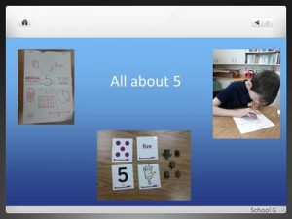

Why is good numeracy important?
In today’s world, numeracy is one of the most important competencies a person can have. The definition of numeracy is the ability to understand, interpret and work confidently with numbers, but numeracy goes far beyond simple arithmetic. Numeracy includes reasoning, understanding data and problem solving. These are skills that are important across both private and public life. In a world which is driven by data and economic information, good numeracy lets people make informed decisions, develop critical awareness and fully participate in social, political and economic systems (National University, 2024). Learning numeracy in the classroom is very important for students, which will help them later in life with understanding economic policies, political accountability, and social movements. Unfortunately, inequalities in attaining mathematics are causing economic and regional divides in the UK. This essay is going to explore why good numeracy is important, understanding its impact on political, social and economics and arguing that competence in numeracy is important to both individual empowerment and group progress.
Numeracy helps individuals understand data, handle their finances and make logical decisions. In the modern UK economy, which is reliant on digital and quantitative skills, low numeracy skills affect employability. In a survey conducted by the 2022 Skills for Life found an estimated half of working age adults in the UK have a numeracy no better than an primary school child age 9 to 11-years-old (National Numeracy, 2022). This influences the labour market, halts innovation and adds to the economic inequality. In 2022, the UK government launched the Multiply programme, providing £559 million over 3 years to improve adult numeracy, offering free courses, digital training and tutoring for adults without GCSE-level maths, aiming to improve confidence, money management, career prospects, productivity and reduce social disparities to help people use maths in daily life and work (National Numeracy, 2024). Without a numeric workforce, governments can not sustain economic growth, implement effective policies, or attract investment in high skilled sectors. Therefore, good numeracy effects education, employment, and economic strategy.
Not only is numeracy important in economic competence, but it is also essential for political literacy. Citizens need to interpret quantitative information shown through media and political policies, such as the budget statements, opinion polls and spending plans which are all transmitted through numbers. For citizens to critically interpret this data, they must posses an understanding of percentages, probabilities and statistical numbers. (Gigerenzer, 2015). Politicians rely on statistics to portray their narrative, and without numeric literacy, people might misunderstand or accept misleading data. A great example of this was in May 2016, Dominic Cummings from the Brexit referendum claimed that the UK sends £350m a week to the EU, despite attempts to debunk this claim which were done by multiple independent authorities including the UK Statistics Authority (Full Fact, 2017). A study by King’s College London director Bobby Duffy, found that 42% of people still believe the claim is true, with 36% thinking it was false, and 22% still unsure (Stone, 2018).
“It’s not as simple as people just changing their minds if they had the correct facts” Professor Bobby Duffy
A person with good numeracy, will question whether this accounts the UK’s budget rebate which was negotiated by Margaret Thatcher and did it factor in the money returned to the UK for agricultural and research purposes. With these rebates, the actual figure was down to 136-160m a week (Ashworth-Hayes, 2016). By allowing citizens to deconstruct these claims, numeracy strengthens political transparency and accountability. As the UK faces complex issues such as healthcare funding and accountability, having a numerical electorate is important to ensuring policy debate is informed and evidence based.
In society, inequality and numeracy attainment are directly linked. The most disadvantaged communities in the UK experience lower average levels of numeracy, which restricts pathways to education and employment. The Sutton Trust (2021) concluded that students from low-income families were less likely to achieve a pass grade in GCSE mathematics than their wealthier peers (Sutton Trust, 2026). This disadvantage maintains social immobility and reduces future potential earnings, creating social injustice. By enhancing numeracy teaching in schools, especially in deprived areas, this will help individuals advance and create community resilience, whilst investing in numeracy education will address the skills shortages as well as inequities across generations.
The importance of numeracy helps people in everyday life. People use numeracy to help budget, compare mortgage rates, food prices, interpret medical data, and help manage personal finances. Studies by Health at a Glance, reveal that people with higher numeracy levels are more likely to save regularly, avoid debt traps and make informed health choices (OECD, 2019). Alternately, people with low numeracy levels tend to face financial distress, poor health outcomes and lack confidence in decision making.
The need for improved numeracy in the UK is widely accepted, although practical challenges persist. People’s attitudes towards mathematics remains negative, with many adults expressing embarrassment about their poor math’s ability. The government’s policy to extend maths for students who are 16 to 18 years old is a positive step in the right direction, although achieving lasting change requires a cultural shift as well as policy reform (Lewis & Maisuria, 2023). People with good numeracy are better equipped to challenging false claims, understand scientific studies and engage in digital debates. Therefore, education systems must adapt to include applied numeracy and statical reasoning to sustain democratic participation in an information society.
Sadly, teacher shortages, especially ones who are proficient in mathematics, disparities in school funding, which can deter potential suitable teachers from applying, and inconsistent school curricula continue to limit this progress. Addressing these issues demand long term political commitment and investment. Promoting adult numeracy like the Springboard does with Functional Skills Maths, in certain schools where funding is available, alongside school-based learning ensures the benefits extend to the wider population, not just future generations (Springboard, 2026). Stronger numeracy skills will help families make the correct steps to making informed decisions, healthier choices, better job prospects, higher income and earnings whilst slowly helping to bring out of poverty (UK Parlement, 2019).
In conclusion, numeracy is far more than an academic discipline. It lets people make rational choices, enables citizens to debate and criticise political claims and be a political safeguard. For the UK, investing in numeracy is both a moral and strategic move, reducing inequality and enhancing productivity, whilst safeguarding democratic accountability. Therefore, good numeracy must be recognised as a universal right, not a as a privilege of education afforded to some.

References
- Ashworth-Hayes, S. (2016) Why Vote Leave’s use of £350m figure is a lie https://infacts.org/vote-leave-lying-saying-send-eu-350-million-week/#:~:text=The%20Chair%20of%20the%20UKSA,which%20is%20%E2%80%9Cclearly%20absurd%E2%80%9D. Last accessed on 17-01-2026
- Full Fact, (2017) £350 million EU claim "a clear misuse of official statistics" https://fullfact.org/europe/350-million-week-boris-johnson-statistics-authority-misuse/#:~:text=It%20was%20often%20claimed%20during,This%20needs%20to%20be%20corrected Last accessed 17-0102026
- Gigerenzer, G. (2015). Risk Savvy: How to Make Good Decisions. Penguin Books
- Lewis, J. & Maisuria, A. ‘Maths to 18’ in England https://commonslibrary.parliament.uk/research-briefings/cbp-9780/#:~:text=Rishi%20Sunak%20has%20confirmed%20the,people%20aged%2016%20to%2018. Last accessed on 17-01-2026
- National Numeracy, (2022) Our Impact in Focus 2022 https://www.nationalnumeracy.org.uk/sites/default/files/2025-02/National-Numeracy_Impact-Report_2022.pdf Last accessed on 17-01-2026
- National Numeracy, (2024) Multiply Programme: Impact report for Year 1 & 2 https://www.nationalnumeracy.org.uk/sites/default/files/documents/Multiply%20Year%201%262%20Impact%20report/Multiply%20-%20Year%201%20%26%202%20Impact%20report.pdf Last accessed on 17-01-2026
- National University, (2024) Why Study Economics? https://www.nu.edu/blog/why-study-economics/ Last accessed on 17-01-2026
- OECD, (2019) Health at a Glance 2019 https://www.oecd.org/en/publications/2019/11/health-at-a-glance-2019_f58fa178.html Last accessed on 17-01-2026
- Springboard, (2026) Functional Skills Maths – City & Guilds accredited https://springboard.me.uk/community-courses/functional-skills-maths/?cn-reloaded=1 Last accessed on 17-01-2026
- Stone, J. (2018) British public still believe Vote Leave ‘£350million a week to EU’ myth from Brexit referendum https://www.independent.co.uk/news/uk/politics/vote-leave-brexit-lies-eu-pay-money-remain-poll-boris-johnson-a8603646.html Last accessed on 17-01-2026
- Sutton Trust, (2026) Higher Education https://www.suttontrust.com/our-priorities/higher-education/#:~:text=Our%20work%20to%20help%20young,leading%20universities%20in%20the%20States.&text=Private%20schools%20were%20almost%20twice,as%20state%20schools%20during%20lockdown.&text=The%20proportion%20of%20undergraduate%20students,affected%20due%20to%20the%20crisis.&text=Two%20thirds%20of%20students%20heading,losing%20face%20to%20face%20teaching. Last accessed on 17-01-2026
- UK Parliament, (2019) Written evidence submitted by National Numeracy https://committees.parliament.uk/writtenevidence/104394/pdf/#:~:text=1.,with%20the%20lowest%20skill%20level. Last accessed on 17-01-2026

What can schools do to encourage numeracy?
The Evolution of Numeracy Education: How Pedagogy and Policy Shape the Way We Teach Maths
If I were to tell you what subject unites every classroom across the country, yes you got that right, mathematics and numeracy. Whether it is counting numbers whilst building in nursery or puzzles, to learning Pythagoras theory in KS3 year 9, numeracy is always at the centre of school life. The way we teach and think about numeracy, has changed dramatically over time. The days of learning maths by memorising times tables and doing pages of sums are long gone. The definition of numeracy is to understand and work confidently with numbers. In Wales, the journey of numeracy provision in schools has been shaped by a combination of educational research, political policy and classroom practice. Shifts in curriculum priorities, pedagogical philosophies and accountability measures have shaped how schools teach maths and how learners engage with numeracy. In this blog, we will explore how pedagogy and policy have evolved together to shape modern numeracy provision.
From Finding Sums to Making Sense
Can you remember how mathematics was taught to you in your school? Years before, being good at maths meant being fast and accurate with calculations. A classroom lesson would focus on repetition, memorisation and getting the right answer as quickly as possible which is a useful skill, but not enough to prepare students for the real world where critical thinking and problem solving are vital. I can fondly remember my early years with mathematics. My math’s teacher was also a very skilled artist who used to have a portfolio of comic book hero drawings he made, and he would use these drawings as a prize for winning his game of Around the World. This game was about times tables and who could quickly answer the question. If you got it right, you moved onto the next student and that student stayed sat in that desk. If you lost, you would sit down and the person who was quickest advanced into the finals. The final battle was the two winners battling out to see who answered quickest and they won the drawing. Being great at math’s, and fast at it if I say so myself, I won most of the games. I remember this memory as my teacher made it fun and rewarding, and this stuck with me on how I want to do my teaching.
Educational thinking theorist like Piaget and Vygotsky both were similar in saying children are active learners who construct their own understanding, and both emphasised child-centered learning, over just memorising information. The difference was Piaget focused on individual exploration, whilst Vygotsky more on social interaction and scaffolding (StudySmarter, 2022). Teaching has gradually moved towards a more interactive and explorative style. Instead of teachers just showing students how to solve a problem, they are starting to ask why a certain method works, allowing students to build their own understanding, test ideas and talk through the solutions they came up with. This in turn has made the classroom a place where making sense of a problem matters, instead of how fast a student solved it. An example of this was my teacher told us that the number 9 in multiplication was like the number 10, which is an even number to use, minus the 1 figure. By learning this, I came up with a method where 09 became 18(1+8=9), where the first digit was the lowest going against the second digit which was the highest, and as you went, the first digit increased and the second digit decreased, whilst always adding to 9. By doing this myself, my teacher’s role became the guide on the side, with classroom discussions, collaborating with peers and reflection now sitting at the core of effective numeracy teaching (King, 2013).
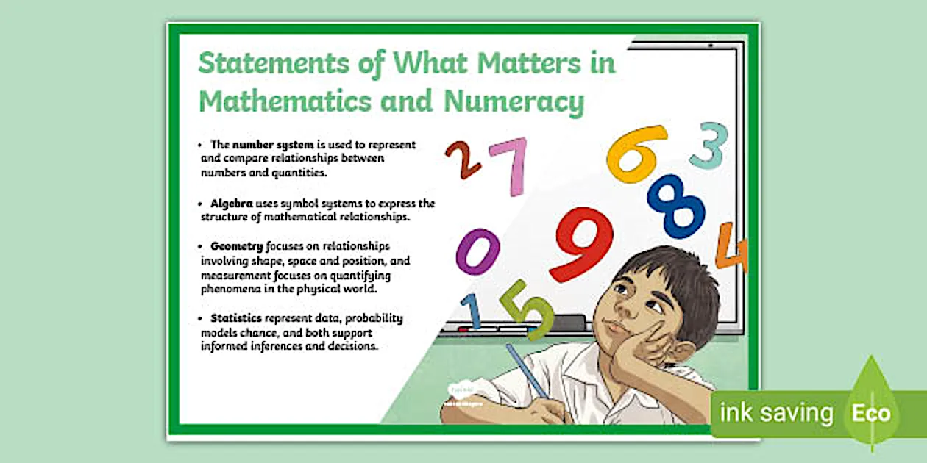
Figure 1(Twinkl, 2026)
Policy Meets Practice
As we know, classroom change does not happen overnight. Government policies play a huge role in shaping how numeracy is taught in schools in Wales. Currently, schools in Wales are implementing a range of national and local initiatives to encourage numeracy, which is driven by the Mathematics and Numeracy Plan 2023 (Gov.Wales, 2023) and the cross-curriculum requirements of the Curriculum of Wales (Draft Curriculum for Wales, 2022). The first programme focuses on building number-confident communities by training teaching staff and engaging parents in programmes like Springboard to reduce people’s anxiety towards maths and builds confidence in using maths in all aspects of everyday life (Springboard, 2026). With the Curriculum of Wales, progression in mathematics and numeracy area involves the development of five connected and interdependent proficiencies. These are crucial considerations for schools when designing their curriculum to ensure the progression of learners: Conceptual understanding, Communication using symbols, Fluency, Logical reasoning and Strategic competence (HWB, 2020).
Whereas in the past, schools just wanted students to memorise numbers without explanation to how they got the answer, policies want students to not only get the correct answers, but to show the methods on how they achieved the answer, which shows the thinking behind their methods, which eliminated students cheating by copying answers, or memorising answers by having good memory and not good understanding of how you got the answer. Inspired by PISA success stories, especially from Singapore and Shanghai (OECD, 2016), the government began valuing depth over speed, which resulted on putting more focus on reasoning, representation and problem-solving.
Saying this, policy isn’t always perfect. Tight accountability systems and standardised test have sometimes led schools to “teach to the test” rather than having genuine understanding (Brown et al., 2020). Schools hiring the right teachers who are qualified to teach maths, as well as how they put their teaching style forward to students, is also key to student success in numeracy. As I said before, I owe my love for maths to my brilliant math’s teacher, and it was how he taught it that made it fun for me. For children with ALN, who might feel like being left behind, targeted support is essential to ensure those students also understand numeracy (Nunes & Bryant, 2009). Some students can learn numeracy with technology, but if used carelessly, it can reduce maths to pushing buttons and not understanding how the answer was achieved. This is where teachers play a vital role in helping pupils think critically about information they encounter online and how to interpret data sensibly.

Moving Forward: What’s next for Numeracy
Numeracy progress in Wales must come from meaningful partnerships – between researchers, policy makers and teachers. Pedagogy is at the heart which understands how pupils learn, policy provides the structure and resources that makes progress sustainable, and when these two align, students start to think mathematically, and that is the goal: to raise a generation of numerate citizens for the future.
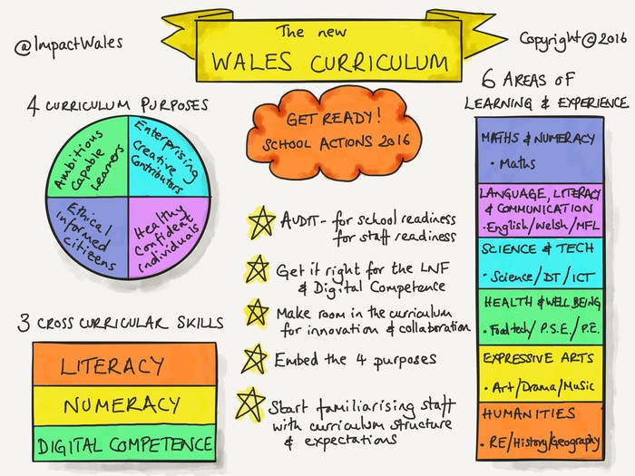
Figure 2 (Model Church in Wales School, 2016)

References
- Brown et al, (2020) Contemporary Issues in Mathematics Education. Oxford: Routledge
- Draft Curriculum for Wales, (2022) Mathematics and Numeracy https://dera.ioe.ac.uk/id/eprint/33314/5/draft-statutory-guidance-mathematics-and-numeracy.pdf Last accessed on 24-01-2026
- Gov.Wales, (2023) Mathematics and numeracy plan 2023 https://www.gov.wales/mathematics-and-numeracy-plan-2023-html#:~:text=Numeracy%2C%20alongside%20literacy%20and%20digital,experience%20of%20Curriculum%20for%20Wales. Last accessed on 24-01-2026
- HWB, (2020) Mathematics and Numeracy https://hwb.gov.wales/curriculum-for-wales/mathematics-and-numeracy Last accessed on 24-01-2026
- King, A. (2013) From Sage on the Stage to Guide on the Side https://faculty.washington.edu/kate1/ewExternalFiles/SageOnTheStage.pdf Last accessed on 24-01-2026
- Model Church in Wales School, (2016) Curriculum for Wales https://www.model.ysgolccc.cymru/en_GB/gwerthoedd-gydol-oes/?doing_wp_cron=1769272745.7834620475769042968750 Last accessed on 24-01-2026
- Nunes, T. & Bryant, P. (2009) Children’s Understanding of Mathematics: 11–16. Oxford: Wiley-Blackwell
- OCED, (2016) PISA publications https://www.oecd.org/en/about/programmes/pisa/pisa-publications.html Last accessed on 24-01-2026
- Springboard, (2026) Community Courses https://springboard.me.uk/community-courses/#:~:text=Functional%20Skills%20Maths%20%E2%80%93%20City%20&%20Guilds,advantage%20in%20the%20job%20market. Last accessed 24-01-2026
- Study Smarter, (2022) Piaget vs Vygotsky https://www.studysmarter.co.uk/explanations/psychology/social-context-of-behaviour/piaget-vs-vygotsky/#:~:text=Similarities%20between%20Piaget%20and%20Vygotsky:%20Child%2Dcentred%20approaches,a%20child%20with%20appropriate%20scaffolding. Last accessed on 24-01-2026
- Twinkl, (2026) CfW What Matters Statements Maths and Numeracy Poster https://www.twinkl.co.uk/resource/what-matters-mathematics-and-numeracy-display-poster-ks2-wl2-n-134 Last accessed on 24-01-2026

Numbers by 20 – Supporting Numeracy Skills
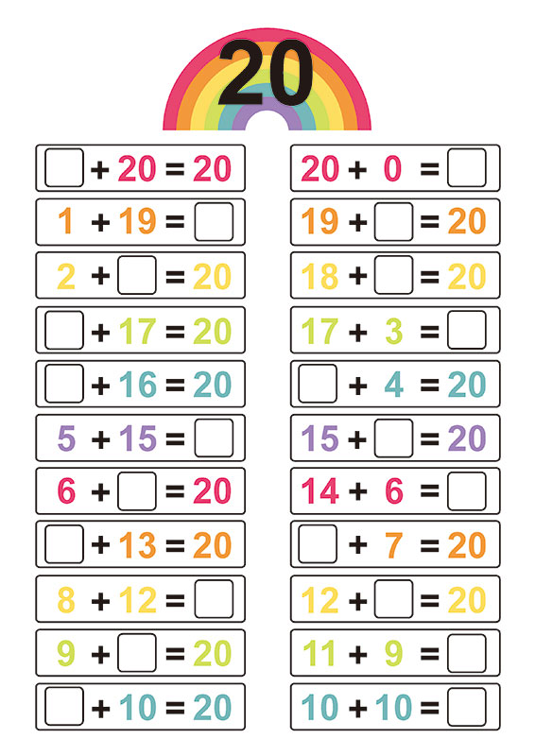
Figure 3(Brother Industries, 2026)
What is the purpose of this resource?
Professionals in schools using Numbers by 20 addition serves as an important milestone in mathematics for young learners, which connects basic counting to much more complex arithmetic. The main purpose of using this game is to develop a relationship with numbers, with students going from concrete counting to mental strategies and establish and understanding of number values (Teachable Math, 2026). This game is often used to teach strategy, and number sense, which can be linked to Piaget’s theory on cognitive development through play (Lorina, 2023).

This game builds a strong foundation for place value, introducing learners to the “teen numbers” which are fundamental to learning and understanding that numbers are composed of ones and tens. It encourages students to move beyond counting every number or object to start with larger numbers and count on. By mastering these mathematic sums, it helps pupils transition from slow hand counting to quick mental recall, freeing up working memory for more difficult problem solving later. Children playing numbers by 20 is also practical for everyday situations, such as managing small amounts of money, counting items in groups and playing various games (Activity Village, 2026). Students then start developing key strategies like making 10 which help solve harder number problems, using near doubles to help solve equations like 7+7 to solve 7+8, and commutative property which is the student learning that 4+8 is the same as 8+4, which makes calculating more flexible (Starr, 2026).

The Curriculum for Wales specifically outcomes 1-3 in Key Stage 2 mathematics says that learners will anticipate, follow, respond and join in with familiar number rhymes, stories, songs, activities, and games, showing an awareness of number activities and counting beyond 10 (HWB, 2016). By playing numbers by 20, children can get a great start in school life by gaining the foundational skills that help them transition from basic counting to advanced mathematical equations all whilst having fun (Doppler, 2025).
Numbers by 20 – Supporting Numeracy Skills
Progression & Assessment in Early Numeracy

🧒 Age Range
Children aged 3–6 who are beginning to learn simple addition.
This can also apply to learners who find numeracy difficult.
(Twinkl, 2024)

🎯 Level of Ability
Children are expected to master this early numeracy skill during early primary school (ages 5–7) according to the Descriptions of Learning.
(IXL, 2026)

🚧 Specific Barriers to Learning in Numeracy
Educational & Systemic Barriers
- Inconsistent teaching
- Lack of specialist support
Cognitive & Developmental Barriers
- Misconceptions of mathematical purpose
- Difficulty grasping number relationships
- Challenges understanding whole vs. part numbers
Social-Economic & Psychological Barriers
- Maths anxiety
- Low support at home
- Limited access to resources
- Families living in poverty
(Core Learning, 2024)

📈 How the Resource Demonstrates Learner Progress
Playing “Numbers by 20” demonstrates progress by moving beyond memorisation and showing deeper number understanding.
(HWB, 2019)

🔍 How to Tell Progress Has Been Made
Learners show progress when they move from concrete to abstract, such as:
- Using hands or counters to understand value
- Understanding whole numbers (5, 10, etc.)
- Knowing how to apply numbers to complete simple equations

📏 How Progress is Measured
Progress is tracked using:
- Curriculum for Wales: Descriptions of Learning
- Personalised Assessments and Progress Steps
These measures usually place learners within Progress Step 1 or 2.
(Eastern High, 2026)

🧩 Can the Learner Use This as a Self-Assessment Tool?
Yes — this activity works as a self-assessment tool under the Assessment for Learning (AfL) framework.
The Curriculum for Wales supports pupils using:
- Practical experiences
- Play-based assessment
- A range of tools to actively track their progression
(HWB, 2025)

References
- Activity Village, (2026) Addition within 20 https://www.activityvillage.co.uk/addition-within-20#:~:text=the%20previous%20one.-,Addition%20to%2020%20Using%20Number%20Lines,solve%20the%20addition%20problems%20given. Last accessed on 25-01-2026
- Brother Industries, (2026) Number bonds to 20 – Addition https://www.creativecenter.brother/en-gb/home/home-category/learning-activities/worksheets/number-bonds-20 Last accessed on 25-01-2026
- Care Learning, (2024) Analyse factors which affect children's learning of mathematical concepts https://carelearning.org.uk/qualifications/level-3-diploma-eyp/unit-36-mathematical/1-1-analyse-factors-which-affect-childrens-learning-of-mathematical-concepts/ Last accessed on 25-01-2026
- Doppler, M. (2025) 36 Math Problems For 1st Graders With Answers & Teaching Ideas https://thirdspacelearning.com/us/blog/math-problems-for-1st-graders/#:~:text=They%20build%20on%20kindergarten%20math%20concepts%20such,as%20addition%20and%20subtraction%20up%20to%2020. Last accessed on 25-01-2026
- Eastern High, (2026) Assessment Reporting https://www.easternhigh.org.uk/page/?title=Assessment+Reporting&pid=41 Last accessed on 25-01-2026
- HWB, (2016) Curriculum for Wales https://hwb.gov.wales/api/storage/e2aad4fc-faae-4054-a382-242d08ee2021/programme-of-study-for-mathematics.pdf#:~:text=This%20document%20sets%20out%20the,the%20national%20curriculum%20for%20Wales.&text=They%20carry%20out%20simple%20addition,5%20and%20understand%20that%20zero Last accessed on 25-01-2026
- HWB, (2019) Mathematics and Numeracy https://hwb.gov.wales/storage/ee62ba8e-b15d-4dda-aad5-b8ba05100be6/draft-statutory-guidance-mathematics-and-numeracy.pdf Last accessed on 25-01-2026
- HWB, (2025) Personalised assessments: Guidance for practitioners on individual learner feedback and progress reports 2024-2025 https://hwb.gov.wales/api/storage/5f0935f2-78cc-4a9e-89bd-18dcf1a72900/personalised-assessments-guidance-for-practitioners-on-individual-learner-feedback-and-progress-reports-en.pdf Last accessed on 25-01-2026
- IXL, (2026) Skills available for Wales year 1 maths curriculum https://uk.ixl.com/standards/wales/maths/year-1#:~:text=and%20mental%20strategies-,Complete%20a%20sequence%20%2D%20up%20to%2020%20(1%2DD.,(2%2DK.2) Last accessed on 25-01-2026
- Lorina, (2023) Child Theorists and Their Theories in Practice https://aussiechildcarenetwork.com.au/articles/childcare-articles/child-theorists-and-their-theories-in-practice Last accessed on 01-02-2026
- Starr, J. (2026) Make Addition within 20 Click: Powerful Strategies to Build Fluency https://jillianstarrteaching.com/addition-within-20-strategies/#:~:text=grab%20these%20freebies!-,Make%20Addition%20within%2020%20Click:%20Powerful%20Strategies%20to%20Build%20Fluency,ten%20when%20they're%20ready. Last accessed on 25-01-2026
- Teachable Math, (2026) Singapore Strategies for Teaching Addition and Subtraction – Part 2: Numbers to 20 https://teachablemath.com/teaching-addition-and-subtraction-for-numbers-to-20/#:~:text=Addition%20and%20Subtraction%20to%2020,strong%20foundation%20in%20number%20sense. Last accessed on 25-01-2026
- Twinkl, (2024) Addition: What should KS1 children know? https://www.twinkl.co.uk/homework-help/maths-homework-help/addition/addition-what-should-ks1-children-know#:~:text=What%20addition%20facts%20should%20my,expected%20to%20be%20able%20to:&text=Use%20numbers%20up%20to%2020,%2Ddigit)%20in%20addition%20problems.&text=Solve%20missing%20number%20addition%20problems.&text=Use%20objects%20or%20pictures%20of,will%20be%20expected%20to%20use.&text=Your%20browser%20can't%20play%20this%20video.&text=An%20error%20occurred.,is%20disabled%20in%20your%20browser. Last accessed on 25-01-2026

Link to Numbers by 20 3-Minute Video & Resources

- https://1drv.ms/v/c/2ac3b680fa9edec6/IQBoRXbWfeIET5OBvjmton4yAdmbrWhgXYYaz6thFYM-ew4 (*hold control and click with mouse to access video via link*)

References
- Fun Hands-on Learning, (2025) Teaching Children with Autism (Math Activity Kindergarten Level) https://www.youtube.com/watch?v=EyqKMJuCTtE Last Accessed on 31-01-2026
- Pixabay, (2026) Numbers Counting, Counting GIF https://pixabay.com/gifs/numbers-counting-count-16965/ Last accessed on 31-01-2026

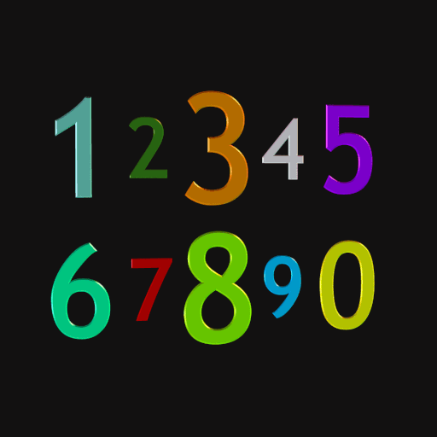
Figure 4 (Pixabay, 2026)

Evaluation of Numbers by 20 as a Numeracy Resource
This evaluation is going to explore the effectiveness of students playing the game Numbers by 20, looking at both its benefits and limitations. It draws on the Numeracy Framework for Wales, some learning theories, and evidence on pupils’ progress from game-based numeracy activities, while considering factors that may influence outcomes and the suitability of different learners.
Students playing numbers by 20 can boost their engagement by providing a concrete, context for practising mathematic facts and mental calculation, in line with Piaget’s cognitive development that learns construct knowledge through hands-on interaction with their environment instead of memorising information (LearnButWhy, 2025). Playing this game can lead to more time on task and repeated practice, improving a student’s number addition.
Numbers by 20 can offer immediate feedback and clear progression a student is making as in increasing the difficulty or raising levels, which supports learning principles. Parents giving help and guidance will allow learners to see their own progress and can adjust strategies to improve their accuracy. New learners will benefit from seeing progress made through small increments in counting by playing the game multiple times, as they will be able to recognise numbers quicker, strengthening their counting skills all whilst enjoying playing the game (Twinkl, 2026).
Students using numbers by 20 helps support their numeracy by establishing essential building blocks for more complex maths such as regrouping, multi-step problems, and place value, whilst building confidence in maths and numeracy. Practicing the game repeatedly, particularly by breaking the numbers down, chunking or using automating basic calculations may reduce cognitive load, allowing the brain to focus on more complex tasks, freeing working memory for learning problem-solving strategies, and attaining new, high-level skills (Almond, 2018). Vygotsky’s sociocultural theory says cognitive development is inherently social, driven by the interactions with what he called MKO’s (more knowledgeable others) which are their parents, teachers and siblings, and scaffolding where the student has tailored support to help them reach a higher competence (PressBook, 2026), which happened when playing the numbers by 20 with an assistant helping plus guiding and a sibling also taking part which helps by leading by example.
James Paul Gee said playing games can be a powerful tool, and when aligning with a well-established Numeracy Framework of Wales (Hwb, 2026), such games and activities can promote situated learning, fluency in numeracy and reasoning, help with engagement in the game and transfer their knowledge and skills to none-game situations, helping students construct understanding of addition beyond just repetition (Gee, 2008). When played in a classroom or small group, it can help build confidence with numeracy, help with forming strategies which pupils adapt to and helps with turn-taking, which is an important aspect not only in the classroom but also in life. A well-scaffolded Numbers by 20 game, with clear goals and constructive feedback, can help support learning than overload working memory, particularly for younger learners (Starr, 2026).
There are unfortunately limitations and drawback to playing this game. For example, students might excel at the game quickly, but as the game is only to 20, they might struggle to apply similar strategies to larger numbers that require flexible thinking. Another drawback is not all learners will benefit equally. Learners with prior knowledge or from a household where they had support from parents and caretakers will pick this game up quicker than compared to their peers who did not have the same luxury. In the classroom, if the emphasis is on speed, learners may prioritise speed over accuracy or strategy development, which can affect deep understanding. This is especially vital in a day and age where schools are understaffed and teachers are under pressure to ensure students achieve a high pass mark, which might lead to getting the answer as quick as possible without forming strategies to help students understand how they came up with the answer (Unison, 2025). Some learners, especially with attention or processing challenges or with numeracy anxiety, might find this game mentally challenging. This is where taking regular breaks and varying the task can help with managing their cognitive load and help with staying engaged (Hunt, 2022).
This game is not a universal solution, with the game alone unlikely to address all aspects of numeracy, such as mental math strategies, word problems and applying arithmetic in real-life situations. This is where complement activities that build number sense, reasoning and problem solving are necessary for numeracy progress. This game also relies on the teacher or facilitator to implement the game correctly and effectively, with poor implementation risking limited or skewed outcomes for the learner (ScienceDirect, 2020).
Students playing Numbers by 20 provides them with measurable progress in numeracy, with several studies offering direct evidence of the game’s effectiveness (Berner, et al, 2024). Research using the House of Numbers up to 20 shows that primary school students achieved higher gains in basic mathematic skills compared to those students who did not play. Playing these games takes students from simple counting strategies to more advanced counting on of number facts, showing progress in numeracy. It also helps students develop their mental number line and understanding of the quantity a number represents. Mathematic games have shown to produce gains in students’ knowledge that remain significant over a year after the program ends. This is consistent with the pedagogical aims teachers report when teaching mathematics through games (Russo, et al. 2024). Key success factors like immediate feedback during play, tailoring to the child’s ability and skill level and offering encouragement and motivation to play the game goes well together in ensuring the success progress on the learner (Woodham, 2011).
In conclusion, Numbers by 20 can be a valuable tool within a well-rounded numeracy programme, which offers the learner engagement, structure, and opportunities to build foundational mathematic fluency in line with the learning theories and the Numeracy Framework for Wales. However, for this game to be successful for the student, it needs teachers who are competent to implement this effectively, using broader mathematical concepts like place value, reasoning and problem solving. The approach a teacher takes should not concentrate on speed or repetition but should meet the diverse needs of the individual, whether that is help and guidance, and teaching strategies which will help the learner progress. When used as a thoughtfully part of a balanced curriculum, paired with ongoing assessments and evidence gathering, along with having teachers who have a great understanding in mathematics and numeracy, the game has potential to contribute to a meaningful progress in early numeracy for young learners which will go towards helping improve the PISA report (GeoMaths, 2024).

References
- Almond, N. (2018) Ramble #3: The power of 11 in reducing the cognitive load when teaching long multiplication and division. https://nutsaboutteaching.wordpress.com/2018/10/30/ramble-3-the-power-of-11-in-reducing-the-cognitive-load-when-teaching-long-multiplication-and-division/#:~:text=I%20have%20yet%20to%20come,in%20their%20long%2Dterm%20memory. Last accessed on 08-02-2026
- Berner, V. et al, (2024) Play-integrated fostering of basic mathematical skills: findings of two experiments https://www.tandfonline.com/doi/full/10.1080/01443410.2024.2329638#:~:text=Recent%20research%20on%20board%20game,et%20al.%2C%202012). Last accessed on 08-02-2026
- Gee, J.P, (2008) Learning and Games https://search.issuelab-dev.org/resources/861/861.pdf Last accessed on 08-02-2026
- GeoMaths, (2024) Maths PISA Results in Wales https://geomaths.co.uk/2024/04/29/maths-pisa-results-in-wales/#:~:text=PISA%20scores%20were%20published%20in,lack%20understanding%20of%20the%20subject%E2%80%9D Last accessed on 08-02-2026
- Hunt, T. (2022) Maths Anxiety and Mental Health https://www.nationalnumeracy.org.uk/news/maths-anxiety-and-mental-health Last accessed on 08-02-2026
- Hwb, (2026) Literacy and Numeracy Framework (LNF) https://hwb.gov.wales/curriculum-for-wales/cross-curricular-skills-frameworks/literacy-and-numeracy-framework-lnf Last accessed on 08-02-2026
- LearnButWhy, (2025) Jean Piaget and the Theory of Cognitive Development https://www.learnbutwhy.com/guide/jean-piaget#:~:text=of%20Cognitive%20Development-,Piaget's%20Theory%20of%20Cognitive%20Development,teach%20children%20at%20different%20ages. Last accessed on 08-02-2026
- PressBook, (2026) Zone of Proximal Development and Scaffolding https://pressbooks.pub/childpsychology/chapter/social-constructivism/ Last accessed on 08-02-2026
- Russo, J. et al, (2024) Non-Digital Games That Promote Mathematical Learning in Primary Years Students: A Systematic Review https://www.mdpi.com/2227-7102/14/2/200# Last accessed on 08-02-2026
- ScienceDirect, (2020) Enhancing children’s numerical skills through a play-based intervention at kindergarten and at home: a quasi-experimental study https://www.sciencedirect.com/science/article/abs/pii/S088520062030106X#:~:text=This%2012%2Dweek%20quasi%2Dexperimental%20study%20tested,to%20families%20delivered%20added%20value. Last accessed on 08-02-2026
- Starr, J. (2026) Make Addition within 20 Click: Powerful Strategies to Build Fluency https://jillianstarrteaching.com/addition-within-20-strategies/#:~:text=grab%20these%20freebies!-,Make%20Addition%20within%2020%20Click:%20Powerful%20Strategies%20to%20Build%20Fluency,addition%20within%20100%20and%20beyond. Last accessed on 08-02-2026
- Twinkl, (2026) Numbers to 20 Peg Recognition Game https://www.twinkl.co.uk/resource/t-n-2388-number-recognition-to-20-peg-activity Last accessed on 08-02-2026
- Unison, (2025) Staff shortages blighting children’s education, warns UNISON https://www.unison.org.uk/news/2025/11/staff-shortages-blighting-childrens-education-warns-unison/#:~:text=UNISON%20head%20of%20education%20Mike,public%2C%20voluntary%20and%20private%20sectors. Last accessed on 08-02-2026
- Woodham, L. (2011) Going for Games https://nrich.maths.org/articles/going-games#:~:text=Of%20course%2C%20there%20are%20many%20other%20reasons,think%20it%20is%20sufficient%20on%20its%20own. Last accessed on 08-02-2026

